Supplementary appendix

Appendix 1: Search strategy p1
Table S1: PRISMA 2009 checklist p2-3
Figure S1: Forrest plot of PTSD prevalence with time difference p4
Figure S2: Forrest plot of PTSD prevalence with time difference by population p5
Figure S3: Forrest plot of PTSD prevalence across genders p6
Figure S4: Forrest plot of PTSD prevalence across genders by population p7
Figure S5: Forrest plot of PTSD prevalence across regions p8
Figure S6: Forrest plot of PTSD prevalence across regions by population p9
Figure S7: Forrest plot of PTSD prevalence for different pandemics p10
Figure S8: Forrest plot of PTSD prevalence for different pandemics by population p11
Figure S9: Forrest plot of PTSD prevalence using different assessment instruments p12
Figure S10: Forrest plot of PTSD prevalence using different assessment instruments p13
by population

Figure S11: Forrest plot of PTSD prevalence of frontline medical staffs p14
vs. other medical staff

Figure S12: Forrest plot of PTSD prevalence of quarantined individuals p15
vs. non-quarantined individuals

Figure S13: Forrest plot of PTSD prevalence of quarantined individuals p16
vs. non-quarantined individuals by population

Figure S14: Sensitivity analysis p17
Table S2: Factors that increase risk of post-pandemic PTSD in detail p18

1. Search strategy

((("stress disorders, traumatic"[MeSH] OR "stress disorders" OR "post-traumatic stress" OR "posttraumatic stress" OR "trauma" OR "emotional trauma" OR "traumatic neurosis" OR "acute stress disorder" OR "traumatic stress" OR "PTSD")) AND ((( "risk factors"[MeSH] OR "Factor, Risk" OR "Factors, Risk" OR "Risk Factor" OR "Population at Risk" OR "Risk, Population at" OR "Populations at Risk" OR "Risk, Populations at")) OR (("Epidemiological" OR "Cross-sectional" OR "Prevalence" OR "Cohort" OR "Longitudinal" OR "Incidence" OR "Follow up" OR "Follow-up" OR "Surveys" OR "Questionnaires" OR "Prevalence"[MeSH] OR "Epidemiology"[MeSH] OR "Epidemiology")))) AND (( "Influenza A Virus, H5N1 Subtype"[MeSH] OR "H5N1" OR "influenza A virus" OR "bird flu virus" OR "H5N1 virus" OR "H5N1 Viruses" OR "Virus, H5N1" OR "Viruses, H5N1" OR "H5N1 avian influenza" OR "H5N1 Virus infection") OR ("Human Influenza" OR "Influenza Pandemic" OR "Influenza Epidemic") OR ("Nipah Virus"[MeSH]) OR ("Middle East Respiratory Syndrome Coronavirus"[MeSH] OR "MERS-CoV" OR "coronavirus infections" OR "MERS Virus" OR "MERS Viruses" OR "Virus, MERS" OR "Viruses, MERS" OR "Middle East respiratory syndrome-related coronavirus" OR "Middle East respiratory syndrome related coronavirus" OR "MERS") OR ("SARS Virus"[MeSH] OR "Severe Acute Respiratory Syndrome" OR "SARS" OR "Severe Acute Respiratory Syndrome Virus" OR "SARS-Related Coronavirus" OR "Coronavirus, SARS-Related" OR "SARS Related Coronavirus" OR "SARS-CoV" OR "Urbani SARS-Associated Coronavirus" OR "Coronavirus, Urbani SARS-Associated" OR "SARS-Associated Coronavirus, Urbani" OR "Urbani SARS Associated Coronavirus" OR "SARS Coronavirus" OR "Coronavirus, SARS" OR "Severe acute respiratory syndrome-related coronavirus" OR "Severe acute respiratory syndrome related coronavirus" OR "SARS-Associated Coronavirus" OR "Coronavirus, SARS-Associated" OR "SARS Associated Coronavirus") OR ("Poliomyelitis"[MeSH] OR "Poliomyelitis" OR "Polio" OR "Polios" OR "Polio Encephalitis" OR "Infantile Paralysis" OR "Poliomyelitis, Epidemic Acute" OR "Epidemic Acute Poliomyelitis" OR "Poliomyelitis Infection" OR "Preparalytic Poliomyelitis") OR ("Hemorrhagic Fever, Ebola"[MeSH] OR "Ebola" OR "Ebola Infection" OR "Infection, Ebola" OR "Ebola Virus Disease" OR "Ebola Virus Infection" OR "Infection, Ebola Virus" OR "Virus Infection, Ebola" OR "Ebolavirus Infection" OR "Ebolavirus Infections" OR "Infection, Ebolavirus" OR "Infections, Ebolavirus" OR "Ebola Hemorrhagic Fever") OR ("Zika Virus Infection"[MeSH] OR "Zika" OR "Infection, Zika Virus" OR "Virus Infection, Zika" OR "ZikV Infection" OR "Infection, ZikV" OR "Fever, Zika" OR "Zika Virus Disease" OR "Disease, Zika Virus" OR "Virus Disease, Zika" OR "Zika Fever" OR "Congenital Zika Syndrome" OR "Congenital Zika Virus Infection") OR ("Influenza A Virus, H1N1 Subtype"[MeSH] OR "H1N1" OR "H1N1 Virus" OR "H1N1 Viruses" OR "Virus, H1N1" OR "Viruses, H1N1" OR "Swine-Origin Influenza A H1N1 Virus" OR "Swine Origin Influenza A H1N1 Virus") OR ("coronavirus" OR "coronaviruses" OR "2019 novel coronavirus disease" OR "COVID 19" OR "COVID-19" OR "SARS-CoV-2" OR "COVID-19 virus" OR "2019 novel coronavirus" or "2019-nCoV" or "coronavirus disease 2019" or "coronavirus disease-19" or "2019-nCoV disease" or "COVID-19 virus infection" or "severe acute respiratory syndrome coronavirus 2"))
Table S1: PRISMA 2009 Checklist
Section/topic | # | Checklist item | Reported on page #
TITLE
Title | 1 | Identify the report as a systematic review, meta-analysis, or both. | 1
ABSTRACT
Structured summary | 2 | Provide a structured summary including, as applicable: background; objectives; data sources; study eligibility criteria, participants, and interventions; study appraisal and synthesis methods; results; limitations; conclusions and implications of key findings; systematic review registration number. | 3
INTRODUCTION
Rationale | 3 | Describe the rationale for the review in the context of what is already known. | 4
Objectives | 4 | Provide an explicit statement of questions being addressed with reference to participants, interventions, comparisons, outcomes, and study design (PICOS). | 5
METHODS
Protocol and registration | 5 | Indicate if a review protocol exists, if and where it can be accessed (e.g., Web address), and, if available, provide registration information including registration number. | 6
Eligibility criteria | 6 | Specify study characteristics (e.g., PICOS, length of follow-up) and report characteristics (e.g., years considered, language, publication status) used as criteria for eligibility, giving rationale. | 6
Information sources | 7 | Describe all information sources (e.g., databases with dates of coverage, contact with study authors to identify additional studies) in the search and date last searched. | 6
Search | 8 | Present full electronic search strategy for at least one database, including any limits used, such that it could be repeated. | Appendix 1
Study selection | 9 | State the process for selecting studies (i.e., screening, eligibility, included in systematic review, and, if applicable, included in the meta-analysis). | 6
Data collection process | 10 | Describe method of data extraction from reports (e.g., piloted forms, independently, in duplicate) and any processes for obtaining and confirming data from investigators. | 7
Data items | 11 | List and define all variables for which data were sought (e.g., PICOS, funding sources) and any assumptions and simplifications made. | 7
Risk of bias in individual studies | 12 | Describe methods used for assessing risk of bias of individual studies (including specification of whether this was done at the study or outcome level), and how this information is to be used in any data synthesis. | 8
Summary measures | 13 | State the principal summary measures (e.g., risk ratio, difference in means). | 8
Synthesis of results | 14 | Describe the methods of handling data and combining results of studies, if done, including measures of consistency (e.g., I²) for each meta-analysis. | 8

Section/topic | # | Checklist item | Reported on page #
Risk of bias across studies | 15 | Specify any assessment of risk of bias that may affect the cumulative evidence (e.g., publication bias, selective reporting within studies). | 8
Additional analyses | 16 | Describe methods of additional analyses (e.g., sensitivity or subgroup analyses, meta-regression), if done, indicating which were pre-specified. | 8
RESULTS
Study selection | 17 | Give numbers of studies screened, assessed for eligibility, and included in the review, with reasons for exclusions at each stage, ideally with a flow diagram. | 8
Study characteristics | 18 | For each study, present characteristics for which data were extracted (e.g., study size, PICOS, follow-up period) and provide the citations. | Table 1
Risk of bias within studies | 19 | Present data on risk of bias of each study and, if available, any outcome level assessment (see item 12). | Fig.3
Results of individual studies | 20 | For all outcomes considered (benefits or harms), present, for each study: (a) simple summary data for each intervention group (b) effect estimates and confidence intervals, ideally with a forest plot. | Fig.2
Synthesis of results | 21 | Present results of each meta-analysis done, including confidence intervals and measures of consistency. | 8-11
Risk of bias across studies | 22 | Present results of any assessment of risk of bias across studies (see Item 15). | 11
Additional analysis | 23 | Give results of additional analyses, if done (e.g., sensitivity or subgroup analyses, meta-regression [see Item 16]). | 8-11
DISCUSSION
Summary of evidence | 24 | Summarize the main findings including the strength of evidence for each main outcome; consider their relevance to key groups (e.g., healthcare providers, users, and policy makers). | 13-19
Limitations | 25 | Discuss limitations at study and outcome level (e.g., risk of bias), and at review-level (e.g., incomplete retrieval of identified research, reporting bias). | 19
Conclusions | 26 | Provide a general interpretation of the results in the context of other evidence, and implications for future research. | 20
FUNDING
Funding | 27 | Describe sources of funding for the systematic review and other support (e.g., supply of data); role of funders for the systematic review. | 21

From: Moher D, Liberati A, Tetzlaff J, Altman DG, The PRISMA Group (2009). Preferred Reporting Items for Systematic Reviews and Meta-Analyses: The PRISMA Statement. PLoS Med 6(7): e1000097. doi:10.1371/journal.pmed1000097
Figure S1: Forrest plot of PTSD prevalence with time difference
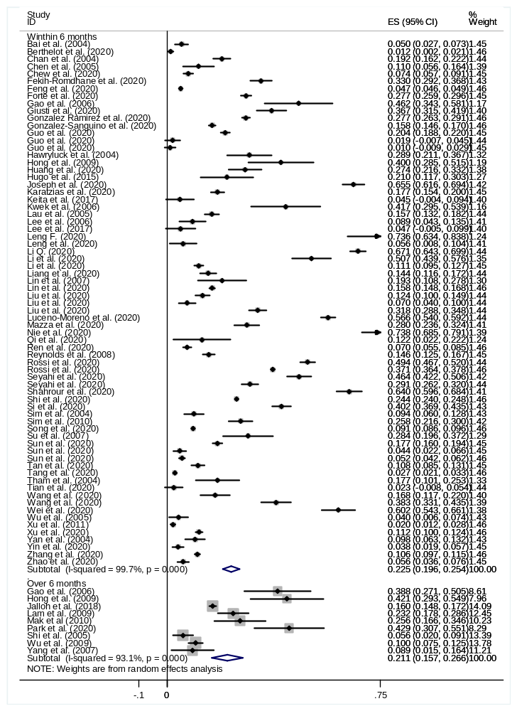
Figure S2: Forrest plot of PTSD prevalence with time difference by population
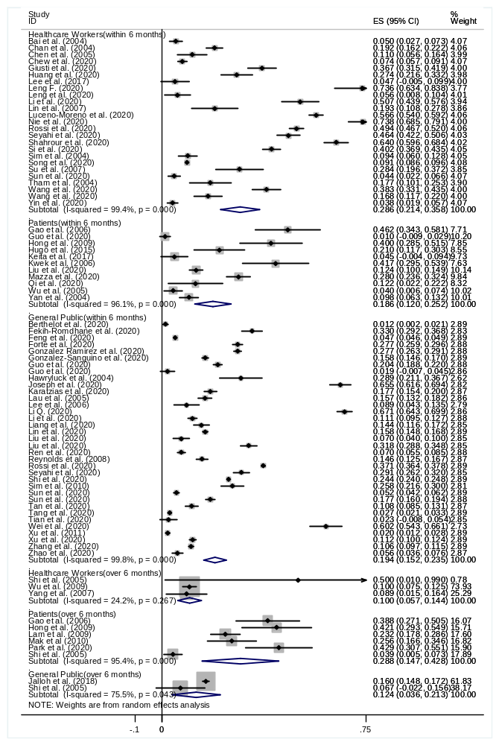
Figure S3: Forrest plot of PTSD prevalence across genders
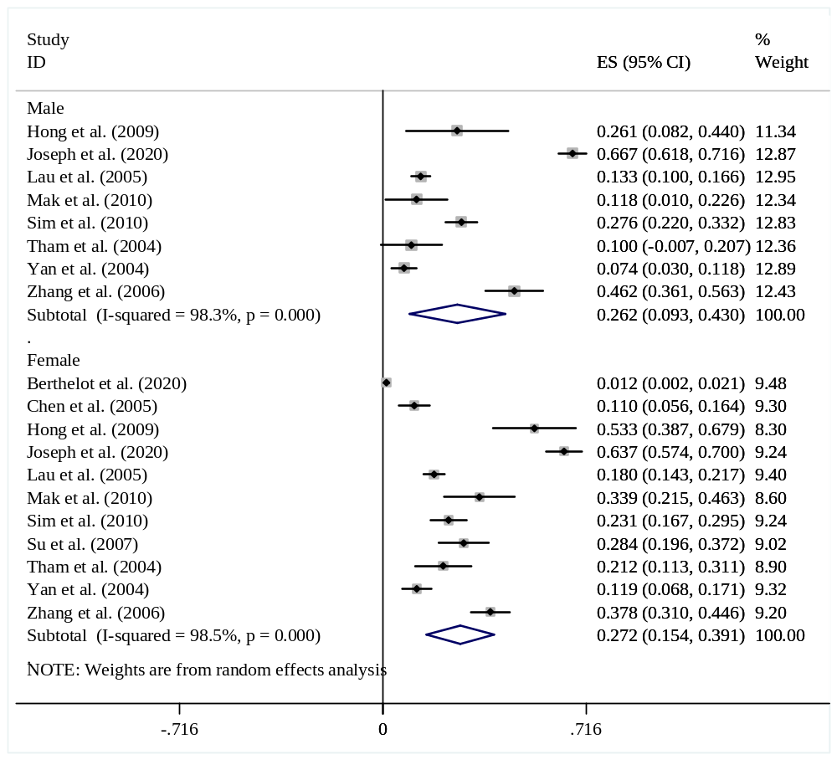

Figure S4: Forrest plot of PTSD prevalence across genders by population
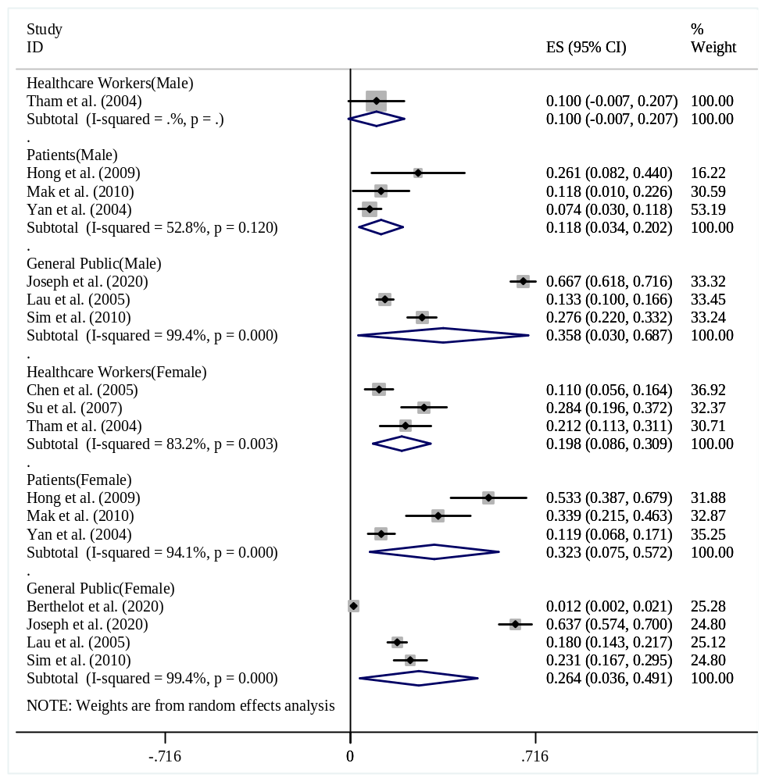

Figure S5: Forrest plot of PTSD prevalence across regions
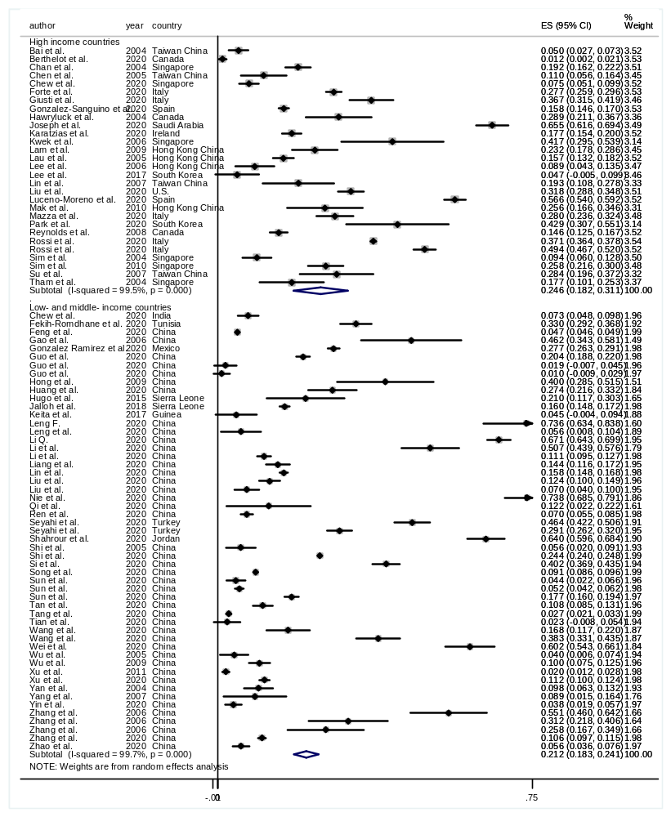
Figure S6: Forrest plot of PTSD prevalence across regions by population
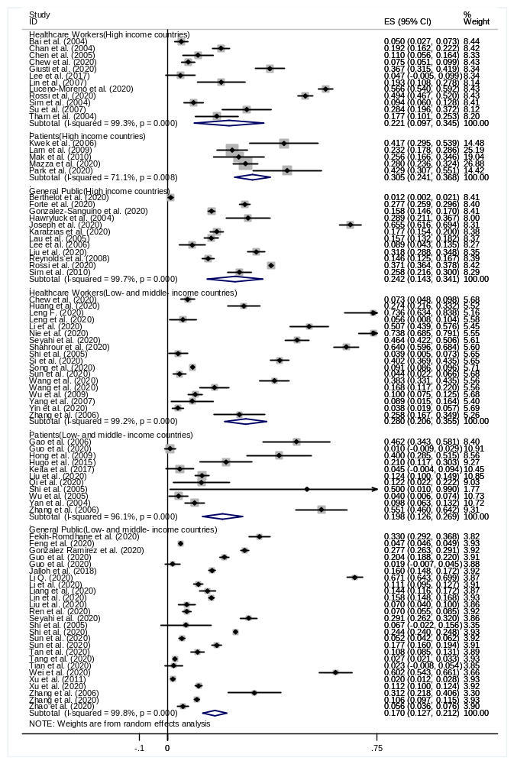
Figure S7: Forrest plot of PTSD prevalence for different pandemics
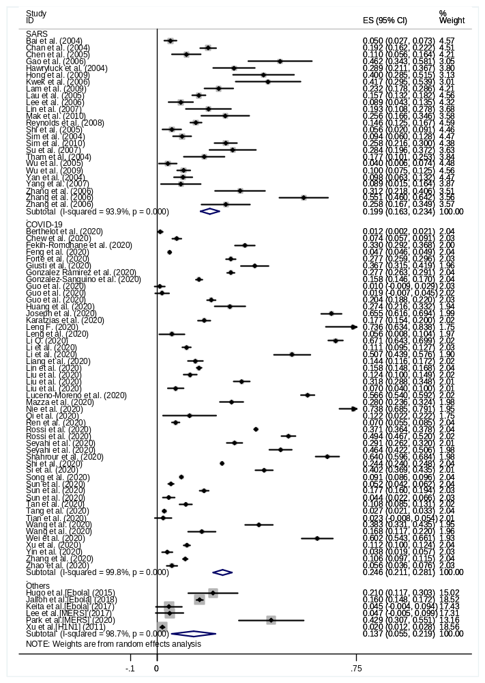
Figure S8: Forrest plot of PTSD prevalence for different pandemics by population
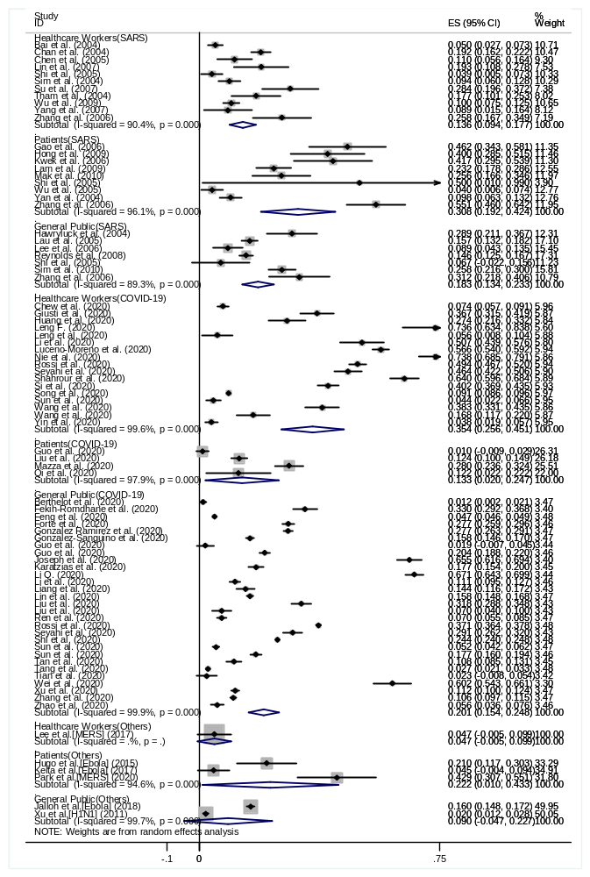
Figure S9: Forrest plot of PTSD prevalence using different assessment instruments
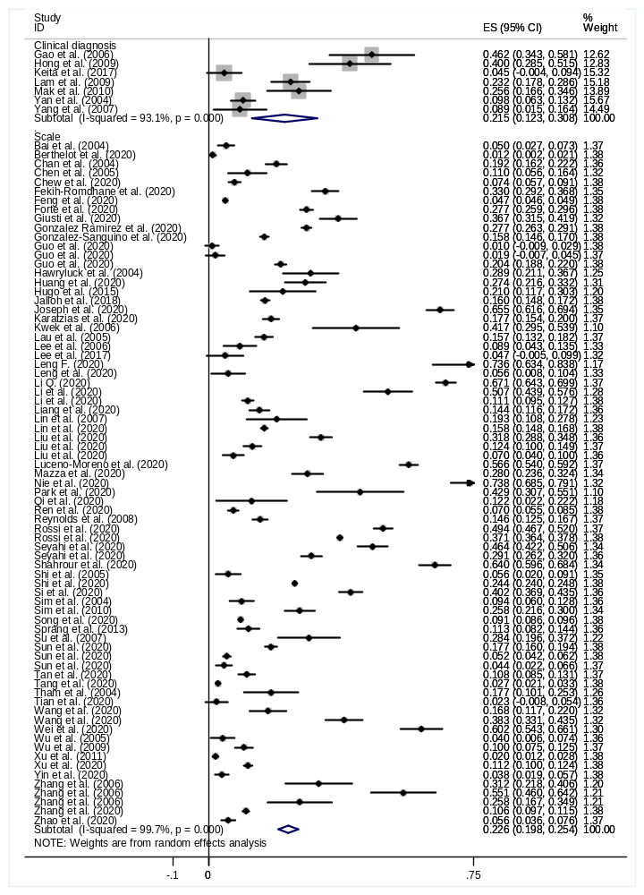
Figure S10: Forrest plot of PTSD prevalence using different assessment instruments by population
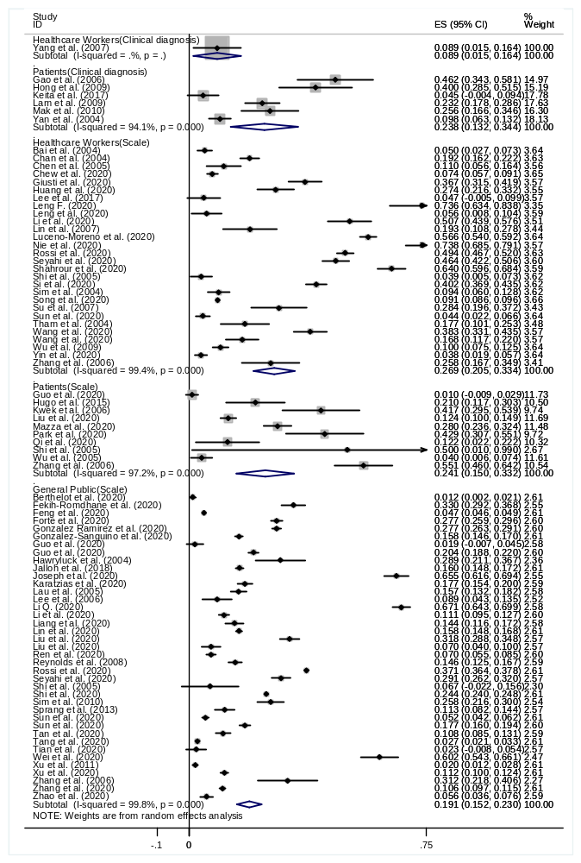
Figure S11: Forrest plot of PTSD prevalence of frontline HCWs vs. other HCWs

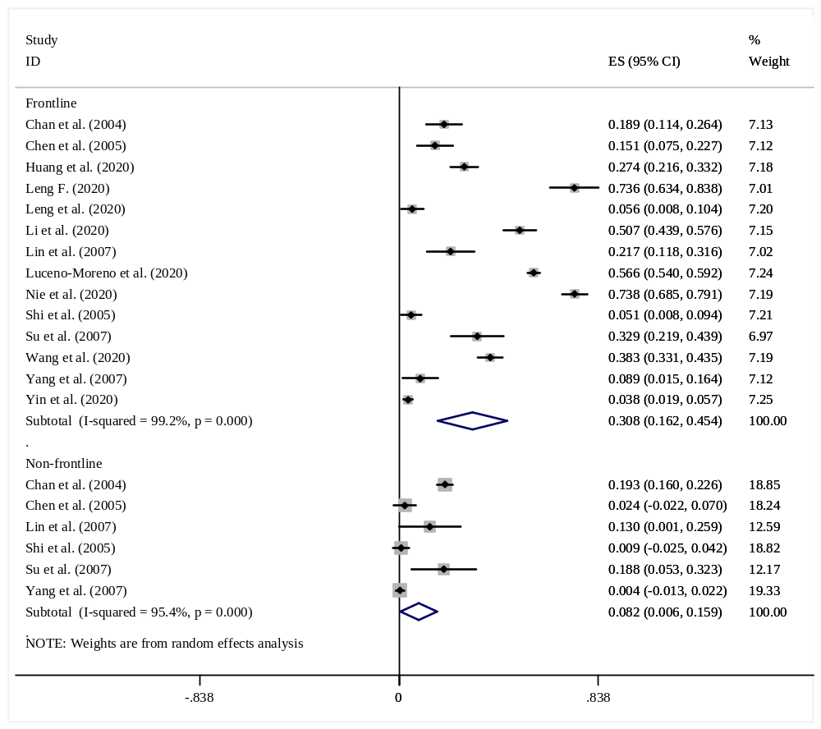
Figure S12: Forrest plot of PTSD prevalence of quarantined individuals vs. non-quarantined individuals

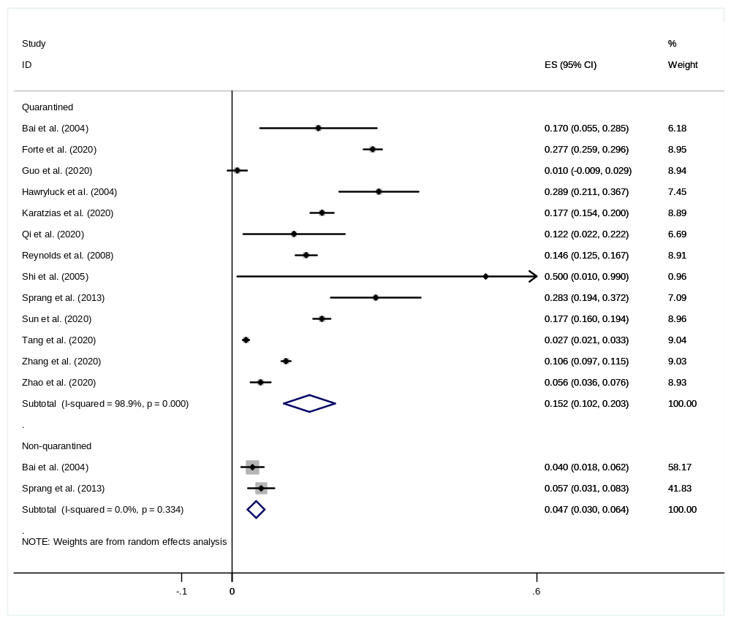
Figure S13: Forrest plot of PTSD prevalence of quarantined individuals vs. non-quarantined individuals by population

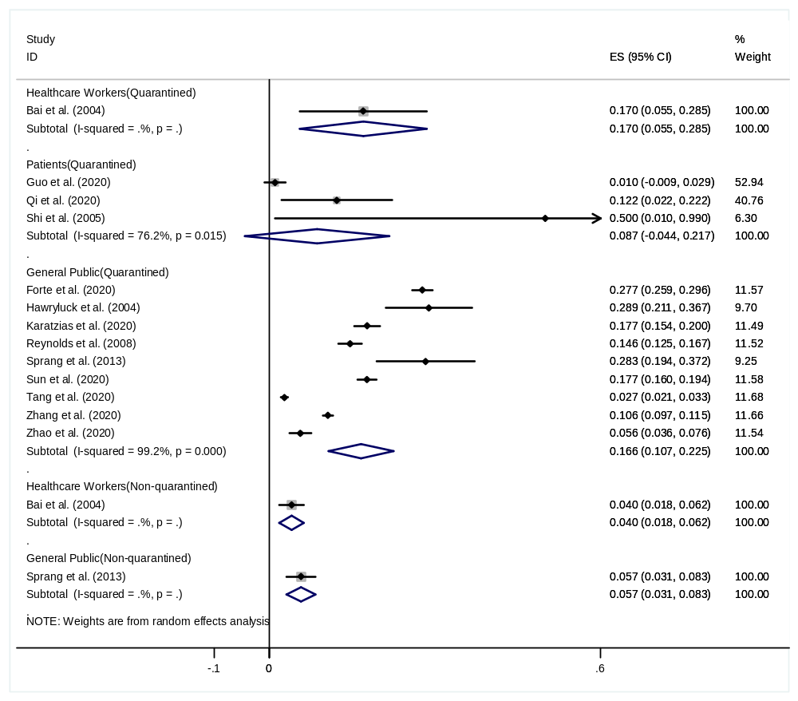
Figure S14: Sensitivity analysis
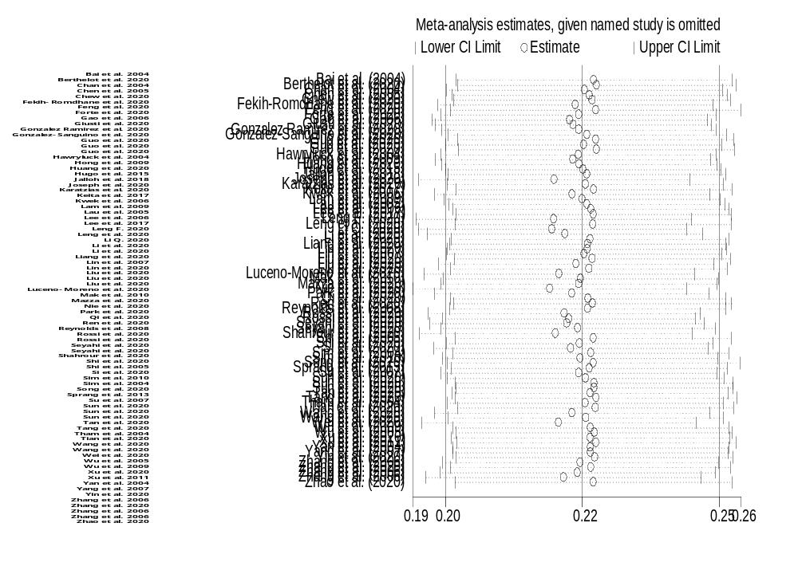
Table S2: Factors that increase risk of post-pandemic PTSD in detail
Study | Population | Risk factors
Arpacioglu et al. | Healthcare workers | Older age, female sex, anxiety and depression level, anxiety about the COVID-19, trauma history
Ausin et al. | General Public | Female sex
Bai et al. | Healthcare workers | Quarantine experience
Berthelot et al. | General Public | NA
Chan et al. | Healthcare workers | NA
Chen et al. | Healthcare workers | Working in higher-risk units (nurses)
Chew et al. | Healthcare workers | Presence of physical symptoms
Chong et al. | Healthcare workers | Male gender, technicians, working less than 2 years, during the repair phase (SARS situation under control), exposed to SARS patients, not living with familiy
Fekih-Romdhane et al. | General Public | Female sex, psychiatric disease history
Feng et al. | General Public | Female sex, older than 45 years, primary school education, university/college education, working in buisiness units, working as Healthcare workers, married
Forte et al. | General public | Female sex, aged between 18 and 49 years, having uncertainty of the possibility of contracting the infection, possibility of having had direct contact with people infected by COVID-19, knowing someone infected or who hospitalized in ICU or who had died due to COVID-19
Gao et al. | Patients | NA
Garcia-Fernandez et al. | General Public | Less than 60 years old, economic losses, having increased anxiolytic substances intake
Giusti et al. | Healthcare workers | NA
Gonzalez Ramirez et al. | General Public | Younger age, female sex, employed (economic loss), single, in social isolation, more days in isolation, those with 3-5 people at home, the perception of having a high risk of contracting COVID-19, change in routine, less activity, loss of income
Gonzalez-Sanguino et al. | General Public | Female sex, previous dianoses of mental health problems or neurological disorders, having symptoms associated with the virus, those with a close relative infected
Guo Q et al. | Patients  /General Public | COVID-19 patients
Guo J et al. | General Public | More emotional-focused coping; more impact on livelihood
Hawryluck et al. | General Public | Longer duration of quarantine, low annual income; acquaintance with or exposure to someone who was hospitalized with SARS
Ho et al. | Healthcare workers | Insecurity (fear of potnetail harm, death, and life out of control) followed by instability (work-environment changes & assignment to high risk units) and infection
Hong et al. | Patients | Older, female sex, married, having higher numbers of close relative who suffered and/or died from SARS, to have femoral head necrosis
Huang et al. | Healthcare workers | NA
Hugo et al. | Patients | NA
Jalloh et al. | General Public | knowing someone who died from Ebola alone, knew someone quarantined due to Ebola exposure alone, knew at least one person who died from Ebola and someone quarantined, with any Ebola experience, perceived some ongoing threat of Ebola, had Ebola experience and also perceived ongoing Ebola threat
Jiang et al. | General Public | Lower level of education, family or friends infected with COVID-19, those having siblings, female participants living alone, younger, having children, having family or friends as healthcare workers, having family or friends recently visiting Wuhan
Joseph et al. | General public | Prefer the Arabic language, having personal experience with COVID-19 related events, know COVID-19 hospitalized cases, moderate-severe threat perception
Karatzias et al. | General public | Younger age, male sex, living in a city, living with children, moderate and high perceived risk of COVID-19 infection, screening positive for anxiety or depression
Keita et al. | Patients | NA
Kwek et al. | Patients | NA
Lam et al. | patients | NA
Lau et al. | General Public | increased work-related and family-related stress; poorer social life (associated with IES intrusion and hyperarousal); worsened emotional states of family members(associated with IES intrusion and avoidance); Those who felt horrified, apprehensive, and helpless because of SARS
Lee TM et al. | General Public | Older, living in high SARS-prevalent regions
Lee AM et al. | Patients | Female sex, health care workers
Lee HW et al. | Healthcare workers | NA
Lee SM et al. | Healthcare workers | Perform MERS-related tasks
Leng F. | Healthcare workers | Having colleague infected, never participated in public emergency response work before, having anxiety/depression symptoms
Leng M. et al. | Healthcare workers | Nurses’ original unit; nurses’ general stress level
Li CS et al. | Healthcare workers | Working duration, non-local aid worker, educational level
Li,Q | General Public | Problem-focused coping, psychiatric disorder
Li Y et al. | General Public | Female sex, higher baseline depression, anxiety and stress, high childhood adverse experiences, high internet addiction
Liang et al. | General Public | NA
Lin CY et al. | Healthcare workers | Self-observation about the severity of the stress caused by SARS, working in the emergency department
Lin et al. | General public | Degree of threat from COVID-19
Liu CH et al. | General public | High level of loneliness and worries about COVID-19, low level of distress tolerance, low levels of family support
Liu N et al. | General Public | Female sex, poor sleep quality
Liu D et al. | Patients | Higher COVID-19 disease severity, living with children, death of family member, regarding oneself as having been the target of discrimination
Luceno-Moreno et al. | Healthcare workers | Working in the Autonomous Community of Madrid, working in a hospital, female sex, concerned that a person he/she lives with may be infected, thinks that he/she is very likely to be infected
Mak et al. | Patients | Female sex, pre-SARS presence of chronic medical illness, presence of avascular necrosis
Mazza et al. | Patients | NA
McAlonan et al. | Healthcare workers | High-risk level
Nie et al. | Healthcare workers | More working years, concern for own being infected, negative coping style
Park et al. | Patients | Pervious visit to psychiatric clinic, anxiety during MERS, MERS stigma during MERS
Plomecka et al. | General Public | Psychiatric condition that worsened during the COVID-19 pandemic, previous exposure to trauma, working remotely from home, female sex
Qi et al. | Patients | Negative coping inclination
Reynolds et al. | General Public | Healthcare workers, increasing perceived difficulty with compliance, longer quarantine and compliance with quarantine requirements
Ren et al. | General public | NA
Rossi et al. | Healthcare workers | Female sex, frontline healthcare workers, general practitioners, having a colleague deceased, having a colleague hospitalized, having a colleague in quarantine
Rossi et al. | General public | Female sex, younger age, participants from southern Italy, being under quarantine because infected or in close proximity to infected people, having experienced a stressful life event due to COVID-19, working actively discontinued due to COVID-19, working more than usual due to COVID-19, having a loved one deceased by COVID-19, having a loved one diagnosed with COVID-19
Seyahi et al. | Healthcare workers  General public | Female sex, length of education less than 8 years, having child, time spent watching TV or using social media over 1h, being a smoker (either currently or in the past), having a comorbid disease, history of psychiatric disorders or psychiatric drug use for at least 3 months
Shahrour et al. | Healthcare workers | NA
Shi L et al. | General Public | Younger than 40, having lower income levels, haivng a personal history of psychiatric disorders, male sex, unmarried, individuals who confirmed or suspected COVID-19, family members or friends of patients with COVID-19, potential occupational exposure risk to patients with COVID-19, centralized quarantine or home quarantine experience, Hubei residents, frontline workers
Shi et al. | Patients  Healthcare workers  General public | Neurotic and psychopathic individual, higher stress intensity, negative coping style, psychological health status (compulsion-obsession, somatization, interpersonal sensitivity)
Si et al. | Healthcare workers | Nurses, ever had chronic disease, have high concern to the outbreak, had confirmed cases among their relatives and friends, more fears of infection, passive coping strategies, current tobacco user
Sim et al.（2010） | General Public | Increased use of denial as coping measures, planning as coping measures
Sim et al.（2004） | Healthcare workers | Married; GHQ-28 total score ≥ 5; younger age; increased use of specific coping strategies(Behavioral disengagement; Religion); decreased use of specific coping strategies(venting; humor; acceptance)
Sprang et al. | General public | Experience of quarantine or isolation; women; younger; family member with high score of PTSD
Song et al. | Healthcare workers | Male, nurses, middle aged, worked for fewer years, had longer daily work time, had lower levels of social support
Styra et al. | Healthcare workers | Working in high-risk unit, taking care of only one SARS patient, perception of personal risk, impact on work life, depressive affect
Su TP et al. | Healthcare workers | Perceived negative feelings towards SARS at baseline
Sun L et al. | General public  Healthcare workers | Female sex, exposure history of Wuhan, high risk public of infection, poor sleep quality
Sun SF et al. | General public | financial stress due to COVID-19, perceived COVID-19 risk, perceived COVID-19 societal stigma
Tan et al. | General public | respondents who were divorced, separated or widowed; poorer physical health; respondents who had not returned to work and had returned to work within 7 days (compared to those who had returned to work for >15 days); respondents who observed small improvement in workplace hygiene after the outbreak (compared to those who believed workplace hygiene was good enough before the outbreak); respondents who believed that workplace hygiene required further improvement; respondents who viewed returning to work as serious health hazard
Tang et al. | General public | Short sleep durations (<6 h/ night); felt extreme fear; living in the worst-hit areas; being a graduating/final year student, sleep duration per night
Tham et al. | Healthcare workers | NA
Tian et al. | General public | NA
Wang YX et al. | Healthcare workers | Degree of job satisfaction, female sex, negative coping strategy
Wang YY et al. | Healthcare workers | NA
Wei Y. et al. | General Public | Company employment, high degree of being affected by economic
Wu KK et al. | Patients | History of psychiatric consultation(predict IES-R all 3 subscales); being healthcare workers(predict IES-R intrusion and hyperarousal); The lowest level of SaO2 during hospitalization(predict IES-R intrusion and avoidance)
Wu P et al. | Healthcare workers | Relative or friend got SARS; Perceived risk level
Xu et al. | General Public | Women over 30 years old who are not the only child, whose parents are not living, married or have children
Xu J et al. | General Public | In North China, female sex, having H1N1 influenza, having family members, friends, or acquaintances with H1N1 influenza, and being afraid of H1N1 influenza
Yan et al. | Patients | Aged between 40-49, widowed/divorced/live apart, family deceased due to SARS
Yang et al. | Healthcare workers | Working frontline
Yin et al. | Healthcare workers | Female sex
Zhang et al. | Patients  Healthcare workers  General public | Negative coping style (among patients and the public)
Zhang Y. et al. | General Public | Junior high students, grade 12 students, female sex, students living in single parent family or reconstituted family
Zhao et al. | General Public | NA

