Figure S3: Summary ROC plots per diagnostic indicators.
Accuracy of symptoms (A), risk conditions (B), and genetic factors that predispose for coeliac disease (C) as diagnostic indicators. Blue line: HSROC line; green line: 95% confidence ellipse; red dot: summary estimate; circles: estimates per study, size is proportionate to the sample size.

A. Symptoms
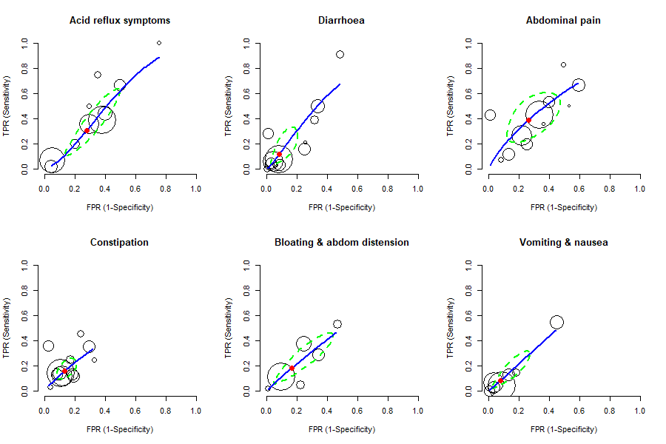
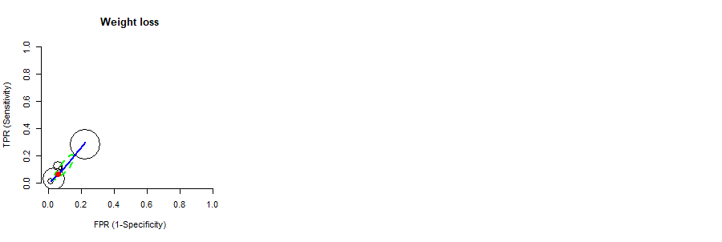

B. Risk conditions
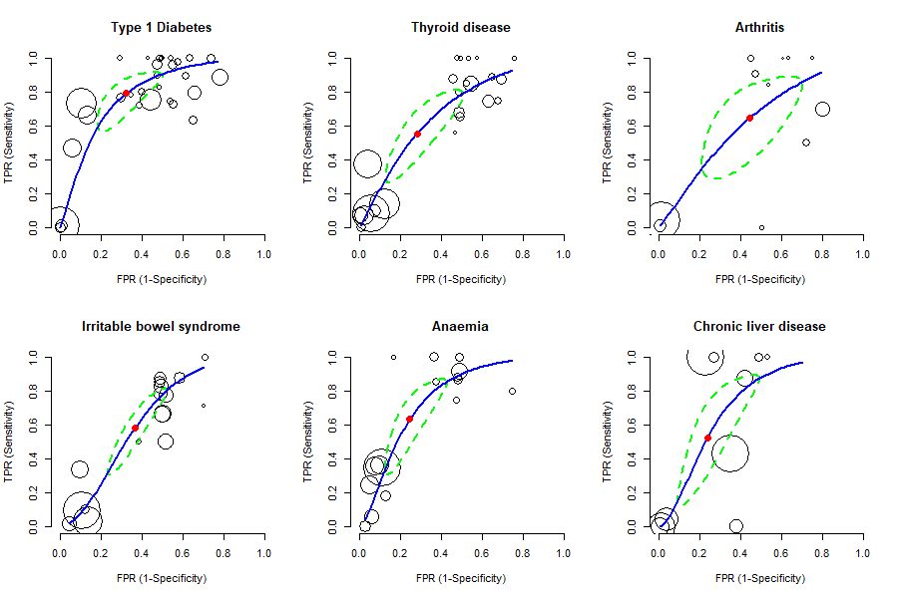
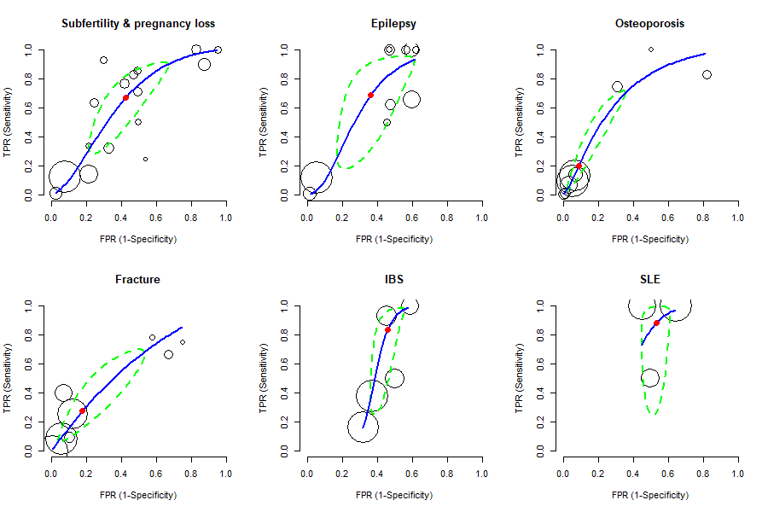
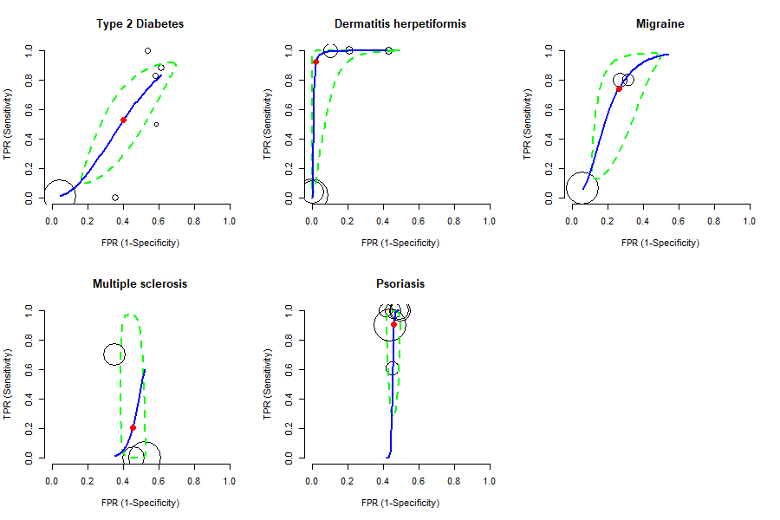

C. Genetic predisposition


