Supplementary Figure 1. Analysis of the influence of sesame consumption on serum FBS concentrations in adults. CI, confidence interval; FBS, Fasting blood sugar

Supplementary Figure 2. Analysis of the influence of sesame consumption on serum HbA1c concentrations in adults. CI, confidence interval; HbA1c, Hemoglobin A1c

Supplementary Figure 3. Analysis of the influence of sesame consumption on serum insulin concentrations in adults. CI, confidence interval

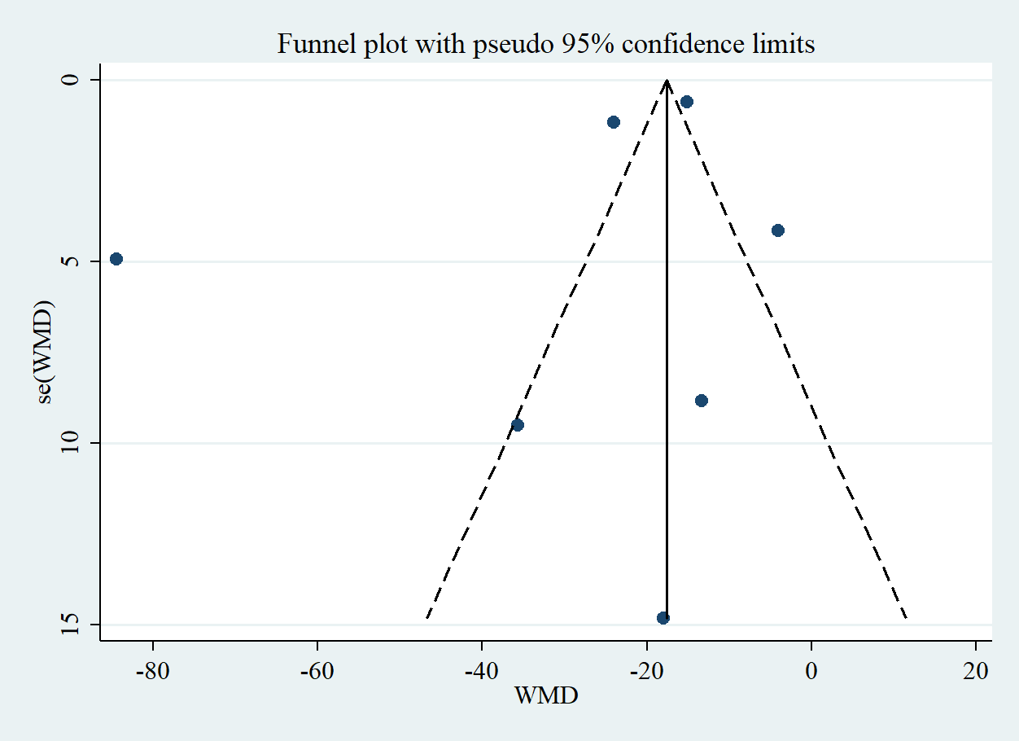
Supplementary Figure 4. Funnel plot for assessing publication bias in the studies reporting the effects of sesame consumption on serum FBS concentrations in adults. FBS, Fasting blood sugar; SE, standard error; WMD, weighted mean difference

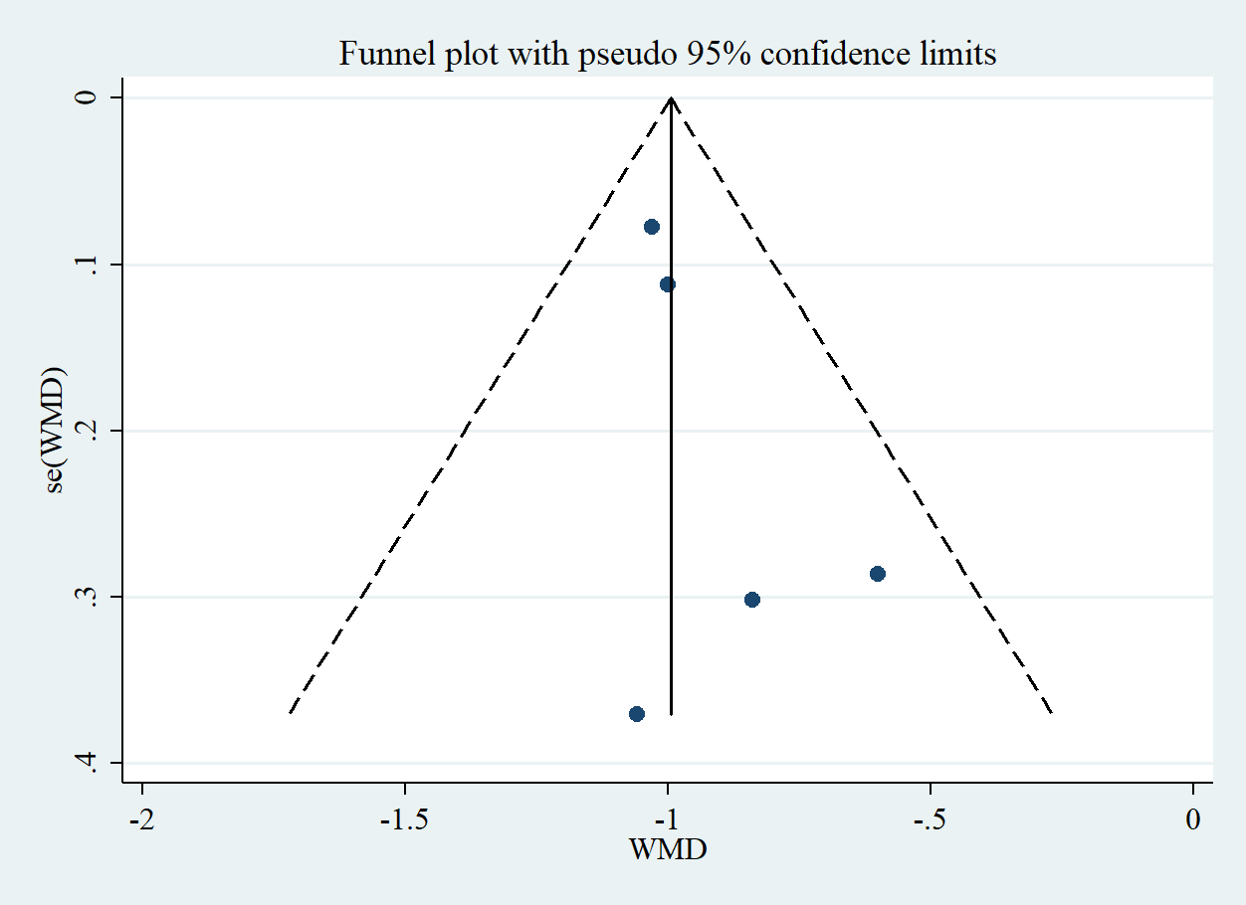
Supplementary Figure 5. Funnel plot for assessing publication bias in the studies reporting the effects of sesame consumption on serum HbA1c concentrations in adults. HbA1c, Hemoglobin A1c; SE, standard error; WMD, weighted mean difference

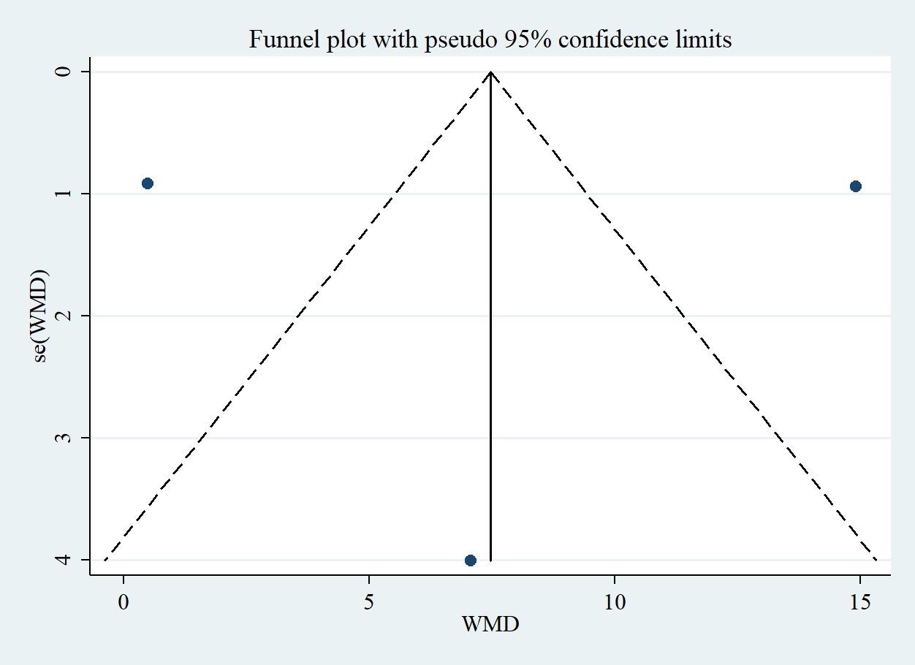
Supplementary Figure 6. Funnel plot for assessing publication bias in the studies reporting the effects of sesame consumption on serum insulin concentrations in adults. SE, standard error; WMD, weighted mean difference

