Supplementary Material

Search strategy

PubMed (from 1 January 2010 to 13 July 2021)
Search number | Query | Results
#1 | "Heavy Ions"[Mesh] | 1,142
#2 | "Heavy Ion Radiotherapy"[Mesh] | 5,141
#3 | "Protons"[Mesh] | 29,986
#4 | (((((heavy ion*[Title/Abstract]) OR (Carbon ion*[Title/Abstract])) OR (C-ion*[Title/Abstract])) OR (Particle[Title/Abstract])) OR (Ion[Title/Abstract])) OR (Proton*[Title/Abstract]) | 627,821
#5 | #1 OR #2 OR #3 OR #4 | 635,015
#6 | "Prostatic Neoplasms"[Mesh] | 134,615
#7 | (((((Prostate Neoplasm*[Title/Abstract]) OR (Prostatic Neoplasm*[Title/Abstract])) OR (Prostate Cancer*[Title/Abstract])) OR (Prostatic Cancer*[Title/Abstract])) OR (Prostate Tumor*[Title/Abstract])) OR (Prostatic Tumor*[Title/Abstract]) | 135,824
#8 | #6 OR #7 | 169,923
#9 | #5 AND 38 | 2,049
#10 | #9 AND ((humans[Filter]) AND (2010/1/1:2021/7/13[pdat])) | 1108

EMBASE (from 1 January 2010 to July 2021)
Search number | Query | Results
#1 | 'heavy ion'/exp | 1,557
#2 | 'ion therapy'/exp | 2,478
#3 | 'proton'/exp | 46,170
#4 | 'heavy ion*':ab,ti OR 'carbon ion*':ab,ti OR 'c ion*':ab,ti OR particle:ab,ti OR ion:ab,ti OR proton*:ab,ti | 683,781
#5 | #1 OR #2 OR #3 OR #4 | 693,856
#6 | 'prostate tumor'/exp | 264,393
#7 | 'prostate neoplasm*':ab,ti OR 'prostatic neoplasm*':ab,ti OR 'prostate cancer*':ab,ti OR 'prostatic cancer*':ab,ti OR 'prostate tumor*':ab,ti OR 'prostatic tumor*':ab,ti | 198,848
#8 | #6 OR #7 | 280,357
#9 | #5 AND #8 | 3,416
#10 | #9 AND 'human'/de | 2,898
#11 | #9 AND 'human'/de AND [embase]/lim NOT ([embase]/lim AND [medline]/lim) | 1,088

Cochrane library (from 1 January 2010 to July 2021)
Search number | Query | Results
#1 | MeSH descriptor: [Heavy Ion Radiotherapy] explode all trees | 50
#2 | MeSH descriptor: [Heavy Ions] explode all trees | 1
#3 | MeSH descriptor: [Protons] explode all trees | 109
#4 | (heavy ion*):ti,ab,kw OR (Carbon ion*):ti,ab,kw OR (C-ion*):ti,ab,kw OR (Particle):ti,ab,kw OR (Ion):ti,ab,kw | 11940
#5 | (Proton*):ti,ab,kw (Word variations have been searched) | 5993
#6 | # 240 OR #241 OR #242 OR #243 OR #244 | 34901
#7 | MeSH descriptor: [Prostatic Neoplasms] explode all trees | 5746
#8 | (Prostate Neoplasm*):ti,ab,kw OR (Prostatic Neoplasm*):ti,ab,kw OR (Prostate Cancer*):ti,ab,kw OR (Prostatic Cancer*):ti,ab,kw OR (Prostate Tumor*):ti,ab,kw | 15237
#9 | (Prostatic Tumor*):ti,ab,kw | 3334
#10 | #246 or #247 or #248 | 15237
#11 | #245 AND #249 | 424

Web of science (from 1 January 2010 to July 2021)
Search number | Query | Results
#1 | TS=(heavy ion* ) OR TS=(Carbon ion*) OR TS=(C-ion*) OR TS=(Particle) OR TS=(Ion) OR TS=(Proton*) Index Date: 2010-01-01 to 2021-07-13 | 1,753,023
#2 | TS=(Prostate Neoplasm*) OR TS=(Prostatic Neoplasm*) OR TS=(Prostate Cancer*) OR TS=( Prostatic Cancer*) OR TS=(Prostate Tumor*) OR TS=(Prostatic Tumor*) Index Date: 2010-01-01 to 2021-07-13 | 158,054
#3 | #1 AND #2 | 3,758

Risk of bias assessment (cohort studies)
Study, year | Selection |  |  |  | Comparability |  | Outcome
Study, year | Representativeness of the exposed cohort | Selection of the non exposed cohort | Ascertainment of exposure | Demonstration that outcome of interest was not present at start of study | Comparability of cases and controls on the basis of the design or analysis | Ascertainment of outcome |  | Was follow-up long enough for outcomes to occur | Adequacy of follow up of cohorts | Quality score
Nakajima 2018 | * | * | * | * | / | * |  | / | * | 7
Fang 2014 | * | * | * | * | ** | * |  | * | * | 9
Pan 2018 | * | * | * | * | ** | * |  | / | / | 7
Santos 2019 | * | * | * | * | / | * |  | * | * | 8
Yu 2012 | * | * | * | * | * | * |  | / | * | 8
Mishra 2019 | * | * | * | * | / | * |  | * | * | 8

Forest plots of outcomes
FIGURE 1 Forest plots of the LCR of CIRT for prostate cancer
FIGURE 2 Forest plots of the BRF of CIRT for prostate cancer

FIGURE 3 Forest plots of the AGI of CIRT for prostate cancer

FIGURE 4 Forest plots of the LGI of CIRT for prostate cancer
FIGURE 5 Forest plots of the AGI of PBT for prostate cancer

FIGURE 6 Forest plots of the lGI of PBT for prostate cancer

FIGURE 7 Forest plots of the AGU of CIRT for prostate cancer
FIGURE 8 Forest plots of the LGU of CIRT for prostate cancer

FIGURE 9 Forest plots of the AGU of PBT for prostate cancer
FIGURE 10 Forest plots of the LGU of PBT for prostate cancer

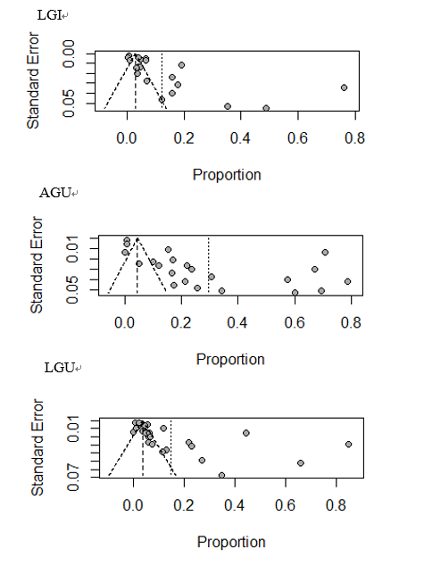

FIGURE 11 Funnel plots of the LGI, AGU and LGU of PBT for prostate cancer

