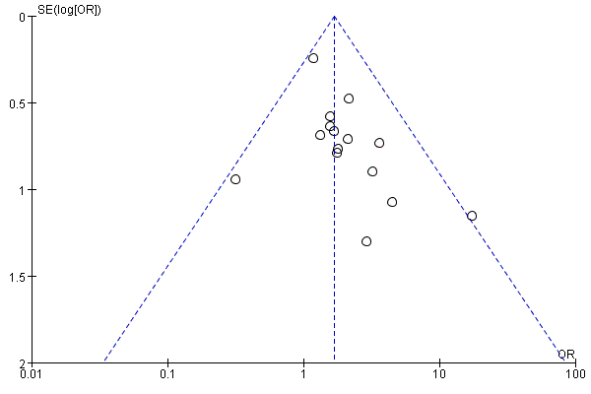
Supplementary Figure 1 – the funnel plot for meta-analysis of the proportion of Gleason scores ≥8 between the group of AR-V7-positive and negative CRPC
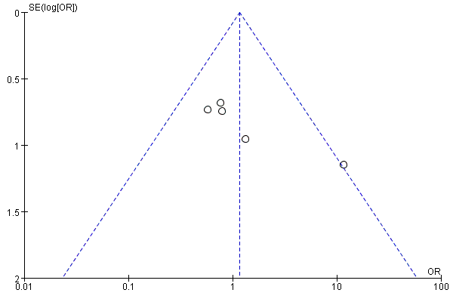
Supplementary Figure 2A – the funnel plot for meta-analysis of the proportion of T3/T4 stage between the group of AR-V7-positive and negative CRPC
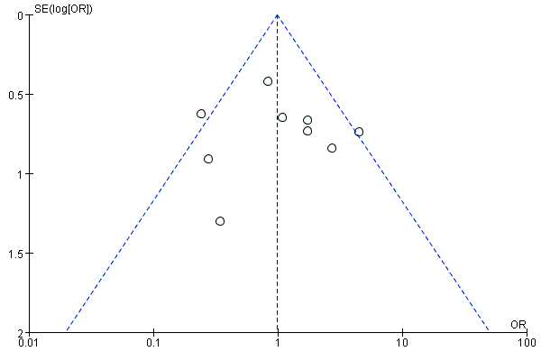
Supplementary Figure 2B – the funnel plot for meta-analysis of the proportion of N1 stage between the group of AR-V7-positive and negative CRPC
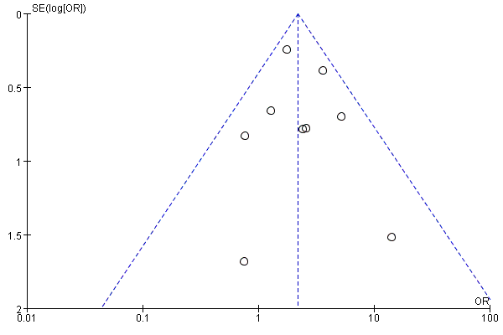
Supplementary Figure 3 A – the funnel plot for meta-analysis of the proportion of any site metastasis between the group of AR-V7-positive and negative CRPC
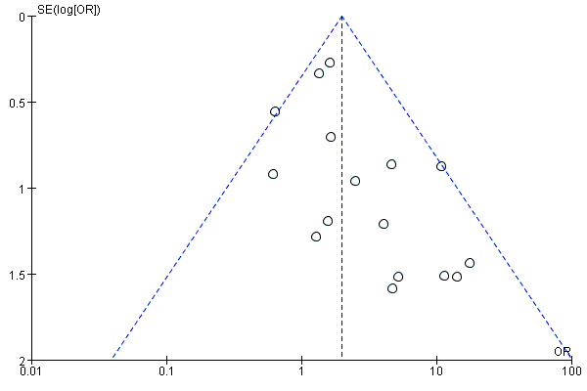
Supplementary Figure 3 B – the funnel plot for meta-analysis of the proportion of bone metastasis between the group of AR-V7-positive and negative CRPC
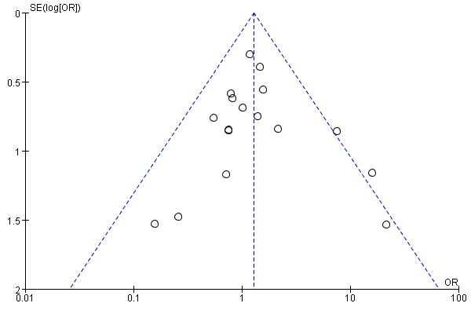
Supplementary Figure 3C – the funnel plot for meta-analysis of the proportion of visceral metastasis between the group of AR-V7-positive and negative CRPC
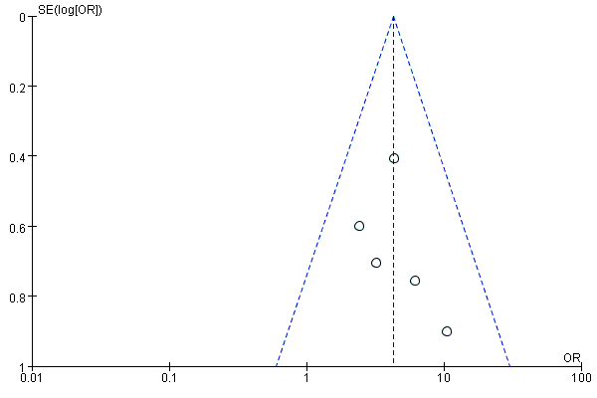
Supplementary Figure 4A – the funnel plot for meta-analysis of the proportion of pain sufferance between the group of AR-V7-positive and negative CRPC
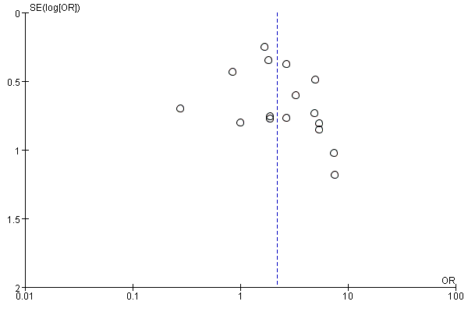
Supplementary Figure 4B – the funnel plot for meta-analysis of the proportion of ECOG score ≥1 between the group of AR-V7-positive and negative CRPC
Supplementary Table 1 – Target specimens and AR-V7 detection assay of studies in the clinicopathological features of different AR-V7 status CRPC meta-analysis.
Study | Target specimens | AR-V7 detection assay
Antonarakis[1] | CTC mRNA | CTC analyses were conducted using the commercially-available AlereTM CTC AdnaTest platform (AdnaGen, Langenhagen, Germany). AR-V7 positivity was defined as detection of the AR-V7 transcript by means of a quantitative RT-PCR assay at 36 or fewer PCR cycles.
Antonarakis[2] | CTC mRNA | CTC analyses were conducted using a modified AdnaTest platform (QIAGEN, Hannover, Germany). Used a modified version of the AdnaTest platform for CTC analysis, as Antonarakis previously described [1].
Nakazawa[3] | CTC mRNA | AdnaTest platform for CTC analysis. CTCs were enriched from peripheral blood using the ProstateCancerSelect kit, mRNA expression analysis was conducted using the ProstateCancerDetect kit. Used a modified version of the AdnaTest platform for CTC analysis, as Antonarakis previously described [1].
Sharp[4] | IHC on FFPE PC patient tissue biopsies | A recombinant rabbit monoclonal antibody (Clone RM7) was developed against CE3 of AR-V7. AR-V7 was defined as positive (nuclear AR-V7 HS > 10) or negative (nuclear AR-V7 HS ≤ 10).
Zadra[5] | Immuno-fluorescence staining of mCRPC tissue | The slides were incubated with antibodies against ARV7 (Clone RM7, 31-1109-00, RevMAb Biosciences, dilution 1: 300).
Antonarakis[6] | CTC mRNA | The CTC analyses were conducted using a modification of the commercially available AdnaTest platform (Qiagen).  Custom primers were used to detect the full-length AR (ARFL) mRNA and AR-V7 mRNA. AR-V7 positivity was defined as detection of the AR-V7 transcript by means of a quantitative RT-PCR assay at 36 or fewer PCR cycles.
Sieuwerts[7] | CTC mRNA | CellSearch-enriched CTCs were subjected to RNA isolation using the AllPrep DNA/RNA Micro Kit (Qiagen, Hilden, Germany).  Samples were considered to be positive for any of the AR variants if a positive signal was detected within 8.5 cycles after the epithelial signal was detected.
Del Re [8] | plasma-derived exosomal RNA | The analysis of AR-V7 in RNA was performed by ddPCR using the One-Step RT-ddPCR kit, Exosomes were isolated and RNA extracted for analysis of AR-V7 by ddPCR.  The ddPCR QuantaSoft software determined the absolute target concentration as copies/ml in the samples. Statistical analyses were performed separately in the AR-V7 positive (> 0 copies/ml) and AR-V7-negative (0 copies/ml) cohorts.
Takeuchi T.[9] | Whole blood RNA | Total RNA was extracted from 0.4 mL of whole blood using oligo dT primer and a DNA Extractor® WB-Rapid Kit (Wako Pure Chemical Industries, Ltd, Osaka, Japan).
Lee[10] | Immunofluorescent Staining, Immunohistochemistry of PCa Tissues | Immunofluorescent staining for AR-V7 was performed. The secondary antibody was an Alexa Fluor 488-conjugated goat anti-rabbit antibody (Invitrogen)
Wang[11] | CTC mRNA | Total RNA of CTCs was extracted using the RNAprep pure Tissue Kit (QIAGEN, USA). Relative expression of those samples higher than 0.2-fold of AR-V7 was defined as AR-V7-positive and vice versa.
Tagawa [12] | CTC mRNA | Total RNA was extracted from the enriched CTCs pool using the RNAeasy Plus Micro kit (Qiagen)
Steinestel [13] | CTC mRNA | For CTC isolation, we employed the AdnaTest ProstateCancerSelect Kit (AdnaGen, Langenhagen, Germany).
Onstenk [14] | CTC mRNA | CTCs were enumerated from 7.5 ml blood drawn in a CellSave tube using the CellSearch System (Janssen Diagnostics LLC, Raritan, NJ, USA).
Zhang [15] | Tissue RNA | Total tissue RNA was isolated from minced fresh tissue usingTrizol reagent (Invitrogen) according to the manufacturer’s instructions.
Saylor [16] | RISH in FFPE tissues | The AR-V7 RNA ISH probe was designed to target the unique cryptic exon CE3 as identified in the NCBI nucleotide database, using multiple tiling probes.  Samples with RNA in situ hybridization signal for AR and AR-V7 seen at 2X and 4X magnification were scored as 3+, signal seen at 10X magnification was scored as 2+, signal seen at 20X and 40X magnification was scored as 1+, and no staining for AR and AR-V7 at 40X magnification was scored as 0.
Belderbos [17] | CTC mRNA | CTC enrichment occurred from 7.5 mL of peripheral blood using the CellSearch System. If a sample had sufficient Cq values for the reference and epithelial targets, but did not produce a quantitative PCR signal for AR-V7 within 8.5 cycles after the average Cq of the epithelial markers, the sample was considered AR-V7 negative.
Cattrini [18] | CTC mRNA | CTC were isolated by immuno-magnetic beads with an EpCAM-based method (AdnaTest Prostate Cancer Select). Patients with detectable (below 10 copies/mL) AR-V7 and AR-FL on CTC were considered as positive.
Taplin [19] | CTC mRNA | CTC-based AR-V7 clinical trial assay utilized modification of the methods reported by Antonarakis
Sharp [20] | CTC mRNA | Isolation and enrichment of CTCs from mCRPC patient peripheral blood (PB) draws were carried out using the AdnaTest ProstateCancerSelect (Qiagen, Hilden, Germany). AR-V7 status is presented as present >1 copy/ml and absent <1 copy/ml outcomes.
Maillet [21] | CTC mRNA | The CTC enrichment procedure was using the AdnaTest platform(Qiagen)
Okegawa [22] | CTC mRNA | CTC cells were made for On-chip multi-imaging flow cytometry system. The test was adapted for detectionof AR-V7bypolymerase chain reaction (PCR)using custom primers specific for AR-V7
Chung [23] | CTC mRNA | The CTC isolation and mRNA recovery methods are described inour previous study reported by Antonarakis
El-Heliebi [24] | CTC immuno-fluorescence staining | CTCs were enriched from EDTA blood using the size-dependent, label-free Parsortix system (ANGLE plc)
FFPE=formalin fixed paraffin embedded tissue, RRP= radical prostatectomy, TURP= transurethral resection of prostate, RNA ISH = RNA in situ hybridization, qRT-PCR= Quantitative real-time polymerase chain reaction, CTC = circulating tumor cell

1. Antonarakis, E.S., C. Lu, H. Wang, B. Luber, M. Nakazawa, J.C. Roeser, et al., AR-V7 and resistance to enzalutamide and abiraterone in prostate cancer. N Engl J Med, 2014. 371(11): p. 1028-38. DOI: 10.1056/NEJMoa1315815.
2. Antonarakis, E.S., C. Lu, B. Luber, H. Wang, Y. Chen, Y. Zhu, et al., Clinical Significance of Androgen Receptor Splice Variant-7 mRNA Detection in Circulating Tumor Cells of Men With Metastatic Castration-Resistant Prostate Cancer Treated With First- and Second-Line Abiraterone and Enzalutamide. J Clin Oncol, 2017: p. JCO2016701961. DOI: 10.1200/jco.2016.70.1961.
3. Nakazawa, M., C. Lu, Y. Chen, C.J. Paller, M.A. Carducci, M.A. Eisenberger, et al., Serial blood-based analysis of AR-V7 in men with advanced prostate cancer. Ann Oncol, 2015. 26(9): p. 1859-65. DOI: 10.1093/annonc/mdv282.
4. Sharp, A., I. Coleman, W. Yuan, C. Sprenger, D. Dolling, D.N. Rodrigues, et al., Androgen receptor splice variant-7 expression emerges with castration resistance in prostate cancer. J Clin Invest, 2019. 129(1): p. 192-208. DOI: 10.1172/jci122819.
5. Zadra, G., C.F. Ribeiro, P. Chetta, Y. Ho, S. Cacciatore, X. Gao, et al., Inhibition of de novo lipogenesis targets androgen receptor signaling in castration-resistant prostate cancer. Proc Natl Acad Sci U S A, 2019. 116(2): p. 631-640. DOI: 10.1073/pnas.1808834116.
6. Antonarakis, E.S., C. Lu, B. Luber, H. Wang, Y. Chen, M. Nakazawa, et al., Androgen Receptor Splice Variant 7 and Efficacy of Taxane Chemotherapy in Patients With Metastatic Castration-Resistant Prostate Cancer. JAMA Oncol, 2015. 1(5): p. 582-91. DOI: 10.1001/jamaoncol.2015.1341.
7. Sieuwerts, A.M., W. Onstenk, J. Kraan, C.M. Beaufort, M. Van, B. De Laere, et al., AR splice variants in circulating tumor cells of patients with castration-resistant prostate cancer: relation with outcome to cabazitaxel. Mol Oncol, 2019. 13(8): p. 1795-1807. DOI: 10.1002/1878-0261.12529.
8. Del Re, M., E. Biasco, S. Crucitta, L. Derosa, E. Rofi, C. Orlandini, et al., The Detection of Androgen Receptor Splice Variant 7 in Plasma-derived Exosomal RNA Strongly Predicts Resistance to Hormonal Therapy in Metastatic Prostate Cancer Patients. Eur Urol, 2017. 71(4): p. 680-687. DOI: 10.1016/j.eururo.2016.08.012.
9. Takeuchi, T., Y. Okuno, M. Hattori-Kato, M. Zaitsu, and K. Mikami, Detection of AR-V7 mRNA in whole blood may not predict the effectiveness of novel endocrine drugs for castration-resistant prostate cancer. Res Rep Urol, 2016. 8: p. 21-5. DOI: 10.2147/rru.s98877.
10. Lee, C.H., J.Y. Ku, J.M. Ha, S.S. Bae, J.Z. Lee, C.S. Kim, et al., Transcript Levels of Androgen Receptor Variant 7 and Ubiquitin-Conjugating Enzyme 2C in Hormone Sensitive Prostate Cancer and Castration-Resistant Prostate Cancer. Prostate, 2017. 77(1): p. 60-71. DOI: 10.1002/pros.23248.
11. Wang, S., S. Yang, C. Nan, Y. Wang, Y. He, and H. Mu, Expression of Androgen Receptor Variant 7 (AR-V7) in Circulated Tumor Cells and Correlation with Drug Resistance of Prostate Cancer Cells. Med Sci Monit, 2018. 24: p. 7051-7056. DOI: 10.12659/msm.909669.
12. Tagawa, S.T., E.S. Antonarakis, A. Gjyrezi, G. Galletti, S. Kim, D. Worroll, et al., Expression of AR-V7 and ARv(567es) in Circulating Tumor Cells Correlates with Outcomes to Taxane Therapy in Men with Metastatic Prostate Cancer Treated in TAXYNERGY. Clin Cancer Res, 2019. 25(6): p. 1880-1888. DOI: 10.1158/1078-0432.ccr-18-0320.
13. Steinestel, J., M. Luedeke, A. Arndt, T.J. Schnoeller, J.K. Lennerz, C. Wurm, et al., Todenhofer T,Detecting predictive androgen receptor modifications in circulating prostate cancer cells. Oncotarget, 2015. DOI: 10.18632/oncotarget.3925.
14. Onstenk, W., A.M. Sieuwerts, J. Kraan, M. Van, A.J. Nieuweboer, R.H. Mathijssen, et al., Efficacy of Cabazitaxel in Castration-resistant Prostate Cancer Is Independent of the Presence of AR-V7 in Circulating Tumor Cells. Eur Urol, 2015. 68(6): p. 939-45. DOI: 10.1016/j.eururo.2015.07.007.
15. Zhang, X., C. Morrissey, S. Sun, M. Ketchandji, P.S. Nelson, L.D. True, et al., Androgen receptor variants occur frequently in castration resistant prostate cancer metastases. PLoS One, 2011. 6(11): p. e27970. DOI: 10.1371/journal.pone.0027970.
16. Saylor, P.J., R.J. Lee, K.S. Arora, V. Deshpande, R. Hu, K. Olivier, et al., Branched chain RNA in situ hybridization for androgen receptor splice variant AR-V7 as a prognostic biomarker for metastatic castration-sensitive prostate cancer. Clin Cancer Res, 2016. DOI: 10.1158/1078-0432.ccr-16-0237.
17. Belderbos, B.P.S., A.M. Sieuwerts, E.O. Hoop, B. Mostert, J. Kraan, P. Hamberg, et al., Associations between AR-V7 status in circulating tumour cells, circulating tumour cell count and survival in men with metastatic castration-resistant prostate cancer. Eur J Cancer, 2019. 121: p. 48-54. DOI: 10.1016/j.ejca.2019.08.005.
18. Cattrini, C., A. Rubagotti, L. Zinoli, L. Cerbone, E. Zanardi, M. Capaia, et al., Role of Circulating Tumor Cells (CTC), Androgen Receptor Full Length (AR-FL) and Androgen Receptor Splice Variant 7 (AR-V7) in a Prospective Cohort of Castration-Resistant Metastatic Prostate Cancer Patients. Cancers (Basel), 2019. 11(9). DOI: 10.3390/cancers11091365.
19. Taplin, M.E., E.S. Antonarakis, K.J. Ferrante, K. Horgan, B. Blumenstein, F. Saad, et al., Androgen Receptor Modulation Optimized for Response-Splice Variant: A Phase 3, Randomized Trial of Galeterone Versus Enzalutamide in Androgen Receptor Splice Variant-7-expressing Metastatic Castration-resistant Prostate Cancer. Eur Urol, 2019. DOI: 10.1016/j.eururo.2019.08.034.
20. Sharp, A., J.C. Welti, M.B.K. Lambros, D. Dolling, D.N. Rodrigues, L. Pope, et al., Clinical Utility of Circulating Tumour Cell Androgen Receptor Splice Variant-7 Status in Metastatic Castration-resistant Prostate Cancer. Eur Urol, 2019. DOI: 10.1016/j.eururo.2019.04.006.
21. Maillet, D., N. Allioli, J. Peron, A. Plesa, M. Decaussin-Petrucci, S. Tartas, et al., Improved Androgen Receptor Splice Variant 7 Detection Using a Highly Sensitive Assay to Predict Resistance to Abiraterone or Enzalutamide in Metastatic Prostate Cancer Patients. Eur Urol Oncol, 2019. DOI: 10.1016/j.euo.2019.08.010.
22. Okegawa, T., N. Ninomiya, K. Masuda, Y. Nakamura, M. Tambo, and K. Nutahara, AR-V7 in circulating tumor cells cluster as a predictive biomarker of abiraterone acetate and enzalutamide treatment in castration-resistant prostate cancer patients. Prostate, 2018. 78(8): p. 576-582. DOI: 10.1002/pros.23501.
23. Chung, J.S., Y. Wang, J. Henderson, U. Singhal, Y. Qiao, A.B. Zaslavsky, et al., Circulating Tumor Cell-Based Molecular Classifier for Predicting Resistance to Abiraterone and Enzalutamide in Metastatic Castration-Resistant Prostate Cancer. Neoplasia, 2019. 21(8): p. 802-809. DOI: 10.1016/j.neo.2019.06.002.
24. El-Heliebi, A., C. Hille, N. Laxman, J. Svedlund, C. Haudum, E. Ercan, et al., In Situ Detection and Quantification of AR-V7, AR-FL, PSA, and KRAS Point Mutations in Circulating Tumor Cells. Clin Chem, 2018. 64(3): p. 536-546. DOI: 10.1373/clinchem.2017.281295.

