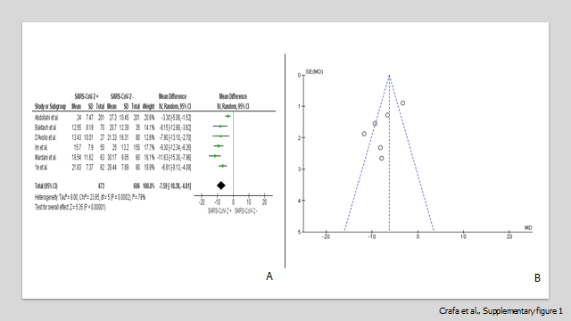
Supplementary Figure 1. Panel A. Forest plot of studies with concomitant cases and controls that assessed 25(OH)D levels as a continuous variable in SARS-CoV-2 positive and negative patients Panel B. Funnel plot showing the source of heterogeneity of studies with concomitant cases and controls that evaluated 25(OH)D levels as a continuous variable in SARS-CoV-2 positive and negative patients. Serum 25(OH)D levels are expressed in ng/ml.
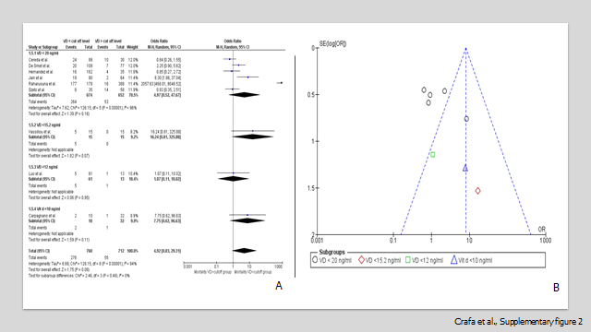
Supplementary Figure 2. Panel A. Forest plot of studies that assessed the risk of mortality in COVID-19 patients with 25(OH)D values below or above a specified cut-off. The different cut-offs used by the studies allowed for subgroup analysis. Studies using cut-off values higher than those established by the Endocrine Society for the diagnosis of Vitamin D Deficiency (<20 ng/ml) were not included. Panel B. Funnel plot showing the source of heterogeneity of studies that evaluated the risk of mortality in COVID-19 patients with 25(OH)D values below or above a specified cut-off

Supplementary Table 1. MOOSE Checklist for Meta-analyses of Observational Studies

Item No | Recommendation | Reported on Page No
Reporting of background should include
1 | Problem definition | 4
2 | Hypothesis statement | 5
3 | Description of study outcome(s) | 4-5
4 | Type of exposure or intervention used | 4-5
5 | Type of study designs used | 4-5
6 | Study population | 4-5
Reporting of search strategy should include
7 | Qualifications of searchers (eg, librarians and investigators) | 6
8 | Search strategy, including time period included in the synthesis and key words | 6
9 | Effort to include all available studies, including contact with authors | 6
10 | Databases and registries searched | 6
11 | Search software used, name and version, including special features used (eg, explosion) | 6
12 | Use of hand searching (eg, reference lists of obtained articles) | 6
13 | List of citations located and those excluded, including justification | 6-7
14 | Method of addressing articles published in languages other than English | -
15 | Method of handling abstracts and unpublished studies | -
16 | Description of any contact with authors | 6
Reporting of methods should include
17 | Description of relevance or appropriateness of studies assembled for assessing the hypothesis to be tested | 6-7
18 | Rationale for the selection and coding of data (eg, sound clinical principles or convenience) | 6-7
19 | Documentation of how data were classified and coded (eg, multiple raters, blinding and interrater reliability) | 7
20 | Assessment of confounding (eg, comparability of cases and controls in studies where appropriate) | 7
21 | Assessment of study quality, including blinding of quality assessors, stratification or regression on possible predictors of study results | 6-7
22 | Assessment of heterogeneity | 7
23 | Description of statistical methods (eg, complete description of fixed or random effects models, justification of whether the chosen models account for predictors of study results, dose-response models, or cumulative meta-analysis) in sufficient detail to be replicated | 7
24 | Provision of appropriate tables and graphics | Figs 2-6
Reporting of results should include
25 | Graphic summarizing individual study estimates and overall estimate | Figs 2-6
26 | Table giving descriptive information for each study included | Table 1
27 | Results of sensitivity testing (eg, subgroup analysis) | 8-10, Figs 2-6
28 | Indication of statistical uncertainty of findings | 8-10, Figs 2-6

Supplementary Table 2. Prisma Checklist
Item No | Recommendation | Reported on Page No
Reporting of discussion should include
29 | Quantitative assessment of bias (eg, publication bias) | 8-10
30 | Justification for exclusion (eg, exclusion of non-English language citations) | Suppl. Table 4
31 | Assessment of quality of included studies | Tables 2-3
Reporting of conclusions should include
32 | Consideration of alternative explanations for observed results | 10-15
33 | Generalization of the conclusions (ie, appropriate for the data presented and within the domain of the literature review) | 10-15
34 | Guidelines for future research | 10-15
35 | Disclosure of funding source | -
From: Stroup DF, Berlin JA, Morton SC, et al, for the Meta-analysis Of Observational Studies in Epidemiology (MOOSE) Group. Meta-analysis of Observational Studies in Epidemiology. A Proposal for Reporting. JAMA. 2000;283(15):2008-2012. doi: 10.1001/jama.283.15.2008.

Supplementary Table 3. Selection criteria in included studies (PECO).
 | Included | Excluded
Population | Patients with or without COVID-19  Patients with or without VDD | Patients treated with vitamin D
Exposure | VDD  COVID-19 | /
Comparison | Patients without COVID-19  Patients with COVID-19 having normal vitamin D levels | /
Primary Outcome | Vitamin D levels (in i. patients with vs. without COVID-19; ii. patients with severe vs. non-severe COVID-19; iii. death vs. discharged COVID-19 patients)  COVID-19 severity (in patients with VDD vs. those having normal vitamin D levels)  COVID-19 mortality (in patients with VDD vs. those having normal vitamin D levels) | /
Other(s) | / | /
Study type | Observational cohort, cross-sectional and case-control study designs | Case-reports, comments, letters to the editor, systematic or narrative reviews
Abbreviations: COVID-19, coronavirus disease 19; VDD, vitamin D deficiency.
Supplementary Table 4. Reasons why studies were excluded from the analysis.
Reason | Study
Studies where the extraction of data needed to evaluate at least one of the proposed outcomes was not possible | [12-23]
Studies where Vitamin D was supplemented and Interventional studies evaluating the effects of vitamin D supplementation | [24, 61-68]
Study where cut-off for VDD was over 20 ng/ml | [25]
Study where cut-off for VDD was not establish | [26]

