Funnel plots of main outcomes evaluated

Outcome 1: "Diarrhea rate"
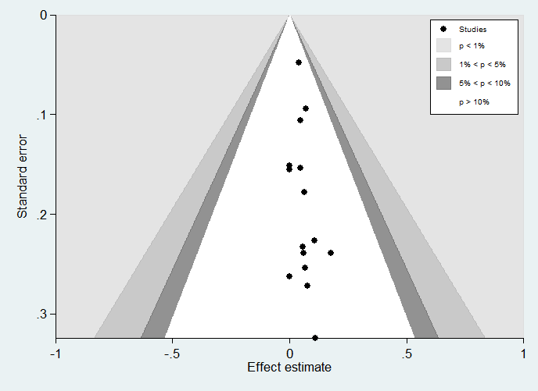

Outcome 2: "Cesarean section"
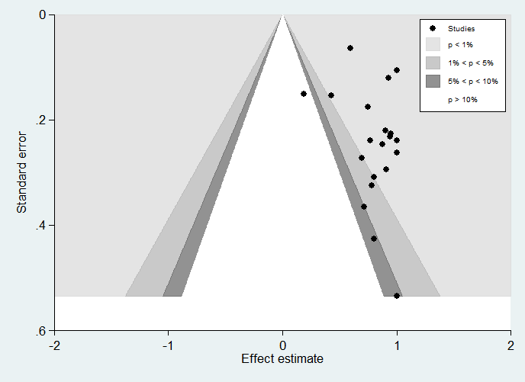

Outcome 3: "NICU COVID-related with therapy"
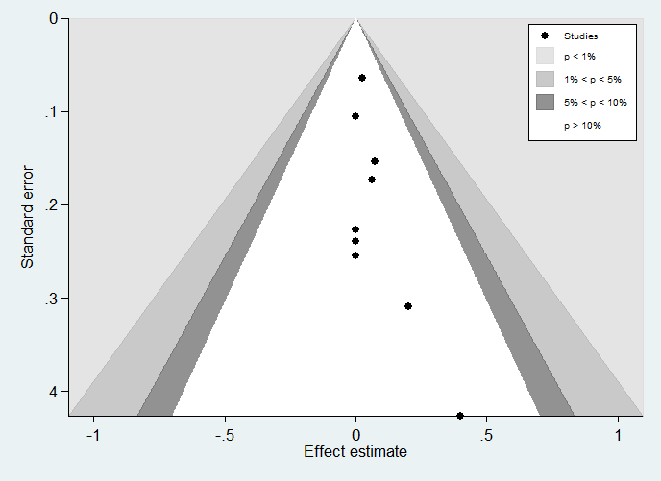

Outcome 4: "NICU COVID-related with respiratory distress"
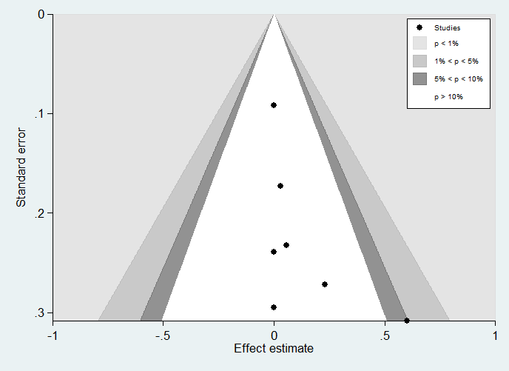

Outcome 5: "Apgar 5' less than 7"
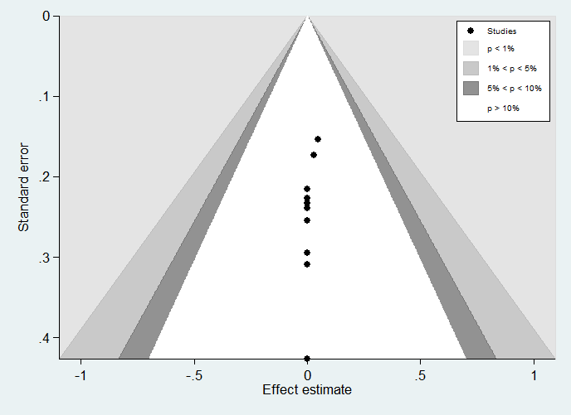

Outcome 6: "pPROM"
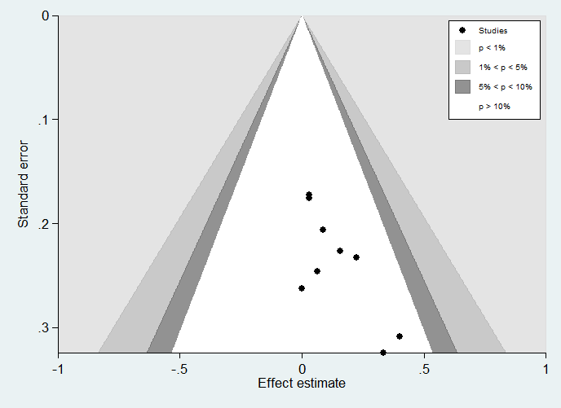

Outcome 7: "Maternal deaths"
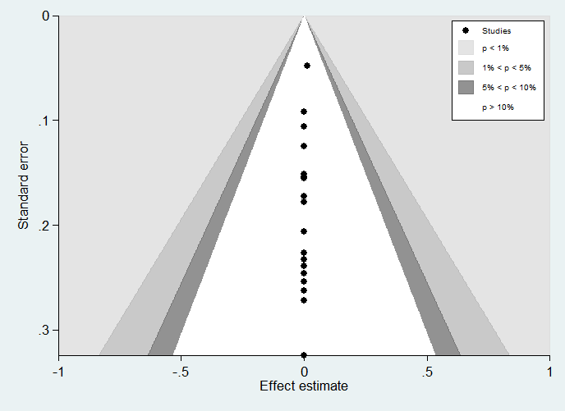

Outcome 8: "Neonatal deaths"


