Supplements: Nucleic acid-amplification tests from respiratory samples for the diagnosis of Coronavirus infections: systematic review and meta-analysis

Supplement 1: Search strategy for PubMed
("Respiratory Tract Infections"[Mesh] OR (respiratory infection*) OR (acute respiratory illness*) OR “pneumonia”[Mesh] OR pneumonia OR (lung infection*) OR (lung abscess*) OR (pulmonary infection*) OR (pulmonary abscess*) OR bronchiolitis OR (acute bronchitis) OR influenza OR "influenza, human"[Mesh] OR “Pharyngitis”[Mesh] OR pharyngitis OR “Tonsillitis”[Mesh] OR tonsillitis OR “Peritonsillar abscess”[Mesh] OR (pharyngeal abscess*) OR (tonsillar abscess*)) AND ("Community-Acquired Infections"[Mesh] OR outpatient* OR (community acquired) OR CAP OR (community onset) OR (long term facilit*) OR (nursing home*) OR (residential home) OR (rehabilitation facilit*) OR (rehabilitation centre*) OR (rehabilitation center*) OR veteran OR "child"[MeSH Terms] OR "adolescent"[MeSH Terms] OR paediatric* [All fields] OR pediatric* [All fields] OR “pediatrics” [MeSH term] OR children OR "Ambulatory Care"[Mesh] OR "Family Practice"[Mesh] OR general practice OR GP OR "Physicians, Family"[Mesh] OR "Primary Health Care"[Mesh] OR "Emergency Service, Hospital"[Mesh] OR (primary care*) OR (general practi*) OR GP OR (family doctor*) OR (emergency room*) OR ER OR (emergency unit*) OR (emergency department*)) AND (“sensitivity and specificity”[Mesh] OR (sensitivity specificity) OR “predictive value of tests”[Mesh] OR (predictive value) OR “reproducibility of results”[Mesh] OR (diagnostic test) OR (diagnostic tests)) AND ((“molecular diagnostic techniques”[Mesh] OR “nucleic acid amplification techniques”[Mesh] OR NAAT OR "polymerase chain reaction"[Mesh] OR “microarray analysis”[Mesh] OR (antigen test*) OR (antigen assay*) OR (antigenic test*) OR (antigenic assay*) OR “Immunoglobulin M”[Mesh] OR “immunoassay”[Mesh])) OR ((antimicrobial sensitivity test*) OR (antimicrobial susceptibility test*) OR (antimicrobial resistance test*) OR (antibiotic sensitivity test*) OR (antibiotic susceptibility test*) OR (antibiotic resistance test*) OR (resistan* gene) OR (resistan* genes) OR “molecular diagnostic techniques”[Mesh] OR “nucleic acid amplification techniques”[Mesh] OR NAAT OR “polymerase chain reaction”[Mesh] OR “microarray analysis”[Mesh]))

Supplement 2: QUADAS adaptation for this review
- Was a consecutive or random sample of patients: all patients defined for inclusion included consecutively
- Was a case-control design avoided?
- Did the study avoid inappropriate exclusions? Were all samples collected analyzed?
  - Patient selection risk of bias: High risk if any of #1-3 was "no"; low risk if all "yes" or inappropriate exclusions unclear; otherwise unclear risk of bias
  - Patient applicability: High risk if target condition not defined; low risk if type of ARTI defined; unclear if not described
- Were the index test results interpreted without knowledge of the results of the reference standard?
- If a threshold was used (for index test), was it pre-specified?
  - Index test risk of bias: High risk whenever #4 was "no" or when #4 was unclear and #5 was "no"; low risk when both "yes" or #4 was "yes" and #5 was "unclear"; otherwise unclear risk of bias.
  - Index test applicability: High risk if the index test was evaluated on different specimens that were not separated (nasopharyngeal aspirate, nasopharyngeal swab, sputum, bronchoalveolar lavage) or the specimen types were not defined; low risk if a single specimen type.
- Is the reference standard likely to correctly classify the target condition?
"Yes" if using an algorithm based on more than one NAAT and clinical/ radiological findings; "No" if using a single PCR test disregarding clinical presentation; "unclear" otherwise.
- Were the reference standard results interpreted without knowledge of the results of the index test?
  - Reference standard risk of bias: Low risk if both #6 and #7 "yes"; High risk if both "no"; otherwise unclear risk of bias
  - Reference standard applicability: High risk if the reference standard was an in-house PCR or undefined PCR; low risk if commercial test used
- Was there an appropriate interval between index test(s) and reference standard? "Yes" if both were taken and analyzed together; "No" if taken on different occasions; "unclear if taken together but analyzed at different times
- Did all patients receive a reference standard? 100% of samples analyzed for the index test received the reference standard
- Did patients receive the same reference standard?
- Were all patients included in the analysis?
  - Flow and time risk of bias: High risk if any of #8-#11 "no"; low risk if all "yes", or #8 unclear and #9-#10 "yes"; otherwise unclear risk of bias

Supplement 3: Tables of excluded articles
Table S1: Excluded publications because of lack of crude numbers for sensitivity and/or specificity and inability to calculate them
PMID or DOI | Author, year | Title
28633962 | Radko S, 2017 | Evaluation of three commercial multiplex assays for the detection of respiratory viral infections
15714410 | van Kraaij MG, 2005 | Frequent detection of respiratory viruses in adult recipients of stem cell transplants with the use of real-time polymerase chain reaction, compared with viral culture
22981482 | Renaud C, 2012 | Comparison of FilmArray Respiratory Panel and laboratory-developed real-time reverse transcription-polymerase chain reaction assays for respiratory virus detection
20691735 | Bruijnesteijn van Coppenraet LE, 2010 | Comparison of two commercial molecular assays for simultaneous detection of respiratory viruses in clinical samples using two automatic electrophoresis detection systems
24308853 | Kim H, 2014 | Comparison of two multiplex PCR assays for the detection of respiratory viral infections
23743345 | Cho CH, 2013 | Evaluation of a novel real-time RT-PCR using TOCE technology compared with culture and Seeplex RV15 for simultaneous detection of respiratory viruses
25448378 | Driscoll AJ, 2014 | Evaluation of fast-track diagnostics and TaqMan array card real-time PCR assays for the detection of respiratory pathogens
25100822 | Prachayangprecha S, 2014 | Exploring the potential of next-generation sequencing in detection of respiratory viruses
29386970 | Kuan CS, 2017 | Detection of Respiratory Viruses from ARTI Patients by xTAG RVP Fast v2 Assay and Conventional Methods
21571585 | Jansen RR, 2011 | Development and evaluation of a four-tube real time multiplex PCR assay covering fourteen respiratory viruses, and comparison to its corresponding single target counterparts
23509772 | Sugiura H, 2013 | Prescription surveillance and polymerase chain reaction testing to identify pathogens during outbreaks of infection
20542205 | She RC, 2010 | Performance of diagnostic tests to detect respiratory viruses in older adults
32073353 | Fang Y, 2020 | Sensitivity of Chest CT for COVID-19: Comparison to RT-PCR
28191331 | Hashemzadeh MS, 2016 | Development of Dual TaqMan Based One-Step rRT-PCR Assay Panel for Rapid and Accurate Diagnostic Test of MERS-CoV: A Novel Human Coronavirus, Ahead of Hajj Pilgrimage
16998894 | Freymuth F, 2006 | Comparison of multiplex PCR assays and conventional techniques for the diagnostic of respiratory virus infections in children admitted to hospital with an acute respiratory illness
15131160 | Hui RK, 2004 | Reverse transcriptase PCR diagnostic assay for the coronavirus associated with severe acute respiratory syndrome
14707219 | Tang P, 2004 | Interpretation of diagnostic laboratory tests for severe acute respiratory syndrome: the Toronto experience
32330291 | Infantino M, 2020 | Diagnostic Accuracy of an Automated Chemiluminescent Immunoassay for anti-SARS-CoV-2 IgM and IgG Antibodies: An Italian Experience
32320064 | Yong G, 2020 | Evaluation of the Auxiliary Diagnostic Value of Antibody Assays for the Detection of Novel Coronavirus (SARS-CoV-2)
32361285 | Uhteg K, 2020 | Comparing the Analytical Performance of Three SARS-CoV-2 Molecular Diagnostic Assays
32301746 | Ferrari D, 2020 | Routine Blood Tests as a Potential Diagnostic Tool for COVID-19
32335089 | Ishige T, 2020 | Highly sensitive detection of SARS-CoV-2 RNA by multiplex rRT-PCR for molecular diagnosis of COVID-19 by clinical laboratories
32444354 | Broder K, 2020 | Test Agreement between Roche Cobas 6800 and Cepheid GeneXpert Xpress SARS-CoV-2 Assays at High Cycle Threshold Ranges
https://doi.org/10.1101/2020.03.14.20036129 | Dong L, preprint | Highly accurate and sensitive diagnostic detection of SARS-CoV-2 by digital PCR
https://doi.org/10.1101/2020.04.26.2008130 | Guruceaga X, reprint | Fast SARS-CoV-2 detection protocol based on RNA precipitation and RT-qPCR in nasopharyngeal swab samples
https://doi.org/10.1101/2020.05.20.20108530 | Hu X, preprint | Development and clinical application of a rapid and sensitive loop-mediated isothermal amplification test for SARS-CoV-2 infection
32856766 | Miller TE, 2020 | Clinical sensitivity and interpretation of PCR and serological COVID-19 diagnostics for patients presenting to the hospital
32303564 | Rhoads DD, 2020 | Comparison of Abbott ID Now, DiaSorin Simplexa, and CDC FDA Emergency Use Authorization Methods for the Detection of SARS-CoV-2 from Nasopharyngeal and Nasal Swabs from Individuals Diagnosed with COVID-19
https://doi.org/10.1101/2020.03.02.20030130 | Yang W, 2020 | Rapid Detection of SARS-CoV-2 Using Reverse transcription RT-LAMP method

Table S2: Excluded publications because the studies are not diagnostic accuracy studies or analytical performance only assessed
PMID or DOI | Author, year | Title
24153118 | Lu X, 2013 | Real-time reverse transcription-PCR assay panel for Middle East respiratory syndrome coronavirus
18632902 | Pabbaraju K, 2008 | Comparison of the Luminex xTAG respiratory viral panel with in-house nucleic acid amplification tests for diagnosis of respiratory virus infections
25724853 | Costa E, 2015 | Comparison of the performance of 2 commercial multiplex PCR platforms for detection of respiratory viruses in upper and lower tract respiratory specimens
23608639 | Weinberg GA, 2013 | Field evaluation of TaqMan Array Card (TAC) for the simultaneous detection of multiple respiratory viruses in children with acute respiratory infection
27401400 | Esposito S, 2016 | Partial comparison of the NxTAG Respiratory Pathogen Panel Assay with the Luminex xTAG Respiratory Panel Fast Assay V2 and singleplex real-time polymerase chain reaction for detection of respiratory pathogens
18571541 | Chiu CY, 2008 | Utility of DNA microarrays for detection of viruses in acute respiratory tract infections in children
15545854 | Jennings LC, 2004 | Viral etiology of acute respiratory tract infections in children presenting to hospital: role of polymerase chain reaction and demonstration of multiple infections
23054853 | Beka H, 2012 | Frequency of common viruses in etiology of acute respiratory tract infections
32074516 | Shirato K, 2020 | Development of Genetic Diagnostic Methods for Novel Coronavirus 2019 (nCoV-2019) in Japan
22311356 | Woo PC, 2012 | Epidemiology of coronavirus-associated respiratory tract infections and the role of rapid diagnostic tests: a prospective study
18694314 | Lin C, 2008 | Signal amplification on a DNA-tile-based biosensor with enhanced sensitivity
16470249 | Zahariadis G, 2006 | Risk of ruling out severe acute respiratory syndrome by ruling in another diagnosis: variable incidence of atypical bacteria coinfection based on diagnostic assays
16111269 | Kuratsuji T, 2005 | Diagnostic tests: SARS-Corona virus
16111268 | Ieki R, 2005 | Diagnostic tests: Corona virus
15811330 | Lu W, 2005 | Synthetic peptides derived from SARS coronavirus S protein with diagnostic and therapeutic potential
15224676 | Louis Y Chan, 2004 | Diagnostic Criteria during SARS Outbreak in Hong Kong
15071137 | Yu AC, 2004 | Boosting the sensitivity of real-time polymerase-chain-reaction testing for SARS
14526121 | Zhang J, 2003 | De novo synthesis of PCR templates for the development of SARS diagnostic assay
12779001 | No author listed, 2003 | SARS: new sequence could lead to better diagnostic tests
32342927 | Z Zainol Rashid, 2020 | Diagnostic Performance of COVID-19 Serology Assays
32217609 | Patel R, 2020 | Report From the American Society for Microbiology COVID-19 International Summit, 23 March 2020: Value of Diagnostic Testing for SARS-CoV-2/COVID-19
32260471 | Kumar Vashist S, 2020 | In Vitro Diagnostic Assays for COVID-19: Recent Advances and Emerging Trends
32321116 | Carlotti APCP, 2020 | COVID-19 Diagnostic and Management Protocol for Pediatric Patients
32329877 | Chakraborty C, 2020 | SARS-CoV-2 Causing Pneumonia-Associated Respiratory Disorder (COVID-19): Diagnostic and Proposed Therapeutic Options
32307322 | Chang TH, 2020 | Clinical Characteristics and Diagnostic Challenges of Pediatric COVID-19: A Systematic Review and Meta-Analysis
32259132 | Mardani R, 2020 | Laboratory Parameters in Detection of COVID-19 Patients With Positive RT-PCR; A Diagnostic Accuracy Study
32300101 | Xu R, 2020 | Saliva: Potential Diagnostic Value and Transmission of 2019-nCoV
32216961 | Wang K, 2020 | Imaging Manifestations and Diagnostic Value of Chest CT of Coronavirus Disease 2019 (COVID-19) in the Xiaogan Area
32301646 | Kim H, 2020 | Diagnostic Performance of CT and Reverse Transcriptase-Polymerase Chain Reaction for Coronavirus Disease 2019: A Meta-Analysis
32282894 | Cheng MP, 2020 | Diagnostic Testing for Severe Acute Respiratory Syndrome-Related Coronavirus-2: A Narrative Review
32324359 | Korsós A, 2020 | Diagnostic Consideration and Bedside Estimation of the Prognosis in COVID-19 Patients
32232648 | Himoto Y, 2020 | Diagnostic Performance of Chest CT to Differentiate COVID-19 Pneumonia in Non-High-Epidemic Area in Japan
32364959 | He JL, 2020 | Diagnostic Performance Between CT and Initial Real-Time RT-PCR for Clinically Suspected 2019 Coronavirus Disease (COVID-19) Patients Outside Wuhan, China
32361529 | Kashir J, 2020 | Loop Mediated Isothermal Amplification (LAMP) Assays as a Rapid Diagnostic for COVID-19
32385976 | Jędrusik P, 2020 | Diagnostic Role of Chest Computed Tomography in Coronavirus Disease 2019
32344058 | Wu F, 2020 | COVID-19 Diagnostic Process in Mainland China: The Math Beyond Pneumonia
32265036 | Nair A, 2020 | A British Society of Thoracic Imaging Statement: Considerations in Designing Local Imaging Diagnostic Algorithms for the COVID-19 Pandemic
32352022 | Quintana-Castanedo L, 2020 | Urticarial Exanthem as Early Diagnostic Clue for COVID-19 Infection
32369578 | Hanson KE, 2020 | Molecular Testing for Acute Respiratory Tract Infections: Clinical and Diagnostic Recommendations From the IDSA's Diagnostics Committee
https://doi.org/10.1101/2020.05.12.20095638 | Anahtar MN, preprint | Clinical assessment and validation of a rapid and sensitive SARS-CoV-2 test using reversetranscription loop-mediated isothermal amplification
https://doi.org/10.1101/2020.06.30.20142935 | Fowler VL, preprint | A reverse-transcription loop-mediated isothermal amplification (RT-LAMP) assay for the rapid detection of SARS-CoV-2 within nasopharyngeal and oropharyngeal swabs at Hampshire Hospitals NHS Foundation Trust
https://doi.org/10.1101/2020.08.01.20166538 | Garneret P, preprint | Highly performing point-of-care molecular testing for SARS-CoV-2 with RNA extraction and isothermal amplification
32350048 | Lieberman JA, 2020 | Comparison of Commercially Available and Laboratory-  Developed Assays for In Vitro Detection of SARS-CoV-2 in  Clinical Laboratories
32708870 | Petrillo S, 2020 | A Novel Multiplex qRT-PCR Assay to Detect SARS-CoV-2 Infection: High Sensitivity and Increased Testing Capacity
https://doi.org/10.1101/2020.07.28.20163626 | Sahajpal NS, preprint | Clinical validation of innovative, low cost, kit-free, RNA processing protocol for RT-PCR 1 based COVID-19 testing
https://doi.org/10.1101/2020.04.28.20083956 | Zhou Y, preprint | Sensitivity evaluation of 2019 novel coronavirus (SARS-CoV-2) RT -PCR 1 detection kits and strategy to reduce false negative
32692666 | Zhu X, 2020 | Multiplex reverse transcription loop-mediated isothermal amplification combined with nanoparticle-based lateral flow biosensor for the diagnosis of COVID-19

Table S3: articles excluded because of the number of patients/samples is less than 20
PMID | Author, year | Title
16189379 | Yip SP, 2005 | Use of dual TaqMan probes to increase the sensitivity of 1-step quantitative reverse transcription-PCR: application to the detection of SARS coronavirus
32416600 | van Kasteren PB, 2020 | Comparison of Seven Commercial RT-PCR Diagnostic Kits for COVID-19
32132196 | Chan JF, 2020 | Improved molecular diagnosis of COVID-19 by the novel, highly sensitive and specific COVID-19-RdRp/Hel real time reverse transcription PCR assay validated In vitro and with clinical specimens
32416600 | van Kasteren PB, 2020 | Comparison of seven commercial RT-PCR diagnostic kits for COVID-19

Table S4: Publications excluded since the index test or the reference standard was based only on serology, culture or clinical/ radiological features
PMID or DOI | Author, year | Title
https://doi.org/10.1101/2020.07.13.20152439 | Leber W, preprint | RT-PCR testing to detect a COVID-19 outbreak in Austria: rapid, accurate and early diagnosis in primary care (The REAP study)
32502646 | Ong DSY, 2020 | Comparison of diagnostic accuracies of rapid serological tests and ELISA to molecular diagnostics in patients with suspected coronavirus disease 2019 presenting to the hospital
https://doi.org/10.1101/2020.06.19.20135756 | Williams TC, preprint | Sensitivity of RT-PCR testing of upper respiratory tract samples for SARS-CoV-2 in hospitalised patients: a retrospective cohort study.
32731151 | Zeng H, 2020 | Diagnostic value of combined nucleic acid and antibody detection in suspected COVID-19 cases
14748074 | Coiras MT, 2004 | Simultaneous Detection of Fourteen Respiratory Viruses in Clinical Specimens by Two Multiplex Reverse Transcription Nested-PCR Assays
32334183 | Döhla M, 2020 | Rapid point-of-care testing for SARS-CoV-2 in a community screening setting shows low sensitivity

Table S5: Publications excluded due to lack of access to full text version
PMID | Author, year | Title
18095623 | Freymuth F., 2007 | Techniques used for the diagnostic of upper and lower respiratory tract viral infections
16816854 | Zou SM., 2006 | Establishment of molecular differential diagnostic (MDD) technology for detection of common respiratory viruses
16706344 | Lai J., 2006 | The research and development of new diagnostic gene chips for SARS coronavirus
32364358 | Vásárhelyi B., 2020 | The Diagnostic Value of Rapid Anti IgM and IgG Detecting Tests in the Identification of Patients With SARS-CoV-2 Virus Infection

Supplement 4: Studies reporting the primer gene used for the PCR test
Author, year | Coronavirus species | Primer gene
Puppe W, 2012 | 229E | Cor229E-FP5, Cor229E-RP5
Li J, 2012 | NL63, OC43, 229E, HKU1 | Polymerase, N gene
Li J, 2013 | NL63, OC43, 229E, HKU1 | Polymerase, N gene
Choudhary ML, 2013 | OC43 | Membrane
Hecht LS, 2019 | MERS-CoV | N gene
Poljak M, 2020 | SARS CoV-2 | ORF1, E gene
Zhen W, 2020 | SARS CoV-2 | N1 and N2, RNase, P gene
Cradic K, 2020 | SARS-CoV-2 | RdRp
Basu A, 2020 | SARS-CoV-2 | RdRp
Hou T, 2020 | SARS-CoV-2 | Orf1ab
Matzkies, LM 2020 | SARS-CoV-2 | S gene
Ridgday JP, 2020 | SARS-CoV-2 | N2 and E genes and ORF1, E gene
Assennato SM, preprint | SARS-CoV-2 | Orf1 and N regions
Bisoffi Z, preprint | SARS-CoV-2 | N1 and N2
Brandsma E, preprint | SARS-CoV-2 | N gene
Collier D, preprint | SARS-CoV-2 | Orf1 and N genes
Dao Thi VL, preprint | SARS-CoV-2 | Orf1A and N genes
Ghofrani M, preprint | SARS-CoV-2 | RdRp
Harrington A, 2020 | SARS-CoV-2 | RdRp
Hogan CA, 2020 | SARS-CoV-2 | N gene
Moore NM, preprint | SARS-CoV-2 | RdRp
Moran A, 2020 | SARS-CoV-2 | E and N2
Österdahl MF, preprint | SARS-CoV-2 | ORF1a gene
Wolters F, 2020 | SARS-CoV-2 | E and N2
Williams E, preprint | SARS-CoV-2 | Orf1ab
Wei S, preprint | SARS-CoV-2 | Orf1ab
Suo T, preprint | SARS-CoV-2 | Orf1ab and N
Smithgall MC, 2020 | SARS-CoV-2 | E and N2
Rohaim MA, preprint | SARS-CoV-2 | RdRp
Mitchell SL, 2020 | SARS-CoV-2 | RdRp
Jiang M, 2020 | SARS-CoV-2 | ORF1ab and N genes
Loeffelholz MJ, 2020 | SARS-CoV-2 | E and N2
Rodriguez-Manzano J, preprint | SARS-CoV-2 | N gene

Supplementary Figure 1: Results risk of bias per study according to the QUADAS-2 tool
Study | Patient selection |  |  | Index test |  | Reference standard |  | Time and flow
First author, year | Consecutive or random sample of patients enrolled | Case!control design avoided | Inappropriate exclusions avoided | Index test interpreted without k!wledge of the results of the reference standard | Threshold prespecified | Reference standard likely to correctly classify the target condition | Reference standard interpreted without knowledge of the results of the index test | Appropriate interval between index test and reference standard | All patients receive a reference standard | Patients received the same reference standard | Were all patients included in the analysis?
Nolte FS, 2007 | ! | + | ! | ? | + | ! | + | ? | ? | ! | !
Gadsby NJ, 2010 | + | + | ? | ? | ! | ! | ? | ? | + | + | +
Gharabaghi F, 2011 | ! | + | + | ! | ! | ! | ? | ? | + | ! | +
Pabbaraju K, 2011 | ? | + | + | ! | + | ! | + | + | + | + | +
Bierbaum S, 2012 | + | + | + | + | + | ! | + | ? | + | + | +
Li J, 2012 | ? | + | + | ? | ! | ! | + | ? | + | + | +
Puppe W, 2012 | ! | + | ? | + | ? | ? | + | + | ! | ! | !
Sakthivel SK, 2012 | ! | + | + | ? | ? | ! | ? | ? | + | + | +
Choudhary ML, 2013 | ! | + | + | ? | + | ! | ? | ? | + | + | +
Kim HK, 2013 | ! | + | + | ! | + | ! | + | ? | + | + | +
Li J, 2013 | ? | + | + | + | ! | ! | + | ? | + | + | +
Bierbaum S, 2014 | + | + | + | ? | + | ! | ? | ? | + | + | +
Salez N, 2015 | ? | + | + | ? | + | ! | ? | ? | + | ! | +
Beckmann C, 2016 | + | + | + | ? | ? | ! | ? | ? | + | + | +
Chen H, 2017 | + | + | + | ? | ! | ! | ? | ? | + | ! | +
Ko DH, 2017 | ! | + | + | ! | ! | ! | ? | ? | + | + | +
Mohamed DH, 2017 | ! | ! | + | + | + | ! | + | ? | + | + | +
Babady NE, 2018 | ? | + | + | ? | + | ! | ? | ! | + | + | !
Leber AL, 2018 | + | + | + | ? | ! | ! | ? | ? | + | ! | +
Vos LM, 2018 | ! | + | + | ? | + | ! | ? | ? | + | + | +
Hecht LS, 2019 | ? | + | + | ! | + | ! | + | ? | + | + | +
Li X, 2019 | + | + | + | + | + | ! | ? | ? | + | + | !
Assennato SM, preprint | + | + | ? | + | + | + | + | + | + | + | +
Basu A, 2020 | + | + | + | ? | + | ! | ? | + | + | + | +
Bisoffi Z, preprint | + | + | + | + | + | + | ? | + | + | + | +
Brandsma E, preprint | ? | ! | ? | ! | ! | ! | + | + | + | + | +
Collier D, preprint | ! | + | ? | ! | ! | ? | + | + | + | + | +
Cradic K, 2020 | ! | + | ! | ? | + | ? | ? | + | + | + | +
Dao Thi VL, preprint | ! | ! | ! | ! | ! | ? | + | + | + | ! | !
Ghofrani M, preprint | ! | + | ? | ! | + | ? | + | ! | + | ! | !
Harrington A, 2020 | + | + | + | + | + | ? | + | + | + | + | +
Hogan CA, 2020 | ! | ! | ! | ! | ! | ! | + | + | + | + | !
Hou T, 2020 | ! | ! | ! | ! | ? | + | ? | ? | ? | + | +
Jiang M, 2020 | + | + | + | + | + | ! | + | + | + | + | +
Loeffelholz MJ, 2020 | ! | + | ? | ? | + | ? | ? | ? | + | ! | !
Matzkies, LM 2020 | ! | ! | ! | ? | + | ! | + | ? | + | + | !
Mitchell SL, 2020 | ! | ! | + | ! | + | ? | + | ? | + | ? | +
Moore NM, preprint | ! | ! | ? | ! | ! | + | + | + | + | + | !
Moran A, 2020 | ? | ! | ? | ? | + | ? | ? | ? | + | + | +
Österdahl MF, preprint | + | + | + | ? | ! | + | + | + | + | + | +
Poljak M, 2020- pro | + | + | + | + | ? | ? | + | + | + | + | !
Poljak M, 2020- retro | ? | + | + | ! | ? | ? | + | ? | + | + | !
Ridgday JP, 2020 | + | + | + | ! | + | + | + | + | + | + | +
Rodriguez-Manzano J, preprint | ? | ! | ! | ? | + | ? | ? | ? | + | ! | !
Rohaim MA, preprint | ? | + | + | ? | + | ? | + | ? | + | + | +
Smithgall MC, 2020 | ! | ! | ? | ! | + | ? | + | + | + | + | +
Suo T, preprint | ? | + | + | + | + | + | + | ? | + | + | !
Wei S, preprint | ! | ! | ? | ! | + | ! | + | ? | + | + | +
Williams E, preprint | ! | ! | ? | ! | ! | ? | + | ? | + | ! | !
Wolters F, 2020 | ! | ! | ! | ! | ! | ? | + | ? | + | ! | !
Zhen W, 2020 | + | + | + | ? | + | ? | ? | ? | + | + | +

! | No | + | Yes | ? | Unclear

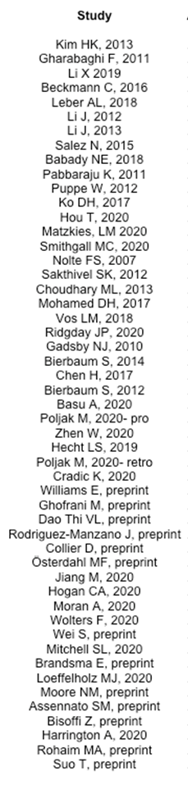
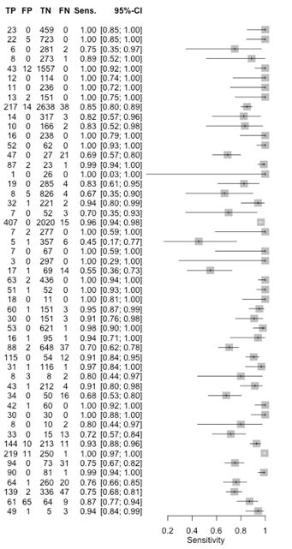
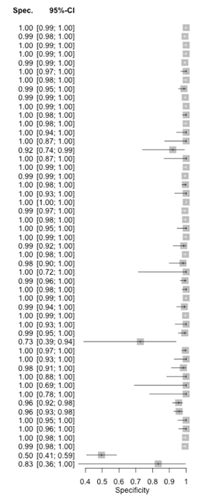
Supplementary Figure 2: Meta-analysis of sensitivity and specificity of NAAT in respiratory samples for diagnosis of Coronavirus ARTI ¹
¹ CI, confidence interval; FN, false negative; FP, false positive; TN, true negative; TP, true positive

Supplementary Figure 3: Summary ROC plot of studies evaluating PCR on respiratory samples for diagnosis of coronavirus infections
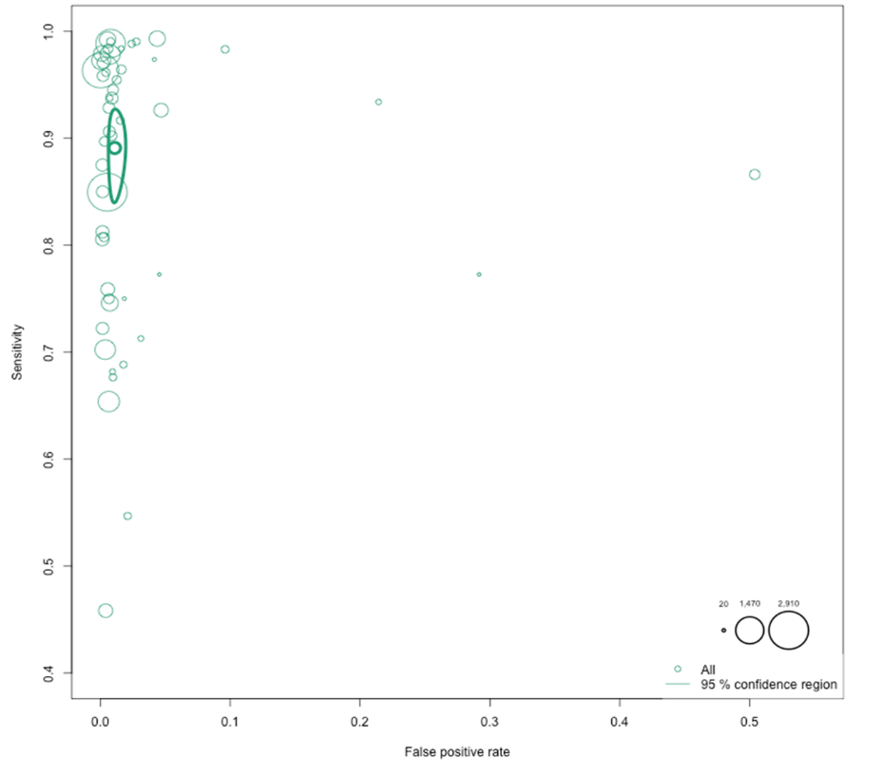

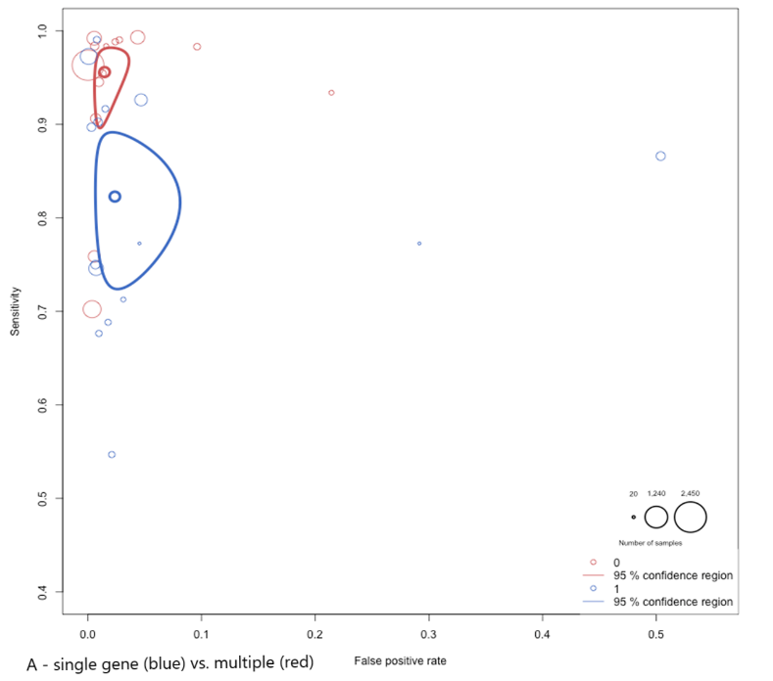
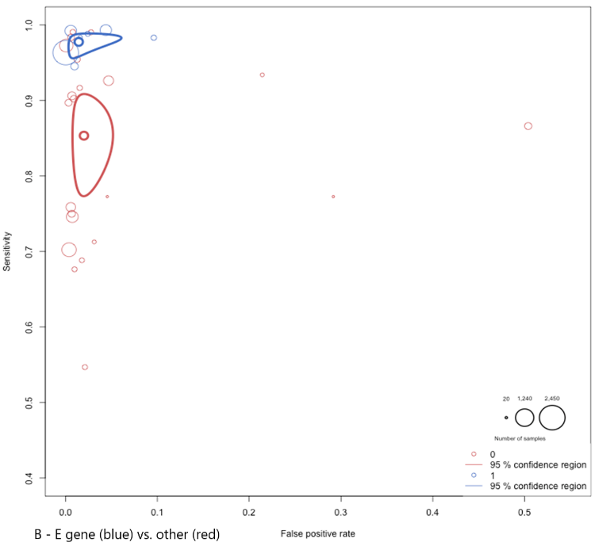
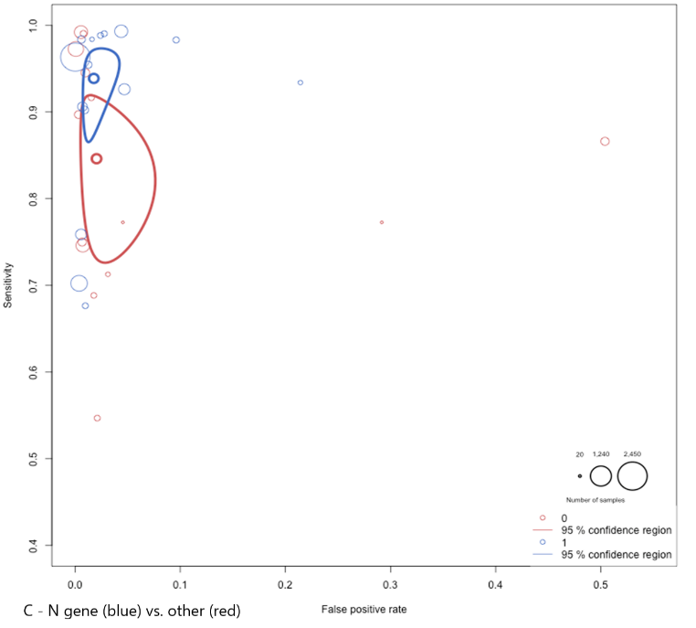
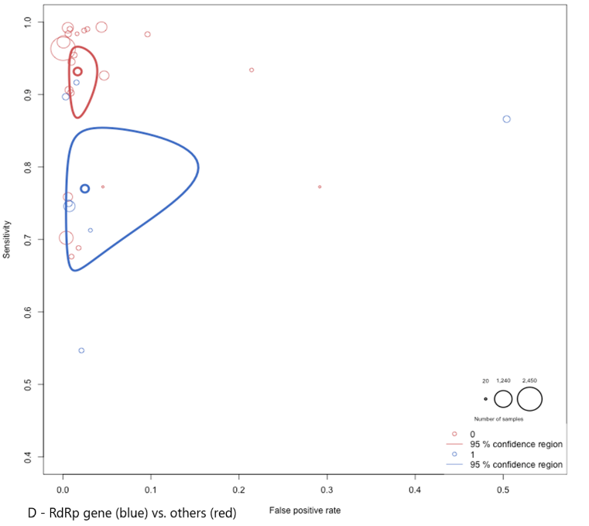
Supplementary Figure 4: Summary ROC plot of NAATs for SARS-COV-2 diagnosis, by specific gene target ¹

¹ A – single vs. more than 1 gene target; B – E gene; C – N gene; D – RdRp gene

