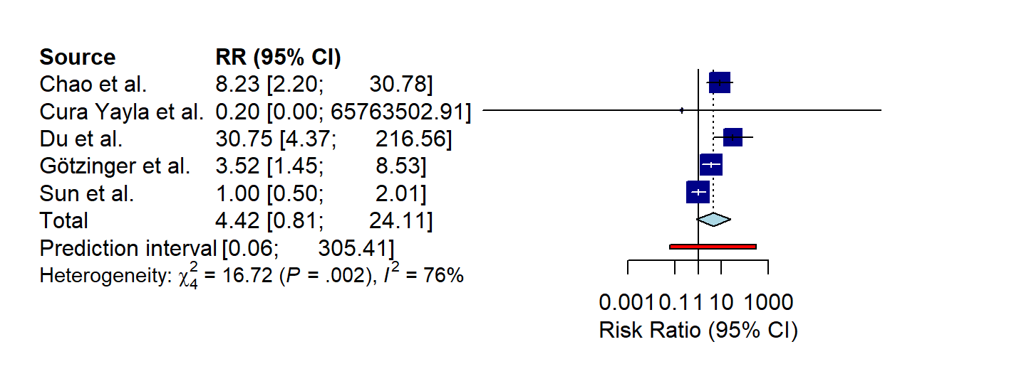
Supplement S4: Relative risk of cancer on severe manifestations of COVID-19 in pediatric patients.

