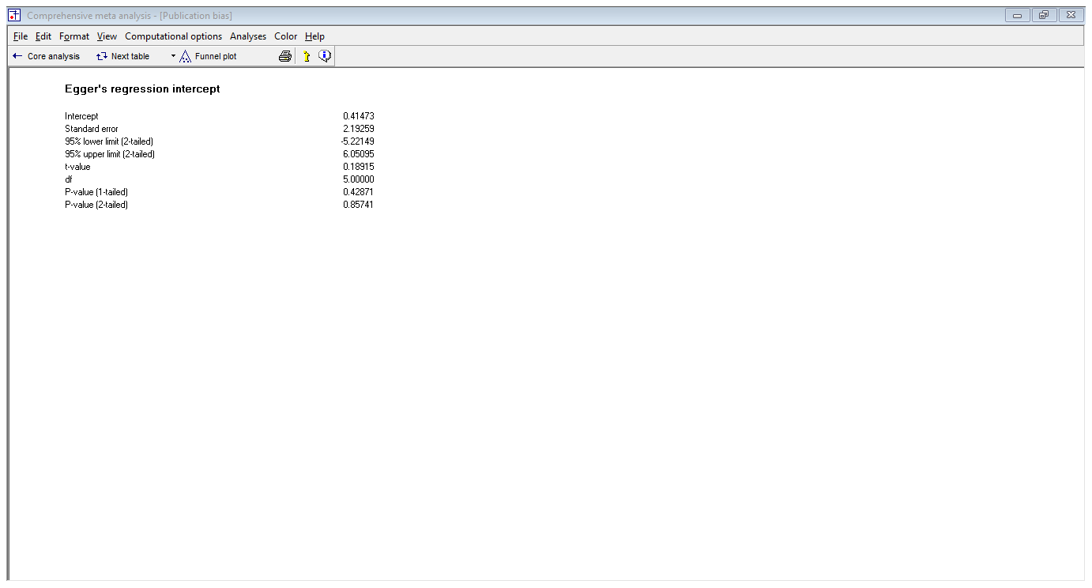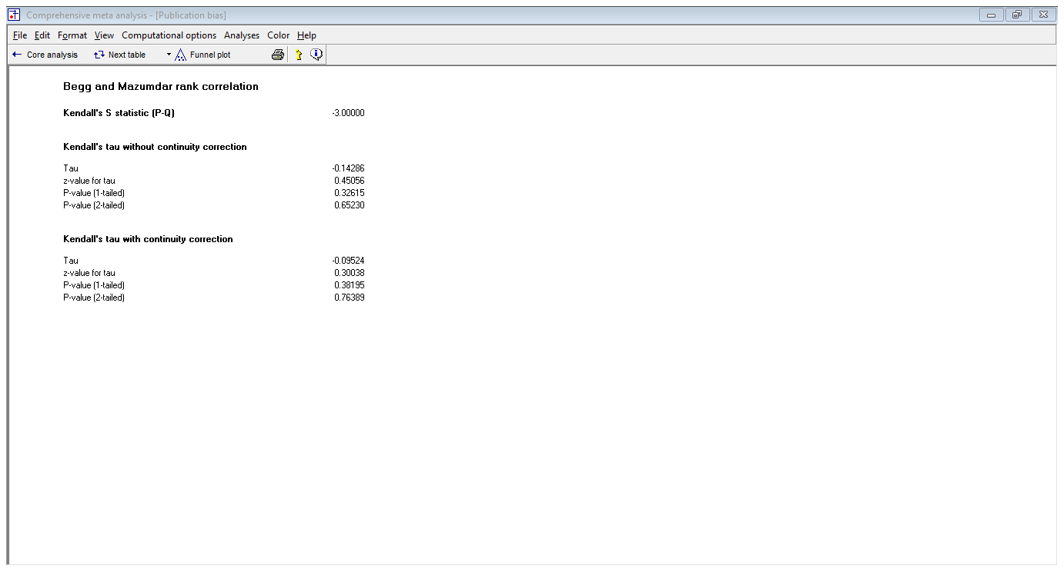

Supplementary file: 1: Funnel plot displaying publication bias of association of iron folate supplementation with anemia among pregnant women in Sub-Saharan Africa

