Supplemental Table 1. Search strategy for MEDLINE.
# | Searches
1 | Mothers/
2 | (mother or mothers or motherhood or maternal* or maternity).tw,kf.
3 | 1 or 2
4 | body weight/ or exp body weight changes/ or ideal body weight/
5 | exp body composition/ or body mass index/ or body size/
6 | waist-hip ratio/ or skinfold thickness/ or waist circumference/ or waist-height ratio/
7 | exp overweight/ or thinness/
8 | (adipose tissue hyperplasia or adipositas or obesitas or fat or fatty or excess bodyweight or body distribution or adipose tissue distribution or body water or body fluid or body lipid or adiposity or obesity or obesities or obese or over-weight or overweight or BMI or "body ban mass" or quetelet index or "quetelet's index" or quetelets index or body composition* or "waist-hip" or "waist to hip" or "waist hip" or "waist-to-hip" or "hip to waste" or "hip waist" or skinfold or skin fold or skin thickness or thin or thinness or lean or leanness or underweight or under-weight or emaciation* or cachexia or body mass or body masses or weight or weights or weighing or lipid accumulation product or lipid accumulation products or waist height or "waist to height" or "waist-height" or "height-weight" or waist circumference* or waist size or waist sizes).tw,kf.
9 | malnutrition/ or overnutrition/ or anthropometry/ or nutritional status/
10 | (overnutrition or hypernutrition or malnutrient or malnutrition or malnourish* or underfed or underfeed* or anthropometric* or anthropometry or body measurement or nutritio* or nutrient* or undernutrition or undernourish* or malabsorption or dietary or excessive feeding or excessive eating or overeating or overfeeding or macronutrient or macronutrients or macro-nutrient or macro-nutrients or energy density or nutrient density or "nutrition* status").tw,kf.
11 | or/4-10
12 | 3 and 11
13 | maternal nutritional physiological phenomena/
14 | (maternal diet or maternal nutrition*).tw,kf.
15 | maternal health/
16 | (maternal health or maternal welfare).tw,kw.
17 | or/13-16
18 | 12 or 17
19 | breast milk/ or lactation/ or breast feeding/
20 | (breastmilk* or breast milk* or breast feed* or breastfeed* or human milk or breast fed or woman milk or mother milk or maternal milk or milk secretion or milk excretion or milk release or lactic secretion or breast secretion or mammary gland secretion or lactation*).tw,kf.
21 | or/19-20
22 | lipids/ or triglycerides/ or fats/ or fatty acids/ or proteins/ or amino acids/ or energy intake/
23 | (lipid* or triacylglycerol* or triglyceride* or tryglyceride or fat or fats or fatty acid* or FFA or nefa or aliphatic acids or protein* or amino acid* or aminoacid or aminoacyl or calorie* or caloric or kilocalorie* or energy intake or dietary energy).tw,kf.
24 | or/22-23
25 | 18 and 21 and 24
26 | exp animals/ not humans.sh.
27 | (animal or animals or rat or rats or mice or mouse or rodents or horses or guinea pigs or pigs or piglets or baboons or dogs or cats or rabbits).tw.
28 | 26 or 27
29 | 25 not 28

Supplemental Table 2. Search strategy for Embase.
# | Searches
1 | Mother/
2 | (mother or mothers or motherhood or maternal* or maternity).tw,kw.
3 | 1 or 2
4 | body weight/ or body weight change/ or body weight loss/ or body weight gain/ or ideal body weight/
5 | body composition/ or body fat/ or body fat distribution/ or body mass/ or body size/
6 | waist hip ratio/ or skinfold thickness/ or waist circumference/ or waist-height ratio/ or body distribution/
7 | exp overweight/ or thinness/
8 | (adipose tissue hyperplasia or adipositas or obesitas or fat or fatty or excess bodyweight or body distribution or adipose tissue distribution or body water or body fluid or body lipid or adiposity or obesity or obesities or obese or over-weight or overweight or BMI or "body ban mass" or quetelet index or "quetelet's index" or quetelets index or body composition* or "waist-hip" or "waist to hip" or "waist hip" or "waist-to-hip" or "hip to waste" or "hip waist" or skinfold or skin fold or skin thickness or thin or thinness or lean or leanness or underweight or under-weight or emaciation* or cachexia or body mass or body masses or weight or weights or weighing or lipid accumulation product or lipid accumulation products or waist height or "waist to height" or "waist-height" or "height-weight" or waist circumference* or waist size or waist sizes).tw,kw.
9 | malnutrition/ or overnutrition/ or anthropometry/ or nutritional status/
10 | (overnutrition or hypernutrition or malnutrient or malnutrition or malnourish* or underfed or underfeed* or anthropometric* or anthropometry or body measurement or nutritio* or nutrient* or undernutrition or undernourish* or malabsorption or dietary or excessive feeding or excessive eating or overeating or overfeeding or macronutrient or macronutrients or macro-nutrient or macro-nutrients or energy density or nutrient density or "nutrition* status").tw,kw.
11 | or/4-10
12 | 3 and 11
13 | maternal nutrition/
14 | (maternal diet or maternal nutrition*).tw,kw.
15 | maternal welfare/
16 | (maternal health or maternal welfare).tw,kw.
17 | or/13-16
18 | 12 or 17
19 | breast milk/ or lactation/ or breast feeding/
20 | (breastmilk* or breast milk* or breast feed* or breastfeed* or human milk or breast fed or woman milk or mother milk or maternal milk or milk secretion or milk excretion or milk release or lactic secretion or breast secretion or mammary gland secretion or lactation*).tw,kw.
21 | or/19-20
22 | lipids/ or triacylglycerol/ or fat/ or fatty acid/ or protein/ or amino acid/ or caloric intake/
23 | (lipid* or triacylglycerol* or triglyceride* or tryglyceride or fat or fats or fatty acid* or FFA or nefa or aliphatic acids or protein* or amino acid* or aminoacid or aminoacyl or calorie* or caloric or kilocalorie* or energy intake or dietary energy).tw,kw.
24 | or/22-23
25 | 18 and 21 and 24
26 | exp animal/ not human.sh.
27 | (animal or animals or rat or rats or mice or mouse or rodents or horses or guinea pigs or pigs or piglets or baboons or dogs or cats or rabbits).tw.
28 | 26 or 27
29 | 25 not 28

Supplemental Table 3. Techniques used to quantitate the energy, fat, and total protein of human milk.

Outcomes | Quantification techniques
Energy (kcal/L) | Bomb calorimetry¹  Calculated energy
Fat (g/L) | Gravimetric method (Folch, Mojonnier, Roese-Gottlieb)¹  Chromatography  Creamatocrit  Infrared (IR) spectrophotometry  Jeejeebhoy method  Gerber method  Other
Protein (g/L) | Nitrogen analysis (Kjeldahl, Dumas)¹  Amino acid analysis  Colorimetry (bicinchoninic acid assay, Biuret, Bradford, Lowry-Petersen)  Infrared (IR) spectrophotometry  Other
Unlike the dairy industry there is no national or international body that recommends specific methods for human milk analysis; however, the techniques denoted by ¹ are frequently described by experts in the field as the “gold standard” or “preferred” methods. Other methods may be suitable with appropriate validation and are in routine use.
Supplemental Table 4. Titles and abstracts for which a full text could not be located.
Author and year | Title | Title or abstract located
Xu, 2019 | Energy supply nutrients and mineral composition analysis in breast milk in Lanzhou urban | Abstract
Wang, 2006 | Investigation and analysis of the level of nutrients in diet and breast milk of rural women in Chengcheng county of Shanxi | Abstract
Udosen, 1992 | Milk macronutrient level during the first month of term and preterm Nigerian mothers | Abstract
Patil, 1989 | Proximate principle and energy content of human milk in well-nourished urban mother | Abstract
Holemans, 1954 | Etude qualitative et quantitative du lait des femmes indigenes du Kwango (Congo belge). Qualitative and quantitative study of the maternal milk of female aborigenes of the Kwango region (Belgian Congo) | Title
Ferris, 1988 | Macronutrients in human milk at 2, 12, and 16 weeks postpartum | Abstract
Corvaglia, 2007 | High variability in nitrogen and fat contents of human milk (HM) from mothers of pre term and term infants measured by near-infrared reflectance analysis (NIRA) | Title
Bates, 1990 | Zinc in breast milk during prolonged lactation: comparison between the UK and the Gambia | Abstract
Sanchez-Pozo, 1987 | Protein composition of human milk in relation to mothers' weight and socioeconomic status | Abstract
Ojofeitimi, 1983 | Protein and Lactose Contents of Breast-Milk from Mothers of Malnourished Children | Title
Albers, 1950 | Does maternal undernourishment in the puerperium affect the fat content of the milk? | Title

Supplemental Table 5. Characteristics of studies of preterm infants included in this systematic review.
Study | Country (classification) | Study design | Preterm sample size¹ | Maternal age (years)² | Maternal body mass index (kg/m²)^{2,3} | Human milk energy quantification | Human milk fat quantification | Human milk protein quantification | Conclusions
Aleali, 2018 | Iran (LMIC) | Observational | 51 | 27.5 ± 5.6 | 26.4 ± 5.6 (postpartum) | Calculated energy | IR spectrophotometry | IR spectrophotometry | No significant associations between maternal BMI and human milk composition
Butte, 1984 | United States of America (HIC) | Observational | 8 | 27.5 ± 3.0 | 20.7 ± 2.0 (pre-pregnancy) | Bomb calorimetry | Gravimetric method | Nitrogen analysis | The mean protein nitrogen concentration in the preterm milk was statistically higher than that of term milk
Hascoet, 2019 | France (HIC) | Observational | 81 | 29 ± 6 | 23.2 ± 6.7 (pre-pregnancy) | Calculated energy | IR spectrophotometry | IR spectrophotometry | There was no relationship between the milk composition and the mothers’ BMI before pregnancy
Hopkinson, 1992 | United States of America (HIC) | Observational | 27 | 27.9 ± 4.7 | 22.1 ± 5.2 (postpartum) | - | Jeejeebhoy method | Nitrogen analysis | Maternal weight for height was unrelated to milk production rates
Hsu, 2014 | Taiwan (HIC) | Observational | 17 | 30.4 ± 5.0 | 24.2 ± 2.7 (postpartum) | Calculated energy | IR spectrophotometry | IR spectrophotometry | There were no significant differences in most components of breast milk between full-term and preterm mothers
Moran-Lev, 2015 | Israel (HIC) | Observational | 32 | 35.0 ± 5.7 | 25.7 ± 3.9 (pre-pregnancy) | Calculated energy | IR spectrophotometry | IR spectrophotometry | There are little daily variations in protein and carbohydrates content, but fat concentrations are more variable

¹Human milk samples at timepoint closest to three months postpartum.
²Data are presented as means ± standard deviation for maternal age and body mass index.
³Body mass index categories are underweight (below 18.5kg/m²), normal weight (between 18.5kg/m² and 24.9kg/m²), overweight (between 25.0kg/m² and 29.9kg/m²), and obese (at least 30.0kg/m²).
A dash (-) indicates that human milk energy, fat, or protein were not quantified.
Supplemental Table 6. Meta-regression subgroup analyses for maternal body mass index and human milk energy, fat, and total protein, respectively.
Maternal BMI and Human Milk Energy
Subgroups | Number of datapoints | Meta-regression estimates (β) | 95% confidence intervals | P-values | Statistical heterogeneity (I²)
Quantification techniques
Bomb calorimetry | 9 | 7.6kcal/L | -21.3, 36.5 | 0.55 | 91.6%
Calculated energy | 31 | 4.1kcal/L | -2.1, 10.2 | 0.19 | 93.9%
Exclusive breastfeeding
Yes | 23 | 2.1kcal/L | -5.6, 9.8 | 0.57 | 94.5%
No | 17 | 7.4kcal/L | -1.4, 16.2 | 0.094 | 91.2%
Complete breast expression
Yes | 23 | 4.3kcal/L | -4.5, 13.1 | 0.32 | 95.1%
No | 17 | 2.9kcal/L | -5.0, 10.8 | 0.81 | 87.9%
24-hour collection
Yes | 9 | 8.3kcal/L | -3.8, 20.4 | 0.15 | 88.3%
No | 31 | 3.9kcal/L | -2.8, 10.5 | 0.25 | 93.1%
BMI measurement
Pre-pregnancy | 11 | 9.2kcal/L | -5.6, 23.9 | 0.19 | 94.6%
Postpartum | 29 | 1.9kcal/L | -3.9, 7. | 0.50 | 91.9%
Country classification
Low- and middle-income | 9 | 8.3kcal/L | -19.3, 35.9 | 0.50 | 97.4%
High-income | 31 | 3.5kcal/L | -2.1, 9.1 | 0.21 | 90.2%
Study design
Observational | 35 | 5.5kcal/L | -0.83, 1.2 | 0.086 | 92.9%
Experimental | 5 | -5.3kcal/L | -20.5, 9.8 | 0.34 | 87.6%
Maternal BMI and Human Milk Fat
Subgroups | Number of datapoints | Meta-regression estimates (β) | 95% confidence intervals | P-values | Statistical heterogeneity (I²)
Quantification techniques
All techniques | 63 | 0.56g/L | 0.034, 1.1 | 0.04 | 93.7%
Gravimetric | 17 | 0.84g/L | -0.45, 2.1 | 0.19 | 93.6%
Everything except gravimetric | 46 | 0.44g/L | -0.17, 1.1 | 0.15 | 93.6%
Gravimetric and creamatocrit | 36 | 0.95g/L | -0.17, 2.1 | 0.094 | 94.4%
Gravimetric and IR spectrophotometry | 34 | 0.58g/L | 0.016, 1.2 | 0.04 | 90.0%
Exclusive breastfeeding
Yes | 33 | 0.51g/L | -0.22, 1.2 | 0.16 | 92.6%
No | 30 | 0.58g/L | -0.27, 1.4 | 0.17 | 93.6%
Complete breast expression
Yes | 34 | 0.45g/L | -0.23, 1.1 | 0.18 | 93.2%
No | 29 | 0.68g/L | -0.19, 1.5 | 0.12 | 94.4%
24-hour collection
Yes | 13 | 0.97g/L | -0.54, 2.5 | 0.18 | 90.9%
No | 50 | 0.53g/L | -0.060, 1.1 | 0.077 | 94.1%
BMI measurement
Pre-pregnancy | 14 | 0.62g/L | -0.42, 1.7 | 0.22 | 85.3%
Postpartum | 49 | 0.54g/L | -0.082, 1.2 | 0.087 | 94.1%
Country classification
Low- and middle-income | 24 | 1.2g/L | -0.24, 2.7 | 0.097 | 96.2%
High-income | 39 | 0.43g/L | -0.11, 0.97 | 0.12 | 89.9%
Study design
Observational | 51 | 0.75g/L | 0.11, 1.4 | 0.02 | 93.0%
Experimental | 12 | 0.056g/L | -0.94, 1.1 | 0.90 | 95.7%
Maternal BMI and Human Milk Total Protein
Subgroups | Number of datapoints | Meta-regression estimates |  |  | Statistical heterogeneity (I²)
Quantification techniques
All techniques | 40 | 0.13g/L | -0.16, 0.41 | 0.37 | 99.1%
Nitrogen and amino acid analysis | 16 | 0.21g/L | -0.31, 0.73 | 0.40 | 97.7%
Everything except nitrogen and amino acid analysis | 24 | 0.20g/L | -0.18, 0.58 | 0.28 | 99.0%
Nitrogen and amino acid analysis and colorimetry | 29 | 0.28g/L | -0.041, 0.61 | 0.084 | 97.5%
Nitrogen and amino acid analysis and IR spectrophotometry | 27 | -0.052g/L | -0.40, 0.30 | 0.76 | 99.3%
Exclusive breastfeeding
Yes | 26 | 0.21g/L | -0.15, 0.57 | 0.24 | 98.4%
No | 14 | -0.11g/L | -0.74, 0.52 | 0.72 | 99.1%
Complete breast expression
Yes | 27 | 0.24g/L | -0.15, 0.63 | 0.22 | 99.1%
No | 13 | -0.028g/L | -0.48, 0.43 | 0.89 | 98.5%
24-hour collection
Yes | 8 | 0.064g/L | -0.20, 0.33 | 0.58 | 87.9%
No | 32 | 0.14/L | -0.21, 0.50 | 0.41 | 99.2%
BMI measurement
Pre-pregnancy | 7 | -0.027g/L | -1.8, 1.7 | 0.97 | 99.7%
Postpartum | 33 | 0.13/L | -0.14, 0.40 | 0.34 | 98.6%
Country classification
Low- and middle-income | 8 | 0.83/L | -0.38, 2.0 | 0.15 | 98.5%
High-income | 32 | 0.17g/L | -0.12, 0.46 | 0.25 | 99.1%
Study design
Observational | 35 | -0.040g/L | -0.36, 0.28 | 0.80 | 99.1%
Experimental | 5 | 0.56g/L | -0.19, 1.3 | 0.098 | 96.4%

Supplemental Table 7. Quality of the evidence for human milk energy, fat, and total protein based on the GRADE approach.
Outcomes | Quality of the evidence (GRADE)
Energy (kcal/L) | ⊕⊕⊝⊝  LOW^{1,2}  due to inconsistency, indirectness
Fat (g/L) | ⊕⊕⊝⊝  VERY LOW^{1,2,3}  due to inconsistency, indirectness
Total protein (g/L) | ⊕⊝⊝⊝  VERY LOW^{1,2,3}  due to inconsistency, indirectness
¹Limited number of studies including mothers with low or high body mass index.
² High statistical heterogeneity based on meta-regression results.
³Several different human milk quantification techniques were used.

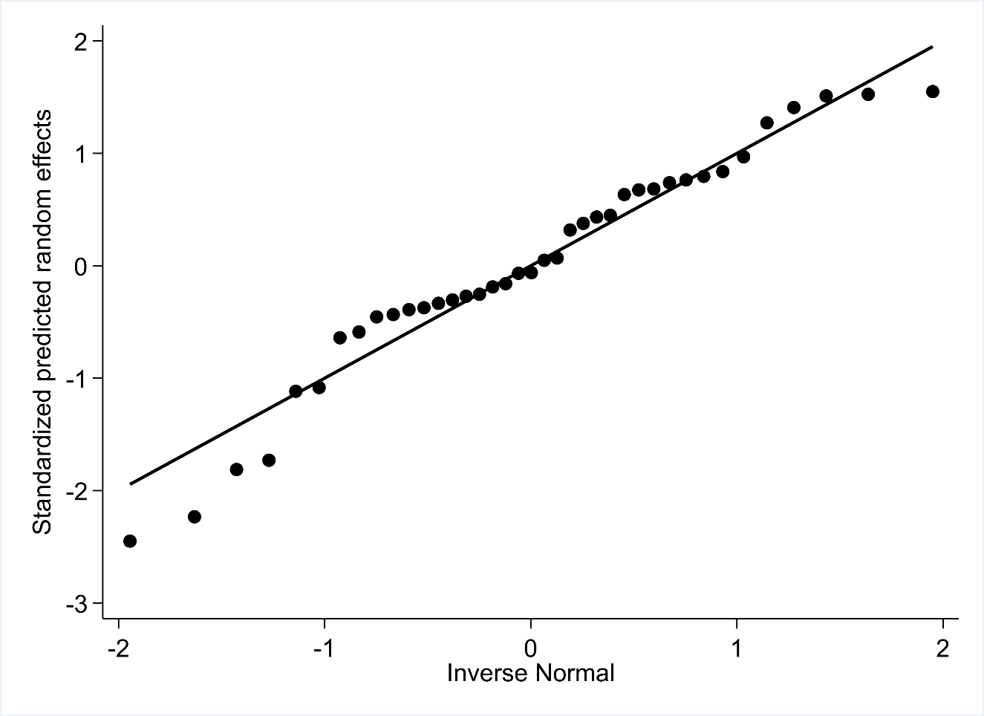
Supplemental Figure 1. Q–Q plot of maternal body mass index and human milk energy.

Supplemental Figure 2. Q–Q plot of maternal body mass index and human milk fat.
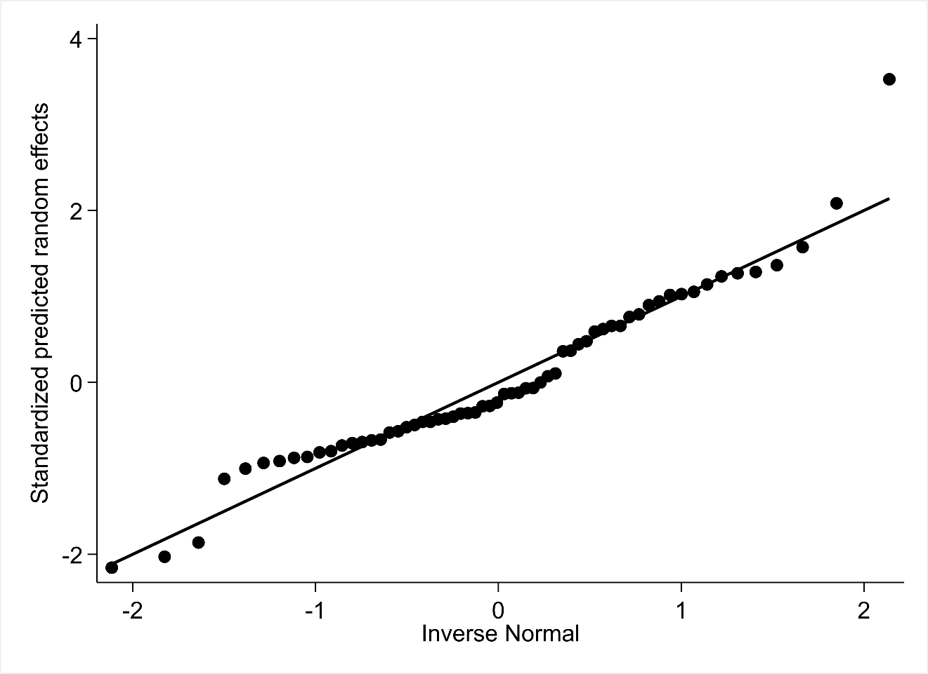

Supplemental Figure 3. Q–Q plot of maternal body mass index and human milk total protein.
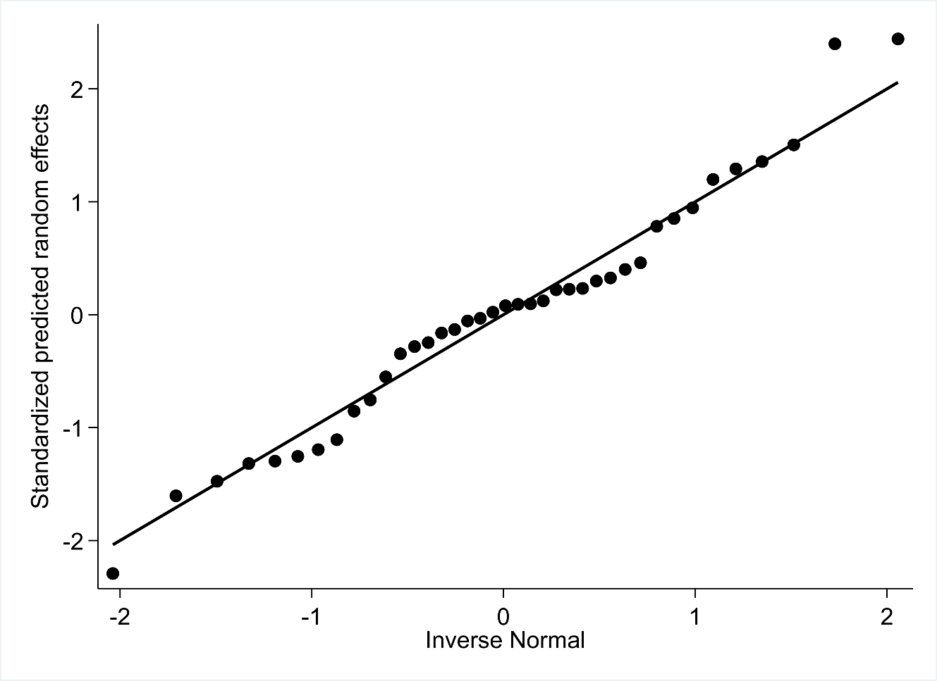

Supplemental Figure 4. Q–Q plot of maternal body mass index and human milk lactose.
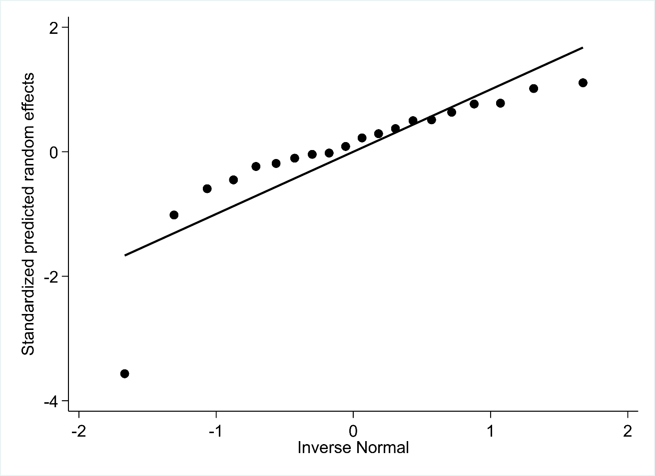

Supplemental Figure 5. Meta-regression of the relationship between maternal body mass index and human milk lactose.
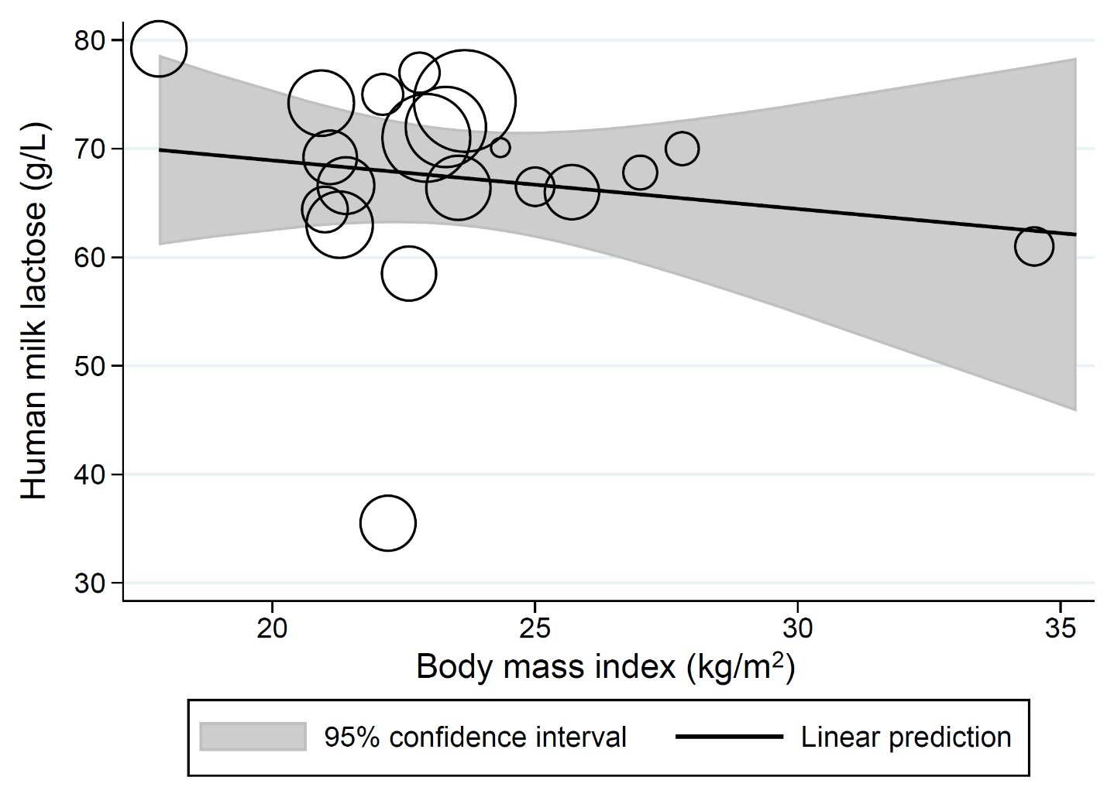
The bubble sizes in this meta-regression are proportional to the inverse of the study-level standard error for human milk lactose. The solid line represents the linear prediction for the means of human milk lactose as a function of the mean body mass index observed at the study level (β: -0.45g/L, 95% CI [-1.8, 0.88], p=0.49, I²=99.6%, n=20 datapoints).

