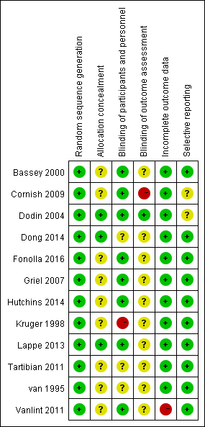
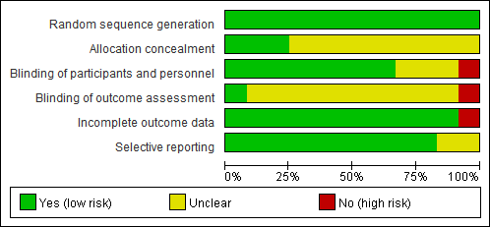
Figure 1. Risk of bias assessment for literatures included in this meta-analysis

Figure 2. Sensitivity analysis results for bone-specific alkaline phosphatase (BALP), osteocaclin (OC), type I collagen cross-linked C-terminal peptide (CTX), urinary type I collagen cross-linked N-terminal peptide (NTX) and bone mineral density (BMD).

Figure 3. Meta-regression analysis of the relationship between the supplement dose and the changes in bone-specific alkaline phosphatase (BALP), osteocaclin (OC), type I collagen cross-linked C-terminal peptide (CTX), urinary type I collagen cross-linked N-terminal peptide (NTX) and bone mineral density (BMD). Weighted mean differences of changes for bone turnover markers (y-axis) and supplement dose (x-axis) are shown. Weights of included trials were based on the inverse of the total variance and are shown by the size of the circles.

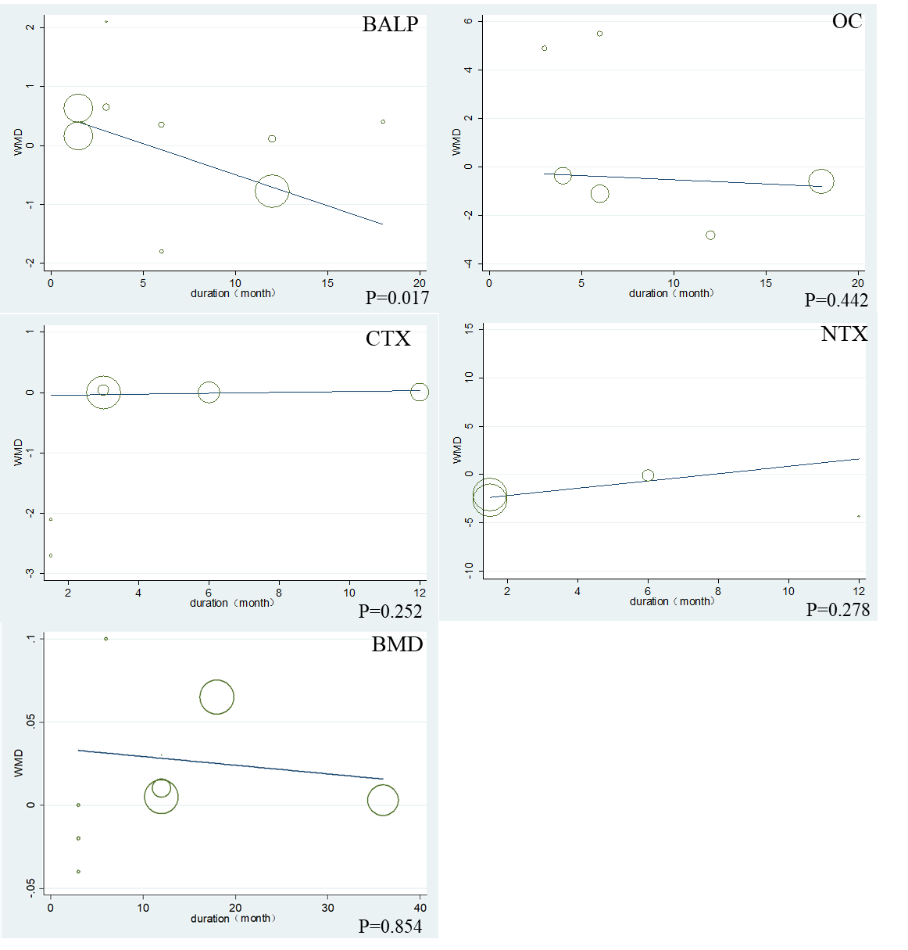

Figure 4. Meta-regression analysis of the relationship between the intervention duration and the changes in bone-specific alkaline phosphatase (BALP), osteocaclin (OC), type I collagen cross-linked C-terminal peptide (CTX), urinary type I collagen cross-linked N-terminal peptide (NTX) and bone mineral density (BMD). Weighted mean differences of changes for bone turnover markers (y-axis) and intervention duration (x-axis) are shown. Weights of included trials were based on the inverse of the total variance and are shown by the size of the circles.

Figure 5. Funnel plot for bone-specific alkaline phosphatase (BALP), osteocaclin (OC), type I collagen cross-linked C-terminal peptide (CTX), urinary type I collagen cross-linked N-terminal peptide (NTX) and bone mineral density (BMD).

