Appendices

Contents Page
- Detailed Search Strategy for question 1 and 2 2
- Study characteristics
  - Question 1 (hyperuricemia and kidney function decline) 11
  - Question 2 (urate lowering therapy and kidney function)
  - Studies excluded (not meeting inclusion criteria)
- Key definitions hyperuricemia question 36
- Quality assessment of included randomized trials 37
- Hyperuricemia and Kidney outcomes: From main analyses 38
- Meta-analyses of cross-sectional data for hyperuricemia question 41
- GRADE evidence profile for hyperuricemia and kidney outcomes (question 1)
  - Highest Uric acid tertile/quartile/quintile vs lowest 42
  - Hyperuricemia vs. Normouricemia 43
  - Continuous increase in uric acid 44
- ULT and kidney function: from main analyses 45
- ULT and kidney function: Secondary Outcomes 48
- Summary of findings for Urate lowering therapy and kidney function
  - ULT vs. Control 59
  - Allopurinol 100-300 mg/day vs. Control 61
  - Febuxostat 10-60 mg/day vs. Control 64
  - Allopurinol 100-300 mg/day vs. Febuxostat 10-80 mg/day 66
- Assessment of publication bias
  - Funnel plots 68
  - Egger’s test 69

Appendix 1: Search Strategy

Q1: Is hyperuricemia is a risk factor for the deterioration of renal function?

MEDLINE
#8
#3 AND #4 AND #7

#7
#5 OR #6

#6
(observational study[pt] OR "observational study as topic"[MeSH Terms] OR observational[tiab] OR "case-control studies"[MeSH Terms] OR "case control"[tiab] OR "case comparison"[tiab] OR retrospective[tiab] OR "cohort studies"[MeSH Terms] OR cohort[tiab] OR cohorts[All Fields] OR follow-up[tiab] OR longitudinal[tiab] OR prospective[tiab]) NOT ("animals"[MeSH Terms] NOT "humans"[MeSH Terms])

#5
((((randomized controlled trial[pt] OR controlled clinical trial[pt] OR randomized[tiab] OR placebo[tiab])) OR (clinical trials as topic[mesh:noexp] OR randomly[tiab] OR trial[ti]))) NOT ((animals[mh] NOT humans[mh]))

#4
Hyperuricemia[mh] OR hyperuric*[tiab] OR hyper-uric*[tiab] OR uric acid/blood[mh] OR uricacidem*[tiab] OR uricem*[tiab] OR Gout[mh] OR Gouty Arthritis[mh] OR gout[tiab] OR gouty[tiab] OR ((elevate[tiab] OR elevated[tiab] OR elevates[tiab] OR elevating[tiab] OR elevation*[tiab] OR increase[tiab] OR increased[tiab] OR increases[tiab] OR increasing[tiab] OR high[tiab] OR higher[tiab]) AND (urate[tiab] OR urates[tiab] OR uric acid[mh] OR uric-acid*[tiab]))

#3
#1 OR #2

#2
Kidney Diseases [mh:noexp] OR kidney-disease* [tiab] OR renal-disease* [tiab] OR AIDS-Associated Nephropathy [mh] OR nephropath* [tiab] OR Anuria [mh] OR anuria* [tiab] OR Diabetes Insipidus [mh] OR Diabetic Nephropathies [mh] OR glomerulosclero* [tiab] OR kimmelstiel-wilson [tiab] OR Fanconi Syndrome [mh] OR fanconi*[tiab] OR Hepatorenal Syndrome [mh] OR Hydronephrosis [mh] OR hydronephro* [tiab] OR pyonephro* [tiab] OR Hyperoxaluria [mh] OR hyperoxal* [tiab] OR oxaluria [tiab] OR oxalosis [tiab] OR Renal Hypertension [mh] OR renal-hypertension [tiab] OR renovascular-hypertension [tiab] OR Kidney Cortex Necrosis [mh] OR kidney-cortex-necrosis [tiab] OR renal-cortical-necrosis [tiab] OR renal-tubule-necrosis [tiab] OR renal-tubular-necrosis [tiab] OR kidney-tubular-necrosis [tiab] OR glomerular-necrosis [tiab] OR Cystic Kidney Diseases [mh] OR cystic-kidney-disease* [tiab] OR cystic-renal-disease* [tiab] OR Cystic Kidney [mh] OR Polycystic Kidney Diseases [mh] OR polycystic-kidney* [tiab] OR Kidney Neoplasms [mh] OR kidney-neoplasm* [tiab] OR renal-neoplasm* [tiab] OR kidney-cancer* [tiab] OR renal-cancer* [tiab] OR renal-cell-carcinoma* [tiab] OR renal-cell-cancer* [tiab] OR renal-cell-adenocarcinoma* [tiab] OR hypernephro* [tiab] OR mesoblastic-nephroma* [tiab] OR wilms-tumo* [tiab] OR denys-drash [tiab] OR wagr [tiab] OR Kidney Papillary Necrosis [mh] OR kidney-papillary-necrosis [tiab] OR renal-medullary-necrosis [tiab] OR Nephritis [mh] OR nephritis [tiab] OR nephritides [tiab] OR glomerulonephr* [tiab] OR bright-disease [tiab] OR brights-disease [tiab] OR bright’s-disease [tiab] OR pyeliti* [tiab] OR pyelocystiti* [tiab] OR pyelonephriti* [tiab] OR Nephrocalcinosis [mh] OR nephrocalcino* [tiab] OR Nephrolithiasis [mh] OR nephrolith* [tiab] OR Urolithiasis [mh] OR urolithiasis [tiab] OR Kidney Calculi [mh] OR kidney-calcul* [tiab] OR renal-calcul* [tiab] OR kidney-stone* [tiab] OR Nephrosclerosis [mh] OR nephroscler* [tiab] OR Nephrosis [mh] OR nephrosis [tiab] OR nephroses [tiab] OR nephrotic-syndrome* [tiab] OR Perinephritis [mh] OR perinephritis [tiab] OR Renal Artery Obstruction [mh] OR renal-artery-obstruction* [tiab] OR renal-artery-stenos* [tiab] OR Renal Insufficiency [mh] OR renal-insufficienc* [tiab] OR kidney-insufficienc* [tiab] OR renal-failure [tiab] OR kidney-failure [tiab] OR frasier-syndrome [tiab] OR esrd OR end-stage-kidney [tiab] OR end-stage renal [tiab] OR acute-kidney-injur* [tiab] OR acute-renal-injur* [tiab] OR Renal Nutcracker Syndrome [mh] OR nutcracker-syndrome [tiab] OR renal-vein-entrapment [tiab] OR Renal Osteodystrophy [mh] OR renal-osteodystroph* [tiab] OR renal-ricket* [tiab] OR Renal Tubular Transport, Inborn Errors [mh] OR renal-tubular-acidosis [tiab] OR bartter*[tiab] OR fanconi*[tiab] OR gitelman*[tiab] OR glycosuri* [tiab] OR liddle*[tiab] OR oculocerebrorenal [tiab] OR pseudohypoaldosteron* [tiab] OR aminoaciduri* [tiab] OR cystinuri* [tiab] OR Renal Tuberculosis [mh] OR renal-tuberculos* [tiab] OR Uremia [mh] OR uremia [tiab] OR uremias [tiab] OR uremic [tiab] OR ureami* [tiab] OR Zellweger Syndrome [mh] OR zellweger* [tiab] OR renal dialysis [mh] OR renal-dialysis [tiab] OR kidney-dialysis [tiab] OR hemodialysis [tiab]

#1
Kidney/pathology OR Kidney/physiopathology OR Kidney/drug effects OR Kidney Diseases/blood OR Kidney Diseases/urine OR Kidney Function Tests[mh:noexp] OR Blood Urea Nitrogen[mh] OR blood-urea-nitrogen[tiab] OR BUN[tiab] OR Glomerular Filtration Rate[mh] OR glomerular-filtration[tiab] OR GFR[tiab] OR eGFR[tiab] OR Radioisotope Renography[mh] OR renograph*[tiab] OR kidney-function*[tiab] OR renal-function*[tiab] OR glomerular-function*[tiab] OR Urinalysis[mh] OR urinalysis[tiab] OR Urine/analysis OR Renal Circulation[mh] OR renal-circulation[tiab] OR kidney-circulation[tiab] OR Creatinine/blood OR creatinine-clearance[tiab] OR Creatinine/urine OR Cystatin C [mh] OR cystatin-c [tiab]

EMBASE

#1 = 60,232
'hyperuricemia'/exp OR hyperuric*:ab,ti OR hyper NEXT/1 uric* OR 'uric acid'/exp OR 'uric acid':ab,ti OR uric NEXT/1 acid* OR 'uric acid blood level'/exp OR 'uric acid blood level' OR 'uric acid urine level'/exp OR 'uric acid urine level' OR 'urate'/exp OR 'urate':ab,ti OR urate*:ab,ti OR 'gout'/exp OR gout:ab,ti OR gouty:ab,ti

#2 = 444,912
'kidney function'/exp OR kidney NEXT/1 function* OR renal NEXT/1 function* OR glomerular NEXT/1 function* OR 'dose kidney function relation'/exp OR 'kidney function test'/exp OR 'urea nitrogen blood level'/exp OR ‘blood urea nitrogen’ OR ‘bun’ OR 'glomerulus filtration rate'/exp OR 'glomerulus filtration rate' OR ‘glomerular filtration’ OR ‘grf’ OR ‘egfr’ OR 'kidney examination'/exp OR renograph* OR 'urinalysis'/exp OR 'kidney circulation'/exp OR ‘kidney circulation’ OR ‘renal circulation’ OR 'creatinine clearance'/exp OR 'creatinine'/exp OR 'cystatin c'/exp OR 'cystatin c'

#3 = 38,245
'kidney'/exp OR 'kidney' AND ('drug effect'/exp OR 'drug effect')

#4 = 799,680
'kidney disease'/exp OR 'kidney disease' OR 'kidney diseases' OR 'renal disease' OR 'renal diseases' OR nephropath* OR anuria* OR cystinuria OR gitelman* OR glomerulopath* OR glomerulosclero* OR ‘gordon syndrome’ OR hepatorenal OR ‘kidney amloidosis’ OR ‘kidney amyloid’ OR ‘renal amyloidosis’ OR ‘renal amyloid’ OR nephrocalcino* OR nephrolith* OR urolithiasis OR kidney NEXT/1 calcul* OR renal NEXT/1 calcul* OR ‘kidney calcification’ OR ‘kidney calcinosis’ OR ‘renal calcification’ OR ‘renal calcinosis’ OR ‘nephric calcinosis’ OR ‘kidney colic’ OR ‘renal colic’ OR ‘cystic kidney’ OR ‘cystic renal’ OR 'kidney dysfunction'/exp OR ‘kidney dysfunction’ OR ‘renal dysfunction’ OR ‘glomerular dysfunction’ OR ‘kidney impairment’ OR ‘renal impairment’ OR ‘tubular dysfunction’ OR ‘polycystic kidney’ OR ‘kidney failure’ OR ‘renal failure’ OR ‘kidney fibrosis’ OR ‘renal fibrosis’ OR renal NEXT/1 insufficienc* OR kidney NEXT/1 insufficienc* OR ‘renal failure’ OR ‘kidney failure’ OR oliguria OR ‘frasier syndrome’ OR esrd OR ‘end stage kidney’ OR ‘end stage renal’ OR ‘acute kidney’ OR ‘acute renal’ OR hydronephro* OR pyonephro* OR hyperoxal*

#5 = 210,193
oxaluria OR oxalosis OR ‘renal hypertension’ OR ‘renovascular hypertension’ OR renal NEAR/2 necro* OR kidney NEAR/2 necro* OR glomerular NEAR/2 necro* OR ‘diabetes insipidus’ OR ‘kimmelstiel wilson’ OR fanconi* OR kidney NEXT/1 neoplasm* OR renal NEXT/1 neoplasm* OR kidney NEXT/1 cancer* OR renal NEAR/2 carcinoma* OR kidney NEAR/2 carcinoma* OR renal NEAR/2 cancer* OR renal NEAR/2 adenocarcinoma* OR kidney NEAR/2 adenocarcinoma* OR hypernephro* OR mesoblastic NEXT/1 nephroma* OR wilms NEXT/1 tumo* OR ‘denys drash’ OR wagr OR nephritis OR nephritides OR glomerulonephr*

#6 = 124,709
‘bright disease’ OR ‘brights disease’ OR pyeliti* OR pyelocystiti* OR pyelonephriti* OR nephroscler* OR nephrosis OR nephroses OR nephrotic OR perinephritis OR pyonephrosis OR ‘renal artery obstruction’ OR ‘renal artery stenosis’ OR ‘renal nutcracker’ OR ‘nutcracker syndrome’ OR nephrotox*

#7 = 161,052
‘renal vein entrapment’ OR ‘renal osteodystrophy’ OR renal NEXT/1 ricket* OR ‘renal tubular transport’ OR ‘renal tubular acidosis’ OR bartter* OR glycosuri* OR liddle* OR oculocerebrorenal OR pseudohypoaldosteron* OR aminoaciduri* OR cystinuri* OR ‘Renal Tuberculosis’ OR uremia OR uremias OR uremic OR ureami* OR zellweger* OR ‘renal dialysis’ OR ‘kidney dialysis’ OR hemodialysis

#8 = 1,158,303
#2 OR #3 OR #4 OR #5 OR #6 OR #7

#9 = 2,899,976
'observational study'/de OR 'observational study'/exp OR 'observational':ab,ti OR 'case control study'/de OR 'case control':ab,ti OR 'case comparison':ab,ti OR 'retrospective':ab,ti OR 'cohort analysis'/de OR 'cohort':ab,ti OR 'cohorts':ab,ti OR 'follow up':ab,ti OR 'longitudinal':ab,ti OR 'prospective':ab,ti OR 'randomized controlled trial'/de OR 'controlled clinical trial'/de OR 'randomized':ab,ti OR 'placebo':ab,ti OR 'clinical trial (topic)'/exp OR 'randomly':ab,ti OR 'trial':ti NOT ('animal'/exp NOT 'human'/de)

#10 = 4,581
#1 AND #8 AND #9

#11 = 1,859
#10 AND [embase]/lim NOT [medline]/lim

Cochrane Library
ID Search Hits
#1 MeSH descriptor: [Hyperuricemia] explode all trees 86

#2 MeSH descriptor: [Uric Acid] explode all trees 834

#3 MeSH descriptor: [Kidney] explode all trees and with qualifier(s): [Drug effects - DE, Pathology - PA, Physiopathology - PP] 2345

#4 MeSH descriptor: [Kidney Function Tests] explode all trees 3217

#5 MeSH descriptor: [Kidney Diseases] explode all trees 10086

#6 #1 or #2 863

#7 #3 or #4 or #5 12891

#8 #6 and #7 in Trials 170

CINAHL

Search ID – Line 8
#3 AND #4 AND #7 – Results: 26
Search ID – Line 7
#5 OR #6 – Results: 114,225
Search ID – Line 6 – Results: 74,850
(Observational study OR Nonexperimental Studies OR Case Control Studies OR Case Control OR Case Comparison OR Retrospective OR Cohort Studies OR Cohort OR Cohorts OR follow-up OR longitudinal OR prospective NOT (animals NOT humans))

Search ID- Line 5 – Results: 47,895
(randomized controlled trial OR controlled clinical trial OR randomized OR Random Assignment OR placebo) OR Clinical Trials OR trial NOT (animals NOT humans))

Search ID – Line 4
#1 OR #2 – Results: 16,410

Search ID – Line 3 – Results: 1,103
Hyperuricemia OR hyperuric* OR hyper-uric* OR uricacidem* OR uricem* OR Gout OR Gouty Arthritis OR gouty

OR
(elevate OR elevated OR elevates OR elevating OR elevation* OR increase OR increased OR increases OR increasing OR high OR higher) AND (urate OR urates OR uric acid OR uric-acid*)

Search ID – Line 2 – Results: 4,117
Kidney/pathology OR Kidney/physiopathology OR Kidney/drug effects OR Kidney Diseases/blood OR Kidney Diseases/urine OR Kidney Function Tests OR Blood Urea Nitrogen OR blood-urea-nitrogen OR BUN OR Glomerular Filtration Rate OR glomerular-filtration OR GFR OR eGFR OR Radioisotope Renography OR renograph* OR kidney-function* OR renal-function* OR glomerular-function* OR Urinalysis OR urinalysis OR Urine/analysis OR Renal Circulation OR renal-circulation OR kidney-circulation OR Creatinine/blood OR creatinine-clearance OR Creatinine/urine OR Cystatin C OR cystatin-c

Search ID – Line 1 – Results: 13,912
Kidney Diseases OR kidney-disease* OR renal-disease* OR AIDS-Associated Nephropathy OR nephropath* OR Anuria OR anuria* OR Diabetes Insipidus OR Diabetic Nephropathies OR glomerulosclero* OR kimmelstiel-wilson OR Fanconi Syndrome OR fanconi* OR Hepatorenal Syndrome OR Hydronephrosis OR hydronephro* OR pyonephro* OR Hyperoxaluria OR hyperoxal* OR oxaluria OR oxalosis OR Renal Hypertension OR renal-hypertension OR renovascular-hypertension OR Kidney Cortex Necrosis OR kidney-cortex-necrosis OR renal-cortical-necrosis OR renal-tubule-necrosis OR renal-tubular-necrosis OR kidney-tubular-necrosis OR glomerular-necrosis OR Cystic Kidney Diseases OR cystic-kidney-disease* OR cystic-renal-disease* OR Cystic Kidney OR Polycystic Kidney Diseases OR polycystic-kidney* OR Kidney Neoplasms OR kidney-neoplasm* OR renal-neoplasm* OR kidney-cancer* OR renal-cancer* OR renal-cell-carcinoma* OR renal-cell-cancer* OR renal-cell-adenocarcinoma* OR hypernephro* OR mesoblastic-nephroma* OR wilms-tumo* OR denys-drash OR wagr OR kidney-papillary-necrosis OR renal-medullary-necrosis OR Nephritis OR nephritis OR glomerulonephr* OR pyeliti* OR pyelonephriti* OR Nephrocalcinosis OR nephrocalcino* OR Nephrolithiasis OR nephrolith* OR Urolithiasis OR urolithiasis OR Kidney Calculi OR kidney-calcul* OR renal-calcul* OR kidney-stone* OR Nephrosclerosis OR nephroscler* OR Nephrosis OR nephrosis OR nephroses OR nephrotic-syndrome* OR Perinephritis OR perinephritis OR Renal Artery Obstruction OR renal-artery-obstruction* OR renal-artery-stenos* OR Renal Insufficiency OR renal-insufficienc* OR kidney-insufficienc* OR renal-failure OR kidney-failure OR frasier-syndrome OR esrd OR end-stage-kidney OR end-stage renal OR acute-kidney-injur* OR acute-renal-injur* OR Renal Nutcracker Syndrome OR nutcracker-syndrome OR renal-vein-entrapment OR Renal Osteodystrophy OR renal-osteodystroph* OR renal-ricket* OR Renal Tubular Transport, Inborn Errors OR renal-tubular-acidosis OR barter* OR fanconi* OR gitelman* OR glycosuri* OR liddle OR oculocerebrorenal OR pseudohypoaldosteron* OR aminoaciduri* OR cystinuri* OR Renal Tuberculosis OR renal-tuberculos* OR Uremia OR uremia OR uremias OR uremic OR ureami* OR Zellweger Syndrome OR zellweger* OR renal dialysis OR renal-dialysis OR kidney-dialysis OR hemodialysis
(The following terms were excluded in this search from the PubMed search string as they did not show up in Cinahl:
Bright Disease OR Brights Disease
Pyelocystiti*Nephritides
Q2: Is the use of urate lowering treatments (ULTs) is associated with improvement in renal function, and to what extent?

MEDLINE
#38
#3 AND #37 AND #7

#7
#5 OR #6

#5
((((randomized controlled trial[pt] OR controlled clinical trial[pt] OR randomized[tiab] OR placebo[tiab])) OR (clinical trials as topic[mesh:noexp] OR randomly[tiab] OR trial[ti]))) NOT ((animals[mh] NOT humans[mh]))

#6
(observational study[pt] OR "observational study as topic"[MeSH Terms] OR observational[tiab] OR "case-control studies"[MeSH Terms] OR "case control"[tiab] OR "case comparison"[tiab] OR retrospective[tiab] OR "cohort studies"[MeSH Terms] OR cohort[tiab] OR cohorts[All Fields] OR follow-up[tiab] OR longitudinal[tiab] OR prospective[tiab]) NOT ("animals"[MeSH Terms] NOT "humans"[MeSH Terms])

#37
((uricosuric agents[pa] OR "uricosuric agents"[MeSH Terms] OR "uricosuric agents"[tiab]) OR (((("xanthine oxidase"[MeSH Terms] AND enzyme inhibitors[pa]) OR ("xanthine oxidase"[MeSH Terms] AND "enzyme inhibitors"[MeSH Terms])) OR (xanthine oxidase inhibitors[tiab] OR xanthine oxidase inhibitors[tiab])) OR "xanthine oxidase/antagonists and inhibitors"[MeSH Terms])) OR ((((((("apazone"[MeSH Terms] OR Apazone[tiab] OR "benzbromarone"[MeSH Terms] OR Benzbromarone[tiab]) OR ("benziodarone"[Supplementary Concept] OR benziodarone[tiab] OR "halofenate"[MeSH Terms] OR Halofenate[tiab])) OR (indacrinone[tiab] OR "indacrinone"[Supplementary Concept] OR "MK 473"[nm] OR "MK 473"[tiab])) OR ("probenecid"[MeSH Terms] OR Probenecid[tiab] OR "sulfinpyrazone"[MeSH Terms] OR Sulfinpyrazone[tiab])) OR ("traxanox"[Supplementary Concept] OR traxanox[tiab] OR "zoxazolamine"[MeSH Terms] OR Zoxazolamine[tiab])) OR ("ticrynafen"[MeSH Terms] OR Ticrynafen[Tiab])) OR "(3-methyl-2-(3-pyridyl)-1-indoleoctanoic acid"[nm] OR "3-methyl-2-(3-pyridyl)-1-indoleoctanoic acid"[tiab]) OR CGS12970[tiab] OR CGS-12970[tiab] OR ((((allopurinol[tiab] OR "allopurinol"[MeSH Terms] OR "zyloprim"[TIAB] OR ("febuxostat"[Supplementary Concept] OR febuxostat[tiab] OR uloric[tiab])) OR ("amlodipine"[MeSH Terms] OR Amlodipine[tiab] OR "atorvastatin"[Supplementary Concept] OR atorvastatin[tiab])) OR ("fenofibrate"[MeSH Terms] OR fenofibrate[tiab] OR "losartan"[MeSH Terms] OR losartan[tiab])) OR ("guaifenesin"[MeSH Terms] OR guaifenesin[tiab] OR "cortisone"[MeSH Terms] OR cortisone[tiab]))

#3
#1 OR #2

#1
Kidney/pathology OR Kidney/physiopathology OR Kidney/drug effects OR Kidney Diseases/blood OR Kidney Diseases/urine OR Kidney Function Tests[mh:noexp] OR Blood Urea Nitrogen[mh] OR blood-urea-nitrogen[tiab] OR BUN[tiab] OR Glomerular Filtration Rate[mh] OR glomerular-filtration[tiab] OR GFR[tiab] OR eGFR[tiab] OR Radioisotope Renography[mh] OR renograph*[tiab] OR kidney-function*[tiab] OR renal-function*[tiab] OR glomerular-function*[tiab] OR Urinalysis[mh] OR urinalysis[tiab] OR Urine/analysis OR Renal Circulation[mh] OR renal-circulation[tiab] OR kidney-circulation[tiab] OR Creatinine/blood OR creatinine-clearance[tiab] OR Creatinine/urine OR Cystatin C [mh] OR cystatin-c [tiab]

#2
Kidney Diseases [mh:noexp] OR kidney-disease* [tiab] OR renal-disease* [tiab] OR AIDS-Associated Nephropathy [mh] OR nephropath* [tiab] OR Anuria [mh] OR anuria* [tiab] OR Diabetes Insipidus [mh] OR Diabetic Nephropathies [mh] OR glomerulosclero* [tiab] OR kimmelstiel-wilson [tiab] OR Fanconi Syndrome [mh] OR fanconi*[tiab] OR Hepatorenal Syndrome [mh] OR Hydronephrosis [mh] OR hydronephro* [tiab] OR pyonephro* [tiab] OR Hyperoxaluria [mh] OR hyperoxal* [tiab] OR oxaluria [tiab] OR oxalosis [tiab] OR Renal Hypertension [mh] OR renal-hypertension [tiab] OR renovascular-hypertension [tiab] OR Kidney Cortex Necrosis [mh] OR kidney-cortex-necrosis [tiab] OR renal-cortical-necrosis [tiab] OR renal-tubule-necrosis [tiab] OR renal-tubular-necrosis [tiab] OR kidney-tubular-necrosis [tiab] OR glomerular-necrosis [tiab] OR Cystic Kidney Diseases [mh] OR cystic-kidney-disease* [tiab] OR cystic-renal-disease* [tiab] OR Cystic Kidney [mh] OR Polycystic Kidney Diseases [mh] OR polycystic-kidney* [tiab] OR Kidney Neoplasms [mh] OR kidney-neoplasm* [tiab] OR renal-neoplasm* [tiab] OR kidney-cancer* [tiab] OR renal-cancer* [tiab] OR renal-cell-carcinoma* [tiab] OR renal-cell-cancer* [tiab] OR renal-cell-adenocarcinoma* [tiab] OR hypernephro* [tiab] OR mesoblastic-nephroma* [tiab] OR wilms-tumo* [tiab] OR denys-drash [tiab] OR wagr [tiab] OR Kidney Papillary Necrosis [mh] OR kidney-papillary-necrosis [tiab] OR renal-medullary-necrosis [tiab] OR Nephritis [mh] OR nephritis [tiab] OR nephritides [tiab] OR glomerulonephr* [tiab] OR bright-disease [tiab] OR brights-disease [tiab] OR bright’s-disease [tiab] OR pyeliti* [tiab] OR pyelocystiti* [tiab] OR pyelonephriti* [tiab] OR Nephrocalcinosis [mh] OR nephrocalcino* [tiab] OR Nephrolithiasis [mh] OR nephrolith* [tiab] OR Urolithiasis [mh] OR urolithiasis [tiab] OR Kidney Calculi [mh] OR kidney-calcul* [tiab] OR renal-calcul* [tiab] OR kidney-stone* [tiab] OR Nephrosclerosis [mh] OR nephroscler* [tiab] OR Nephrosis [mh] OR nephrosis [tiab] OR nephroses [tiab] OR nephrotic-syndrome* [tiab] OR Perinephritis [mh] OR perinephritis [tiab] OR Renal Artery Obstruction [mh] OR renal-artery-obstruction* [tiab] OR renal-artery-stenos* [tiab] OR Renal Insufficiency [mh] OR renal-insufficienc* [tiab] OR kidney-insufficienc* [tiab] OR renal-failure [tiab] OR kidney-failure [tiab] OR frasier-syndrome [tiab] OR esrd OR end-stage-kidney [tiab] OR end-stage renal [tiab] OR acute-kidney-injur* [tiab] OR acute-renal-injur* [tiab] OR Renal Nutcracker Syndrome [mh] OR nutcracker-syndrome [tiab] OR renal-vein-entrapment [tiab] OR Renal Osteodystrophy [mh] OR renal-osteodystroph* [tiab] OR renal-ricket* [tiab] OR Renal Tubular Transport, Inborn Errors [mh] OR renal-tubular-acidosis [tiab] OR bartter*[tiab] OR fanconi*[tiab] OR gitelman*[tiab] OR glycosuri* [tiab] OR liddle*[tiab] OR oculocerebrorenal [tiab] OR pseudohypoaldosteron* [tiab] OR aminoaciduri* [tiab] OR cystinuri* [tiab] OR Renal Tuberculosis [mh] OR renal-tuberculos* [tiab] OR Uremia [mh] OR uremia [tiab] OR uremias [tiab] OR uremic [tiab] OR ureami* [tiab] OR Zellweger Syndrome [mh] OR zellweger* [tiab] OR renal dialysis [mh] OR renal-dialysis [tiab] OR kidney-dialysis [tiab] OR hemodialysis [tiab]

EMBASE

#11 = 1,554
#10 AND [embase]/lim NOT [medline]/lim

#10 = 5,405
#1 AND #2 AND #9

#9 = 1,158,303
#3 OR #4 OR #5 OR #6 OR #7 OR #8

#8 = 444,912
'kidney function'/exp OR kidney NEXT/1 function* OR renal NEXT/1 function* OR glomerular NEXT/1 function* OR 'dose kidney function relation'/exp OR 'kidney function test'/exp OR 'urea nitrogen blood level'/exp OR ‘blood urea nitrogen’ OR ‘bun’ OR 'glomerulus filtration rate'/exp OR 'glomerulus filtration rate' OR ‘glomerular filtration’ OR ‘grf’ OR ‘egfr’ OR 'kidney examination'/exp OR renograph* OR 'urinalysis'/exp OR 'kidney circulation'/exp OR ‘kidney circulation’ OR ‘renal circulation’ OR 'creatinine clearance'/exp OR 'creatinine'/exp OR 'cystatin c'/exp OR 'cystatin c'

#7 = 38,245
'kidney'/exp OR 'kidney' AND ('drug effect'/exp OR 'drug effect')

#6 = 799,680
'kidney disease'/exp OR 'kidney disease' OR 'kidney diseases' OR 'renal disease' OR 'renal diseases' OR nephropath* OR anuria* OR cystinuria OR gitelman* OR glomerulopath* OR glomerulosclero* OR ‘gordon syndrome’ OR hepatorenal OR ‘kidney amloidosis’ OR ‘kidney amyloid’ OR ‘renal amyloidosis’ OR ‘renal amyloid’ OR nephrocalcino* OR nephrolith* OR urolithiasis OR kidney NEXT/1 calcul* OR renal NEXT/1 calcul* OR ‘kidney calcification’ OR ‘kidney calcinosis’ OR ‘renal calcification’ OR ‘renal calcinosis’ OR ‘nephric calcinosis’ OR ‘kidney colic’ OR ‘renal colic’ OR ‘cystic kidney’ OR ‘cystic renal’ OR 'kidney dysfunction'/exp OR ‘kidney dysfunction’ OR ‘renal dysfunction’ OR ‘glomerular dysfunction’ OR ‘kidney impairment’ OR ‘renal impairment’ OR ‘tubular dysfunction’ OR ‘polycystic kidney’ OR ‘kidney failure’ OR ‘renal failure’ OR ‘kidney fibrosis’ OR ‘renal fibrosis’ OR renal NEXT/1 insufficienc* OR kidney NEXT/1 insufficienc* OR ‘renal failure’ OR ‘kidney failure’ OR oliguria OR ‘frasier syndrome’ OR esrd OR ‘end stage kidney’ OR ‘end stage renal’ OR ‘acute kidney’ OR ‘acute renal’ OR hydronephro* OR pyonephro* OR hyperoxal*

#5 = 210,193
oxaluria OR oxalosis OR ‘renal hypertension’ OR ‘renovascular hypertension’ OR renal NEAR/2 necro* OR kidney NEAR/2 necro* OR glomerular NEAR/2 necro* OR ‘diabetes insipidus’ OR ‘kimmelstiel wilson’ OR fanconi* OR kidney NEXT/1 neoplasm* OR renal NEXT/1 neoplasm* OR kidney NEXT/1 cancer* OR renal NEAR/2 carcinoma* OR kidney NEAR/2 carcinoma* OR renal NEAR/2 cancer* OR renal NEAR/2 adenocarcinoma* OR kidney NEAR/2 adenocarcinoma* OR hypernephro* OR mesoblastic NEXT/1 nephroma* OR wilms NEXT/1 tumo* OR ‘denys drash’ OR wagr OR nephritis OR nephritides OR glomerulonephr*

#4 = 124,709
‘bright disease’ OR ‘brights disease’ OR pyeliti* OR pyelocystiti* OR pyelonephriti* OR nephroscler* OR nephrosis OR nephroses OR nephrotic OR perinephritis OR pyonephrosis OR ‘renal artery obstruction’ OR ‘renal artery stenosis’ OR ‘renal nutcracker’ OR ‘nutcracker syndrome’ OR nephrotox*

#3 = 161,052
‘renal vein entrapment’ OR ‘renal osteodystrophy’ OR renal NEXT/1 ricket* OR ‘renal tubular transport’ OR ‘renal tubular acidosis’ OR bartter* OR glycosuri* OR liddle* OR oculocerebrorenal OR pseudohypoaldosteron* OR aminoaciduri* OR cystinuri* OR ‘Renal Tuberculosis’ OR uremia OR uremias OR uremic OR ureami* OR zellweger* OR ‘renal dialysis’ OR ‘kidney dialysis’ OR hemodialysis

#2 = 2,899,976
'observational study'/de OR 'observational study'/exp OR 'observational':ab,ti OR 'case control study'/de OR 'case control':ab,ti OR 'case comparison':ab,ti OR 'retrospective':ab,ti OR 'cohort analysis'/de OR 'cohort':ab,ti OR 'cohorts':ab,ti OR 'follow up':ab,ti OR 'longitudinal':ab,ti OR 'prospective':ab,ti OR 'randomized controlled trial'/de OR 'controlled clinical trial'/de OR 'randomized':ab,ti OR 'placebo':ab,ti OR 'clinical trial (topic)'/exp OR 'randomly':ab,ti OR 'trial':ti NOT ('animal'/exp NOT 'human'/de)

#1 = 129,252
'uricosuric agent'/exp OR 'uricosuric agent' OR 'uricosuric agents' OR 'xanthine oxidase inhibitor'/exp OR 'xanthine oxidase inhibitor' OR 'xanthine oxidase inhibitors' OR 'azapropazone'/exp OR 'azapropazone' OR 'apazone' OR 'benzbromarone'/exp OR 'benzbromarone' OR 'benziodarone'/exp OR ‘benziodarone’ OR 'halofenate'/exp OR 'halofenate' OR 'indacrinone'/exp OR indacrinone OR 'mk 473'/exp OR 'mk 473' OR '(2 cyclopentyl 6, 7 dichloro 2 methyl 1 oxo 5 indanyloxy) acetic acid'/exp OR '(2 cyclopentyl 6, 7 dichloro 2 methyl 1 oxo 5 indanyloxy) acetic acid' OR 'probenecide'/exp OR 'probenecide' OR 'sulfinpyrazone'/exp OR sulfinpyrazone OR 'traxanox'/exp OR 'traxanox' OR 'zoxazolamine'/exp OR 'zoxazolamine' OR 'tienilic acid'/exp OR 'tienilic acid' OR 'ticrynafen' OR '3 methyl 2 (3 pyridyl) 1 indoleoctanoic acid'/exp OR '(3-methyl-2-(3-pyridyl)-1-indoleoctanoic acid' OR ‘CGS12970’ OR ‘CGS 12970’ OR 'allopurinol'/exp OR 'allopurinol' OR ‘zyloprim’ OR 'febuxostat'/exp OR 'febuxostat' OR ‘uloric’ OR 'amlodipine'/exp OR 'amlodipine' OR 'atorvastatin'/exp OR 'atorvastatin' OR 'fenofibrate'/exp OR ‘fenofibrate’ OR 'losartan'/exp OR 'losartan' OR 'guaifenesin'/exp OR 'guaifenesin' OR 'cortisone'/exp OR 'cortisone'

Cochrane Library

ID Search Hits
#1 MeSH descriptor: [Hyperuricemia] explode all trees 86
#2 MeSH descriptor: [Uric Acid] explode all trees 834
#3 MeSH descriptor: [Kidney] explode all trees and with qualifier(s): [Drug effects - DE, Pathology - PA, Physiopathology - PP] 2345
#4 MeSH descriptor: [Kidney Function Tests] explode all trees 3217
#5 MeSH descriptor: [Kidney Diseases] explode all trees 10086
#6 #1 or #2 863
#7 #3 or #4 or #5 12891
#8 #6 and #7 in Trials 170
#9 MeSH descriptor: [Uricosuric Agents] explode all trees 58
#10 #7 and #9 in Trials 11

CINAHL

Search ID – Line 10
#4 AND #7 AND #9 – Results: 35

Search ID - Line 9 – Results: 1,242
uricosuric agents OR (xanthine oxidase AND enzyme inhibitors) OR xanthine oxidase inhibitors OR xanthine oxidase antagonists OR apazone OR benzbromarone OR benziodarone OR halofenate OR indacrinone OR "MK 473" OR probenecid OR sulfinpyrazone OR traxanox OR zoxazolamine OR ticrynafen OR "3-methyl-2-(3-pyridyl)-1-indoleoctanoic acid" OR CGS12970 OR CGS-12970 OR allopurinol OR zyloprim OR febuxostat OR uloric OR amlodipine OR atorvastatin OR fenofibrate OR losartan OR guaifenesin OR cortisone

Search ID – Line 7 – Results: 114,225
(randomized controlled trial OR controlled clinical trial OR randomized OR Random Assignment OR placebo)) Clinical Trials OR trial NOT (animals NOT humans))

OR
(Observational study OR Nonexperimental Studies OR Case Control Studies OR Case Control OR Case Comparison OR Retrospective OR Cohort Studies OR Cohort OR Cohorts OR follow-up OR longitudinal OR prospective NOT (animals NOT humans))

Search ID – Line 4 – Results: 16,410
#1 OR #2
Kidney/pathology OR Kidney/physiopathology OR Kidney/drug effects OR Kidney Diseases/blood OR Kidney Diseases/urine OR Kidney Function Tests OR Blood Urea Nitrogen OR blood-urea-nitrogen OR BUN OR Glomerular Filtration Rate OR glomerular-filtration OR GFR OR eGFR OR Radioisotope Renography OR renograph* OR kidney-function* OR renal-function* OR glomerular-function* OR Urinalysis OR urinalysis OR Urine/analysis OR Renal Circulation OR renal-circulation OR kidney-circulation OR Creatinine/blood OR creatinine-clearance OR Creatinine/urine OR Cystatin C OR cystatin-c

OR
Kidney Diseases OR kidney-disease* OR renal-disease* OR AIDS-Associated Nephropathy OR nephropath* OR Anuria OR anuria* OR Diabetes Insipidus OR Diabetic Nephropathies OR glomerulosclero* OR kimmelstiel-wilson OR Fanconi Syndrome OR fanconi* OR Hepatorenal Syndrome OR Hydronephrosis OR hydronephro* OR pyonephro* OR Hyperoxaluria OR hyperoxal* OR oxaluria OR oxalosis OR Renal Hypertension OR renal-hypertension OR renovascular-hypertension OR Kidney Cortex Necrosis OR kidney-cortex-necrosis OR renal-cortical-necrosis OR renal-tubule-necrosis OR renal-tubular-necrosis OR kidney-tubular-necrosis OR glomerular-necrosis OR Cystic Kidney Diseases OR cystic-kidney-disease* OR cystic-renal-disease* OR Cystic Kidney OR Polycystic Kidney Diseases OR polycystic-kidney* OR Kidney Neoplasms OR kidney-neoplasm* OR renal-neoplasm* OR kidney-cancer* OR renal-cancer* OR renal-cell-carcinoma* OR renal-cell-cancer* OR renal-cell-adenocarcinoma* OR hypernephro* OR mesoblastic-nephroma* OR wilms-tumo* OR denys-drash OR wagr OR kidney-papillary-necrosis OR renal-medullary-necrosis OR Nephritis OR nephritis OR glomerulonephr* OR pyeliti* OR pyelonephriti* OR Nephrocalcinosis OR nephrocalcino* OR Nephrolithiasis OR nephrolith* OR Urolithiasis OR urolithiasis OR Kidney Calculi OR kidney-calcul* OR renal-calcul* OR kidney-stone* OR Nephrosclerosis OR nephroscler* OR Nephrosis OR nephrosis OR nephroses OR nephrotic-syndrome* OR Perinephritis OR perinephritis OR Renal Artery Obstruction OR renal-artery-obstruction* OR renal-artery-stenos* OR Renal Insufficiency OR renal-insufficienc* OR kidney-insufficienc* OR renal-failure OR kidney-failure OR frasier-syndrome OR esrd OR end-stage-kidney OR end-stage renal OR acute-kidney-injur* OR acute-renal-injur* OR Renal Nutcracker Syndrome OR nutcracker-syndrome OR renal-vein-entrapment OR Renal Osteodystrophy OR renal-osteodystroph* OR renal-ricket* OR Renal Tubular Transport, Inborn Errors OR renal-tubular-acidosis OR barter* OR fanconi* OR gitelman* OR glycosuri* OR liddle OR oculocerebrorenal OR pseudohypoaldosteron* OR aminoaciduri* OR cystinuri* OR Renal Tuberculosis OR renal-tuberculos* OR Uremia OR uremia OR uremias OR uremic OR ureami* OR Zellweger Syndrome OR zellweger* OR renal dialysis OR renal-dialysis OR kidney-dialysis OR hemodialysis

Appendix 2:

Appendix 2A: Characteristics of included studies (the hypeuricemia question:Q1)
Sr. No. | Author | Study period | Location | Source of data or study population | Study design | Total Participants | Mean follow up period or range (years) | Mean/median age (years) | Male % or M: F numbers | Hyperuricemia definition (mg/dL) | Ascertainment of hyperuricemia | Outcomes, ascertainment method and number | Risk of Bias-NOS scale
1 | Al-Rubeaan K 2018 | April 2014 to June 2015 | Saudi Arabia | Patients with type 2 diabetes of >10year duration | Retrospective cohort | 640 | 18.21 | 56.64±6.62 | M: 285;  W: 355 | M:≥6.8; W:≥6 | No description | 1.Microalbuminuria: 30-299 mg/g Cr  2.Macroalbuminuria: >/=300 mg/g Cr  3.ESRD: eGFR (estimated glomerular filteration rate) <15ml/min/1.73m² | High
2 | Barkas, F 2017 | 1995 to 2015 | Greece | Patients with dyslipidaemia of >3 years | Retrospective Cohort | 1095 | 6 (4-10) | 54-57 | M: 510; W: 585 | >6 | No description | CKD stage III: eGFR <60ml/min/1.73m² | Low
3 | Bartakova, V. 2016 | NA | Czech Republic | Type 2 diabetes with median duration of 15 years | Retrospective Cohort | 422 | 3.5 | >67 | M: 216, W: 206 | M:≥7.06; W:≥6.05 | Uricase based enzymatic test on cobas 8000 analyser, Roche | CKD stage III  i) eGFR <60ml/min/1.73m²  ii) overt proteinuria,  iii) progression of CKD by at least one stage those with baseline stage III or IV CKD | High
- 1  4 | Bellomo, G. 2010 | 2003- 2008 | Italy | Healthy person were recruited from blood donors in the hospital | Cohort | 824 | 4.9 | M: 41.6 to 44.7  W: 39 to 42.8 | M: 681  F: 143 | M:≥6.3  W:≥4.9 | NA | Decline in eGFR: >10 mL/min/1.73 m² MDRD study equation and CKD-EPI equation | Low
5 | Ben-Dov, I.Z. 2011 | 1979 to 2007 | Israel | Hyperlipidaemia patients from 2nd visit of Jerusalem Lipid research clinic cohort | Retrospective Cohort | 2,449 | 20-24 | 35-78 | M: 1470,  F: 979 | M:≥6.5  W:≥5.3 | Auto-analyser by phosphotungstate method | CKD stage III: linking with national population registry ICD codes (ICD 9: 485) | Low
6 | Bjornstad, P. 2015 | 2000- 2014 | USA | Data of Type 1 diabetes patients from Coronary artery calcification in Type 1 Diabetes Study | Reterospective cohort | 652 | 6.1 | 19-56 | M: 298;  W: 354 | UA is 1 mg/dL increase | Uricase based commercial kit | 1. Albuminuria: AER ≥ 20 μg/min (timed urine sample) an ACR ≥ 30 mg/g for spot sample.  2. GFR decline: annual GFR loss > 3.3% | High
7 | Cain, L. 2010 | 2005-2006 | USA | Appalachian individuals residing in six communities West Virginia and Ohio. | Cross sectional | 49,295 | NA | >18 (43.4) | W: 26346; M: 22949 | M:>7.1  W:>5.5 | Uric acid (enzymatic uricase method) The normal analytical range was 0.5–12 mg/dL | CKD stage III: was defined as an eGFR of <60mL/min/1.73 m² (MDRD equation). | Low
8 | Cao, X. 2017 | May 2011 to April 2016 | China | Healthy adults from community | Prospective Cohort | 6495 | 4.4 | 49 (35-74) | M: 4110, W: 2385 | M:>6.74  W:>4.66 | Serum uric acid was determined on an autoanalyzer by the uricase-per- oxidase method. | 1. Rapid decline of kidney function: eGFR loss of >3mL/min/1.73m²  2.CKD stage III: defined as eGFR<60ml/min/1.73m² or positive proteinuria | Low
9 | Chang Y.H. 2015 | October 2006 to September 2014 | Taiwan | Outpatient clinic patients with type 2 DM | Cohort | 2,367 | 4.6 | 60.2 ± 10.7 (1133); 61.9 ± 10.3 (487); 59 ± 10.2 (747) | M: 1136; W: 1231 | >8.18 | Enzymatic method | CKD: Stage III or more | High
10 | Chang, H.Y. et al. 2013 | 2008-2012 | Taiwan | Residents of Chiayi County (no comorbidities) | Prospective Cohort | 1,829 | 4 | 66.09 ± 9.61 | M: 679,  F: 1150 | M:>7.5,  W:>6.5 | Technicon RA-1000 analyser | Albuminuria: Microalbuminuria (ACR: 30-300 mg/g) | Low
11 | Chen, N. 2009 | 2009 | China | Subjects from Changing district are randomly selected in three stages | Cross Sectional | 2,554 | NA | 58.4 ± 15 | M: 911,  F: 1643 | M:>7.06; W:>6.05 | Laboratory data | CKD stage III: eGRF (<60 mL/min/1.73m²) or hematuria (microscopy)/albuminuria (dipstick). | Low
12 | Chen, W. 2009 | July 2006- June 2007 | China | General Adult population in Guangzhou in Southern China | Cross Sectional | 6,101 | NA | 51.6 ± 12.8 | NA | >7 | Measured by an auto analyser | CKD stage III: either albuminuria, hematuria or eGFR values <60 mL/min/1.73m². | Low
13 | Chen, W. 2011 | 2010 | China | Local Tibetan resident age ≥18 yr. were invited | Cross-sectional | 1,289 | NA | 43.7 ± 14.3 | NA | >7 | Measured by auto analyser | CKD stage III: defined as albuminuria, hematuria or eGFR values <60 mL/min/1.73m²  Albuminuria: UACR >30 mg/g | Low
14 | Chen, Z. 2014 | November 2009 to June 2011 | China | Patient diagnosed with stable CAD and T2DM hospitalized | Prospective Cohort | 526 | 0.5 | 69.31 ± 9.91 | M: 257, W: 269 | >6.13 | Urate oxidase method | CKD stage III: eGFR < 60 mL/min/1.73m² | High
15 | Chini, L.S.N. 2017 | 2008 to 2014 | Brazil | Office workers in non laborious activities | Retrospective cohort | 1094 | 5.05±1.05 | 48.7±8.8 | M: 822  W: 272 | M:>7  W:>6 | Serum UA was measured by an enzymatic method (Liquiform, Labtest, Brazil) | 1. CKD stage III: eGFR<60mL/min/1.73m²  2. Fast progression of kidney decline (>4mL/min/1.73m²) | Moderate
16 | Chonchol, M. et al. 2007 | 1989-2006 | USA | Cohort of 4 different communities and cohort of African American male and females | Cohort (cross sectional + longitudinal analysis) | 5,808 in cross sectional and 4,610 in longitudinal | 6.9 | >65 (73 ± 6) | M: 2497,  F: 3311 | ≥6.91 | Auto analyser | 1. decrease in GFR ≥ 3 mL/min/1.73 m²/year  2. CKD stage III: eGFR <60-mL/min/1.73 m² at | High
17 | Chou, Y.C. 2014 | 2002 to 2007 | Taiwan | Individuals from TwSHHH* | Cohort | 3,605 | 5.18 | 39.52 ± 14.63 | M: 1770  F: 1835 | M:≥7  W:≥6 | SUA level was assayed using the Colorimetric uricase-peroxidase principle. | 1. CKD stage III: eGFR (< 60 mL/min per 1.73 m²) or proteinuria (with urine dipstick reading ≥ 2 +) | Low
18 | Cirillo, M 2006 | 2006 | Italy | From Gubbio area | Cross sectional | 4,574 | NA | 45.95 | M: 2,083, W: 2,491 | M:>7.0;  W:>5.4 | Auto analyzer | CKD Stage III: GFR < 60 ml/min/1.73 m² | Low
19 | De Cosmo, S. 2015 | January 2001 to June 2008 | Italy | Type 2 diabetes Patients followed up at 207 diabetic centers | Retrospective cohort | 13,964 | 4 | 63-65 | M: 7814;  W: 6150 | M:≥5.8;  W:≥6.4 | Enzymatic methods | 1. CKD stage III: eGFR <60 ml/min/1.73 m² or albuminuria 2. Albuminuria: urinary albumin concentration >30 mg/L or urine albumin excretion rate > 20 μg/min or urine ACR is > 2.5 mg/mmol in men and > 3.5 mg/mmol in women | Low
20 | Desai, R.J. 2018 | January 2004 to September 2015 | USA | Gout patients claims data from commercial insurance programmes in USA | Retrospective Cohort | 21,182 | 2.6 | 62.7±12.2 | M: 15813  W: 5369 | >6.8 | From charts | Decline in eGFR ≥ 30% from baseline | Moderate
21 | Domrongkitchaiporn, S. 2005 | 1985-1997 | Thailand | Employees if Electricity Generating Authority of Thailand (EGAT) were surveyed. | Cohort | 2,967 (completed follow up) | 12 | 42.5 ± 4.84 | M: 2,252  W: 715 | >6.2 | Not mentioned | 1. CKD stge III: GFR <60 mL/min/1.73m²  2. Increased Serum Creatinine: defined as Sr. Creatinine > 1.49 mg/dL for men and 1.13mg/dL for women | High
22 | Duan, JY 2019 | December 2017 to June 2018 | China | Three communities in 3 districts of Zheng- zhou | Cross sectional | 5231 | N/A | 42.5±16.5 | M: 2945  F: 2,286 | M:>4.77 mg/dL  W:>4.10 mg/dL | Not mentioned | 1.CKD Stage III: eGFR<60ml/min/1.73m²  2.Albuminuria: ACR≥30mg/g | Moderate
23 | Guo, M. 2015 | October 2012 to September 2013 | China | Type 1 and type 2 DM, impaired glucose tolerance, and impaired fasting glucose patients | Cross sectional | 20,207 | NA | 71±7 | M: 8,541; W: 11,666 | M:>7.06;  W:>6.05 | Auto-analyzer | 1.CKD Stage III: < 60 ml/min/1.73 m²;  2.Albuminuria: >30 mg/g | Low
24 | Hanai, K. 2018 | 1st January 2004 to 30th April 2016 | Japan | Clinical and lab data of type 2 diabetes mellitus patients from clinical information system (electronic medical records) | Retrospective Cohort study | 7,033 | 5.5 (2.5 to 9.4) | 61±12 | M: 4,540  W: 2,493 | >6.2 and 1mg/dl increase | Using enzymatic methods | 1.eGFR decline ≥30% from baseline  2.Renal failure: ≥50% decline in eGFR or RRT | Low
25 | Hayashino, Y. 2016 | October 2009 to December 2012 | Japan | Type 2 diabetes patients data from diabetes registry of hospital | Retrospective Cohort study | Development cohort: 1385 | 1.9 | 64.6±11.9 | M: 882  W: 503 | >6.5 | NA | 1. Diabetic nephropathy:  a.development (UACR 30-300mg/dCre)  b.Progression  (UACR ≥300 mg/dCre) | Moderate
26 | Hovind, P. 2009 | September 1979 to August 1984 | Denmark | Newly diagnosed T1DM patietns admitted | Prospective Cohort | 263 | 18.1 | 28.18 | M: 156;  F: 107 | M:>7.57; W:>5.88 | Colorimetric slide test | Albuminuria: Defined as UAER >30mg/24 hrs. | Low
27 | Hsieh, Y.P. 2017 | January 1st 2001 to December 31st 2011 | Taiwan | Stage 3-5 CKD patients were screened | Retrospective Cohort | 2,408 | 3.03 | 65.7±12.6 | M: 1370  W: 1038 | 1mg/dL increase in UA | Database | Renal replacement therapy: start of dialysis  Rapid kidney progression: decline in eGFR>3ml/min/1.73m² | Low
28 | Hsu, C.Y. 2009 | 1964- 1973 | USA | Kaiser Permanente of Norhern California Members participated in multiphasic Health Testing Service Program | Retrospective Cohort | 1,77,570 | 25 | No ESRD: 40.7 ± 14.0 ESRD: 42.3 ± 10.3; Average: 40.7 | W: 96309 M: 81261 | >6.00 | Laboratory data | ESKD: US Kidney Data System ESRD treatment registry. | Moderate
29 | Hu, G. 2019 | 1999-2006 | USA | NHANES ( National Health and Nutrition Examination Survey) | Cross sectional | 6,776 | N/A | Mean age 38.4 to 45 | All female | ≥5.7 | Unclear Lab test | CKD stage III: eGFR<60mL/min/1.73m² | Low
30 | Ingsathit, A. 2010 | August 2007 to June 2008 | Thailand | selected from 4 regions of thiland | Cross Sectional | 3,459 | NA | >18 (45.2) | Men: 1569 Women:1890 | >5.61 | Auto-analyser | CKD stage III: GFR <60 mL/min/1.73 m² or presence of albuminuria, ACR ≥ 30mg/g or hematuria | Low
31 | Iseki, K. 2001 | 1997 to 2003 | Japan | Data from community based annual examination | Cohort | 6,403 | 3 | >18 (48.3) | M: 4222 F: 2181 | M:≥7.0 ;  W:≥6.0 | Autoanalyser | Elevated Sr-Cr Men > 1.4 mg/dl and Women >1.2 mg/dl | Low
32 | Iseki, K. 2004 | 1993 to 2000 | Japan | Data from community based annual examination | Retrospective Cohort | 48,177 | <8 | 52.2 ± 15.6 | M: 22,949, F: 25,228 | M:≥ 7  W:≥ 6 | Autoanalyser | ESKD (identifying dialysis patients through medical record) | Low
33 | Jil, A. 2019 | January to December 2016 | China | Elderly population in Qingdao | Cross sectional | 34,588 | N/A | 71±6.7 | M: 43.3% (14,977 )  F: 56.17 (19,611 ) | M:>7.9  W:>6.1 | Autoanalyzer | 1. CKD stage III: eGFR<60 mL/min/1.73m2 or markers of kidney damage  2. Albuminuria: ACR>30 mg/g | Low
34 | Johnson, E.S. 2011 | 2000-2004 | USA, Canada | Data from (Kaiser Permanente Northwest) electronic medical record | Case Control | 2,464 | 25 | 64.4 | M: 1,124  W: 1,340 | >7.0 | Laboratory data | ESKD: Patients on renal replacement therapy were identified. | Low
35 | Jolly, S E. 2012 | 2000-2004 | Alaska | Population (from Eskimos of Alaska) | Cross Sectional | 1,077 | NA | >18 (42.53) | M: 466  W: 611 | 1 mg/dl increase in UA | Uricase method | CKD stage III: eGFR <60 mL/min/1.73m2 | Moderate
36 | Kanabay, M. 2020 | 1993-2016 | France | STANISLAS cohort | Cohort | 961 (only aduld parent) | 20 | 42±5 | M:478  W:483 | 1.2 mg/dL increase in UA | Lab test | Albuminuria: uACR≥3mg/g | Moderate
37 | Kawashima, M. 2011 | 1990 to 2007 | Japan | Male factory worker | Retrospective cohort | 1,285 | 7.9 | >40 | Only males | > 7.0 | records | CKD stage III (eGFR < 60 mL/min/1.73m²) | Low
38 | Kim, E.S. 2011 | July 2005 to November 2009 | Korea | Type 2 DM patients from Hospital | Cross Sectional | 504 | NA | 57.3 ± 13.9 | M: 47.4% | >5.5 | Enzymatic methods | Albuminuria: microalbuminuria (20-199.9 μg/min) or macroalbuminuria (≥ 200 μg/min) | Moderate
39 | Kim, W.J. 2014 | January 2008 to April 2013 | Korea | Outpatients patients with type 2 DM | Retrospective Cohort | 512 | 3.0 | 18-86 (56 ± 11.3) | M: 208; W: 304 | >8 | From Records | 1.Albuminuria: ACR >30 mg/g 2.CKD stage III: eGFR < 60 mL/min/1.73m² | Low
40 | Kuo, C.F. 2011 | 2008 to 2010 | Taiwan | Subjects from northern campus of Chang Gung Medical Foundation | Retrospective Cohort | 63,785 | 12 | 50.0 ± 14.9 | M: 35,596,  F: 28,189 | M:>7.7,  W:>6.6 | Autoanalyser | 1. Accelerated eGFR decline (decline of eGFR ≥ 3 mL/min/1.73m²) 2. CKD stage III: eGFR <60mL/min/1.73 m2. | Low
41 | Kuwabara, M 2017 | 2004 to 2009 | Japan | Annual health check-up medical records were checked in 2004 and 2009 | Retrospective Cohort | 12,578 | 5 | 30-85 | M: 6000  W: 6578 | 1mg/dL increase in UA | From medical records | Rapid eGFR decline: highest quartile of change of eGFR (4th) | Low
42 | Kuwata, H 2016 | January 2011 to December 2013 | Japan | Data of type 2 diabetes mellitus patients from Diabetes registry of Tertiary care hospital, | Retrospective cohort | 3,454 | 13.6±9.9 | 65.1±11.3 | M: 2134  W: 1320 | ≥8 | SUA was estimated by uricase/POD and end-point essay method. | Rapid progression of CKD: eGFR decline ≥30% ove 2 years | Moderate
43 | Lee, J.E. 2006 | April 2004 to May 2005 | Korea | Medical Records reviewed at Health promotion center of Samsung Medical Center in Seoul, Korea. | Cross Sectional | 6771 (4819 are Normotensive) | NA | Prehypertension: 52.7 ± 7.9; Normotensive: 50.3 ± 7.3 | Women: Prehypertension: 27.2%.  Normotensive: 37.5 % | M:≥7.06; W:≥6.56 | Laboratory Test | Albuminuria:.uACR >30mg/g | Low
44 | Lee, C. 2019 | January 2007-December 2013 | Taiwan | Medical records of hospital | Retrospective Cohort | 4,381 | 2.5 | 71±14.8 | M: 2747  W: 1634 | M:>7  W:>6 | Hospital records | Kidney failure: hemodialysis, peritoneal dialysis or renal trans- plantation | Moderate
45 | Li, Z 2012 | 2006-2007 | China | Adult population from Guangzhou and Zhuhai | Cross- sectional | 7053 | NA | > 20 (51.3 ± 12.8) | M: 2327, F: 4726 | M:>7.0,  F: >6.0 | Uric acid was measured by auto-analyzer | CKD stage III: eGFR as < 60 mL/min/1.73m²) or albuminuria (uACR > 30 mg/g) | Low
46 | Liao, L.N. 2014 | 2004 to 2009 | Taiwan | Taichung city residents were selected by random stratified sampling | Prospective cohort | 1,648 (1434 for analysis) | 3 | 56.1 ± 10.7 | Men: 836; Women: 812 | M:>7;  W:>6 | Auto analyzer | Albuminuria: uACR >30 mg/g (micro and macro albuminuria) | Low
47 | Lin, M.Y. 2013 | 2007 | Taiwan | Participants Selected from Household Register Database | Cross-Sectional | 3,352 | NA | 47.5 ± 17.4 | Males: 48.6% | M:>7;  W:>6 | Autoanalyzer | CKD stge III: <60 ml/min per 1.73 m² or proteinuria/microalbuminuric stage by one measurement only (dipstick). | Low
48 | Liu L 2020 | 2006-2017 | China | Community cohort of diabetes patients | Prospective Cohort | 1,327 | 10.2 ± 0.4 | 53.7±8 | M: 1016  W: 311 | M:>7.06  W:>6.05 | Autoanalyzer | Incident CKD: eGFR<60mml/min/1.73m² and/or macrobuminuria (ACR≥30mg/mM)  Albuminuria: ACR>30mg/mM | Low
49 | Liu, Q. 2012 | December 2006- January 2007 | China | Random sample from Zhuhai rural area in southern China | Cross Sectional | 1,186 | NA | > 20 (49.4 ± 13.5) | NA | >7 | Autoanalyzer (COBAS INTEGRA) | 1. Albuminuria uACR >30 mg/g  2. CKD stage III: eGFR < 60ml/min/1.73 m²; albuminuria | Low
50 | Liu, W. 2015 | January 2010 to June 2014 | China | Inpatient hospitalized patients at Guangdong General Hospital | Cross sectional | 1,062 | NA | 79.6 ± 5.6 | M: 721; W: 341 | M:>7.06; W>6.05 | Auto analyzer | CKD stage III: eGFR < 60 mL/min/1.73m² | High
51 | Liu, W.C. 2012 | 2002-2010 | Taiwan | Subjects who joined CKD care program, Kaohsiung | Prospective Cohort | 3,303 | 2.79 | 63.5 ± 13.5 | M: 1,909  F: 1,394 | Average in hyperuricemia group: 10.5±1.4 | Laboratory Data | 1.Renal replacement therapy : hemodialysis, peritoneal dialysis, and kidney transplantation.  2.eGFR decline: slope <-6 ml/min per 1.73 m² /year | Low
52 | Liu, Z. 2015 | December 2007 to February 2008 | China | Population from Rugao longevity cohort (95+ years) | Cross sectional | 463 | NA | 97.4 | M: 252;  W: 211 | M:>7.06 W:>6.05 | Standard Lab techniques | CKD stage III: eGFR < 60 mL/min/1.73m² | Low
53 | Madero, M. 2009 | 1989-1993 | USA | MDRD (Modification of diet in kidney disease) study | Reterospective cohort | 838 | 10 | 52 ± 12 | M: 511  F: 327 (according to 61 % male) | M:>9  W:>8 | MDRD Study Central Biochemistry Laboratory | Kidney failure: requirement for dialysis or transplantation (ICD-9 codes) | Low
54 | Mok, Y. 2012 | 2004 to 2010 | Korea | Participants at Severance Health Promotion Center | Cohort | 14,939 | 6.5 | 43.66 | M: 8685  F: 6254 | M:≥6.6; W:≥4.6 | Hitachi-7600 analyzer (Hitachi Ltd, Tokyo, Japan) | CKD stage III: GFR of <60 mL/min/1.73m² | Low
55 | Mun, K.H. 2018 | 2004 to 2013 | Korea | Cohort to assess the risk factors associated with CVD in Korean population. | Prospective Cohort | 5,577 | 3.9 | 58.91 to 63.72 (rage of average ages in each quartile) | M: 2133  W: 3444 | M:>6.8  W:>5.1 | ADVIA automatic analyser (Siemens, New York, NY, USA) | CKD stage III: defined as eGFR<60mL/min/1.73m² | Moderate
56 | Nacak, H. 2015 | January 2005 to December 2012 | Sweden | Data from Swedish Kidney Registry- Chronic Kidney Disease | Retrospective Cohort | 2466 | 2.16 | 69 ± 13.6 | M: 1602  W: 864 | 1 mg/dl increase in UA | Laboratory test | ESKD: renal replacement therapy | Low
57 | Nagano, S 2017 | 2002 to 2012 | Japan | Normotensive individuals were selected from population-based health study | Prospective Cohort | 407 | 10 | 48.3±9.2 | M: 171  W: 236 | >9.6 | Using enzymatic method (uricase-UV) | eGFR in ml/min/1.73m² was calculated based on Japanese equation | Low
58 | Obermayr, R. P. 2008 | 1990-2007 | Austria | Study Sample is taken from Vienna Health Screening Project | Cohort | 21,475 | 7.4 | 20-89 (41.8) | Women: 46.5% | >7 | Enzymatic method | CKD stage III: eGFR <60 mL/min/1.73 m² | Low
59 | Oh, C.M. 2014 | 2005 to 2010 | Korea | Korean Men who visited Health Promotion center of Kangbuk Samsung Hospital | Prospective Cohort | 4,074 | 5 | 52.8 ± 10.4 | M: 4074  F: 0 | ≥ 6.4 | Fossati enzymatic reaction using uricase with a Trinder-like endpoint | Albuminuria: uACR > 30 mg/g | Low
60 | Oh, T. R. 2019 | Before and after 2013 | Korea | CKD patient from KNOW-CKD cohort study | Retrospective cohort | 2,042 | 2.12 | 53.8±12.1 | M: 1,255  F: 787 | 1mg/dl increase in UA and UA quartiles | Not defined | Composite Kidney failure: dialysis or transplantation, two fold increase in serum creatinine levels, or a 50% decline in eGFR | Moderate
61 | Ponte, B. 2013 | 2003-2006 | Switzerl and | Data from CoLaus Study were used | Cross- Sectional | 5921 | NA | 35-75 (53.02) | M: 2810  F: 3111 | 1.2mg/dL increase in UA | Measured using Uricase-PAP (inter- and intra-batch CV: 1.0–0.5%) | CKD stage III: eGFR < 60 mL/min/1.73 m² or the albuminuria | Low
62 | Rincon-Choles, H. 2017 | January 2005 to Spetember 2009 | USA | Electronic health based registry of CKD patients | Retrospective cohort | 1,676 | 2.8 | 67.9±12.7 | M: 971  W: 705 | M:>8  W:>7 | Chart review (lab test) | Kidney failure: composite of 50% drop in eGFR or progression to ESRD | Low
63 | Roughley, M. 2018 | 1998 to 2016 | UK | Gout patients and matched non-gout patients identified from database of UK primary care records | Retrospective Cohort | 41,446 | 6 | 57.2 | M: 33,574  W: 7,872 | Gout patients | NA | CKD stage III: eGFR<60ml/min/1.73m² | Moderate
64 | Ryoo, J.H. 2013 | 2005-2009 | Korea | Employees from Korean companies who participate in comprehensive health examination | Cohort | 18778 | 4 | 41.8 ± 6.3 | M: 18778; F: 0 | >7.0 | Bayer Reagent Packs on an automated analyzer | CKD stage III: eGFR of < 60 mL/min per 1.73 m² ( | Low
65 | Satirapoj B. 2010 | January to December 2007 | Thailand | Random Sample of all individual from the registry of Thai Army | Cross Sectional | 5546 | NA | Mean: 45.76. | Men: 4084 Women: 1462 | >7.7 | Urease method. | CKD stage III: GFR <60 mL/min/1.73m² (MDRD equation) | Moderate
66 | Sedaghat, S. 2013 | 1990- 2013 | Netherlands | Patients from Rotterdam Study | Cohort | 4975 (only 2405 completed follow up) | 6.5 | > 55 (70.4) | Men: 1873 Women: 3102 | >6 | Determined by Kone Diagnostica reagent kit and Kone autoanalyzer | CKD stage III: GFR <60 mL/min/1.73m² (MDRD equation). | Low
67 | Sheikhbahaei, S 2014 | June 2008 to July 2013 | Iran | Type 2 DM patients visiting outpatient clinic of University Hospital | Cross sectional | 1463 | NA | 20-82 (55.17) | M: 661; W: 802 | M: ≥ 7;  W: ≥ 6.5 | Photometric Methods | 1. CKD stage III: eGFR <60 mL/min/1.73 m² or albuminuira;  2. Albuminuria: micro or macro albuminuria | Moderate
68 | Singh, J.A. 2019 | 2006-2012 | USA | Medicare beneficiaries enrolled in Medicare fee-for-service (Parts A, B) | Reterospective cohort | 1,699,613 | 2.3 | Gout: 74.9 ± 7.0  No gout: 75.3±7.6 | M: 717,495  W: 982,18 | Gout vs no gout | ICD codes | CKD Stage III: eGFR<60 ml/min/1.73m² or albuminuria | Moderate
69 | Sonoda, H. 2011 | 2001-2009 | Japan | Subjects who participated in a health checkup program in hospital. | Cohort | 7078 | 4.6 | 52.8 ± 10.7 | M: 4547  F: 2531 | M:≥7.0  W:≥6.0 | Laboratory data | CKD Stage III: eGFR < 60 ml/min/1.73 m² | Low
70 | Srivastava, A. 2017 | June 2003 to September 2008 | USA | Subjects recruited from seven clinical centres in USA | Prospective cohort | 3,885 | 7.9 | 58.2±11 | M: 2,136  W: 1,749 | >8.7 | Uricase/peroxidase enzymatic methods (DAX96: Bayer Diagnostics) | Kidney failure: defined as initiation of dialysis therapy or kidney transplantation. | Low
71 | Strohaug, H.M. 2015 | 1995-2008 | Northern Norway | Multiple Surveys in the municipality of Tromso | Prospective Cohort | 2637 | 7 and 13 | 55-74 | M: 1270; W: 1367 | M:>7.01; W:>5.7 | Enzymatic colorimetric | CKD stage III: eGFR <60 mL/min/1.73m² or ACR ≥ 1.13 mg/mmol | High
72 | Sturm, G. 2008 | 2000 to 2007 | Germany, Austria, South Tyrol | Patients were recruited from 8 nephrology departments in Germany, Austria, South Tyrol | Cohort | 227 | 4.4 | 45.45 | M: 154  F: 73 | >7.81 | Laboratory data | Kidney failure: Doubling of serum creatinine and/or terminal kidney failure necessitating renal replacement therapy. | Low
73 | Suzuki, K. 2013 | 2004 to 2006 | Japan | Cohort was recruited from community based annual health check-up | Prospective Cohort | 3126 (Cross sectional analysis), 1388 (longitudinal analysis) | 1 | 61.96 | M: 1393,  W: 1733 | >7.0 | Laboratory data- enzymatic method | Albuminuria: UACR ≥ 30 mg/g. | Low
74 | Takae, K 2016 | 2003 to 2007 | Japan | Patients in town of Hisayama were recruited by screening survery | Prospective Cohort | 2,059 | 5 | 58-60 (mean age range) | M: 851  W: 1,208 | ≥5.9 | SUA was determined by enzymatic method | 1. CKD stage III: eGFR <60mL/min/1.73m²  2. Albuminuria: uACR ≥30mg/g | Low
75 | Tanaka, K. 2015 | January 1969 to December 2008 | Japan | Patients with type 2 DM with nephropathy attending Institute for Adult Disease, Tokyo | Retrospective Cohort | 29011 | 4.8 | 61.9 ± 9.8 | M: 231;  W: 59 | M:≥7;  W:≥6 | Laboratory test | Kidney failure: Doubling of serum Creatinine levels | Low
76 | Tao, M. 2019 | Januaryy 2015 to December | China | Residents who participated in heath checks | Cross sectional | 26, 768 | NA | 48.93±15.47 | M: 15,041  W: 11,727 | M:≥7  W:≥6 | Uricase peroxidase method | CKD Stage III: eGFR<60mL/min/1.73m² or proteinuria/hematuria | Low
77 | Tomita, M 2000 | 1975 to 1985 | Japan | Japanese male railway workers health records | Retrospective Cohort | 49,413 | 5.4 | 25-60 (44 ± 8.48) | No Women | >8.5 | Determined through: 1.phospho-tungstic acid procedure 2.uricase peroxidase | Kidney failure: Defined by ICD-9 codes on records (ICD 582-586) | High
78 | Toyama, T. 2015 | 1998-2007 | Japan | General population who underwent an annual medical | Retrospective Cohort | 41,632 | 4 | 45.4 ± 11.9 | No females | >7 | From data base (method not clear) | CKD stage III: eGFR < 60 ml/min/1.73m2 | Low
79 | Tsai, C. W. 2017 | NA | Taiwan | Patients enrolled in pre and end stage renal disease program in tertiary care hospital. | Prospective cohort | 5,090 | 2.6 | 67.2 (56.8 to 75.9) | M: 3021  W: 2069 | 1mg/dL increase in UA | SUA measured by calorimetric method. | ESKD/Risk of dialysis | Low
80 | Tseng, W. C. 2019 | 2001 to 2010 | Tiwan | Taipei cty health examination database | Reterospective chort | 44,078 | 2 | 71 | M: 23,202  W: 20,876 | >7 | colorimetric uricase–peroxidase system | Decline in eGFR ≥30% | Moderate
81 | Wang, J. 2018 | 2008 to 2013 | China | Type 2 diabetes cases from DTFJ cohort | Prospective Cohort | 3,123 | 5 | 64.1±7 | M: 1450  W: 1673 | M:>6.17  W:>5.26 | automatic analyzer | CKD stage III: eGFR<60mL/min/1.73m² | Moderate
82 | Wang, S. 2011 | 1997-2004 | Taiwan | Data from MJ Heath Screening Center | Retrospective Cohort | 94,422 | 3.5 | ≥ 20 (39.7) | M: 47,589  W: 46,833 | ≥7.3 | autoanalyzer | CKD stage III: Decrease of GFR <60 ml/min/1.73m² at a follow-up examination | Low
83 | Weiner, D.E. 2008 | 1987-1990 | USA | Individual Patient Data from two community base Cohorts, ARIC†Study and CHS‡ | Cohort | 13,338 (Creatinine) 12819 (eGFR) | 8.5 | ≥45 (57.4 ± 9.0) | M:5789,  W:7549 (creatinine) | M:>7.4  W:>6.1 | Autoanalyzer in CHS and by the Uricase method in ARIC study. | Incident kidney disease: (1) eGFR decrease of ≥ 15 ml/min per 1.73 m² in participants with baseline eGFR ≥ 60 mL/min/ 1.73 m² and final eGFR below this threshold (eGFR < 60 mL/min/1.73m²); MDRD equation. | Low
84 | Yamada, T. 2011 | 2000 to 2005 | Japan | Participants underwent annual health checkups at Okazaki City Medical Association | Longitudinal Cohort | 12,227 | 5 | M: 48.4 ± 9.9 F:49.9 ± 9.0 Combined: -48.8 | M: 6,887  W: 5,340 | ≥6.70 | Hitachi autoanalyzer model 7700 (Hitachi Medical, Tokyo, Japan) | CKD stage III: eGFR <60 mL/min/1.73 m² (MDRD equation) | Low
85 | Yang, Y. 2019 | June 2016 to June 2017 | China | Health screening data from NanRui Community Health center | Cross sectional | 4,242 | NA | 67.11±6.24 | M: 2700  W:1542 | M:≥7.05  W:≥6.04 | Oxidiation method | CKD Stage III: eGFR<60mL/min/1.73m² | Low
86 | Ye, M. 2018 | 2011 to 2016 | China | Data of patients participating in annual medical check-ups at hospital | Retrospective cohort | 5,183 | 6 | M: 48  W: 49 | M: 3,176  W: 2,007 | M:>7  W:>6 | SUA measured by uricase method | CKD stage III: eGFR <60 ml/min/1.73m² | Low
87 | Yen, C.J. 2009 | January 2002 to August 2007 | Taiwan | Subjects receiving annual health checkup under the health care policy of the Bureau of National Health Insurance | Prospective Cohort | 519 | 2.7 | >65 yr. (74.5) | M: 318  W: 201 | >5.9 | NA | 1. eGFR decline: ≥ 3 mL/min/1.73 m² per year.  2. CKD stage III: eGFR < 60 mL/min/1.73m² | High
88 | Yu, K.H. 2012 | 2001- 2008 | Taiwan | National Health Insurance Research Database (NHIRD) | Retrospective Cohort | 656,108 | 8.0 | > 20 (41.1 ± 15.6) | M: 336,733  W: 319,375 | Gout | NA | ESKD: By linking the Longitudinal Health Insurance Database (LHID) to the registry for catastrophic illnesses. | Low
89 | Zhang, L. 2012 | 2007-2011 | China | Community based participants | Prospective Cohort | 1,563 | 4 | ≥40 (59.1 ± 9.4) | M: 758  W: 805 | M:≥ 6.3  W:≥ 5.1 | Uricase method | decrease in eGFR ≥20% during 4 years of follow up OR eGFR decrease ≥20% during 4 years of follow up and eGFR <60 mL/min/1.73 m² at second visit | Low
90 | Zhou, Y. 2012 | 2008 | China | Residents were randomly selected from Pudong New Area, shanghai through multiple stage sampling | Cross sectional | 3,326 | NA | 18.0-94.1 (48.2±17.2) | Males: 45.9% | M:>7.0,  W:>6.0 | NA | CKD stage III: defined as GFR <60 mL/min/1.63m² | Low
91 | Zhou, F. 2019 | 2001-2016 | China | Healthy physical examination population at Hospital | Reterospective cohort | 10,677 | 31.27 ± 13.90 | 50.10 ± 14.61 | M: 5849  W: 4828 | M:>7.51  W:>5.67 | Autoanalyzer | Decreased in eGFR >30% or progression to eGFR of <60 | Moderate
92 | Zhu, Y. 2012 | 2007-2008 | USA | Data from National Health and Nutrition Examination; Survey (NHANES) | Cross-sectional | 5,707 (for gout) and 24,693 for hyperuricemia | NA | >20 (47) | Males: 11816 Women: 12877; and for gout: Men: 2797 Women:2910 | M:>7.  W:>5.7 | Oxidization with the specific enzyme uricase to form allantoin and H₂O₂. | CKD stage III: (GFR <60 mL/min per 1.73 m2) | Low
93 | Zoppini, G. 2012 | January 2000 to December 2007 | Italy | Type 2 diabetics attending outpatient clinic at University Hospital Verona | Prospective Cohort | 1449 | 5 yrs. | 66.1 | M: 888.  W: 561 | M:≥ 7  W:≥ 6.5 | Uricase /peroxidase enzymatic method | 1. CKD stage III: eGFR <60 mL/min/1.73m² or macroalbuminuria.  2.Macroalbuminuria: ACR ≥ 30 mg/mmol | Moderate

Appendix 2B. Characteristics of included studies (the ULT question:Q2)
S. No. | Author | Type of study / design | Country | Setting | Number of Participants | Age group / Mean age (years) | Number of Males and Females | Mean Follow up period | Randomized and Analyzed per group | Intervention per group | Major Outcome
1 | Badve S 2020 | Randomized Controlled Trial (RCT) | Australia and New Zealand | Multicentric | 363 | Allopurinol Group: 62.3 ± 12.6  Placebo group: 62.6 ± 12.9 | M: 228  F: 135 | 24 month | Allopurinol group: 182  Placebo group: 181 | Active: Allopurinol 100/200/300mg  Control: Placebo | 1. eGFR (estimated glomerular filteration rate)  2. End stage kidney disease (ESKD)  3. Death
2. | Bayram, D.  2015 | RCT | Turkey | Hospital | 60 | 57.5 | M: 27; F: 33 | 3 months | Active: Randomized:30, Analyzed: 30. Control:  R: 30, A: 30 | Active Group: Allopurinol 300 mg/d Control Group: placebo | 1.Creatinine Clearance, 2. 24 hr urine protein
3. | Beddhu 2016 | RCT | USA | Hospital | 80 | 68±10 | M: 52  F: 28 | 6 months | Active  Febuxostat group: 40  Placebo group:40 | Active: febuxostat 80mg/day  Control: placebo | 1.eGFR
4. | Deng Y  2010 | RCT | China | Hospital | 68 | Control: 58.8 ± 9.4  Active: 60.0 ± 11.1 | M:32 F:19 | 12 months | Active group:  R: 33, A: 29;  Control group  R: 35, A: 32 | Active group: Allopurinol 100mg to 300 mg/day and Control group: Placebo | 1. eGFR
5. | Dogan A  2011 | RCT | Turkey | Hospital | 100 | Control: 50 ± 6.0  Active: 5.0 ± 5.0 | M: 51, F: 29 | 3 months | Active and placebo group: Randomised and Analysed 50 each | Active group: Allopurinol 900mg/ day and other group: Placebo | 1. BP  2.sUA (serum uric acid)
6. | Doria A 2020 | RCT | USA | Multicentric | 530 | Active group: 50.4 ± 11.2  Placebo group: 51.8 ± 10.6 | M: 351  F: 179 | 36 months | Allopurinol group: 267  Placebo group: 263 | Active: Allopurinol 100 mg/day for 4 weeks then 400mg per day  Control: Placebo | 1. eGFR  2. Urine albumin exretion rate  3. Serum creatinine doubling or progression to End-stage renal kidney disease
7. | Gibson T  1982 | Controlled trial | UK | Hospital | 59 | 49 ± 12 | M: 58, F:1 | 24 months | Active group: Randomized:33, Analyzed: different for each outcome Placebo group: Randomized:26 Analyzed: different for each outcome | Active group: allopurinol 200mg/day + colchicine.  Placebo group: colchicine | 1. Serum Creatinine 2. eGFR
8. | Givertz, M.  2015 | RCT | USA | Multicenter trial | 253 | 63 years | M: 208; F: 45 | 6 months | Active: R: 128, A: 128  Control: R: 125, A: 125 | Active group: Allopurinol 300 mg/day (increased to 600 mg/d) Control group: Placebo | 1.Cystatin C
9. | Goicoechea,  M. 2010 | RCT | Spain | Hospital | 113 | Controls: 71.4± 9.5,  Active group: 72.1 ± 7.9 | No Description | 23.4 ± 7.8 months | Active group: R: 57; A: 51 and Control group: R:56; A:47 | Active group: Allopurinol 100 mg/day Control group: placebo | 1. eGFR  2. serum Cystatin C levels  3. albuminuria
10. | Golmohammadi 2017 | RCT | Iran | Hospital | 196 | NA | M: 107  F: 89 | 12 months | Allopurinol: 96  Placebo: 100 | Active: Allopurinol 100mg  Control: placebo | 1.eGFR
11. | Hosoya 2014 | RCT | Japan | Multiple centers | 122 | 63.53 | M: 109, F:13 | 5.5 months | Topiroxostat:  R: 62, A:62  Placebo:  R: 61, A:60 | Active group: Topiroxostat PO at initial dose of 40 mg/day for 2 weeks, followed in a stepwise manner by increase of dose to 80mg/day for 4 weeks, 120 mg/day for 8 weeks, and 160 mg/day for 8 weeks and Control group: placebo. | 1. eGFR  2. Albuminuria
12. | Kanbay, M.  2011 | RCT | Turkey | Hospital | 105 | > 18 years | M: 48, F: 49 | 4 months | Active group: R:32 A:30 , Hyperuricemic group: R:40 A:37, Normouricemia: R:33,A:30 | Allopurinol group= 300 mg/day for 4 months Control group= no treatment | 1. eGFR
13. | Kao Michelle  P 2011 | RCT | UK | Hospital | 67 | 72.12 | M: 38, F: 29 | 9 months | Active group:  R: 27, A:27  Control:  R: 26, A:26 | Active: Allopurinol 300 mg/day Control: placebo | 1.eGFR,  2.Albuminuria, 3.Cystatin C
14. | Kimura 2018 | RCT | Japan | Hospital | 441 | Active group: 65.3±11.8  Control group: 65.4±12.3 | M: 341  F: 100 | 27 months | Active: 219  Placebo: 222 | Active: Febuxostat 40mg  Placebo: none | 1. eGFR,  2. sUA  3. Serum creatinine  4. Blood pressure(BP)
15 | Kojima, S. 2019 | RCT | Japan | Hospital | 1070 | 75.7 ± 6.6 | M: 739  W: 331 | Active group: 35.5 months  Control: 35.1 months | Active: 215  Control: 245 | Active: Febuxostat  Control: Allopurinol 100mg | 1. Renal Impairement: microalbuminuria, progression to overt albuminuria, or worsening of albuminuria, doubling of serum creatinine, progession to ESKD.  2.sUA
16. | Lei Jie 2009 | RCT | China | Hospital | 57 | Control: 49.5 ± 9.8  Active: 48.6 ± 10.2 | M: 39, F: 18 | 12 months | Active group:  R: 29, A: 29;  Control group  R: 28, A: 28 | Active group: Allopurinol 100 mg to 200 mg/day and Control group: Placebo | 1. GFR  2. Albuminuria
17 | Liu Jin 2007 | RCT | China | Hospital | 47 | Active:  45.6 ± 12.5  Control: 46.5 ± 13.8 | M: 29, F ; 18 | 12 months | Active 24  Control: 23 | Active group: Allopurinol 100-200mg/day to start, later adjust as per uric acid  Control: routine management | 1) Stable kidney function, increase in serum creatinine < 40 %  2) Kidney function decline define by decrease in Scr by 40%  3) ESKD/dialysis  4) Death
18. | Liu P 2015 | Open Lable Trial | China | Hospital | 176 | 51 years | M: 85, F:91 | 36 months | Allopurinol group: R: 88, A:72 and Control group R: 88 and A: 82 | Active group: allopurinol 100 mg/day and Control group: conventional treatment | 1. GFR  2. Serum Creatinine  3. Albuminuria
19. | Liu Zhi 2010 | RCT | China | Hospital | 113 | 38.2 ± 7.6 | M: 108, F:9 | 1 month | Active:  R: 58, A: 58 and Placebo:  R: 55 cases, A: 55 | Active group: Benzbromarone 50 mg/day, Control group: Placebo | 1.Sr. Creatinine,  2.Albuminuria
20. | Malaguarnera,  M. 2009 | RCT | Italy | Hospital | 38 | 65-85 | M:11, F: 27 | 2 months | Active group=  R;20, A:20,  Placebo  R: 18, A: 18 | Rasburicase group: 4.5 mg rasburicase in100 cc physiologic solution and Placebo group: only physiologic solution | 1. Creatinine Clearance  2. serum creatinine
21. | Matsuo H 2019 | Open label trial | Japan | Multicentric | 94 | Febuxostat group: 61.9 ± 12.8  Topiroxostat group:61.8 ± 12.5 | M: 67  F: 27 | 6 months | Febuxostat: 48  Topiroxostat: 46 | Febuxostat 10mg  Topiroxostat 40mg | 1. sUA  2.eGFR  3.uPCR (urine protein creatinine ratio)
22. | Mizukoshi 2018 | RCT | Japan | Hospital | 80 | High dose: 69.8 ± 9.4  Low dose: 68.6 ±12 | M: 40  F: 40 | 6 months | High dose:  R:40, A:40  Low dose:  R:40, A:40 | Topiroxostat high dose: 160 mg/day  Topiroxostast low dose: 40 mg/day | 1.eGFR  2.UACR (urine albumin creatinine ratio)  3.BP  4.sUA
23. | Moeinzadeh, F. 2019 | RCT | Iran | Unicenter | 80 | Active: 59.1±16.4  Control: 53.8±16.8 | M: 38  F: 42 | 6 months | Active: 40  Control: 40 | Active group: Allopurinol 100mg/day  Control: no Allopurinol | 1. eGFR  2.sUA  3. BP
24. | Momeni A  2010 | RCT | Iran | Various nephrology clinics | 40 | 57.7 | M: 18, F:22 | 4 months | Active: R: 20, A:20. Control: R:20, A:20 | Active: Allopurinol 100 mg/day Control: placebo | 1.Sr. Creatinine. 2.Albuminuria
25. | Mukiri 2018 | Open lable trial | Malasia | Hospital | 100 | Active: 64+/-10  Placebo: 67 +/- 6 | M: 50  F: 43 | 6 months | Febuxostate: 47  Placebo: 46 | Active: Febuxostat 40mg  Control: placebo | 1.eGFR  2.sUA  3.Adverse events
26. | Nakagomi, A.  2015 | Open label trial | Japan | Hospital | 66 | 71.5 ± 8.4 | M: 39 F: 27 | 12 months | Active: R:30, A:30 Control: R:31, A:31 | Active: Allopurinol 100 mg/day to 300 mg/d, Control: Febuxostat 10 mg/day to 40 mg/d, Dosing according to baseline renalkidney functions | 1.eGFR,  2. Cystatin C,  3. Albuminuria
27. | Saag, Kenneth  G. 2016 | RCT | USA | Hospital | 96 | 65.7 ± 10.57 | M: 77 F: 19 | 12 months | Active 1: R:32 A:32 Active 2: R:32 A:31 Control: R:32 A:32 | Active 1: Febuxostat 30 mg BID Active 2: Febuxostat 40/80 mg/d Control: Placebo | 1. Serum Creatinine,  2. eGFR  3. sUA
28. | Sezai 2013 | RCT | Japan | Hospital | 140 | 67.4 ± 10.3 | M: 115, F: 25 | 6 months | Febuxostat group: R:71 A:71; Allopurinol group: R:70 A:69 | Active group: Febuxostat: 60 mg/day  Control group: Allopurinol 300 mg/d | 1. eGFR  2. Serum Creatinine. 3. Albuminuria
29. | Sharbaf 2017 | RCT | Iran & USA | Hospital | 70 | Active Rx group: 6.3±2.9  Control group: 6.2±2.7 | M: 38  F: 32 | 4 months | Active: 38  Placebo: 32 | Active: allopurinol 5mg/kg/day  Control: placebo | 1. eGFR,  2. sUA  3. Blood pressure
30. | Shen 2010 | RCT | China | Hospital | 52 | Contro: 47.1+11.8  Active: 47.6+12.4 | M: 35,  F: 72 | 12 months | Active: Allopurinol group 26  Control group: 26 | Active treatment: Allopurinol 100-200mg /day or more depending on uric acid levels  Control group; routine management | 1)Stable kidney function, increase in serum creatinine < 40 %  2) Kidney function decline define by decrease in Scr by 40%  3) ESKD/dialysis  4) Death
31. | Shi Y 2012 | RCT | China | Hospital | 40 | 39.9 | M: 22, F:18 | 6 months | Active group: R: 21, A: 21; Control group R: 19, A: 19 | Active group; Allopurinol 100mg/day or 300 mg/day depending on renalkidney function.  Control: Usual treatment | 1. GFR  2. Albuminuria
32. | Sircar D 2015 | RCT | India | Hospital | 93 | 18-65 | M:66 F: 27 | 6 months | Active group: R:54, A:45 and Placebo group: R:54 A:48 | Active group: Febuxostat 40 mg/day and  Control group: Placebo | 1. eGFR
33. | Siu, Y.P. 2006 | RCT | China | Patients from RenalKidney Clinic | 54 | Active group: 47.7±12.9;  Control group: 48.8±16.8 | M:23 F:31 | 12 months | Active Group: R= 26, A=25 and Control group: R= 28, A= 26 | Active group: Allopurinol 200 mg/day if Sr. Creatinine is ≤ 1.70 mg/dL and 100 mg/day if Sr. Creatinine is > 1.70 mg/dL  Control group: regular therapy | 1. serum creatinine 2. albuminuria
34. | Tan Yan 2011 | RCT | China | Hospital | 140 | Active Rx group: 59.3±9  Control  58.6±8 | M: 72, F: 68 | 24 months | Active Allopurinol: 72  Control group: 68 | Active: Allopurinol target uric acid below 360 micromol/litre  Control group: usual therapy | 1) doubling of serum creatinine  2) ESKD or creatinine > 707umol/L  3)all cause mortality
35. | Tanaka 2015 | Open Lable Trial | Japan | Hospital | 45 | 68.2 | M:35, F: 5 | 3 months | Febuxostat: R: 25, A: 21 and Control group: R: 20, A: 19 | Active group: Febuxostat 10 mg/day to 40 mg/day and  Control group: conventional therapy | 1. eGFR  2. Serum Creatinine 3. Albumin
36. | Tani, S. 2015 | Open label trial | Japan | Hospital | 60 | 67±12 | M: 57 F: 7 | 6 months | Active: R:30 A: 30. Control: R: 30 A:30 | Active: Febuxostat started with 10 mg/day (adjusted to maintain serum UA level <6 mg/d)  Control: Placebo | 1.Serum Creatinine,  2.eGFR
37.. | Wada 2018 | RCT | Japan | Hospital | 65 | Topiroxostate: 63±8.7  Placebo: 60.5±10.1 | M: 57  F: 8 | 7 months | Topiroxostate: 43  Placebo: 22 | Active: Topiroxostate: 40, 80, 120, 160 mg/day  Control: placebo | 1. eGFR  2.Urine ACR  3.Serum UA
38. | Yu Halbo 2018 | RCT | China | Hospital | 66 | Benzbromazone: 63.2±7.6  Febuxostat: 59.5±9.0 | M: 46  F: 20 | 12 months | Benzbromarone: 33  Febuxostat: 33 | Benzbromarone  Febuxostat | 1.eGFR  2.Creatinine  3.Urine ACR  4.sUA

Appendix 2C: Excluded: studies not meeting inclusion criteria
Sr. No. | Author | Study period | Location | Source of data or study population | Study design | Total Participants | Mean follow up period or range (years) | Mean/median age (years) | Male % or M: F numbers | Hyperuricemia definition (mg/dL) | Ascertainment of hyperuricemia | Outcomes, ascertainment method and number | Risk of Bias-NOS scale | Reason for exclusion
 | Cerellio, A. 2017 | NA | Italy | Database study for patients with type 2 diabetes mellitus | Retrospective cohort | Albuminuria cohort= 4231;  eGFR cohort=7560 | Albuminuria: 3.4 (1.7-4.2)  eGFR: 2.6 (1.1-4.1) | Albuminuria: 67.4  eGFR: 65 | Albuminuria, M: 2154, W: 2077  eGFR, M: 4491,1 W: 3069 | NA | NA | 1. Albuminuria  2. CKD stage III: eGFR < 60 ml/min/1.73m² | Low | Unknown hyperuricemia
 | Chukwuonye, I 2019 | September 2016 to December 2016 | Nigeria | Adults >18 yr from Agbowa, a community in Ikosi- Ejirin Local Council Development Area, Lagos, Nigeria. | Cross sectional | 440 | NA | 46.5±16 | M: 179  F: 221 | NA | NA | CKD stage III: eGFR<60ml/min/1.73m² | Moderate | Unknown hyperuricemia definition
 | Herrera-Anazco P 2017 | January 1st 2011 to August 31st 2011 | Peru | Analysis of database from diabetes and hypertension primary care centre | Retrospective cohort | 1,121 | NA | 65.8 yrs. | M: 405  W: 716 | > 7 | NA | CKD stge III: defined as eGFR<60ml/min/1.73m² and/or albuminuria | High | Unknow follow up duration
 | Liu, B.C. 2008 | September 2004- August 2005 | China | Files of Hospitalized patients | Cross Sectional | 13,383 | NA | Mean(SD): 50.7 ± 18.8 | M: 6215; W: 7168 | Hyperuricemia: patients file (not defined) | Enzyme colorimetry method | CKD stage III: defined as eGFR < 60 ml/min/1.73 m² and/or proteinuria ≥ 1+ (dipsticks-dry chemistry method) | Low | Unknown hyperuricemia definition
 | Pilemann-Lyber, S. 2019 | 2009 and 2011 | Denmark | Caucasian patients with typle 1 DM | Cross sectional | 670 | NA | 55±12 | M: 372 | Doubling of uric acid/exclude | Dry chemistry coloricmetric slide test | Decline of eGFR ≥30% | Low | Unknown hyperuricemia definition
 | Razi, F. 2017 | NA | Iran | Diabetes patients with or without diabetic nephropat hy | Case-control | 201 | NA | 56.6 to 62.5 yrs. | M: 92  W: 109 | >5.6 | SUA measured by commercial kits | CKD stage III GFR < 60 | High | Unknown follow up duration
 | Su, S.L.2015 | January 2008 to July 2010 | Taiwan | People from multiple centres across Taiwan are included | Case-Control Study | 10,463 | NA | 57 years | M: 5218; W: 5245 | based on interview and records from patients, no value | Questionnaire | CKD stage III: eGFR < 60 mL/min/1.73 m2 or proteinuria | Moderate | Unknown hyperuricemia definition
 | Toda, A. 2014 | 2002 to 2007 | Japan | Subjects who underwent heath checkups at The Center for Multiphasic Health Testing and services, Mitsui Memorial Hospital | Retrospective Cohort | 10788 (cross sectional) and 1388 (longitudinal) | 5 | M: 53.8 ± 10.7 years, W: 50.3 ± 12.6 years; Combined: -52.3 years | M: 6289,  W: 4499 | NA/exclude | Laboratory data- enzymatically | CKD stage III: eGFR <60 ml/min/1.73 m² or proteinuria ≥ 2+, or both | Low | Unknown hyperuricemia definition
 | Viru-Loza, M.A. 2014 | January 2005- July 2011 | Peru | Patient treated for chronic cardio renal syndrome | Retrospective Cohort | 103 | Not clear | 69.8 ± 11.6 | M: 36; W: 67 | >7 | Laboratory test | Kidney failure: CKD progression was defined as a reduction 50% of the estimated glomerular filtration rate | Low | Unknown follow up duration
 | Wang, T 2019 | April 2010 to April 2015 | China | Hospitalized patients | Retrospective Cohort | 210 | 2.5 yr | NA | M: 102  W: 108 | NA | Autoanalyzer | Albuminuria: macroalbuminuria ≥300mg/24hr | High | Unknown hyperuricemia definition

Appendix 3

Appendix 3A. Key definitions (for hyperuricemia question)
Hyperuricemia: Included studies used one of the following definition for hyperuricemia: a) divided all subjects in hyperuricemia and normouricemic group based on a single cutoff value for hyperuricemia; b) divided all subjects in tertiles, quartiles, quintiles, sextiles based on uric acid levels c) for continuous increase in uric acid levels (either 1mg/dl or 1SD elevation in serum uric acid).
Chronic Kidney Disease: Included studies have defined CKD in one of the following way: a) only based on eGFR, <60 ml/min/1.73m² for at least 3 month; b) based on eGFR and albuminuria, either eGFR should be <60 ml/min/1.73 m² or stage 1 or 2 eGFR with albuminuria or hematuria; c) based on ICD codes. See appendix 2.
Kidney Failure: Composite of chronic kidney disease at which patients required renal replacement therapy, eGFR decline >50% or. doubling of serum creatinine.
Albuminuria: Defined as both microalbuminuria (30-300 mg/d) and macroalbuminuria (>300 mg/d) or based on urine albumin creatinine ratio >30 mg/g.
Decline in eGFR: Five studies defined decline in eGFR as ≥ 3 ml/min/1.73m² per year. One study(1) defined it as decline of eGFR 10 ml/min/1.73 m² per year. Another described it in the form of slope of eGFR trajectory (-6 ml/min/1.73m2). Two described it as percent decline in eGFR, one describe it as annual GFR loss >3.3%.

Creatinine Clearance: Decline of ≥ 3 ml/min/1.73 m² per year.
Serum Creatinine: One study defined increased SrCr as >1.4 mg/dL in men and >1.2 mg/dL in women, whereas other described as SrCr >1.49 mg/dL in men and >1.13 mg/dL in women. One study provides data for doubling of serum creatinine levels.

Appendix 4: Quality assessment for included controlled trials based on Cochrane risk of bias assessment tool

(i) Graphical representation: review authors' judgments about each risk of bias item presented as percentages across all included studies.
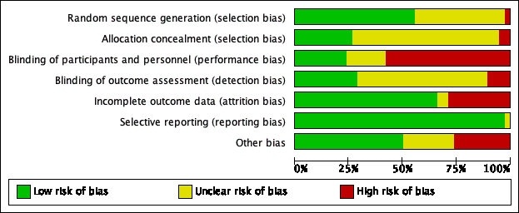

(ii) Risk of bias summary: review authors' judgments about each risk of bias item for each included study
Green cirlces with ‘+’ represents low risk of bias
Yellow circles with ‘?’ represents unclear risk of bias
Red Circles with ‘-’represents high risk of bias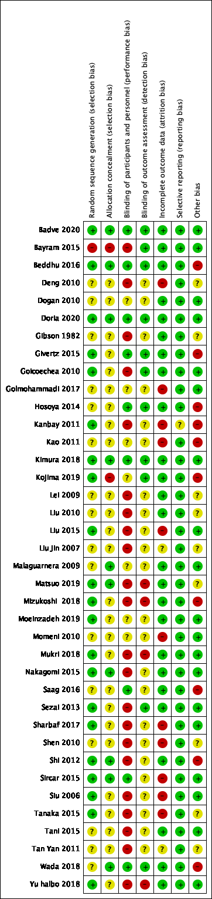

Appendix 5. Hyperuricemia and Kidney outcomes: From main analyses
Appendix 5A. HR for kidney failure in patients with hyperuricemia compared to patients with normouricemia
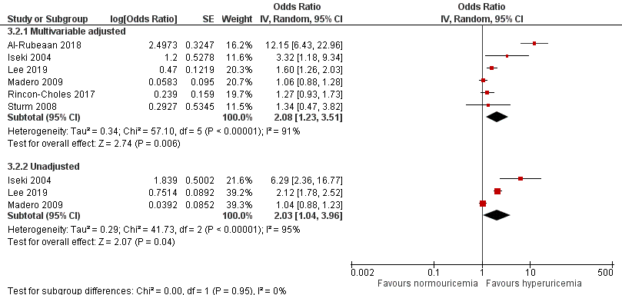

Appendix 5B. Combined HR/OR of Albuminuria for every 1 mg/dl increase in sUA
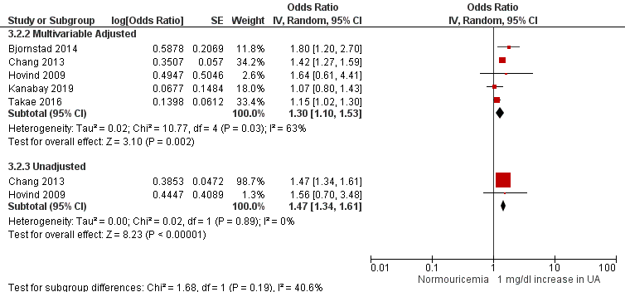

Appendix 5C. Combined OR/HR of CKD for every 1 mg/dL increase in sUA
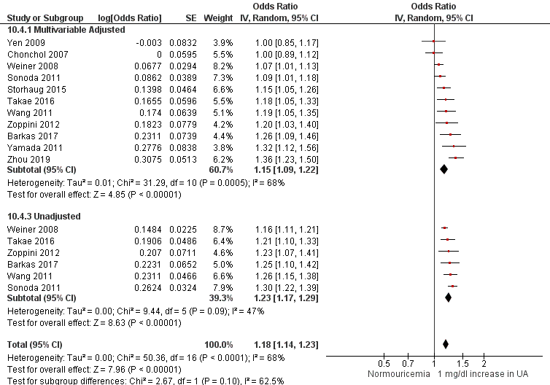

Appendix 5D. HR of kidney failure for every 1mg/dL increase in sUA
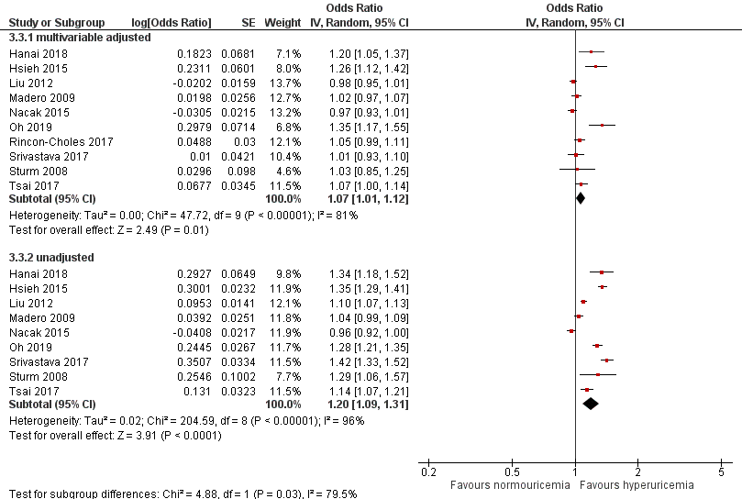

Appendix 6. Meta-analyses of cross-sectional data for question 1

Comparison | Stage 3CKD |  | Albuminuria
Comparison | Adjustment | Effect estimate (OR) | Adjustment | Effect estimate (OR)
Highest vs. Lowest UA quartile | Multivariable adjusted | 4.29, 95% CI 2.75 to 6.70; I² of 97%; n=10 | Multivariable adjusted | 2.21, 95% CI, 1.35 to 3.61; I² of 0%; n=2‡
Highest vs. lowest UA quartile | Unadjusted | 4.04, 95% CI 2.86, 5.70; I² of 96%; n=10 | Unadjusted | 1.88, 95% CI, 0.40 to 8.84; n=2‡
Hyperuricemia vs. Normouricemia§ | Age adjusted | 2.42, 95% CI 1.76 to 3.33; I² of 95%; n=10 | Multivariable adjusted | 1.30, 95% CI, 1.10 to 1.54; I² of 83%; n=7
Hyperuricemia vs. Normouricemia | Mutlivariable adjusted | 1.70, 95% CI 1.01 to 2.85, I² of 94%, n=3 | Unadjusted | 1.68, 95% CI, 0.96 to 2.94; I² of 77%; n=2
Uric Acid as continuous variable (every 1 mg/dl increase) * | Multivariable Adjusted | 1.65, 95% CI 1.37 to 1.99; I² of 86%; n=3 | Multivariable adjusted | 1.07, 95% CI, 0.69 to 1.66; n=1
Uric Acid as continuous variable (every 1mg/dl increase) | Unadjusted | 1.52, 95% CI 1.08 to 2.14; I² of 92%; n=2
Every 0.17 mg/dL increase in Uric acid | Multivariable Adjusted | 1.05, 95% CI 1.03, 1.07; n=1
Every 0.17 mg/dL increase in Uric acid | Unadjusted | 1.09, 95% CI 1.07 to 1.11; n=1
Gout vs. Non-gout† | Age and Gender Adjusted | 1.91, 95% CI 1.46, 2.50; I² of 0%; n=2
Footnotes: * for chonchol 2007 the definition of hyperuricemia was every 1mg/dL rise but for Sheikhabahei and Jolly (assumed) it was every 1SD elevation of UA; †effect estimates are hazard ratio; ‡ Sheikhabahei gave data for micro and macroalbuminuria separately while Lee 2006 gave data for men and women separately and combined; § Guo is a study with diabetes /HTN patients and Liu Z 2015 is the study with old age population

Appendix 7. GRADE evidence profile for hyperuricemia and kidney outcomes (question 1)

Appendix 8A. GRADE evidence profile; Highest Uric acid tertile/quartile/quintile vs. lowest for development of kidney function decline.
Question: Can Uric Acid in Highest Tertile/Quartile/Quintile cause kidney function decline in General Adult Population? Author(s):
Certainty assessment |  |  |  |  |  |  | № of patients |  | Effect |  | Certainty | Importance
№ of studies | Study design | Risk of bias | Inconsistency | Indirectness | Imprecision | Other considerations | uric acid in highest quintile/quartile/tertile | lowest | Relative  (95% CI) | Absolute  (95% CI) | Certainty | Importance
Albuminuria (follow up: range 1 years to 5 years; assessed with: 24 hr albumin in urine or albumin/creatinine ratio)
8 | observational studies | serious | serious ª | not serious | not serious | strong association |  |  | OR 1.94  (1.34 to 2.79) | 2 fewer per 1,000  (from 2 fewer to 1 fewer) | ⨁◯◯◯  VERY LOW | CRITICAL
Rapid Decline of eGFR (follow up: range 2.79 years to 12 years; assessed with: MDRD equation or cockcroft-gault or CKD-EPI equation)
4 | observational studies | not serious | not serious | not serious | not serious | none |  |  | OR 1.38  (1.20 to 1.59) | 1 fewer per 1,000  (from 2 fewer to 1 fewer) | ⨁⨁◯◯  LOW | CRITICAL
Chronic Kidney Disease (follow up: range 0.5 years to 25 years; assessed with: eGFR + albuminuria or hematuria)
20 | observational studies | serious ^{b} | serious ^{c} | not serious | not serious | strong association |  |  | OR 2.13  (1.74 to 2.61) | 2 fewer per 1,000  (from 3 fewer to 2 fewer) | ⨁◯◯◯  VERY LOW | CRITICAL
Kidney failure (follow up: range 4 years to 50 years; assessed with: Medical Records/ ICD codes/ Treatment)
9 | observational studies | not serious | serious ª | not serious | not serious | none |  |  | HR 1.53  (1.18 to 1.99)  [Kidney failure] | -- per 1,000  (from -- to --) | ⨁◯◯◯  VERY LOW | CRITICAL
 |  |  |  |  |  |  | - | 0.0% | HR 1.53  (1.18 to 1.99)  [Kidney failure] | -- per 1,000  (from -- to --) | ⨁◯◯◯  VERY LOW | CRITICAL
CI: Confidence interval; OR: Odds ratio; HR: Hazard Ratio
Explanations
a. May represent substantial heterogeneity with I squared of 77%
b. Chen 2014, Domrongkitchaiporn 2005, Mun 2018 have low quality of evidence.
c. May represent substantial to considerable heterogeneity with I squared of 83%.

Appendix 7B. GRADE evidence profile; Hyperuricemia vs. Normouricemia for development of CKD
Question: Can hyperuricemia cause kidney function decline in general adult population?

Certainty assessment |  |  |  |  |  |  | № of patients |  | Effect |  | Certainty | Importance
№ of studies | Study design | Risk of bias | Inconsistency | Indirectness | Imprecision | Other considerations | Hyperuricemia | normouricemia | Relative  (95% CI) | Absolute  (95% CI) | Certainty
Albuminuria (follow up: range 3 years to 18.2 years; assessed with: 24 hr albumin in urine or albumin/creatinine ratio)
2 | observational studies | not serious | serious ª | not serious | not serious | strong association |  |  | OR 3.05  (1.06 to 8.77) | 3 fewer per 1,000  (from 9 fewer to 1 fewer) | ⨁⨁◯◯  LOW | CRITICAL
Chronic Kidney Disease (follow up: range 3.5 years to 12 years; assessed with: eGFR <60mL/min/1.7m2 + albuminuria or hematuria)
6 | observational studies | not serious | serious ^{b} | not serious | not serious | none |  |  | OR 1.78  (1.50 to 2.13) | 2 fewer per 1,000  (from 2 fewer to 2 fewer) | ⨁◯◯◯  VERY LOW | CRITICAL
Kidney Failure (follow-up 4-10 years) (follow up: range 2.8 years to 18.21 years; assessed with: Medical Records/ ICD codes/ Treatment)
6 | observational studies | not serious | serious ^{c} | not serious | not serious | strong association |  | 0.0% | OR 2.08  (1.23 to 3.51) | 2 fewer per 1,000  (from 3 fewer to 1 fewer) | ⨁⨁◯◯  LOW | CRITICAL
CI: Confidence interval; OR: Odds ratio

Explanations
a. Considerable heterogeneity with I squared of 83%.
b. Considerable heterogeneity with I squared of 93%.
c. Considerable heterogeneity with I squared of 88%

Appendix 7C. GRADE evidence profile; Kidney function with continuous (1 mg/dl) increase in uric acid
Question: Can continuous increase in UA cause kidney function decline in general adult population?
Question: Increase in uric acid levels compared to stable uric acid levels for renal function decline

Certainty assessment |  |  |  |  |  |  | № of patients |  | Effect |  | Certainty | Importance
№ of studies | Study design | Risk of bias | Inconsistency | Indirectness | Imprecision | Other considerations | increase in uric acid levels | stable uric acid levels | Relative  (95% CI) | Absolute  (95% CI) | Certainty | Importance
Albuminuria (follow up: range 1.5 years to 13 years; assessed with: 24 hr albumin in urine or albumin/creatinine ratio)
4 | observational studies | serious ª | serious ^{b} | not serious | not serious | none |  |  | OR 1.30  (1.10 to 1.53) | 1 fewer per 1,000  (from 2 fewer to 1 fewer) | ⨁◯◯◯  VERY LOW | CRITICAL
Rapid Decline of eGFR (follow up: range 2.5 years to 7 years; assessed with: MDRD equation or cockcroft-gault or CKD-EPI equation)
5 | observational studies | serious ^{c} | not serious | not serious | not serious | none |  |  | OR 1.22  (1.14 to 1.30) | 1 fewer per 1,000  (from 1 fewer to 1 fewer) | ⨁◯◯◯  VERY LOW | CRITICAL
Chronic Kidney Disease (follow up: range 2.5 to 13 years; assessed with: eGFR + albuminuria or hematuria)
11 | observational studies | not serious | serious ^{d} | not serious | not serious | none |  |  | OR 1.15  (1.09 to 1.22) | 1 fewer per 1,000  (from 1 fewer to 1 fewer) | ⨁◯◯◯  VERY LOW | CRITICAL
Kidney Failure (follow up: range 2 years to 10 years; assessed with: Medical Records/ ICD codes/ Treatment)
10 | observational studies | not serious | serious ^{e} | not serious | not serious | none |  | 0.0% | OR 1.07  (1.01 to 1.12) | 1 fewer per 1,000  (from 1 fewer to 1 fewer) | ⨁◯◯◯  VERY LOW | CRITICAL
CI: Confidence interval; OR: Odds ratio

Explanations
a. Low quality of evidence for Bjornstad, P. 2014.
b. Considerable heterogeneity with I2 of 67%
c. Bjornstand 2014, Yen 2009 have low quality of evidence.
d. May have substantial heterogeneity with I squared of 63%
e. Considerable heterogeneity of I2 of 84%.

Appendix 8. ULT and kidney function: from main analyses

Appendix 8A. ULT vs. Control: 24hr Proteinuria (≥ 1 year): Subgroup analysis by drug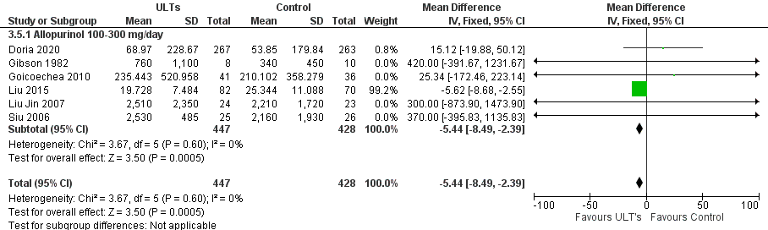

Appendix 8B. ULT vs. Control: 24hr Proteinuria (<1 year): Subgroup analysis by drug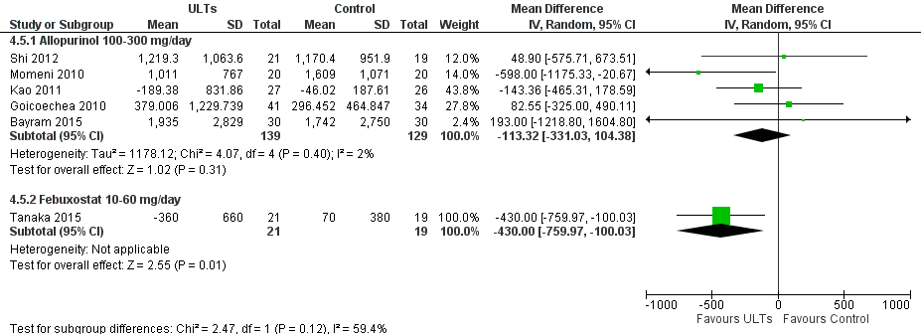

Appendix 8C. Allopurinol 100-300 mg/day vs. Febuxostat 10-80 mg/day: eGFR
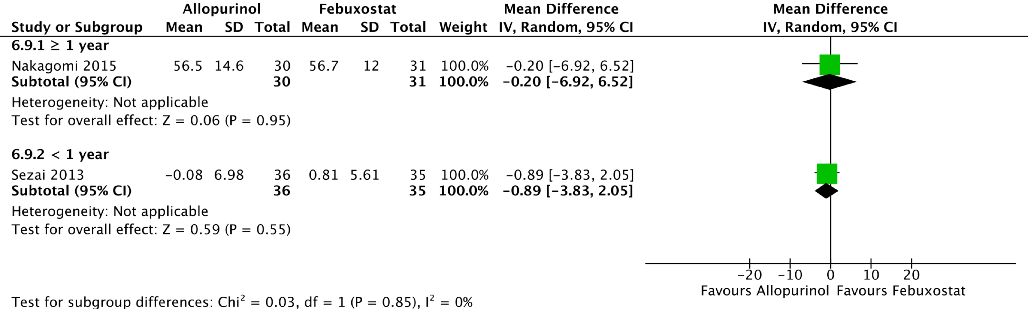

Appendix 8D. Allopurinol 100-300 mg/day vs. Febuxostat 10-80 mg/day: Serum creatinine
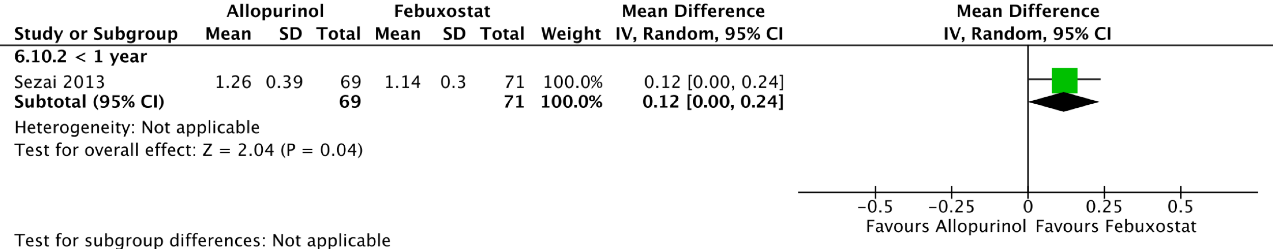

Appendix 8E. Allopurinol 100-300 mg/day vs. Febuxostat 10-80 mg/day: Albuminuria 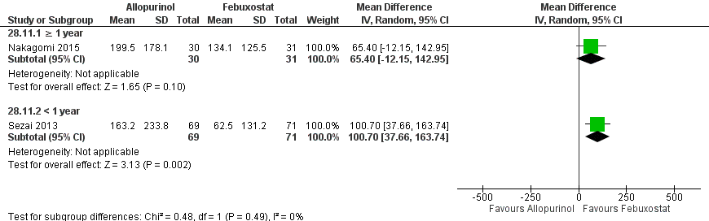

Appendix 8F. Allopurinol 100-300 mg/day vs. Control: Serum Cystatin C (mg/L)
(1). Follow up duration ≥1 year: Cystatin C levels were significant lower in allopurinol 100-300 mg/day group compared to placebo group (MD, -0.50 mg/L, 95% CI -0.78 to -0.22, n=1).
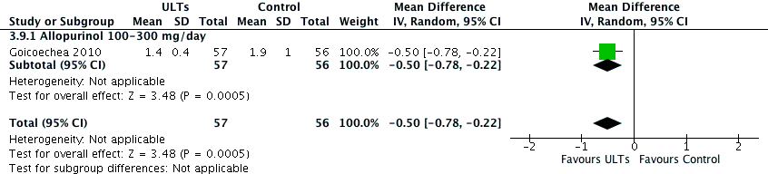

(2). Follow up duration <1 year: No significant improvement was found.
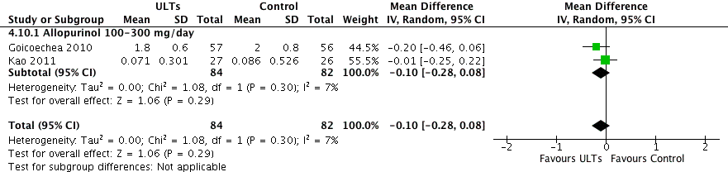

Appendix 8G. Allopurinol 100-300 mg/day vs. Febuxostat 10-80 mg/day: Serum Cystatin C

Regardless of duration, no significant difference between allopurinol and febuxostat group was found.
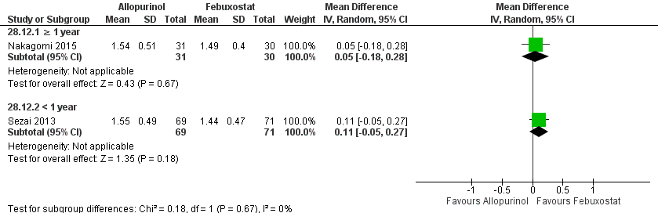

Appendix 9. ULT and kidney function: Secondary outcomes

Appendix 9A. ULT vs. Control: For uric acid levels as outcome
Significantly lower sUA levels were found in patients on ULT compared to placebo after a year or more follow up period (MD, -2.78 mg/dl, 95% CI -3.81 to -1.75, I²=100%, n=12). Similarly, for lesser follow up duration, difference was significant (MD, -2.06 mg/dl, 95% CI -2.57 to -1.55, I²=99%, n=18). 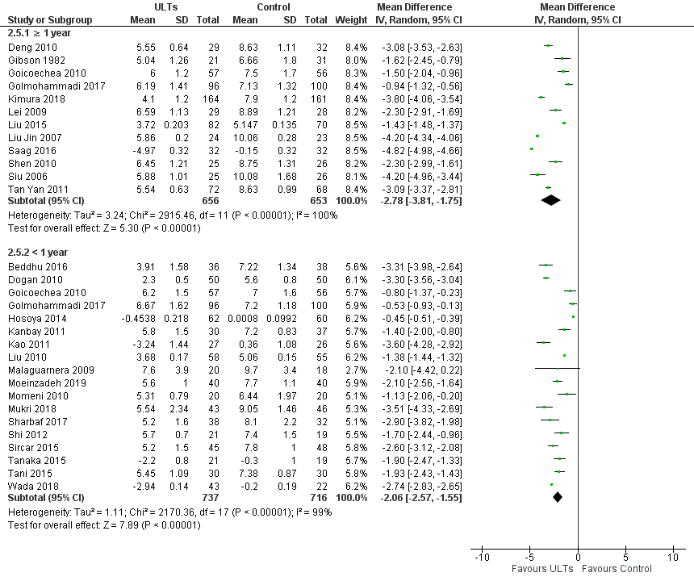

Appendix 9B. ULT vs. Control: stratified analysis by drug type and follow up duration for serum uric acid (sUA)
(1) Follow up duration: ≥1 year
Significant improved sUA levels were found in allopurinol (MD, -2.47 mg/dl, 95% CI -3.47 to -1.46, I²= 99%, n=10) and febuxostat (MD, -4.32 mg/dl, 95% CI -5.32 to -3.31, I²=98%, n=2) groups compared to placebo. Improvement of sUA levels were better with febuxostat compared to allopurinol (MD, 0.60 mg/dl, 95% CI 0.32 to 0.88, n=1).

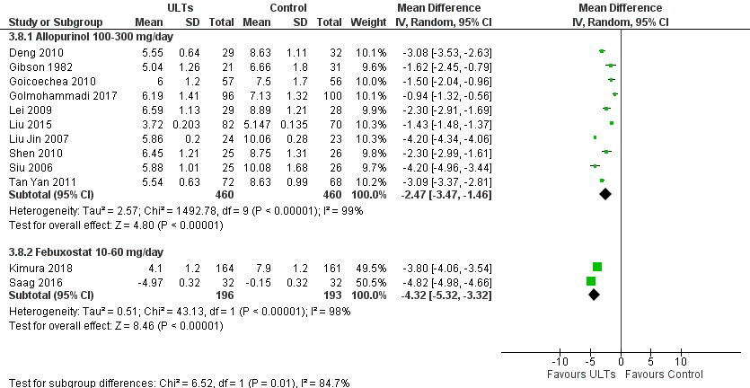

(2) Follow up Duration: <1 year
Significantly improved sUA levels were found in allopurinol 100-300 mg/day (MD, -1.75 mg/dl, 95% CI -2.48 to -1.02, I² of 91%, n=8), allopurinol 900mg/day (MD, -3.30 mg/dl, 95% CI -3.56 to -3.04, n=1), febuxostat (MD, -2.61 mg/dl, 95% CI -3.22 to -1.99, I²= 81%, n=5) compared to placebo. Where as no significant difference was found in comparisons: topiroxostat vs. placebo (MD, -1.60 mg/dl, 95% CI -3.84 to 0.64 mg/dl, I²=100%, n=2) and rasburicase 4.5 mg vs. placebo (MD, -2.10 mg/dl, 95% CI -4.42 to 0.22, n=1). 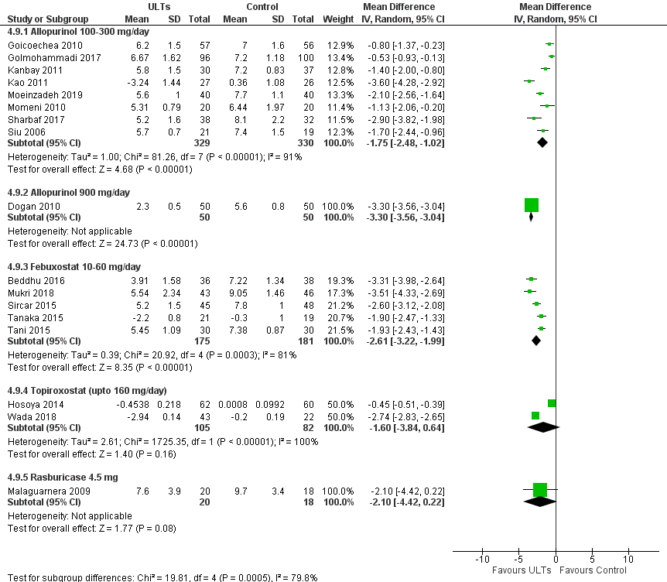

Appendix 9C. Allopurinol vs. Febuxostat: sUric Acid
Patients on febuxostat had significantly lower sUA levels compared to allopurinol group (≥1year follow up duration) (MD 0.60 mg/dl, 95% CI 0.32 to 0.88, n=1). In Sezai 2013 after 1 month of follow up uric acid in febuxostat group was lower compared to allopurinol group (no data available).

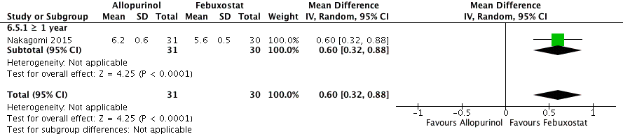

Appendix 9D. ULT vs. Control: Inflammatory markers
(1) Follow up duration: ≥ 1 year
Fibrinogen: Significantly lower fibrinogen was found in allopurinol 100-300 mg/day group compared to placebo group, (MD, -33.0 mg/dl, 95% CI -61.65 to -4.35, n=1).

(2) Follow up duration: < 1 year
C-reactive protein: No statistically significant difference was found in C reactive protein between allopurinol 100-300 mg/day and placebo group (MD, 2.63 mg/L, 95% CI -5.68 to 10.93, I² of 90%, n=2).
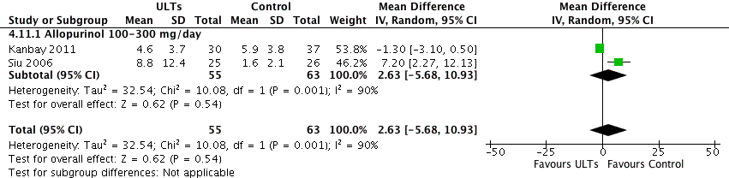

Appendix 9E. ULT vs. Control: Blood pressure
Compared to placebo significantly improved systolic Blood pressure (sBP) was found for ULT group regardless of follow up duration. Where as no significant improvement in diastolic blood pressure (dBP) was found regardless of duration.

(1) ULT vs. Control: Systolic Blood Pressure

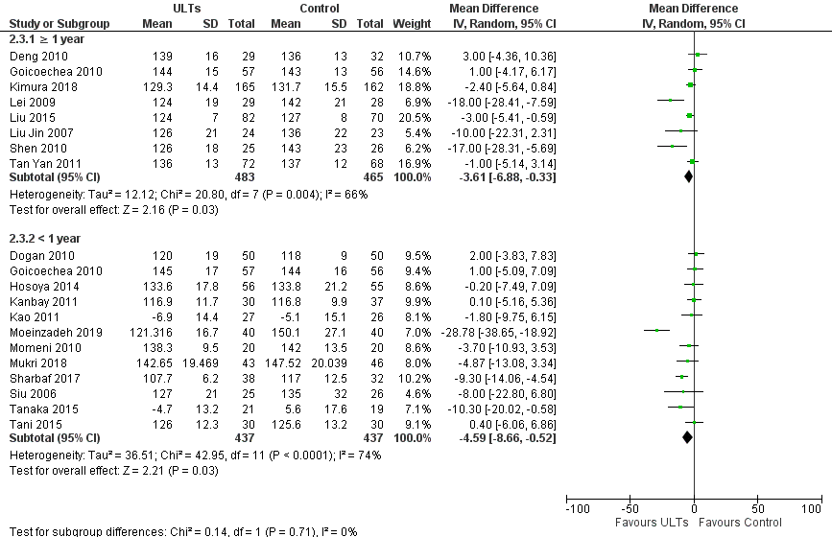

(2) ULT vs. Control: Diastolic Blood Pressure
No significant difference was found between ULT and Control for diastolic blood pressure.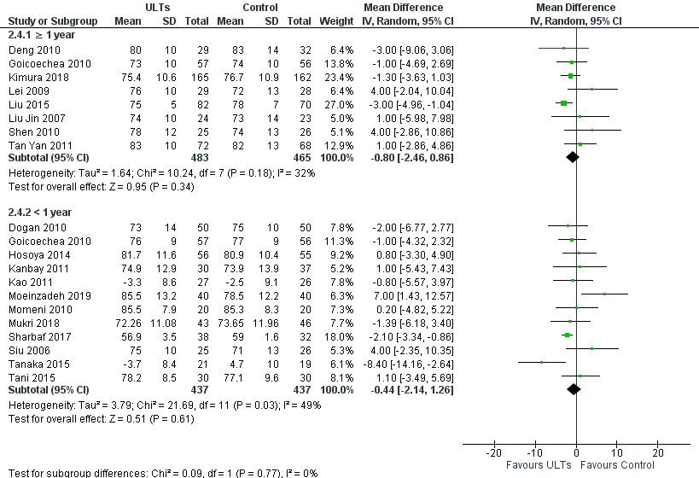

Appendix 9F. ULTs vs. Control: stratified analysis by drug type and follow up duration for sBP

(1) Follow up duration: ≥ 1 year
The sBP was improved with allopurinol compared to placebo (MD -4.33 mmHg, 95% CI -8.57 to -0.10, p=0.05, I²=71%, n=7).

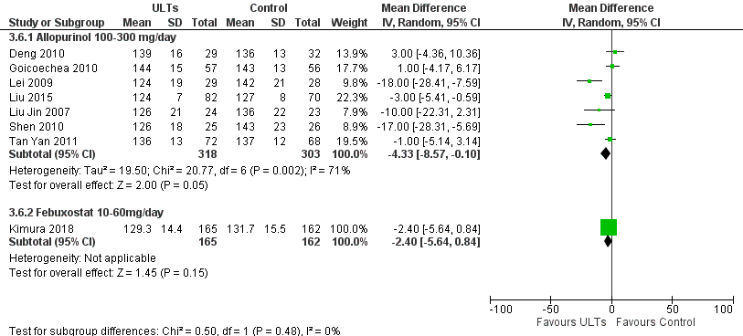

(2) Follow up duration: < 1 year
Compared to placebo significantly improve sBP was found with allopurinol (100-300 mg) (MD -6.60 mmHg 95% CI -12.95 to -0.25, I²=82%, n=7). Compared to placebo no difference was found for allopurinol 900 mg/d (MD 2.00 mmHg CI -3.83 to 7.83, n=1), febuxostat (MD -4.08 mmHg 95% CI -10.09 to 1.94, I²=41%, n=3) and topiroxostat (MD -0.20 mmHg, 95% CI -7.49 to 7.09 mmHg, n=1). 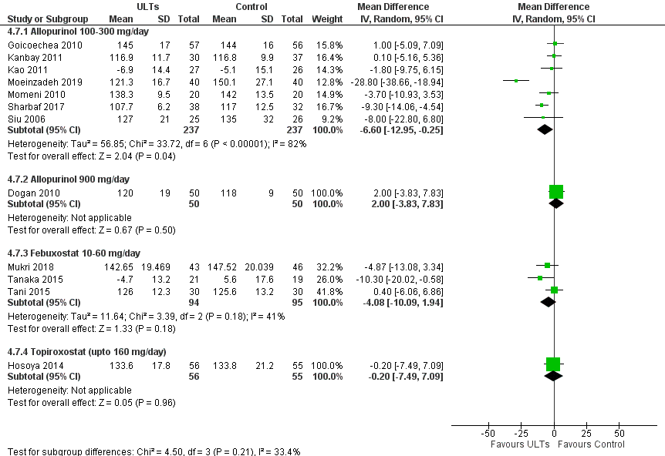

Appendix 9G. ULTs vs. Control: stratified analysis by drug type and follow up duration for dBP

(1) Follow up duration: ≥1 year
No significant difference found when Allopurinol (MD -0.38 mmHg, 95% CI -2.57 to 1.81, I² = 41%, n=7) and febuxostat (MD -1.30 mmHg, 95% CI -3.63 to 1.03, n=1) were compared to placebo for dBP.

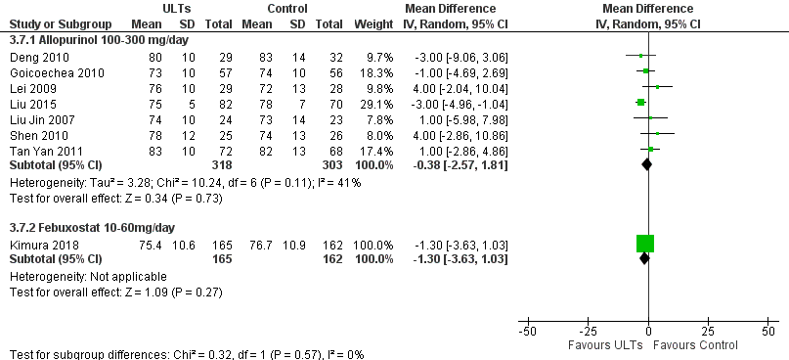

(2) Follow up duration: <1 year
Compared to placebo no significant difference was found in allopurinol 100-300 mg/day (MD 0.38 mmHg, 95% CI -1.93 to 2.70 mmHg, I²=56%, n=7), allopurinol 900 mg/day (MD -2.00 mmHg, CI -6.77 to 2.77, n=1), febuxostat (MD, -2.65 mmHg, 95% CI -7.90 to 2.60 mmHg, I² of 69%, n=3), and topiroxostat (MD, 0.80 mmHg, 95% CI -3.30 to 4.90, n=1) group.
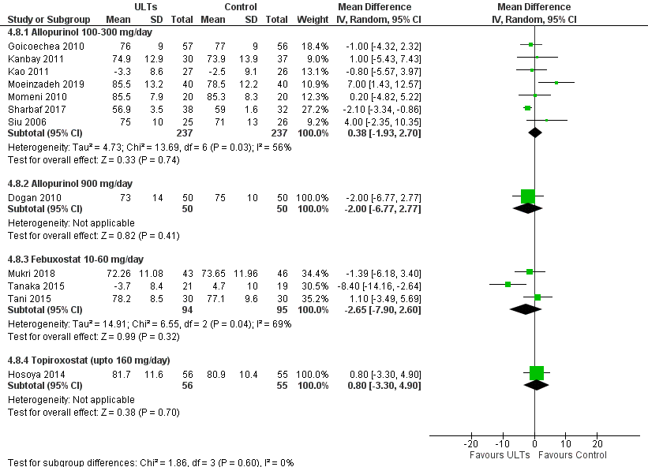

Appendix 9H. Allopurinol vs. Febuxostat
(1) Systolic Blood Pressure:
There was no significant difference in systolic blood pressure between febuxostat and allopurinol group (follow up > 1 year) (MD, 1.00 mmHg, 95% CI -3.78 to 5.78, n=1] and < 1 year [MD, -5.82 mmHg, 95% CI-13.03 to 1.39, n=1]
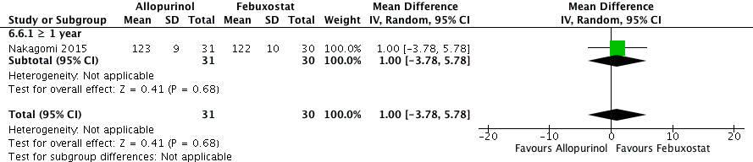

(2) Diastolic Blood Pressure
Sezai 2013 found no statistically significant difference between both groups, but patients on febuxostat had more improved blood pressure compared to allopurinol group.

Appendix 9I. ULTs vs. Control: Mean Arterial Pressure
(1) Follow up duration: <1 year
There was significant difference between patients on allopurinol 100 -300 mg/day vs.placebo (MD, -10.10 mmHg 95% CI -12.77 to 7.43, n=1)

Appendix 9J. Adverse Events
Analyses of overall adverse events showed no significant differences between ULT and Control (RR 1.05, 95% CI 0.93 to1.18, p=0.47) for ≥1 year follow up duration. Similar results were found with <1 year follow up duration.
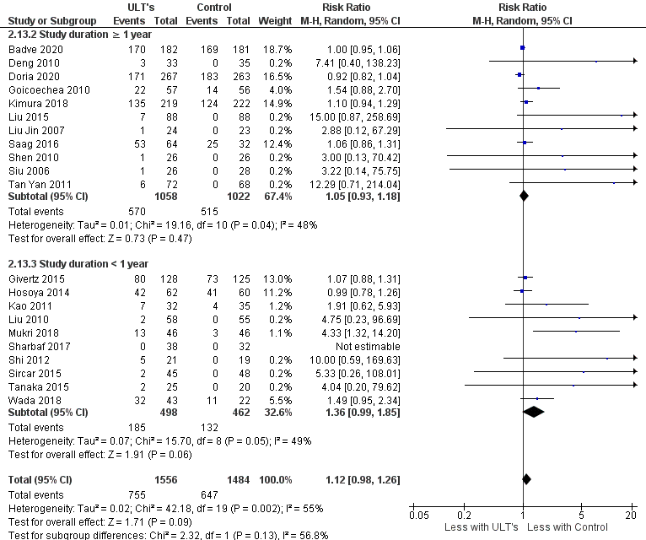

Appendix 9K. Deaths

There was no significant difference between deaths in ULT and Control group with follow up ≥ 1 year and < 1 year.
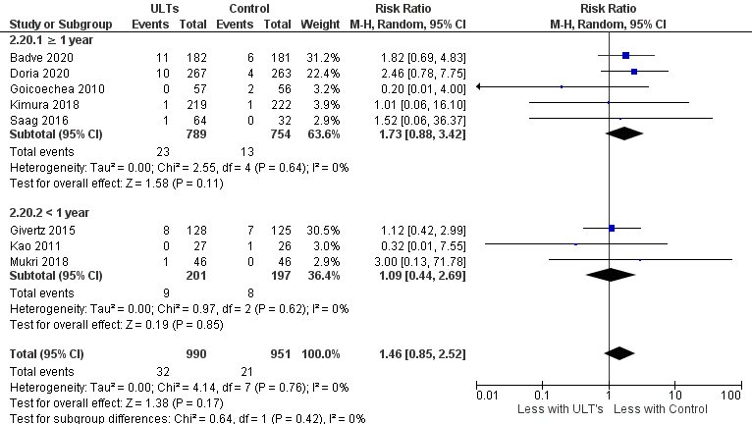

Appendix 10. Summary of findings for Urate lowering therapy and kidney function

Appendix 10A. All ULTs vs. Control
Summary of findings:
ULTs compared to Control (placebo, no treatment or usual care) for Improving kidney function
Patient or population: Improving kidney function
Setting: Hospital
Intervention: ULTs
Comparison: Control (placebo, no treatment or usual care)
Outcomes | Anticipated absolute effects* (95% CI) |  | Relative effect  (95% CI) | № of participants  (studies) | Certainty of the evidence  (GRADE) | Comments
Outcomes | Risk with Control (placebo, no treatment or usual care) | Risk with ULTs
Estimated Glomerular filtration rate. Follow up > 1 year. (eGFR)  assessed with: MDRD or CKD EPI equation or Cockcroft - Gault formula.  follow up: mean >1 years | The mean estimated Glomerular filtration rate. Follow up > 1 year. ranged from 35-91 mL/min/1.73m2 | MD 1.81 mL/min/1.73m2 higher  (0.26 higher to 3.35 higher) | - | 1782  (8 RCTs) | ⨁◯◯◯  VERY LOW ^{a,b,c}
Estimated Glomerular Filtration Rate (eGFR)  assessed with: MDRD or CKD EPI or Cockrcroft-Gault formula  follow up: mean <1 years | The mean estimated Glomerular Filtration Rate ranged from 25-85 mL/min/1.73m2 | MD 1.43 mL/min/1.73m2 higher  (0.67 lower to 3.53 higher) | - | 1743  (16 RCTs) | ⨁◯◯◯  VERY LOW ^{d,e,f}
Serum Creatinine  assessed with: Lab test  follow up: mean >1 years | The mean serum Creatinine ranged from 0.8 to 4.6 mg/dL | MD 0.33 mg/dL lower  (0.47 lower to 0.19 lower) | - | 1194  (11 RCTs) | ⨁⨁◯◯  LOW ^{g,h}
Serum Creatinine  assessed with: Lab test or Medical records  follow up: mean <1 years | The mean serum Creatinine ranged from 0-2.7 mg/dL | MD 0.01 mg/dL lower  (0.07 lower to 0.04 higher) | - | 576  (7 RCTs) | ⨁⨁◯◯  LOW ^{i,j}
Proteinuria (P)/Albuminuria(A)  assessed with: 24 hr urine P or A, urine P or A by creatinine ratio  follow up: mean >1 years | The mean proteinuria (P)/Albuminuria(A) ranged from 25 to 2210 mg/day | MD 5.44 mg/day lower  (8.49 lower to 2.39 lower) | - | 875  (6 RCTs) | ⨁⨁◯◯  LOW ^{k,l}
Proteinuria (P)/Albuminuria(A)  assessed with: 24 hr urine P or A, urine P or A by creatinine ratio  follow up: mean <1 years | The mean proteinuria (P)/Albuminuria(A) ranged from 70 to 1742 mg/day | MD 201.12 mg/day lower  (418.98 lower to 16.73 higher) | - | 308  (6 RCTs) | ⨁⨁◯◯  LOW ^{f,m}
Renal failure  assessed with: Number of patients having doubling of creatinine or fall in eGFR by >50% or ESRD (eGFR < 15ml/ min/1.73m2) or requiring dialysis | 146 per 1,000 | 89 per 1,000  (50 to 163) | RR 0.61  (0.34 to 1.12) | 1293  (8 RCTs) | ⨁◯◯◯  VERY LOW ^{b,f,n}
*The risk in the intervention group (and its 95% confidence interval) is based on the assumed risk in the comparison group and the relative effect of the intervention (and its 95% CI).
CI: Confidence interval; MD: Mean difference; RR: Risk ratio
GRADE Working Group grades of evidence
High certainty: We are very confident that the true effect lies close to that of the estimate of the effect
Moderate certainty: We are moderately confident in the effect estimate: The true effect is likely to be close to the estimate of the effect, but there is a possibility that it is substantially different
Low certainty: Our confidence in the effect estimate is limited: The true effect may be substantially different from the estimate of the effect
Very low certainty: We have very little confidence in the effect estimate: The true effect is likely to be substantially different from the estimate of effect

Explanations
a. Gibson 1982 & Liu 2015 had a high risk of bias in blinding of participants. Golmohammadi 2017 has high risk of attrition bias. Saag 2016 had high risk of other bias (pharmaceutical support).
b. Substantial heterogeneity, resulting downgrade due to significant inconsistency.
c. Wide confidence interval, if lower end of CI is true the outcome is clinically not significant. Hence it is downgraded.
d. Bayram 2015 had high risk of bias in randomisation, allocation concealment and blinding of participants and personnel. Kanabay 2011, Kao 2011, Shi 2012, Shabraf 2018 and Golmohammadi 2017 had attrition bias. Shi 2012, Tanaka 2015 and Tani 2015 had a high risk of bias in blinding of participants. Kanabay 2011, Kao 2011, Shi 2012 had high risk of other bias.
e. Heterogeneity is 85%, which is considerable and hence result is inconsistent.
f. 95% confidence interval includes no effect and the upper or lower confidence limit crosses the minimal important difference (MID).
g. Included studies have high risk of performance bias and attrition bias.
h. Heterogeneity is 92%, hence downgraded for severe inconsistency.
i. Liu 2010, Momeni 2010, Tani 2015 had an unclear risk of random sequence generation and allocation concealment. Mukiri 2018 had high risk of performance and detection bias. Momeni 2010, Tanaka 2015 and Golmohammadi 2017 had high risk of attrition bias.
j. 95% confidence interval includes no effect and the upper or lower confidence limit crosses the minimal important difference (MID).
k. Liu 2010, Liu Jin 2007 & Siu 2006 had high risk of bias in blinding of participants. Siu 2006 had a high risk of attrition bias. One study contributed to majority of outcome.
l. Effect size is not clinically significant and confidence interval fails to exclude important benefits of ULT for proteinuria.
m. Bayram 2015 had high risk of bias in randomisation, allocation concealment and blinding of participants and personnel. Kao 2011 , Momeni 2010 and Tanaka 2015 had high risk of attrition bias. Kao 2011 had high risk of other bias.
n. All studies have high risk of performance bias. Shen 2010, Deng 2010 and Siu 2006 have high attrition bias risk.

m.

Appendix 10B. Allopurinol 100-300 mg/day vs. Control
Summary of findings:
Allopurinol 100-300 mg/day compared to Control (placebo, no treatment or usual care) for improvement of renal function
Patient or population: improvement of renal function
Setting:
Intervention: Allopurinol 100-300 mg/day
Comparison: Control (placebo, no treatment or usual care)
Outcomes | Anticipated absolute effects* (95% CI) |  | Relative effect  (95% CI) | № of participants  (studies) | Certainty of the evidence  (GRADE) | Comments
Outcomes | Risk with Control (placebo, no treatment or usual care) | Risk with Allopurinol 100-300 mg/day
Estimate Glomerular Filteration rate (eGFR )  assessed with: MDRD or CKD EPI equation or Cockcroft - Gault formula.  follow up: mean >1 years | The mean estimate Glomerular Filteration rate ranged from 35-91 mL/min/1.73m2 | MD 2.1 mL/min/1.73m2 higher  (0.47 lower to 4.67 higher) | - | 1393  (6 RCTs) | ⨁◯◯◯  VERY LOW ^{a,b,c}
Estimated Glomerular Filteration Rate (eGFR)  assessed with: MDRD or CKD EPI equation or Cockcroft - Gault formula.  follow up: mean <1 years | The mean estimated Glomerular Filteration Rate ranged from 35-85 mL/min/1.73m2 | MD 2.68 mL/min/1.73m2 higher  (0.17 higher to 5.2 higher) | - | 1194  (9 RCTs) | ⨁◯◯◯  VERY LOW ^{d,e,f}
Serum Creatinine  assessed with: Lab test  follow up: mean >1 years | The mean serum Creatinine ranged from 0.8 to 46 mg/dL | MD 0.61 mg/dL lower  (0.91 lower to 0.32 lower) | - | 805  (9 RCTs) | ⨁⨁◯◯  LOW ^{g,h}
Serum Creatinine  assessed with: Lab test  follow up: mean <1 years | The mean serum Creatinine ranged from 1.5 to 2 mg/dL | MD 0.06 mg/dL lower  (0.25 lower to 0.13 higher) | - | 236  (2 RCTs) | ⨁⨁◯◯  LOW ^{c,i}
Proteinuria (P)/Albuminuria(A)  assessed with: 24 hr urine P or A, urine P or A by creatinine ratio.  follow up: mean >1 years | The mean proteinuria (P)/Albuminuria(A) was 25 to 2210 mg/day | MD 5.44 mg/day lower  (8.49 lower to 2.39 lower) | - | 875  (6 RCTs) | ⨁⨁◯◯  LOW ^{j,k}
Proteinuria (P)/Albuminuria(A)  assessed with: 24 hr urine P or A, urine P or A by creatinine ratio.  follow up: mean <1 years | The mean proteinuria (P)/Albuminuria(A) ranged from -46 to 1750 mg/day | MD 113.32 mg/day lower  (331.03 lower to 104.38 higher) | - | 268  (5 RCTs) | ⨁⨁◯◯  LOW ^{c,l}
Renal failure  assessed with: Number of patients having doubling of creatinine or fall in eGFR by > 50% or ESRD (eGFR < 15ml/ min/1.73m2) or requiring dialysis  follow up: mean >1 years | 146 per 1,000 | 89 per 1,000  (50 to 163) | RR 0.61  (0.34 to 1.12) | 1293  (8 RCTs) | ⨁⨁◯◯  LOW ^{c,m}
*The risk in the intervention group (and its 95% confidence interval) is based on the assumed risk in the comparison group and the relative effect of the intervention (and its 95% CI).
CI: Confidence interval; MD: Mean difference; RR: Risk ratio
GRADE Working Group grades of evidence
High certainty: We are very confident that the true effect lies close to that of the estimate of the effect
Moderate certainty: We are moderately confident in the effect estimate: The true effect is likely to be close to the estimate of the effect, but there is a possibility that it is substantially different
Low certainty: Our confidence in the effect estimate is limited: The true effect may be substantially different from the estimate of the effect
Very low certainty: We have very little confidence in the effect estimate: The true effect is likely to be substantially different from the estimate of effect

Explanations
a. Gibson 1982, Goicoechea 2010 and Liu 2015 had high risk of bias in blinding of participants. Liu 2015 and Golmohammadi 2017 had high risk of attrition bias.
b. Moderate heterogeneity was found.
c. 95% Confidence interval crossed the midpoint (or line of no effect)
d. Bayram 2015 had high risk of bias with randomization, allocation concealment and blinding of patients. Goiocechea 2010, Shi 2012, Kanbay 2011 and Sharbaf 2017 had high risk of bias in blinding of patients. Kanbay 2011, Kao 2011 had high risk of attrition and other bias while Shi 2011, Golmohammadi 2017 and Sharbaf 2017 had high risk of attrition bias.
e. Have high heterogeneity with I2 of 61%.
f. Wide confidence interval, if lower end of CI is true the outcome will no more clinically significant. Hence one level downgrade is indicated.
g. All studies were found to have high risk of bias with blinding of participants except Golmohammadi 2017. Attrition bias was significant in Deng 2010, Golmohammadi 2017, Shen 2010, Siu 2006.
h. High heterogeneity with I2 of 94% was found.
i. High risk of attrition bias in both studies was found.
j. All studies have high risk of performance bias (blinding of participants and personnel). Liu 2015 and Siu 2006 have high attrition bias.
k. Effect size is not clinically significant and confidence interval fails to exclude important benefits of allopurinol for proteinuria.
l. Bayram 2015 had high risk of bias in random sequence generation, allocation concealment and blinding of participants. Kao 2011 & Momeni 2010 had high risk of attrition bias. Kao 2011 had high risk of other bias.
m. Deng 2010, Liu Jin 2007, Shen 2010, Tan yan 2011 and Siu 2006 had high risk of bias in blinding of patients. Deng 2010 and Siu 2006 had high risk of attrition bias.

.

Appendix 10C: Febuxostat 10-60 mg/d vs Control
Summary of findings:
Febuxostat 10-60 mg/day compared to Control (placebo, no treatment or usual care) for improvement of kidney function
Patient or population: improvement of kidney function
Setting:
Intervention: Febuxostat 10-60 mg/day
Comparison: Control (placebo, no treatment or usual care)
Outcomes | Anticipated absolute effects* (95% CI) |  | Relative effect  (95% CI) | № of participants  (studies) | Certainty of the evidence  (GRADE) | Comments
Outcomes | Risk with Control (placebo, no treatment or usual care) | Risk with Febuxostat 10-60 mg/day
Estimated Glomerular Filteration Rate (eGFR)  assessed with: MDRD or CKD EPI equation or Cockcroft Gault Formula.  follow up: mean >1 years | The mean estimated Glomerular Filteration Rate was 44.2 mL/min/1.73m2 | MD 2.32 mL/min/1.73m2 higher  (1.75 higher to 2.89 higher) | - | 389  (2 RCTs) | ⨁⨁⨁◯  MODERATE ª
Estimated Glomerular Filteration Rate (eGFR)  assessed with: MDRD or CKD EPI equation or Cockcroft Gault Formula  follow up: mean <1 years | The mean estimated Glomerular Filteration Rate ranged from 27-62 mL/min/1.73m2 | 0.4 mL/min/1.73m2 higher  (2.18 lower to 2.97 higher) | - | 362  (5 RCTs) | ⨁⨁◯◯  LOW ^{b,c}
Serum Creatinine  assessed with: Lab Test  follow up: mean >1 years | The mean serum Creatinine ranged from 0.19 to 1.32 mg/dL | MD 0.09 mg/dL lower  (0.14 lower to 0.04 lower) | - | 389  (2 RCTs) | ⨁⨁⨁◯  MODERATE ª
Serum Creatinine  assessed with: Lab test  follow up: mean <1 years | The mean serum Creatinine ranged from 19046 mg/dL | MD 0.01 mg/dL higher  (0.06 lower to 0.08 higher) | - | 189  (3 RCTs) | ⨁⨁◯◯  LOW ^{c,d}
Proteinuria (P)/Albuminuria(A)  assessed with: 24 hr urine P or A, urine P or A by creatinine ratio  follow up: mean <1 years | The mean proteinuria (P)/Albuminuria(A) was 40 mg/day | MD 430 mg/day lower  (759.97 lower to 100.03 lower) | - | 40  (1 RCT) | ⨁⨁◯◯  LOW ^{e,f}
Renal failure  assessed with: Number of patients having doubling of creatinine or fall in eGFR by > 50% or ESRD (eGFR < 15ml/ min/1.73m2) or requiring dialysis  follow up: mean <1 years | 83 per 1,000 | 133 per 1,000  (40 to 442) | RR 1.60  (0.48 to 5.30) | 93  (1 RCT) | ⨁⨁◯◯  LOW ^{g,h}
*The risk in the intervention group (and its 95% confidence interval) is based on the assumed risk in the comparison group and the relative effect of the intervention (and its 95% CI).
CI: Confidence interval; MD: Mean difference; RR: Risk ratio
GRADE Working Group grades of evidence
High certainty: We are very confident that the true effect lies close to that of the estimate of the effect
Moderate certainty: We are moderately confident in the effect estimate: The true effect is likely to be close to the estimate of the effect, but there is a possibility that it is substantially different
Low certainty: Our confidence in the effect estimate is limited: The true effect may be substantially different from the estimate of the effect
Very low certainty: We have very little confidence in the effect estimate: The true effect is likely to be substantially different from the estimate of effect

Explanations
a. Saag 2016 had high risk of other bias (sponsored by pharmaceutical company), had unclear risk in randomization, allocation concealment and blinding of outcomes.
b. Tanaka 2015 & Tani 2015 had high risk performance bias. Sircar 2015 and Tanaka 2015 had high risk of attrition bias. Mukri has high risk of both performance and detection bias.
c. 95% confidence interval crosses midpoint or line of no effect
d. Tanaka 2015 & Tani 2015 had high risk performance bias. Tanaka 2015 had high risk of attrition bias. Mukri 2018 has high risk of both performance and detection bias.
e. Tanaka 2015 had a high risk of bias in the blinding of patients and high risk of attrition bias. Suboptimal information size : Only one study with low numbers
f. only one trial, with 40 participants. Does not meet optimum information size criteria
g. Sircar 2015 have high risk of attrition bias and unknown risk of detection bias.
h. Small sample size, single trial, CI include no effect.

Appendix 10D: Allopurinol 300 mg/d vs Febuxostat 10-80 mg/d
 | Allopurinol vs Febuxostat for hyperuricemia and improving kidney function
Patient or population: improving kidney function, Setting: Hospita/Community
Intervention: Allopurinol, Comparison: Febuxostat
Outcomes |  | Anticipated absolute effects* (95% CI) |  | Relative effect  (95% CI) | № of participants  (studies) | Certainty of the evidence  (GRADE) | Comments
 |  | Risk with Febuxostat | Risk with Allopurinol
Estimated Glomerular filtration rate  assessed with: MDRD or CKD EPI equation or Cockcroft Gault formula. Follow up > 1 year |  | The mean eGFR - ≥ 1 year was 56.5 to 56.7 ml/min/1.73m2 (actual value or difference) | The mean eGFR - ≥ 1 year in the intervention group was 0.2 ml/min/1.73m2 lower (6.92 lower to 6.52 higher) | - | 61  (1 RCT) | ⨁⨁◯◯  LOW ^{a,b,c}
Estimated Glomerular Filtration rate  assessed with: MDRD or CKD EPI equation or Cockcroft Gault Formula. Follow up < 1 year |  | The mean eGFR - < 1 year was -0.08 to 0.81 ml/min/1.73m2 (actual value or difference) | The mean eGFR - < 1 year in the intervention group was 0.89 ml/min/1.73m2 lower (3.83 lower to 2.05 higher) | - | 71  (1 RCT) | ⨁⨁◯◯  LOW ^{b,c,d}
Serum creatinine  assessed with: Lab tests/Medical records. Follow up < 1 year |  | The mean serum Creatinine - < 1 year was 1.14 - 1.26 mg/dl (actual value or difference) | The mean serum Creatinine - < 1 year in the intervention group was 0.12 mg/dl higher (0 to 0.24 higher) | - | 140  (1 RCT) | ⨁⨁◯◯  LOW ^{b,c,d}
Proteinuria (P)/Albuminuria (A)  assessed with: 24 hr urine P or A, urine P or A by creatinine ratio. Follow up > 1 year |  | The mean albuminruria mg/day - ≥ 1 year was 125.5 -199.5 mg/day (actual value or difference) | The mean albuminruria mg/day - ≥ 1 year in the intervention group was 65.4 mg/day higher (12.15 lower to 142.95 higher) | - | 61  (1 RCT) | ⨁⨁◯◯  LOW ^{a,b,c}
Proteinuria (P)/Albuminuria (A)  assessed with: 24 hr urine P or A, urine P or A by creatinine ratio. Follow up < 1 year |  | The mean albuminruria mg/day - < 1 year was 131.2 - 163.2 mg/day (actual value or difference) | The mean albuminruria mg/day - < 1 year in the intervention group was 100.7 mg/day higher (37.66 higher to 163.74 higher) | - | 140  (1 RCT) | ⨁⨁◯◯  LOW ^{b,d}
*The risk in the intervention group (and its 95% confidence interval) is based on the assumed risk in the comparison group and the relative effect of the intervention (and its 95% CI). CI: Confidence interval; MD: Mean difference
GRADE Working Group grades of evidence
High certainty: We are very confident that the true effect lies close to that of the estimate of the effect
Moderate certainty: We are moderately confident in the effect estimate: The true effect is likely to be close to the estimate of the effect, but there is a possibility that it is substantially different
Low certainty: Our confidence in the effect estimate is limited: The true effect may be substantially different from the estimate of the effect
Very low certainty: We have very little confidence in the effect estimate: The true effect is likely to be substantially different from the estimate of effect
a. Nakagomi 2015 had high risk of bias in blinding of participants.
b. Only one study. Suboptimal information size.
c. 95% confidence interval crosses midline or line of no effect.
d. Sezai 2013 had a high risk of bias in blinding of participants

Appendix 11. Assessment of publication bias

Appendix 11A. Funnel plots

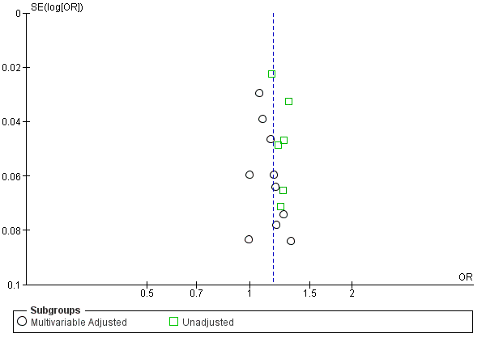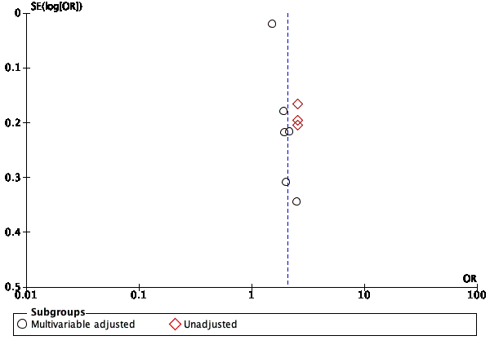
1. CKD- UA as continuous variable 2. CKD- Hyperuricemia vs. Normouricemia

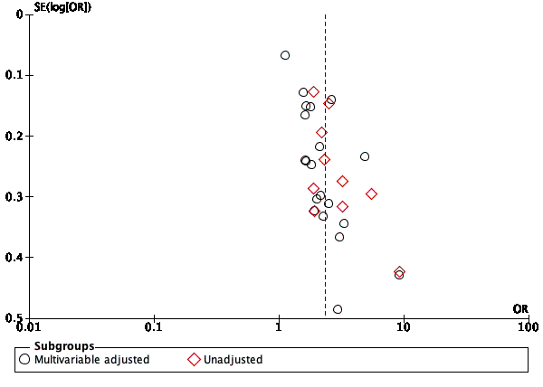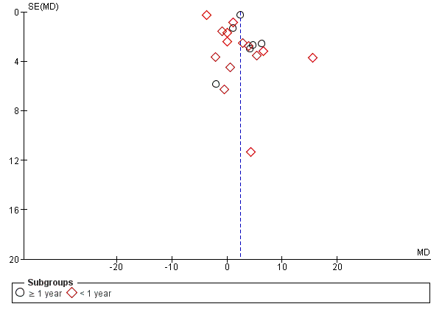
3. CKD- UA tertiles 4. ULTs vs. Control: eGFR

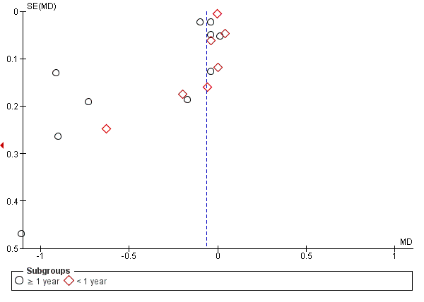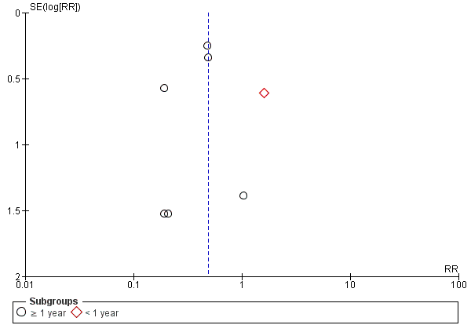
5. ULTs vs. Control: Serum Creatinine 6. ULTs vs Control : Kidney Failure

Appendix 11B. Egger’s test for CKD as outcome for comparisons: 1. Highest vs. lowest tertile and 2. Every 1 mg/dL increase in uric acid

1.For comparison between highest uric acid tertile vs. lowest uric acid tertile
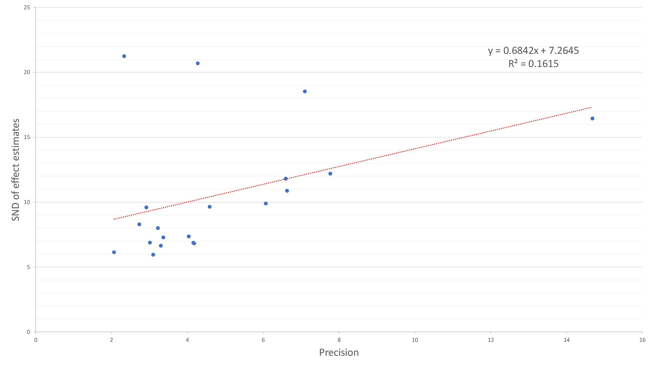

2. For comparison between ULT vs control for serum creatinine


