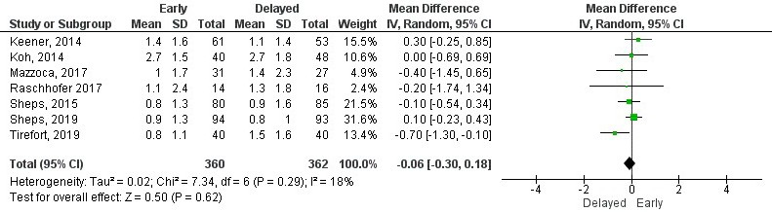
S5 File. Forest plots.
Supplementary file 5.1. Forest plot of pain intensity at six months by visual analogue scale.
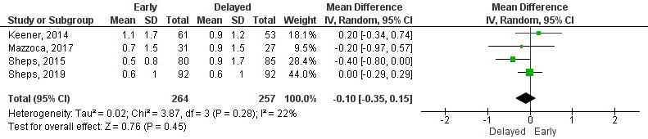
Supplementary file 5.2. Forest plot of pain intensity at one year by visual analogue scale.
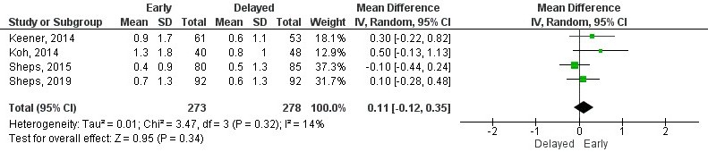
Supplementary file 5.3. Forest plot of pain intensity at two years by visual analogue scale.
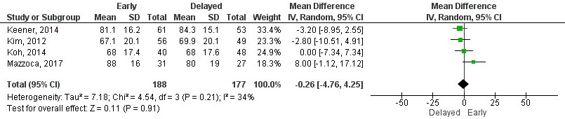
Supplementary file 5.4. Forest plot of function at six months by American Shoulder and Elbow Surgery score.
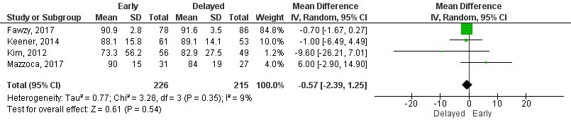
Supplementary file 5.5. Forest plot of function at one year by American Shoulder and Elbow Surgery score.
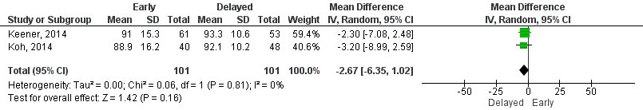
Supplementary file 5.6. Forest plot of function at two years by American Shoulder and Elbow Surgery score.
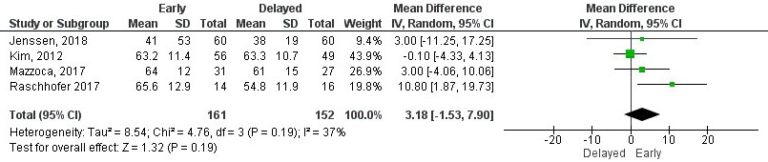
Supplementary file 5.7. Forest plot of function at three months years by Constant-Murley score.
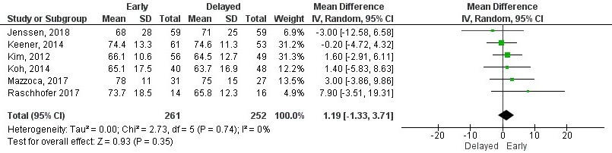
Supplementary file 5.8. Forest plot of function at six months by Constant-Murley score.
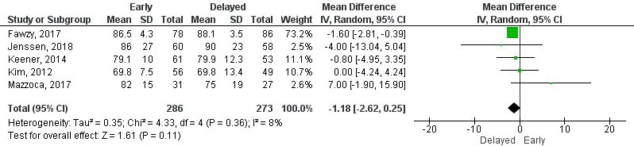
Supplementary file 5.9. Forest plot of function at one year by Constant-Murley score.
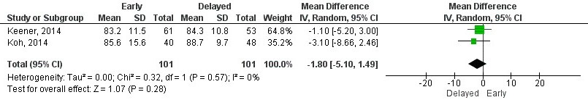
Supplementary file 5.10. Forest plot of function at two years by Constant-Murley score.
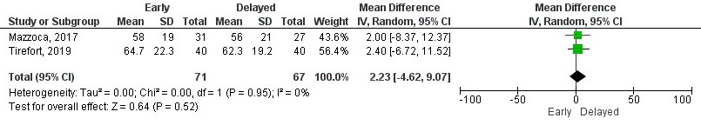
Supplementary file 5.11. Forest plot of function at three months by Single Assessment Numeric Evaluation.
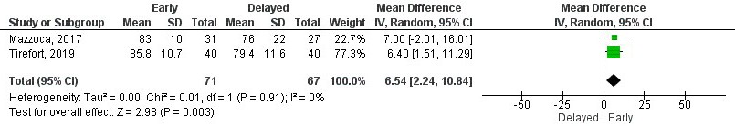
Supplementary file 5.12. Forest plot of function at six months by Single Assessment Numeric Evaluation.
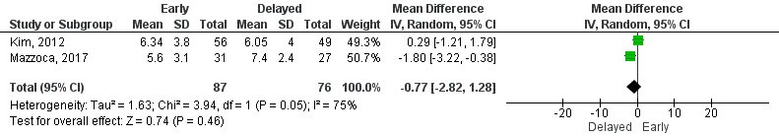
Supplementary file 5.13. Forest plot of function at three months by Simple Shoulder Test.
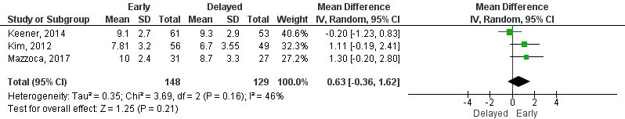
Supplementary file 5.14. Forest plot of function at six months by Simple Shoulder Test.
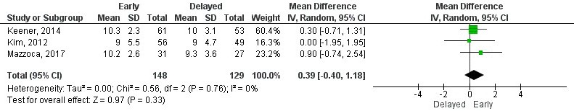
Supplementary file 5.15. Forest plot of function at one year by Simple Shoulder Test.
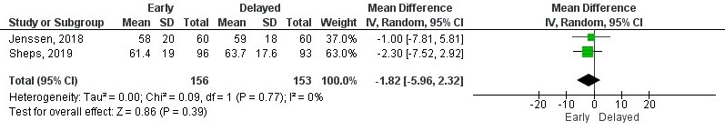
Supplementary file 5.16. Forest plot of function at three months by Western Ontario Rotator Cuff Index.
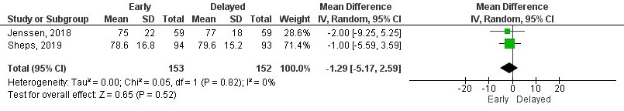
Supplementary file 5.17. Forest plot of function at six months by Western Ontario Rotator Cuff Index.
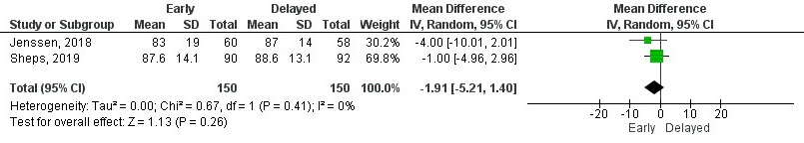
Supplementary file 5.18. Forest plot of function at one year by Western Ontario Rotator Cuff Index.
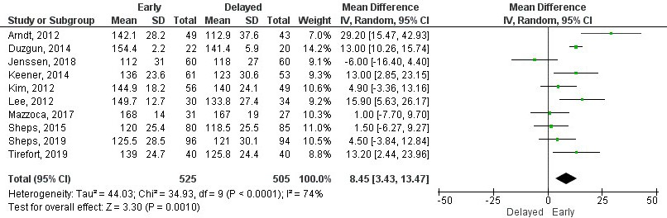
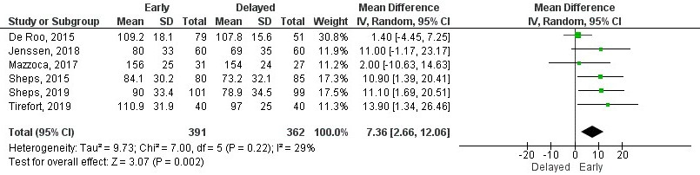
Supplementary file 5.19. Forest plot of range of movement for shoulder flexion at six weeks.
Supplementary file 5.20. Forest plot of range of movement for shoulder flexion at three months.

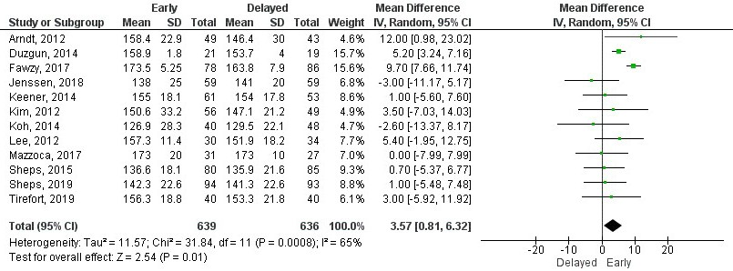
Supplementary file 5.21. Forest plot of range of movement for shoulder flexion at six months.
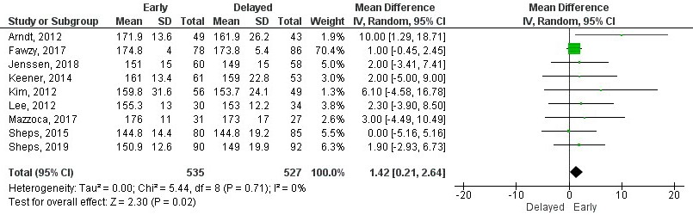

Supplementary file 5.22. Forest plot of range of movement for shoulder flexion at one year.

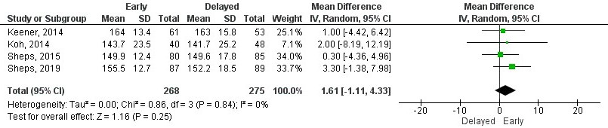
Supplementary file 5.23. Forest plot of range of movement for shoulder flexion at two years.

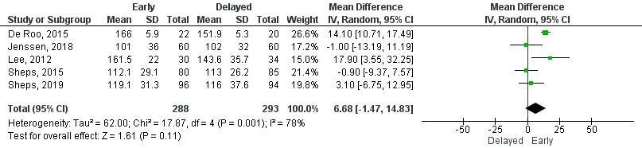
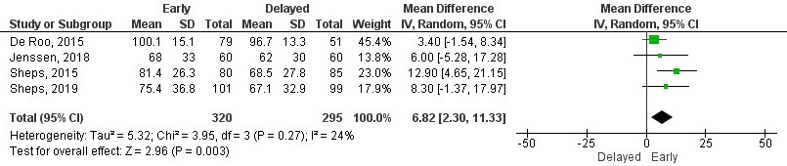
Supplementary file 5.24. Forest plot of range of movement for shoulder abduction at six weeks.
Supplementary file 5.25. Forest plot of range of movement for shoulder abduction at three months.

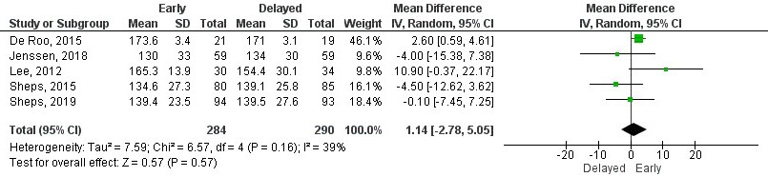
Supplementary file 5.26. Forest plot of range of movement for shoulder abduction at six months.
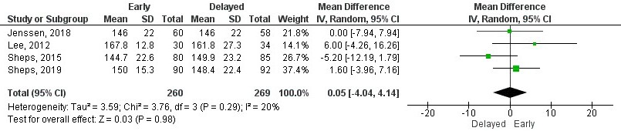
Supplementary file 5.27. Forest plot of range of movement for shoulder abduction at one year.

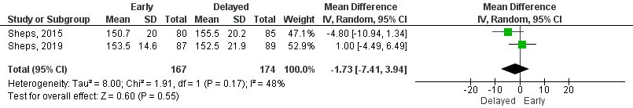
Supplementary file 5.28. Forest plot of range of movement for shoulder abduction at two years.
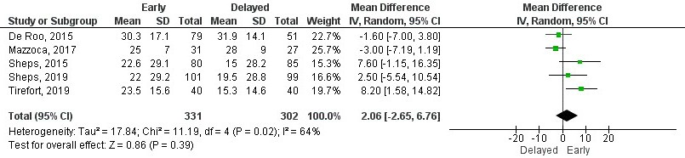
Supplementary file 5.29. Forest plot of range of movement for external rotation at six weeks.

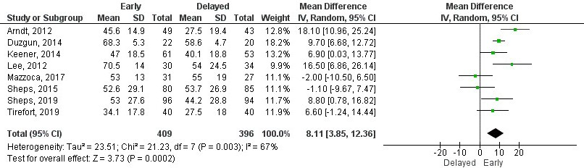
Supplementary file 5.30. Forest plot of range of movement for external rotation at three months.

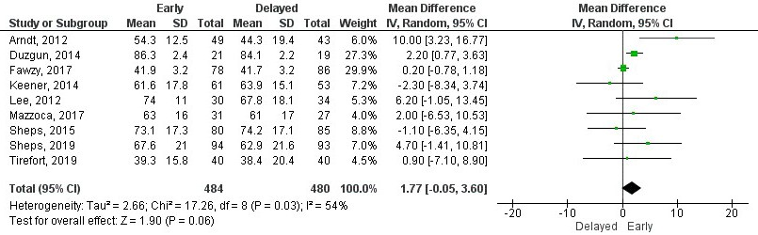
Supplementary file 5.31. Forest plot of range of movement for external rotation at six months.

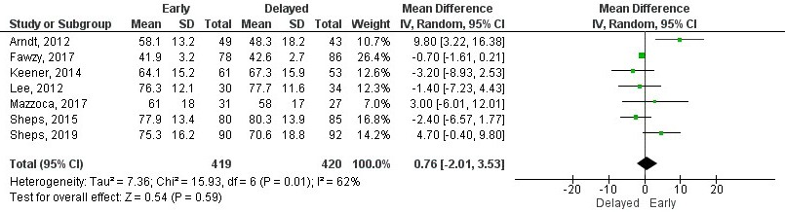
Supplementary file 5.32. Forest plot of range of movement for external rotation at one year.

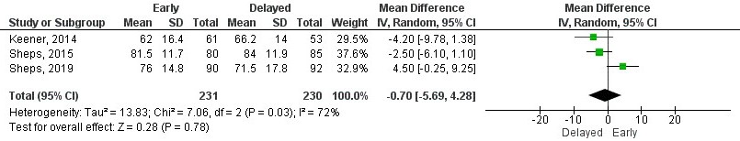
Supplementary file 5.33. Forest plot of range of movement for external rotation at two years.

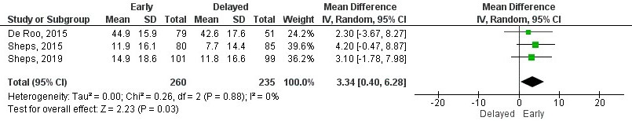
Supplementary file 5.34. Forest plot of range of movement for internal rotation at six weeks.
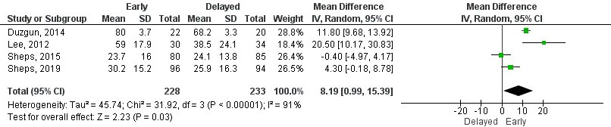
Supplementary file 5.35. Forest plot of range of movement for internal rotation at three months.
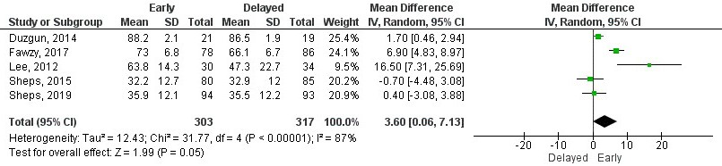
Supplementary file 5.36. Forest plot of range of movement for internal rotation at six months.

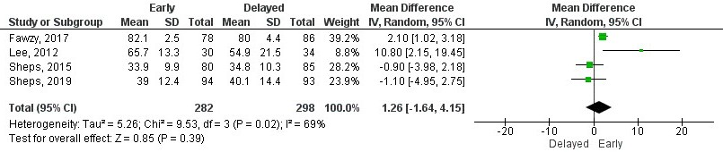
Supplementary file 5.37. Forest plot of range of movement for internal rotation at one year.
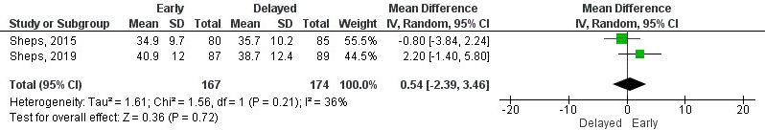
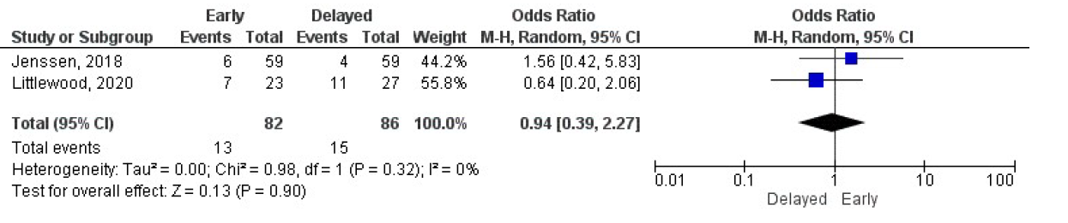
Supplementary file 5.38. Forest plot of range of movement for internal rotation at two years.

Supplementary file 5.39. Forest plot of odds ratio for repair integrity at three months.

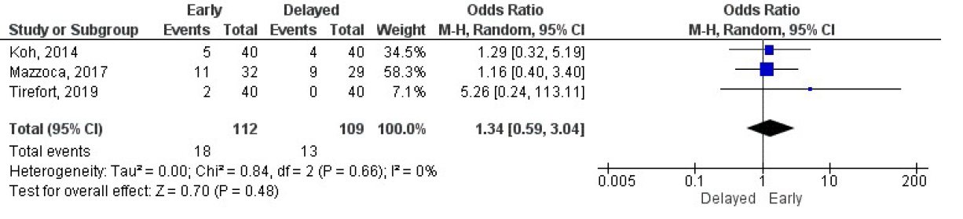
Supplementary file 5.40. Forest plot of odds ratio for repair integrity at six months.

