Supplementary Figure S1. Forest plot showing SMDs in pain intensity scores from sub-analysis of different chronic pain conditions in middle-aged and elderly patients. NOTE: CI confidence interval, SMD standard mean difference, KOA knee osteoarthritis, CLBP chronic low back pain, a yoga, b tai chi, c qigong.
Supplementary Figure S2. Forest plot showing SMDs in pain intensity scores from sub-analysis of different types of mind-body exercises. NOTE: CI confidence interval, SMD standard mean difference, a yoga, b tai chi, c qigong.
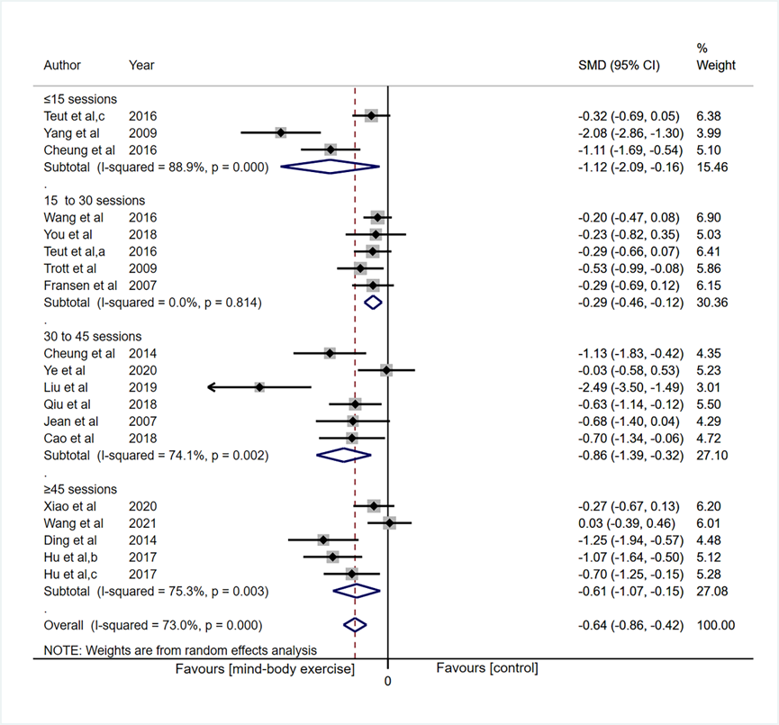
Supplementary Figure S3. Forest plot showing SMDs in pain intensity scores from sub-analysis of the number of sessions. NOTE: CI confidence interval, SMD standard
mean difference, a yoga, b tai chi, c qigong.
Supplementary Figure S4. Forest plot showing SMDs in self-reported function scores from sub-analysis of different chronic pain conditions in middle-aged and elderly patients. NOTE: CI confidence interval, SMD standard mean difference, KOA knee osteoarthritis, CLBP chronic low back pain, a yoga, b tai chi, c qigong.
Supplementary Figure S5. Forest plot showing SMDs in self-reported function scores from sub-analysis of different types of mind-body exercises. NOTE: CI confidence interval, SMD standard mean difference, a yoga, b tai chi, c qigong.
Supplementary Figure S6. Forest plot showing SMDs in self-reported function scores from sub-analysis of the number of sessions. NOTE: CI confidence interval, SMD standard mean difference, a yoga, b tai chi, c qigong.
Supplementary Figure S7. Funnel plots with standard errors plotted against effect sizes for determining publication bias in self-reported function.

