Supplement

First author  Table 1. Characteristics of included studies of genomic biomarkers of bacterial infection. | Population | Region/  Country | Study type | Biomarker | Platform | Specimen | Validation/  test group
Herberg  2016  (18) | Children | United Kingdom, Spain, Netherlands, United States | Cross-sectional | 2-transcript RNA signature (FAM89A, IFI44L)  (DRS) | Microarray | Whole blood | Yes
El-Hefnawy  2021  (29) | Children | Neonatal intensive care unit, Menoufia University, Egypt | Case control | miRNA-16a, miRNA-451 | RT-PCR | Serum | No
Fouda  (2021)  (30) | Children | NICU of Menoufia University Hospital, Egypt | Case control | miRNA 15b, miRNA 378a | RT-PCR | Whole blood | No
Tian  (2021)  (31) | Children | Shenzhen Children’s Hospital and Beijing Children’s Hospital | Case control | FAM89A and IFI44L (DRS) | RT-PCR | Whole blood | No
Mahle  (2021)  (50) | Adult | US Emergency Depts. | Case control | 81-gene signature | RT-PCR | Whole blood | Yes
Mendel-sohn  (2021)  (51) | Adult | South Africa | Case control | RISK11 signature | RT-PCR | Whole blood | No
Xu  (2021)  (52) | Adult | Shandong province, China | Case control | 2-transcript biomarker (IFI44L and PI3 transcripts) | RT-PCR | Whole blood | Yes
Barral-Arca  2018  (35) | Children | Mexico | Cross-sectional | 2-transcript RNA signature (FAM89A, IFI44L)  (DRS) | RNA-seq | Whole blood | Yes
Barry  2018  (49) | Adult | Yinchuan, Ningxia, China | Case control | 5-miRNA signature:  miRs −29a,  −99b, −21, −146a, −652 | qRT-PCR | Whole blood | Yes
Berner  2000  (33) | Children | Freiburg, Germany | Case control | IL-8 mRNA | RT-PCR | Whole blood  (cord) | No
Cernada  2014  (34) | Children | Spain | Case control | GWEP | RT-PCR  Microarray (validation) | Whole blood | No
Francisco  2017  (53) | Adult | China | Case control | GBP5,DUSP3,KLF2 | RT-PCR | Whole blood, PBMC | No
Ge  2013  (35) | Children | China | Case control | 5 miRNA profile (miR-202, miR-342-5p, miR-206, miR-487b, miR-576-5p) | Micoarray, qRT-PCR (further evaluation) | Serum | No
Gjoen  2017  (36) | Children | India | Cross-sectional | 10-transcript signature: IFNG, NLRP1, NLRP3, TGFBR2, TAGAP, NOD2,  GBP5, IFITM1/3, KIF1B and TNIP  7-transcript signature: MMP9, CD3E, NOD2, GBP5, IFITM1/3, KIF1B and  TNIP1. | dcRT-MLPA | Whole blood | Yes
Gomez-Carballa  2019  (37) | Children | Europe | Case control | FAM89A and IFI44L genes | RT-qPCR | Whole blood | Yes
Kaforou  2017  (38) | Children | United States | Cross-sectional | 2-transcript RNA signature (FAM89A, IFI44L)  (DRS) | Microarray | Whole blood | Yes
Liu, G  2020  (39) | Children | Weifang, China | Case control | MicroRNA (miR)-181a No GO | RT-qPCR | Whole blood | No
Mahajan  2016  (17) | Children | United States | Cross-sectional | 66 classifier genes, 10 classifier genes | Microarray | Whole blood | Yes
Pan  2017  (40) | Children | Zhengzhou, China | Case control | MiR-29a | RT-qPCR | PBMC, CSF | No
Ng  2019  (41) | Children | Hong Kong | Case control | miR-1290 | Microarray, RT-qPCR (further analysis) | Whole blood | No
Pan  2019  (54) | Adult | Beijing | Case control | 4 miRNA panel  (miR-126-3p, miR-130a-3p, miR-151a-3p, and miR-199a-5p) | Microarray | Whole blood, CSF | Yes
Penn-Nicholson  2020  (55) | Adult | South Africa, The Gambia, Ethiopia, Brazil, Peru | Case control | RISK6 transcriptomic signature  (GBP2, FCGR1B, SERPING1, TUBGCP6,TRMT2A, and SDR39U1) | RT-qPCR | Whole blood | Yes
Smith  2014  (42) | Children | Edinburgh, Scotland | Case control | 52-gene-classifier | Microarray | Whole blood | Yes
Tornheim  2020  (43) | Children | Byramjee Jeejeebhoy Government Medical College, Maharashtra,  India | Case control | TB Risk Signature | RNA seq | Whole blood | Yes
Verhagen  2013  (44) | Children | Venezuela | Case control | 5-gene signature  (S100P, HBD, PIGC, CHRM2 and ACOT7) | Microarray | Whole blood | Yes
Wang  2015  (45) | Children | Laiwu City, Shandong Province, China | Case control | microRNA-31 | RT-PCR | PBMC | No
Zhou  2016  (46) | Children | Children's Hospital of Chongqing Medical University, Chongqing, China | Case control | 8 miRNA  (miR-1, miR-10a, miR-125b miR-146a, miR-150, miR-155 and miR-31, miR-29) | Microarray, RT-qPCR (validation) | PBMC | Yes
Cui  2017  (56) | Adults | Harbin and Heilongjiang Province China | Case control | Risk Score Analysis (3-miRNA signature) | RNA seq, RT-qPCR (validation) | Whole blood | Yes
Salim  2020  (47) | Children | Egypt | Case control | miR-187, miR-101 | RT-qPCR | Whole blood | No
Warsinske  2018  (57) | Adult | South Africa, Brazil | Case control | TB Risk Score (DUSP3, GBP5, KLF2) | Microarray, RNA seq, RT-qPCR | Whole blood | Yes
Berry  2010  (58) | Adult | United Kingdom, South Africa | Case control | 393-transcript signature, 86-gene signature | Microarray | Whole blood | Yes
Kelly  2018  (59) | Adult | United States | Case control | 3-predictor gene expression model  (RAD18, MAPKAPK3, JAG1) | RNA seq | Whole blood | No
Gliddon  2021  (60) | Adult | Cape Town, South Africa and Karonga District, Northern Malawi | Case control | FS-PLS signature for TB/OD (4-transcript signature)  (GBP6, TMCC1, PRDM1, and ARG1) | Microarray,  RT-dPCR | Whole blood | Yes
Abd-El-Fattah  2013  (61) | Adult | Cairo, Egypt | Case control | miR-155, miR-197 | Microarray, RT-qPCR | Whole blood | No
Bloom  2013  (62) | Adult | United Kingdom, France | Case control | 144-transcript signature | Microarray | Whole blood | Yes
Darboe  2019  (63) | Adult | South Africa | Case control | 11-gene ACS COR signature | Microarray | Whole blood | Yes
de Araujo  2016  (64) | Adult | Brazil | Case control | NPC2, EPHA4, DOCK9 mRNA | RNA seq | Whole blood | Yes
Ho  2020  (65) | Adult | Vietnam | Case control | 7-gene signature (IFI6, TGIF1, GZMA, DHRS9, APOL6, FCGR1C, IFI35)  3-gene signature (RAP1A, C11orf2, SEPT4) | RNA seq | Whole blood | No
Jorge  2017  (66) | Adult | Brazil | Case control | Four miRNAs (miR-101, miR-196b, miR-27b, and miR-29c) | Microarray, RT-qPCR | Skin biopsy specimen | No
Kathirvel  2020  (48) | Children | Puducherry, India | Case control | miR-31 | RT-qPCR | Whole blood | No
Latorre  2015  (67) | Adult | Barcelona, Spain | Case control | miRNA-signature for rapid pulmonary TB diagnosis  (hsa-miR-150, hsa-miR-21, hsa-miR-29c and hsa-miR-194) | Microarray, RT-qPCR | Whole blood | No
Lee  2016  (68) | Adult | Taoyuan, Taiwan | Case control | PTPRC, ASUN, DHX29 | Microarray, RT-qPCR | PBMC | Yes
Lei  2021  (69) | Adult | China | Case control | 2-gene model  (S100A12 + CD177) | RT-qPCR | Whole blood | Yes
Li  2020  (70) | Adult | Beijing, China | Case control | miRNA-29a | RT-qPCR | Whole blood | No
Lydon  2019  (71) | Adult | United States | Case control | 87-transcript signature | RT-qPCR | Whole blood | Yes
Maertzdorf  2016  (72) | Adult | Bangalore, India | Case control | 4-gene signature  (GBP1, ID3, P2RY14, IFITM3) | RT-qPCR | Whole blood | Yes
Mihret  2014  (73) | Adult | Addis Ababa, Ethiopia | Case control | BLR1, Bcl2, IL4d2, FCGR1A, MARCO, CCL19, and LTF, TGFB1, and Foxp3, FPR1 and TGFB1. | dcRT-MLPA | Whole blood | No
Miotto  2013  (74) | Adult | Italy, Tanzania, Uganda | Case control | 10 miRNA signature (European)  12 miRNA signature (African-specific sig.) | Microarray | Whole blood | No
Ndzi  2019  (75) | Adult | Yaounde, Cameroon | Case control | miR-29a-3p, MiR-155-5p, MiR-361-5p | RT-qPCR | Whole blood | No
Perumal  2021  (76) | Adult | India, United Kingdom | Case control | GBP1, IFIT3, IFITM3, SAMD9L | qPCR | Whole blood | No
Petrilli  2020  (77) | Adult | Brazil | Case control | CD274, CEACAM1, CR1, FCGR1A/B, IFITM1, IRAK3, LILRA6, MAPK14, PDCD1LG2 | NanoString platform | Whole blood | No
Poore  2018  (79) | Adult | United States | Case control | Bacterial vs viral miRNA signature (40 DE miRNA)  Bacterial vs healthy miRNA signature (67 DE miRNA) | Microarray | Whole blood | No
Roe  2020  (79) | Adult | United Kingdom, South Africa | Case control | 3-gene transcript signature  (BATF2, GBP5, SCARF1) | RNA seq | Whole blood | Yes
Satproedprai  2015  (80) | Adult | Chiangrai Prachanukroh Hospital,  Thailand | Case control | TB Sick Score  (FCGR1A, FCGR1B variant 1, FCGR1B variant 2, APOL1, STAT1, MAFB and KAZN) | Microarray | Whole blood | No
Sampson  2020  (81) | Adult | London, United Kingdom | Case control | SeptiCyte™ TRIAGE (DIAPH2/IL7R, GBP2/GIMAP4, TLR5/FGL2)  Combined SeptiCyte™ | NanoString platform | Whole blood | Yes
Serrano  2016  (82) | Adult | Mexico | Case control | NCF1 and ORM, FPR2, CST7, PSTPIP1 | RT-qPCR | PBMC | No
Sivakum-aran  2021  (83) | Adult | Chittoor district, Andhra Pradesh, India, United Kingdom, South Africa | Case control | 11-gene signature No GO  (CASP8, CD3E, CD8A, CD14, GBP5,  GNLY, NLRP2, NOD2, TAGAP, TLR5, and TNF) | dcRT-MLPA | Whole blood | Yes
Sodersten  2021  (84) | Adult | South Africa, Peru | Case control | Xpert-MTB-HR-Prototype  (GBP5, DUSP3, and KLF2) | Xpert assay  (RT-PCR) | Whole blood | No
Suarez  2015  (22) | Adult | New York, United States | Case control | 10 classifier genes | Microarray | Whole blood | No
Wang  2018  (85) | Adult | China | Case control | miR-21-5p, miR-92a-3p, miR-125a-5p, miR-148b-3p | Solexa seq  RT-qPCR (validation) | Whole blood | No
Wu  2007  (86) | Adult | United States | Case control | IFN-γ mRNA | qPCR | PBMC | No
Wu  2012  (87) | Adult | Shanghai, China | Case control | miR-155, miR-155* | Microarray  RT-qPCR (validation) | PBMC | Yes
Zhang  2019  (88) | Adult | Shanghai, China | Case control | MiR-892b; miR-199b-5p and miR-582–5p | RT-qPCR | PBMC | No
Burel  2018  (89) | Adult | United States | Case control | 74-gene signature | RNA seq | PBMC | No
Sun  2021  (90) | Adult | Shanxi Provincial Institute for Tuberculosis Control and Prevention, China | Case control | miR-125b | RT-qPCR | PBMC | No
Nabiel  2019  (91) | Adult | Egypt | Case control | microRNA-155 | RT-PCR | Ascitic fluid | No
Dawany  2014  (92) | Adult | South Africa | Case control | 251-gene TB signature | Microarray | PBMC | Yes
Mamishi  2021  (93) | Adult | Tehran, Iran | Case control | ASUN, NEMF, PTPRC and DHX29 | RT-PCR | Whole blood | No
Pennisi  2021  (21) | Adult | United Kingdom | Case control | 2-transcript signature (IFI44L and EMR1-ADGRE1) | Electronic RT-LAMP (RT-eLAMP) | Whole blood | No
Chen  2017  (94) | Adult | Fujian Province, China | Case control | Four lncRNAs  (NR_03822, NR_003142, ENST00000570366, ENST00000422183) | RT-qPCR | Whole blood | No
de Araujo  2019  (95) | Adult | Brazil | Case control | 4 sncRNA  (let-7a-5p, miR-589-5p, miR-196b-5p, and SNORD104) | RNA seq | Whole blood | No
Huang  2018  (96) | Adult | China | Case control | hsa_circ_0001953 and hsa_circ_0009024 | Microarray | Whole blood | No
DRS Disease Risk Score; RT-qPCR Quantiative reverse transcription PCR; dcRT-MLPA Dual colour multiplex ligation-dependent probe amplification; lncRNA Long noncoding RNA; sncRNA Small noncoding RNA; RT-eLAMP/electronic RT-lamp Reverse Transcription Loop-mediated Isothermal Amplification.

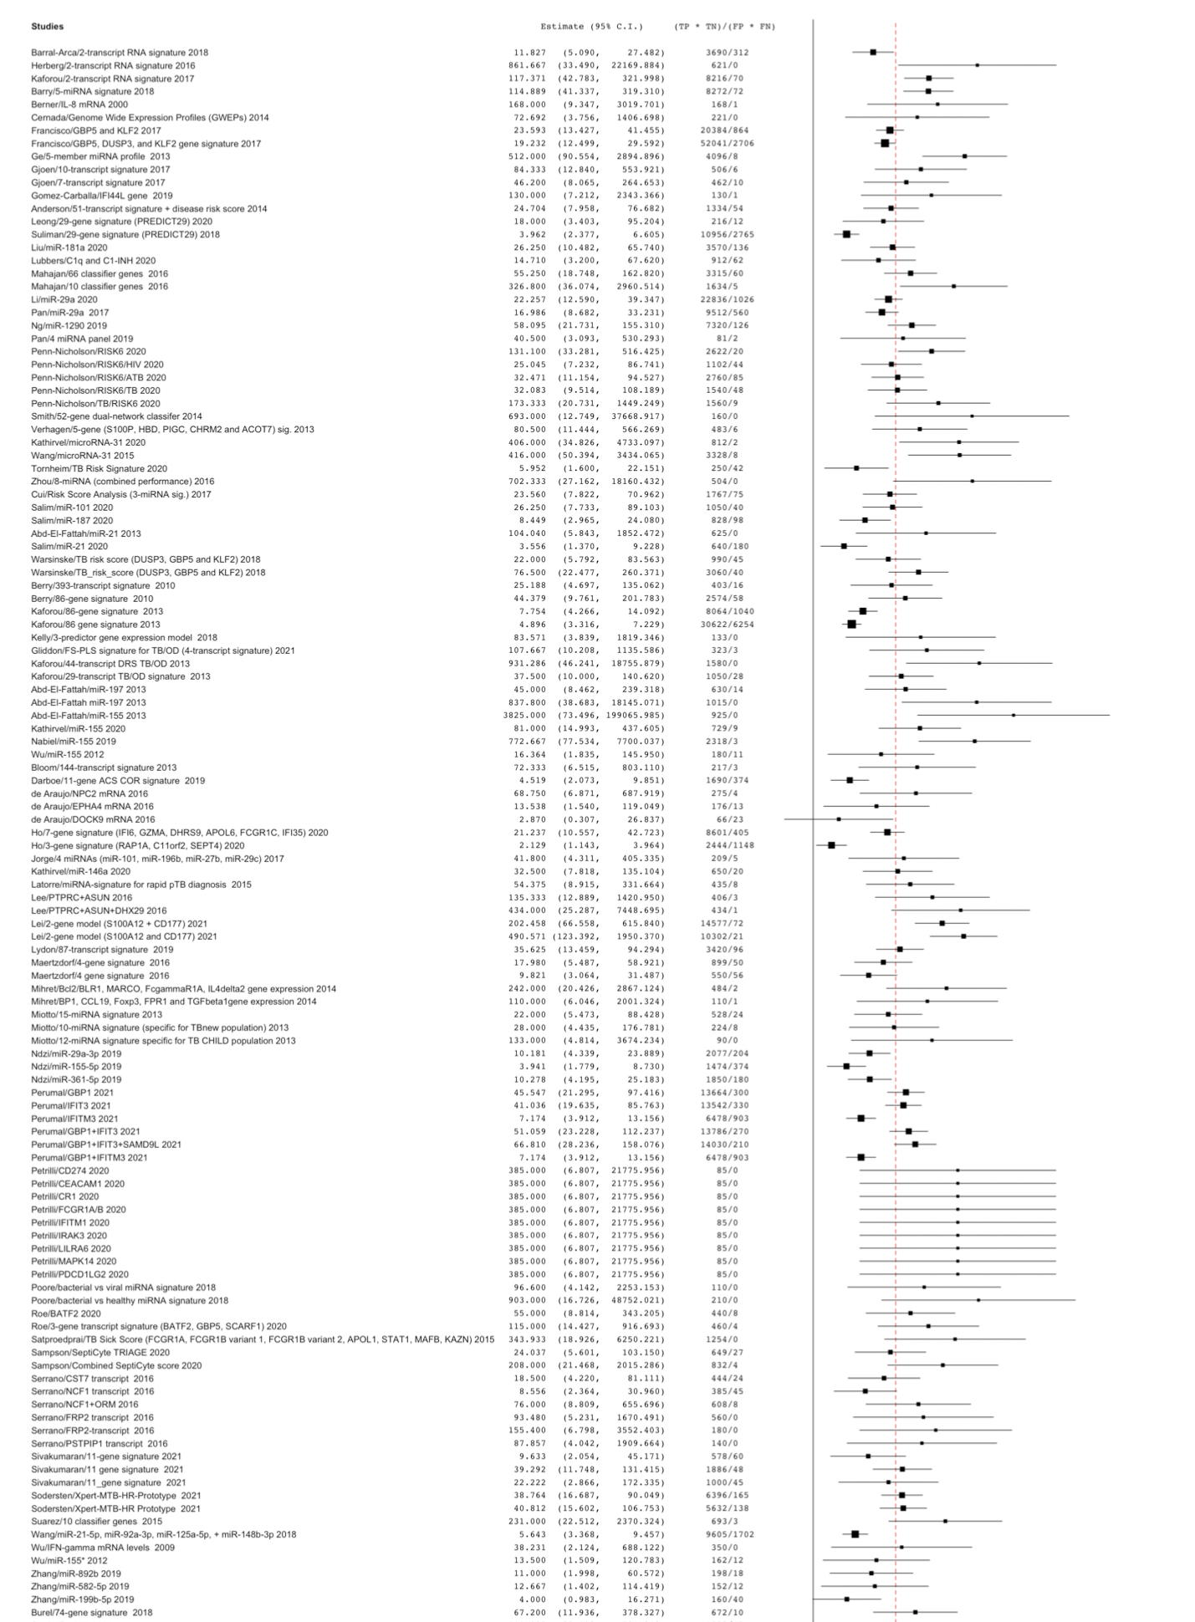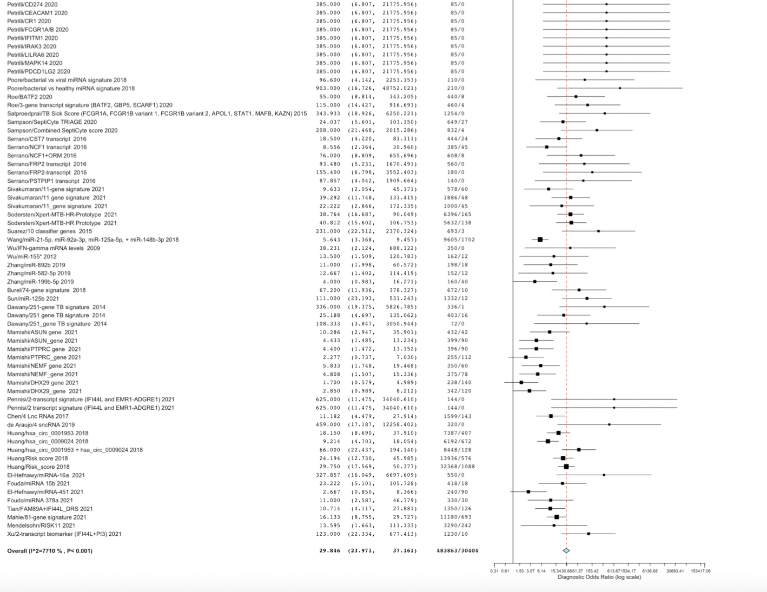

Figure 1: Forest plot of diagnostic odds ratio of transcriptomic biomarkers of bacterial infection.

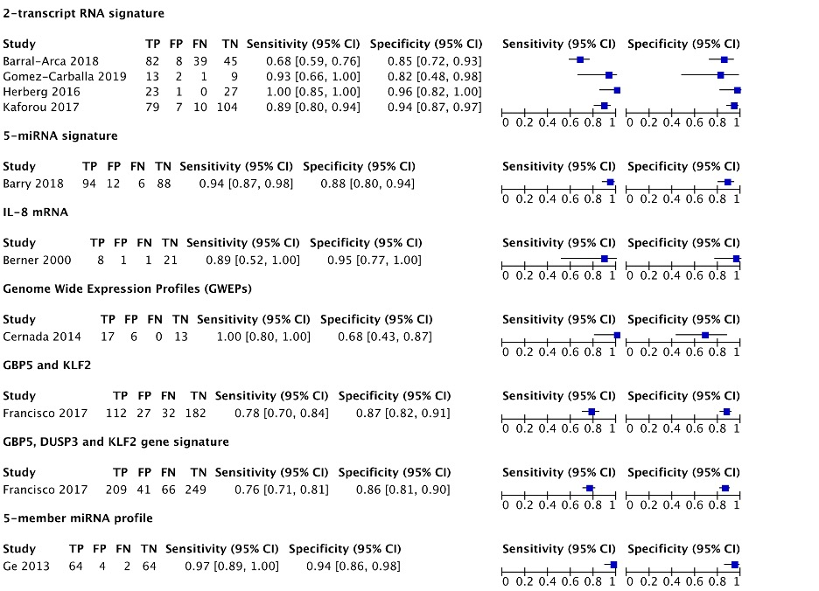

Figure 2. Forest plots of sensitivity and specificity of each genomic biomarker

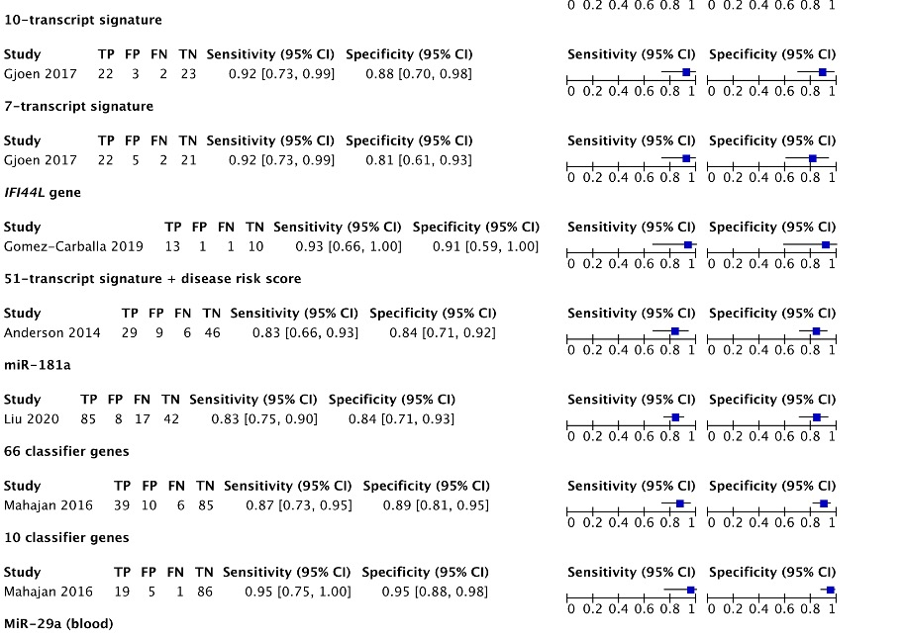

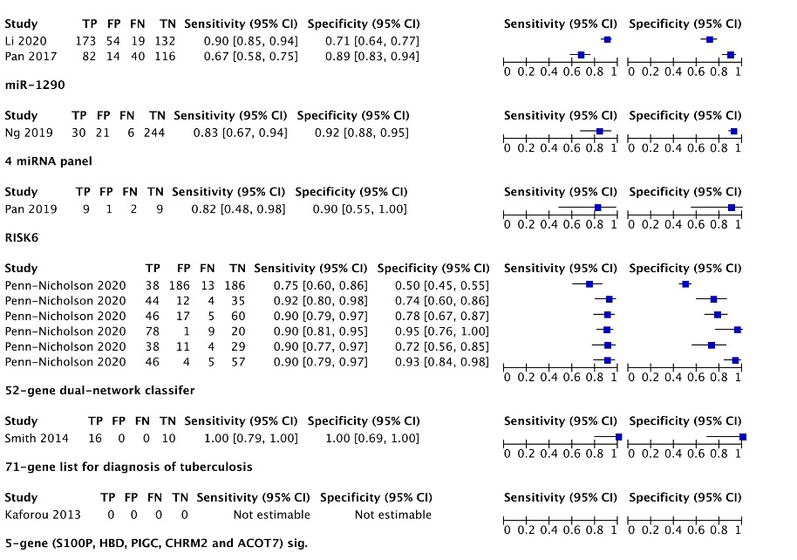
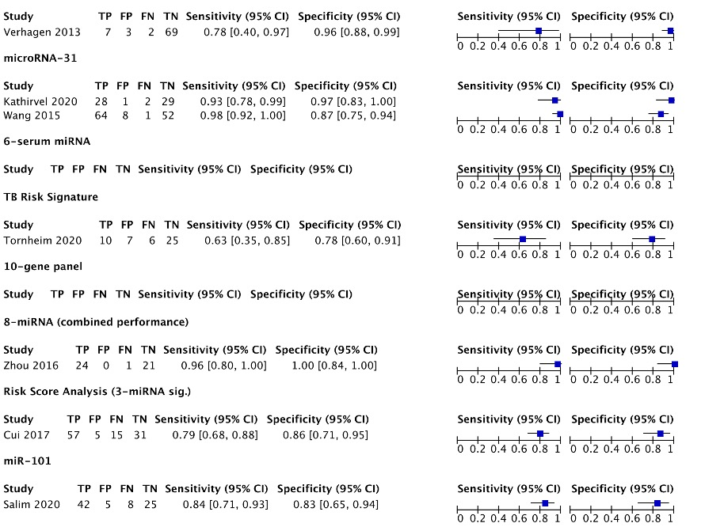

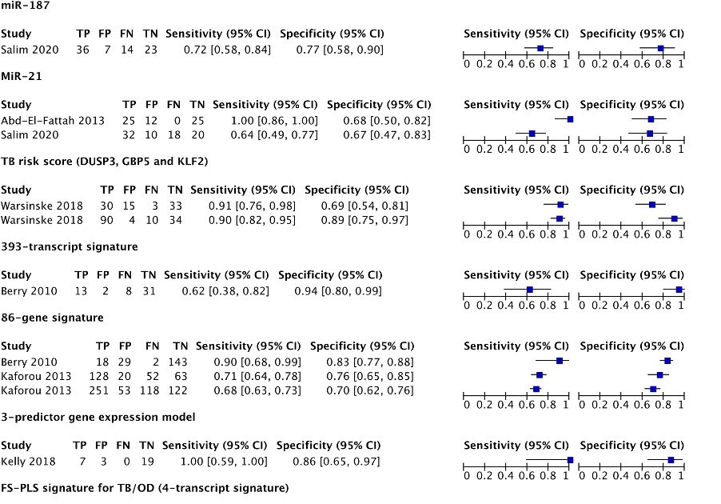
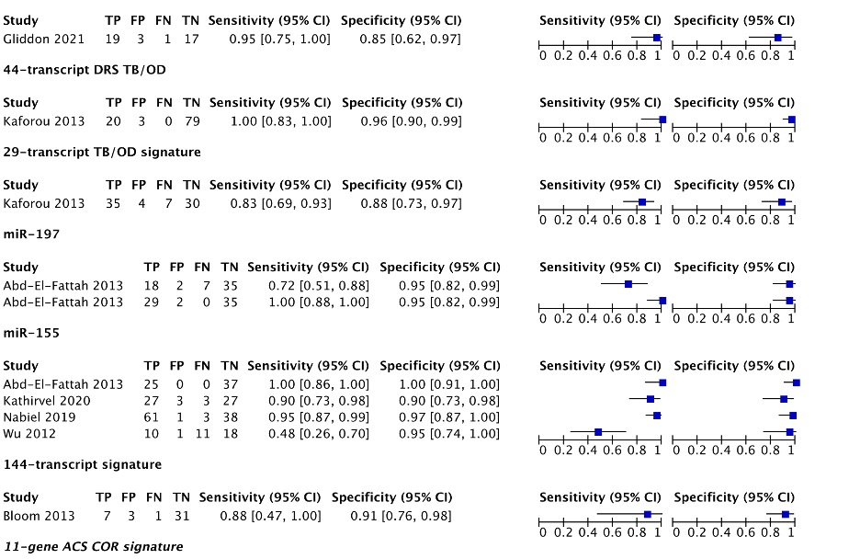

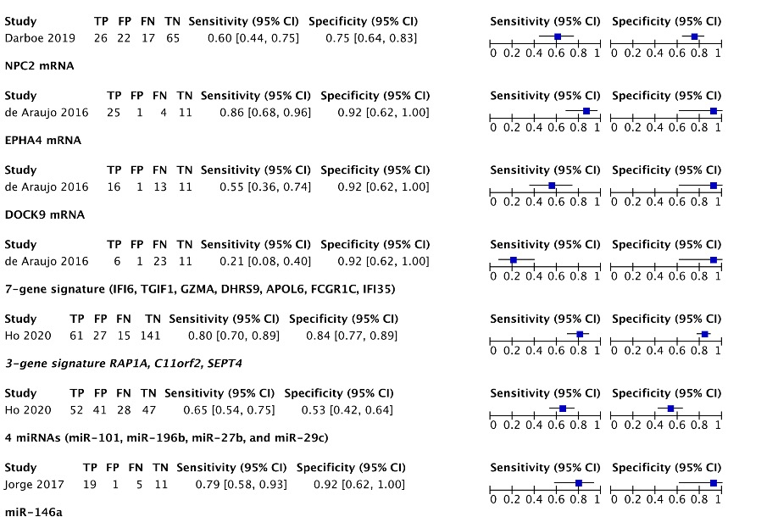
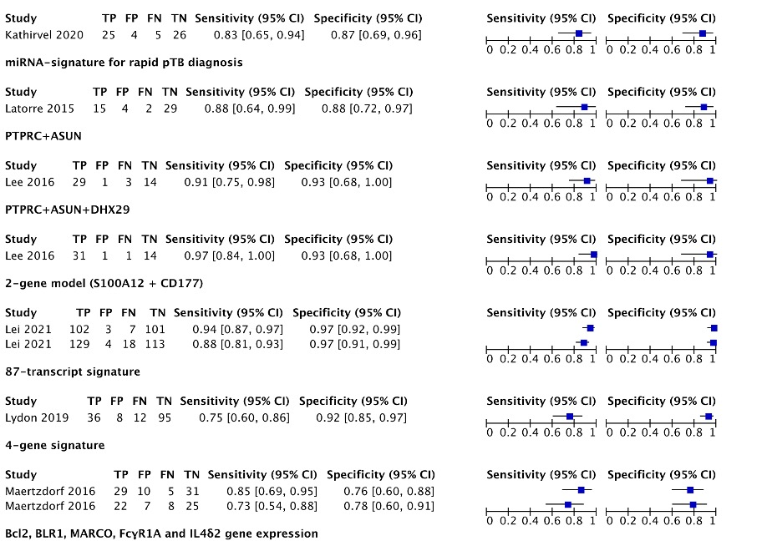

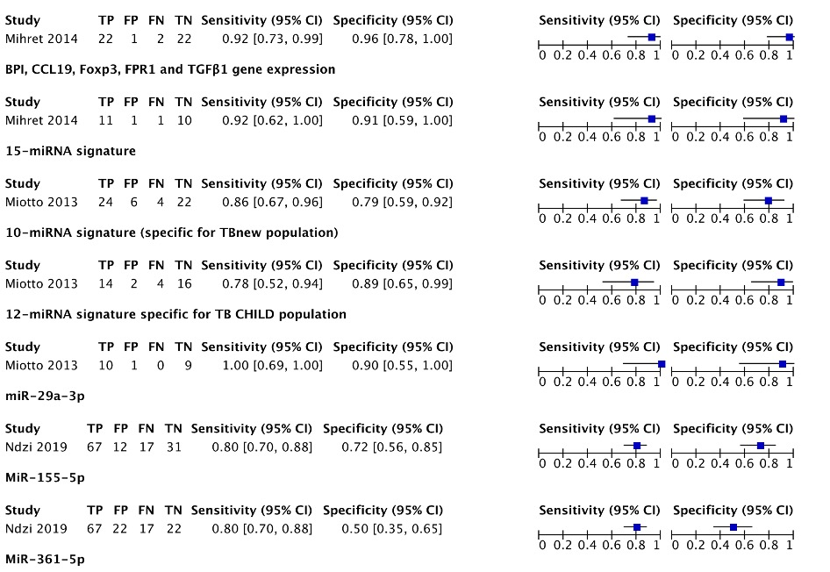
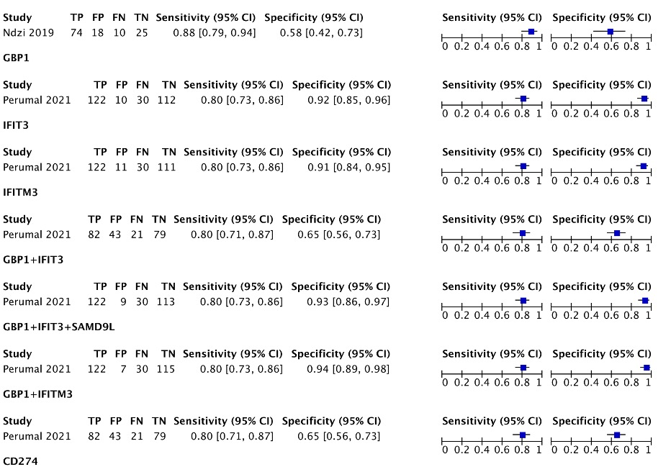

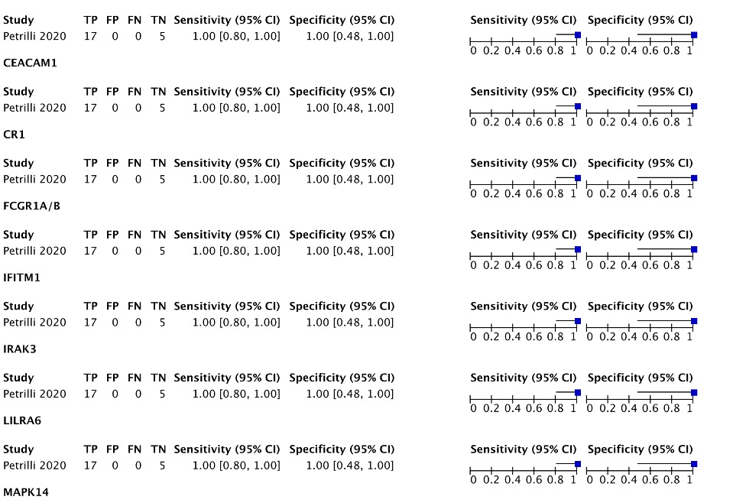
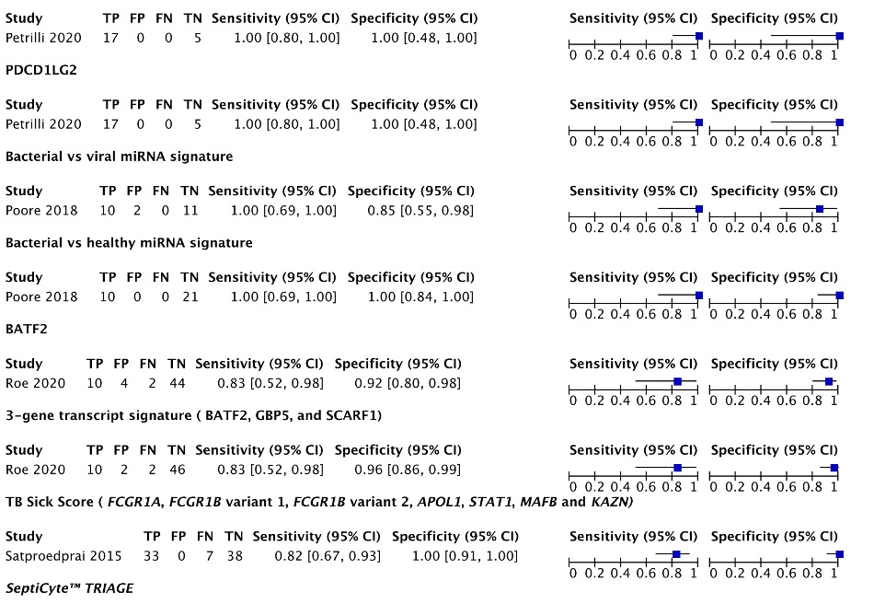

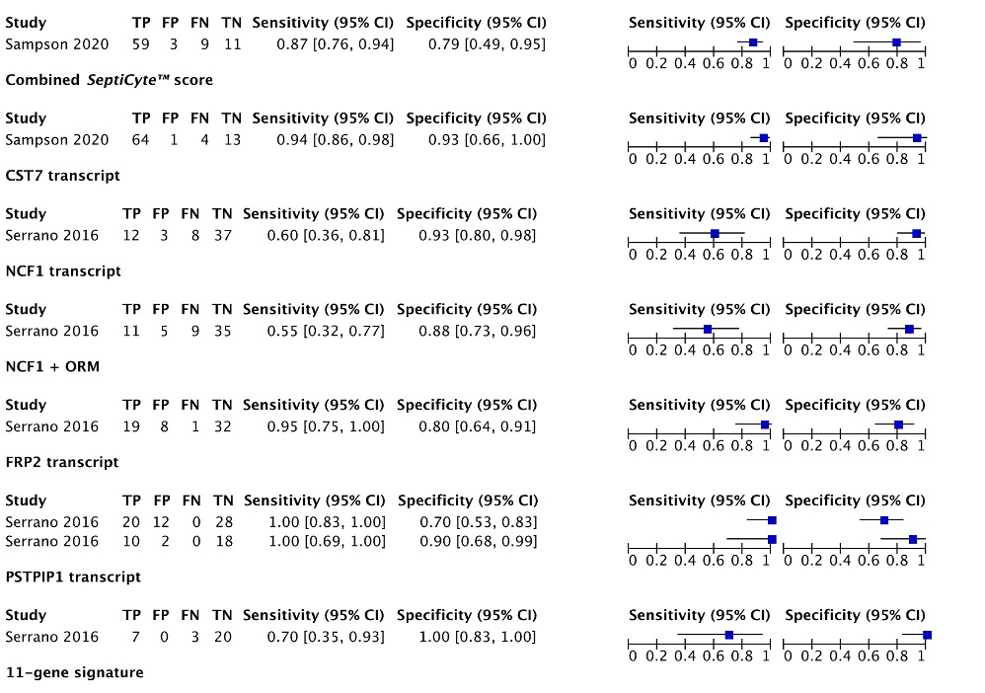
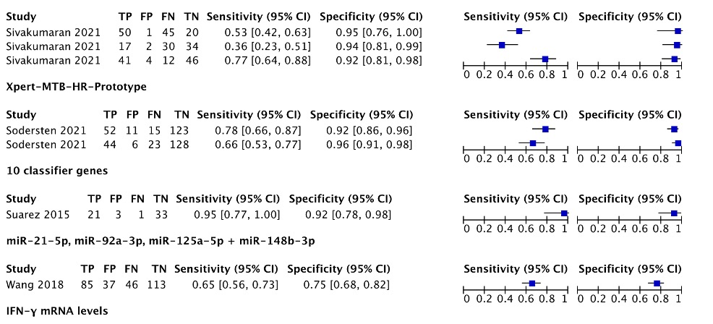

Search syntax

Database: Medline (Ovid MEDLINE® Epub Ahead of Print, In-Process & Other Non-Indexed Citations, Ovid MEDLINE® Daily and Ovid MEDLINE®) 1946 to present

Search Strategy:

1 adolescent/ or exp child/ or exp infant/ (3573654)
2 (infan* or newborn* or new-born* or perinat* or neonat* or baby* or babies or toddler* or minor* or boy* or girl* or kid or kids or child* or schoolchild* or adolescen* or juvenil* or youth* or teen* or pubescen* or pediatric* or paediatric* or peadiatric*).tw. (2739563)
3 1 or 2 (4588296)
4 "sensitivity and specificity"/ (348167)
5 (sensitivity or specificity or ((pre-test or pretest) and probability) or "post-test probability" or "predictive value*" or "likelihood ratio*").tw. (1108494)
6 4 or 5 (1303293)
7 exp Infections/ (2626424)
8 (infectious or infection* or "communicable disease*").tw. (1545075)
9 7 or 8 (3241939)
10 exp Biomarkers/ not Biomarkers, Tumor/ (606297)
11 biomarker*.tw. (265244)
12 "biological marker*".tw. (8747)
13 (biosignature* or "RNA signature*" or "gene expression").tw. (401863)
14 10 or 11 or 12 or 13 (1162443)
15 3 and 6 and 9 and 14 (2673)

Embase search strategy
Database: Embase 1974 to present

Search Strategy:

1 exp juvenile/ (3454296)
2 (infan* or newborn* or new-born* or perinat* or neonat* or baby* or babies or toddler* or minor* or boy* or girl* or kid or kids or child* or schoolchild* or adolescen* or juvenil* or youth* or teen* or pubescen* or pediatric* or paediatric* or peadiatric*).tw. (3373914)
3 1 or 2 (4674191)
4 "sensitivity and specificity"/ (367616)
5 (sensitivity or specificity or ((pre-test or pretest) and probability) or "post-test probability" or "predictive value*" or "likelihood ratio*").tw. (1413211)
6 4 or 5 (1551439)
7 exp infection/ (3289657)
8 (infectious or infection* or "communicable disease*").tw. (1957624)
9 7 or 8 (3814824)
10 biological marker/ (315510)
11 biomarker*.tw. (413370)
12 "biological marker*".tw. (12378)
13 (biosignature* or "RNA signature*" or "gene expression").tw. (521208)
14 10 or 11 or 12 or 13 (1008645)
15 3 and 6 and 9 and 14 (1914)

Scopus search strategy

infan* or newborn* or new-born* or perinat* or neonat* or baby* or babies or toddler* or minor* or boy* or girl* or kid or kids or child* or schoolchild* or adolescen* or juvenil* or youth* or teen* or pubescen* or pediatric* or paediatric* or peadiatric*
+
sensitivity or specificity or ((pre-test or pretest) and probability) or {post-test probability} or {predictive value*} or {likelihood ratio*}
+
infectious or infection* or {communicable disease*}
+
biomarker* or {biological marker*} or biosignature* or {RNA signature*} or {gene expression}

