Supplementary materials

Table 1 English literature search strategy(Pubmed)
Number | Search terms
1 | imatinib [Title/Abstract]
2 | imatinib[MeSH Terms]
3 | 1 OR 2
4 | Nilotinib [Title/Abstract]
5 | Nilotinib[MeSH Terms]
6 | 4 OR 5
7 | 3 AND 6
8 | Chronic myeloid leukemia[Title/Abstract]
9 | Chronic myeloid leukemia[MeSH Terms]
10 | Chronic Myelogenous Leukemia[Title/Abstract]
11 | Chronic Myelogenous Leukemia[MeSH Terms]
12 | Chronic Myelocytic Leukemia[Title/Abstract]
13 | Chronic Myelocytic Leukemia[MeSH Terms]
14 | Chronic Granulocytic Leukemia[Title/Abstract]
15 | Chronic Granulocytic Leukemia[MeSH Terms]
16 | Philadelphia-Positive Myeloid Leukemia[Title/Abstract]
17 | Philadelphia-Positive Myeloid Leukemia[MeSH Terms]
18 | Ph1-Positive Myelogenous Leukemia[Title/Abstract]
19 | Ph1-Positive Myelogenous Leukemia[MeSH Terms]
20 | Ph1-Positive Myeloid Leukemia[Title/Abstract]
21 | Ph1-Positive Myeloid Leukemia[MeSH Terms]
22 | 8 OR 9 OR 10 OR 11 OR 12 OR 13 OR 14 OR 15 OR 16 OR 17 OR 18 OR 19 OR 20 OR 21
23 | Cardio* [Title/Abstract]
24 | Vascular [Title/Abstract]
25 | Arterial [Title/Abstract]
26 | Myocardial [Title/Abstract]
27 | Atherosclerosis [Title/Abstract]
28 | Coronary [Title/Abstract]
29 | Angina [Title/Abstract]
30 | Cardiac [Title/Abstract]
31 | Cardiotoxicity [MeSH Terms]
32 | Heart [Title/Abstract]
33 | Occlusive [Title/Abstract]
34 | Ischemic [Title/Abstract]
35 | 23 OR 24 OR 25 OR 26 OR 27 OR 28 OR 29 OR 30 OR 31 OR 32 OR 33 OR 34
36 | 7 AND 22 AND 35

Table 2 English literature search strategy(Embase)
Number | Search terms
1 | imatinib [Title/Abstract]
2 | Nilotinib [Title/Abstract]
3 | 1 OR 2
4 | Chronic myeloid leukemia[Title/Abstract]
5 | Chronic Myelogenous Leukemia[Title/Abstract]
6 | Chronic Myelocytic Leukemia[Title/Abstract]
7 | Chronic Granulocytic Leukemia[Title/Abstract]
8 | Philadelphia-Positive Myeloid Leukemia[Title/Abstract]
9 | Ph1-Positive Myelogenous Leukemia[Title/Abstract]
10 | Ph1-Positive Myeloid Leukemia[Title/Abstract]
11 | 4 OR 5 OR 6 OR 7 OR 8 OR 9 OR 10
12 | Ischemic [Title/Abstract]
13 | Cardio* [Title/Abstract]
14 | Vascular [Title/Abstract]
15 | Arterial [Title/Abstract]
16 | Myocardial [Title/Abstract]
17 | Atherosclerosis [Title/Abstract]
18 | Coronary [Title/Abstract]
19 | Angina [Title/Abstract]
20 | Cardiac [Title/Abstract]
21 | Cardiotoxicity [MeSH Terms]
22 | Heart [Title/Abstract]
23 | Occlusive [Title/Abstract]
24 | 12 OR 13 OR 14 OR 15 OR 16 OR 17 OR 18 OR 19 OR 20 OR 21 OR 22 OR 23
25 | 3 AND 11 AND 24

Table3 English literature search strategy( Cochrane library)
Number | Search terms
1 | imatinib [Title Abstract Keyword]
2 | Nilotinib [Title Abstract Keyword]
3 | 1 OR 2
4 | Chronic myeloid leukemia[Title Abstract Keyword]
5 | Chronic Myelogenous Leukemia[Title Abstract Keyword]
6 | Chronic Myelocytic Leukemia[Title Abstract Keyword]
7 | Chronic Granulocytic Leukemia[Title Abstract Keyword]
8 | Philadelphia-Positive Myeloid Leukemia[Title Abstract Keyword]
9 | Ph1-Positive Myelogenous Leukemia[Title Abstract Keyword]
10 | Ph1-Positive Myeloid Leukemia[Title Abstract Keyword]
11 | 4 OR 5 OR 6 OR 7 OR 8 OR 9 OR 10
12 | Ischemic [Title Abstract Keyword]
13 | Cardio* [Title Abstract Keyword]
14 | Vascular [Title Abstract Keyword]
15 | Arterial [Title Abstract Keyword]
16 | Myocardial [Title Abstract Keyword]
17 | Atherosclerosis [Title Abstract Keyword]
18 | Coronary [Title Abstract Keyword]
19 | Angina [Title Abstract Keyword]
20 | Cardiac [Title Abstract Keyword]
21 | Cardiotoxicity [MeSH Terms]
22 | Heart [Title Abstract Keyword]
23 | Occlusive [Title Abstract Keyword]
24 | 12 OR 13 OR 14 OR 15 OR 16 OR 17 OR 18 OR 19 OR 20 OR 21 OR 22 OR 23
25 | 3 AND 11 AND 24

As was showed in the Table 4, P-value of Begg’s and Egger’s test was all above 0.05, so no significant publication bias was found, expect for the two outcomes(HF and arrhythmia ).

Table 4 Publication bias assessment
 | Number of studies | P-value of Begg’s test | P-value of Egger’s test
CAE-OR | 14 | 0.2983 | 0.2875
CAE-HR | 2 | -- | --
CAD | 9 | 0.6767 | 0.7176
ACS | 6 | 0.3476 | 0.7479
CVA | 9 | 0.1376 | 0.0494
PAOD | 10 | 0.8153 | 0.1037
HF | 3 | -- | --
Arrhythmia | 2 | -- | --

Table5 Quality assessment of included studies according to the Newcastle-Ottawa Scale.

Study | Selection |  |  |  | Comparability |  | Outcome |  |  | In total
Study | 1* | 2* | 3* | 4* | 5* | 6* | 7* | 8* | 9* | In total
Isao Fujioka 2018 | 1 | 1 | 1 | 1 | 1 | 0 | 1 | 1 | 1 | 8
Torsten Dahlén 2022 | 1 | 1 | 1 | 1 | 1 | 0 | 1 | 1 | 1 | 8
Petrikova L 2021 | 1 | 1 | 1 | 1 | 1 | 0 | 1 | 1 | 0 | 7
Torsten Dahlen 2016 | 1 | 1 | 1 | 1 | 1 | 0 | 1 | 0 | 1 | 7
Mei-Tsen Chen 2021 | 1 | 1 | 1 | 1 | 1 | 0 | 1 | 1 | 1 | 8
Preetesh Jain 2021 | 1 | 1 | 1 | 1 | 1 | 0 | 1 | 1 | 1 | 8
Masahiro Kizaki 2019 | 1 | 1 | 1 | 1 | 1 | 0 | 1 | 1 | 1 | 8
F J Giles 2013 | 1 | 1 | 1 | 1 | 1 | 0 | 0 | 1 | 1 | 7
Yu-Chien Yang 2021 | 1 | 1 | 1 | 1 | 1 | 0 | 1 | 0 | 1 | 7
Kantarjian HM 2021 | 1 | 1 | 1 | 1 | 1 | 0 | 1 | 1 | 1 | 8
Anna Sicuranza 2022 | 1 | 1 | 1 | 1 | 1 | 0 | 1 | 0 | 1 | 7
T D Kim 2013 | 1 | 1 | 1 | 1 | 1 | 0 | 1 | 1 | 1 | 8
Jianxiang Wang 2015 | 1 | 1 | 1 | 1 | 1 | 0 | 1 | 0 | 1 | 7
Alessandra Bettiol 2018 | 1 | 1 | 1 | 1 | 1 | 0 | 1 | 1 | 0 | 7

1*: Representativeness of the exposed cohort, 2*: Selection of the non exposed cohort, 3*: Ascertainment of exposure, 4*: Demonstration that outcome of interest was not present at start of study, 5*: Study controls for the most important factor, 6*: Study controls for any additional factor, 7*: Assessment of outcome, 8*: Was follow-up long enough for outcomes to occur, 9*: Adequacy of follow up of cohorts.

Table 6 TOP 10 hub genes according to 5 kinds of criteria( human cardiomyocytes)
Rank | MCC | Degree | EPC | Betweenness | EcCentricity
1 | CXCL8 | CXCL8 | IL6 | BIRC3 | BIRC3
2 | IL6 | IL6 | CXCL8 | MAD2L1 | MAD2L1
3 | CCL2 | CCL2 | NFKBIA | IL6 | IL6
4 | CXCL2 | NFKBIA | CCL2 | CXCL8 | CXCL8
5 | NFKBIA | CXCL2 | CXCL2 | NFKBIA | NFKBIA
6 | CCL20 | SOD2 | SOD2 | SOD2 | SOD2
7 | SOD2 | CCL20 | BIRC3 | MT1E | RIPK2
8 | TSLP | BIRC3 | CCL20 | CCL2 | CCL2
9 | BIRC3 | MAD2L1 | TSLP | NUSAP1 | NUSAP1
10 | NAMPT | TSLP | RIPK2 | TOP2A | TOP2A

Table 7 TOP 10 hub genes according to 5 kinds of criteria(Mus musculus liver samples)
Rank | MCC | Degree | EPC | Betweenness | EcCentricity
1 | Tyrobp | Ptprc | Ptprc | Cd44 | Ptprc
2 | Csf1r | Itgb2 | Itgb2 | Ptprc | Itgax
3 | Ctss | Tyrobp | Tyrobp | Actb | Cd44
4 | C1qa | Csf1r | Csf1r | Itgb2 | Tlr2
5 | C1qb | Ctss | Ctss | C1qa | Icam1
6 | C1qc | Cd44 | C1qa | Tyrobp | Lgals3
7 | Cd68 | Rac2 | Cd68 | Tlr2 | Bgn
8 | Aif1 | Actb | C1qb | Dcn | Itgb2
9 | Ly86 | C1qa | Itgax | Pik3cd | Tyrobp
10 | Lyz2 | C1qb | Vav1 | Col1a1 | Csf1r

A  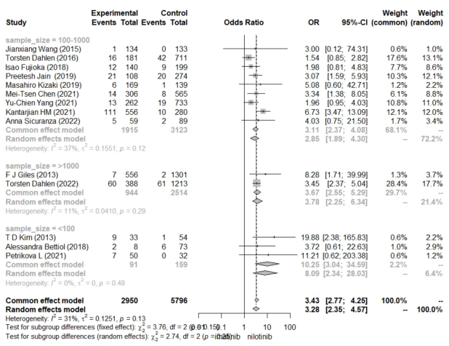 | B  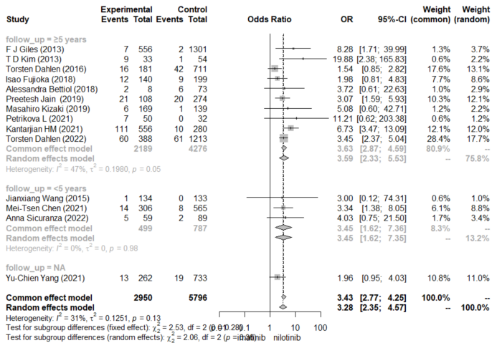
C  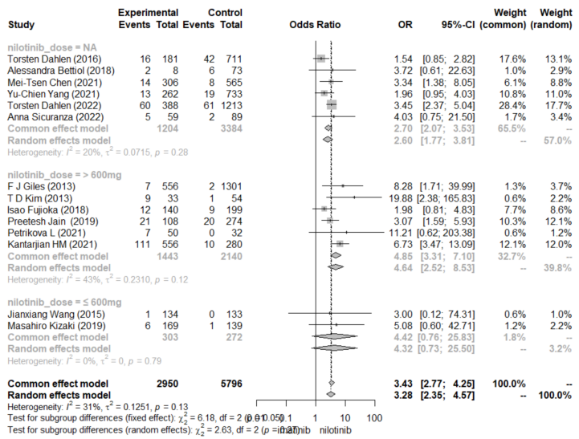 | D  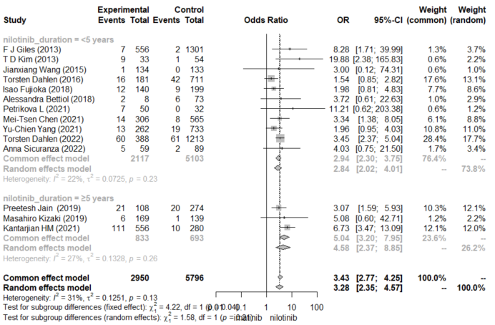
E.  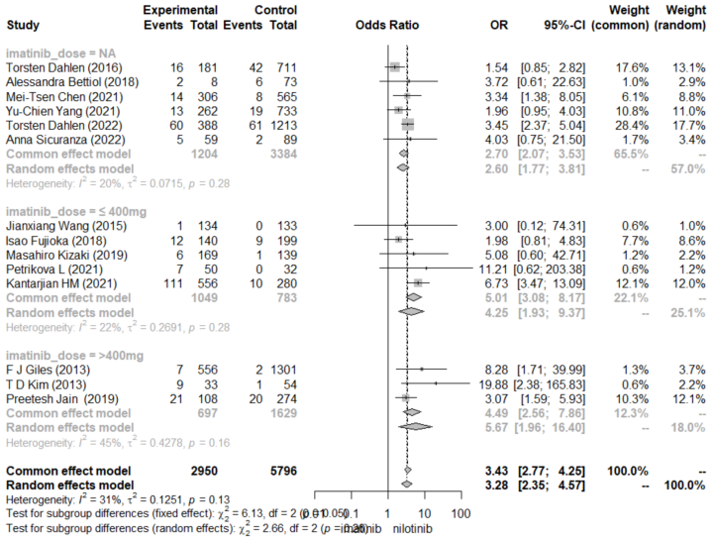 | F.  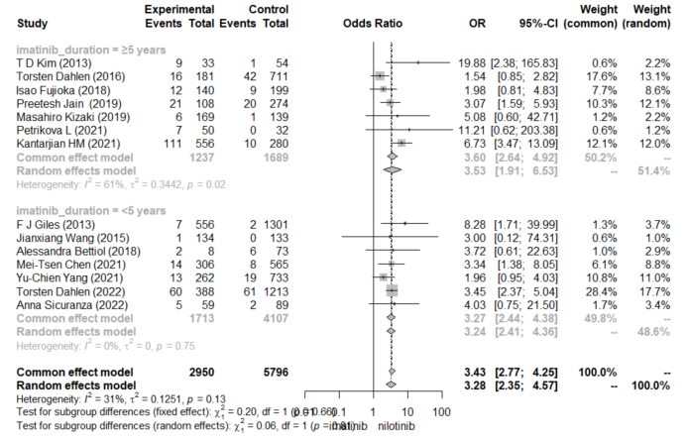
G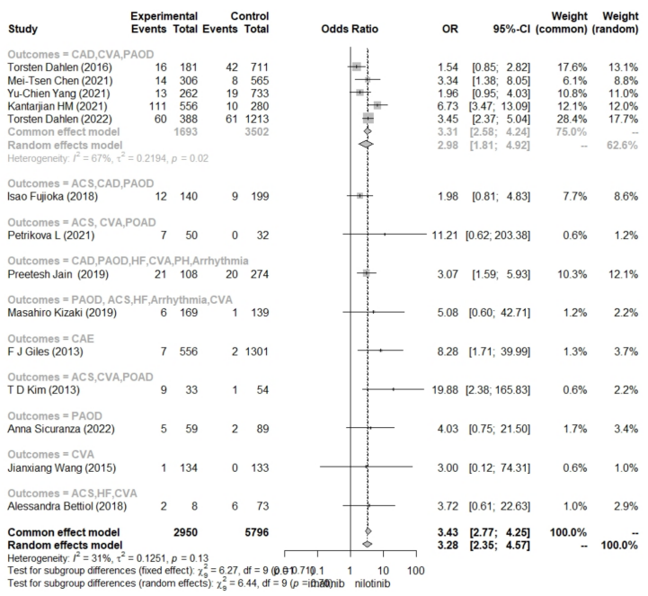

Figure 1 Subgroup analysis for CAE (A.sample size B. median follow-up time C.nilotinib dose D. nilotinib duration E. imatinib_dose F. imatinib_duration G. outcomes)

A  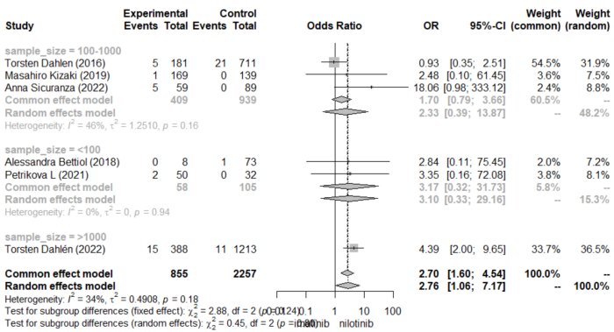 | B  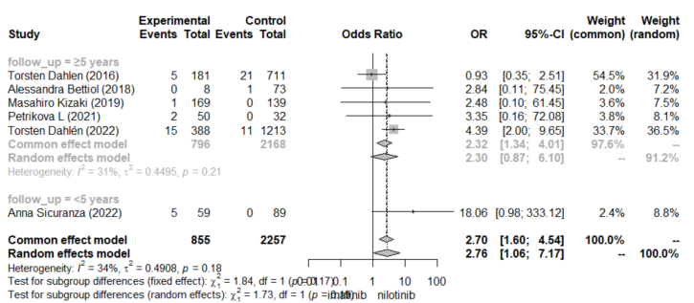
C  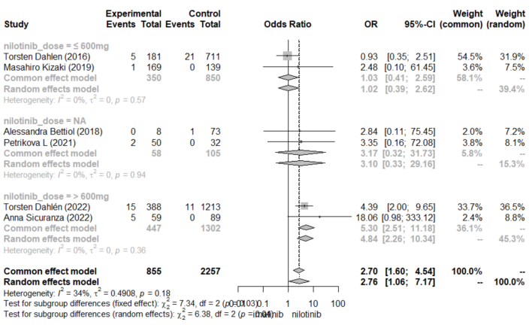 | D  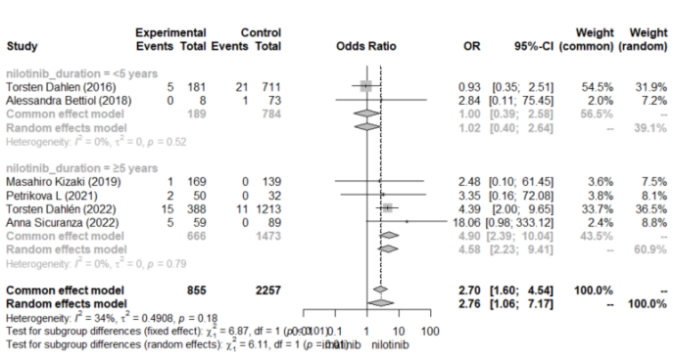
E  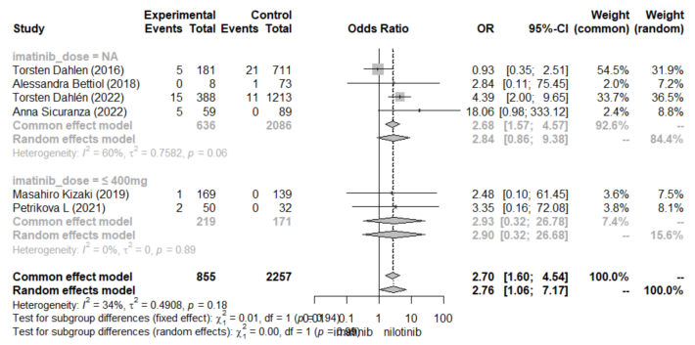 | F  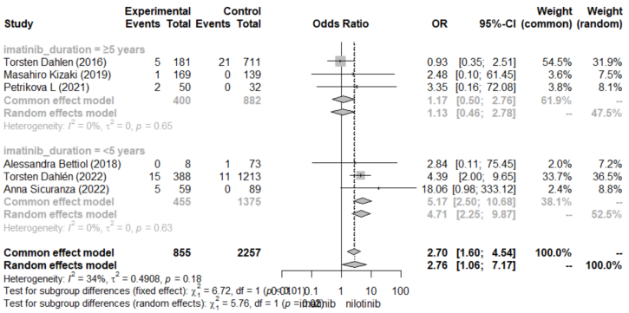

Figure 2 Subgroup analysis for ACS (A.sample size B. median follow-up time C.nilotinib dose D. nilotinib duration E. Imatinib_dose F. Imatinib_duration )

A  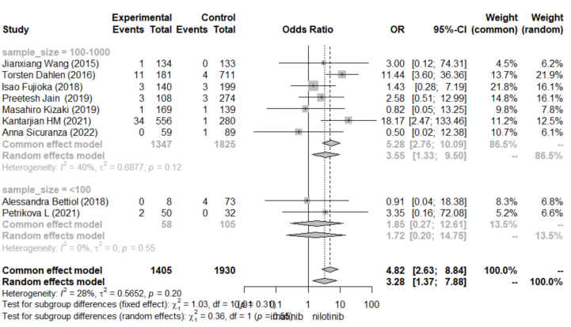 | B  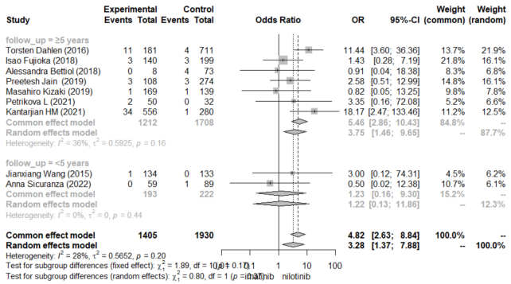
C  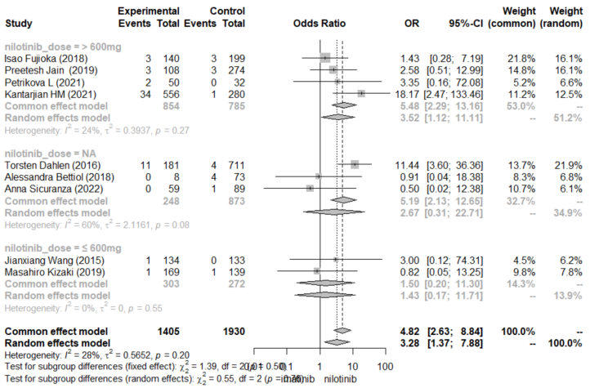 | D  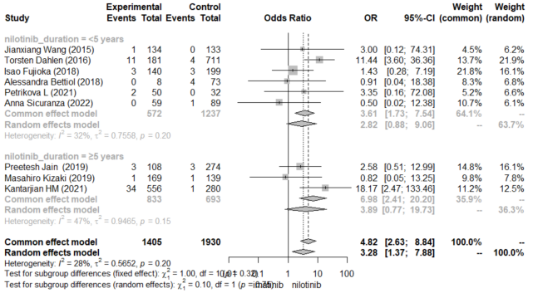
E  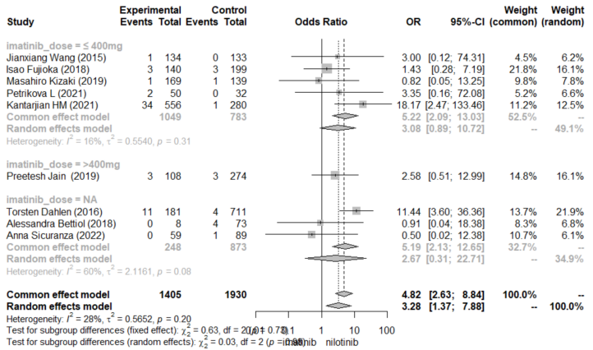 | F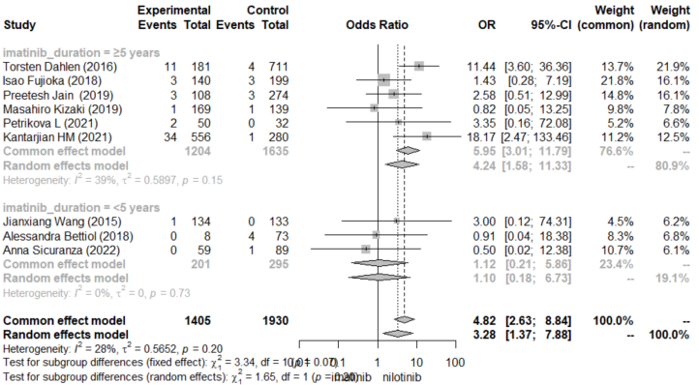
Figure 3 Subgroup analysis for CVA (A.sample size B. median follow-up time C.nilotinib dose D. nilotinib duration E. Imatinib_dose F. Imatinib_duration)

A  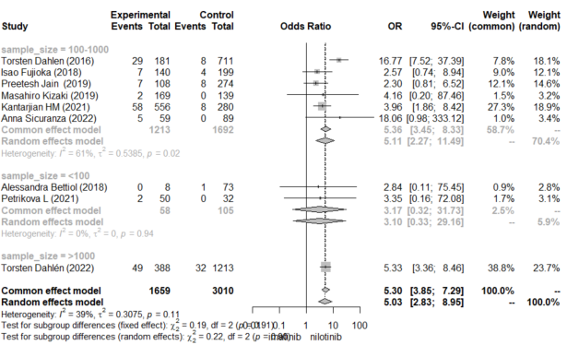 | B  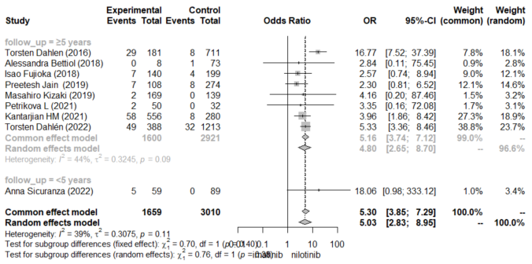
C  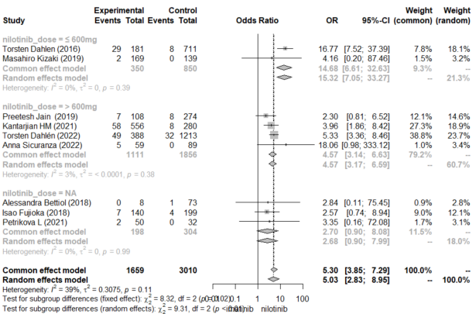 | D  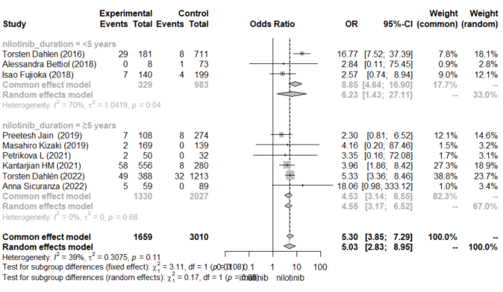
E  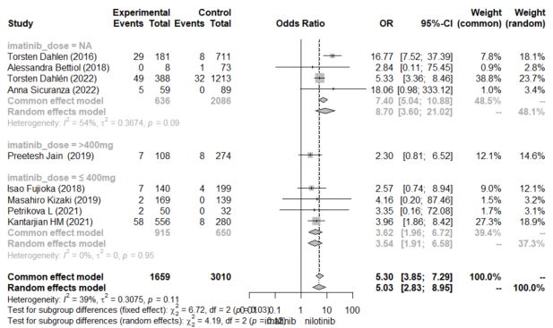 | F  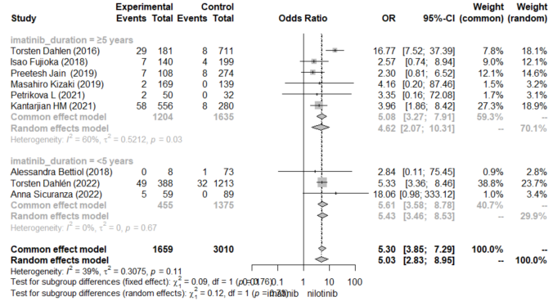

Figure 4 Subgroup analysis for CAD (A.sample size B. median follow-up time C.nilotinib dose D. nilotinib duration E. Imatinib_dose F. Imatinib_duration )

A  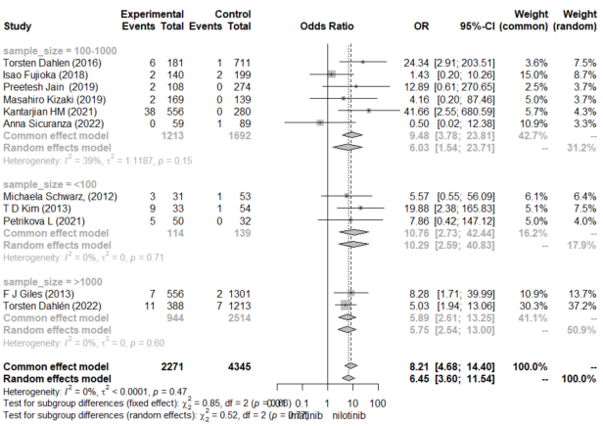 | B  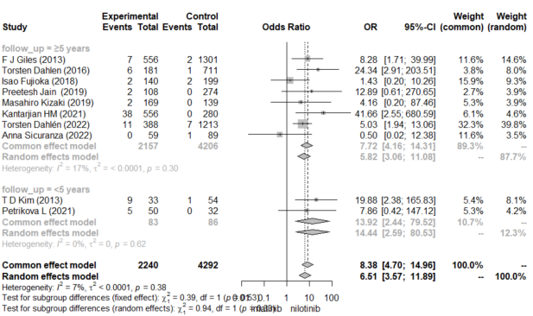
C  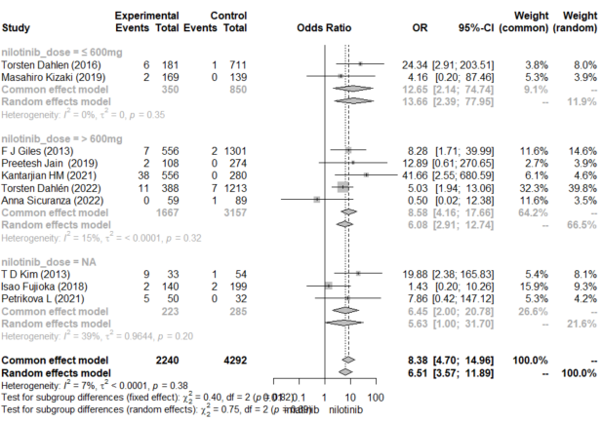 | D  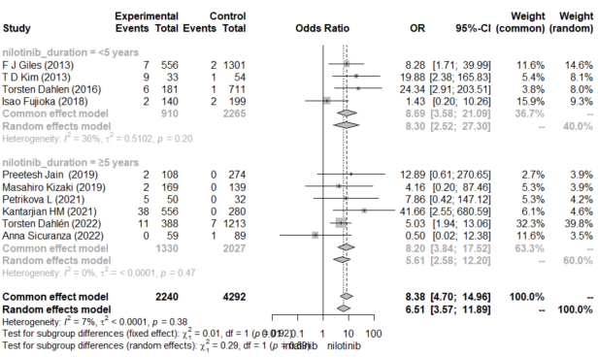
E  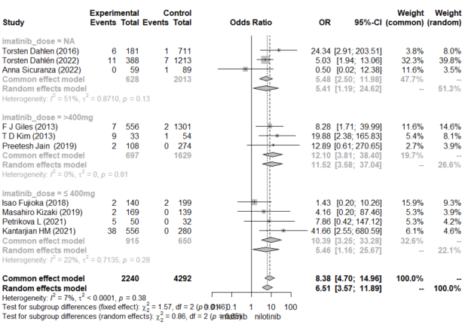 | F  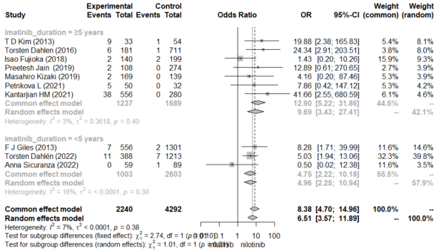
Figure 5 Subgroup analysis for PAOD (A.sample size B. median follow-up time C.nilotinib dose D. nilotinib duration E. Imatinib_dose F. Imatinib_duration )

A  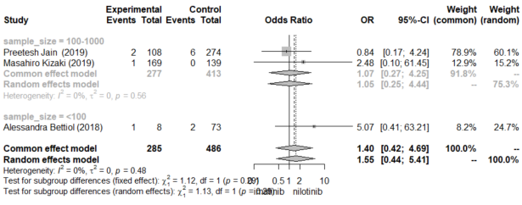 | B  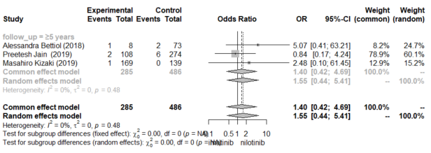
C  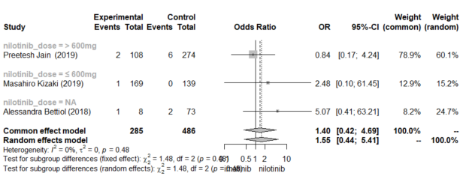 | D  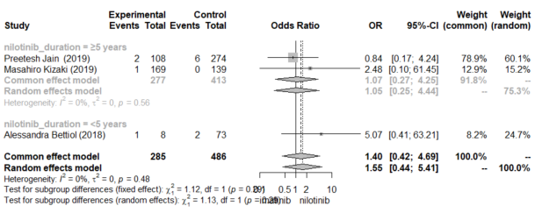
E  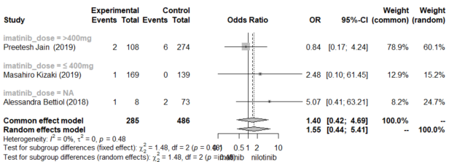 | F  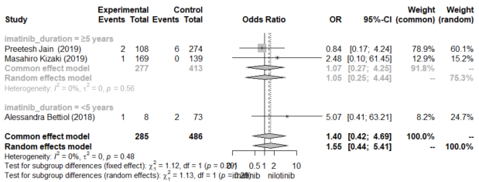
Figure 6 Subgroup analysis for HF (A.sample size B. median follow-up time C.nilotinib dose D. nilotinib duration E. imatinib_dose F. imatinib_duration)

A.  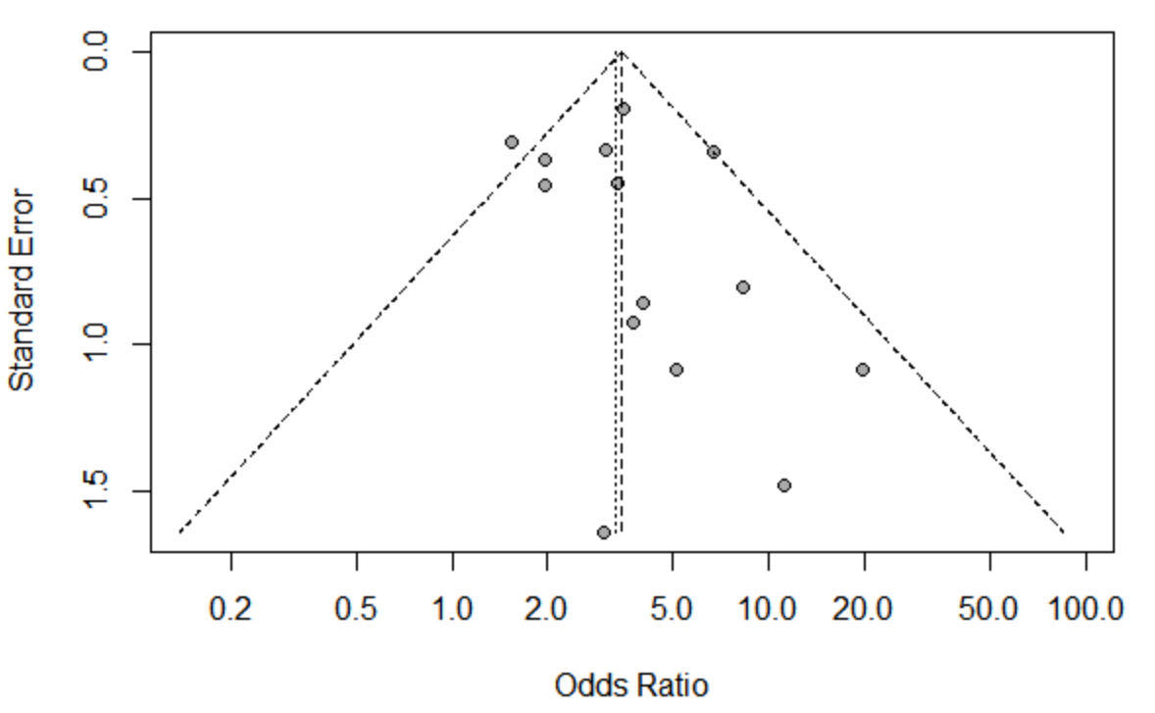 | B.  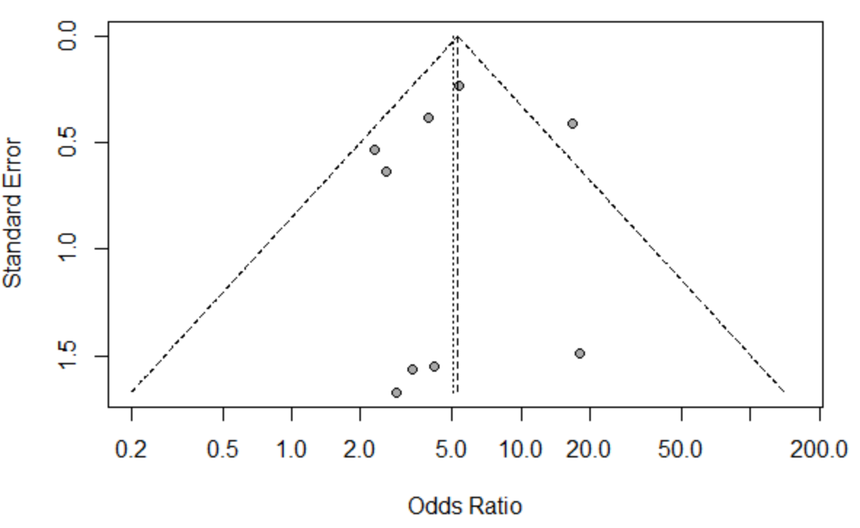
C.  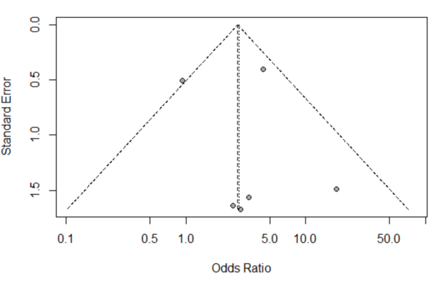 | D.  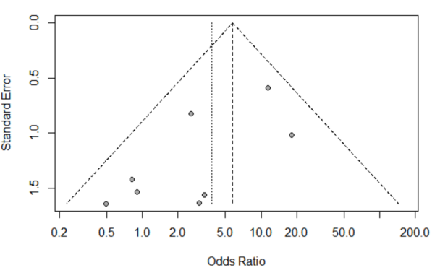
E.  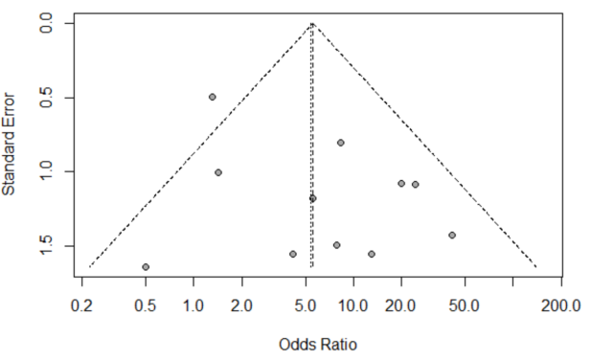 | 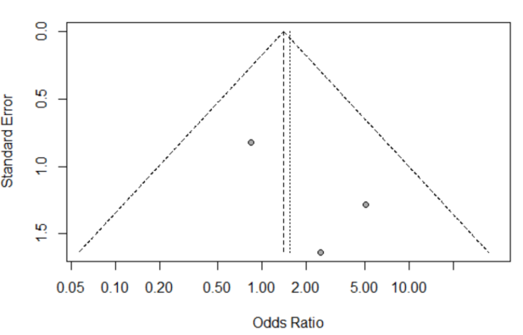
Figure 7 Begg’s forest plots ( A. CAE-OR B. CAE-HR C. CAD D. ACS E. CVA F.PAOD G. HF H.Arrhythmia)

A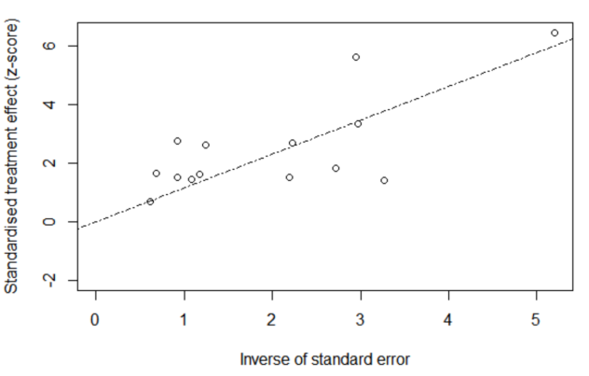 | B  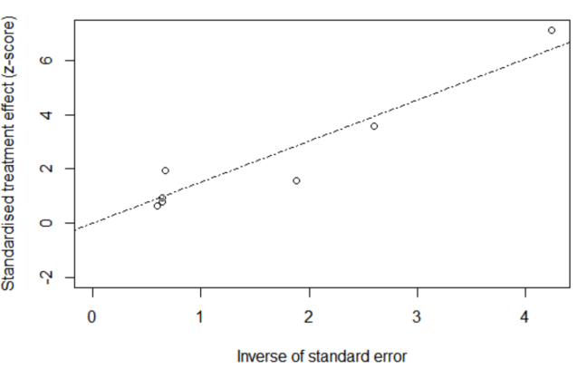
C  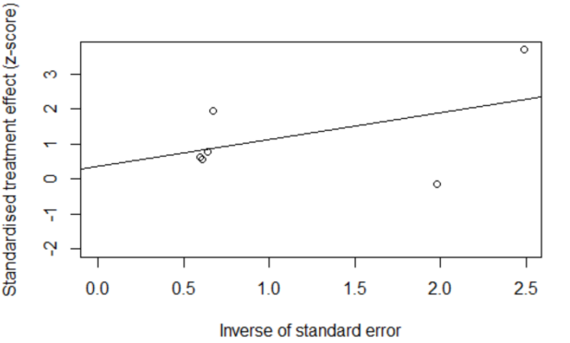 | D  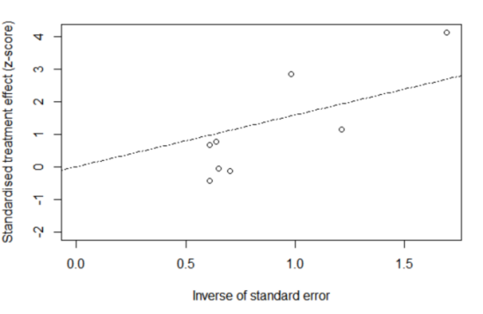
E  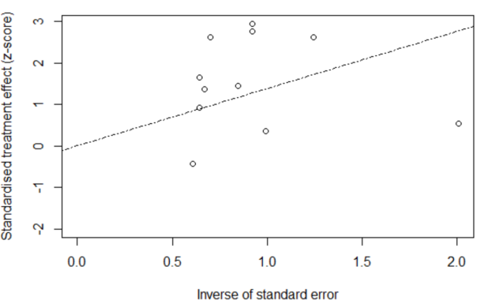 | F  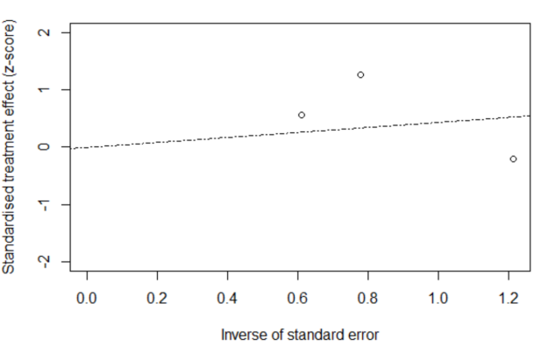
Figure 8 Egger’s regression asymmetry plots ( A. CAE-OR B. CAE-HR C. CAD D. ACS E. CVA F.PAOD G. HF H.Arrhythmia)

Except for the ACS , the results for every outcome could be considered as stable. In terms of the ACS, except for the (Torsten Dahlen,2016), omitting anyone of the studies would change the results.

A  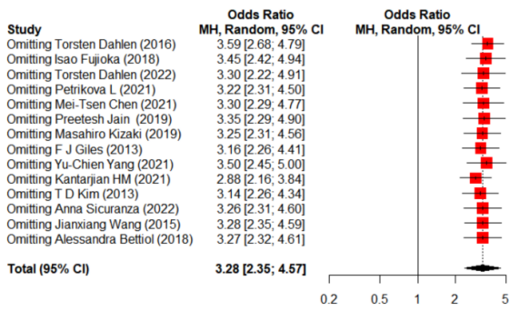 | B  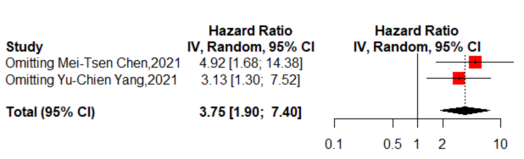
C  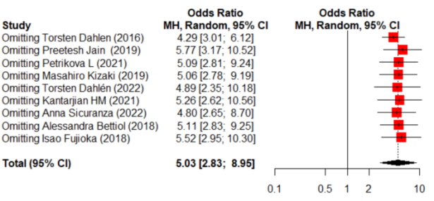 | D  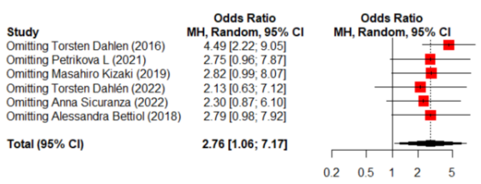
E  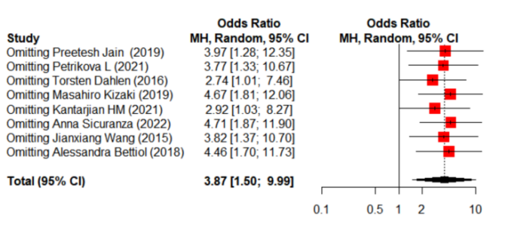 | F  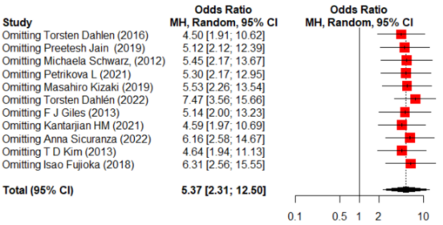
G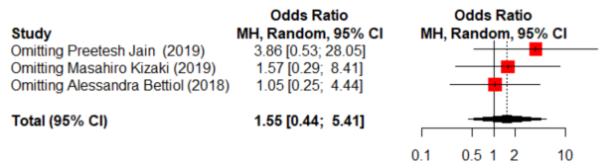 | H  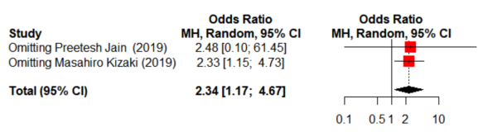
Figure 9 Sensitivity analysis ( A. CAE-OR B. CAE-HR C. CAD D. ACS E. CVA F.PAOD G. HF H.Arrhythmia)

(Torsten Dahlen,2016) contributed the most to heterogeneity in the comparison of CAD, ACS, CVA, while in CAE, PAOD and HF, (Yu-Chien Yang,2021), (Torsten Dahlén,2022)and (Alessandra Bettiol,2018) contributed the most to heterogeneity respectively.

A  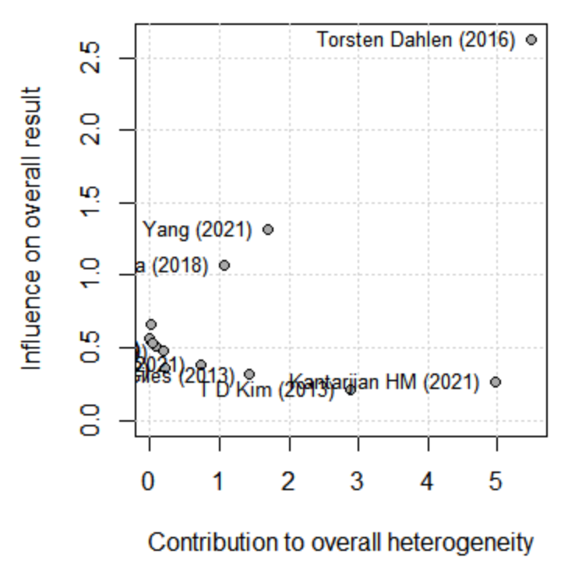 | B  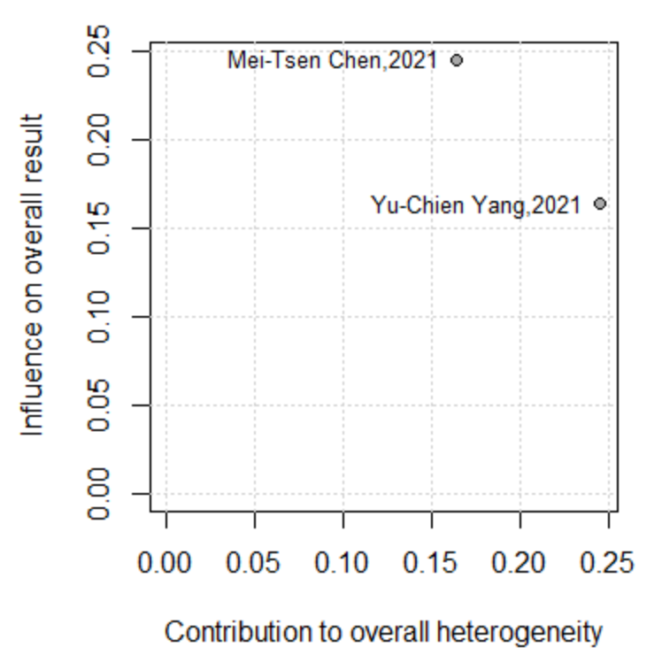
C  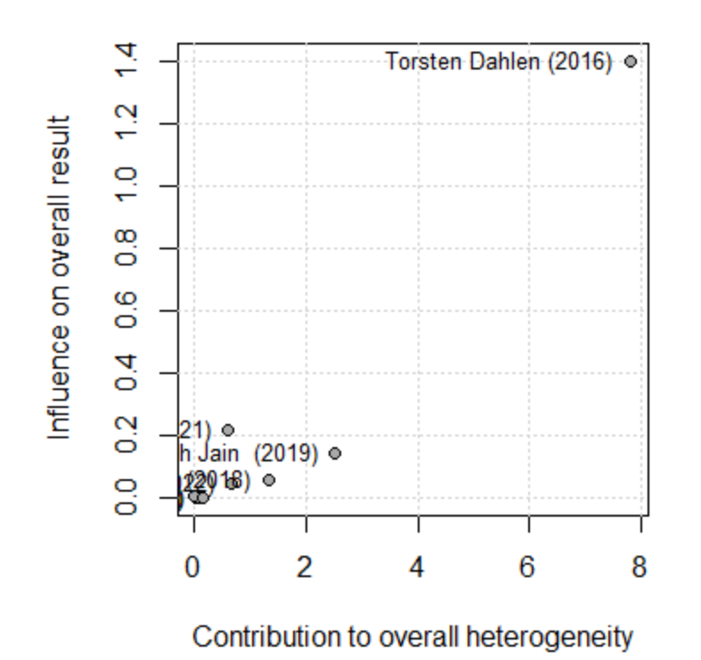 | D  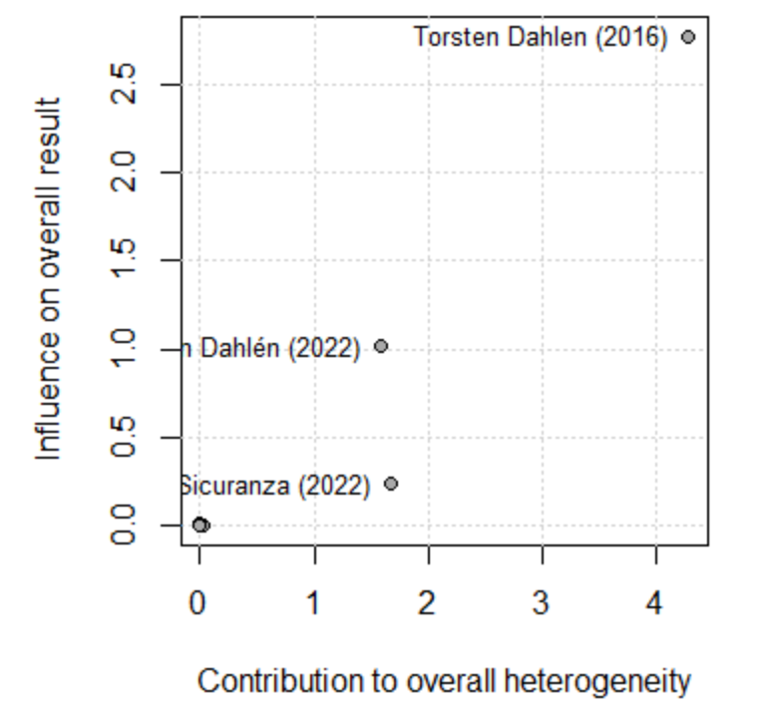
E  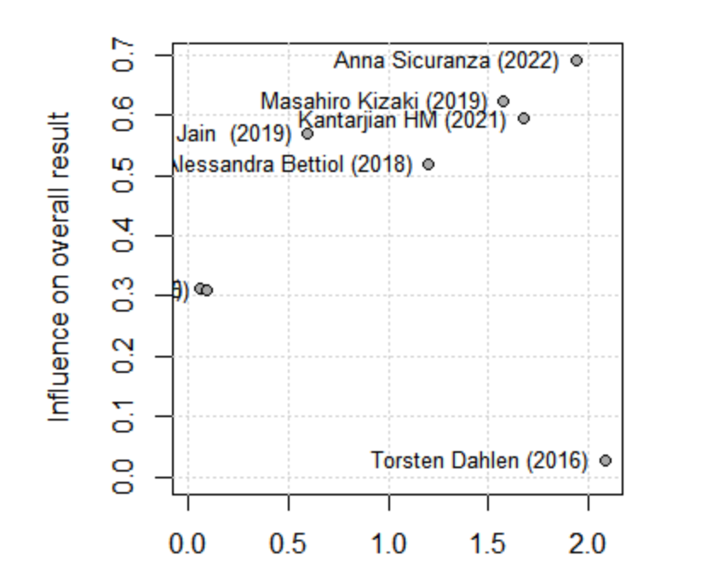 | F  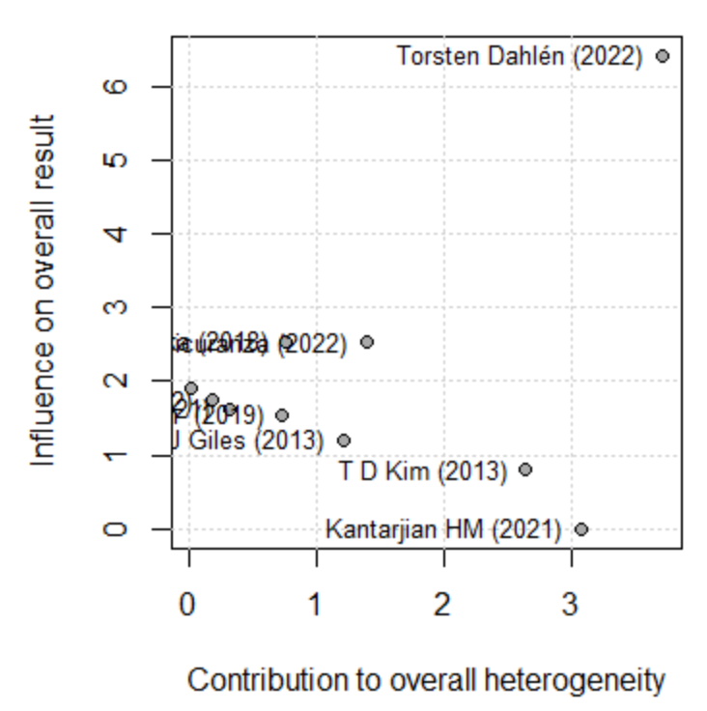
G  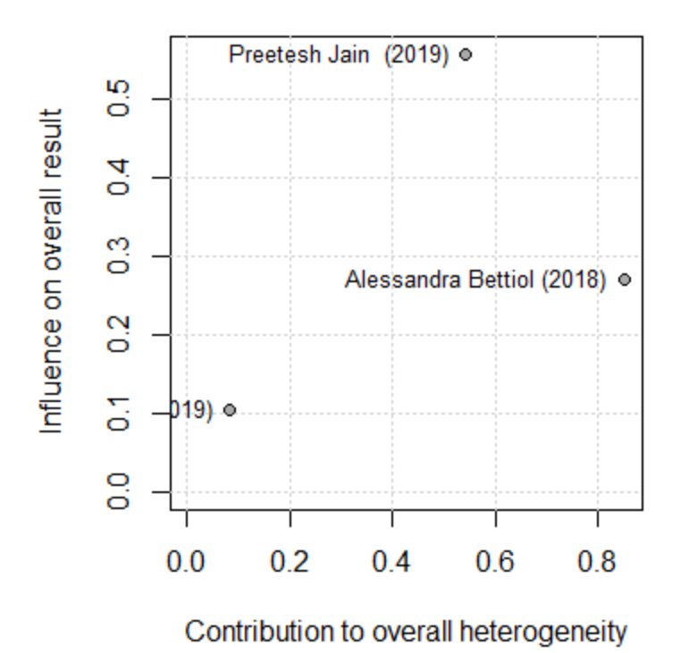 | H  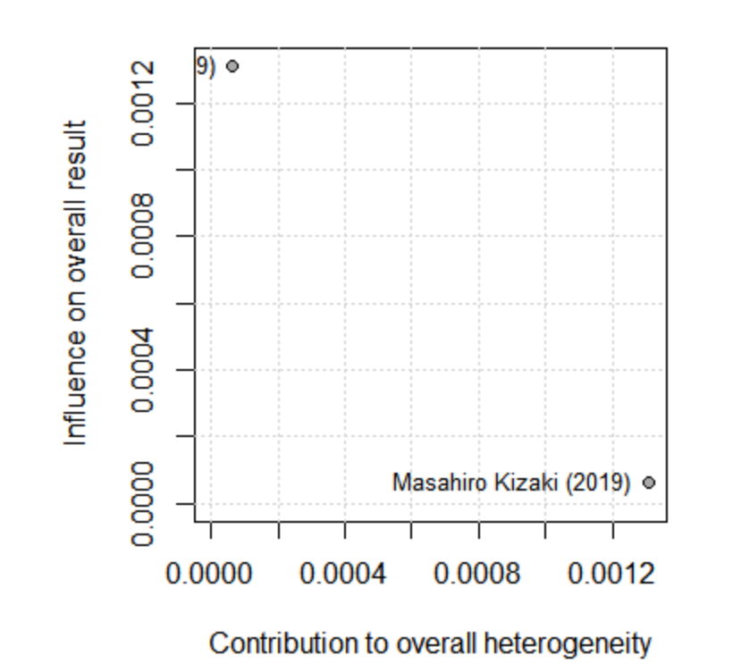
Figure 10 Baujat Plots for heterogeneity analysis( A. CAE-OR B. CAE-HR C. CAD D. ACS E. CVA F.PAOD G. HF H.Arrhythmia)

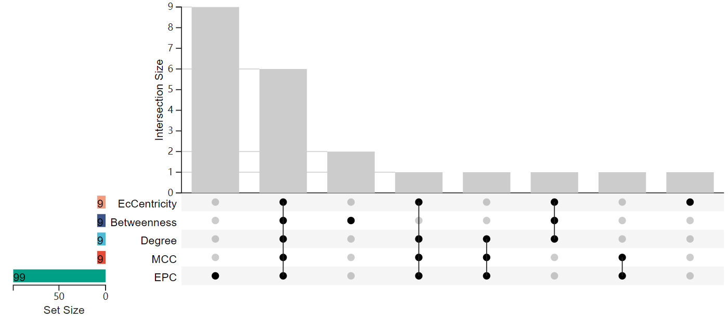
Figure 11 Upset-R plots for TOP 10 hub genes ( human cardiomyocytes)

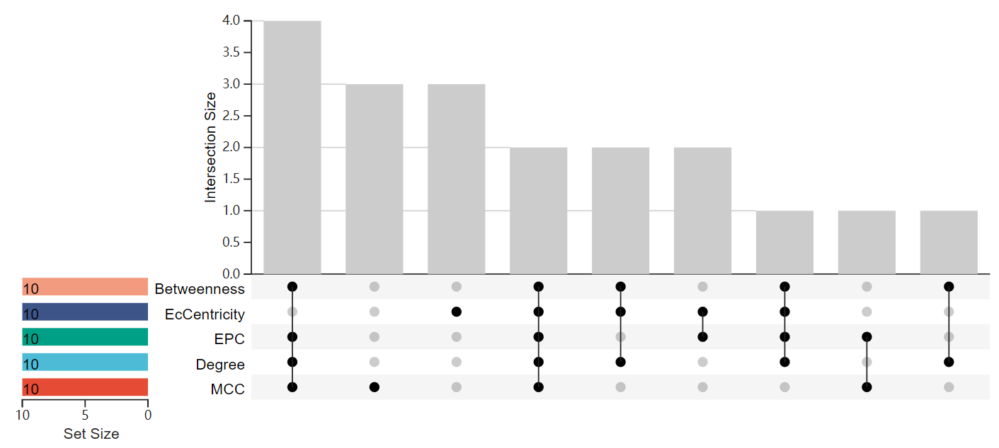
Figure 12 Upset-R plots for TOP 10 hub genes(Mus musculus liver samples)

