Supplementary material
Search Strategy

Database | Number of literatures
PubMed | 410
Embase | 20
Cochrane | 1
Medline | 4

PubMed:
(endoscopic grading of gastric intestinal metaplasia) OR (EGGIM)
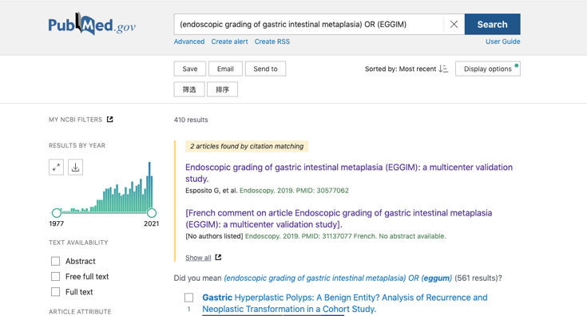

Embase:
'endoscopic grading of gastric intestinal metaplasia':ti,ab,kw OR eggim:ti,ab,kw


Cochrane
(endoscopic grading of gastric intestinal metaplasia) OR (EGGIM)
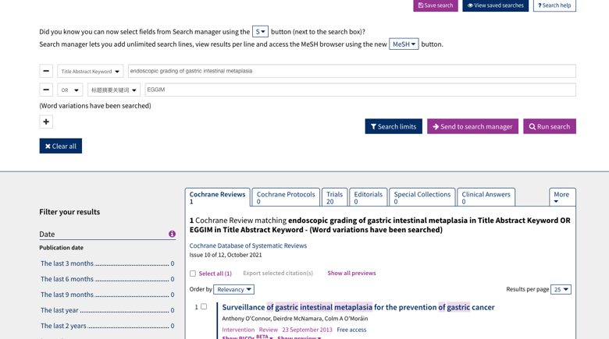

Medline:
(endoscopic grading of gastric intestinal metaplasia) OR (EGGIM)


