Supplementary Materials
Study protocol and search strategy
- INTRODUCTION
Most children with COVID-19 have milder clinical symptoms and better prognosis when compared with adults. However, as the number of confirmed cases in children and adolescents continues to rise globally, the number of children with poor prognosis such as respiratory failure and multiple organ failure is increasing. Therefore, a clear understanding of risk factors for poor prognosis is helpful for early identification of high-risk children, hierarchical management and prevention of disease development.

- METHODS
2.1. Types of included studies
a) studies that conducted with COVID-19 children and adolescents (aged ≤18 years) and that focused on risk factors for poor prognosis.
b) poor prognosis included death, admission to ICU, receiving respiratory support, and progression to severe or critical disease.
c) cohort studies, case-control studies and case series.
d) we excluded duplicates, non-English or Chinese articles, conference abstracts, and studies where full text could not be retrieved or data were missing.
2.2. Searches
2.2.1. Search approach:
a) Electronic databases: MEDLINE (via PubMed), WHO COVID-19 database, Web of Science, the Cochrane library, China Biology Medicine (CBM), China National Knowledge Infrastructure (CNKI), Wanfang Data
b) clinical trial registry platforms: the WHO Clinical Trials Registry Platform and US National Institutes of Health Trials Register.
c) preprint servers: MedRxiv, BioRxiv and SSRN;
d) Google.
2.2.2. Search time:
from inception to March 8, 2021
2.2.3. Search strategy
The following search strategy that developed combining the Mesh and key words by an information specialist will be used:
MEDLINE (via PubMed)
#1. "COVID-19"[Mesh]
#2. "SARS-CoV-2"[Mesh]
#3. "COVID-19"[Title/Abstract]
#4. "SARS-COV-2"[Title/Abstract]
#5. "SARS COV 2"[Title/Abstract]
#6. "Novel coronavirus"[Title/Abstract]
#7. "2019-novel coronavirus"[Title/Abstract]
#8. "Coronavirus disease-19"[Title/Abstract]
#9. "Coronavirus disease 19"[Title/Abstract]
#10. "Coronavirus disease 2019"[Title/Abstract]
#11. "COVID 19"[Title/Abstract]
#12. "Novel CoV"[Title/Abstract]
#13. "2019-nCoV"[Title/Abstract]
#14. "2019 nCoV"[Title/Abstract]
#15. "2019-CoV"[Title/Abstract]
#16. OR/#1-#15
#17. "Risk Factors"[Mesh]
#18. "Prognosis"[Mesh]
#19. "Prognostic" [Title/Abstract]
#20. "Prognosis" [Title/Abstract]
#21. "Predictor*" [Title/Abstract]
#22. OR/#17-#21
#23. "Risk"[Title/Abstract]
#24. "Associated"[Title/Abstract]
#25. OR/#23-#24
#26. "Factor*"[Title/Abstract]
#27. #25 AND #26
#28. #22 OR/#27
#29. "Child" [Mesh]
#30. "Adolescent" [Mesh]
#31. "Children" [Title/Abstract]
#32. "Adolescen*" [Title/Abstract]
#33. "Pediatric*" [Title/Abstract]
#34. "Paediatric*" [Title/Abstract]
#35. "Infant" [Title/Abstract]
#36. "junior*" [Title/Abstract]
#37. "juvenile*" [Title/Abstract]
#38. "neona*" [Title/Abstract]
#39. "newborn*" [Title/Abstract]
#40. "young*" [Title/Abstract]
#41. "teen*" [Title/Abstract]
#42. OR/#29-#41
#43. #16 AND #28 AND #42
#44. "Animals"[Mesh]
#45. "Humans"[Mesh]
#46. #44 NOT # 45
#47. #43 NOT # 46
#48. Filters in Humans
#49. From 2020/1/1 to 3000/12/12

WHO COVID-19 database
#1. tw:(Prognostic)
#2. tw:(Prognosis)
#3. tw:(Predictor*)
#4. OR/#1-#3
#5. tw:(Risk)
#6. tw:(Associated)
#7. OR/#5-#6
#8. tw:(Factor*)
#9. #7 AND #8
#10. #4 OR/#9
#11. "Children" [Title/Abstract]
#12. "Adolescen*" [Title/Abstract]
#13. "Pediatric*" [Title/Abstract]
#14. "Paediatric*" [Title/Abstract]
#15. "Infant" [Title/Abstract]
#16. "junior*" [Title/Abstract]
#17. "juvenile*" [Title/Abstract]
#18. "neona*" [Title/Abstract]
#19. "newborn*" [Title/Abstract]
#20. "young*" [Title/Abstract]
#21. "teen*" [Title/Abstract]
#22. #11 OR/#21
#23. #10 AND #22
#24. Filter in WHO COVID database and Grey literature

Web of Science
#1. TOPIC: “COVID-19”
#2. TOPIC: “SARS-COV-2”
#3. TOPIC: “SARS-COV 2”
#4. TOPIC: “Novel coronavirus”
#5. TOPIC: “2019-novel coronavirus”
#6. TOPIC: “coronavirus disease-19”
#7. TOPIC: “coronavirus disease 19”
#8. TOPIC: “coronavirus disease 2019”
#9. TOPIC: “COVID 19”
#10. TOPIC: “Novel CoV”
#11. TOPIC: “2019-nCoV”
#12. TOPIC: “2019 nCoV”
#13. TOPIC: “2019-CoV”
#14. OR/#1-#13
#15. TOPIC: “Prognostic”
#16. TOPIC: “Prognosis”
#17. TOPIC: “Predictor*”
#18. OR/#15-#18
#19. TOPIC: “Risk”
#20. TOPIC: “Associated”
#21. OR/#19-#20
#22. TOPIC: “Factor*”
#23. #21 AND #22
#24. #18 OR/#23
#25. TOPIC: “Children”
#26. TOPIC: “Adolescen*”
#27. TOPIC: “Pediatric*”
#28. TOPIC: “Paediatric*”
#29. TOPIC: “Infant”
#30. TOPIC: “junior*”
#31. TOPIC: “juvenile*”
#32. TOPIC: “neona*”
#33. TOPIC: “newborn*”
#34. TOPIC: “young*”
#35. TOPIC: “teen*”
#36. OR/#25-#35
#37. #14 AND #24 AND #36

The Cochrane Library
#1 MeSH descriptor: [COVID-19] explode all trees
#2 "COVID-19":ti,ab,kw
#3 "SARS-COV-2":ti,ab,kw
#4 "SARS-COV 2":ti,ab,kw
#5 "Novel coronavirus":ti,ab,kw
#6 "2019-novel coronavirus" :ti,ab,kw
#7 "coronavirus disease-19" :ti,ab,kw
#8 "coronavirus disease 19" :ti,ab,kw
#9 "coronavirus disease 2019" :ti,ab,kw
#10. "COVID 19" :ti,ab,kw
#11. "Novel CoV" :ti,ab,kw
#12. "2019-nCoV" :ti,ab,kw
#13. "2019 nCoV" :ti,ab,kw
#14 "2019-CoV" :ti,ab,kw
#15. OR/#1-#14
#16. MeSH descriptor: [Risk Factors] explode all trees
#17. MeSH descriptor: [Prognosis] explode all trees
#18. "Prognostic" :ti,ab,kw
#19. "Prognosis" :ti,ab,kw
#20. "Predictor*" :ti,ab,kw
#21. OR/#16-#20
#22. "Risk" :ti,ab,kw
#23. "Associated" :ti,ab,kw
#24. OR/#22-#23
#25. "Factor*" :ti,ab,kw
#26. #24 AND #25
#27. #21 OR/#26
#28. MeSH descriptor: [Child] explode all trees
#29. MeSH descriptor: [Adolescent] explode all trees
#30. "Children":ti,ab,kw
#31. "Adolescen*":ti,ab,kw
#32. "Pediatric*":ti,ab,kw
#33. "Paediatric*":ti,ab,kw
#34. "Infant":ti,ab,kw
#35. "junior*":ti,ab,kw
#36. "juvenile*":ti,ab,kw
#37. "neona*":ti,ab,kw
#38. "newborn*":ti,ab,kw
#39. "young*":ti,ab,kw
#40. "teen*":ti,ab,kw
#41. OR/#28-#40
#42. #15 AND #27 AND #41

CNKI
#1. "新型冠状病毒"(主题)
#2. "COVID-19"(主题)
#3. "COVID 19"(主题)
#4. "2019-nCoV"(主题)
#5. "2019 nCoV"(主题)
#6. "2019-CoV"(主题)
#7. "2019 CoV"(主题)
#8. "SARS-CoV-2"(主题)
#9. "SARS COV 2"(主题)
#10. "新冠肺炎"(主题)
#11. OR/#1-#10
#12. "预后"(主题)
#13. "因素"(主题)
#14. "死亡"(主题)
#15. OR/#12-#14
#16. "儿童"(主题)
#17. "幼儿"(主题)
#18. "婴儿"(主题)
#19. "新生儿"(主题)
#20. "青少年"(主题)
#21. OR/#16-#20
#22. #11 AND #15 AND #21
#23. 限定医药卫生科技
#24. 限定中文文献

WanFang Data
#1. "新型冠状病毒"(主题)
#2. "COVID-19"(主题)
#3. "COVID 19"(主题)
#4. "2019-nCoV"(主题)
#5. "2019 nCoV"(主题)
#6. "2019-CoV"(主题)
#7. "2019 CoV"(主题)
#8. "SARS-CoV-2"(主题)
#9. "SARS COV 2"(主题)
#10. "新冠肺炎"(主题)
#11. OR/#1-#10
#12. "预后"(主题)
#13. "因素"(主题)
#14. "死亡"(主题)
#15. OR/#12-#14
#16. "儿童"(主题)
#17. "幼儿"(主题)
#18. "婴儿"(主题)
#19. "新生儿"(主题)
#20. "青少年"(主题)
#21. OR/#16-#20
#22. #11 AND #15 AND #21
#23. 限定医药卫生

CBM
#1. "新型冠状病毒"[常用字段:智能]
#2. "COVID-19"[常用字段:智能]
#3. "COVID 19"[常用字段:智能]
#4. "2019-nCoV"[常用字段:智能]
#5. "2019 nCoV"[常用字段:智能]
#6. "2019-CoV"[常用字段:智能]
#7. "2019 CoV"[常用字段:智能]
#8. "SARS-COV-2"[常用字段:智能]
#9. "SARS-COV 2"[常用字段:智能]
#10. "新冠肺炎"[常用字段:智能]
#11. OR/#1-#10
#12. "预后"[不加权:扩展]
#13. "危险因素"[不加权:扩展]
#14. "预后"[常用字段:智能]
#15. "死亡"[常用字段:智能]
#16. "因素"[常用字段:智能]
#17. OR/#12-#16
#18. "儿童"[不加权:扩展]
#19. "青少年"[不加权:扩展]
#20. "儿童"[常用字段:智能]
#21. "幼儿"[常用字段:智能]
#22. "婴儿"[常用字段:智能]
#23. "新生儿"[常用字段:智能]
#24. "青少年"[常用字段:智能]
#25. OR/#18-#24
#26. #11 AND #17 AND #25

2.5. Data extraction (selection and coding)
2.5.1. Selection of studies:
One review author will search all databases based on the search strategy and exclude duplicate literatures. Then four review authors in two groups of two will independently screen titles and abstracts for inclusion of all potential studies at first. In the case of disagreement, difference will be solved through discussion, and a senior review author will be consulted if it is necessary. All reasons for exclusion of the studies will be documented. The details of the selection process will be provided in the PRISMA flow diagram.
2.5.2. Data extraction:
Two independent review author will use a standard form for all extracted data. Before the formal extraction, a pretest will be conducted.
2.6. Risk of bias assessment
a) cohort studies: Newcastle-Ottawa Scale
- Representativeness of the exposed cohort
- Selection of the non exposed cohort
- Ascertainment of exposure to implants
- Demonstration that outcome of interest was not present at start of study
- Study controls the most important factor
- Study controls for any additional factor
- Assessment of outcome
- Was follow up long enough for outcomes to occur
- Adequacy of follow up of cohorts
b) case-control studies: Newcastle-Ottawa Scale
- Is the Case Definition Adequate?
- Representativeness of the Cases
- Selection of Controls
- Definition of Controls
- Study controls the most important factor
- Study controls for any additional factor
- Ascertainment of Exposure
- Same method of ascertainment for cases and controls
- Non-Response Rate
c) case series: Institute of Health Economics checklist
- Is the hypothesis, aim, objective of the study clearly stated?
- Are the characteristics of the participants included in the study described?
- Were the cases collected in more than one centre?
- Are the eligibility criteria for entry into the study clearly stated?
- Were participants recruited consecutively?
- Did participants enter the study at a similar point in the disease?
- Was the intervention of interest clearly described?
- Were additional interventions (co-interventions) reported in the study?
- Are the outcome measures established a priori?
- Were the relevant outcomes measured with appropriate objective and/or subjective methods?
- Were the relevant outcomes measured before and after the intervention?
- Were the statistical tests used to assess the relevant outcomes appropriate?
- Was the length of follow-up reported?
- Was the loss to follow-up reported?
- Does the study provide estimates of the random variability in the data analysis of relevant outcomes?
- Are the adverse events related with the intervention reported?
- Are the conclusions of the study supported by results?
- Are both competing interests and sources of support for the study reported?
- Was the study conducted prospectively?
- Were the relevant outcomes assessed blinded to intervention status?
2.7. Data analysis
2.7.1.Meta-analysis
In this systematic review, we will use the odds ratio (OR) and mean difference (MD) between groups with 95% confidence interval (CIs) as effect indicators for dichotomous and continuous outcomes. If data is sufficient, we will process the data according to the Cochrane Handbook by using random-effects models using Stata 14 software.
2.7.2. Missing data
For missing standard deviation, standard errors (SE) will be converted to SDs when SE is presented, and if both are missing, we will estimate SDs from P values or 95% CI. For missing means, we will estimate them from interquartile ranges and medians.
2.7.3. Assessment of heterogeneity
The I² statistic will becalculated to present between-study heterogeneity, where I² ≤40%, between 30% and 60%, between 50% and 90%, and ≥75% are considered to indicate low, moderate, substantial, and considerable heterogeneity, respectively.
2.7.4. Assessment of reporting bias
Publication bias will be assessed by examining the symmetry of the funnel-plot if sufficient studies were present.
2.8. Quality of evidence
The certainty of evidence will be assessed by using the GRADE (Grading of Recommendations Assessment, Development, and Evaluation) approach.

Contact
Yaolong Chen,
Email: chevidence@lzu.edu.cn

Risk of bias
eTable 1. Risk of bias for the included cohort studies as assessed by the Newcastle-Ottawa Scale
Study ID | Selection of exposure
Study ID | Representativeness of the exposed cohort | Selection of the non exposed cohort | Ascertainment of exposure to implants | Demonstration that outcome of interest was not present at start of study
Alfraij et al, 2021 | Yes | Yes | Yes | Yes
Antúnez-Montes et al, 2021 | Yes | Yes | Yes | Yes
Bailey et al, 2021 | Yes | Yes | Yes | No
Bari et al, 2021a | Yes | Yes | Yes | Yes
Basalely et al, 2021 | Yes | Yes | Yes | No
Besli et al, 2021 | Yes | Yes | Yes | No
Farzan et al, 2021 | No | Yes | Yes | No
Fernandes et al, 2021 | Yes | Yes | Yes | Yes
Götzinger et al, 2020 | Yes | Yes | Yes | Yes
Graff et al, 2021 | Yes | Yes | Yes | Yes
Kainth et al, 2020 | No | Yes | Yes | No
Kari et al, 2021 | Yes | Yes | Yes | No
Kelly et al, 2021 | Yes | Yes | Yes | No
Madhusoodhan et al, 2021 | Yes | Yes | Yes | No
Prata-Barbosa et al, 2020 | Yes | Yes | No | Yes
Shi et al, 2021 | Yes | Yes | Yes | No
Song et al, 2021 | Yes | Yes | Yes | No
Surendra et al, 2021 | Yes | Yes | Yes | No
Swann et al, 2020 | Yes | Yes | Yes | Yes
Tripathi et al, 2021 | Yes | Yes | Yes | No
Verma et al, 2021 | Yes | Yes | No | Yes
Yazidi et al, 2021 | Yes | Yes | Yes | No

Continued eTable 1
Study ID | Comparability |  | Outcome |  |  |  | Total score
Study ID | Study controls the most important factor | Study controls for any additional factor |  | Assessment of outcome | Was follow up long enough for outcomes to occur | Adequacy of follow up of cohorts | Total score
Alfraij et al, 2021 | No | No |  | Yes | Yes | Yes | 7
Antúnez-Montes et al, 2021 | No | No |  | Yes | Yes | Yes | 7
Bailey et al, 2021 | No | No |  | Yes | Yes | Yes | 6
Bari et al, 2021a | No | No |  | No | Yes | Yes | 6
Basalely et al, 2021 | No | No |  | Yes | Yes | Yes | 6
Besli et al, 2021 | No | No |  | Yes | Yes | Yes | 6
Farzan et al, 2021 | No | No |  | Yes | Yes | Yes | 5
Fernandes et al, 2021 | Yes | No |  | No | Yes | Yes | 7
Götzinger et al, 2020 | No | No |  | Yes | Yes | Yes | 7
Graff et al, 2021 | No | No |  | Yes | Yes | Yes | 7
Kainth et al, 2020 | No | No |  | Yes | Yes | Yes | 5
Kari et al, 2021 | No | No |  | Yes | Yes | Yes | 6
Kelly et al, 2021 | No | No |  | Yes | Yes | Yes | 6
Madhusoodhan et al, 2021 | Yes | No |  | Yes | Yes | Yes | 7
Prata-Barbosa et al, 2020 | No | No |  | No | Yes | Yes | 5
Shi et al, 2021 | No | No |  | Yes | Yes | Yes | 6
Song et al, 2021 | Yes | Yes |  | Yes | Yes | Yes | 8
Surendra et al, 2021 | Yes | Yes |  | Yes | Yes | Yes | 8
Swann et al, 2020 | No | No |  | Yes | Yes | Yes | 7
Tripathi et al, 2021 | No | No |  | Yes | Yes | Yes | 6
Verma et al, 2021 | No | No |  | No | Yes | Yes | 5
Yazidi et al, 2021 | No | No |  | Yes | Yes | Yes | 6
 | eTable 2. Risk of bias for the included case-control studies as assessed by the Newcastle-Ottawa Scale
 | Study ID |  |  |  |  | Selection
 |  |  |  |  |  | Is the Case Definition Adequate? |  |  |  |  |  | Representativeness of the Cases |  |  |  |  |  |  |  | Selection of Controls |  |  |  | Definition of Controls
 | Abrams et al, 2021 |  |  |  |  | Yes |  |  |  |  |  | Yes |  |  |  |  |  |  |  | No |  |  |  | No
 | Aykac et al, 2021 |  |  |  |  | Yes |  |  |  |  |  | Yes |  |  |  |  |  |  |  | No |  |  |  | Yes
 | Cho et al, 2021 |  |  |  |  | Yes |  |  |  |  |  | Yes |  |  |  |  |  |  |  | No |  |  |  | No
 | Chopra et al, 2021 |  |  |  |  | Yes |  |  |  |  |  | No |  |  |  |  |  |  |  | No |  |  |  | Yes
 | Coronado Munoz et al, 2021 |  |  |  |  | Yes |  |  |  |  |  | Yes |  |  |  |  |  |  |  | No |  |  |  | Yes
 | Lu et al, 2021 |  |  |  |  | No |  |  |  |  |  | No |  |  |  |  |  |  |  | No |  |  |  | Yes
 | Moreira et al, 2021 |  |  |  |  | Yes |  |  |  |  |  | Yes |  |  |  |  |  |  |  | No |  |  |  | No
 | Ozsurekci et al, 2020 |  |  |  |  | Yes |  |  |  |  |  | Yes |  |  |  |  |  |  |  | No |  |  |  | Yes
 | Wang et al, 2020 |  |  |  |  | Yes |  |  |  |  |  | Yes |  |  |  |  |  |  |  | No |  |  |  | Yes
 | Continued eTable 2
 | Study ID |  |  | Comparability |  |  |  |  |  |  |  |  |  |  | Exposure |  |  |  |  |  |  |  |  |  |  |  |  |  | Total score
 |  |  |  | Study controls the most important factor |  |  |  |  |  | Study controls for any additional factor |  |  |  |  | Ascertainment of Exposure |  |  | Same method of ascertainment for cases and controls |  |  |  |  |  |  | Non-Response Rate
 | Abrams et al, 2021 |  |  | No |  |  |  |  |  | No |  |  |  |  | Yes |  |  | Yes |  |  |  |  |  |  | Yes |  |  |  | 5
 | Aykac et al, 2021 |  |  | No |  |  |  |  |  | No |  |  |  |  | Yes |  |  | Yes |  |  |  |  |  |  | Yes |  |  |  | 6
 | Cho et al, 2021 |  |  | No |  |  |  |  |  | No |  |  |  |  | Yes |  |  | Yes |  |  |  |  |  |  | Yes |  |  |  | 5
 | Chopra et al, 2021 |  |  | No |  |  |  |  |  | No |  |  |  |  | Yes |  |  | Yes |  |  |  |  |  |  | Yes |  |  |  | 5
 | Coronado Munoz et al, 2021 |  |  | No |  |  |  |  |  | No |  |  |  |  | Yes |  |  | Yes |  |  |  |  |  |  | Yes |  |  |  | 6
 | Lu et al, 2021 |  |  | No |  |  |  |  |  | No |  |  |  |  | Yes |  |  | Yes |  |  |  |  |  |  | Yes |  |  |  | 4
 | Moreira et al, 2021 |  |  | No |  |  |  |  |  | No |  |  |  |  | Yes |  |  | Yes |  |  |  |  |  |  | Yes |  |  |  | 5
 | Ozsurekci et al, 2020 |  |  | Yes |  |  |  |  |  | No |  |  |  |  | No |  |  | Yes |  |  |  |  |  |  | No |  |  |  | 5
 | Wang et al, 2020 |  |  | Yes |  |  |  |  |  | No |  |  |  |  | No |  |  | Yes |  |  |  |  |  |  | No |  |  |  | 5
eTable 3. Risk of bias for the included case series as assessed by the Institute of Health Economics checklist
Study ID |  |  | Study objective |  |  |  | Study population
 |  |  | Is the hypothesis, aim, objective of the study clearly stated? |  |  |  | Are the characteristics of the participants included  in the study described? |  |  |  |  |  | Were the cases collected in more than one centre? |  |  |  | Are the eligibility criteria for entry into the study clearly stated? |  |  |  |  |  | Were participants recruited consecutively? |  |  |  | Did participants enter the study at a similar point in the disease?
Bari et al, 2021b |  |  | Yes |  |  |  | Yes |  |  |  |  |  | No |  |  |  | Yes |  |  |  |  |  | Yes |  |  |  | No
Bhavsar et al, 2021 |  |  | Yes |  |  |  | Yes |  |  |  |  |  | Yes |  |  |  | Yes |  |  |  |  |  | Yes |  |  |  | No
Bhumbra et al, 2020 |  |  | Yes |  |  |  | Yes |  |  |  |  |  | No |  |  |  | Partially reported |  |  |  |  |  | Yes |  |  |  | No
Bjornstad et al, 2021 |  |  | No |  |  |  | Yes |  |  |  |  |  | Yes |  |  |  | Partially reported |  |  |  |  |  | Yes |  |  |  | No
Chao et al, 2020 |  |  | Yes |  |  |  | Yes |  |  |  |  |  | No |  |  |  | No |  |  |  |  |  | Yes |  |  |  | No
Derespina et al, 2020 |  |  | Yes |  |  |  | Yes |  |  |  |  |  | Yes |  |  |  | Partially reported |  |  |  |  |  | Yes |  |  |  | No
Desai et al, 2020 |  |  | Yes |  |  |  | Yes |  |  |  |  |  | Yes |  |  |  | No |  |  |  |  |  | YeS |  |  |  | No
Du et al, 2021 |  |  | Yes |  |  |  | Yes |  |  |  |  |  | No |  |  |  | Partially reported |  |  |  |  |  | Yes |  |  |  | No
Fisler et al, 2020 |  |  | Yes |  |  |  | Yes |  |  |  |  |  | Yes |  |  |  | Partially reported |  |  |  |  |  | Yes |  |  |  | No
Giacomet et al, 2020 |  |  | Yes |  |  |  | Yes |  |  |  |  |  | Yes |  |  |  | Partially reported |  |  |  |  |  | Yes |  |  |  | No
Haslak et al, 2021 |  |  | Yes |  |  |  | Yes |  |  |  |  |  | Yes |  |  |  | Partially reported |  |  |  |  |  | Yes |  |  |  | No
Hoseinyazdi et al, 2021 |  |  | Yes |  |  |  | Yes |  |  |  |  |  | Yes |  |  |  | Yes |  |  |  |  |  | Yes |  |  |  | No
Jimenez et al, 2020 |  |  | Yes |  |  |  | Yes |  |  |  |  |  | Yes |  |  |  | Partially reported |  |  |  |  |  | Yes |  |  |  | No
Kanburoglu et al, 2020 |  |  | Yes |  |  |  | Yes |  |  |  |  |  | Yes |  |  |  | Yes |  |  |  |  |  | Yes |  |  |  | No
Kompaniyets et al, 2021 |  |  | Yes |  |  |  | Yes |  |  |  |  |  | Yes |  |  |  | Partially reported |  |  |  |  |  | Yes |  |  |  | No
Lazzerini et al, 2021 |  |  | Yes |  |  |  | Yes |  |  |  |  |  | Yes |  |  |  | Partially reported |  |  |  |  |  | Yes |  |  |  | No
Ouldali et al, 2021 |  |  | Yes |  |  |  | Yes |  |  |  |  |  | Yes |  |  |  | Partially reported |  |  |  |  |  | Yes |  |  |  | No
Parri et al, 2020 |  |  | Yes |  |  |  | Yes |  |  |  |  |  | Yes |  |  |  | Partially reported |  |  |  |  |  | Yes |  |  |  | No
Pereira et al, 2020 |  |  | Yes |  |  |  | Yes |  |  |  |  |  | Yes |  |  |  | Partially reported |  |  |  |  |  | Yes |  |  |  | No
Qian et al, 2021 |  |  | Yes |  |  |  | Yes |  |  |  |  |  | Yes |  |  |  | Partially reported |  |  |  |  |  | Yes |  |  |  | No
Rao et al, 2021 |  |  | Yes |  |  |  | Yes |  |  |  |  |  | No |  |  |  | Partially reported |  |  |  |  |  | Yes |  |  |  | No
Ramírez-Soto et al, 2021 |  |  | Yes |  |  |  | Yes |  |  |  |  |  | Yes |  |  |  | Partially reported |  |  |  |  |  | Yes |  |  |  | Unclear
Rivas-Ruiz et al, 2020 |  |  | Yes |  |  |  | Yes |  |  |  |  |  | Yes |  |  |  | Partially reported |  |  |  |  |  | Yes |  |  |  | No
Sena et al, 2021 |  |  | Yes |  |  |  | Yes |  |  |  |  |  | No |  |  |  | Partially reported |  |  |  |  |  | Yes |  |  |  | No
Zachariah et al, 2020 |  |  | No |  |  |  | Yes |  |  |  |  |  | No |  |  |  | Yes |  |  |  |  |  | Yes |  |  |  | No
Continued eTable 3
Study ID |  |  | Intervention and co-intervention |  |  |  |  |  |  |  |  |  |  | Outcome measure
 |  |  | Was the intervention of interest clearly described? |  |  |  |  |  | Were additional interventions (co-interventions) reported in the study? |  |  |  |  | Are the outcome measures established a priori? |  |  |  |  | Were the relevant outcomes measured with appropriate objective and/or subjective methods? |  |  |  |  |  | Were the relevant outcomes measured before and after the intervention?
Bari et al, 2021b |  |  | No |  |  |  |  |  | No |  |  |  |  | Yes |  |  |  |  | Yes |  |  |  |  |  | Unclear
Bhavsar et al, 2021 |  |  | No |  |  |  |  |  | No |  |  |  |  | Yes |  |  |  |  | Unclear |  |  |  |  |  | Unclear
Bhumbra et al, 2020 |  |  | Partially reported |  |  |  |  |  | Unclear |  |  |  |  | Partially reported |  |  |  |  | Unclear |  |  |  |  |  | Unclear
Bjornstad et al, 2021 |  |  | No |  |  |  |  |  | No |  |  |  |  | Partially reported |  |  |  |  | Unclear |  |  |  |  |  | Unclear
Chao et al, 2020 |  |  | Partially reported |  |  |  |  |  | No |  |  |  |  | Yes |  |  |  |  | Unclear |  |  |  |  |  | Unclear
Derespina et al, 2020 |  |  | Partially reported |  |  |  |  |  | No |  |  |  |  | Partially reported |  |  |  |  | Unclear |  |  |  |  |  | Unclear
Desai et al, 2020 |  |  | Partially reported |  |  |  |  |  | No |  |  |  |  | No |  |  |  |  | No |  |  |  |  |  | Unclear
Du et al, 2021 |  |  | Partially reported |  |  |  |  |  | No |  |  |  |  | Yes |  |  |  |  | Yes |  |  |  |  |  | Unclear
Fisler et al, 2020 |  |  | No |  |  |  |  |  | No |  |  |  |  | Yes |  |  |  |  | Yes |  |  |  |  |  | Unclear
Giacomet et al, 2020 |  |  | No |  |  |  |  |  | No |  |  |  |  | Partially reported |  |  |  |  | Unclear |  |  |  |  |  | Unclear
Haslak et al, 2021 |  |  | Partially reported |  |  |  |  |  | No |  |  |  |  | Yes |  |  |  |  | Yes |  |  |  |  |  | Unclear
Hoseinyazdi et al, 2021 |  |  | Partially reported |  |  |  |  |  | No |  |  |  |  | Yes |  |  |  |  | Unclear |  |  |  |  |  | Unclear
Jimenez et al, 2020 |  |  | Partially reported |  |  |  |  |  | Unclear |  |  |  |  | Yes |  |  |  |  | Unclear |  |  |  |  |  | Unclear
Kanburoglu et al, 2020 |  |  | No |  |  |  |  |  | No |  |  |  |  | Partially reported |  |  |  |  | Unclear |  |  |  |  |  | Unclear
Kompaniyets et al, 2021 |  |  | No |  |  |  |  |  | No |  |  |  |  | Yes |  |  |  |  | Yes |  |  |  |  |  | Unclear
Lazzerini et al, 2021 |  |  | No |  |  |  |  |  | No |  |  |  |  | Partially reported |  |  |  |  | Unclear |  |  |  |  |  | Unclear
Ouldali et al, 2021 |  |  | Partially reported |  |  |  |  |  | Unclear |  |  |  |  | Yes |  |  |  |  | Unclear |  |  |  |  |  | Unclear
Parri et al, 2020 |  |  | Partially reported |  |  |  |  |  | No |  |  |  |  | Partially reported |  |  |  |  | Unclear |  |  |  |  |  | Unclear
Pereira et al, 2020 |  |  | Partially reported |  |  |  |  |  | Unclear |  |  |  |  | Yes |  |  |  |  | Yes |  |  |  |  |  | No
Qian et al, 2021 |  |  | No |  |  |  |  |  | No |  |  |  |  | Partially reported |  |  |  |  | Yes |  |  |  |  |  | Unclear
Rao et al, 2021 |  |  | Partially reported |  |  |  |  |  | Yes |  |  |  |  | Yes |  |  |  |  | Yes |  |  |  |  |  | Unclear
Ramírez-Soto et al, 2021 |  |  | No |  |  |  |  |  | No |  |  |  |  | Yes |  |  |  |  | Unclear |  |  |  |  |  | Unclear
Rivas-Ruiz et al, 2020 |  |  | No |  |  |  |  |  | No |  |  |  |  | Yes |  |  |  |  | Unclear |  |  |  |  |  | Unclear
Sena et al, 2021 |  |  | Partially reported |  |  |  |  |  | Unclear |  |  |  |  | Yes |  |  |  |  | Unclear |  |  |  |  |  | Unclear
Zachariah et al, 2020 |  |  | Yes |  |  |  |  |  | No |  |  |  |  | Yes |  |  |  |  | Unclear |  |  |  |  |  | Unclear
Continued eTable 3
Study ID |  | Statistical analysis |  |  |  |  |  | Results and conclusions
 |  | Were the statistical tests used to assess the relevant outcomes appropriate? |  |  |  |  |  | Was the length of follow-up reported? |  |  | Was the loss to follow-up reported? |  |  |  |  | Does the study provide estimates of the random variability in the data analysis of relevant outcomes? |  |  |  |  |  | Are the adverse events related with the intervention reported? |  |  |  | Are the conclusions of the study supported by results?
Bari et al, 2021b |  | Yes |  |  |  |  |  | Yes |  |  | No |  |  |  |  | Yes |  |  |  |  |  | No |  |  |  | Yes
Bhavsar et al, 2021 |  | Yes |  |  |  |  |  | Yes |  |  | No |  |  |  |  | Yes |  |  |  |  |  | No |  |  |  | Yes
Bhumbra et al, 2020 |  | Yes |  |  |  |  |  | No |  |  | No |  |  |  |  | Yes |  |  |  |  |  | No |  |  |  | Yes
Bjornstad et al, 2021 |  | Yes |  |  |  |  |  | Yes |  |  | No |  |  |  |  | Yes |  |  |  |  |  | No |  |  |  | Yes
Chao et al, 2020 |  | Yes |  |  |  |  |  | No |  |  | No |  |  |  |  | Yes |  |  |  |  |  | No |  |  |  | Yes
Derespina et al, 2020 |  | Yes |  |  |  |  |  | Yes |  |  | No |  |  |  |  | Yes |  |  |  |  |  | No |  |  |  | Yes
Desai et al, 2020 |  | Yes |  |  |  |  |  | Yes |  |  | No |  |  |  |  | Yes |  |  |  |  |  | No |  |  |  | Yes
Du et al, 2021 |  | Yes |  |  |  |  |  | Yes |  |  | No |  |  |  |  | Yes |  |  |  |  |  | No |  |  |  | Yes
Fisler et al, 2020 |  | Yes |  |  |  |  |  | Unclear |  |  | No |  |  |  |  | Yes |  |  |  |  |  | No |  |  |  | Yes
Giacomet et al, 2020 |  | Yes |  |  |  |  |  | No |  |  | No |  |  |  |  | No |  |  |  |  |  | No |  |  |  | Yes
Haslak et al, 2021 |  | Yes |  |  |  |  |  | No |  |  | Unclear |  |  |  |  | Yes |  |  |  |  |  | No |  |  |  | Yes
Hoseinyazdi et al, 2021 |  | Yes |  |  |  |  |  | No |  |  | No |  |  |  |  | Yes |  |  |  |  |  | No |  |  |  | Yes
Jimenez et al, 2020 |  | Yes |  |  |  |  |  | Yes |  |  | No |  |  |  |  | Yes |  |  |  |  |  | No |  |  |  | Yes
Kanburoglu et al, 2020 |  | Yes |  |  |  |  |  | Yes |  |  | No |  |  |  |  | Yes |  |  |  |  |  | No |  |  |  | Yes
Kompaniyets et al, 2021 |  | Yes |  |  |  |  |  | No |  |  | No |  |  |  |  | Yes |  |  |  |  |  | No |  |  |  | Yes
Lazzerini et al, 2021 |  | Yes |  |  |  |  |  | No |  |  | No |  |  |  |  | Yes |  |  |  |  |  | No |  |  |  | Yes
Ouldali et al, 2021 |  | Yes |  |  |  |  |  | Yes |  |  | No |  |  |  |  | Yes |  |  |  |  |  | No |  |  |  | Yes
Parri et al, 2020 |  | Yes |  |  |  |  |  | No |  |  | No |  |  |  |  | Yes |  |  |  |  |  | No |  |  |  | Yes
Pereira et al, 2020 |  | Yes |  |  |  |  |  | Yes |  |  | No |  |  |  |  | Yes |  |  |  |  |  | No |  |  |  | Yes
Qian et al, 2021 |  | Yes |  |  |  |  |  | No |  |  | No |  |  |  |  | Yes |  |  |  |  |  | No |  |  |  | Yes
Rao et al, 2021 |  | Yes |  |  |  |  |  | No |  |  | No |  |  |  |  | Yes |  |  |  |  |  | No |  |  |  | Yes
Ramírez-Soto et al, 2021 |  | Yes |  |  |  |  |  | No |  |  | No |  |  |  |  | No |  |  |  |  |  | No |  |  |  | Yes
Rivas-Ruiz et al, 2020 |  | Yes |  |  |  |  |  | No |  |  | No |  |  |  |  | Yes |  |  |  |  |  | No |  |  |  | Yes
Sena et al, 2021 |  | Yes |  |  |  |  |  | Yes |  |  | No |  |  |  |  | Yes |  |  |  |  |  | No |  |  |  | Yes
Zachariah et al, 2020 |  | Yes |  |  |  |  |  | No |  |  | No |  |  |  |  | Yes |  |  |  |  |  | Yes |  |  |  | Yes
Continued eTable 3
Study ID |  |  |  |  | Competing interest and source of support |  |  |  |  |  |  |  |  |  | New items |  |  |  |  |  |  |  |  |  |  |  |  | Total score
 |  |  |  |  | Are both competing interests and sources of  support for the study reported? |  |  |  |  |  |  |  |  |  | Was the study conducted prospectively? |  |  |  |  |  | Were the relevant outcomes assessed blinded to intervention status?
Bari et al, 2021b |  |  |  |  | Yes |  |  |  |  |  |  |  |  |  | Unclear |  |  |  |  |  | Unclear |  |  |  |  |  |  | 12
Bhavsar et al, 2021 |  |  |  |  | Yes |  |  |  |  |  |  |  |  |  | No |  |  |  |  |  | Unclear |  |  |  |  |  |  | 10
Bhumbra et al, 2020 |  |  |  |  | No |  |  |  |  |  |  |  |  |  | Unclear |  |  |  |  |  | Unclear |  |  |  |  |  |  | 6
Bjornstad et al, 2021 |  |  |  |  | Yes |  |  |  |  |  |  |  |  |  | No |  |  |  |  |  | Unclear |  |  |  |  |  |  | 8
Chao et al, 2020 |  |  |  |  | Yes |  |  |  |  |  |  |  |  |  | Unclear |  |  |  |  |  | Unclear |  |  |  |  |  |  | 8
Derespina et al, 2020 |  |  |  |  | Partially reported |  |  |  |  |  |  |  |  |  | No |  |  |  |  |  | Unclear |  |  |  |  |  |  | 8
Desai et al, 2020 |  |  |  |  | Yes |  |  |  |  |  |  |  |  |  | Unclear |  |  |  |  |  | Unclear |  |  |  |  |  |  | 9
Du et al, 2021 |  |  |  |  | Partially reported |  |  |  |  |  |  |  |  |  | No |  |  |  |  |  | Unclear |  |  |  |  |  |  | 9
Fisler et al, 2020 |  |  |  |  | Yes |  |  |  |  |  |  |  |  |  | No |  |  |  |  |  | Unclear |  |  |  |  |  |  | 12
Giacomet et al, 2020 |  |  |  |  | Yes |  |  |  |  |  |  |  |  |  | No |  |  |  |  |  | Unclear |  |  |  |  |  |  | 7
Haslak et al, 2021 |  |  |  |  | Yes |  |  |  |  |  |  |  |  |  | No |  |  |  |  |  | Unclear |  |  |  |  |  |  | 10
Hoseinyazdi et al, 2021 |  |  |  |  | Yes |  |  |  |  |  |  |  |  |  | No |  |  |  |  |  | Unclear |  |  |  |  |  |  | 10
Jimenez et al, 2020 |  |  |  |  | Yes |  |  |  |  |  |  |  |  |  | Unclear |  |  |  |  |  | Yes |  |  |  |  |  |  | 11
Kanburoglu et al, 2020 |  |  |  |  | Yes |  |  |  |  |  |  |  |  |  | Yes |  |  |  |  |  | Unclear |  |  |  |  |  |  | 11
Kompaniyets et al, 2021 |  |  |  |  | Partially reported |  |  |  |  |  |  |  |  |  | No |  |  |  |  |  | Unclear |  |  |  |  |  |  | 9
Lazzerini et al, 2021 |  |  |  |  | Partially reported |  |  |  |  |  |  |  |  |  | No |  |  |  |  |  | Unclear |  |  |  |  |  |  | 7
Ouldali et al, 2021 |  |  |  |  | Yes |  |  |  |  |  |  |  |  |  | Yes |  |  |  |  |  | Unclear |  |  |  |  |  |  | 11
Parri et al, 2020 |  |  |  |  | Yes |  |  |  |  |  |  |  |  |  | Unclear |  |  |  |  |  | Unclear |  |  |  |  |  |  | 8
Pereira et al, 2020 |  |  |  |  | Yes |  |  |  |  |  |  |  |  |  | Unclear |  |  |  |  |  | Unclear |  |  |  |  |  |  | 11
Qian et al, 2021 |  |  |  |  | Yes |  |  |  |  |  |  |  |  |  | No |  |  |  |  |  | Unclear |  |  |  |  |  |  | 9
Rao et al, 2021 |  |  |  |  | Yes |  |  |  |  |  |  |  |  |  | No |  |  |  |  |  | Unclear |  |  |  |  |  |  | 10
Ramírez-Soto et al, 2021 |  |  |  |  | Yes |  |  |  |  |  |  |  |  |  | No |  |  |  |  |  | Yes |  |  |  |  |  |  | 9
Rivas-Ruiz et al, 2020 |  |  |  |  | Yes |  |  |  |  |  |  |  |  |  | No |  |  |  |  |  | Unclear |  |  |  |  |  |  | 9
Sena et al, 2021 |  |  |  |  | Yes |  |  |  |  |  |  |  |  |  | No |  |  |  |  |  | Unclear |  |  |  |  |  |  | 9
Zachariah et al, 2020 |  |  |  |  | Yes |  |  |  |  |  |  |  |  |  | No |  |  |  |  |  | Unclear |  |  |  |  |  |  | 11

GRADE assessment (Summary of Findings table)
 | eTable 4 Summary of risk factors for poor prognosis in children and adolescents with COVID-19
№ of studies | Sample | Certainty assessment |  |  |  |  |  |  |  | Effect Value  (95% CI) | I² | Overall Certainty of evidence
№ of studies | Sample | Risk of bias | Inconsistency | Indirectness | Imprecision | Publications bias | Large magnitude of effect | Dose response gradient | Plausible confounding | Effect Value  (95% CI) | I² | Overall Certainty of evidence
Death
Age (year)
2 | 72 | seriousª | not serious | not serious | not serious | none | none | none | none | WMD 2.32  (-4.41, 9.05) | 36% | ⨁◯◯◯  VERY LOW
Aged less than one year (%)
3 | 1158 | seriousª | serious^{b} | not serious | not serious | none | none | none | none | OR 0.89  (0.14, 5.48) | 64.6% | ⨁◯◯  VERY LOW
Aged less than ten years (%)
7 | 25173 | seriousª | not serious | not serious | not serious | none | none | none | none | OR 1.76  (1.07, 2.90) | 16% | ⨁◯◯◯  VERY LOW
Aged equal or more than three years (%)
1 | 119 | seriousª | serious^{b} | not serious | not serious | none | none | none | none | OR 0.88  (0.29, 2.67) | 100% | ⨁◯◯◯  VERY LOW
Aged less than two years (%)
1 | 53 | seriousª | serious^{b} | not serious | not serious | none | yes^{d} | none | none | OR 2.02  (0.08, 54.42) | 100% | ⨁◯◯◯  VERY LOW
Aged less than 12 years (%)
1 | 53 | seriousª | serious^{b} | not serious | not serious | none | none | none | none | OR 1.75  (0.07, 44.99) | 100% | ⨁◯◯◯  VERY LOW
Aged less than four years (%)
1 | 1443 | seriousª | serious^{b} | not serious | not serious | none | yes^{d} | none | none | OR 4.02  (1.87, 8.65) | 0% | ⨁◯◯◯  VERY LOW
Male sex (%)
6 | 25431 | seriousª | not serious | not serious | not serious | none | none | none | none | OR 1.12  (0.78, 1.60) | 0% | ⨁◯◯◯  VERY LOW
Blood group A (%)
1 | 66 | seriousª | serious^{b} | not serious | not serious | none | yes^{d} | none | none | OR 2.04  (0.31, 13.42) | 100% | ⨁◯◯◯  VERY LOW
Underlying conditions (%)
5 | 20915 | seriousª | not serious | not serious | not serious | serious^{f} | yes^{e} | none | none | OR 8.68  (5.27, 14.30) | 0% | ⨁◯◯◯  VERY LOW
Obesity (%)
2 | 1468 | seriousª | not serious | not serious | serious^{c} | none | none | none | none | OR 1.89  (0.60, 5.91) | 0% | ⨁◯◯◯  VERY LOW
Chronic pulmonary disease (%)
1 | 25 | not serious | serious^{b} | not serious | serious^{c} | none | none | none | none | OR 1.52  (0.05, 43.69) | 100% | ⨁◯◯◯  VERY LOW
Congenital heart disease (%)
1 | 25 | not serious | serious^{b} | not serious | not serious | none | none | none | none | OR 0.43  (0.02, 9.59) | 100% | ⨁◯◯◯  VERY LOW
Immunodeficiency/immunosuppression (%)
2 | 1508 | seriousª | serious^{b} | not serious | serious^{c} | none | yes^{e} | none | none | OR 6.03  (0.61, 59.40) | 53.8% | ⨁◯◯◯  VERY LOW
Neurological diseases (%)
1 | 25 | not serious | serious^{b} | not serious | serious^{c} | none | yes^{d} | none | none | OR 4.25  (0.45, 40.01) | 100% | ⨁◯◯◯  VERY LOW
Asthma (%)
2 | 1481 | seriousª | not serious | not serious | not serious | none | none | none | none | OR 0.54  (0.06, 4.58) | 0% | ⨁◯◯◯  VERY LOW
Diabetes (%)
1 | 1443 | seriousª | serious^{b} | not serious | serious^{c} | none | none | none | none | OR 1.54  (0.09, 26.38) | 100% | ⨁◯◯◯  VERY LOW
Duration of fever (day)
1 | 25 | not serious | serious^{b} | not serious | serious^{c} | none | none | none | none | WMD 2.50  (-12.01,17.01) | 100% | ⨁◯◯◯  VERY LOW
PRISM III score/points (at baseline)
1 | 25 | not serious | serious^{b} | not serious | not serious | none | none | none | none | WMD 2.69  (-12.01, 17.39) | 100% | ⨁◯◯◯  VERY LOW
Respiratory failure (%)
1 | 25 | not serious | serious^{b} | not serious | not serious | none | none | none | none | OR 0.05  (0.00, 0.83) | 100% | ⨁◯◯◯  VERY LOW
Seizure (%)
1 | 25 | not serious | serious^{b} | not serious | serious^{c} | none | yes^{e} | none | none | OR 6.67  (0.32, 137.40) | 100% | ⨁⨁◯◯  LOW
MIS-C (%)
1 | 66 | seriousª | serious^{b} | not serious | serious^{c} | none | yes^{e} | none | none | OR 58.00  (6.39, 526.79) | 100% | ⨁◯◯◯  VERY LOW
Confirmed ARDS (%)
1 | 70 | seriousª | serious^{b} | not serious | serious^{c} | none | yes^{e} | none | none | OR 12.69  (0.58, 276.51) | 100% | ⨁◯◯◯  VERY LOW
Allergic status (%)
1 | 182 | seriousª | serious^{b} | not serious | serious^{c} | none | none | none | none | OR 1.06  (0.04, 26.53) | 100% | ⨁◯◯◯  VERY LOW
AKI (%)
2 | 201 | seriousª | not serious | not serious | not serious | none | yes^{d} | none | none | OR 3.15  (1.25, 7.90) | 0% | ⨁⨁◯◯  LOW
Admission to intensive care unit (%)
5 | 3907 | seriousª | serious^{b} | not serious | serious^{c} | none | yes^{e} | none | none | OR 12.64  (3.42, 46.68) | 69.8% | ⨁◯◯◯  VERY LOW
CRP (mg/L) (at baseline)
2 | 72 | not serious | serious^{b} | not serious | not serious | none | none | none | none | WMD -8.89  (-59.98, 42.20) | 0% | ⨁◯◯◯  VERY LOW
ferritin* (at baseline)
1 | 25 | not serious | serious^{b} | not serious | not serious | none | none | none | none | WMD -771.00  (-1869.09, 327.09) | 100% | ⨁◯◯◯  VERY LOW
D-dimer (ug/L) (at baseline)
1 | 25 | not serious | serious^{b} | not serious | not serious | none | none | none | none | WMD -2526.00  (-4157.67, -894.34) | 100% | ⨁◯◯◯  VERY LOW
Admission to intensive care unit
Age (year)
7 | 1112 | seriousª | not serious | not serious | not serious | none | none | none | none | WMD 2.75  (1.63, 3.88) | 0.2% | ⨁◯◯◯  VERY LOW
Aged less than one month (%)
3 | 1621 | not serious | not serious | not serious | not serious | none | yesd^{d} | none | none | OR 2.29  (1.48, 3.56) | 0% | ⨁⨁⨁◯  MODERATE
Aged less than one year (%)
4 | 1198 | seriousª | serious^{b} | not serious | not serious | none | none | none | none | OR 0.35  (0.14, 0.86) | 74.1% | ⨁◯◯◯  VERY LOW
Aged equal or less than 12 years (%)
3 | 1207 | seriousª | serious^{b} | not serious | not serious | none | none | none | none | OR 0.46  (0.11, 2.01) | 76.1% | ⨁◯◯◯  VERY LOW
Aged less than two years (%)
2 | 154 | seriousª | serious^{b} | not serious | not serious | none | none | none | none | OR 1.09  (0.10, 12.02) | 78% | ⨁◯◯◯  VERY LOW
Aged more than five years (%)
2 | 180 | seriousª | serious^{b} | not serious | not serious | none | yes^{d} | none | none | OR 2.23  (0.39, 12.59) | 50.1% | ⨁◯◯◯  VERY LOW
Male sex (%)
12 | 3308 | seriousª | not serious | not serious | not serious | none | none | none | none | OR 1.20  (1.01, 1.43) | 0% | ⨁◯◯◯  VERY LOW
Sick contact (%)
2 | 128 | seriousª | serious^{b} | not serious | not serious | none | yes^{d} | none | none | OR 2.32  (0.65, 8.29) | 55.2% | ⨁◯◯◯  VERY LOW
Blood group A (%)
1 | 66 | seriousª | serious^{b} | not serious | not serious | none | none | none | none | OR 1.58  (0.41, 6.10) | 100% | ⨁◯◯◯  VERY LOW
Underlying conditions (%)
10 | 2189 | seriousª | not serious | not serious | not serious | none | yes^{d} | none | none | OR 2.41  (1.77, 3.27) | 25.6% | ⨁⨁◯◯  LOW
Asthma (%)
5 | 299 | seriousª | not serious | not serious | not serious | none | none | none | none | OR 1.30  (0.67, 2.54) | 4.8% | ⨁◯◯◯  VERY LOW
Congenital heart disease (%)
4 | 1150 | seriousª | not serious | not serious | not serious | none | yes^{d} | none | none | OR 2.90  (1.26, 6.67) | 0% | ⨁⨁◯◯  LOW
Chronic pulmonary disease (%)
3 | 732 | seriousª | not serious | not serious | not serious | none | yes^{d} | none | none | OR 3.45  (1.47, 8.07) | 0% | ⨁⨁◯◯  LOW
Obesity (%)
7 | 2033 | seriousª | not serious | not serious | not serious | none | none | none | none | OR 1.66  (1.10, 2.50) | 20.4% | ⨁◯◯◯  VERY LOW
Diabetes (%)
4 | 292 | seriousª | not serious | not serious | not serious | none | yes^{d} | none | none | OR 2.42  (0.65, 9.04) | 0% | ⨁⨁◯◯  LOW
Immunodeficiency/immunosuppression (%)
7 | 1374 | seriousª | not serious | not serious | not serious | none | none | none | none | OR 1.60  (0.85, 3.04) | 3.4% | ⨁◯◯◯  VERY LOW
Neurological disease (%)
5 | 1278 | seriousª | not serious | not serious | not serious | none | yes^{d} | none | none | OR 2.03  (0.96, 4.31) | 0% | ⨁⨁◯◯  LOW
Shortness of breath (%)
3 | 1192 | seriousª | serious^{b} | not serious | serious^{c} | none | yes^{e} | none | none | OR 5.28  (1.49, 18,74) | 69.2% | ⨁◯◯◯  VERY LOW
Gastrointestinal symptoms (%)
6 | 1343 | seriousª | not serious | not serious | not serious | none | yes^{d} | none | none | OR 1.92  (1.30, 2.84) | 9.3% | ⨁⨁◯◯  LOW
Suspected or confirmed ARDS (%)
5 | 842 | seriousª | not serious | not serious | serious^{c} | none | yes^{e} | none | none | OR 29.54  (12.69, 68.78) | 0% | ⨁⨁◯◯  LOW
MIS-C (%)
3 | 546 | seriousª | not serious | not serious | serious^{c} | none | yes^{e} | none | none | OR 3.83  (1.48, 9.87) | 44.1% | ⨁⨁◯◯  LOW
AKI (%)
2 | 215 | seriousª | not serious | not serious | serious^{c} | none | yes^{e} | none | none | OR 55.02  (6.26, 483.35) | 0% | ⨁⨁◯◯  LOW
CRP＞10mg/dL (%) (at baseline)
1 | 54 | seriousª | serious^{b} | not serious | serious^{c} | none | yes^{e} | none | none | OR 8.00  (1.60, 39.97) | 100% | ⨁◯◯◯  VERY LOW
Ferritin≥250 ng/mL (%) (at baseline)
1 | 21 | seriousª | serious^{b} | not serious | not serious | none | none | none | none | OR 1.17  (0.20, 6.80) | 100% | ⨁◯◯◯  VERY LOW
D-dimer≥250 ng/mL (%) (at baseline)
1 | 23 | seriousª | serious^{b} | not serious | not serious | none | none | none | none | OR 1.11  (0.19, 6.49) | 100% | ⨁◯◯◯  VERY LOW
IL-6＞5 pg/mL (%) (at baseline)
1 | 29 | seriousª | serious^{b} | not serious | serious^{c} | none | yes^{e} | none | none | OR 8.00  (0.84, 76.37) | 100% | ⨁◯◯◯  VERY LOW
CRP/mg/L (at baseline)
6 | 365 | seriousª | not serious | not serious | not serious | serious^{f} | none | none | none | WMD 60.04  (23.82, 96.26) | 38.6% | ⨁◯◯◯  VERY LOW
Ferritin /pmol/L (at baseline)
1 | 27 | seriousª | serious^{b} | not serious | not serious | none | none | none | none | WMD 61.00  (-2809.33, 2931.33) | 100% | ⨁◯◯◯  VERY LOW
Ferritin /ng/mL (at baseline)
2 | 124 | seriousª | serious^{b} | not serious | not serious | none | none | none | none | WMD 237.15  (-262.29, 736,58) | 83% | ⨁◯◯◯  VERY LOW
D-dimer/ug/L (at baseline)
3 | 137 | seriousª | serious^{b} | not serious | not serious | none | yes^{d} | none | none | WMD 2273.06  (-546.53, 5092.65) | 63.8% | ⨁◯◯◯  VERY LOW
IL-6/pg/mL (at baseline)
2 | 84 | seriousª | not serious | not serious | not serious | none | none | none | none | WMD 11.74  (-13.44, 36.93) | 0% | ⨁◯◯◯  VERY LOW
Receiving respiratory support
Age (year)
2 | 161 | seriousª | serious^{b} | not serious | not serious | none | none | none | none | WMD 5.66  (-4.71, 16.02) | 92.6% | ⨁◯◯◯  VERY LOW
Aged less than one year (%)
3 | 911 | seriousª | serious^{b} | not serious | not serious | none | none | none | none | OR 0.67  (0.14, 3.26) | 83.7% | ⨁◯◯◯  VERY LOW
Aged more than five years (%)
1 | 104 | seriousª | serious^{b} | not serious | not serious | none | none | none | none | OR 0.43  (0.04, 5.05) | 100% | ⨁◯◯◯  VERY LOW
Male sex (%)
2 | 514 | seriousª | not serious | not serious | not serious | none | none | none | none | OR 0.74  (0.41, 1.34) | 0% | ⨁◯◯◯  VERY LOW
Blood group A (%)
1 | 66 | seriousª | serious^{b} | not serious | serious^{c} | none | yes^{e} | none | none | OR 6.00  (1.78, 20.19) | 100% | ⨁◯◯◯  VERY LOW
Underlying conditions (%)
3 | 579 | seriousª | serious^{b} | not serious | not serious | none | none | none | none | OR 1.33  (0.45, 3.91) | 71.7% | ⨁◯◯◯  VERY LOW
Diabetes (%)
1 | 435 | not serious | serious^{b} | not serious | serious^{c} | none | yes^{d} | none | none | OR 4.64  (0.87, 24.79) | 100% | ⨁◯◯◯  VERY LOW
Immunodeficiency/immunosuppression (%)
2 | 500 | seriousª | serious^{b} | not serious | not serious | none | none | none | none | OR 0.95  (0.26, 3.50) | 53.5% | ⨁◯◯◯  VERY LOW
Neurological diseases (%)
1 | 435 | not serious | serious^{b} | not serious | not serious | none | yes^{d} | none | none | OR 2.51  (1.03, 6.15) | 100% | ⨁⨁◯◯  LOW
Asthma (%)
1 | 38 | seriousª | serious^{b} | not serious | not serious | none | none | none | none | OR 0.13  (0.01, 1.12) | 100% | ⨁◯◯◯  VERY LOW
Shortness of breath (%)
1 | 435 | not serious | serious^{b} | not serious | serious^{c} | none | yes^{e} | none | none | OR 16.96  (7.66, 37.51) | 100% | ⨁⨁◯◯  LOW
MIS-C (%)
2 | 460 | seriousª | not serious | not serious | serious^{c} | none | yes^{e} | none | none | OR 6.49  (0.08, 503.12) | 92.4% | ⨁⨁◯◯  LOW
ARDS (%)
1 | 70 | seriousª | serious^{b} | not serious | not serious | none | none | none | none | OR 0.10  (0.03, 0.37) | 100% | ⨁◯◯◯  VERY LOW
AKI (%)
3 | 307 | seriousª | not serious | not serious | not serious | none | none | none | none | OR 1.89  (0.99, 3.59) | 15.4% | ⨁◯◯◯  VERY LOW
CRP/mg/L (at baseline)
1 | 37 | seriousª | serious^{b} | not serious | not serious | none | none | none | none | WMD 18.20  (7.31, 29.09) | 100% | ⨁◯◯◯  VERY LOW
Progression to severe or critical disease
Age (year)
11 | 5751 | seriousª | serious^{b} | not serious | not serious | none | none | none | none | WMD 0.10  (-1.64, 1.85) | 80.7% | ⨁◯◯◯  VERY LOW
Aged less than one year (%)
6 | 10531 | seriousª | serious^{b} | not serious | not serious | none | none | none | none | OR 0.86  (0.34, 2.20) | 95% | ⨁◯◯◯  VERY LOW
Aged less than nine years (%)
3 | 958 | seriousª | not serious | not serious | not serious | none | none | none | none | OR 1.11  (0.56, 2.20) | 17.4% | ⨁◯◯◯  VERY LOW
Aged less than six months (%)
2 | 280 | seriousª | not serious | not serious | not serious | none | yes^{d} | none | none | OR 2.54  (1.08, 5.98) | 0% | ⨁⨁◯◯  LOW
Aged less than two years (%)
4 | 358 | seriousª | serious^{b} | not serious | not serious | none | yes^{d} | none | none | OR 2.41  (0.40, 14.57) | 71.4% | ⨁⨁◯◯  LOW
Aged less than 12 years (%)
3 | 4420 | seriousª | serious^{b} | not serious | not serious | none | none | none | none | OR 1.05  (0.48, 2.28) | 54.4% | ⨁◯◯◯  VERY LOW
Aged more than five years (%)
1 | 104 | seriousª | serious^{b} | not serious | not serious | none | none | none | none | OR 0.66  (0.06, 6.70) | 100% | ⨁◯◯◯  VERY LOW
Male sex (%)
15 | 11804 | seriousª | not serious | not serious | not serious | none | none | none | none | OR 1.12  (0.86, 1.46) | 0% | ⨁◯◯◯  VERY LOW
Blood group A (%)
1 | 66 | seriousª | serious^{b} | not serious | serious^{c} | none | yes^{e} | none | none | OR 8.29  (2.40, 28.66) | 100% | ⨁◯◯◯  VERY LOW
Underlying conditions (%)
7 | 5375 | seriousª | serious^{b} | not serious | not serious | none | yes^{e} | none | none | OR 3.82  (2.17, 6.71) | 60.6% | ⨁⨁◯◯  LOW
Asthma (%)
4 | 747 | seriousª | not serious | not serious | not serious | none | none | none | none | OR 1.53  (0.73, 3.19) | 0% | ⨁◯◯◯  VERY LOW
Congenital heart disease (%)
1 | 65 | seriousª | serious^{b} | not serious | not serious | none | yes^{d} | none | none | OR 3.38  (0.27, 41.64) | 100% | ⨁◯◯◯  VERY LOW
Chronic pulmonary disease (%)
2 | 115 | seriousª | serious^{b} | not serious | not serious | none | yes^{d} | none | none | OR 4.17  (0.22, 77.59) | 53.4% | ⨁◯◯◯  VERY LOW
Hypertension (%)
1 | 98 | seriousª | serious^{b} | not serious | not serious | none | yes^{d} | none | none | OR 2.03  (0.36, 11.44) | 100% | ⨁◯◯◯  VERY LOW
Obesity (%)
7 | 6228 | seriousª | not serious | not serious | not serious | none | yes^{d} | none | none | OR 2.47  (2.00, 3.04) | 0% | ⨁⨁◯◯  LOW
Diabetes (%)
4 | 509 | seriousª | not serious | not serious | not serious | none | yes^{d} | none | none | OR 2.76  (0.68, 11.23) | 0% | ⨁⨁◯◯  LOW
Immunodeficiency/immunosuppression (%)
3 | 242 | seriousª | not serious | not serious | not serious | none | none | none | none | OR 0.63  (0.16, 2.54) | 0% | ⨁◯◯◯  VERY LOW
Neurological diseases (%)
5 | 841 | seriousª | not serious | not serious | not serious | none | yes^{e} | none | none | OR 5.16  (2.30, 11.60) | 27.3% | ⨁⨁⨁◯  MODERATE
Shortness of breath (%)
2 | 342 | seriousª | serious^{b} | not serious | serious^{c} | none | yes^{e} | none | none | OR 8.69  (1.58, 47.70) | 56.1% | ⨁◯◯◯  VERY LOW
Gastrointestinal symptoms (%)
4 | 363 | seriousª | not serious | not serious | not serious | none | yes^{d} | none | none | OR 2.93  (1.19, 7.22) | 47.2% | ⨁⨁◯◯  LOW
Confirmed ARDS (%)
2 | 225 | seriousª | not serious | not serious | serious^{c} | none | yes^{e} | none | none | OR 48.29  (10.88, 214.33) | 0% | ⨁⨁◯◯  LOW
Allergic status (%)
1 | 182 | seriousª | serious^{b} | not serious | not serious | none | none | none | none | OR 1.08  (0.11, 10.65) | 100% | ⨁◯◯◯  VERY LOW
MIS-C (%)
1 | 394 | seriousª | serious^{b} | not serious | not serious | none | yes^{d} | none | none | OR 2.79  (1.84, 4.22) | 100% | ⨁◯◯◯  VERY LOW
AKI (%)
1 | 127 | seriousª | serious^{b} | not serious | serious^{c} | none | yes^{e} | none | none | OR 16.54  (0.65, 420.92) | 100% | ⨁◯◯◯  VERY LOW
Increased level of CRP (%) (at baseline)
1 | 376 | seriousª | serious^{b} | not serious | serious^{c} | none | yes^{e} | none | none | OR 12.24  (4.51, 33.19) | 100% | ⨁◯◯◯  VERY LOW
CRP≥80mg/L (%) (at baseline)
1 | 250 | seriousª | serious^{b} | not serious | serious^{c} | none | yes^{e} | none | none | OR 11.70  (4.37, 31.37) | 100% | ⨁◯◯◯  VERY LOW
D-dimer≥0.5ug/mL (%) (at baseline)
1 | 43 | seriousª | serious^{b} | not serious | serious^{c} | none | yes^{e} | none | none | OR 20.40  (1.76, 236.44) | 100% | ⨁◯◯◯  VERY LOW
CRP/mg/L (at baseline)
5 | 347 | seriousª | serious^{b} | not serious | not serious | none | none | none | none | WMD 33.29  (11.25, 55.33) | 94.3% | ⨁◯◯◯  VERY LOW
Ferritin /ng/mL (at baseline)
1 | 14 | seriousª | serious^{b} | not serious | not serious | none | none | none | none | WMD 40.00  (-208.86, 288.87) | 100% | ⨁◯◯◯  VERY LOW
D-dimer/ng/mL (at baseline)
2 | 139 | seriousª | serious^{b} | not serious | not serious | none | none | none | none | WMD -157.47  (-558.17, 243.24) | 63.3% | ⨁◯◯◯  VERY LOW
IL-6/pg/mL (at baseline)
3 | 194 | seriousª | serious^{b} | not serious | not serious | none | none | none | none | WMD 323.95  (-351.95, 999.84) | 53.8% | ⨁◯◯◯  VERY LOW
Note *ferritin was presented with no unit in the study
OR: odds ratio; WMD: weighted mean difference; CI: confidence interval; AKI: acute kidney injury; ARDS: acute respiratory distress syndrome; CRP: C-reactive protein; MIS-C: multisystem inflammatory syndrome. PRISM III: the pediatric risk of mortality III; IL-6: interleukin- 6

Explanations:
- a: downgrade one level: The risk of bias is high due to the limitations of study design.
- b: downgrade one level: Heterogeneity of data synthesis results, I²> 50%.
- c: downgrade one level: Sample size is less than optimal information sample (OIS) or the confidence interval is too wide.
- d: upgrade one level: Large magnitude of effect with OR＞2.
- e: upgrade two levels: Large magnitude of effect with OR＞5.
- f: downgrade one level: The potential publication bias.

Forest plots and funnel plots
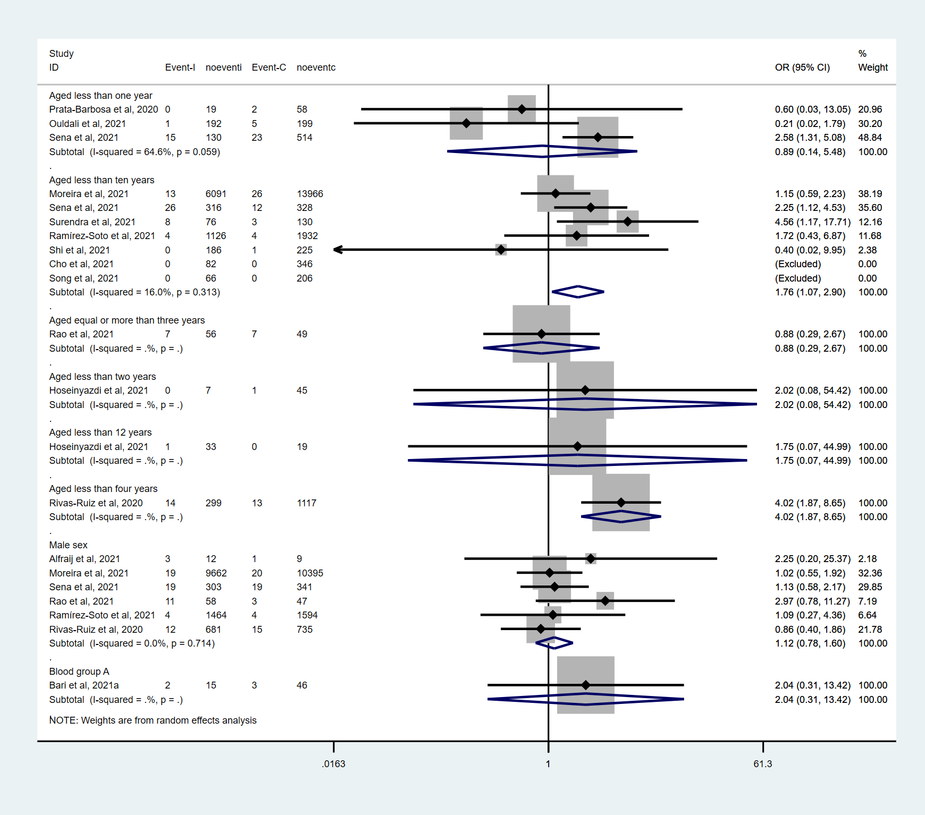
eFigure 1. Forest plot with summary effect sizes for baseline characteristics in children and adolescents with COVID-19 who developed into death compared with those who did not develop into death

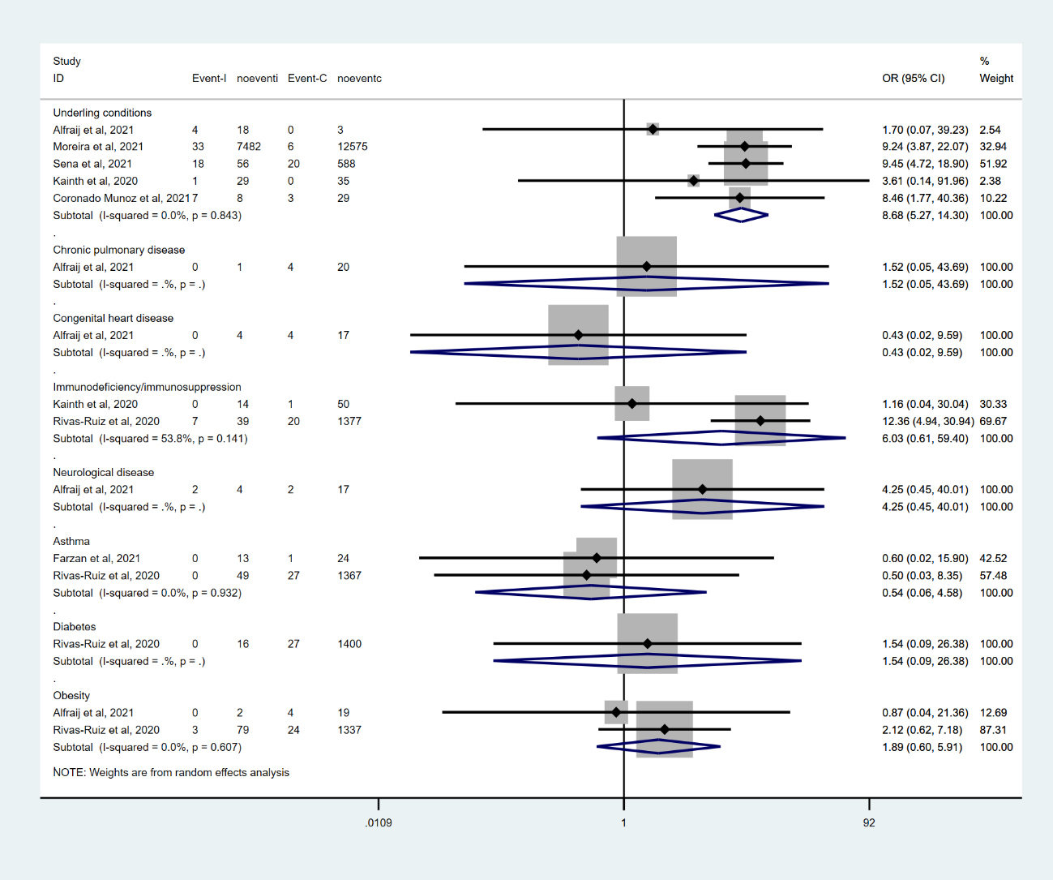
eFigure 2. Forest plot with summary effect sizes for coexisting medical conditions in children and adolescents with COVID-19 who developed into death compared with those who did not develop into death

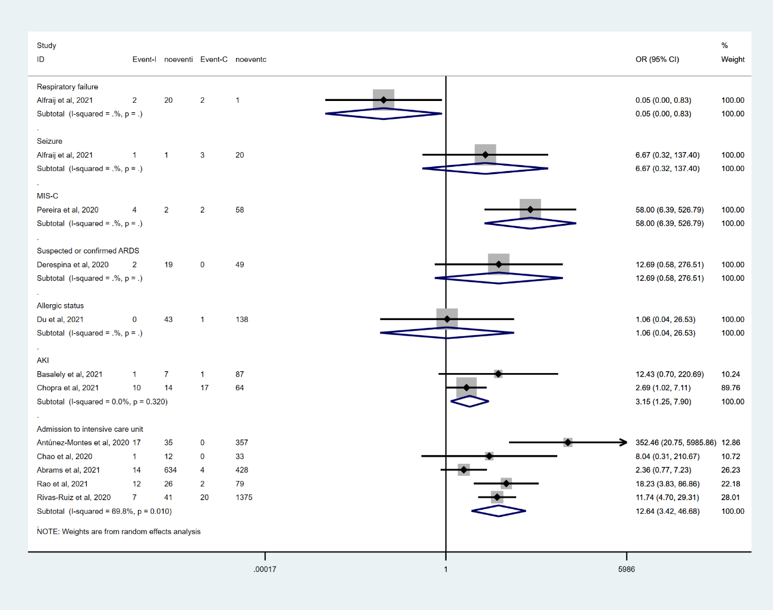
eFigure 3. Forest plot with summary effect sizes for clinical symptoms and complications in children and adolescents with COVID-19 who developed into death compared with those who did not develop into death

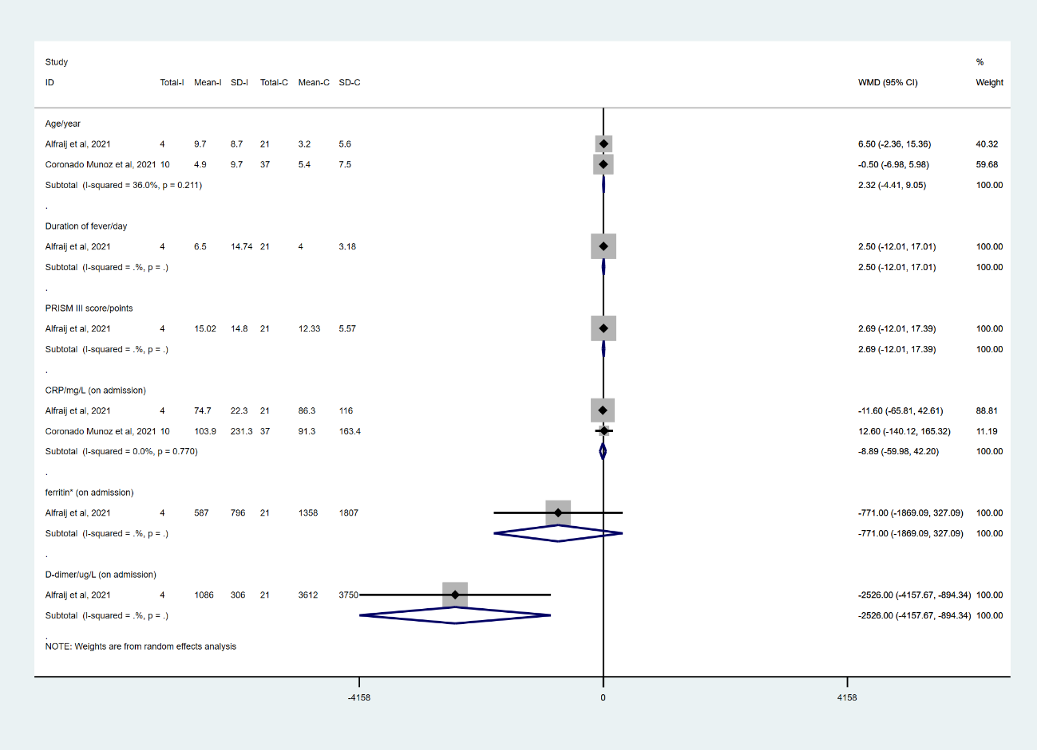
eFigure 4. Forest plot with summary effect sizes for age (continuous data) and laboratory investigations (continuous data) in children and adolescents with COVID-19 who developed into death compared with those who did not develop into death (note: on admission means at baseline)

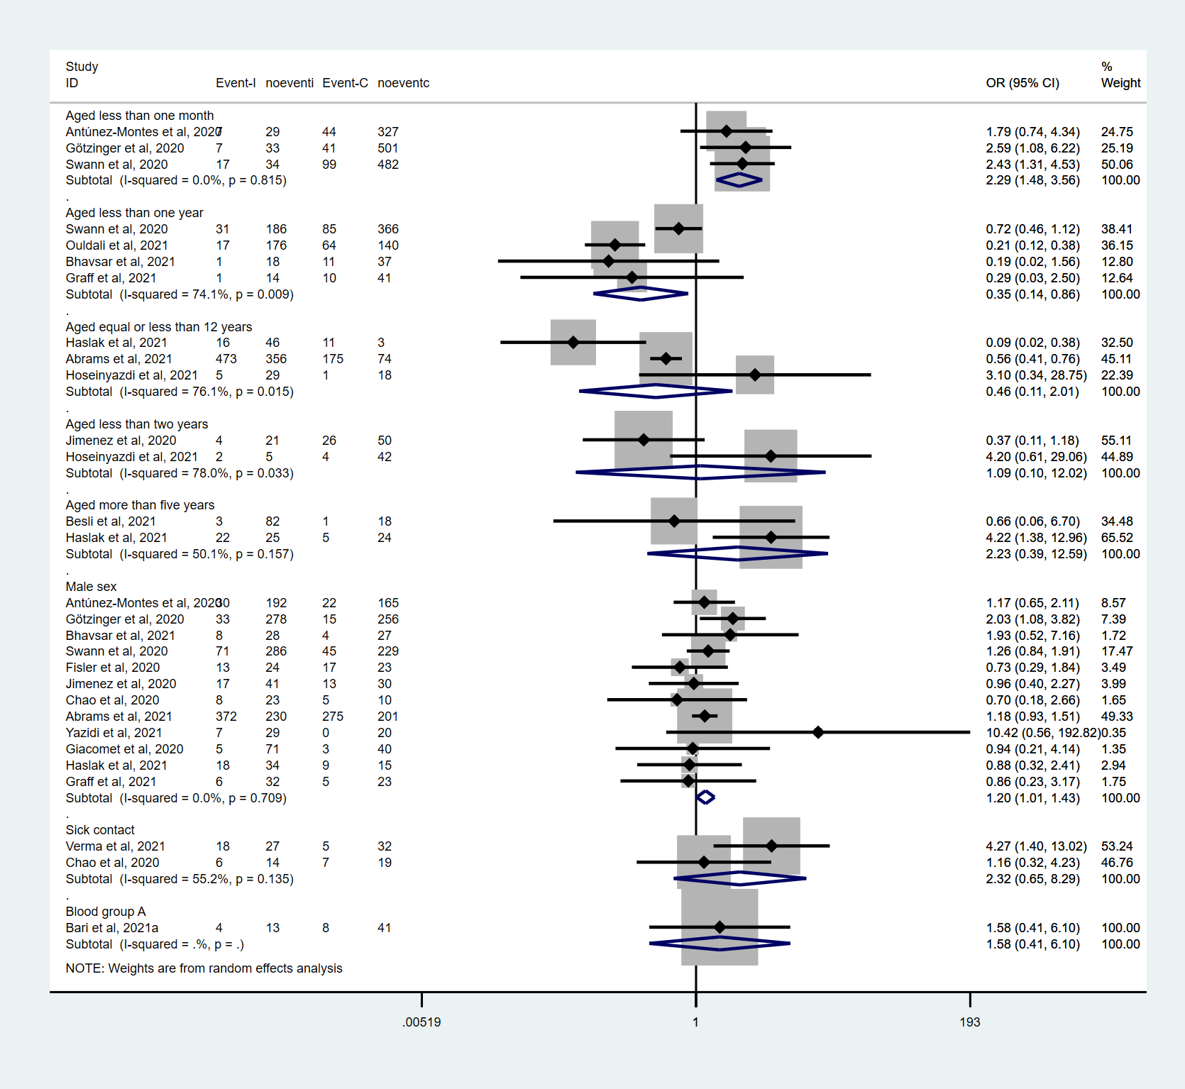
eFigure 5. Forest plot with summary effect sizes for baseline characteristics in children and adolescents with COVID-19 who were admitted to intensive care unit compared with those who were not admitted to intensive care unit

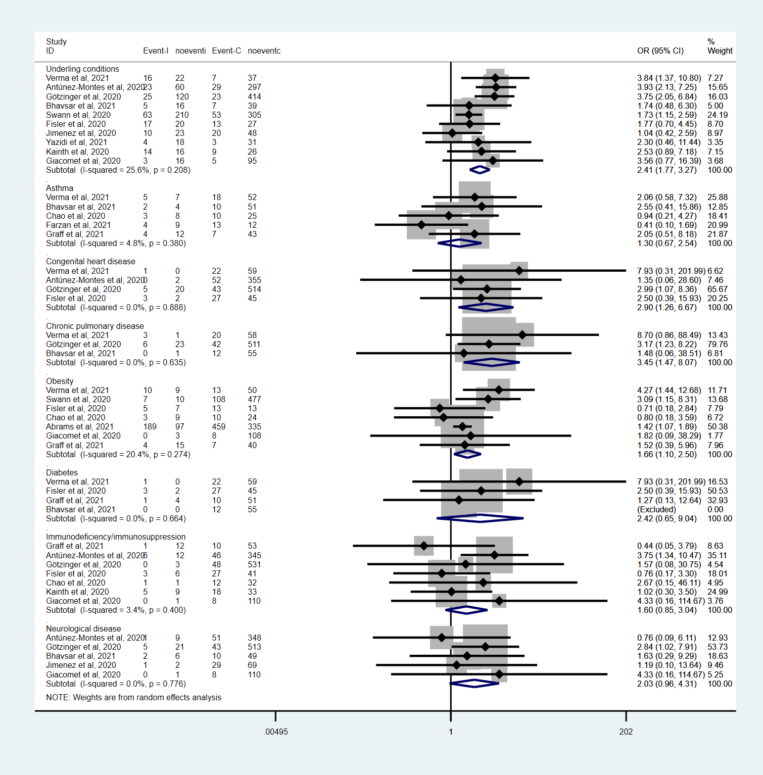
eFigure 6. Forest plot with summary effect sizes for coexisting medical conditions in children and adolescents with COVID-19 who were admitted to intensive care unit compared with those who were not admitted to intensive care unit

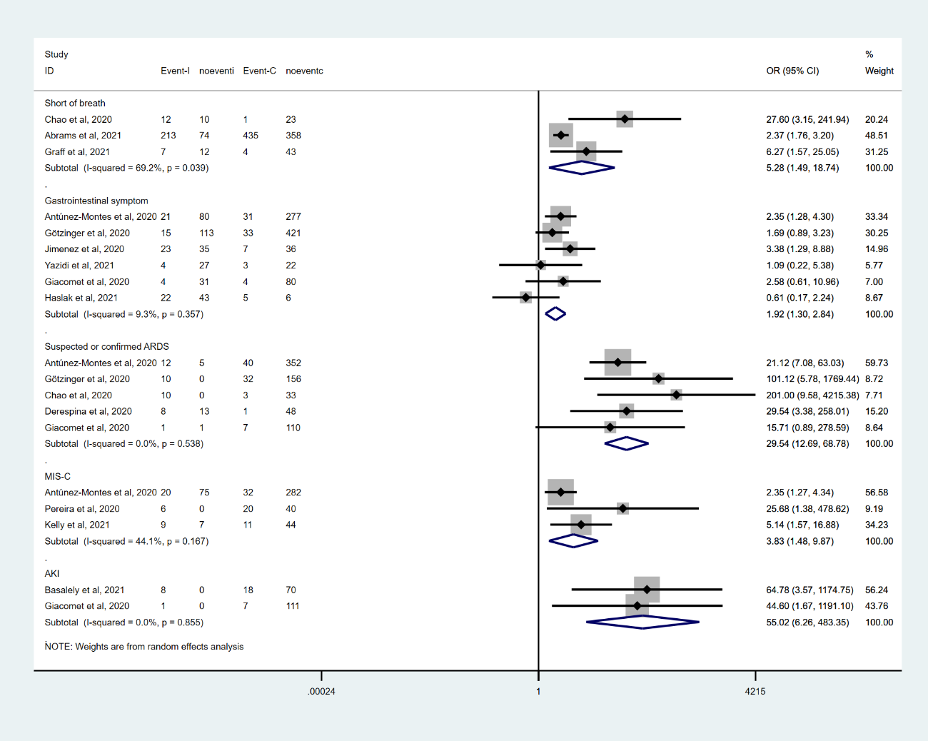
eFigure 7. Forest plot with summary effect sizes for clinical symptoms and complications in children and adolescents with COVID-19 who were admitted to intensive care unit compared with those who were not admitted to intensive care unit

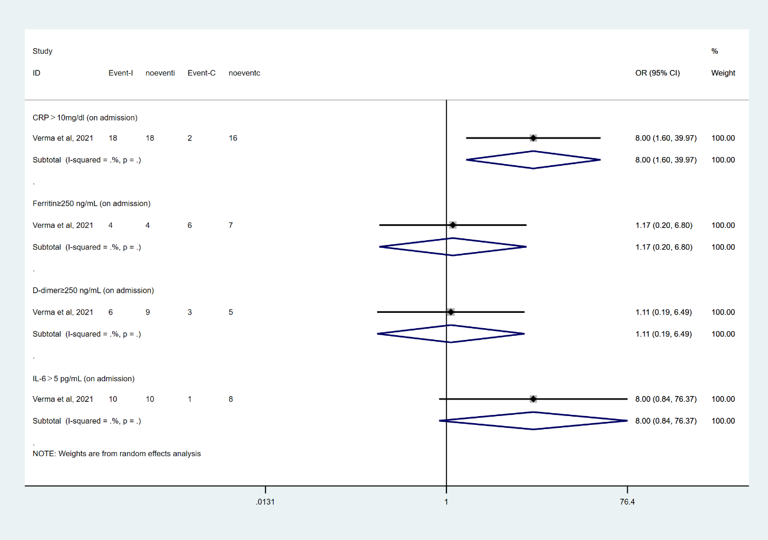
eFigure 8. Forest plot with summary effect sizes for laboratory investigations (dichotomous data) in children and adolescents with COVID-19 who were admitted to intensive care unit compared with those who were not admitted to intensive care unit (note: on admission means at baseline)

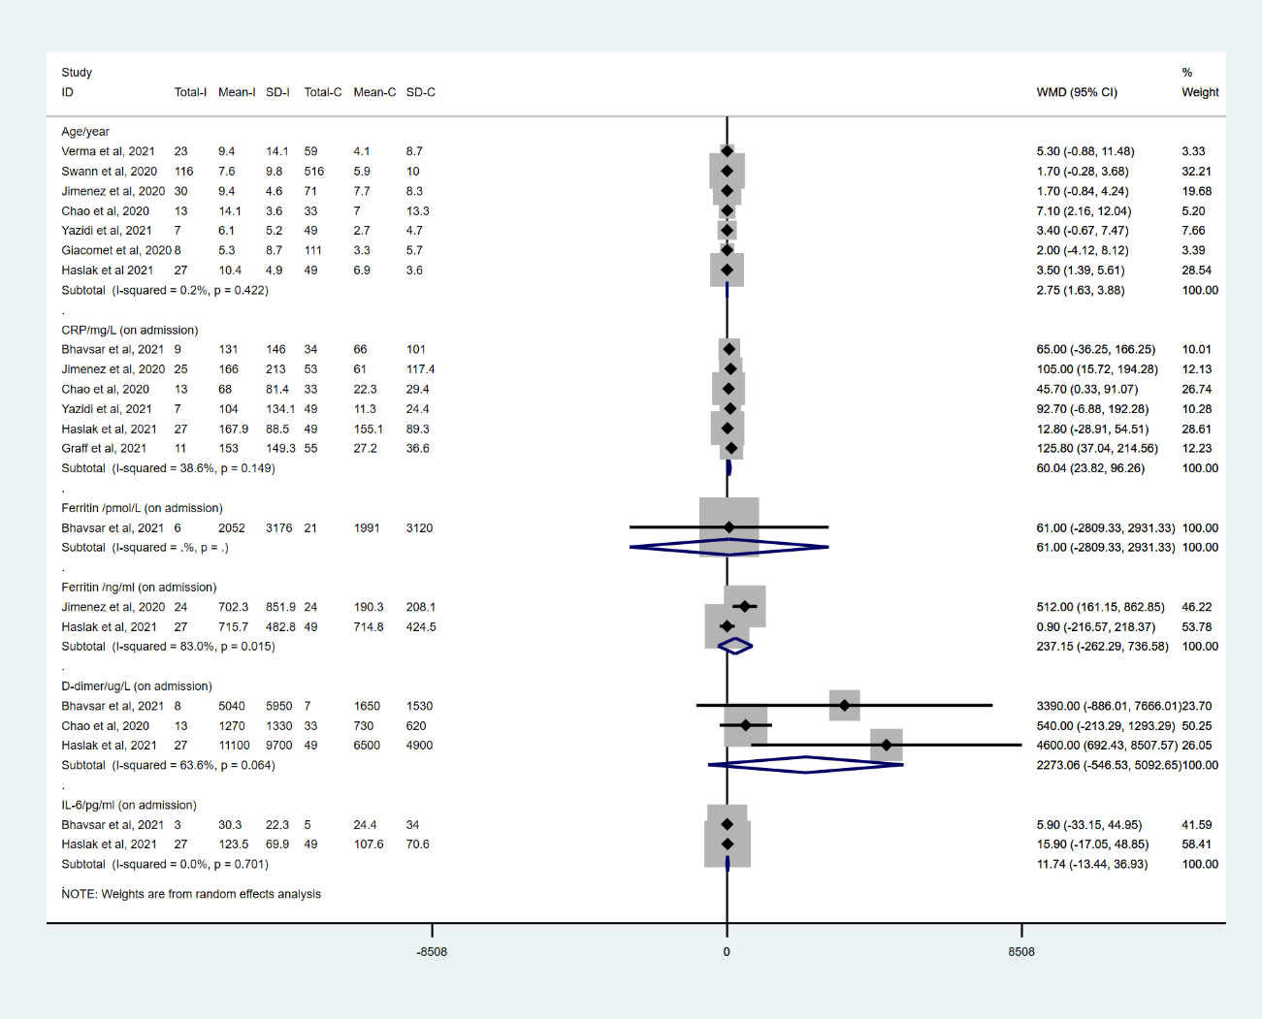
eFigure 9. Forest plot with summary effect sizes for age (continuous data) and laboratory investigations (continuous data) in children and adolescents with COVID-19 who were admitted to intensive care unit compared with those who were not admitted to intensive care unit (note: on admission means at baseline)

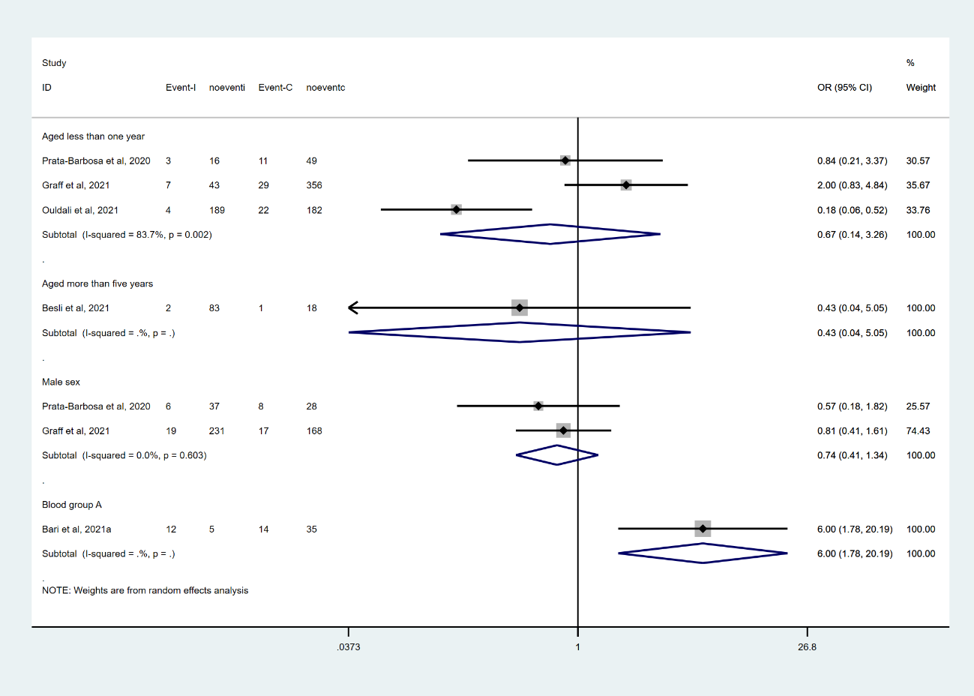
eFigure 10. Forest plot with summary effect sizes for baseline characteristics in children and adolescents with COVID-19 who received respiratory support compared with those who did not receive respiratory support

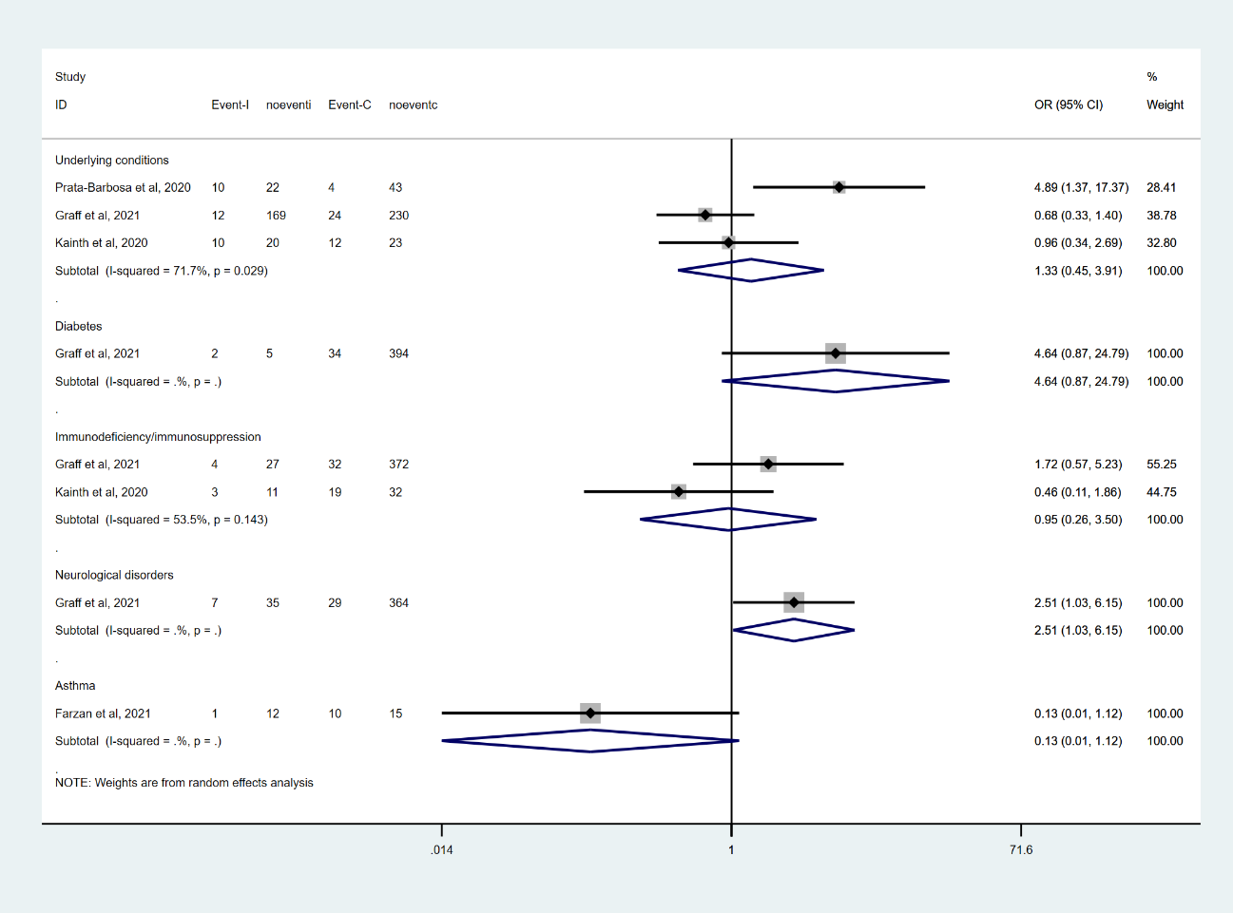
eFigure 11. Forest plot with summary effect sizes for coexisting medical conditions in children and adolescents with COVID-19 who received respiratory support compared with those who did not receive respiratory support

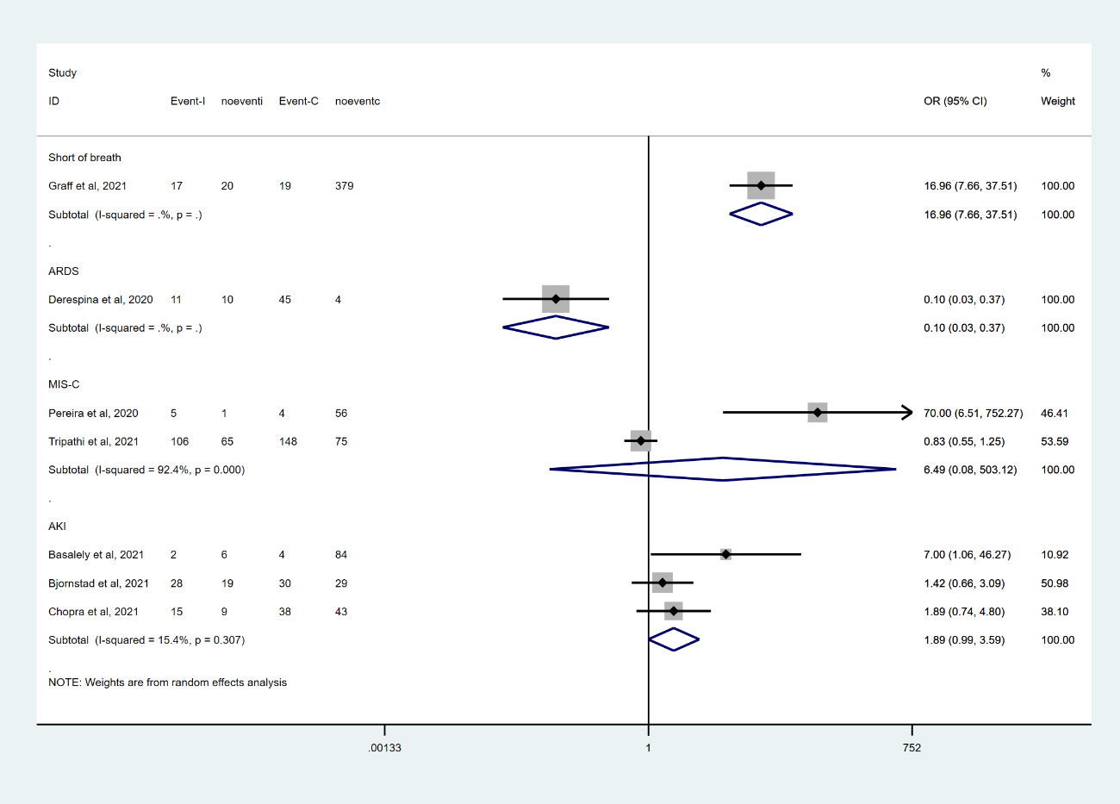
eFigure 12. Forest plot with summary effect sizes for clinical symptoms and complications in children and adolescents with COVID-19 who received respiratory support compared with those who did not receive respiratory support

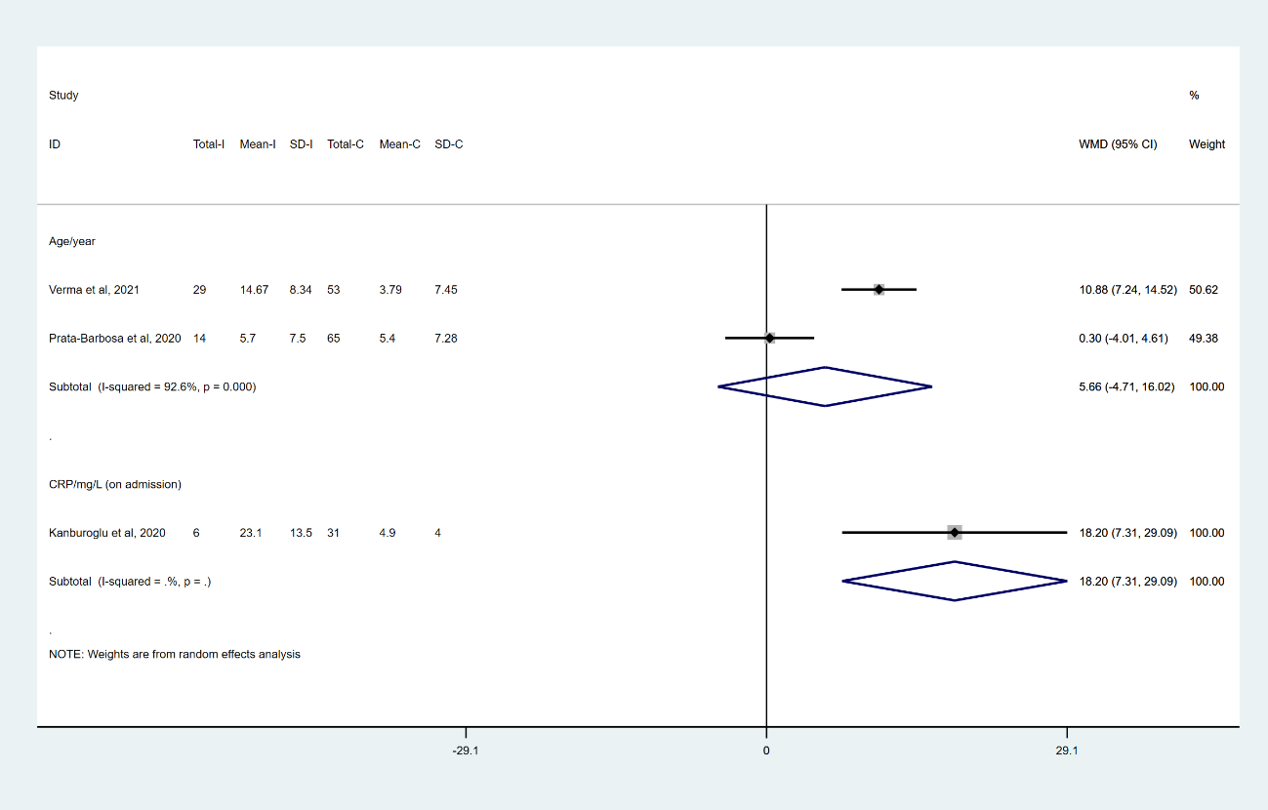
eFigure 13. Forest plot with summary effect sizes for age (continuous data) and laboratory investigations (continuous data) in children and adolescents with COVID-19 who received respiratory support compared with those who did not receive respiratory support (note: on admission means at baseline)

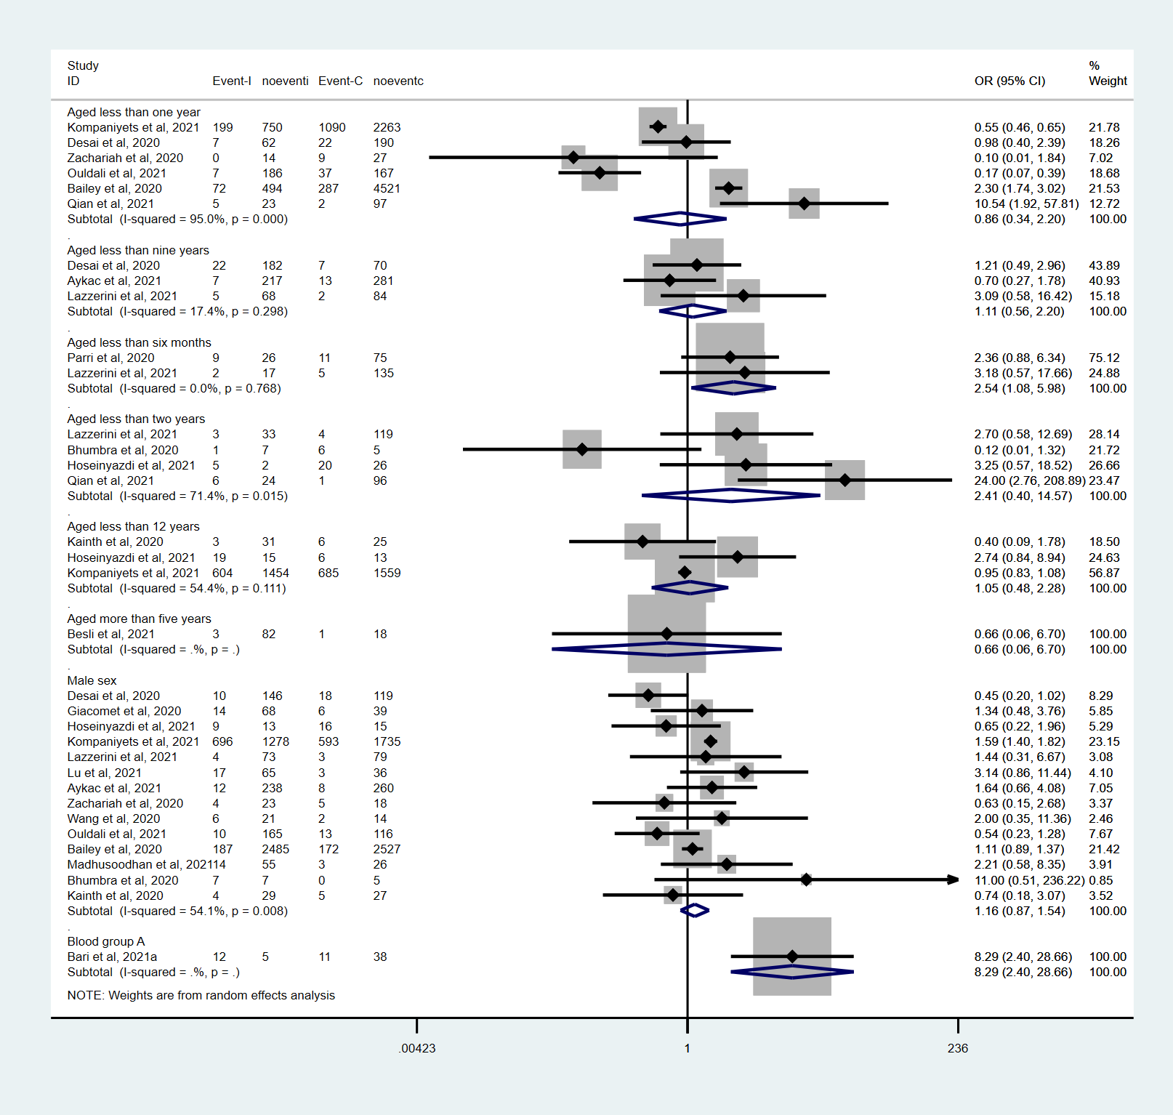
eFigure 14. Forest plot with summary effect sizes for baseline characteristics in children and adolescents with COVID-19 who progressed to severe or critical disease compared with those who did not progress to severe or critical disease (note: for male sex, we combined the meta analysis results in the above figure with the reported OR value in Fernandes et al, 2021, which can not extract the original data, and the final effect size is OR=1.12, 95% CI 0.86, 1.46)

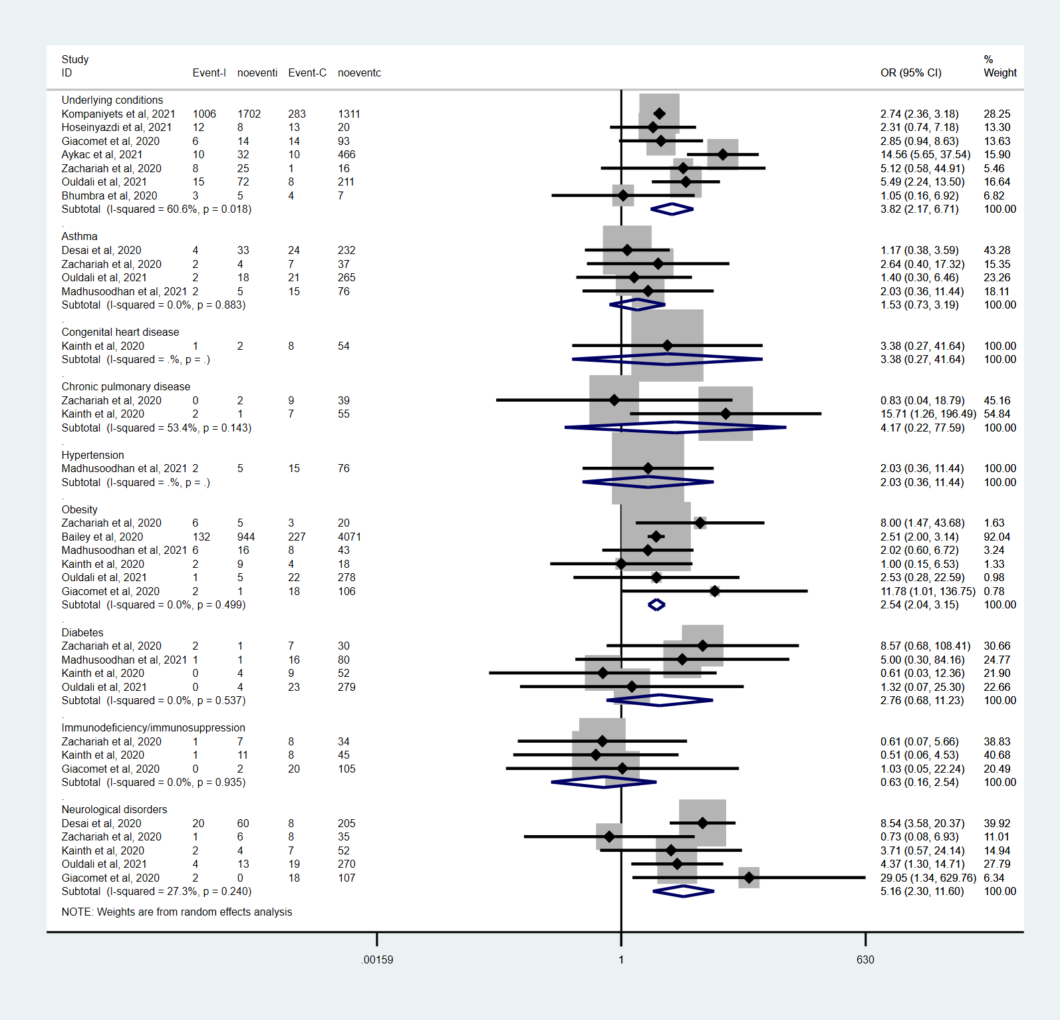
eFigure 15. Forest plot with summary effect sizes for coexisting medical conditions in children and adolescents with COVID-19 who progressed to severe or critical disease compared with those who did not progress to severe or critical disease (note: for obesity, we combined the meta analysis results in the above figure with the reported OR value in Fernandes et al, 2021, which can not extract the original data, and the final effect size is OR=2.47, 95% CI 2.00, 3.04)

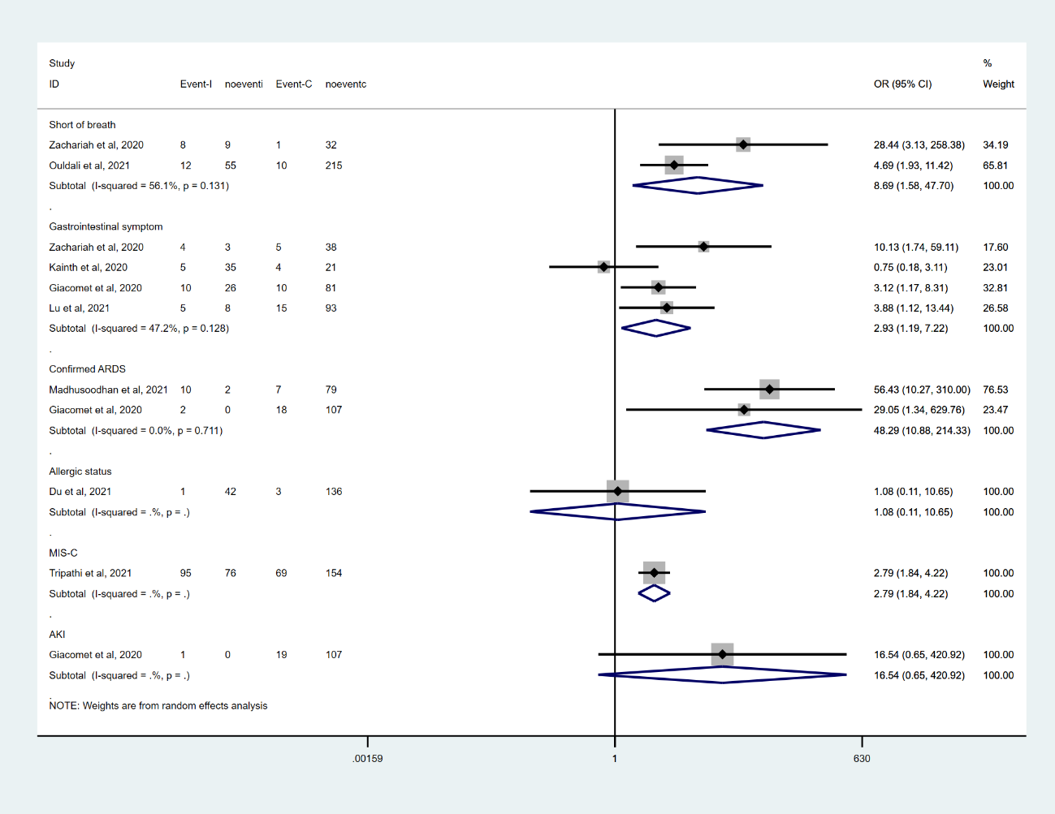
eFigure 16. Forest plot with summary effect sizes for clinical symptoms and complications in children and adolescents with COVID-19 who progressed to severe or critical disease compared with those who did not progress to severe or critical disease

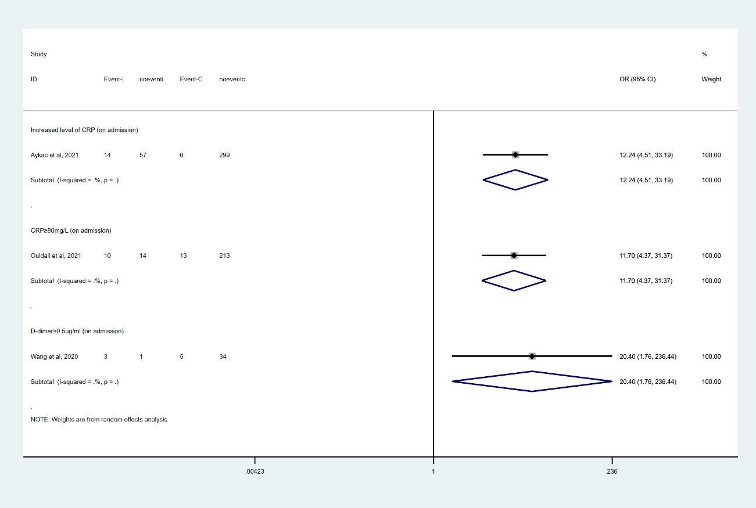
eFigure 17. Forest plot with summary effect sizes for laboratory investigations (dichotomous data) in children and adolescents with COVID-19 who progressed to severe or critical disease compared with those who did not progress to severe or critical disease (note: on admission means at baseline)

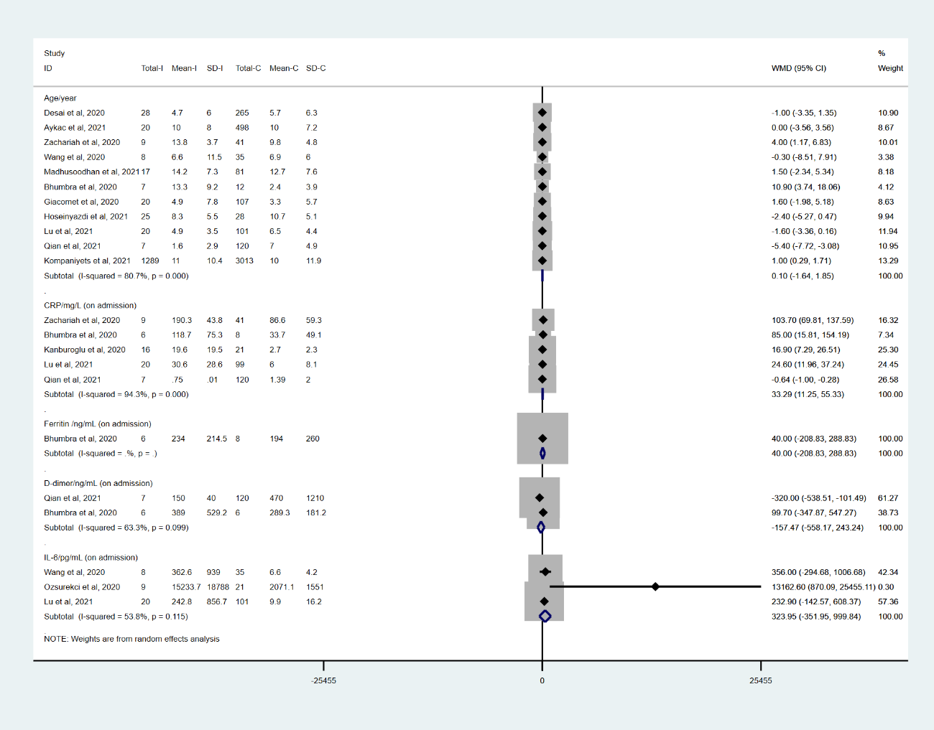
eFigure 18. Forest plot with summary effect sizes for age (continuous data) and laboratory investigations (continuous data) in children and adolescents with COVID-19 who progressed to severe or critical disease compared with those who did not progress to severe or critical disease (note: on admission means at baseline)

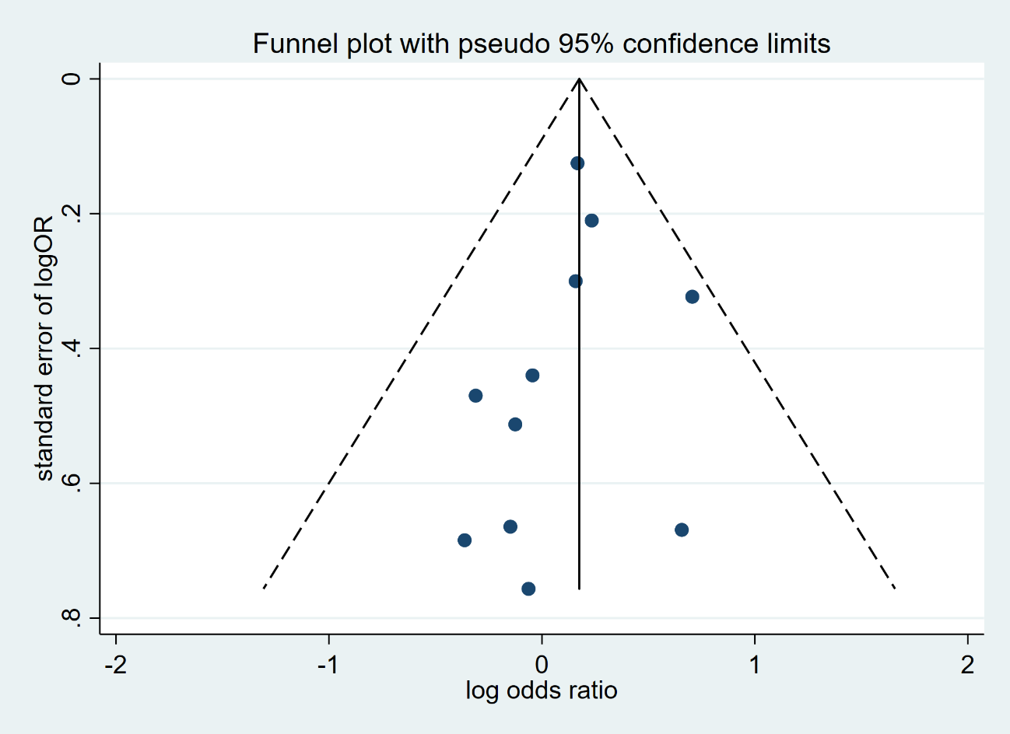
eFigure 19. Publication bias assessed via funnel plots assessed for male sex in children and adolescents with COVID-19 who were admitted to intensive care unit compared with those who were not admitted to intensive care unit. The results suggested that there was no publication bias among studies, but not susceptibility.
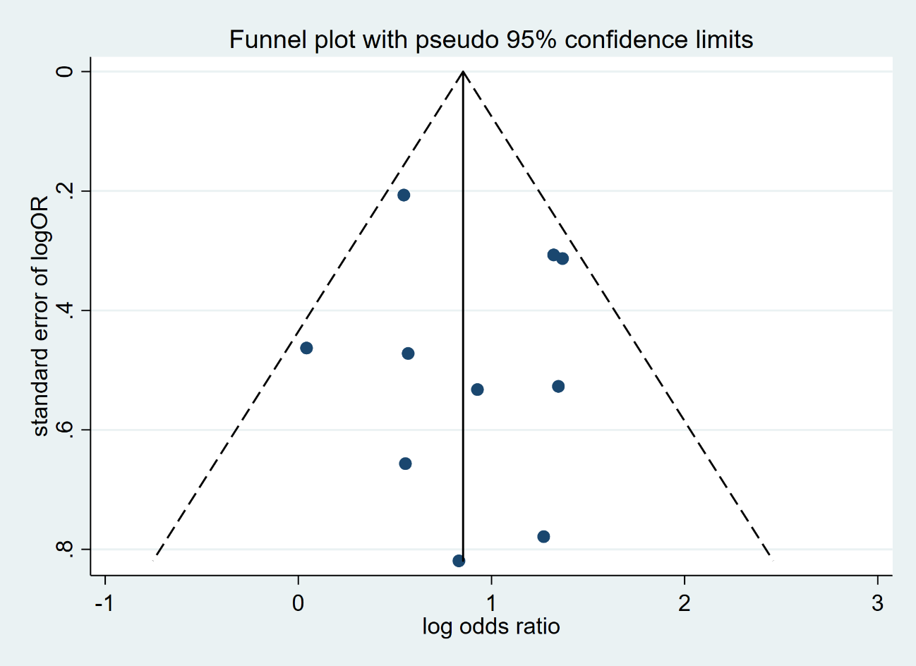
eFigure 20. Publication bias assessed via funnel plots assessed for underlying conditions in children and adolescents with COVID-19 who were admitted to intensive care unit compared with those who were not admitted to intensive care unit. The results suggested that there was no publication bias among studies.

