Appendix S10. Networks for RDD and RBL. The network for residual RDD included only singleton studies while the network for RBL gain comprised from disconnected pieces of evidence.
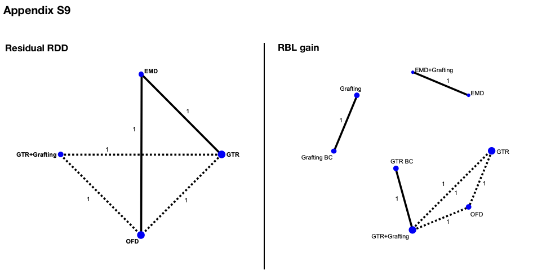
In the present study, NMA for Residual RDD and RBL gain was not possible, because:
a) for RDD, the number of observed comparisons was greater than the number of included trials (five comparisons, 2 two-arm trials and 1 multi-arm trial), and thus, convergence problems are expected to occur;
b) for RBL, a connected network could not be obtained. For each trial, we have merely calculated the mean difference and 95% confidence interval, presented in Table S10.

Table S10. Mean difference and 95% CI for Residual RDD and RBL gain

Trial | Comparisons | MD (95% CI)
Residual RDD†
Crea, 2008 | GTR vs EMD | 0.20 (-0.21, 0.61)
Bhutda, 2013¹ | EMD vs OFD | -1.20 (-1.58, -0.82)
Stavropoulos, 2010 | GTR+Grafting vs OFD | -4.74 (-6.92 -2.56)
Stavropoulos, 2010 | GTR vs OFD | -7.64 (-9.71, -5.57)
Stavropoulos, 2010 | GTR vs GTR+Grafting | 0.54 (-1.45, 2.53)
RBL gain*
Cetinkaya, 2014¹ | GTR BC vs GTR+Grafting | 0.46 (-0.82, 1.74)
Ogihara, 2014 | EMD vs EMD+Grafting | -0.93 (-2.07, 0.21)
Nevins, 2013 | Grafting BC vs Grafting | -0.24 (-0.42, -0.06)
Stavropoulos, 2010 | GTR vs OFD | 3.79 (1.99, 5.59)
Stavropoulos, 2010 | GTR+Grafting vs OFD | 3.88 (2.13, 5.63)
Stavropoulos, 2010 | GTR vs GTR+Grafting | -0.09 (-2.45, 2.27)

CI: confidence interval; MD: mean difference.
¹Split-mouth study: a correlation of 0.5 has been used to correctly calculate the standard error of the mean difference.
†Negative values favor the first intervention, whereas positive values favor the second intervention.
*Positive values favor the first intervention, whereas negative values favor the second intervention.

