Supplement- 1; Additional figures. Meta-analysis, odds ratio, forest blot, and funnel plot

- The Meta-analysis in the COVID-19 severity group
(severe COVID-19 vs. non-severe COVID-19)
- Presence of GI symptoms
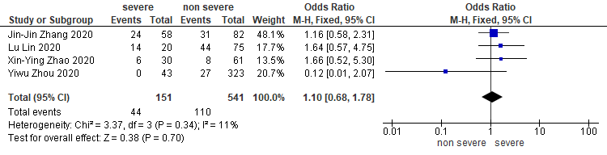
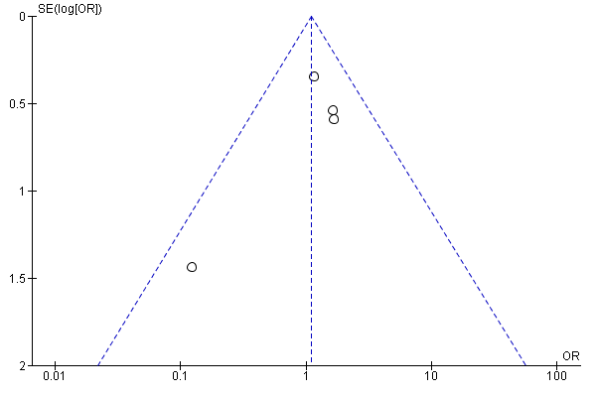

- Presence of diarrhea
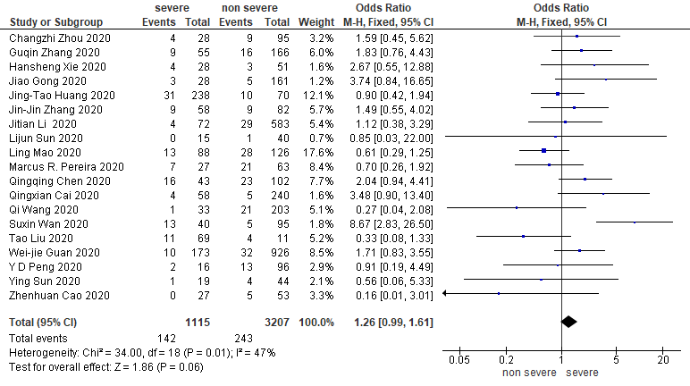
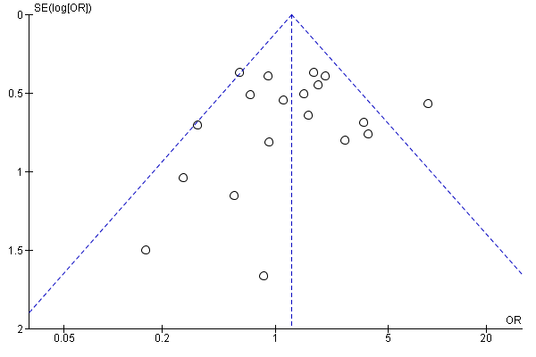

- Presence of abdominal pain

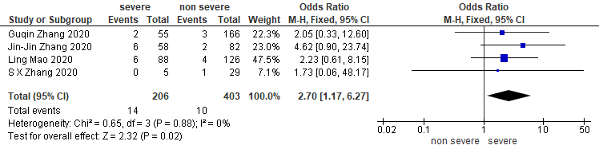
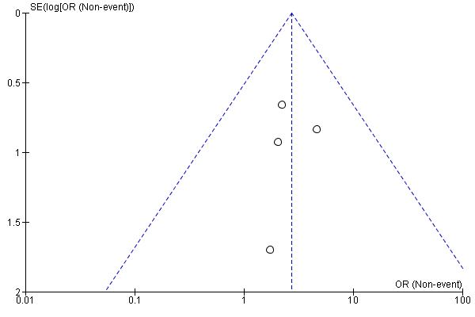

- Presence of nausea
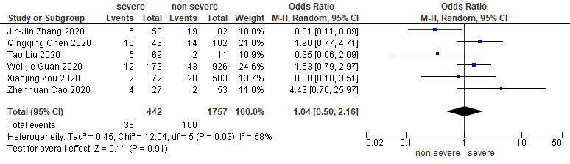
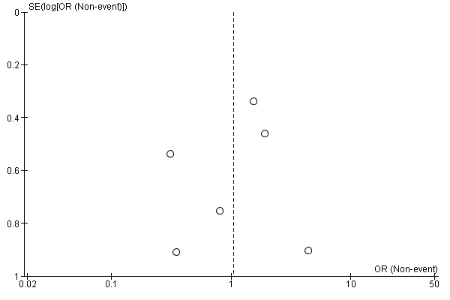
- Presence of vomiting
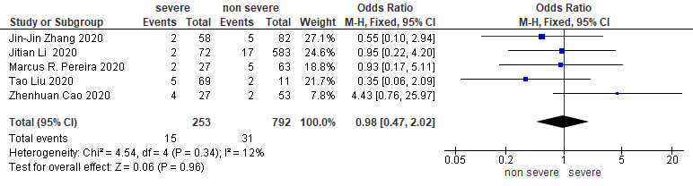
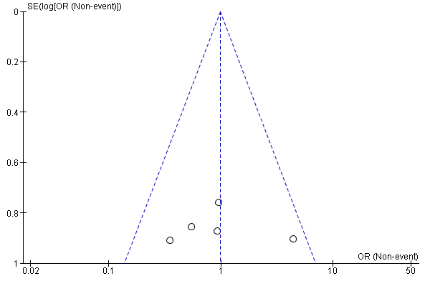

- Presence of anorexia
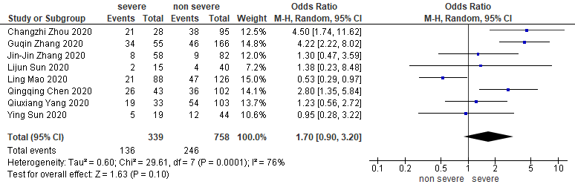
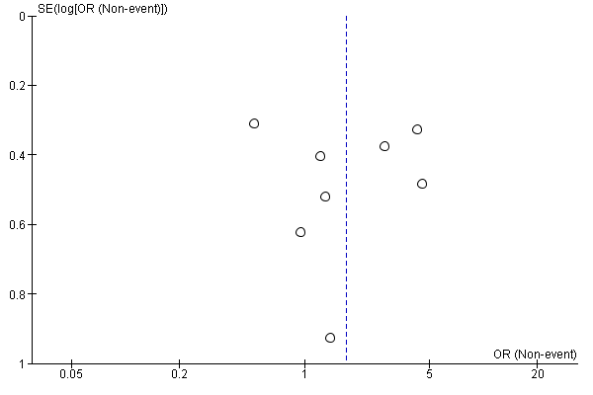
- T.bil
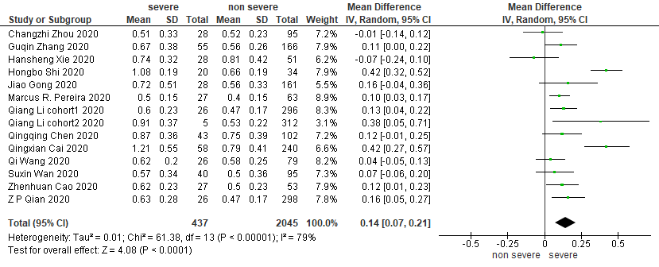

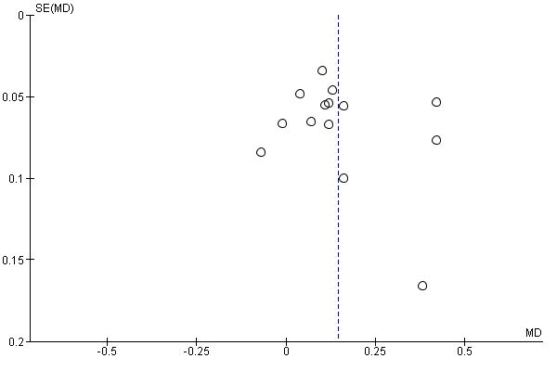

- AST
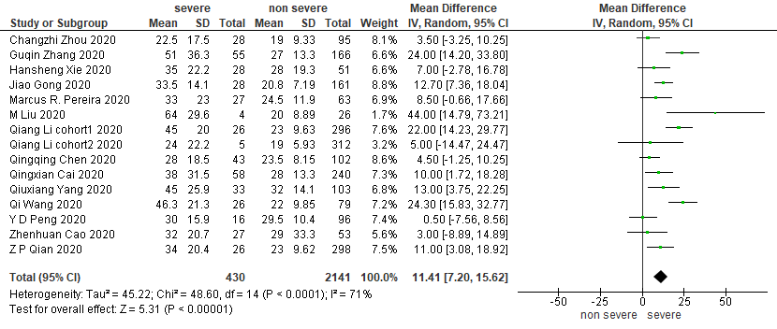
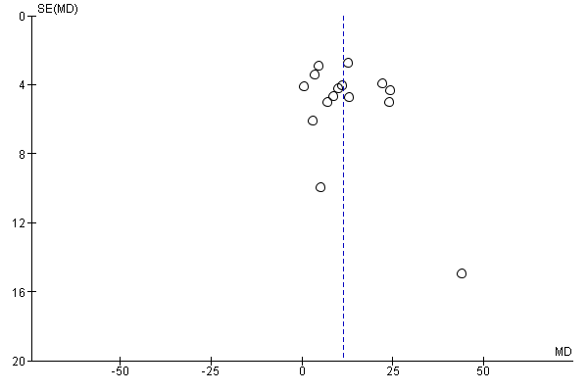

- ALT
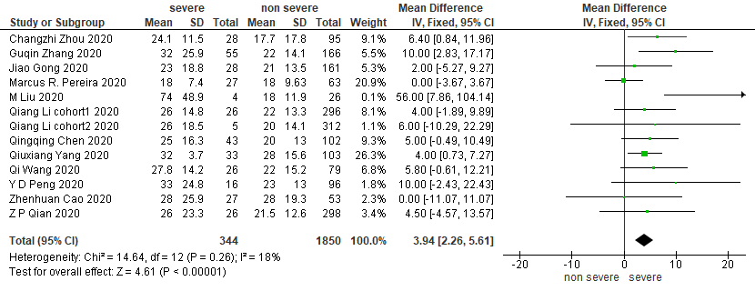
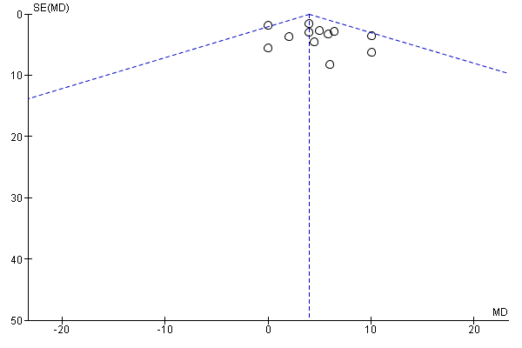
- Γ-GTP
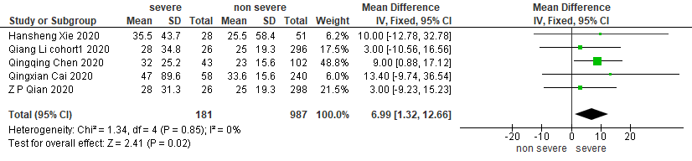
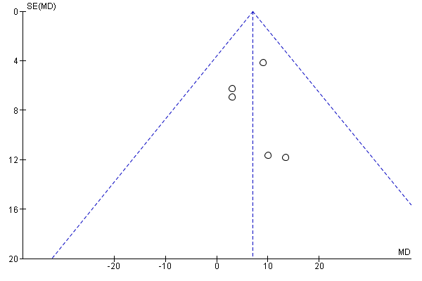
- ALP
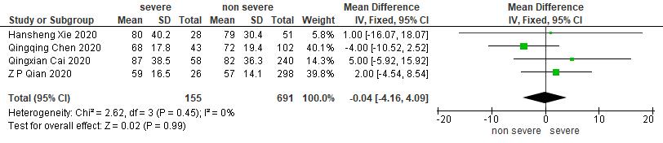
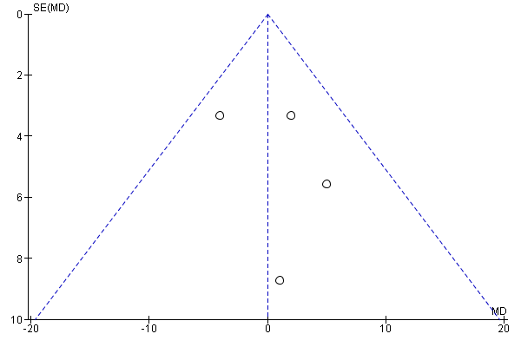
- Presence of liver enzyme elevation (described no details)
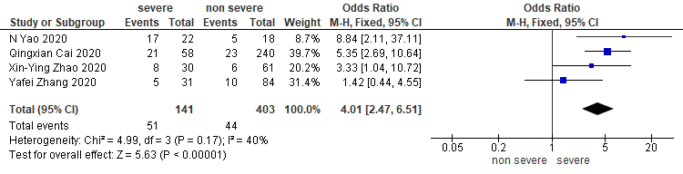
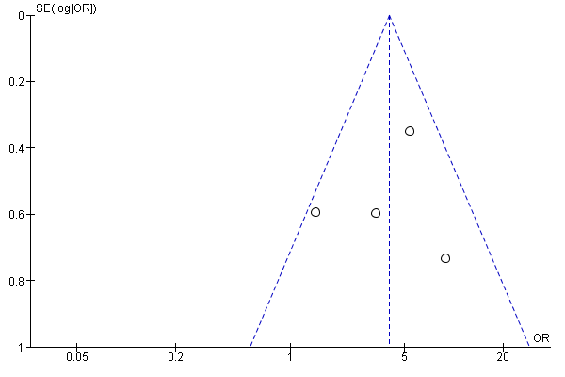
- Presence of past history of liver disease
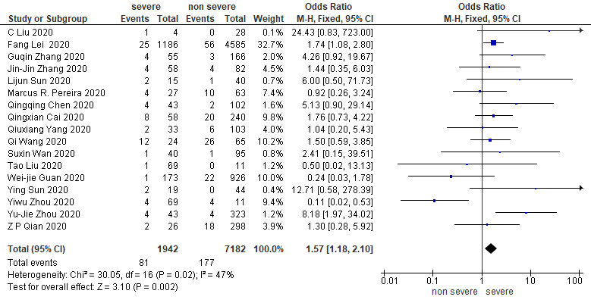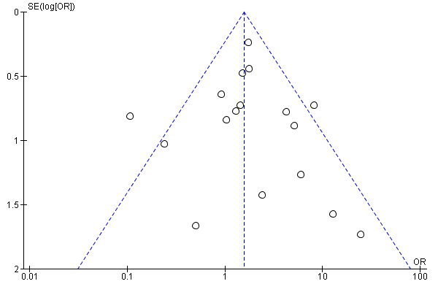
- Presence of past history of GI disease excluded liver
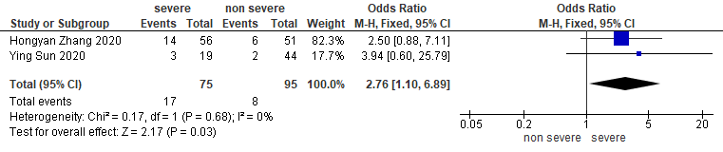
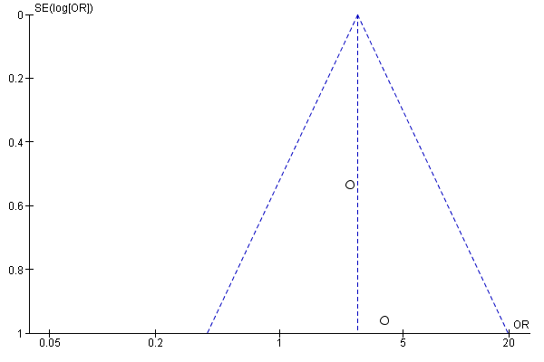
- Presence of past history of DM
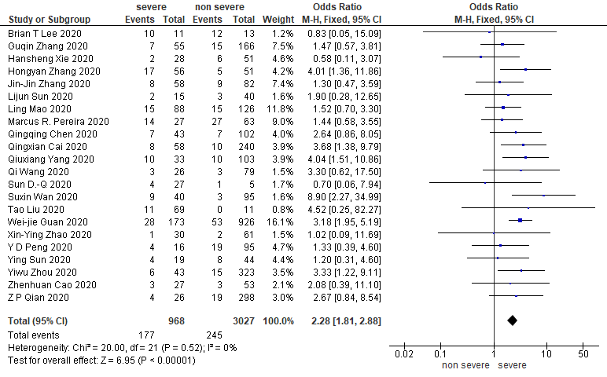
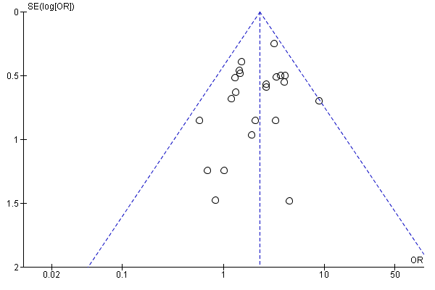
- The Meta-analysis in the presence of liver enzyme elevation
(elevation of liver enzyme vs. non-elevation of liver enzyme)

- Presence of diarrhea
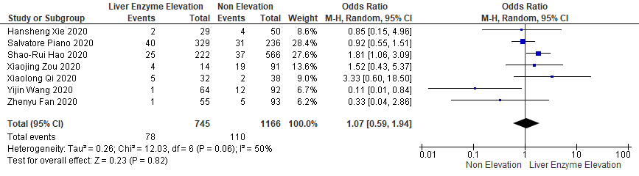
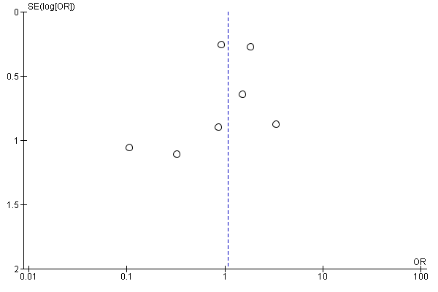
- Presence of abdominal pain
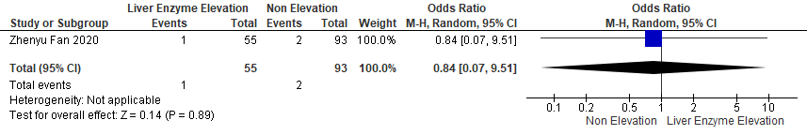

- Presence of nausea
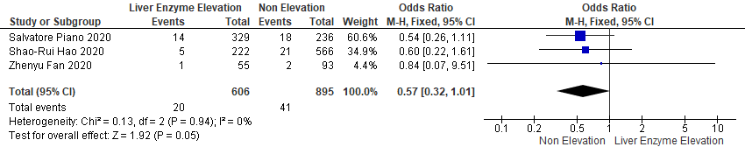
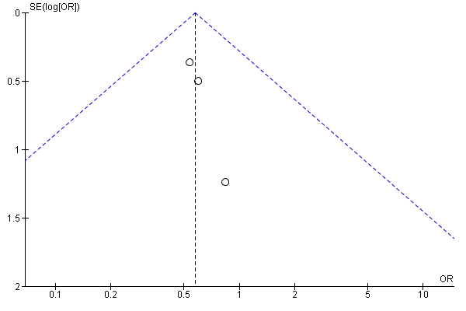

- Presence of vomiting
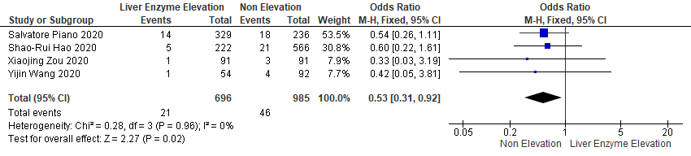
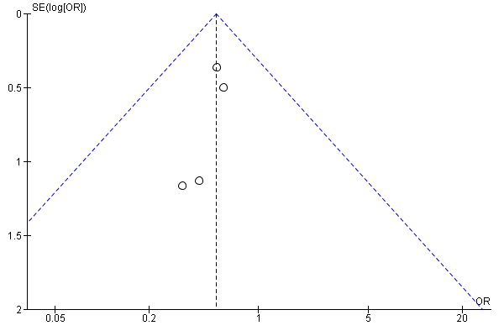
- Presence of anorexia
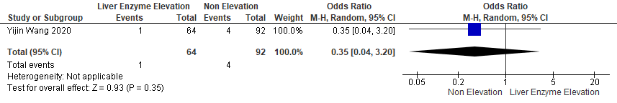

- Presence of past history of liver disease
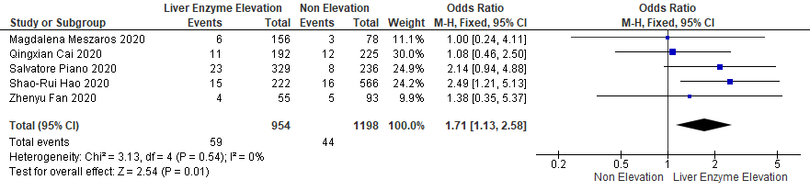
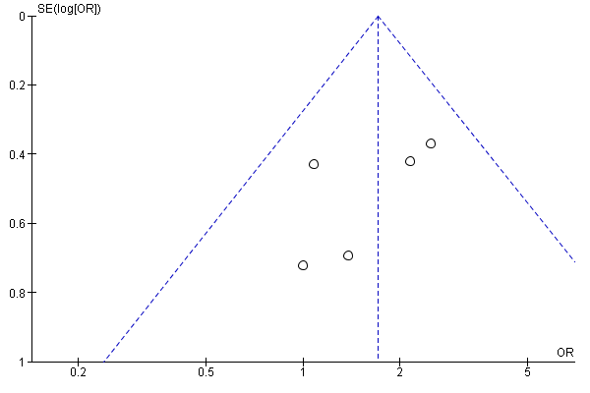

- Presence of past history of DM



