Online supplementary materials to:

Current evidence on the adoption of indicator condition guided testing for HIV in Western Countries: A systematic review and meta-analysis

Appendix 1: PROSPERO study protocol
Appendix 2: PRISMA checklist for reporting Systematic Reviews and Meta-analyses
Appendix 3: Full search strategy
Appendix 4: Data extraction sheet
Appendix 5: Joanna Briggs Institute risk of bias checklist
Appendix 6: Figure: Meta-analyses of HIV positivity by indicator condition
Appendix 7: H-TEAM consortium members

Appendix 1: PROSPERO study protocol

The protocol for this review was published at PROSPERO, registration number CRD42020160243:
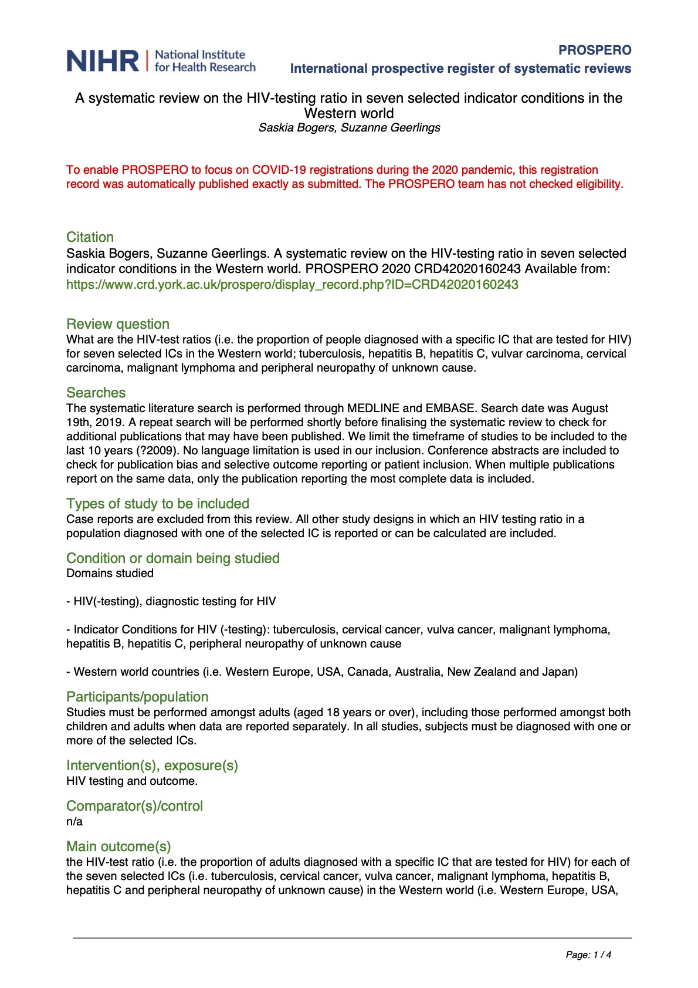
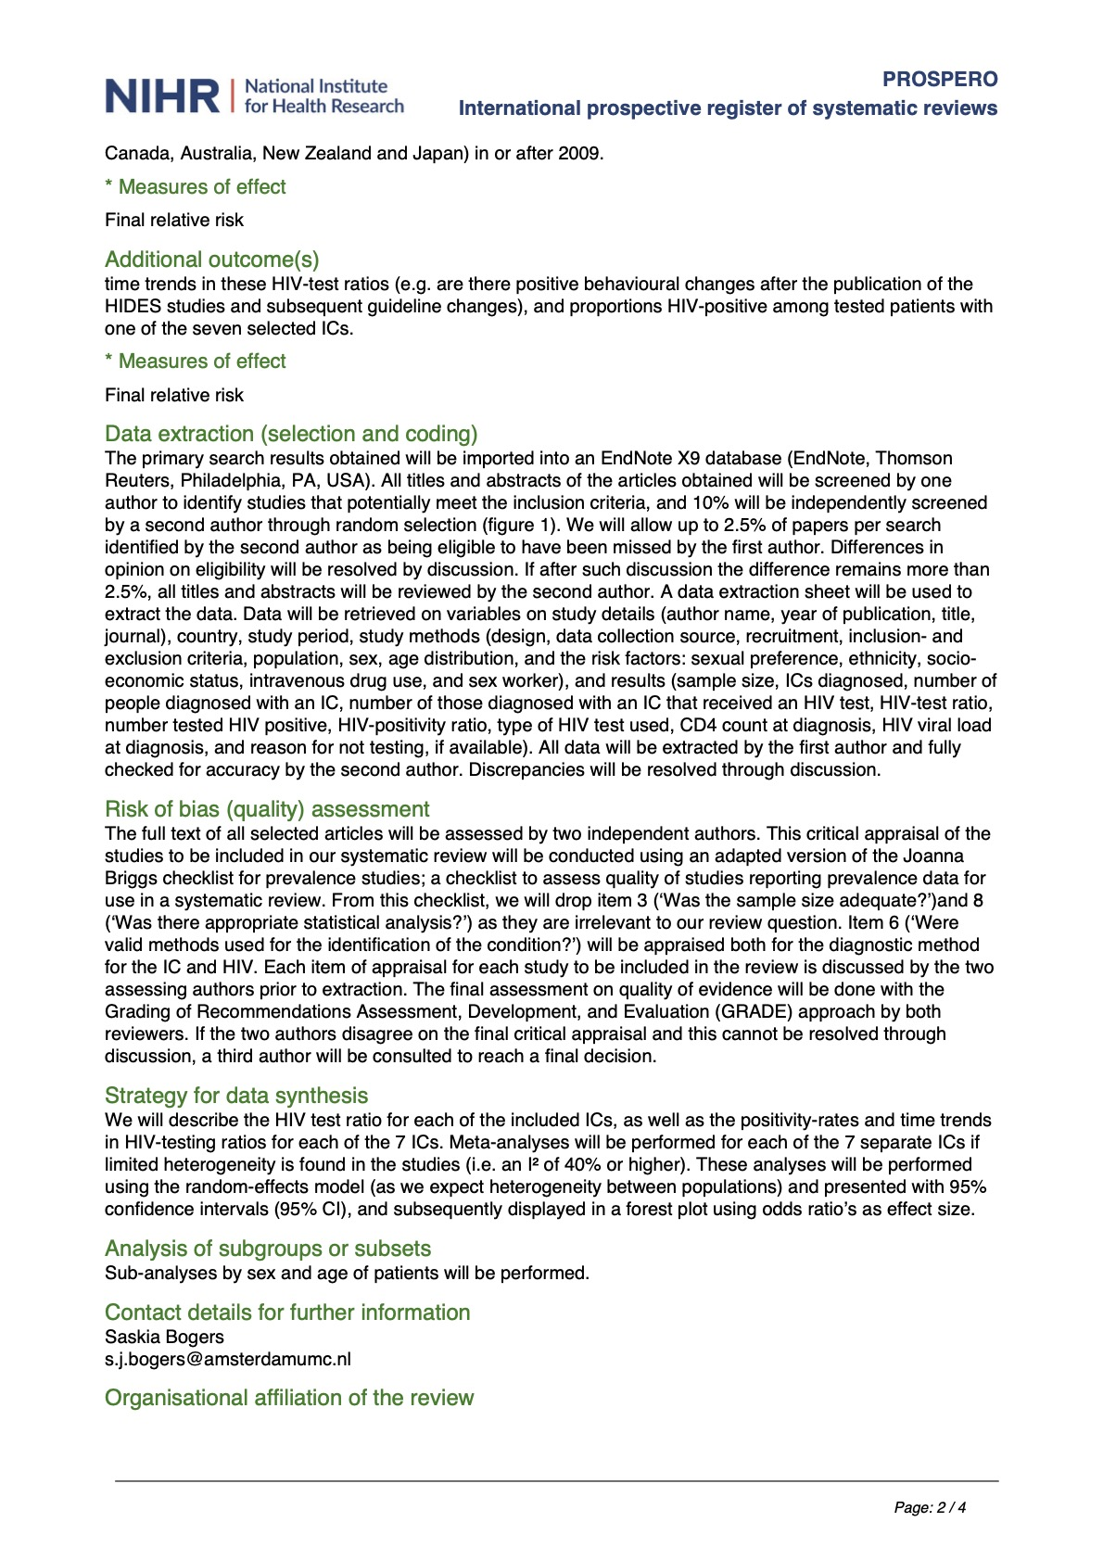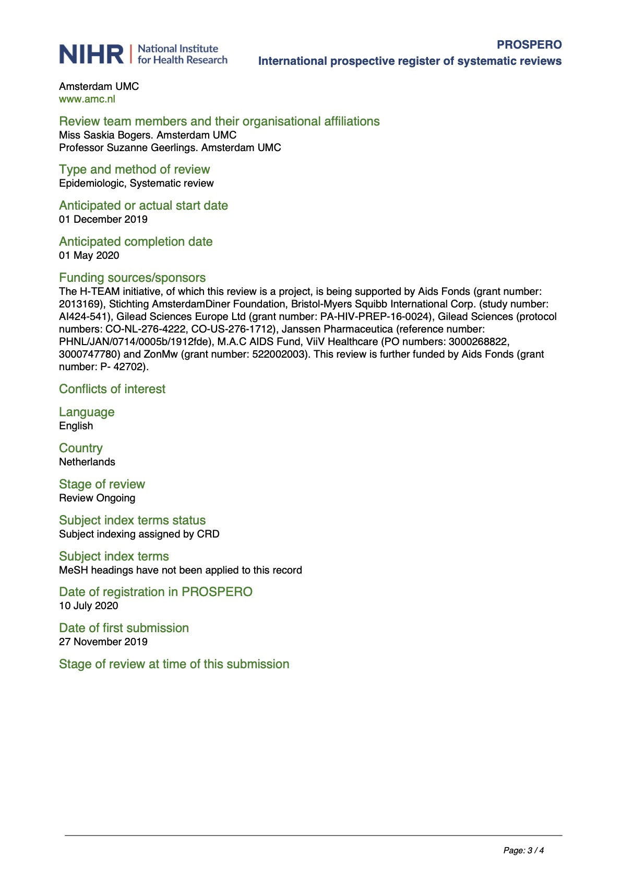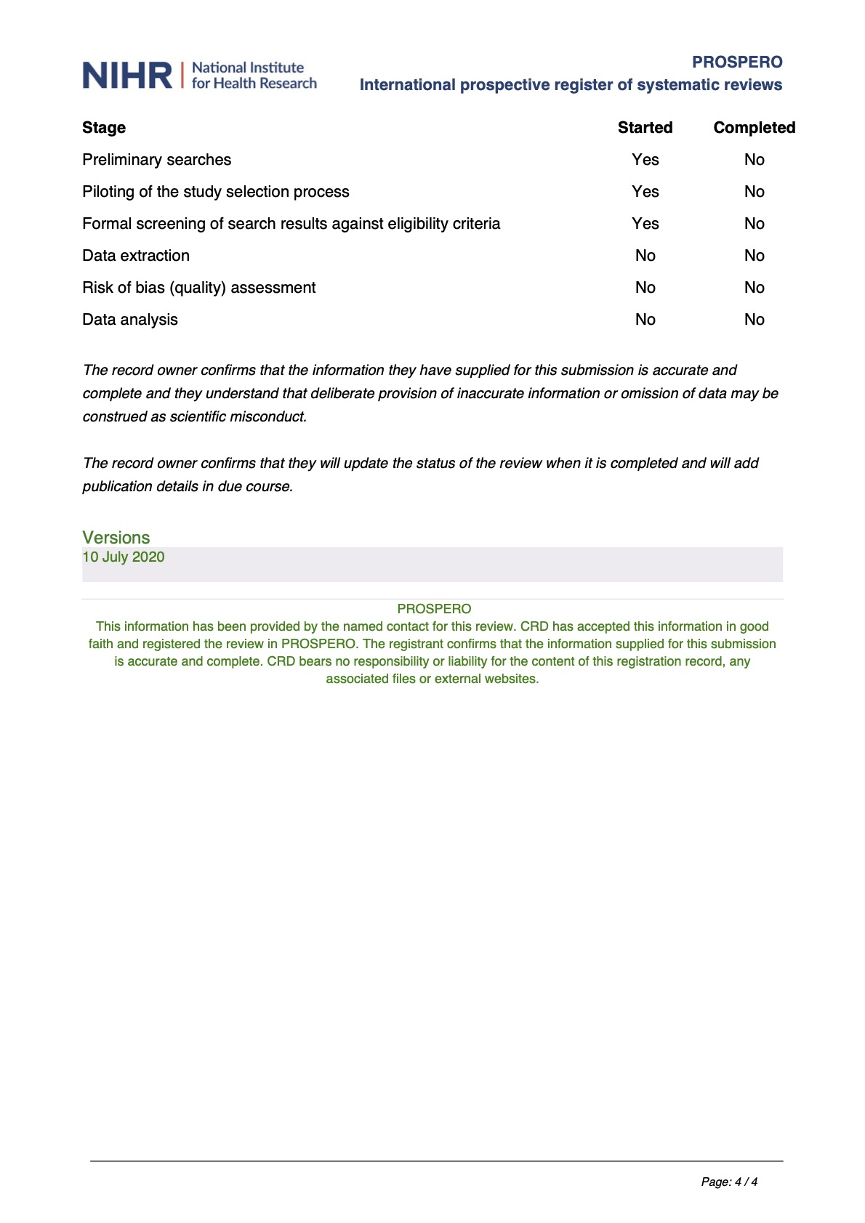

Appendix 2: PRISMA checklist for reporting Systematic Reviews and Meta-analyses

Section/topic | # | Checklist item | Reported on page #
TITLE
Title | 1 | Identify the report as a systematic review, meta-analysis, or both. | 1
ABSTRACT
Structured summary | 2 | Provide a structured summary including, as applicable: background; objectives; data sources; study eligibility criteria, participants, and interventions; study appraisal and synthesis methods; results; limitations; conclusions and implications of key findings; systematic review registration number. | 2
INTRODUCTION
Rationale | 3 | Describe the rationale for the review in the context of what is already known. | 3
Objectives | 4 | Provide an explicit statement of questions being addressed with reference to participants, interventions, comparisons, outcomes, and study design (PICOS). | 3
METHODS
Protocol and registration | 5 | Indicate if a review protocol exists, if and where it can be accessed (e.g., Web address), and, if available, provide registration information including registration number. | 4
Eligibility criteria | 6 | Specify study characteristics (e.g., PICOS, length of follow-up) and report characteristics (e.g., years considered, language, publication status) used as criteria for eligibility, giving rationale. | 4
Information sources | 7 | Describe all information sources (e.g., databases with dates of coverage, contact with study authors to identify additional studies) in the search and date last searched. | 4
Search | 8 | Present full electronic search strategy for at least one database, including any limits used, such that it could be repeated. | 4, appendix page 4
Study selection | 9 | State the process for selecting studies (i.e., screening, eligibility, included in systematic review, and, if applicable, included in the meta-analysis). | 5
Data collection process | 10 | Describe method of data extraction from reports (e.g., piloted forms, independently, in duplicate) and any processes for obtaining and confirming data from investigators. | 5
Data items | 11 | List and define all variables for which data were sought (e.g., PICOS, funding sources) and any assumptions and simplifications made. | 5, appendix page 5
Risk of bias in individual studies | 12 | Describe methods used for assessing risk of bias of individual studies (including specification of whether this was done at the study or outcome level), and how this information is to be used in any data synthesis. | 5, 6, appendix page 6
Summary measures | 13 | State the principal summary measures (e.g., risk ratio, difference in means). | 5-6
Synthesis of results | 14 | Describe the methods of handling data and combining results of studies, if done, including measures of consistency (e.g., I²) for each meta-analysis. | 5-6
Risk of bias across studies | 15 | Specify any assessment of risk of bias that may affect the cumulative evidence (e.g., publication bias, selective reporting within studies). | 5
Additional analyses | 16 | Describe methods of additional analyses (e.g., sensitivity or subgroup analyses, meta-regression), if done, indicating which were pre-specified. | 6

Page 1 of 2

Section/topic | # | Checklist item | Reported on page #
RESULTS
Study selection | 17 | Give numbers of studies screened, assessed for eligibility, and included in the review, with reasons for exclusions at each stage, ideally with a flow diagram. | 7, Figure 1, Table 1
Study characteristics | 18 | For each study, present characteristics for which data were extracted (e.g., study size, PICOS, follow-up period) and provide the citations. | 7-8, Table 2
Risk of bias within studies | 19 | Present data on risk of bias of each study and, if available, any outcome level assessment (see item 12). | 7-8, Table 2
Results of individual studies | 20 | For all outcomes considered (benefits or harms), present, for each study: (a) simple summary data for each intervention group (b) effect estimates and confidence intervals, ideally with a forest plot. | 7-9, Table 2, Figure 2
Synthesis of results | 21 | Present results of each meta-analysis done, including confidence intervals and measures of consistency. | 8-9
Risk of bias across studies | 22 | Present results of any assessment of risk of bias across studies (see Item 15). | n/a  (see pg. 5)
Additional analysis | 23 | Give results of additional analyses, if done (e.g., sensitivity or subgroup analyses, meta-regression [see Item 16]). | 8-9
DISCUSSION
Summary of evidence | 24 | Summarize the main findings including the strength of evidence for each main outcome; consider their relevance to key groups (e.g., healthcare providers, users, and policy makers). | 10
Limitations | 25 | Discuss limitations at study and outcome level (e.g., risk of bias), and at review-level (e.g., incomplete retrieval of identified research, reporting bias). | 11-12
Conclusions | 26 | Provide a general interpretation of the results in the context of other evidence, and implications for future research. | 10-12
FUNDING
Funding | 27 | Describe sources of funding for the systematic review and other support (e.g., supply of data); role of funders for the systematic review. | 36

From: Moher D, Liberati A, Tetzlaff J, Altman DG, The PRISMA Group (2009). Preferred Reporting Items for Systematic Reviews and Meta-Analyses: The PRISMA Statement. PLoS Med 6(7): e1000097.
For more information, visit: www.prisma-statement.org

Page 2 of 2

Appendix 3: Full search strategy

Ovid MEDLINE(R) ALL <1946 to November 20, 2020>
# | Searches | Results
1 | exp Tuberculosis/ | 189990
2 | (tubercul* or tb or tbc).ti,ab,kf. | 252288
3 | 1 or 2 | 277322
4 | Uterine Cervical Neoplasms/ | 72306
5 | (cervi* adj5 (cancer* or neoplas* or carcinom* or malignan* or tumor* or tumour*)).ti,ab,kf. | 85841
6 | 4 or 5 | 104132
7 | exp Vulvar Neoplasms/ | 8033
8 | ((vulva* or clitoris or clitoral) adj3 (cancer* or neoplas* or carcinom* or malignan* or tumor* or tumour*)).ti,ab,kf. | 5955
9 | 7 or 8 | 9525
10 | exp Lymphoma/ | 167356
11 | (lymphoma* or hematologic-neoplasms* or hodgkin* or non-hodgkin* or nonhodgkin* or immuno?ytom* or (hair* adj cell* adj leu*) or burkit* or sezary* or (mycos* adj fungo*) or (h?emato* adj (malign* or neoplas*))).ti,ab,kf. | 219363
12 | 10 or 11 | 259698
13 | hepatitis b/ or hepatitis c/ | 73777
14 | (hepatitis or ((HBV or HCV) adj infection)).ti,ab,kf. | 214749
15 | 13 or 14 | 224454
16 | exp Peripheral Nervous System Diseases/ | 142614
17 | (neuropathy or neuropathies or polyneuropathies or polyneuropathy).ti,ab,kf. | 81375
18 | 16 or 17 | 187244
19 | (indicator adj (diseas* or condition*)).ti,ab. | 228
20 | 3 or 6 or 9 or 12 or 15 or 18 or 19 | 1043189
21 | (HIV adj2 (testing or screening)).ti,ab,kf. | 15936
22 | 20 and 21 | 1946
23 | case reports.pt. | 2038816
24 | 22 not 23 | 1886

Embase Classic + Embase <1947 to November 20, 2020>
# | Searches | Results
1 | exp tuberculosis control/ or exp tuberculosis/ | 258284
2 | (tubercul* or tb or tbc).ti,ab,kw. | 311283
3 | 1 or 2 | 362256
4 | exp uterine cervix cancer/ | 98698
5 | (cervi* adj5 (cancer* or neoplas* or carcinom* or malignan* or tumor* or tumour*)).ti,ab,kw. | 119298
6 | 4 or 5 | 144077
7 | exp vulva cancer/ | 7040
8 | ((vulva* or clitoris or clitoral) adj3 (cancer* or neoplas* or carcinom* or malignan* or tumor* or tumour*)).ti,ab,kw. | 8698
9 | 7 or 8 | 11137
10 | exp lymphoma/ | 311845
11 | (LYMPHOMA* or HEMATOLOGIC-NEOPLASMS* or HODGKIN* or NON-HODGKIN* or NONHODGKIN* or IMMUNO?YTOM* or (HAIR* adj CELL* adj Leu*) or BURKIT* or SEZARY* or (MYCOS* adj FUNGO*) or (H?EMATO* adj (MALIGN* or neoplas*))).ti,ab,kw. | 318893
12 | 10 or 11 | 404124
13 | exp Hepatitis A virus/ or exp hepatitis A/ or exp hepatitis B/ or exp Hepatitis B virus/ | 144399
14 | (hepatitis or ((HBV or HCV) adj infection)).ti,ab,kw. | 310961
15 | 13 or 14 | 338643
16 | exp neuropathy/ | 554778
17 | (neuropathy or neuropathies or polyneuropathies or polyneuropathy).ti,ab,kw. | 125382
18 | 16 or 17 | 575735
19 | (indicator adj (diseas* or condition*)).ti,ab. | 370
20 | 3 or 6 or 9 or 12 or 15 or 18 or 19 | 1778570
21 | (HIV adj2 (testing or screening)).ti,ab,kw. | 20618
22 | 20 and 21 | 3195
23 | case report/ | 2491837
24 | 22 not 23 | 3001
25 | limit 24 to (conference abstracts or embase) | 2621
26 | limit 24 to embase | 1619
27 | limit 24 to conference abstracts | 1002

Appendix 4: Items included in the data extraction sheet

Data extraction was performed using a standard data extraction form created in Microsoft Excel.
The items in the data extraction were:
Item | Further instruction
First author name | Name of first author
Study # | Record number from title/abstract screening results
Indicator condition | Which IC is reported on. If multiple ICs are reported on, extract each IC in a separate entry
Lymphoma type | For lymphoma: Specify which type. Use the exact specification that the article used
Article or abstract | Is the reported data from an article or abstract
Year of publication | Publication year
Title | Title of the publication
Journal | Journal or conference publised/presented
Country/Countries | Country/countries in which the research took place
Study period | Period which was studied
Aim of study | Main research question
Recruitment site | Site of recruitment of patients/ data collection
Study design | Design of study
IC definition | How was the IC diagnosis defined
HIV tested definition | How was 'being tested for HIV' defined
Data collection source | Where was the data collected from (type of data source, e.g. registry, health records)
Inclusion criteria | What were the inclusion criteria
Exclusion criteria | What were the exclusion criteria
Population | Which population was studied (for the data collected in this row of the form, e.g. only the women in one row, and only the men in the next for the same study)
Age (describe what is reported, mean, median, ranges, categories) | Descriptive reporting of age distribution (as described in paper)
# with IC | Number of subjects with the IC, population in this row
# with HIV test | Number of subjects that were tested for HIV
HIV test ratio (calculation) | Calculation column for HIV test ratio
Reported HIV test ratio | HIV test ratio as reported in the record
# positive HIV tests | Number of population that were tested that were positive
Calculated HIV positivity ratio | Calculation column for HIV positivity ratio
Reported HIV positivity ratio | HIV positivity ratio as reported in article
Type of HIV test used | Type of HIV test used in the study
CD4 count at diagnosis | With unit that was used in the article
Viral load at diagnosis | With unit that was used in the article
Reasons for not testing | If reported
Author's comments | Additional comments by authors of record
Reviewer comments | Additional comments of screener
IC: Indicator condition.

Appendix 5: Joanna Briggs Institute risk of bias checklist¹

For assessment of risk of bias of individual included full-text studies, an adapted version of the Joanna Briggs Institute critical appraisal checklist for studies reporting prevalence data was used;

The original checklist contains the following items:

- Was the sample representative of the target population?
- Were study participants recruited in an appropriate way?
- Was the sample size adequate?
- Were the study subjects and setting described in detail?
- Is the data analysis conducted with sufficient coverage of the identified sample?
- Were objective, standard criteria used for measurement of the condition?
- Was the condition measured reliably?
- Was there appropriate statistical analysis?
- Are all important confounding factors/ subgroups/differences identified and accounted for?
- Were subpopulations identified using objective criteria?

For our risk of bias assessment, we dropped item 8 of the checklist, as it was not deemed relevant for our study question. We assessed item 6 for both the indicator condition that was studied, as well as how ‘tested for HIV’ was assessed. Thus, the total number of items was 10.

Scoring of all full-text articles was done by two authors (SJB and SHH) independently and any discrepancies resolved through discussion.

Outcome of risk of bias assessment per study was reported as a score on a 10-point scale (one point per item). As cut-off, a risk of bias score of 7/10 or higher was considered low risk, and a score of 6/10 or lower was deemed a high risk of bias by the researchers.

1. Munn Z, Moola S, Lisy K, Riitano D, Tufanaru C. Methodological guidance for systematic reviews of observational epidemiological studies reporting prevalence and cumulative incidence data. Int J Evid Based Healthc 2015;13(3):147-53.

Appendix 6: Meta-analyses of HIV positivity by indicator condition

Figure 1: Pooled results and estimated proportion tested HIV positive per indicator condition

1A: Tuberculosis
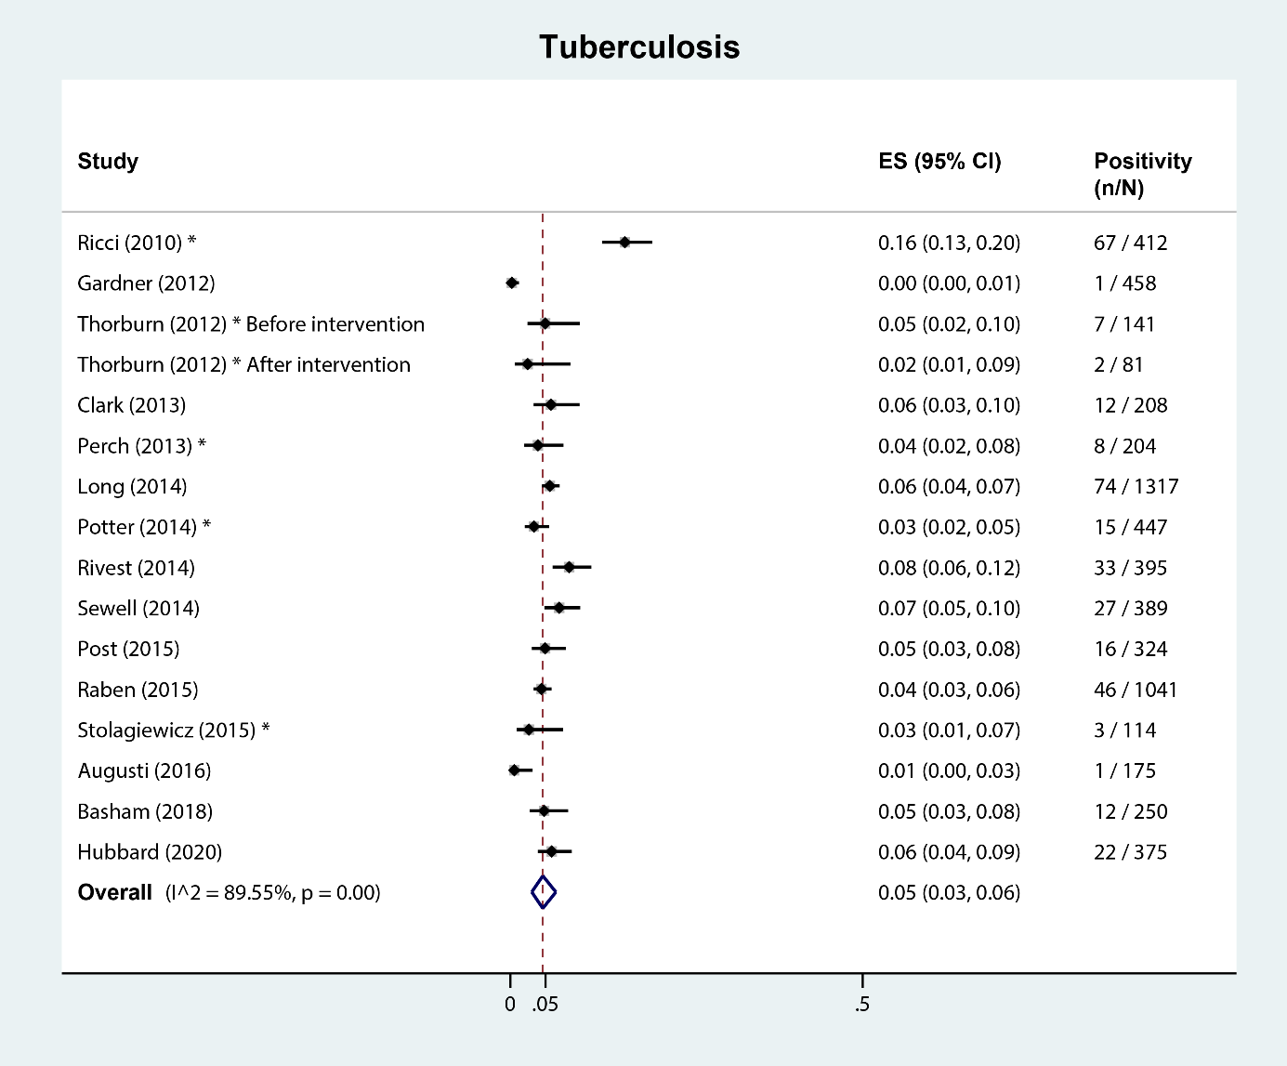
* Other publication types than full-text articles (i.e. abstracts, short communication, and correspondence). ES: estimated proportion. n=cases tested. N=cases identified.

1B: Hepatitis B and C
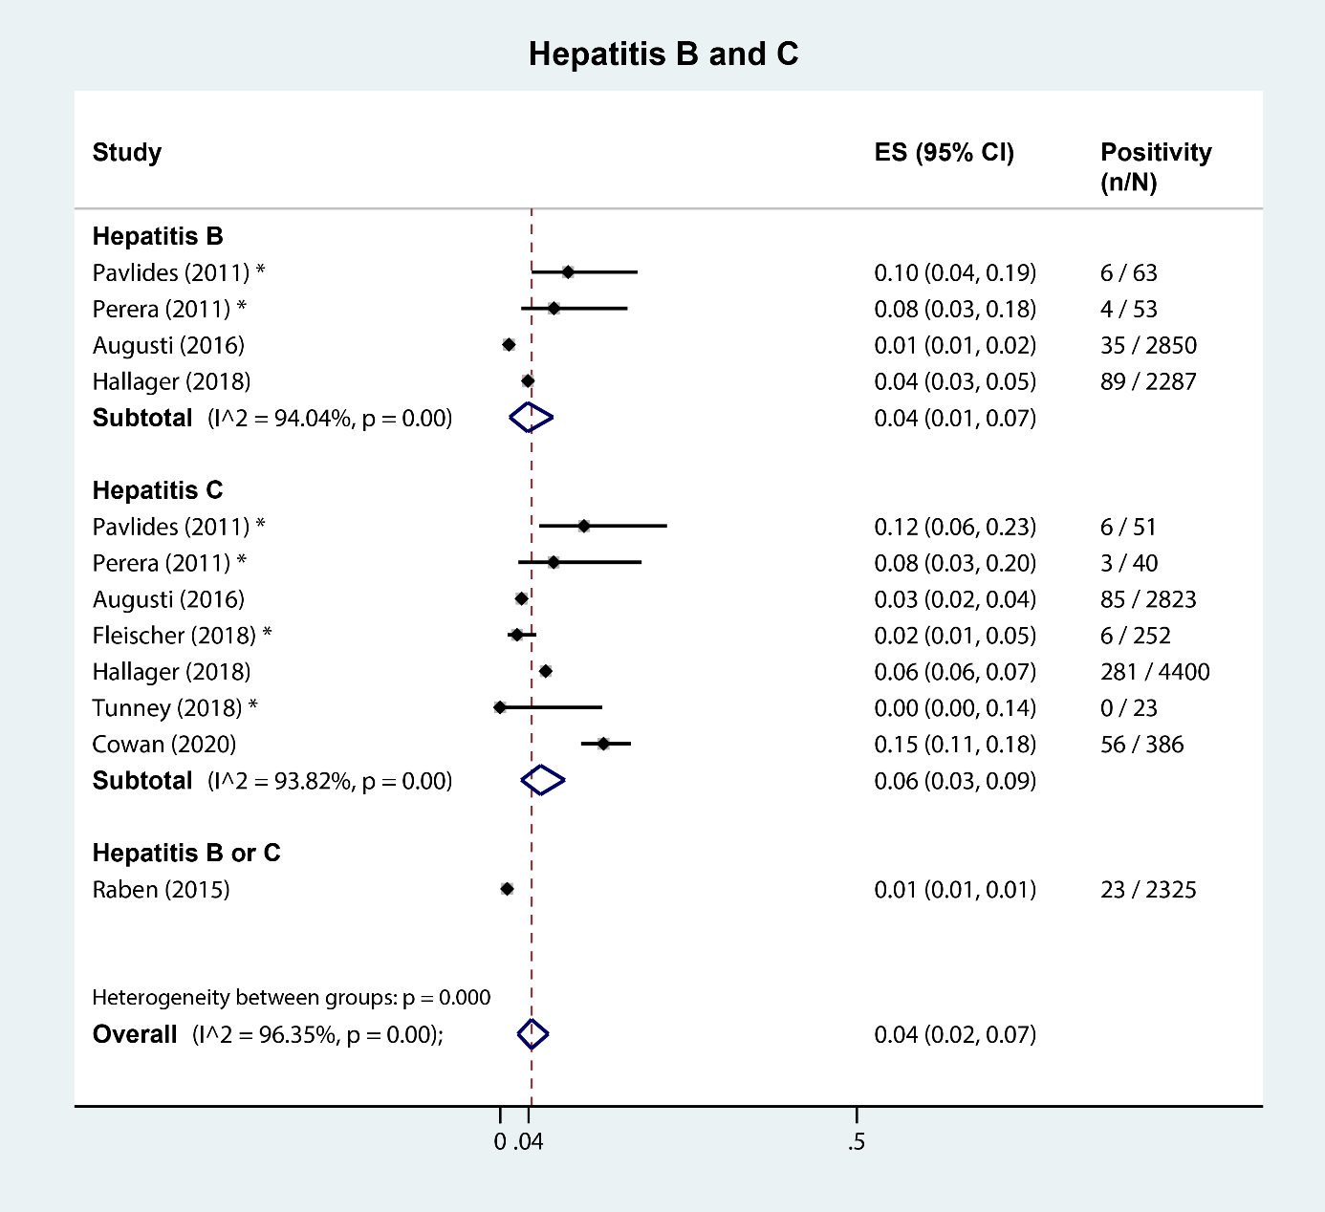
* Other publication types than full-text articles (i.e. abstracts, short communication, and correspondence). ES: estimated proportion. n=cases tested. N=cases identified.

1C: Malignant lymphoma
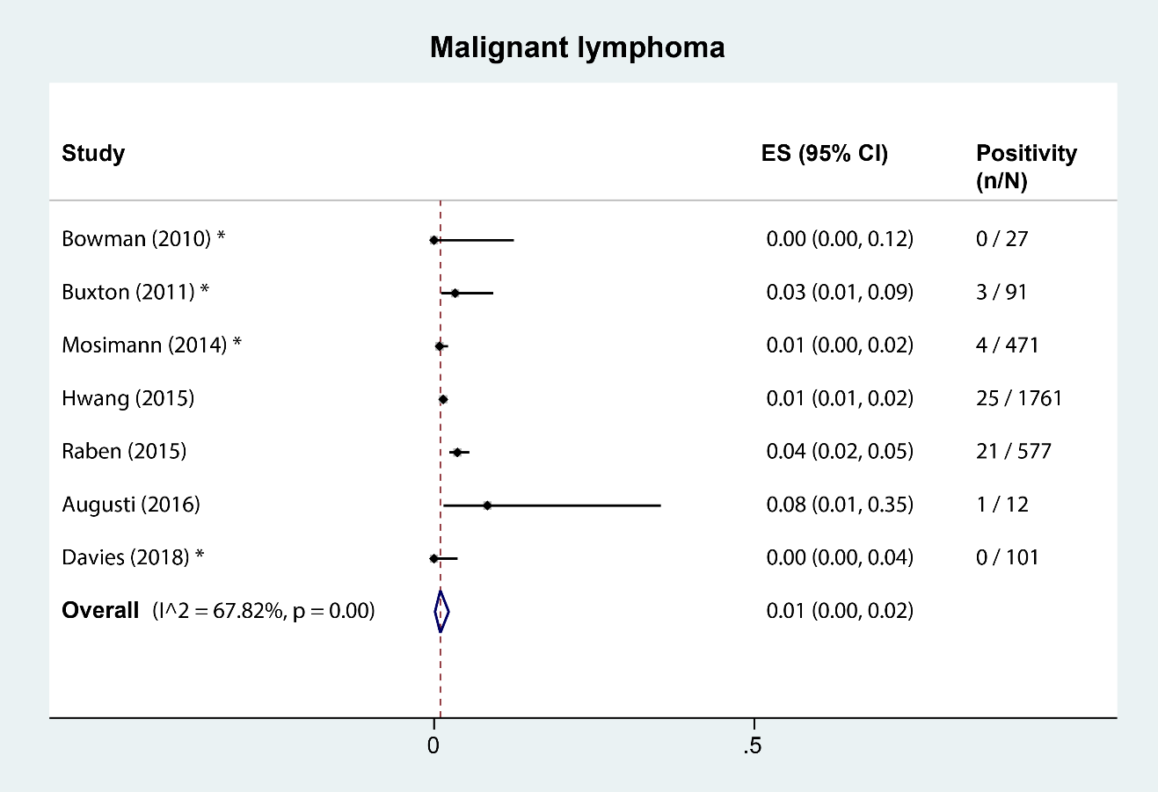
* Other publication types than full-text articles (i.e. abstracts, short communication, and correspondence). ES: estimated proportion. n=cases tested. N=cases identified.

1D: Cervical carcinoma or cervical intraepithelial neoplasia grade 2+
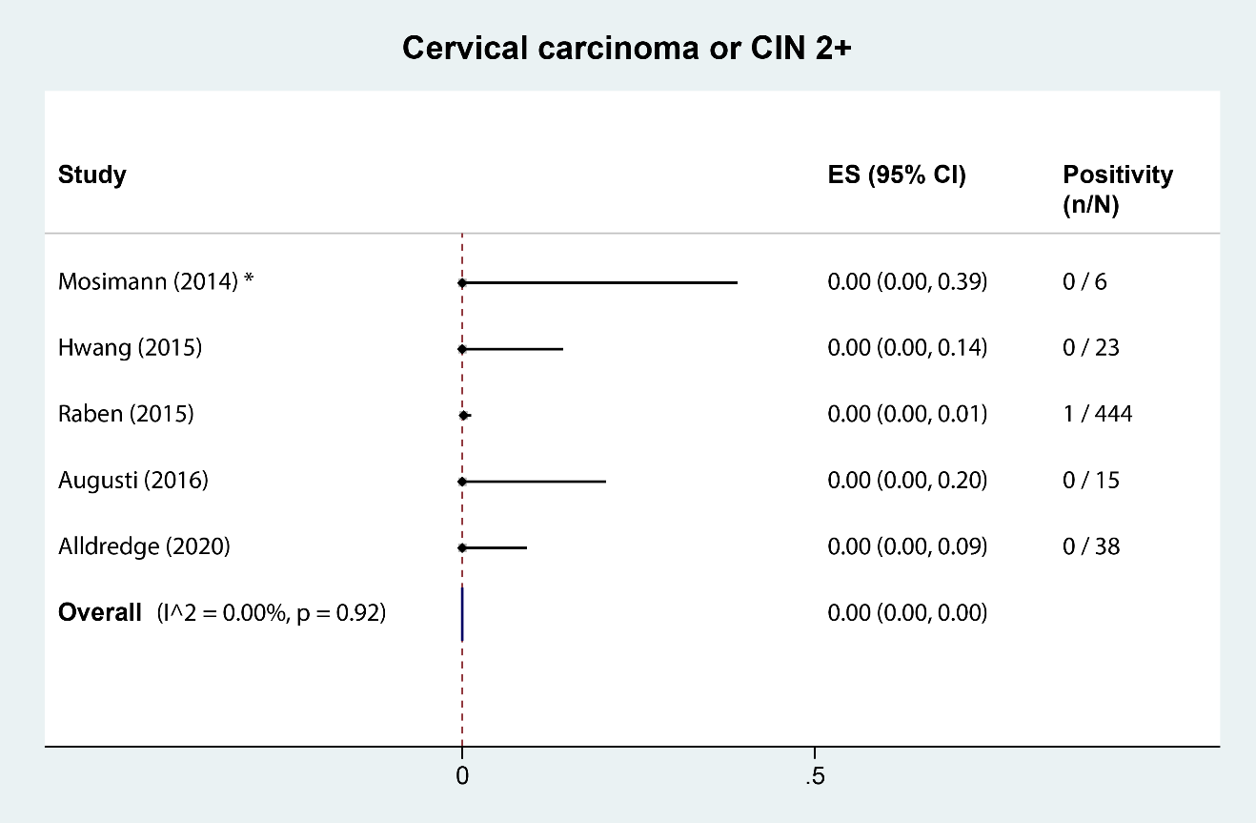
* Other publication types than full-text articles (i.e. abstracts, short communication, and correspondence). CIN: cervical intraepithelial neoplasia. ES: estimated proportion. n=cases tested. N=cases identified.

Appendix 7: H-TEAM consortium members

H-TEAM Steering Committee: J.E.A.M. van Bergen^{1;2;3}, G.J. de Bree^{4;5}, P. Brokx⁶, U. Davidovich^{7;8}, F. Deug¹, S.E. Geerlings⁵, M. Heidenrijk⁴, E. Hoornenborg⁷, A. Oomen¹, M. Prins^{5;7}, P. Reiss^{4;9}, A. van Sighem⁹, M. van der Valk⁵, W. Zuilhof¹

H-TEAM Project Management: N. Schat⁴

H-TEAM additional collaborators: M. van Agtmael¹⁰, J. Ananworanich¹¹, D. Van de Beek¹², G.E.L. van den Berk¹³, D. Bezemer⁹, A. van Bijnen¹, J.P. Bil⁷, W.L. Blok¹², S.J. Bogers⁵, M. Bomers¹⁰, C.A.B. Boucher¹⁴, A. Boyd^{7;9}, W. Brokking¹⁵, D. Burger¹⁶, K. Brinkman¹³, N. Brinkman¹⁷, M. de Bruin¹⁸, S. Bruisten⁷, L. Coyer⁷, R. van Crevel¹⁹, C.G. Daans^{7;20}; M. Dijkstra⁷, Y.T. van Duijnhoven⁷, A. van Eeden¹⁵, L. Elsenburg¹⁵, M.A.M. van den Elshout⁷, E. Ersan², P.E.V. Felipa⁷, T.B.H. Geijtenbeek²¹, J. van Gool⁷, A. Goorhuis⁵, M. Groot¹⁵, C.A. Hankins⁴, A. Heijnen^{22;23}, M.M.J Hillebregt⁹, M. Hommenga⁷, J.W. Hovius⁵, Y. Janssen¹⁷, K. de Jong⁷, V. Jongen⁷, N.A. Kootstra²⁴, R.A. Koup²⁵, F.P. Kroon²⁶, T.J.W. van de Laar^{27;28}, F. Lauw²⁹, M.M. van Leeuwen⁶, K. Lettinga³⁰, I. Linde⁷, D.S.E. Loomans⁷, I.M. van der Lubben⁷, J.T. van der Meer⁵, T. Mouhebati¹, B.J. Mulder⁷, J. Mulder³¹, F.J. Nellen⁵, A. Nijsters¹, H. Nobel⁵, E.L.M. Op de Coul³, E. Peters¹⁰, I.S. Peters⁷, T. van der Poll⁵, O. Ratmann³², C. Rokx³³, M.F. Schim van der Loeff^{7;34}, W.E.M. Schoute¹³, J. Schouten⁷, J. Veenstra³⁰, A. Verbon³³, F. Verdult⁶, J. de Vocht¹⁰, H.J. de Vries^{7;34;35}, S. Vrouenraets³⁰, M. van Vugt⁵, W.J. Wiersinga⁵, F.W. Wit^{5;8}, L.R. Woittiez⁵, S. Zaheri⁹, P. Zantkuijl¹, M.C. van Zelm³⁶, A. Żakowicz³⁷, H.M.L. Zimmermann⁷.

- Soa Aids Nederland, Amsterdam, the Netherlands
- Department of General Practice, Amsterdam UMC – location AMC, University of Amsterdam, Amsterdam, the Netherlands
- Epidemiology and Surveillance Unit, Center for Infectious Disease Control, National Institute of Public Health and the Environment, the Netherlands
- Department of Global Health, Amsterdam UMC – location AMC, and Amsterdam Institute for Global Health and Development, Amsterdam, the Netherlands
- Department of Internal Medicine, Division of Infectious Diseases, Amsterdam UMC – location AMC, Amsterdam, the Netherlands
- Dutch Association of PLHIV, Amsterdam, the Netherlands
- Department of Infectious Diseases, Public Health Service of Amsterdam, Amsterdam, the Netherlands
- Department of Social Psychology, University of Amsterdam, Amsterdam, the Netherlands
- Stichting HIV Monitoring, Amsterdam, the Netherlands
- Department of Internal Medicine, Amsterdam UMC – location VUMC, Amsterdam, the Netherlands
- US Military HIV Research Program and the Henry M. Jackson Foundation for the Advancement of Military Medicine, Bethesda, United States
- Center of Infection and Immunity Amsterdam (CINIMA), Department of Neurology, Amsterdam UMC – location AMC, Amsterdam, the Netherlands
- Department of internal medicine, OLVG – location East, Amsterdam, the Netherlands
- Department of viro-science, Erasmus Medical Center Rotterdam, Rotterdam, the Netherlands
- DC Klinieken, Amsterdam, the Netherlands
- Department of Pharmacy, Radboud University Nijmegen Medical Center, Nijmegen, the Netherlands
- Primary Care Amsterdam and Almere (Elaa), Amsterdam, the Netherlands
- Aberdeen Health Psychology Group, Institute of Applied Health Sciences, University of Aberdeen, Aberdeen, United Kingdom
- Department of Internal Medicine, Radboud University Nijmegen Medical Center, Nijmegen, the Netherlands
- Center of Expertise on Gender Dysphoria, Amsterdam UMC – location VUMC, Amsterdam, the Netherlands
- Laboratory of Experimental Immunology, Amsterdam UMC – location AMC Amsterdam, the Netherlands
- Sexology Center Amsterdam, Amsterdam, the Netherlands
- GP practice Heijnen & de Meij, Amsterdam, the Netherlands
- Laboratory for Viral Immune Pathogenesis, Amsterdam UMC – location AMC Amsterdam, the Netherlands
- Immunology Laboratory, Vaccine Research Center, National Institute of Allergy and Infectious Diseases, National Institutes of Health, Rockville, Maryland, USA
- Department of Infectious Diseases, Leiden University Medical Center, Leiden, the Netherlands
- Department of Medical Microbiology, OLVG, Amsterdam, the Netherlands
- Department of Donor Medicine Research, Laboratory of Blood-borne Infections, Sanquin Research, Amsterdam, the Netherlands
- Department of Internal Medicine, Medical Center Jan van Goyen, Amsterdam, the Netherlands
- Department of Internal Medicine, OLVG – location West, Amsterdam, the Netherlands
- Department of Internal Medicine, Slotervaart Hospital (former), Amsterdam, the Netherlands
- School of Public Health, Faculty of Medicine, Imperial College London, London, United Kingdom
- Department of Internal Medicine and Infectious Diseases, Erasmus Medical Center, Rotterdam, the Netherlands
- Center for Infection and Immunology, Amsterdam (CINIMA), Amsterdam UMC – location AMC, University of Amsterdam, Amsterdam, the Netherlands
- Department of Dermatology, Amsterdam UMC – location AMC, University of Amsterdam, Amsterdam, the Netherlands
- Department of Virology, Erasmus Medical Center, Rotterdam, the Netherlands
- AIDS Healthcare Foundation, Amsterdam, the Netherlands

