Supplementary File

Appendix 1: Search strategies for each database
1. MEDLINE via the PubMed
Domain | No. | Queries
P | #1 | “dry eye”
 | #2 | dry eye[MeSH Terms]
 | #3 | #1 OR #2
 | #4 | “keratoconjunctivitis sicca”
 | #5 | keratoconjunctivitis sicca[MeSH Terms]
 | #6 | #4 OR #5
 | #7 | “dysfunctional tear”
 | #8 | xerophthalmia[MeSH Terms]
 | #9 | #3 OR #6 OR #7 OR #8
I-1 | #10 | blood
 | #12 | platelet
 | #13 | serum
 | #14 | “umbilical cord”
 | #15 | #10 OR #12 OR #13 OR #14
I-2 | #16 | secretagogue
 | #17 | “tear stimul*”
 | #18 | “tear stimulants”
 | #19 | “tear stimulatory”
 | #20 | #17 OR #18 OR #19
 | #21 | diquafosol
 | #22 | diquas
 | #23 | #21 OR #22
 | #24 | rebamipide
 | #25 | gefarnil
 | #26 | “geranyl farnesylacetate”
 | #27 | #25 OR #26
 | #28 | ecabet
 | #29 | lacritin
 | #30 | “galactin 3”
 | #31 | “jbp 485”
 | #32 | eupatilin
 | #33 | “trefoil factor family 3”
 | #34 | “placent* extract*”
 | #35 | “nerve growth factor”
 | #36 | nerve growth factor[MeSH Terms]
 | #37 | #35 OR #36
 | #38 | “hypophysis adenylate cyclase activating polypeptide”
 | #39 | “pituitary adenylate cyclase activating polypeptide”
 | #40 | #38 OR #39
 | #41 | eledosin
 | #42 | “MIM-D3”
 | #43 | “P-321”
I-2 | #44 | #20 OR #23 OR #24 OR #27 OR #28 OR #29 OR #30 OR #31 OR #32 OR #33 OR #34 OR #37 OR #40 OR #41 OR #42 OR #43
I | #45 | #15 OR #44
P & I | #46 | #9 AND #45
Filters | #47 | Clinical study

2. EMBASE
Domain | No. | Queries
P | #1 | 'dry eye'/exp OR 'dry eye' OR 'conjunctivitis sicca'
 | #2 | 'keratoconjunctivitis sicca'/exp OR 'keratoconjunctivitis sicca'
 | #3 | 'dysfunctional tear syndrome'/exp
 | #4 | 'xerophthalmia'/exp
 | #5 | #1 OR #2 OR #3 OR #4
I-1 | #6 | 'blood'/exp
 | #7 | 'serum'/exp
 | #8 | platelet
 | #9 | 'umbilical cord'/exp OR 'umbilical cord'
 | #10 | #6 OR #7 OR #8 OR #9
I-2 | #11 | 'secretagogue'/exp OR 'secretagogue' OR 'secretagogues' OR 'secretion stimulating agent' OR 'secretory stimulant'
 | #12 | 'diquas'/exp OR 'diquafosol'/exp OR 'diquafosol'
 | #13 | 'rebamipide'/exp OR 'mucosta' OR 'rebamipide'
 | #14 | 'gefarnate'/exp OR 'gefarnil' OR 'gefarnate' OR 'geranyl farnesylacetate'
 | #15 | 'ecabet'/exp
 | #16 | 'lacritin'/exp
 | #17 | 'galactin 3'/exp
 | #18 | 'jbp 485'/exp
 | #19 | 'eupatilin'/exp
 | #20 | 'trefoil factor family 3'/exp
 | #21 | 'placenta extract'/exp OR 'placental extracts' OR 'placental extract'
 | #22 | 'nerve growth factor'/exp OR 'nerve growth factor' OR 'nerve growth factors'
 | #23 | 'hypophysis adenylate cyclase activating polypeptide'/exp OR 'pacap' OR 'hypophysis adenylate cyclase activating polypeptide' OR 'pituitary adenylate cyclase-activating polypeptide'
 | #21 | 'eledoisin'/exp
 | #22 | 'tavilermide'/exp OR 'mim d3'
 | #23 | “P-321”
 | #24 | #11 OR #12 OR #13 OR #14 OR #15 OR #16 OR #17 OR #18 OR #19 OR #20 OR #21 OR #22 OR #23
I | #25 | #10 OR #24
S | #26 | 'randomized controlled trial'/exp OR 'controlled trial, randomized' OR 'randomised controlled study' OR 'randomised controlled trial' OR 'randomized controlled study' OR 'randomized controlled trial' OR 'trial, randomized controlled' OR random*
P & I & S | #27 | #5 AND #25 AND #26

3. Scopus
Domain | No. | Queries
P | #1 | TITLE-ABS-KEY ( "dry eye" )
 | #2 | TITLE-ABS-KEY ( "keratoconjunctivitis sicca" )
 | #3 | TITLE-ABS-KEY ( "xerophthalmia" )
 | #4 | TITLE-ABS-KEY ( "dysfunctional tear" )
 | #5 | #1 OR #2 OR #3 OR #4
I-1 | #6 | TITLE-ABS-KEY ( blood )
 | #7 | TITLE-ABS-KEY ( serum )
 | #8 | TITLE-ABS-KEY ( platelet )
 | #9 | TITLE-ABS-KEY ( "umbilical cord" )
 | #10 | #6 OR #7 OR #8 OR #9
I-2 | #11 | TITLE-ABS-KEY ( secretagogu* )
 | #12 | TITLE-ABS-KEY ( "tear stimula*" )
 | #13 | #11 OR #12
 | #14 | TITLE-ABS-KEY ( diquafosol )
 | #15 | TITLE-ABS-KEY ( diquas )
 | #16 | #14 OR #15
 | #17 | TITLE-ABS-KEY ( rebamipide )
 | #18 | TITLE-ABS-KEY ( mucosta )
 | #19 | #17 OR #18
 | #20 | TITLE-ABS-KEY ( gefarnate )
 | #21 | TITLE-ABS-KEY ( gefarnil )
 | #22 | TITLE-ABS-KEY ( "geranyl farnesylacetate" )
 | #23 | #20 OR #21 OR #22
 | #24 | TITLE-ABS-KEY ( ecabet )
 | #25 | TITLE-ABS-KEY ( lacritin )
 | #26 | TITLE-ABS-KEY ( "galactin 3" )
 | #27 | TITLE-ABS-KEY ( "jbp 485" )
 | #28 | TITLE-ABS-KEY ( eupatilin )
 | #29 | TITLE-ABS-KEY ( "trefoil factor family 3" )
 | #30 | TITLE-ABS-KEY ( "placent* extract*" )
 | #31 | TITLE-ABS-KEY ( "nerve growth factor*" )
 | #32 | TITLE-ABS-KEY ( "hypophysis adenylate cyclase activating polypeptide" )
 | #33 | TITLE-ABS-KEY ( "pituitary adenylate cyclase activating polypeptide" )
 | #34 | #32 OR #33
 | #35 | TITLE-ABS-KEY ( eledosin )
 | #36 | TITLE-ABS-KEY ( "MIM-D3" )
 | #37 | TITLE-ABS-KEY ( tavilermide )
 | #38 | #36 OR #37
 | #39 | TITLE-ABS-KEY ( p-321 )
 | #40 | #13 OR #16 OR #19 OR #23 OR #24 OR #25 OR #26 OR #27 OR #28 OR #29 OR #30 OR #31 OR #34 OR #35 OR #36 OR #37 OR #38 OR #39
I | #41 | #10 OR #40
P & I | #48 | #5 AND #41
Filters | #49 | ( LIMIT-TO ( EXACTKEYWORD , "Dry Eye" ) ) AND ( LIMIT-TO ( EXACTKEYWORD , "Controlled Study" ) )

4. ClinicalTrials.gov
Studies with Results | Interventional Studies | "dry eye" OR "keratoconjunctivitis sicca" OR "dysfunctional tear" OR "xerophthalmia" | Adult
5. WHO International Clinical Trials Registry Platform (ICTRP)
dry eye OR keratoconjunctivitis sicca OR dysfunctional tear OR xerophthalmia
Applied Filters: Phase 2-4

Appendix 2: References of 39 included studies
e1. Gilbard JP, Rossi SR, Heyda KG, Dartt DA. Stimulation of tear secretion and treatment of dry-eye disease with 3-isobutyl-1-methylxanthine. Arch Ophthalmol. 1991;109:672-676.
e2. Baek J, Doh SH, Chung SK. The Effect of Topical Diquafosol Tetrasodium 3% on Dry Eye After Cataract Surgery. Curr Eye Res. 2016;41:1281-1285.
e3. Kamiya K, Nakanishi M, Ishii R, et al. Clinical evaluation of the additive effect of diquafosol tetrasodium on sodium hyaluronate monotherapy in patients with dry eye syndrome: a prospective, randomized, multicenter study. Eye (Lond). 2012;26:1363-1368.
e4. Takamura E, Tsubota K, Watanabe H, Ohashi Y. A randomised, double-masked comparison study of diquafosol versus sodium hyaluronate ophthalmic solutions in dry eye patients. Br J Ophthalmol. 2012;96(10):1310-1315.
e5. Gong L, Sun X, Ma Z, et al. A randomised, parallel-group comparison study of diquafosol ophthalmic solution in patients with dry eye in China and Singapore. Br J Ophthalmol. 2015;99:903-908.
e6. Park DH, Chung JK, Seo DR, Lee SJ. Clinical Effects and Safety of 3% Diquafosol Ophthalmic Solution for Patients With Dry Eye After Cataract Surgery: A Randomized Controlled Trial. Am J Ophthalmol. 2016;163:122-31.e2.
e7. Cui L, Li Y, Lee HS, Yang JM, Choi W, Yoon KC. Effect of diquafosol tetrasodium 3% on the conjunctival surface and clinical findings after cataract surgery in patients with dry eye. Int Ophthalmol. 2018;38:2021-2030.
e8. Inoue Y, Ochi S. Effects of 3% diquafosol sodium ophthalmic solution on higher-order aberrations in patients diagnosed with dry eye after cataract surgery. Clin Ophthalmol. 2017;11:87-93.
e9. Miyake K, Yokoi N. Influence on ocular surface after cataract surgery and effect of topical diquafosol on postoperative dry eye: a multicenter prospective randomized study. Clin Ophthalmol. 2017;11:529-540.
e10. Shimazaki-Den S, Iseda H, Dogru M, Shimazaki J. Effects of diquafosol sodium eye drops on tear film stability in short BUT type of dry eye. Cornea. 2013;32:1120-1125.
e11. Kaido M, Kawashima M, Shigeno Y, Yamada Y, Tsubota K. Randomized Controlled Study to Investigate the Effect of Topical Diquafosol Tetrasodium on Corneal Sensitivity in Short Tear Break-Up Time Dry Eye. Adv Ther. 2018;35:697-706.
e12. Matsumoto Y, Ohashi Y, Watanabe H, Tsubota K. Efficacy and safety of diquafosol ophthalmic solution in patients with dry eye syndrome: a Japanese phase 2 clinical trial. Ophthalmology. 2012;119:1954-1960.
e13. Hwang J, Chung SH, Jeon S, Kwok SK, Park SH, Kim MS. Comparison of clinical efficacies of autologous serum eye drops in patients with primary and secondary Sjogren syndrome. Cornea. 2014;33:663-667.
e14. Kim YH, Kang YS, Lee HS, Choi W, You IC, Yoon KC. Effectiveness of Combined Tear Film Therapy in Patients with Evaporative Dry Eye with Short Tear Film Breakup Time. J Ocul Pharmacol Ther. 2017;33:635-643.
e15. Jun I, Choi S, Lee GY, et al. Effects of Preservative-free 3% Diquafosol in Patients with Pre-existing Dry Eye Disease after Cataract Surgery: A Randomized Clinical Trial. Sci Rep. 2019;9:12659.
e16. Toda I, Ide T, Fukumoto T, Ichihashi Y, Tsubota K. Combination therapy with diquafosol tetrasodium and sodium hyaluronate in patients with dry eye after laser in situ keratomileusis. Am J Ophthalmol. 2014;157:616-22e1.
e17. Kinoshita S, Awamura S, Oshiden K, Nakamichi N, Suzuki H, Yokoi N. Rebamipide (OPC-12759) in the treatment of dry eye: a randomized, double-masked, multicenter, placebo-controlled phase II study. Ophthalmology. 2012;119:2471-2478.
e18. Kinoshita S, Oshiden K, Awamura S, Suzuki H, Nakamichi N, Yokoi N. A randomized, multicenter phase 3 study comparing 2% rebamipide (OPC-12759) with 0.1% sodium hyaluronate in the treatment of dry eye. Ophthalmology. 2013;120:1158-1165.
e19. Igarashi A, Kamiya K, Kobashi H, Shimizu K. Effect of Rebamipide Ophthalmic Suspension on Intraocular Light Scattering for Dry Eye After Corneal Refractive Surgery. Cornea. 2015;34:895-900.
e20. Kobashi H, Kamiya K, Shimizu K. Randomized Comparison Between Rebamipide Ophthalmic Suspension and Diquafosol Ophthalmic Solution for Dry Eye After Penetrating Keratoplasty. J Ocul Pharmacol Ther. 2017;33:13-18.
e21. Shimazaki J, Seika D, Saga M, et al. A Prospective, Randomized Trial of Two Mucin Secretogogues for the Treatment of Dry Eye Syndrome in Office Workers. Sci Rep. 2017;7:15210.
e22. Nebbioso M EM, Librando A, Plateroti AM, Pescosolido N. Iatrogenic dry eye disease: An eledoisin/carnitine and osmolyte drops study. Biomed Pharmacother. 2013;67:659-663.
e23. Meerovitch K, Torkildsen G, Lonsdale J, et al. Safety and efficacy of MIM-D3 ophthalmic solutions in a randomized, placebo-controlled Phase 2 clinical trial in patients with dry eye. Clin Ophthalmol. 2013;7:1275-1285.
e24. NCT03019627. An 8-week Study to Evaluate Safety and Efficacy of NGF Eye Drops Solution Versus Vehicle in Patients with Dry Eye. 2017.
e25. NCT03982368. A Study to Evaluate Safety and Efficacy of rhNGF Eye Solution vs Vehicle in Patients With Moderate to Severe Dry Eye. 2019.
e26. Tananuvat N, Daniell M, Sullivan LJ, Yi Q, McKelvie P, McCarty DJ, et al. Controlled study of the use of autologous serum in dry eye patients. Cornea. 2001;20:802-806.
e27. Kojima T, Ishida R, Dogru M, et al. The effect of autologous serum eyedrops in the treatment of severe dry eye disease: a prospective randomized case-control study. Am J Ophthalmol. 2005;139:242-246.
e28. Noda-Tsuruya T, Asano-Kato N, Toda I, Tsubota K. Autologous serum eye drops for dry eye after LASIK. J Refract Surg. 2006;22:61-66.
e29. Urzua CA, Vasquez DH, Huidobro A, Hernandez H, Alfaro J. Randomized double-blind clinical trial of autologous serum versus artificial tears in dry eye syndrome. Curr Eye Res. 2012;37:684-688.
e30. Celebi AR, Ulusoy C, Mirza GE. The efficacy of autologous serum eye drops for severe dry eye syndrome: a randomized double-blind crossover study. Graefes Arch Clin Exp Ophthalmol. 2014;252:619-626.
e31. Yilmaz U, Kucuk E, Koc C, Gokler E. Comparison of Autologous Serum Versus Preservative Free Artificial Tear in Patients with Dry Eyes Due to Systemic Isotretinoin Therapy. Curr Eye Res. 2017;42:827-831.
e32. Noble BA, Loh RS, MacLennan S, et al. Comparison of autologous serum eye drops with conventional therapy in a randomised controlled crossover trial for ocular surface disease. Br J Ophthalmol. 2004;88:647-652.
e33. Mukhopadhyay S, Sen S, Datta H. Comparative role of 20% cord blood serum and 20% autologous serum in dry eye associated with Hansen's disease: a tear proteomic study. Br J Ophthalmol. 2015;99:108-112.
e34. Campos E, Versura P, Buzzi M, et al. Blood derived treatment from two allogeneic sources for severe dry eye associated to keratopathy: a multicentre randomised cross over clinical trial. Br J Ophthalmol. 2020;104:1142-1147.
e35. Fea AM, Aragno V, Testa V, et al. The Effect of Autologous Platelet Lysate Eye Drops: An In Vivo Confocal Microscopy Study. Biomed Res Int. 2016;2016:8406832.
e36. Garcia-Conca V, Abad-Collado M, Hueso-Abancens JR, et al. Efficacy and safety of treatment of hyposecretory dry eye with platelet-rich plasma. Acta Ophthalmol. 2019;97:e170-e178.
e37. Ji YW, Kim HM, Ryu SY, et al. Changes in Human Tear Proteome Following Topical Treatment of Dry Eye Disease: Cyclosporine A Versus Diquafosol Tetrasodium. Invest Ophthalmol Vis Sci. 2019;60:5035-5044.
e38. Park CH, Lee HK, Kim MK, et al. Comparison of 0.05% cyclosporine and 3% diquafosol solution for dry eye patients: a randomized, blinded, multicenter clinical trial. BMC Ophthalmol. 2019;19:131.
e39. Patil A SM. A comparative study between efficacy of cyclosporine 0.1% and rebamipide 2% eye drops in moderate to severe dry eye cases. Asian J Pharm Clin Res. 2018;11:15.

Appendix 3: Risk of bias assessment
R = Bias arising from the randomisation process, D = Bias due to deviations from intended interventions, Mi = Bias due to missing outcome data, Me = Bias in measurement of the outcome, S = Bias in selection of the reported result, and O = Overall risk of bias
2.1 ROB for OSDI score
No. | Author Year | R | D | Mi | Me | S | O
1 | Baek 2016 | Some concern | Some concern | Some concern | Low | Low | Some concern
2 | Park DH 2016 | Low | Some concern | High | High | Low | High
3 | Cui 2018 | Some concern | High | High | High | Some concern | High
4 | Hwang 2014 | Some concern | Some concern | Low | High | Low | High
5 | Kim 2017 | Some concern | Some concern | High | Low | Some concern | High
6 | Jun 2019 | Some concern | Some concern | Low | High | Some concern | High
7 | Nebbioso 2013 | High | Some concern | High | Low | Some concern | High
8 | Meerovitch 2013 | Low | Low | Low | Low | Some concern | Some concern
9 | Urzua 2012 | Low | Low | Low | Low | Low | Low
10 | Celebi 2014 | Low | Low | Low | Low | Some concern | Some concern
11 | Yilmaz 2017 | Low | Low | Low | Some concern | Low | Some concern
12 | Campos 2019 | Low | Low | Low | Low | Some concern | Some concern
13 | Fea 2016 | Some concern | High | High | High | Some concern | High
14 | Garcia-Conca 2019 | Some concern | Some concern | High | High | Some concern | High
15 | Ji 2019 | Low | Low | High | Low | Low | High
16 | Park CH 2019 | Low | Some concern | High | High | Low | High
17 | Patil 2018 | Some concern | Some concern | High | High | Some concern | High

2.2 ROB for corneal fluorescein staining
No. | Author Year | R | D | Mi | Me | S | O
1 | Baek 2016 | Some concern | Some concern | Some concern | Low | Low | Some concern
2 | Kamiya 2012 | Some concern | Some concern | Low | High | Some concern | High
3 | Takamura 2012 | Some concern | Some concern | Low | Low | Low | Some concern
4 | Gong 2015 | Some concern | Some concern | Low | Low | Low | Some concern
5 | Park DH 2016 | Low | Some concern | High | High | Low | High
6 | Cui 2018 | Some concern | High | High | High | Some concern | High
7 | Matsumoto 2012 | Some concern | Low | High | Low | Low | High
8 | Hwang 2014 | Some concern | Some concern | Low | High | Low | High
9 | Kim 2017 | Some concern | Some concern | High | Low | Some concern | High
10 | Jun 2019 | Some concern | Some concern | Low | High | Some concern | High
11 | Toda 2014 | Some concern | High | High | High | High | High
12 | Kinoshita 2012 | Low | Low | Low | Low | Low | Low
13 | Kinoshita 2013 | Low | Some concern | Low | Low | Low | Some concern
14 | Kobashi 2016 | Low | Some concern | Low | High | Some concern | High
15 | Giordano 2017 | Some concern | Some concern | Low | Low | Low | Some concern
16 | Mastropasqua 2019 | Some concern | Some concern | Low | Low | Low | Some concern
17 | Kojima 2005 | Some concern | Some concern | High | High | Some concern | High
18 | Noda-Tsuruya 2006 | High | High | High | High | Some concern | High
19 | Campos 2019 | Low | Low | Low | Low | Some concern | Some concern
20 | Fea 2016 | Some concern | High | High | High | Some concern | High
21 | Garcia-Conca 2019 | Some concern | Some concern | High | High | Some concern | High
22 | Ji 2019 | Low | Low | High | Low | Low | High

2.3 ROB for tear break-up time (TBUT)
No. | Author Year | R | D | Mi | Me | S | O
1 | Baek 2016 | Some concern | Some concern | Some concern | Low | Low | Some concern
2 | Kamiya 2012 | Some concern | Some concern | Low | High | Some concern | High
3 | Gong 2015 | Some concern | Some concern | Low | Low | Low | Some concern
4 | Park DH 2016 | Low | Some concern | High | High | Low | High
5 | Cui 2018 | Some concern | High | High | High | Some concern | High
6 | Inoue 2017 | Some concern | Some concern | High | High | Low | High
7 | Miyake 2017 | Some concern | Some concern | Low | High | Low | High
8 | Shimazaki-Den 2013 | Low | Some concern | High | High | Low | High
9 | Kaido 2018 | Some concern | Some concern | High | High | Some concern | High
10 | Matsumoto 2012 | Some concern | Low | High | Low | Low | High
11 | Hwang 2014 | Some concern | Some concern | Low | High | Low | High
12 | Kim 2017 | Some concern | Some concern | High | Low | Some concern | High
13 | Jun 2019 | Some concern | Some concern | Low | High | Some concern | High
14 | Toda 2014 | Some concern | High | High | High | High | High
15 | Kinoshita 2012 | Low | Low | Low | Low | Low | Low
16 | Kinoshita 2013 | Low | Some concern | Low | Low | Low | Some concern
17 | Igarashi 2015 | Low | Some concern | Low | High | Some concern | High
18 | Kobashi 2016 | Low | Some concern | Low | High | Some concern | High
19 | Shimazaki 2017 | Low | Some concern | Low | High | Low | High
20 | Nebbioso 2013 | High | Some concern | High | Low | Some concern | High
21 | Meerovitch 2013 | Low | Low | Low | Low | Some concern | Some concern
22 | Mastropasqua 2019 | Some concern | Some concern | Low | Low | Low | Some concern
23 | Kojima 2005 | Some concern | Some concern | High | High | Some concern | High
24 | Noda-Tsuruya 2006 | High | High | High | High | Some concern | High
25 | Urzua 2012 | Low | Low | Low | Low | Low | Low
26 | Celebi 2014 | Low | Low | Low | Low | Some concern | Some concern
27 | Yilmaz 2017 | Low | Low | Low | Some concern | Low | Some concern
28 | Mukhopadhyay 2015 | Some concern | Low | Low | Low | Some concern | Some concern
29 | Campos 2019 | Low | Low | Low | Low | Some concern | Some concern
30 | Fea 2016 | Some concern | High | High | High | Some concern | High
31 | Garcia-Conca 2019 | Some concern | Some concern | High | High | Some concern | High
32 | Ji 2019 | Low | Low | High | Low | Low | High
33 | Park CH 2019 | Low | Some concern | High | High | Low | High
34 | Patil 2018 | Some concern | Some concern | High | High | Some concern | High

2.4 ROB for tear Schirmer’s test (ST)
No. | Author Year | R | D | Mi | Me | S | O
1 | Baek 2016 | Some concern | Some concern | Some concern | Low | Low | Some concern
2 | Kamiya 2012 | Some concern | Some concern | Low | High | Some concern | High
3 | Park DH 2016 | Low | Some concern | High | High | Low | High
4 | Cui 2018 | Some concern | High | High | High | Some concern | High
5 | Hwang 2014 | Some concern | Some concern | Low | High | Low | High
6 | Kim 2017 | Some concern | Some concern | High | Low | Some concern | High
7 | Jun 2019 | Some concern | Some concern | Low | High | Some concern | High
8 | Toda 2014 | Some concern | High | High | High | High | High
9 | Kinoshita 2012 | Low | Low | Low | Low | Low | Low
10 | Kinoshita 2013 | Low | Some concern | Low | Low | Low | Some concern
11 | Igarashi 2015 | Low | Some concern | Low | High | Some concern | High
12 | Nebbioso 2013 | High | Some concern | High | Low | Some concern | High
13 | Kojima 2005 | Some concern | Some concern | High | High | Some concern | High
14 | Celebi 2014 | Low | Low | Low | Low | Some concern | Some concern
15 | Yilmaz 2017 | Low | Low | Low | Some concern | Low | Some concern
16 | Mukhopadhyay 2015 | Some concern | Low | Low | Low | Some concern | Some concern
17 | Campos 2019 | Low | Low | Low | Low | Some concern | Some concern
18 | Fea 2016 | Some concern | High | High | High | Some concern | High
19 | Garcia-Conca 2019 | Some concern | Some concern | High | High | Some concern | High
20 | Ji 2019 | Low | Low | Low | Low | Low | High
21 | Park CH 2019 | Low | Some concern | High | High | Low | High
22 | Patil 2018 | Some concern | Some concern | High | High | Some concern | High

2.5 ROB for adverse events
No. | Author Year | R | D | Mi | Me | S | O
1 | Gilbard 1991 | Some concern | Some concern | High | Some concern | High | High
2 | Kamiya 2012 | Some concern | Some concern | Low | High | Some concern | High
3 | Takamura 2012 | Some concern | Some concern | Low | Low | Low | Some concern
4 | Gong 2015 | Some concern | Some concern | Low | Low | Low | Some concern
5 | Park DH 2016 | Low | Some concern | High | High | Low | High
6 | Matsumoto 2012 | Some concern | Low | High | Low | Low | High
7 | Hwang 2014 | Some concern | Some concern | Low | High | Low | High
8 | Kim 2017 | Some concern | Some concern | High | Low | Some concern | High
9 | Kinoshita 2012 | Low | Low | Low | Low | Low | Low
10 | Kinoshita 2013 | Low | Some concern | Low | Low | Low | Some concern
11 | Igarashi 2015 | Low | Some concern | Low | High | Some concern | High
12 | Shimazaki 2017 | Low | Some concern | Low | High | Low | High
13 | Meerovitch 2013 | Low | Low | Low | Low | Some concern | Some concern
14 | Giordano 2017 | Some concern | Some concern | Low | Low | Low | Some concern
15 | Mastropasqua 2019 | Some concern | Some concern | Low | Low | Low | Some concern
16 | Tananuvat 2001 | Some concern | Some concern | Some concern | Some concern | Some concern | High
17 | Celebi 2014 | Low | Low | Low | Low | Some concern | Some concern
18 | Campos 2019 | Low | Low | Low | Low | Some concern | Some concern
19 | Fea 2016 | Some concern | High | High | High | Some concern | High
20 | Ji 2019 | Low | Low | High | Low | Low | High
21 | Park CH 2019 | Low | Some concern | High | High | Low | High

Appendix 4: Data for pooling of OSDI Score
No. | Author Year | Intervention | N | Mean | SD
1 | Baek 2016 | DQ | 32 | 9.3 | 2.99
1 | Baek 2016 | Placebo | 32 | 14.8 | 2.99
2 | Park DH 2016 | DQ | 30 | 9.76 | 7.95
2 | Park DH 2016 | AT | 33 | 16.92 | 13.11
3 | Cui 2018 | DQ | 50 | 22.5 | 3.68
3 | Cui 2018 | AT | 44 | 25.23 | 4.52
4 | Hwang 2014 | DQ | 50 | -5.69 | 5.52
4 | Hwang 2014 | DT | 50 | -8.48 | 6.86
4 | Hwang 2014 | AT | 50 | -3.67 | 4.38
5 | Kim 2017 | DT | 98 | 34.15 | 11
5 | Kim 2017 | AT | 46 | 40.27 | 6.08
6 | Jun 2019 | DQ | 79 | 12.99 | 11.67
6 | Jun 2019 | AT | 38 | 17.63 | 11.45
7 | Nebbioso 2013 | ED | 20 | 25 | 7
7 | Nebbioso 2013 | Placebo | 20 | 36 | 12.1
8 | Meerovitch 2013 | MIM-D3 | 49 | 2.08 | 1.19
8 | Meerovitch 2013 | Placebo | 47 | 2.29 | 1.03
9 | Urzua 2012 | AS | 12 | 30 | 8
9 | Urzua 2012 | AT | 12 | 41 | 8
10 | Celebi 2014 | AS | 10 | 26.5 | 6.18
10 | Celebi 2014 | AT | 10 | 43.2 | 7.34
11 | Yilmaz 2017 | AS | 12 | 24.1 | 3.4
11 | Yilmaz 2017 | AT | 12 | 29.3 | 4.2
12 | Campos 2019 | CBS | 31 | 31 | 12.27
12 | Campos 2019 | AS | 29 | 38 | 19.72
13 | Fea 2016 | APL | 20 | 21.75 | 9.86
13 | Fea 2016 | AT | 10 | 53.6 | 14.91
14 | Garcia-Conca 2019 | PRP | 44 | -24.86 | 15.71
14 | Garcia-Conca 2019 | AT | 39 | -5.56 | 5.67
15 | Ji 2019 | CSA | 9 | 27.47 | 17.11
15 | Ji 2019 | DQ | 9 | 26.75 | 17.91
16 | Park CH 2019 | CSA | 58 | -13.03 | 19.63
16 | Park CH 2019 | DQ | 57 | -16.11 | 20.87
17 | Patil 2018 | CSA | 40 | 33.65 | 5.94
17 | Patil 2018 | RT | 40 | 28.74 | 6.36
APL = autologous platelet lysate, AS = autologous/allogeneic serum, AT = artificial tear, CBS = cord blood serum, CSA = cyclosporine A, DQ = diquafosol, DT = diquafoso + artificial tear, ED = eledoisin, MIM-D3 = small molecule nerve growth factor peptidomimetic, PRP = platelet rich plasma, RB = rebamipide, rhNGF = recombinant human nerve growth factor, RT = rebamipide + artificial tear.

Surface under the cumulative ranking curve of ODSI scores
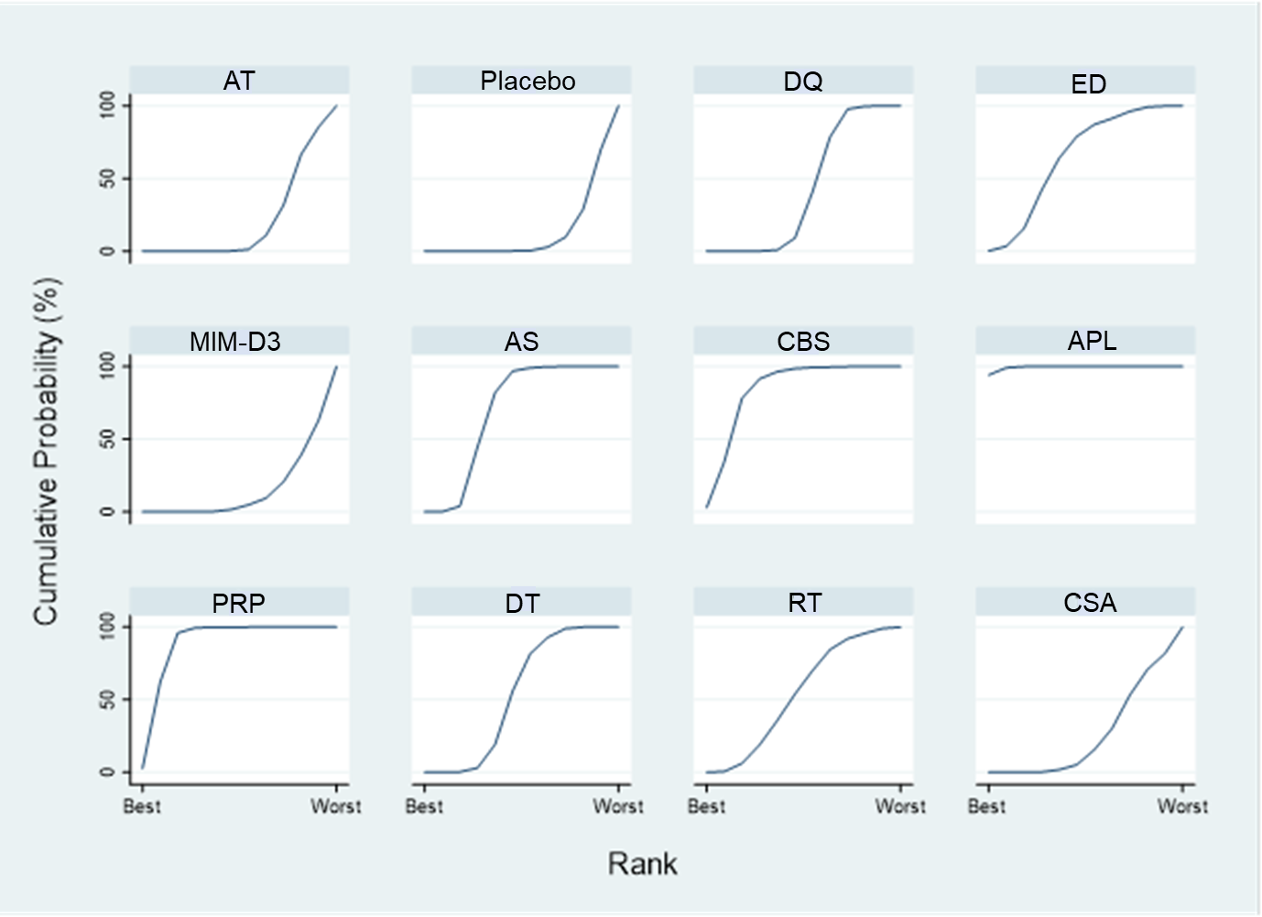
APL = autologous platelet lysate; AS = autologous/allogeneic serum; AT = artificial tears (references); CBS = cord blood serum; CSA = cyclosporine A; DQ = diquafosol; DT = diquafosol + artificial tear; ED = eledoisin; MIM-D3 = a tyrosine kinase TrkA receptor agonist; PRP = platelet rich plasma; RT = rebamipide + artificial tear

Appendix 5: Direct meta-analysis results
Treatment comparison |  | No of studies | Differences | 95% CI | I² (%) | Egger’s test
Comparators | Interventions
OSDI score |  |  | USMD
AT | DQ | 4 | -2.81 | -4.00, -1.63 | 19.99 | 0.085
AT | AS | 3 | -10.62 | -17.86, -3.39 | 83.71 | 0.125
AT | DT | 2 | -5.21 | -7.09, -3.33 | 0 | 0.529
DQ | CSA | 2 | 2.67 | -4.06, 9.40 | 0 | 0.795
Corneal fluorescein staining |  |  | SMD
AT | DQ | 9 | -0.21 | -0.37, -0.05 | 51.28 | 0.357
AT | AS | 2 | 0.04 | -0.69, 0.78 | 42.84 | 0.389
AT | DT | 3 | -0.16 | -0.68, 0.37 | 80.17 | 0.434
Placebo | rhNGF | 2 | 0.11 | -0.85, 1.08 | 61.01 | 0.365
DQ | DT | 2 | -0.02 | -0.61, 0.57 | 69.54 | 0.378
Tear break-up time (TBUT) |  |  | USMD
AT | DQ | 12 | 0.61 | 0.28, 0.94 | 60.55 | 0.040
AT | RB | 2 | 0.84 | -0.61, 2.30 | 84.23 | 0.114
AT | AS | 6 | 3.41 | 1.32, 5.49 | 91.99 | 0.056
AT | DT | 3 | 0.43 | 0.14, 0.72 | 0 | 0.903
DQ | DT | 2 | 0.04 | -0.53, 0.61 | 0 | 0.856
DQ | CSA | 2 | 0.18 | -1.25, 1.61 | 87.16 | 0.304
AS | CBS | 2 | 0.6 | -0.73, 1.93 | 0 | 0.720
Placebo | rhNGF | 2 | -0.4 | -0.97, 0.17 | 0 | 1.000
Schirmer’s test (ST) |  |  | USMD
AT | DQ | 6 | 0.94 | 0.16, 1.72 | 0 | 0.122
AT | RB | 2 | -0.51 | -1.21, 0.20 | 0 | 0.834
AT | AS | 4 | 1.87 | -0.96, 4.70 | 91.79 | 0.149
AT | DT | 3 | 0.99 | -1.05, 3.04 | 73.67 | 0.006
DQ | DT | 2 | 0.81 | -0.64, 2.27 | 0 | 0.323
DQ | CSA | 2 | -0.16 | -2.44, 2.12 | 65.59 | 0.391
AS | CBS | 2 | -0.45 | -2.23, 1.33 | 0 | 0.388
Adverse events |  |  | RR
AT | DQ | 6 | 1.64 | 1.10, 2.46 | 0 | 0.483
AT | DT | 2 | 0.77 | 0.28, 2.09 | 0 | 0.967
DQ | CSA | 2 | 0.71 | 0.14, 3.46 | 0 | 0.844
Placebo | rhNGF | 2 | 2.05 | 0.72, 5.86 | 82.42 | 0.333
AS = autologous/allogeneic serum, AT = artificial tear, CBS = cord blood serum, CI = confident intervals, CSA = cyclosporine A, DQ = diquafosol, MD = mean differences, RB = rebamipide, rhNGF = recombinant human nerve growth factor, RR = relative risks, SMD = standardized mean differences, USMD = unstandardized mean differences.

Appendix 6: GRADE evidence of pairwise estimates and ranking of treatment in OSDI outcome (12 interventions, 66 comparisons)
Comparisons | Mean differences | Nature of evidence | Certainty in evidences | Downgrading due to
 |  |  |  | SL | ID | IC | IP | PB
Placebo vs AT | 1.82  (-4.13,7.77) | Indirect | ⊕⊕○○  Low | X | - | - | X | -
DQ vs AT | -3.67*  (-6.65,-0.70) | Mixed | ⊕○○○  Very low* | X | X | X | X | -
ED vs AT | -9.18  (-19.06,0.69) | Indirect | ⊕○○○  Very low* | X | X | X | X | -
MIM-D3 vs AT | 1.60  (-6.14,9.35) | Indirect | ⊕○○○  Very Low* | X | X | X | X | -
AS vs AT | -9.77*  (-14.04,-5.49) | Mixed | ⊕⊕○○  Low | X | - | X | - | -
CBS vs AT | -16.76*  (-27.40,-6.13) | Indirect | ⊕⊕○○  Low | X | - | X | - | -
APL vs AT | -31.85*  (-43.19,-20.51) | Mixed | ⊕⊕⊕○  Moderate | X | - | - | - | -
PRP vs AT | -19.30*  (-26.32,-12.28) | Mixed | ⊕⊕⊕○  Moderate | X | - | - | - | -
DT vs AT | -5.82*  (-9.59,-2.06) | Mixed | ⊕⊕○○  Low | X | - | X | - | -
RT vs AT | -6.01  (-16.17,4.14) | Indirect | ⊕○○○  Very Low* | X | X | X | X | -
CSA vs AT | -1.10  (-9.55,7.34) | Indirect | ⊕○○○  Very Low* | X | X | X | X | -
DQ vs Placebo | -5.49*  (-10.65,-0.33) | Mixed | ⊕⊕○○  Low* | X | - | X | X | -
ED vs Placebo | -11.00*  (-18.88,-3.12) | Mixed | ⊕⊕○○  Low | X | - | X | - | -
MIM-D3 vs Placebo | -0.21  (-5.19,4.76) | Direct | ⊕⊕○○  Low | X | - | - | X | -
AS vs Placebo | -11.58*  (-18.79,-4.38) | Indirect | ⊕⊕○○  Low* | X | X | X | - | -
CBS vs Placebo | -18.58*  (-30.69,-6.47) | Indirect | ⊕⊕○○  Low* | X | X | X | - | -
APL vs Placebo | -33.67*  (-46.48,-20.86) | Indirect | ⊕⊕○○  Low | X | X | X | - | -
PRP vs Placebo | -21.12*  (-30.32,-11.91) | Indirect | ⊕⊕○○  Low* | X | X | X | - | -
DT vs Placebo | -7.64*  (-14.31,-0.97) | Indirect | ⊕○○○  Very low* | X | X | X | X | -
RT vs Placebo | -7.83  (-18.82,3.15) | Indirect | ⊕○○○  Very low* | X | X | X | X | -
CSA vs Placebo | -2.92  (-12.35,6.50) | Indirect | ⊕○○○  Very low* | X | X | X | X | -
ED vs DQ | -5.51  (-14.93,3.91) | Indirect | ⊕○○○  Very low* | X | X | X | X | -
MIM-D3 vs DQ | 5.28  (-1.88,12.44) | Indirect | ⊕○○○  Very low* | X | X | X | X | -
AS vs DQ | -6.09*  (-11.14,-1.05) | Indirect | ⊕○○○  Very low* | X | X | X | X | -
CBS vs DQ | -13.09*  (-24.06,-2.13) | Indirect | ⊕⊕○○  Low | X | - | X | - | -
APL vs DQ | -28.18*  (-39.90,-16.45) | Indirect | ⊕⊕○○  Low | X | X | X | - | -
PRP vs DQ | -15.63*  (-23.25,-8.00) | Indirect | ⊕⊕○○  Low | X | X | X | - | -
DT vs DQ | -2.15  (-6.39,2.09) | Mixed | ⊕○○○  Very low | X | X | - | X | -
RT vs DQ | -2.34  (-12.04,7.36) | Indirect | ⊕○○○  Very low* | X | X | X | X | -
CSA vs DQ | 2.57  (-5.32,10.46) | Mixed | ⊕⊕○○  Low | X | - | - | X | -
MIM-D3 vs ED | 10.79* (1.46,20.11) | Indirect | ⊕⊕○○  Low | X | - | X | - | -
AS vs ED | -0.58  (-11.26,10.10) | Indirect | ⊕○○○  Very low* | X | X | X | X | -
CBS vs ED | -7.58  (-22.03,6.87) | Indirect | ⊕○○○  Very low* | X | X | X | X | -
APL vs ED | -22.67*  (-37.71,-7.63) | Indirect | ⊕⊕○○  Low | X | X | X | - | -
PRP vs ED | -10.12  (-22.24,2.00) | Indirect | ⊕○○○  Very low* | X | X | X | X | -
DT vs ED | 3.36  (-6.97,13.69) | Indirect | ⊕○○○  Very low* | X | X | X | X | -
RT vs ED | 3.17  (-10.35,16.69) | Indirect | ⊕○○○  Very low* | X | X | X | X | -
CSA vs ED | 8.08  (-4.21,20.36) | Indirect | ⊕○○○  Very low* | X | X | X | X | -
AS vs MIM-D3 | -11.37*  (-20.12,-2.62) | Indirect | ⊕⊕○○  Low* | X | X | X | - | -
CBS vs MIM-D3 | -18.37*  (-31.46,-5.28) | Indirect | ⊕⊕○○  Low* | X | X | X | - | -
APL vs MIM-D3 | -33.45*  (-47.19,-19.72) | Indirect | ⊕⊕○○  Low* | X | X | X | - | -
PRP vs MIM-D3 | -20.90*  (-31.36,-10.45) | Indirect | ⊕⊕○○  Low* | X | X | X | - | -
DT vs MIM-D3 | -7.43  (-15.74,0.89) | Indirect | ⊕○○○  Very low* | X | X | X | X | -
RT vs MIM-D3 | -7.62  (-19.67,4.44) | Indirect | ⊕○○○  Very low* | X | X | X | X | -
CSA vs MIM-D3 | -2.71  (-13.36,7.94) | Indirect | ⊕⊕○○  Low* | X | - | X | X | -
CBS vs AS | -7.00  (-16.73,2.74) | Mixed | ⊕⊕○○  Low* | X | - | X | X | -
APL vs AS | -22.08*  (-34.21,-9.96) | Indirect | ⊕⊕○○  Low | X | - | X | - | -
PRP vs AS | -9.53*  (-17.76,-1.31) | Indirect | ⊕⊕○○  Low* | X | - | X | X | -
DT vs AS | 3.94  (-1.71,9.59) | Indirect | ⊕⊕○○  Low* | X | - | X | X | -
RT vs AS | 3.75  (-7.17,14.67) | Indirect | ⊕⊕○○  Low* | X | - | X | X | -
CSA vs AS | 8.66  (-0.69,18.01) | Indirect | ⊕⊕○○  Low* | X | - | X | X | -
APL vs CBS | -15.09  (-30.63,0.46) | Indirect | ⊕⊕○○  Low* | X | - | X | X | -
PRP vs CBS | -2.54  (-15.28,10.21) | Indirect | ⊕⊕○○  Low* | X | - | X | X | -
DT vs CBS | 10.94  (-0.31,22.20) | Indirect | ⊕⊕○○  Low* | X | - | X | X | -
RT vs CBS | 10.75  (-3.88,25.38) | Indirect | ⊕○○○  Very low* | X | X | X | X | -
CSA vs CBS | 15.66* (2.16,29.16) | Indirect | ⊕⊕○○  Low* | X | X | X | - | -
PRP vs APL | 12.55  (-0.79,25.89) | Indirect | ⊕⊕○○  Low* | X | - | X | X | -
DT vs APL | 26.03* (14.07,37.98) | Indirect | ⊕⊕○○  Low* | X | X | X | - | -
RT vs APL | 25.84* (10.61,41.06) | Indirect | ⊕⊕○○  Low* | X | X | X | - | -
CSA vs APL | 30.75* (16.60,44.89) | Indirect | ⊕⊕○○  Low* | X | X | X | - | -
DT vs PRP | 13.48*  (5.51,21.45) | Indirect | ⊕⊕○○  Low* | X | X | X | - | -
RT vs PRP | 13.29* (0.94,25.63) | Indirect | ⊕⊕○○  Low* | X | X | X | - | -
CSA vs PRP | 18.20* (7.21,29.18) | Indirect | ⊕⊕○○  Low* | X | X | X | - | -
RT vs DT | -0.19  (-10.79,10.40) | Indirect | ⊕○○○  Very low* | X | X | X | X | -
CSA vs DT | 4.72  (-4.25,13.68) | Indirect | ⊕⊕○○  Low* | X | - | X | X | -
CSA vs RT | 4.91  (-0.74,10.56) | Mixed | ⊕⊕○○  Low | X | - | - | X | -
Ranking of treatment | NA | NA | ⊕⊕○○  Low | X | X | - | - | -

Interpretation: High certainty = we are very confident that the true effect lies close to that of the estimate of the effect. Moderate certainty = we are moderately confident in the effect estimate; the true effect is likely to be close to the estimate of the effect, but there is a possibility that it is substantially different. Low certainty = our confidence in the effect estimate is limited; the true effect may be substantially different from the estimate of the effect. Very low certainty = we have very little confidence in the effect estimate; the true effect is likely to be substantially different from the estimate of effect.
Criteria for downgrade the pairwise evidences of OSDI outcome
1) Study limitations (SL): downgraded when the contributions from low RoB comparisons were less than 30% or contributions from some concern RoB comparisons were 70% or greater.
2) Indirectness (ID): We have assured transitivity in our network by limiting the included studies to tear secratagogues and biological tear supplements for dry eye patients. However, we considered to downgrade pairwise estimates, which mainly contributed from study populations with different in baseline characteristics compared to other comparisons.
3) Inconsistency (IC): We looked at the results of side splitting and downgraded the comparisons with important inconsistency (p < 0.1). Because the inconsistency can be detected with only comparisons with mixed evidences, we considered to downgrade for comparisons with only direct or indirect evidence if the magnitude of the heterogeneity estimate from the network was high by looking whether the predictive intervals potentially change the interpretation of the findings compared with the confidence intervals of the mean differences.
4) Imprecision (IP): If the confidence interval of combining the direct and indirect narrowed the confidence interval sufficiently (< 10 scores), we did not rate down for imprecision. However, we considered to downgrade if the interval cross 0.
5) Publication bias (PB): Pairwise comparisons in the network of OSDI contained less than 10 studies, therefore the funnel and contour-enhanced funnel plots might be unreliable. We managed to recruit unpublished information from trial registries which reported the results and keep updating search terms in all databases without language or time restriction. Therefore, the review team decided not to downgrade all comparisons in both networks for potential publication bias.
GRADE for downgrade the ranking of treatments of ODSI outcome
1) Study limitations: We downgraded by one level when the contributions of the whole network from low RoB comparisons were less than 30% and contributions from some concern RoB comparisons were 70% or greater.
2) Indirectness: All effect modifies were identified and compared across all studies. We decided to downgrade due to the absence of data for completely evaluating the severity of DED and minor evidences of uneven distributions of countries, age, gender, and etiology.
3) Inconsistency: We did not downgrade the evidence because no significant inconsistency was observed using both global and local tests.
4) Imprecision: The rankogram illustrated well distinguished rank between low and high probabilities to be the best. We considered that the results were reasonably precise and downgrade was unnecessary.
5) Publication bias: We ordered the treatments according to their previous reported efficacy and novelty. The comparison-adjusted funnel suggested that no substantial small study effect was observed. Conversely, there was a trend to favor active treatments derived from large studies. We were quite confidence about the completeness of the searching, therefore we did not downgrade the ranking the confidence for reasons of publication bias.

* The evidence was downgraded 1 level for simultaneous intransitivity and inconsistency or simultaneous imprecision and inconsistency. The evidence was downgraded 2 levels for simultaneous intransitivity, inconsistency, and imprecision.

Appendix 7: Data for pooling of corneal fluorescein staining
No. | Author Year | Scale | Intervention | N | Mean | SD
1 | Baek 2016 | Oxford | DQ | 34 | 0.16 | 0.7
1 | Baek 2016 | Oxford | Placebo | 34 | 0.9 | 0.7
2 | Kamiya 2012 | Shimmura | DQ | 32 | 2.2 | 3.25
2 | Kamiya 2012 | Shimmura | AT | 32 | 2.7 | 3.25
3 | Takamura 2012 | Shimmura | DQ | 144 | -2.12 | 1.68
3 | Takamura 2012 | Shimmura | AT | 141 | -2.08 | 1.54
4 | Gong 2015 | Shimmura | DQ | 241 | -2.1 | 1.5
4 | Gong 2015 | Shimmura | AT | 248 | -2 | 1.3
5 | Park DH 2016 | NEI | DQ | 30 | 0.44 | 1.26
5 | Park DH 2016 | NEI | AT | 33 | 1.14 | 2.36
6 | Cui 2018 | Miyata | DQ | 50 | 0.14 | 0.44
6 | Cui 2018 | Miyata | AT | 44 | 0.54 | 0.68
7 | Matsumoto 2012 | Shimmura | DQ | 96 | -1.65 | 1.67
7 | Matsumoto 2012 | Shimmura | Placebo | 94 | -1 | 1.36
8 | Hwang 2014 | Shimmura | DQ | 50 | -1.02 | 1.27
8 | Hwang 2014 | Shimmura | DT | 50 | -1.43 | 1.48
8 | Hwang 2014 | Shimmura | AT | 50 | -0.63 | 0.71
9 | Kim 2017 | NEI | DT | 98 | 1.4 | 0.23
9 | Kim 2017 | NEI | AT | 46 | 1.4 | 0.21
10 | Jun 2019 | Oxford | DQ | 79 | 0.33 | 0.51
10 | Jun 2019 | Oxford | AT | 38 | 0.26 | 0.45
11 | Toda 2014 | Shimmura | DQ | 30 | 0.3 | 0.6
11 | Toda 2014 | Shimmura | DT | 27 | 0.5 | 0.7
11 | Toda 2014 | Shimmura | AT | 48 | 0.35 | 0.6
12 | Kinoshita 2012 | NEI | RB | 102 | -3.7 | 2.03
12 | Kinoshita 2012 | NEI | Placebo | 103 | -1.8 | 2.03
13 | Kinoshita 2013 | NEI | RB | 93 | -3.7 | 2.89
13 | Kinoshita 2013 | NEI | AT | 95 | -2.9 | 1.95
14 | Kobashi 2016 | Shimmura | RB | 20 | 1.7 | 1.6
14 | Kobashi 2016 | Shimmura | DQ | 20 | 2.1 | 2
15 | Giordano 2017 | NEI | rhNGF | 88 | -4.4 | 2.8
15 | Giordano 2017 | NEI | Placebo | 42 | -5.1 | 2.93
16 | Mastropasqua 2019 | NEI | rhNGF | 112 | -2.5 | 2.11
16 | Mastropasqua 2019 | NEI | Placebo | 58 | -2.2 | 1.8
17 | Kojima 2005 | Shimmura | AS | 10 | 2.8 | 1.3
17 | Kojima 2005 | Shimmura | AT | 10 | 3.5 | 2.2
18 | Noda-Tsuruya 2006 | Toda | AS | 18 | 0.59 | 1
18 | Noda-Tsuruya 2006 | Toda | AT | 15 | 0.29 | 0.49
19 | Campos 2019 | NEI | CBS | 31 | -0.22 | 0.15
19 | Campos 2019 | NEI | AS | 29 | -0.04 | 0.16
20 | Fea 2016 | Oxford | APL | 20 | 1 | 1.48
20 | Fea 2016 | Oxford | AT | 10 | 3 | 1.48
21 | Garcia-Conca 2019 | Oxford | PRP | 44 | -2.3 | 1
21 | Garcia-Conca 2019 | Oxford | AT | 39 | -0.25 | 0.5
22 | Ji 2019 | NEI | CSA | 9 | 3.26 | 1.69
22 | Ji 2019 | NEI | DQ | 9 | 3.98 | 1.5
APL = autologous platelet lysate, AS = autologous/allogeneic serum, AT = artificial tear, CBS = cord blood serum, CSA = cyclosporine A, DQ = diquafosol, DT = diquafoso + artificial tear, PRP = platelet rich plasma, RB = rebamipide, rhNGF = recombinant human nerve growth factor.

Surface under the cumulative ranking curve of corneal fluorescein staining
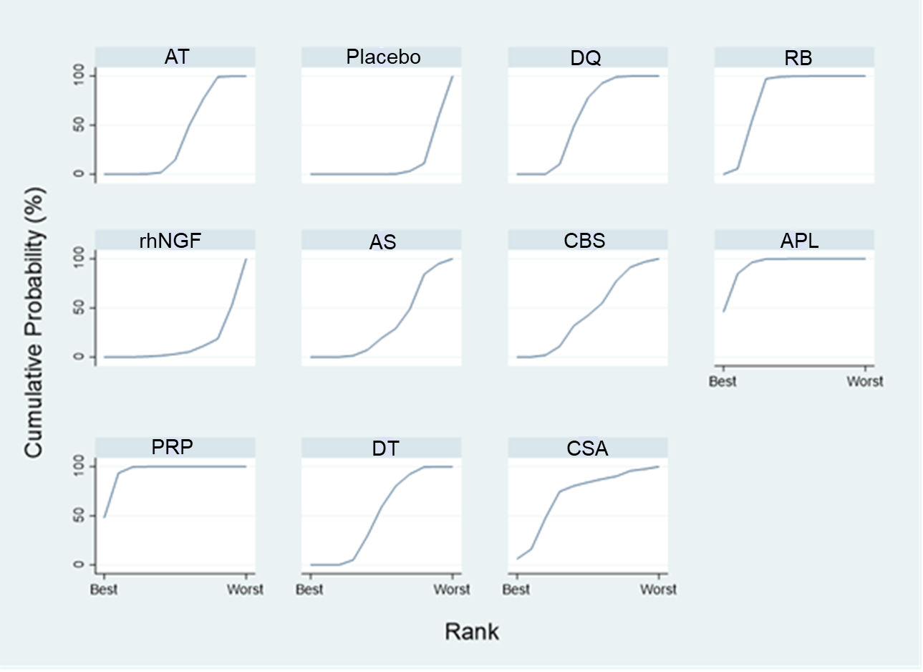
APL = autologous platelet lysate; AS = autologous/allogeneic serum; AT = artificial tears (references); CBS = cord blood serum; CSA = cyclosporine A; DQ = diquafosol; DT = diquafosol + artificial tear; PRP = platelet rich plasma; RB = rebamipide; rhNGF = recombinant human nerve growth factor

Appendix 8: GRADE evidence for evaluation of pairwise effects estimated in the corneal fluorescein staining network (11 interventions, 55 comparisons)
Comparisons | Mean differences | Nature of evidence | Certainty in evidences | Downgrading due to
 |  |  |  | SL | ID | IC | IP | PB
Placebo vs AT | 0.71 (0.25,1.18) | Indirect | ⊕⊕○○  Low | X | X | - | - | -
DQ vs AT | -0.20  (-0.37,-0.02) | Mixed | ⊕⊕⊕○  Moderate | X | - | - | - | -
RB vs AT | -0.30  (-0.67,0.08) | Mixed | ⊕⊕○○  Low | X | - | - | X | -
rhNGF vs AT | 0.75 (0.15,1.35) | Indirect | ⊕⊕○○  Low* | X | X | X | - | -
AS vs AT | 0.07  (-0.55,0.68) | Direct | ⊕⊕○○  Low | X | - | - | X | -
CBS vs AT | -1.08  (-2.00,-0.16) | Indirect | ⊕⊕○○  Low* | X | X | X | - | -
APL vs AT | -1.31  (-2.24,-0.39) | Direct | ⊕⊕⊕○  Moderate | X | - | - | - | -
PRP vs AT | -2.52  (-3.23,-1.82) | Direct | ⊕⊕⊕○  Moderate | X | - | - | - | -
DT vs AT | -0.18  (-0.48,0.13) | Mixed | ⊕⊕○○  Low* | X | - | X | X | -
CSA vs AT | -0.62  (-1.66,0.41) | Indirect | ⊕○○○  Very Low | X | X | - | X | -
DQ vs Placebo | -0.91  (-1.37,-0.45) | Mixed | ⊕⊕○○  Low | X | X | - | - | -
RB vs Placebo | -1.01  (-1.43,-0.60) | Mixed | ⊕⊕⊕⊕  High | - | - | - | - | -
rhNGF vs Placebo | 0.04  (-0.34,0.41) | Direct | ⊕⊕○○  Low | X | - | - | X | -
AS vs Placebo | -0.65  (-1.42,0.13) | Indirect | ⊕○○○  Very Low | X | X | - | X | -
CBS vs Placebo | -1.79  (-2.82,-0.76) | Indirect | ⊕○○○  Very Low | X | X | - | X | -
APL vs Placebo | -2.03  (-3.07,-0.99) | Indirect | ⊕⊕○○  Low | X | X | - | - | -
PRP vs Placebo | -3.24  (-4.08,-2.39) | Indirect | ⊕⊕○○  Low | X | X | - | - | -
DT vs Placebo | -0.89  (-1.44,-0.34) | Indirect | ⊕⊕○○  Low | X | X | - | - | -
CSA vs Placebo | -1.34  (-2.45,-0.22) | Indirect | ⊕⊕○○  Low | X | X | X | - | -
RB vs DQ | -0.10  (-0.48,0.28) | Mixed | ⊕⊕○○  Low | X | - | - | X | -
rhNGF vs DQ | 0.95 (0.35,1.54) | Indirect | ⊕⊕○○  Low | X | X | - | - | -
AS vs DQ | 0.26  (-0.38,0.90) | Indirect | ⊕○○○  Very Low | X | X | - | X | -
CBS vs DQ | -0.88  (-1.82,0.05) | Indirect | ⊕○○○  Very Low | X | X | - | X | -
APL vs DQ | -1.12  (-2.06,-0.18) | Indirect | ⊕⊕○○  Low* | X | X | X | - | -
PRP vs DQ | -2.33  (-3.05,-1.60) | Indirect | ⊕⊕○○  Low | X | X | - | - | -
DT vs DQ | 0.02  (-0.30,0.34) | Mixed | ⊕⊕○○  Low | X | - | - | X | -
CSA vs DQ | -0.43  (-1.45,0.59) | Direct | ⊕⊕○○  Low | X | - | - | X | -
rhNGF vs RB | 1.05 (0.49,1.60) | Indirect | ⊕⊕○○  Low | X | X | - | - | -
AS vs RB | 0.36  (-0.36,1.08) | Indirect | ⊕○○○  Very Low | X | X | - | X | -
CBS vs RB | -0.78  (-1.77,0.21) | Indirect | ⊕○○○  Very Low | X | X | - | X | -
APL vs RB | -1.02  (-2.02,-0.02) | Indirect | ⊕⊕○○  Low* | X | X | X | - | -
PRP vs RB | -2.23  (-3.02,-1.43) | Indirect | ⊕⊕○○  Low | X | X | - | - | -
DT vs RB | 0.12  (-0.35,0.60) | Indirect | ⊕⊕○○  Low | X | - | - | X | -
CSA vs RB | -0.33  (-1.41,0.76) | Indirect | ⊕○○○  Very Low | X | X | - | X | -
AS vs rhNGF | -0.68  (-1.54,0.18) | Indirect | ⊕○○○  Very Low | X | X | - | X | -
CBS vs rhNGF | -1.83  (-2.92,-0.74) | Indirect | ⊕⊕○○  Low | X | X | - | - | -
APL vs rhNGF | -2.06  (-3.17,-0.96) | Indirect | ⊕⊕○○  Low | X | X | - | - | -
PRP vs rhNGF | -3.27  (-4.20,-2.35) | Indirect | ⊕⊕○○  Low | X | X | - | - | -
DT vs rhNGF | -0.93  (-1.59,-0.26) | Indirect | ⊕⊕○○  Low | X | X | - | - | -
CSA vs rhNGF | -1.37  (-2.55,-0.20) | Indirect | ⊕⊕○○  Low* | X | X | X | - | -
CBS vs AS | -1.15  (-1.82,-0.47) | Direct | ⊕⊕⊕○  Moderate | X | - | - | - | -
APL vs AS | -1.38  (-2.49,-0.27) | Indirect | ⊕⊕○○  Low | X | X | - | - | -
PRP vs AS | -2.59  (-3.53,-1.65) | Indirect | ⊕⊕○○  Low | X | X | - | - | -
DT vs AS | -0.24  (-0.93,0.45) | Indirect | ⊕○○○  Very Low | X | X | - | X | -
CSA vs AS | -0.69  (-1.89,0.51) | Indirect | ⊕○○○  Very Low | X | X | - | X | -
APL vs CBS | -0.23  (-1.54,1.07) | Indirect | ⊕○○○  Very Low | X | X | - | X | -
PRP vs CBS | -1.44  (-2.60,-0.29) | Indirect | ⊕⊕○○  Low | X | X | - | - | -
DT vs CBS | 0.90  (-0.06,1.87) | Indirect | ⊕○○○  Very Low | X | X | - | X | -
CSA vs CBS | 0.46  (-0.92,1.84) | Indirect | ⊕○○○  Very Low | X | X | - | X | -
PRP vs APL | -1.21  (-2.37,-0.04) | Indirect | ⊕⊕○○  Low* | X | X | X | - | -
DT vs APL | 1.14 (0.16,2.12) | Indirect | ⊕⊕○○  Low* | X | X | X | - | -
CSA vs APL | 0.69  (-0.70,2.08) | Indirect | ⊕○○○  Very Low | X | X | - | X | -
DT vs PRP | 2.35 (1.58,3.12) | Indirect | ⊕⊕○○  Low | X | X | - | - | -
CSA vs PRP | 1.90 (0.65,3.15) | Indirect | ⊕⊕○○  Low | X | X | - | - | -
CSA vs DT | -0.45  (-1.52,0.62) | Indirect | ⊕○○○  Very Low | X | X | - | X | -
Ranking of treatment | NA | NA | ⊕⊕○○  Low | X | X | - | - | -

Interpretation: High certainty = we are very confident that the true effect lies close to that of the estimate of the effect. Moderate certainty = we are moderately confident in the effect estimate; the true effect is likely to be close to the estimate of the effect, but there is a possibility that it is substantially different. Low certainty = our confidence in the effect estimate is limited; the true effect may be substantially different from the estimate of the effect. Very low certainty = we have very little confidence in the effect estimate; the true effect is likely to be substantially different from the estimate of effect.
Criteria for downgrade the pairwise evidences of corneal FS staining outcome
1) Study limitations (SL): downgraded when the contributions from low RoB comparisons were less than 30% or contributions from some concern RoB comparisons were 70% or greater.
2) Indirectness (ID): We have assured transitivity in our network by limiting the included studies to tear secratagogues and biological tear supplements for dry eye patients. However, we considered to downgrade pairwise estimates, which mainly contributed from study populations with different in baseline characteristics compared to other comparisons.
3) Inconsistency (IC): We looked at the results of side splitting and downgraded the comparisons with important inconsistency (p < 0.1). Because the inconsistency can be detected with only comparisons with mixed evidences, we considered to downgrade for comparisons with only direct or indirect evidence if the magnitude of the heterogeneity estimate from the network was high by looking whether the predictive intervals potentially change the interpretation of the findings compared with the confidence intervals of the mean differences.
4) Imprecision (IP): If the confidence interval of combining the direct and indirect narrowed the confidence interval sufficiently (< 2.5 SMD), we did not rate down for imprecision. However, we considered to downgrade if the interval cross 0.
5) Publication bias (PB): Pairwise comparisons in the network of FS contained less than 10 studies, therefore the funnel and contour-enhanced funnel plots might be unreliable. We managed to recruit unpublished information from trial registries which reported the results and keep updating search terms in all databases without language or time restriction. Therefore, the review team decided not to downgrade all comparisons in both networks for potential publication bias.
GRADE for downgrade the ranking of treatments of corneal FS staining outcome
1) Study limitations: We downgraded by one level when the contributions of the whole network from low RoB comparisons were less than 30% and contributions from some concern RoB comparisons were 70% or greater.
2) Indirectness: All effect modifies were identified and compared across all studies. We decided to downgrade due to the absence of data for completely evaluating the severity of DED and minor evidences of uneven distributions of countries, age, gender, and etiology.
3) Inconsistency: We did not downgrade the evidence because no significant inconsistency was observed using both global and local tests.
4) Imprecision: The rankogram illustrated well distinguished rank between low and high probabilities to be the best. We considered that the results were reasonably precise and downgrade was unnecessary.
5) Publication bias: We ordered the treatments according to their previous reported efficacy and novelty. The comparison-adjusted funnel suggested that no substantial small study effect was observed. Conversely, there was a trend to favor active treatments derived from large studies. We were quite confidence about the completeness of the searching, therefore we did not downgrade the ranking the confidence for reasons of publication bias.

* The evidence was downgraded 1 level for simultaneous intransitivity and inconsistency or simultaneous imprecision and inconsistency. The evidence was downgraded 2 levels for simultaneous intransitivity, inconsistency, and imprecision.

Appendix 9: Data for pooling of tear break-up time (TBUT)
No. | Author Year | Intervention | N | Mean | SD
1 | Baek 2016 | DQ | 32 | 7.87 | 3.47
1 | Baek 2016 | Placebo | 32 | 5.1 | 3.47
2 | Kamiya 2012 | DQ | 32 | 4.4 | 2.67
2 | Kamiya 2012 | AT | 32 | 4.1 | 2.67
3 | Gong 2015 | DQ | 241 | 1.11 | 0.21
3 | Gong 2015 | AT | 248 | 0.86 | 0.11
4 | Park DH 2016 | DQ | 30 | 6.69 | 2.23
4 | Park DH 2016 | AT | 33 | 4.38 | 1.92
5 | Cui 2018 | DQ | 50 | 6.92 | 4.45
5 | Cui 2018 | AT | 44 | 5.57 | 2.34
6 | Inoue 2017 | DQ | 20 | 3.3 | 1.67
6 | Inoue 2017 | AT | 22 | 2.18 | 1.15
7 | Miyake 2017 | DQ | 75 | 3.92 | 1.87
7 | Miyake 2017 | AT | 79 | 3.48 | 1.69
8 | Shimazaki-Den 2013 | DQ | 9 | 6.83 | 4.33
8 | Shimazaki-Den 2013 | AT | 8 | 3.95 | 1.51
9 | Kaido 2018 | DQ | 12 | 4.32 | 2.28
9 | Kaido 2018 | AT | 15 | 4.51 | 2.15
10 | Matsumoto 2012 | DQ | 96 | 0.94 | 2.16
10 | Matsumoto 2012 | Placebo | 94 | 0.69 | 1.94
11 | Hwang 2014 | DQ | 50 | 1.56 | 2.33
11 | Hwang 2014 | DT | 50 | 1.67 | 2.55
11 | Hwang 2014 | AT | 50 | 0.93 | 1.56
12 | Kim 2017 | DT | 98 | 5.58 | 1.06
12 | Kim 2017 | AT | 46 | 5.12 | 0.75
13 | Jun 2019 | DQ | 79 | 5.72 | 3.22
13 | Jun 2019 | AT | 38 | 4.7 | 2.3
14 | Toda 2014 | DQ | 30 | 3.3 | 1.1
14 | Toda 2014 | DT | 27 | 3.3 | 1.6
14 | Toda 2014 | AT | 48 | 3.23 | 1.42
15 | Kinoshita 2012 | RB | 102 | 0.7 | 2.02
15 | Kinoshita 2012 | Placebo | 103 | 0.2 | 2.03
16 | Kinoshita 2013 | RB | 93 | 0.8 | 0.96
16 | Kinoshita 2013 | AT | 95 | 0.6 | 0.97
17 | Igarashi 2015 | RB | 15 | 4.5 | 1.7
17 | Igarashi 2015 | AT | 10 | 2.8 | 0.8
18 | Kobashi 2016 | RB | 20 | 5.9 | 1.5
18 | Kobashi 2016 | DQ | 20 | 5.9 | 1.6
19 | Shimazaki 2017 | RB | 33 | 4.15 | 1.15
19 | Shimazaki 2017 | DQ | 34 | 3.93 | 0.85
20 | Nebbioso 2013 | ED | 20 | 2.3 | 0.6
20 | Nebbioso 2013 | Placebo | 20 | 4.6 | 2.2
21 | Giordano 2017 | rhNGF | 88 | 0.5 | 2.34
21 | Giordano 2017 | Placebo | 42 | 0.9 | 1.42
22 | Mastropasqua 2019 | rhNGF | 107 | 2.3 | 2.61
22 | Mastropasqua 2019 | Placebo | 58 | 2.7 | 2.72
23 | Kojima 2005 | AS | 10 | 4.3 | 2.6
23 | Kojima 2005 | AT | 10 | 2.8 | 2.5
24 | Noda-Tsuruya 2006 | AS | 18 | 5.51 | 2.42
24 | Noda-Tsuruya 2006 | AT | 15 | 4.02 | 1.69
25 | Urzua 2012 | AS | 12 | 6 | 2.61
25 | Urzua 2012 | AT | 12 | 4 | 2.61
26 | Celebi 2014 | AS | 10 | 4 | 0.74
26 | Celebi 2014 | AT | 10 | 3 | 1.48
27 | Yilmaz 2017 | AS | 12 | 11 | 1.1
27 | Yilmaz 2017 | AT | 12 | 7.1 | 0.8
28 | Mukhopadhyay 2015 | CBS | 48 | 22.71 | 8.07
28 | Mukhopadhyay 2015 | AS | 52 | 21.5 | 10.15
28 | Mukhopadhyay 2015 | AT | 44 | 9.25 | 0.96
29 | Campos 2019 | CBS | 31 | 3 | 3
29 | Campos 2019 | AS | 29 | 2.5 | 2.63
30 | Fea 2016 | APL | 20 | 3.5 | 1.48
30 | Fea 2016 | AT | 10 | 2 | 0.74
31 | Garcia-Conca 2019 | PRP | 44 | 0.55 | 1.4
31 | Garcia-Conca 2019 | AT | 39 | 0.2 | 1.5
32 | Ji 2019 | CSA | 9 | 4.28 | 0.49
32 | Ji 2019 | DQ | 9 | 4.78 | 0.6
33 | Park CH 2019 | CSA | 58 | 1.69 | 2.45
33 | Park CH 2019 | DQ | 57 | 0.73 | 2.43
34 | Patil 2018 | CSA | 40 | 6.78 | 2.16
34 | Patil 2018 | RT | 40 | 8.36 | 2.78
APL = autologous platelet lysate, AS = autologous/allogeneic serum, AT = artificial tear, CBS = cord blood serum, CSA = cyclosporine A, DQ = diquafosol, DT = diquafoso + artificial tear, ED = eledoisin, PRP = platelet rich plasma, RB = rebamipide, rhNGF = recombinant human nerve growth factor, RT = rebamipide + artificial tear.

Surface under the cumulative ranking curve of TBUT
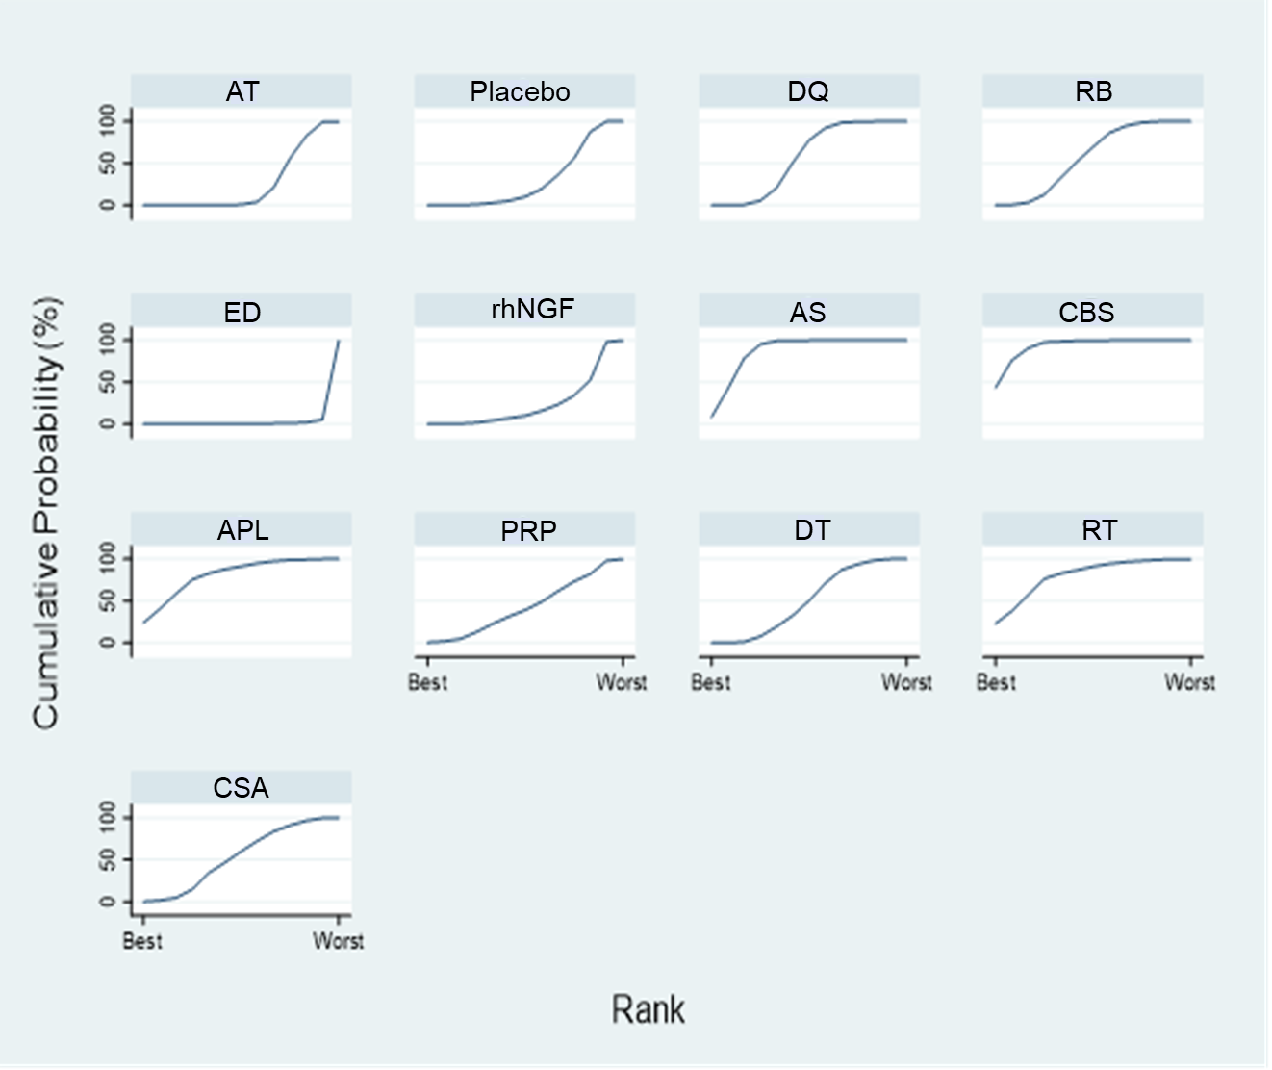
APL = autologous platelet lysate; AS = autologous/allogeneic serum; AT = artificial tears (references); CBS = cord blood serum; CSA = cyclosporine A; DQ = diquafosol; DT = diquafosol + artificial tear; ED = eledoisin; PRP = platelet rich plasma; RB = rebamipide; rhNGF = recombinant human nerve growth factor; RT = rebamipide + artificial tear

Appendix 10: Data for pooling of Schirmer’s test (ST)
No. | Author Year | Intervention | N | Mean | SD
1 | Baek 2016 | DQ | 34 | 10.4 | 3.78
1 | Baek 2016 | Placebo | 34 | 8.9 | 3.78
2 | Kamiya 2012 | DQ | 32 | 7.8 | 6.77
2 | Kamiya 2012 | AT | 32 | 8 | 6.77
3 | Park DH 2016 | DQ | 30 | 4.1 | 2.87
3 | Park DH 2016 | AT | 33 | 2.52 | 2.08
4 | Cui 2018 | DQ | 50 | 6.48 | 5.1
4 | Cui 2018 | AT | 44 | 6.02 | 4.26
5 | Hwang 2014 | DQ | 50 | 2.73 | 2.97
5 | Hwang 2014 | DT | 50 | 3.27 | 4.74
5 | Hwang 2014 | AT | 50 | 1.79 | 4.53
6 | Kim 2017 | DT | 48 | 9.72 | 1.45
6 | Kim 2017 | AT | 46 | 10.12 | 1.47
7 | Jun 2019 | DQ | 79 | 12.72 | 9.11
7 | Jun 2019 | AT | 38 | 14.2 | 8.6
8 | Toda 2014 | DQ | 30 | -1.33 | 5.55
8 | Toda 2014 | DT | 27 | 1.45 | 10.05
8 | Toda 2014 | AT | 48 | -2.37 | 7.41
9 | Kinoshita 2012 | RB | 102 | 0.9 | 3.03
9 | Kinoshita 2012 | Placebo | 103 | 0.5 | 2.03
10 | Kinoshita 2013 | RB | 93 | 0.5 | 1.93
10 | Kinoshita 2013 | AT | 95 | 1 | 2.92
11 | Igarashi 2015 | RB | 15 | 14.9 | 7.4
11 | Igarashi 2015 | AT | 10 | 16.2 | 11.7
12 | Nebbioso 2013 | ED | 20 | 7.7 | 2
12 | Nebbioso 2013 | Placebo | 20 | 4.5 | 2.2
13 | Kojima 2004 | AS | 10 | 3.3 | 2.6
13 | Kojima 2004 | AT | 10 | 3.7 | 3.1
14 | Celebi 2014 | AS | 10 | 4 | 1.29
14 | Celebi 2014 | AT | 10 | 4 | 1.29
15 | Yilmaz 2017 | AS | 12 | 10.3 | 1.3
15 | Yilmaz 2017 | AT | 12 | 10 | 1.6
16 | Mukhopadhyay 2015 | CBS | 48 | 10.36 | 9.79
16 | Mukhopadhyay 2015 | AS | 52 | 12.17 | 8.38
16 | Mukhopadhyay 2015 | AT | 44 | 4 | 1.55
17 | Campos 2019 | CBS | 31 | 5 | 5.04
17 | Campos 2019 | AS | 29 | 5 | 2.63
18 | Fea 2016 | APL | 20 | 3 | 0.74
18 | Fea 2016 | AT | 10 | 3 | 0.37
19 | Garcia-Conca 2019 | PRP | 44 | 1.9 | 1.81
19 | Garcia-Conca 2019 | AT | 39 | 0.4 | 1.25
20 | Ji 2019 | CSA | 9 | 8.95 | 1.36
20 | Ji 2019 | DQ | 9 | 10.17 | 2.08
21 | Park CH 2018 | CSA | 58 | 10.14 | 6.13
21 | Park CH 2018 | DQ | 57 | 9.02 | 5.59
22 | Patil 2018 | CSA | 40 | 7.78 | 2.67
22 | Patil 2018 | RT | 40 | 9.36 | 2.22
APL = autologous platelet lysate, AS = autologous/allogeneic serum, AT = artificial tear, CBS = cord blood serum, CSA = cyclosporine A, DQ = diquafosol, ED = eledoisin, PRP = platelet rich plasma, RB = rebamipide, rhNGF = recombinant human nerve growth factor, RT = rebamipide + artificial tear.
Surface under the cumulative ranking curve of Schimmer’s test
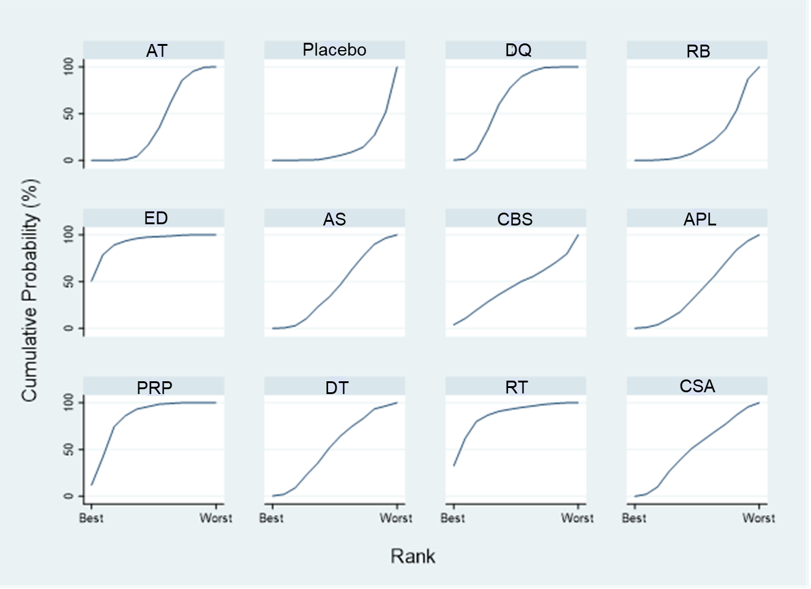
APL = autologous platelet lysate; AS = autologous/allogeneic serum; AT = artificial tears (references); CBS = cord blood serum; CSA = cyclosporine A; DQ = diquafosol; DT = diquafosol + artificial tear; ED = eledoisin; RB = rebamipide; PRP = platelet rich plasma; RT = rebamipide + artificial tear

Appendix 11: Data for pooling of adverse events
No. | Author Year | Intervention | Yes | No | Total
1 | Gilbard 1991 | IBMX | 3 | 8 | 11
1 | Gilbard 1991 | Placebo | 0 | 11 | 11
2 | Kamiya 2012 | DQ | 1 | 31 | 32
2 | Kamiya 2012 | AT | 0 | 32 | 32
3 | Takamura 2012 | DQ | 9 | 135 | 144
3 | Takamura 2012 | AT | 2 | 141 | 143
4 | Gong 2015 | DQ | 29 | 217 | 246
4 | Gong 2015 | AT | 15 | 236 | 251
5 | Park DH 2016 | DQ | 1 | 29 | 30
5 | Park DH 2016 | AT | 0 | 33 | 33
6 | Matsumoto 2012 | DQ | 15 | 81 | 96
6 | Matsumoto 2012 | Placbo | 13 | 81 | 94
7 | Hwang 2014 | DQ | 4 | 46 | 50
7 | Hwang 2014 | DT | 3 | 47 | 50
7 | Hwang 2014 | AT | 4 | 46 | 50
8 | Kim 2017 | DT | 5 | 93 | 98
8 | Kim 2017 | AT | 3 | 43 | 46
9 | Kinoshita 2012 | RB | 2 | 100 | 102
9 | Kinoshita 2012 | Placebo | 5 | 98 | 103
10 | Kinoshita 2013 | RB | 3 | 90 | 93
10 | Kinoshita 2013 | AT | 4 | 91 | 95
11 | Igarashi 2015 | RB | 0 | 15 | 15
11 | Igarashi 2015 | AT | 0 | 10 | 10
12 | Shimazaki 2017 | RB | 0 | 33 | 33
12 | Shimazaki 2017 | DQ | 0 | 34 | 34
13 | Meerovitch 2013 | MIM-D3 | 7 | 43 | 50
13 | Meerovitch 2013 | Placebo | 6 | 44 | 50
14 | Giordano 2017 | rhNGF | 69 | 31 | 100
14 | Giordano 2017 | Placebo | 10 | 40 | 50
15 | Mastropasqua 2019 | rhNGF | 23 | 92 | 115
15 | Mastropasqua 2019 | Placebo | 10 | 49 | 59
16 | Tananuvat 2001 | AS | 2 | 10 | 12
16 | Tananuvat 2001 | Placebo | 0 | 12 | 12
17 | Celebi 2014 | AS | 0 | 10 | 10
17 | Celebi 2014 | AT | 0 | 10 | 10
18 | Campos 2019 | CBS | 0 | 31 | 31
18 | Campos 2019 | AS | 0 | 29 | 29
19 | Fea 2016 | APL | 1 | 19 | 20
19 | Fea 2016 | AT | 0 | 10 | 10
20 | Ji 2019 | CSA | 0 | 9 | 9
20 | Ji 2019 | DQ | 0 | 9 | 9
21 | Park CH 2019 | CSA | 2 | 56 | 58
21 | Park CH 2019 | DQ | 3 | 54 | 57
APL = autologous platelet lysate, AS = autologous/allogeneic serum, AT = artificial tear, CBS = cord blood serum, CSA = cyclosporine A, DQ = diquafosol, DT = diquafoso + artificial tear, IBMX = 3-isobutyl-1-methylxanthine, MIM-D3 = small molecule nerve growth factor peptidomimetic, PRP = platelet rich plasma, RB = rebamipide, rhNGF = recombinant human nerve growth factor, RT = rebamipide + artificial tear.

Surface under the cumulative ranking curve of adverse events
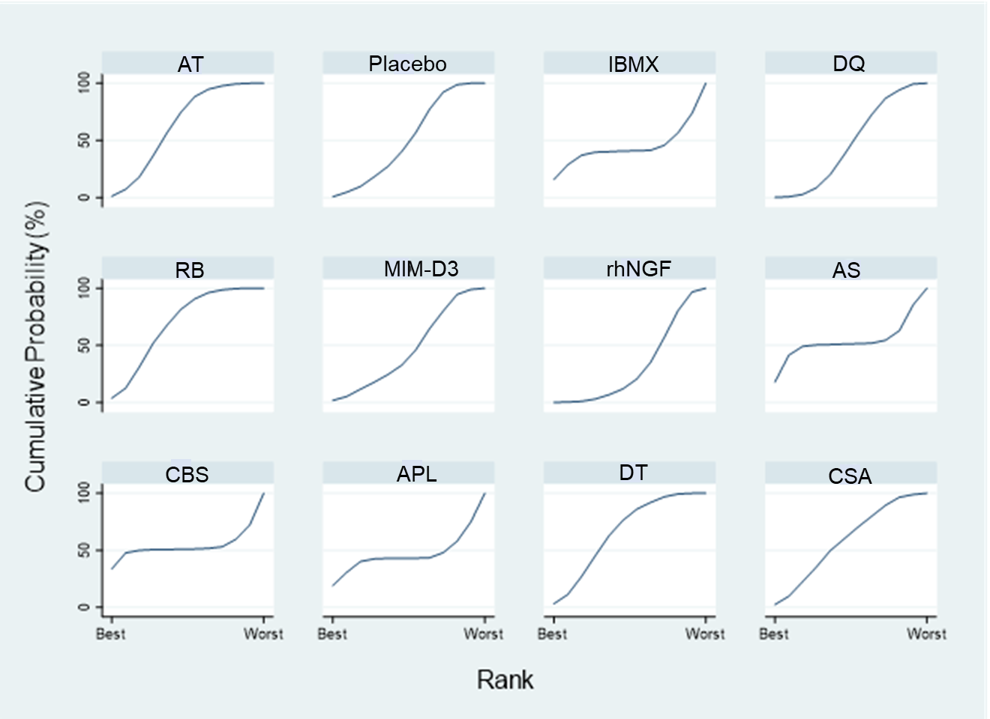
AS = autologous/allogeneic serum; APL = autologous platelet lysate; AT = artificial tears (references); CBS = cord blood serum; CSA = cyclosporine A; DQ = diquafosol; DT = diquafosol + artificial tear; IBMX = 3-Isobutyl-1-methylxanthine; MIM-D3 = a tyrosine kinase TrkA receptor agonist; RB = rebamipide; rhNGF = recombinant human nerve growth factor
Appendix 12: Estimation of relative risk of ocular adverse events by treatments
AT | 1.89 (0.16,22.17) | 106.48  (1.05e-51, 1.08e+55) | 1.62  (0.88,2.99) | 0.76  (0.14,4.09) | 2.20 (0.14,35.69) | 3.94 (0.30,51.27) | 103.12  (1.48e-53 7.20e+56) | 96.45  (5.0e-131 1.8e+134) | 5000.55  (3.75e-82, 6.66e+88) | 0.87  (0.29,2.61) | 1.06  (0.14,8.04)
0.53  (0.05,6.22) | Placebo | 56.40  (5.51e-52, 5.77e+54) | 0.86 (0.07,10.86) | 0.40  (0.07,2.47) | 1.17  (0.32,4.28) | 2.08  (1.01,4.30) | 54.62  (7.80e-54 3.83e+56) | 51.09  (2.7e-131 9.8e+133) | 2648.93  (1.96e-82, 3.58e+88) | 0.46  (0.03,6.84) | 0.56 (0.02,13.63)
0.01  (1.39e-57 6.77e+52) | 0.02  (1.73e-55 1.81e+51) | IBMX | 0.02  (1.49e-55 1.55e+51) | 0.01 (7.04e-56 7.32e+50) | 0.02  (2.01e-55 2.13e+51) | 0.04  (3.61e-55 3.79e+51) | 0.97  (5.19e-77 1.81e+76) | 0.91  (2.8e-143 2.9e+142) | 46.96  (2.47e-99, 8.9e+101) | 0.01  (8.01e-56 8.37e+50) | 0.01  (9.63e-56 1.03e+51)
0.62  (0.33,1.14) | 1.17 (0.09,14.76) | 65.76  (6.45e-52, 6.70e+54) | DQ | 0.47  (0.08,2.81) | 1.36 (0.08,23.53) | 2.43 (0.17,34.01) | 63.69  (9.11e-54 4.45e+56) | 59.57  (3.1e-131 1.1e+134) | 3088.34  (2.32e-82, 4.12e+88) | 0.54  (0.17,1.73) | 0.66  (0.10,4.51)
1.31  (0.24,6.99) | 2.47 (0.41,15.04) | 139.29  (1.37e-51, 1.42e+55) | 2.12 (0.36,12.62) | RB | 2.88 (0.31,26.69) | 5.15 (0.74,36.04) | 134.89  (1.93e-53 9.43e+56) | 126.17  (6.6e-131 2.4e+134) | 6541.28  (4.88e-82, 8.78e+88) | 1.14  (0.15,8.45) | 1.39 (0.10,19.22)
0.45  (0.03,7.36) | 0.86  (0.23,3.15) | 48.35  (4.69e-52, 4.98e+54) | 0.74 (0.04,12.73) | 0.35  (0.04,3.22) | MIM-D3 | 1.79  (0.40,7.91) | 46.82  (6.64e-54 3.30e+56) | 43.79  (2.3e-131 8.4e+133) | 2270.57  (1.67e-82, 3.08e+88) | 0.40  (0.02,7.90) | 0.48 (0.02,15.07)
0.25  (0.02,3.31) | 0.48  (0.23,0.99) | 27.06  (2.64e-52, 2.77e+54) | 0.41  (0.03,5.76) | 0.19  (0.03,1.36) | 0.56  (0.13,2.48) | rhNGF | 26.20  (3.73e-54 1.84e+56) | 24.51  (1.3e-131 4.7e+133) | 1270.56  (9.38e-83, 1.72e+88) | 0.22  (0.01,3.61) | 0.27  (0.01,7.09)
0.01  (1.39e-57 6.77e+52) | 0.02  (2.61e-57 1.28e+53) | 1.03  (5.53e-77, 1.93e+76) | 0.02  (2.25e-57 1.10e+53) | 0.01  (1.06e-57 5.18e+52) | 0.02  (3.03e-57 1.51e+53) | 0.04  (5.44e-57 2.68e+53) | AS | 0.94  (3.9e-121 2.2e+120) | 48.49  (2.7e-100, 8.9e+102) | 0.01  (1.21e-57 5.93e+52) | 0.01  (1.45e-57 7.30e+52)
0.01  (5.4e-135 2.0e+130) | 0.02  (1.0e-134 3.7e+130) | 1.10  (3.4e-143, 3.5e+142) | 0.02  (8.8e-135 3.2e+130) | 0.01  (4.1e-135 1.5e+130) | 0.02  (1.2e-134 4.4e+130) | 0.04  (2.1e-134 7.8e+130) | 1.07  (4.5e-121 2.5e+120) | CBS | 51.84  (2.6e-156, 1.0e+159) | 0.01  (4.7e-135 1.7e+130) | 0.01  (5.7e-135 2.1e+130)
0.00  (1.50e-89 2.66e+81) | 0.00  (2.79e-89 5.11e+81) | 0.02  (1.1e-102, 4.05e+98) | 0.00  (2.43e-89 4.32e+81) | 0.00 (1.14e-89 2.05e+81) | 0.00  (3.24e-89 5.98e+81) | 0.00  (5.81e-89 1.07e+82) | 0.00  (1.1e-103 3.77e+99) | 0.02  (9.6e-160 3.9e+155) | APL | 0.00  (1.31e-89 2.33e+81) | 0.00  (1.58e-89 2.86e+81)
1.15  (0.38,3.42) | 2.16 (0.15,32.06) | 122.09  (1.19e-51, 1.25e+55) | 1.86  (0.58,5.98) | 0.88  (0.12,6.49) | 2.53 (0.13,50.34) | 4.51 (0.28,73.52) | 118.23  (1.69e-53 8.29e+56) | 110.59  (5.8e-131 2.1e+134) | 5733.34 (4.3e-82, 7.7e+88) | DT | 1.22 (0.13,11.61)
0.94  (0.12,7.14) | 1.78 (0.07,43.15) | 100.38  (9.70e-52, 1.04e+55) | 1.53 (0.22,10.51) | 0.72  (0.05,9.96) | 2.08 (0.07,64.96) | 3.71 (0.14,97.59) | 97.21  (1.37e-53 6.89e+56) | 90.92  4.7e-131 1.7e+134) | 90.92  (4.7e-131, 1.7e+134) | 0.82  (0.09,7.85) | CSA
APL = autologous platelet lysate; AS = autologous/allogeneic serum; AT = artificial tears; CBS = cord blood serum, CSA = cyclosporine A, DQ = diquafosol; DT = diquafosol + artificial tear; IBMX = 3-isobutyl-1-methylxanthine; MIM-D3 = tyrosine kinase TrkA receptor agonist; RB = rebamipide; rhNGF = recombinant human nerve growth factor, Relative risk < 1 favors drug in the column of upper triangle, relative risk > 1 favors drug in the row of lower triangle. Numbers in cell e-value and e+value refer to numberx10^{-value} and numberx10^{+value} , respectively.
Appendix 13: Transitivity assessment of all networks
No. | Comparisons | No. of studies | No. of patients | Asia (%) | Age | F (%) | Surgery related DED (%) | SS (%) | OSDI | TBUT | ST | Moderate to severe DED (%)
OSDI
1 | DQ vs Placebo | 1 | 64 | 100 | 67.7 | 72.2 | 100 | 0 | . | 4.1 | 11.2 | .
2 | DQ vs AT | 4 | 374 | 100 | 65.8 | 66.2 | 73.3 | . | 21.3 | 4.6 | 7.2 | .
3 | ED vs Placebo | 1 | 40 | 0 | 67 | 80 | 0 | . | 39.3 | 3 | 4.5 | .
4 | MIM-D3 vs Placebo | 1 | 96 | 0 | 58.2 | 75.3 | 0 | 0 | . | . | . | 100
5 | AS vs AT | 3 | 68 | 0 | 43.7 | 88.2 | 0 | . | 49.5 | 3.9 | 5 | 64.7
6 | CBS vs AS | 1 | 60 | 0 | 62.4 | 73.3 | 0 | 26.7 | 50.1 | 3 | 4.5 | 100
7 | APL vs AT | 1 | 30 | 0 | 59.5 | 96.7 | 0 | 100 | 60.6 | 2 | 3 | 100
8 | PRP vs AT | 1 | 83 | 0 | 64 | 96.4 | 0 | . | 56.1 | 11.3 | 4.1 | 100
9 | DT vs AT | 2 | 244 | 100 | 56.1 | 79 | 0 | . | 37.3 | 3.5 | 7.6 | .
10 | DT vs DQ | 1 | 100 | 100 | 63.6 | 78.7 | 0 | . | 15.9 | 3.6 | 3.5 | .
11 | CSA vs DQ | 2 | 133 | 100 | 46.1 | 65.2 | 0 | . | 42.67 | 4 | 8.17 | .
12 | CSA vs RT | 1 | 80 | 100 | 45 | 25 | 0 | 0 | . | . | . | 100
Corneal FS staining
1 | DQ vs Placebo | 1 | 68 | 100 | 67.7 | 72.2 | 100 | 0 | . | 4.1 | 11.2 | .
2 | DQ vs AT | 9 | 1480 | 100 | 53.8 | 76.1 | 23.8 | . | . | . | . | .
3 | RB vs Placebo | 1 | 205 | 100 | 60.2 | 85.8 | 0 | 15.1 | . | 2.9 | 2.5 | .
4 | RB vs AT | 1 | 188 | 100 | 56.6 | 86.7 | 0 | 18.1 | . | 2.6 | 2.4 | 100
5 | RB vs DQ | 1 | 40 | 100 | 70.3 | 47.5 | 0 | 0 | . | 3.6 | . | 100
6 | rhNGF vs Placebo | 2 | 300 | 0 | 45.7 | 71.7 | 56.7 | . | . | . | . | .
7 | AS vs AT | 2 | 53 | 100 | 42.8 | 30.2 | 62.3 | . | . | 3.5 | . | .
8 | CBS vs AS | 1 | 60 | 0 | 62.4 | 73.3 | 0 | 26.7 | 50.1 | 3 | 4.5 | 100
9 | APL vs AT | 1 | 30 | 0 | 59.5 | 96.7 | 0 | 100 | 60.6 | 2 | 3 | 100
10 | PRP vs AT | 1 | 83 | 0 | 64 | 96.4 | 0 | . | 56.1 | 11.3 | 4.1 | 100
11 | DT vs AT | 3 | 319 | 100 | 50.8 | 74.9 | 23.5 | . | . | . | . | .
12 | DT vs DQ | 2 | 157 | 100 | 52.6 | 72.6 | 36.3 | . | . | . | . | .
13 | CSA vs DQ | 1 | 18 | 100 | 49.8 | 55.5 | 0 | . | 41.2 | 3.3 | 7.2 | .
TBUT
1 | DQ vs Placebo | 1 | 64 | 100 | 67.7 | 72.2 | 100 | 0 | . | 4.11 | 11.21 | .
2 | DQ vs AT | 12 | 1435 | 100 | 55.4 | 53.4 | 38.2 | . | . | . | . | .
3 | RB vs Placebo | 1 | 205 | 100 | 60.2 | 85.8 | 0 | 15.1 | . | 2.9 | 2.5 | 100
4 | RB vs AT | 2 | 213 | 100 | 54.1 | 86.8 | 11.7 | 16 | . | 2.6 | 3.5 | 100
5 | RB vs DQ | 2 | 107 | 100 | 51.2 | 61.7 | 0 | . | . | 3.4 | . | 100
6 | ED vs Placebo | 1 | 40 | 0 | 67 | 80 | 0 | . | 39.3 | 3 | 4.5 | .
7 | rhNGF vs Placebo | 2 | 295 | 0 | 45.9 | 71.9 | 55.9 | . | . | . | . | .
8 | AS vs AT | 5 | 109 | 48.6 | 43.3 | 62.8 | 27.3 | . | . | 3.7 | . | .
9 | CBS vs AS | 1 | 60 | 0 | 62.4 | 73.3 | 0 | 26.7 | 50.1 | 3 | 4.5 | 100
No. | Comparisons | No. of studies | No. of patients | Asia (%) | Age | F (%) | Surgery related DED (%) | SS (%) | OSDI | TBUT | ST | Moderate to severe DED (%)
10 | APL vs AT | 1 | 30 | 0 | 59.5 | 96.7 | 0 | 100 | 60.6 | 2 | 3 | 100
11 | PRP vs AT | 1 | 83 | 0 | 64 | 96.4 | 0 | . | 56.1 | 11.3 | 4.1 | 100
12 | DT vs AT | 3 | 319 | 100 | 50.8 | 74.9 | 23.5 | . | . | . | . | .
13 | DT vs DQ | 2 | 157 | 100 | 52.6 | 72.6 | 36.3 | . | . | . | . | .
14 | CSA vs DQ | 2 | 133 | 100 | 46.1 | 65.2 | 0 | . | 42 | 4 | 8.2 | .
15 | CSA vs RT | 1 | 80 | 100 | 45 | 25 | 0 | 0 | . | . | . | .
Schirmer’s test
1 | DQ vs Placebo | 1 | 68 | 100 | 67.7 | 72.2 | 100 | 0 | . | 4.11 | 11.21 | .
2 | DQ vs AT | 6 | 516 | 100 | 60.8 | 67.4 | 68.2 | . | . | 4.5 | 7.3 | .
3 | RB vs Placebo | 1 | 205 | 100 | 60.2 | 85.8 | 0 | 15.1 | . | 2.9 | 2.5 | 100
4 | RB vs AT | 2 | 213 | 100 | 54.1 | 86.8 | 11.7 | 16 | . | 2.6 | 3.5 | 100
5 | ED vs Placebo | 1 | 40 | 0 | 67 | 80 | 0 | . | 39.3 | 3 | 4.5 | .
6 | AS vs AT | 3 | 64 | 31.2 | 46.8 | 84.4 | 0 | . | . | 3.7 | 4.15 | .
7 | CBS vs AS | 1 | 60 | 0 | 62.4 | 73.3 | 0 | 26.7 | 50.1 | 3 | 4.5 | 100
8 | APL vs AT | 1 | 30 | 0 | 59.5 | 96.7 | 0 | 100 | 60.6 | 2 | 3 | 100
9 | PRP vs AT | 1 | 83 | 0 | 64 | 96.4 | 0 | . | 56.1 | 11.3 | 4.1 | 100
10 | DT vs AT | 3 | 269 | 100 | 51.5 | 74.2 | 27.9 | . | 33.5 | 3.5 | 6.2 | .
11 | DT vs DQ | 2 | 157 | 100 | 52.6 | 72.6 | 36.3 | . | . | . | . | .
12 | CSA vs DQ | 2 | 133 | 100 | 46.1 | 65.2 | 0 | . | 42 | 4 | 8.2 | .
13 | CSA vs RT | 1 | 80 | 100 | 45 | 25 | 0 | 0 | . | . | . | .
Adverse events
1 | IBMX vs Placebo | 1 | 22 | 0 | 61 | 100 | 0 | . | . | . | . | .
2 | DQ vs AT | 6 | 1201 | 100 | 57.6 | 86.3 | 5.2 | . | . | . | . | 94.2
3 | RB vs Placebo | 1 | 205 | 100 | 60.2 | 85.8 | 0 | 15.1 | . | 2.9 | 2.5 | 100
4 | RB vs AT | 2 | 213 | 100 | 54.1 | 86.8 | 11.7 | 16 | . | 2.6 | 3.5 | 100
5 | RB vs DQ | 1 | 67 | 100 | 39.8 | 70.1 | 0 | . | . | 3.3 | 14.4 | 100
6 | MIM-D3 vs Placebo | 1 | 100 | 0 | 58.2 | 75.3 | 0 | 0 | . | . | . | 100
7 | rhNGF vs Placebo | 2 | 324 | 0 | 46.4 | 72.5 | 53.7 | . | . | . | . | .
8 | AS vs Placebo | 1 | 24 | 0 | 59.5 | 58.3 | 0 | 41.7 | . | 0.33 | 1.37 | 100
9 | AS vs AT | 1 | 20 | 0 | 56 | 90 | 0 | . | 55.5 | 2 | 3 | 100
10 | CBS vs AS | 1 | 60 | 0 | 62.4 | 73.3 | 0 | 26.7 | 50.1 | 3 | 4.5 | 100
11 | APL vs AT | 1 | 30 | 0 | 59.5 | 96.7 | 0 | 100 | 60.6 | 2 | 3 | 100
12 | DT vs AT | 2 | 244 | 100 | 56.1 | 79 | 0 | . | 37.3 | 3.3 | 9 | .
13 | DT vs DQ | 1 | 100 | 100 | 63.6 | 78.7 | 0 | . | 15.9 | 3.6 | 3.5 | .
14 | CSA vs DQ | 2 | 133 | 100 | 46.1 | 65.2 | 0 | . | 42.7 | 4 | 8.2 | .
Interventions: AT = artificial tears; DQ = diquafosol; ED = eledoisin; MIM-D3 = a tyrosine kinase TrkA receptor agonist; AS = autologous/allogeneic serum; CBS = cord blood serum; APL = autologous platelet lysate; PRP = platelet rich plasma; DT = diquafosol + artificial tear; RT = rebamipide + artificial tear; CSA = cyclosporine A Abbreviation: DED = dry eye disease, F = female, FS = fluorescein, OSDI = ocular surface disease index, SS = Sjogren syndrome, ST = Schirmer’s test, TBUT = tear break-up time
Appendix 14
Comparison-adjusted funnel plot of OSDI score
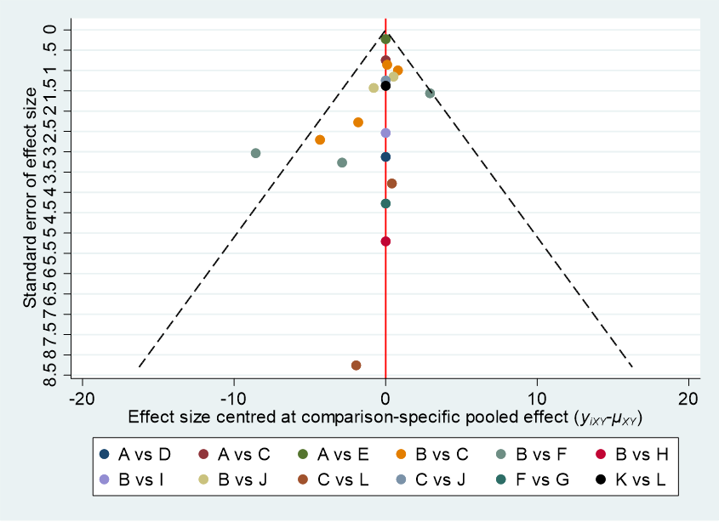
A = placebo; B = artificial tears; C= diquafosol; D = eledoisin; E = MIM-D3 (a tyrosine kinase TrkA receptor agonist); F = autologous/allogeneic serum; G = cord blood serum; H = autologous platelet lysate; I = platelet rich plasma; J = diquafosol + artificial tear; K = rebamipide + artificial tear; L = cyclosporine A
Egger’s test: Coefficeint = -0.32; SE =0.29; P-value = 0.282
Comparison-adjusted funnel plot of corneal fluorescein staining
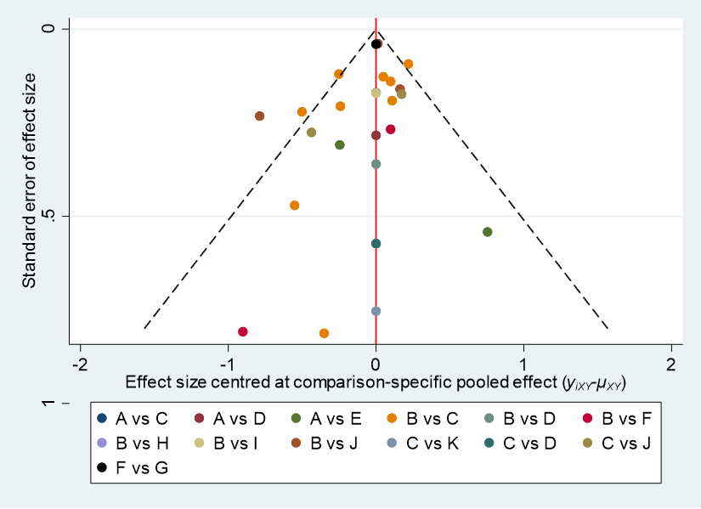
A = placebo; B = artificial tears; C = diquafosol; D = rebamipide; E = recombinant human nerve growth factor; F = autologous/allogeneic serum; G = cord blood serum; H = autologous platelet lysate; I = platelet rich plasma; J = diquafosol + artificial tear; K = cyclosporine A
Egger’s test: Coefficeint = -0.45; SE =0.34; P-value = 0.199
Comparison-adjusted funnel plot of TBUT
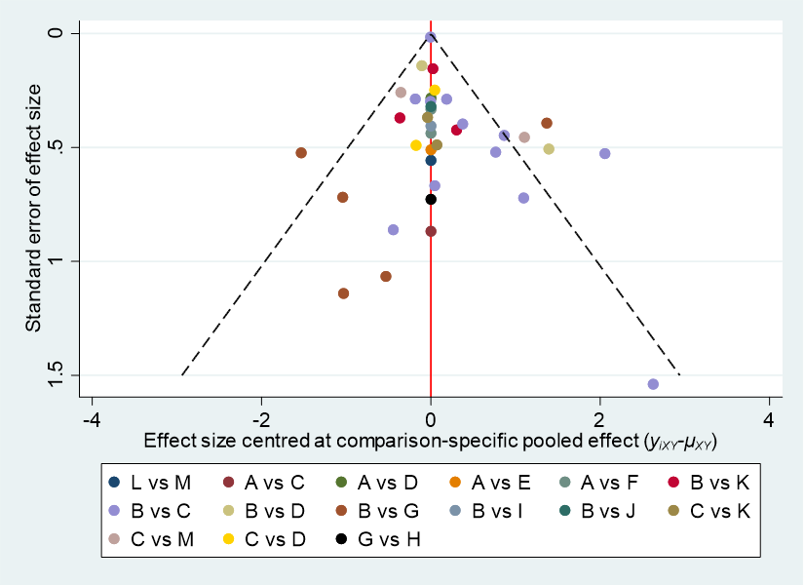
A = placebo; B = artificial tears; C = diquafosol; D = rebamipide; E = eledoisin; F = recombinant human nerve growth factor; G = autologous/allogeneic serum; H = cord blood serum; I = autologous platelet lysate; J = platelet rich plasma; K = diquafosol + artificial tear; L = rebamipide + artificial tear; M = cyclosporine A
Egger’s test: Coefficient = 0.45; SE = 0.29; P-value = 0.130
Comparison-adjusted funnel plot of Schimmer’s test
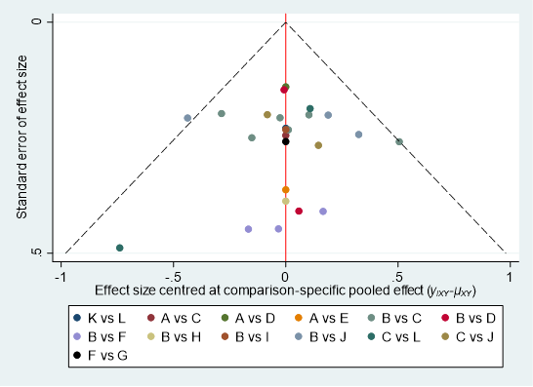
A = placebo; B = artificial tears; C = diquafosol; D = rebamipide; E = eledoisin; F = autologous/allogeneic serum; G = cord blood serum; H = autologous platelet lysate; I = platelet rich plasma; J = diquafosol + artificial tear; K = rebamipide + artificial tear; L = cyclosporine A
Egger’s test: Coefficient = 0.44; SE = 0.47; P-value = 0.356

Comparison-adjusted funnel plot of adverse reactions
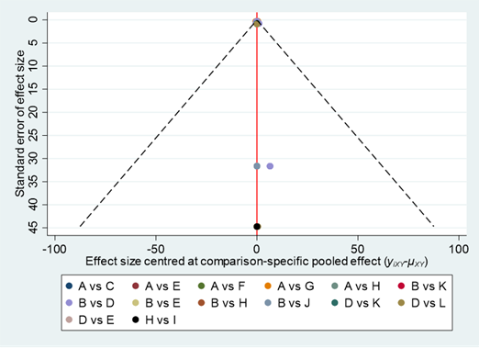
A = placebo; B = artificial tears; B = IBMX (3-Isobutyl-1-methylxanthine); D = diquafosol; E = rebamipide; F = MIM-D3 (a tyrosine kinase TrkA receptor agonist); G = recombinant human nerve growth factor; H = autologous/allogeneic serum; I = cord blood serum; J = autologous platelet lysate; K = diquafosol + artificial tear; L = cyclosporine A
Egger’s test: Coefficient = 0.019; SE = 0.20; P-value = 0.924

