Supplementary Materials:

- Figures S1 to S8
- Tables S1 to S4

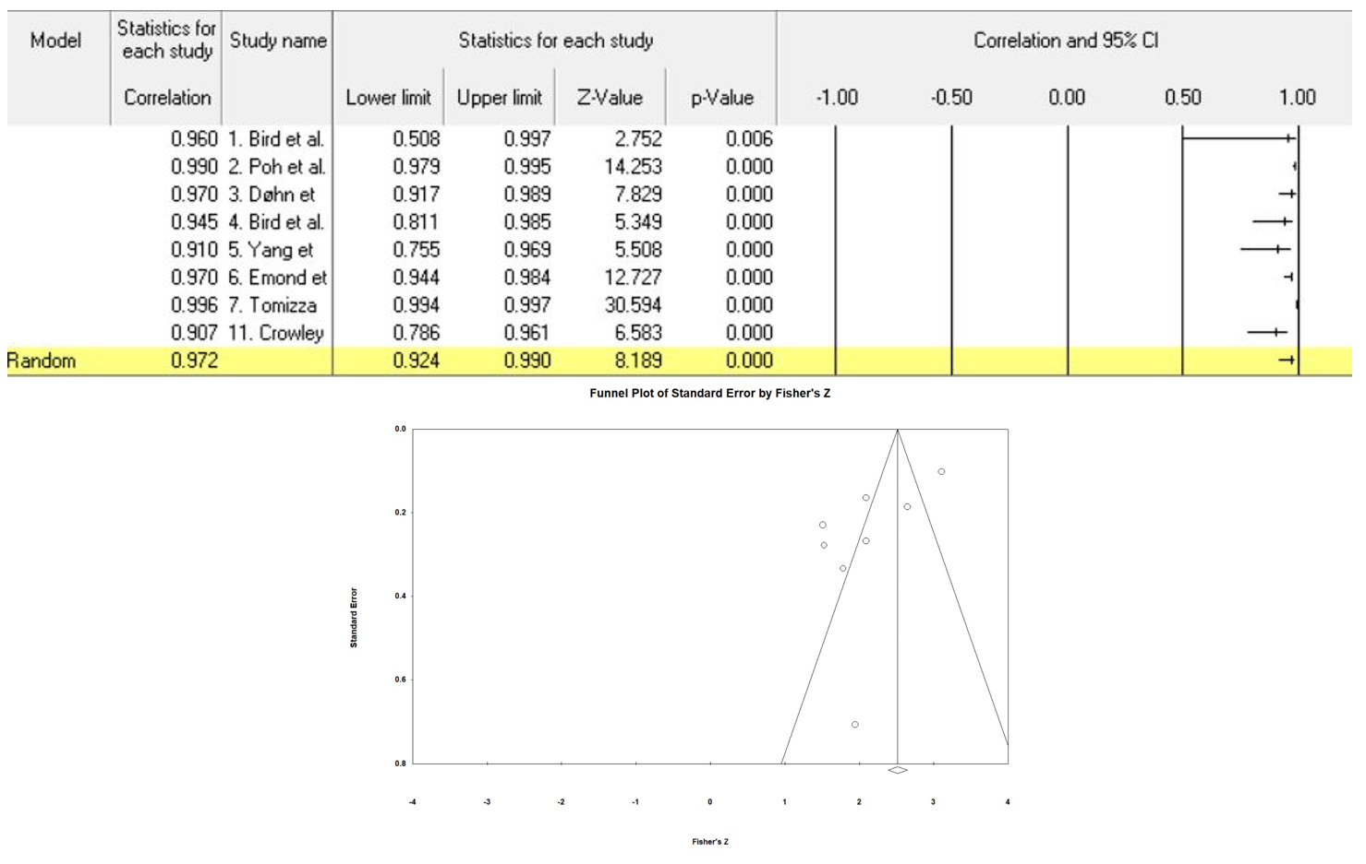
Supplement Figure S1. Correlation coefficient values and Funnel plot for the intra-reader reliability of computer-aided measurement of bone erosion volume (BEV) on MRI.

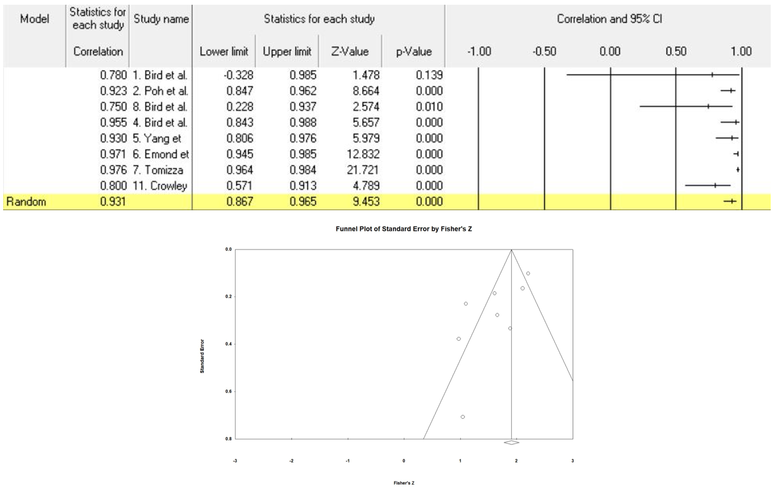
Supplement Figure S2. Correlation coefficient values and Funnel plot for the inter-reader reliability of computer-aided measurement of bone erosion volume (BEV) on MRI.

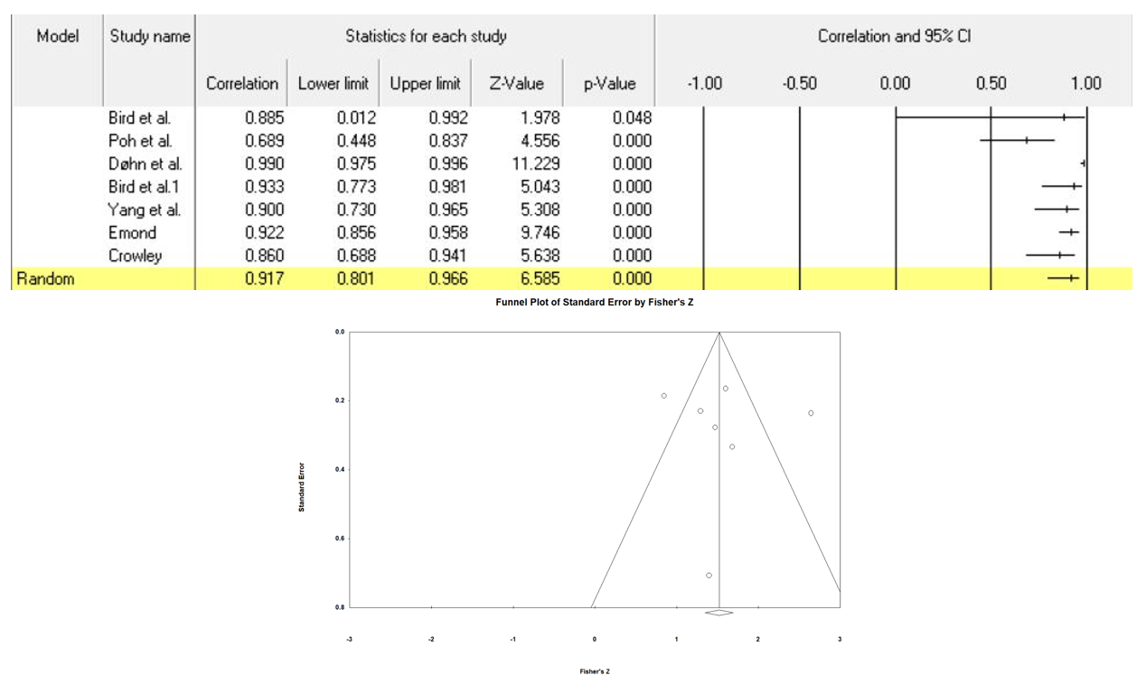
Supplement Figure S3. Correlation coefficient values and Funnel plot for computer-aided bone erosion volume (BEV) measurement on MRI and the OMERACT RAMRIS scores and/or manual measurement.
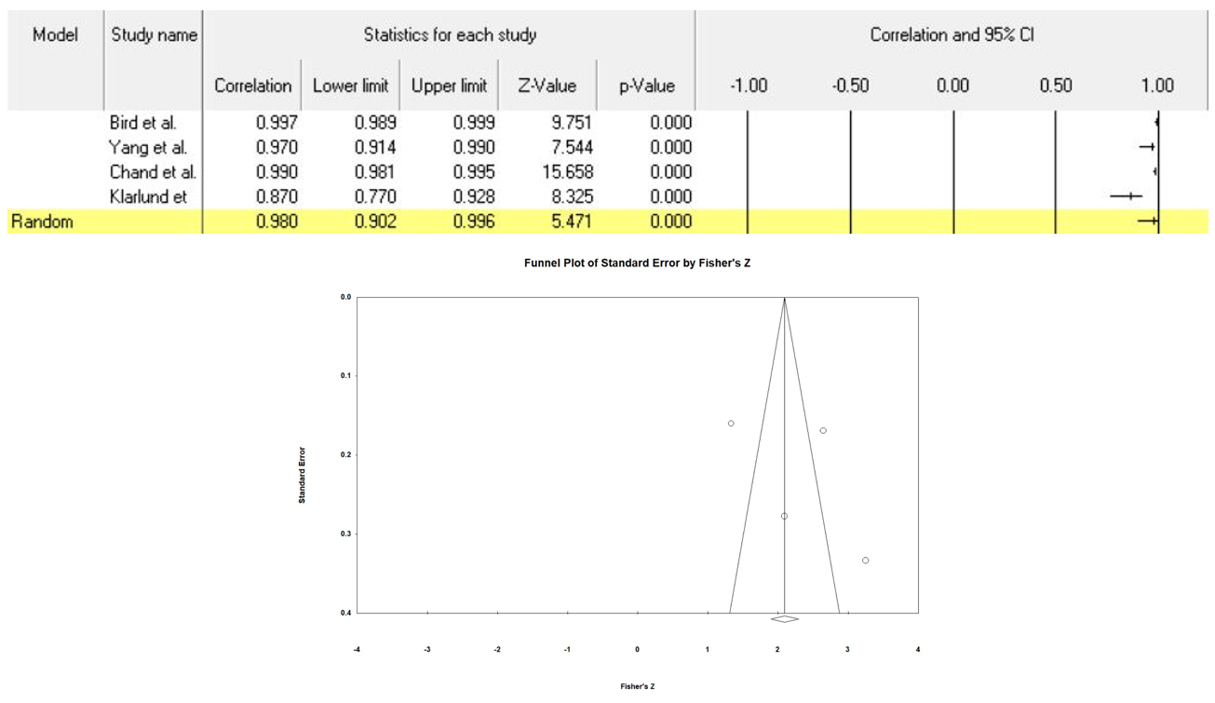
Supplement Figure S4. Correlation coefficient values and Funnel plot for the intra-reader reliability of computer-aided measurement of synovial membrane volume (SV) on MRI.

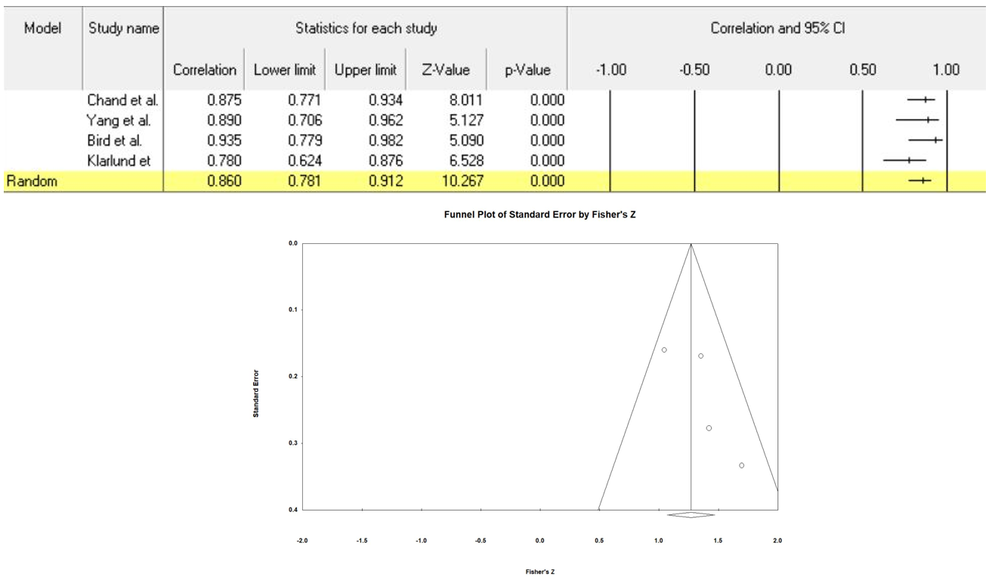
Supplement Figure S5. Correlation coefficient values and Funnel plot for the inter-reader reliability of computer-aided measurement of synovial membrane volume (SV) on MRI.

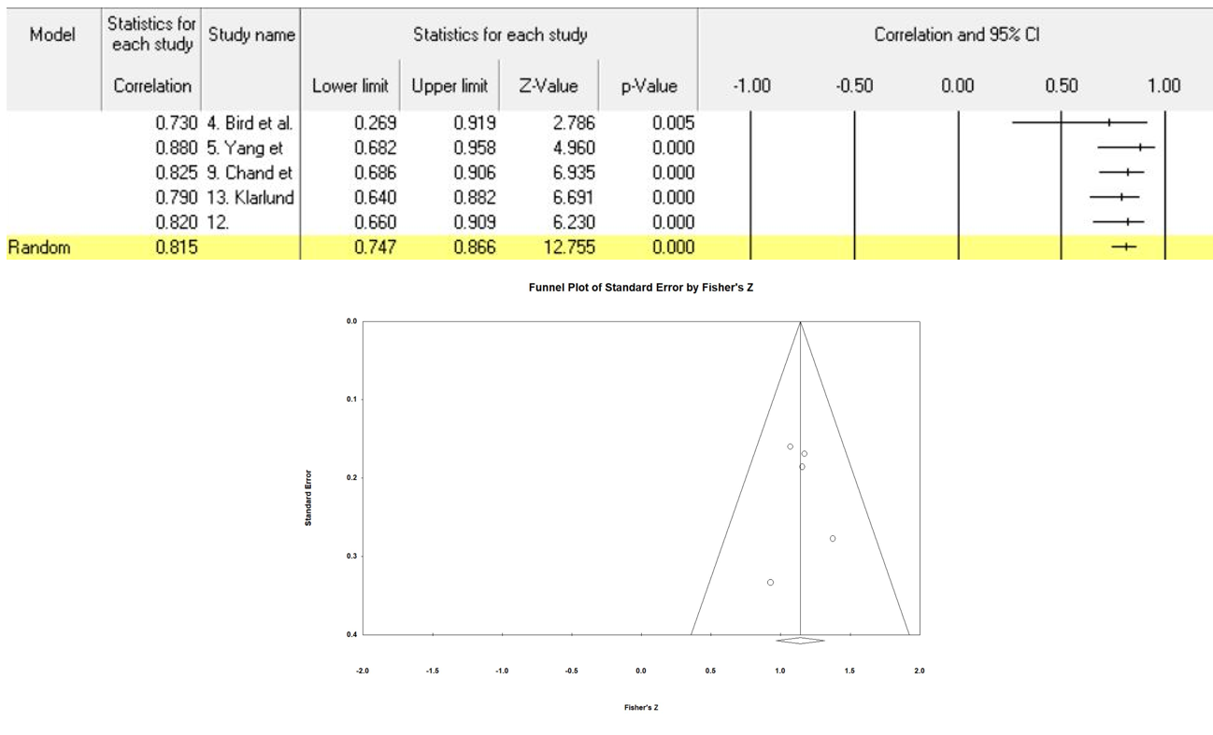
Supplement Figure S6. Correlation coefficient values and Funnel plot for computer-aided synovial membrane volume (SV) measurement on MRI and the OMERACT RAMRIS scores and/or manual measurement.

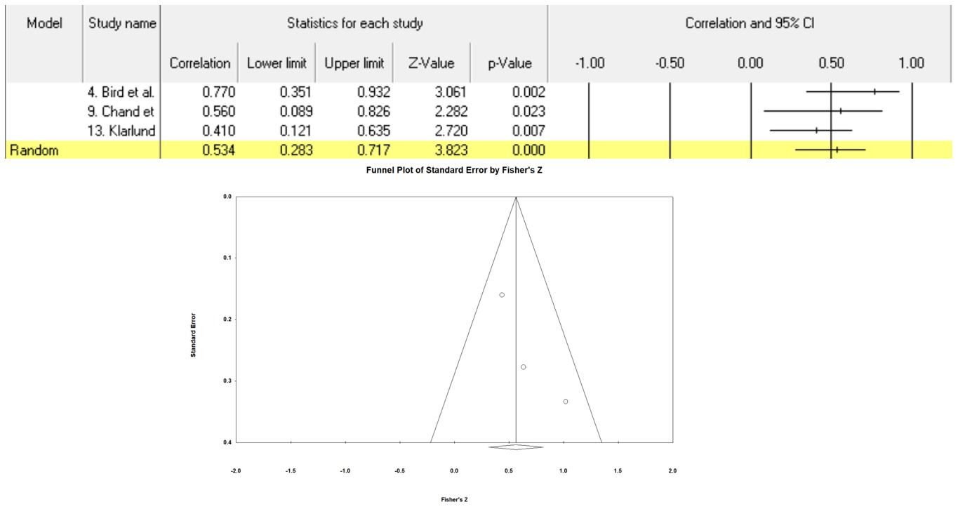
Supplement Figure S7. Correlation coefficient values and Funnel plot for computer-aided synovial membrane volume (SV) measurement on MRI and serum ESR level.

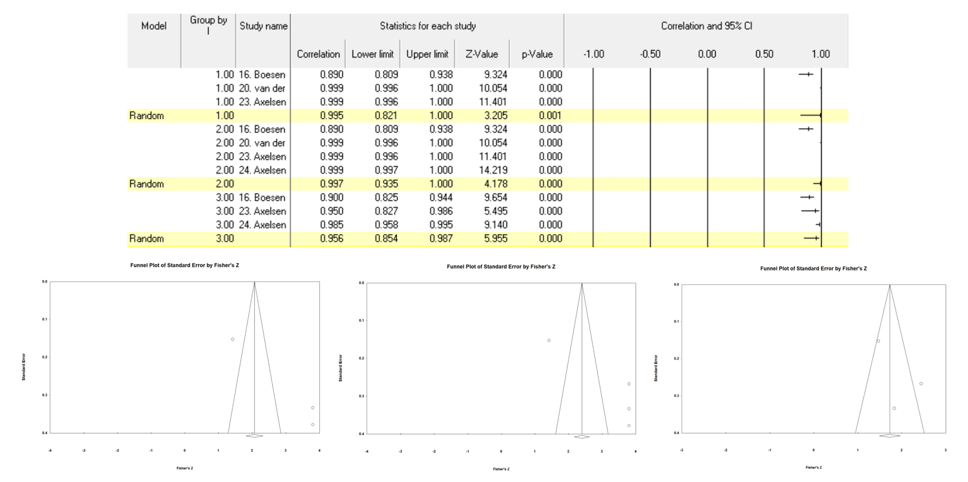
Supplement Figure S8. Correlation coefficient values and Funnel plot for the intra-reader reliability of computer-aided DCE-MRI data analysis for ME, IRE, and N-total (from top to bottom, and left to right).

Supplement Tables S1. Search Strategies
Details of the search strategy, using the keywords and the number of retrieved entries.
DATABASES/WEBSITES:
PubMed: 196 results
EMBASE: 273 results
Medline: 210 results
Cochrane Library: 35 results

EXCLUDE:
Letters, case studies, non-English publications, review articles, animal studies, conference abstracts, editorials, commentaries, letters, thesis, methodology articles.

PubMed
Search String |  |  | Category | No.
#1 | ("artificial intelligence"[MeSH Terms] OR "artificial intelligence"[Text Word] OR "automatic scoring"[Text Word] OR "deep learning"[Text Word] OR "AI"[Text Word] OR "machine learning"[MeSH Terms] OR "machine learning"[Text Word] OR "automated"[Text Word] OR "semiautomated"[Text Word] OR "semi-automated"[Text Word] OR "semi automated"[Text Word] OR "automatic"[Text Word] OR "semiautomatic"[Text Word] OR "semi-automatic"[Text Word] OR "semi automatic"[Text Word] OR "neural network classifying"[Text Word] OR "convolutional neural network"[Text Word] OR "neural network"[Text Word] OR "Computer-Assisted"[Text Word] OR "Computer-Aided"[Text Word]) |  | AI | 628370
#2 | ("arthritis"[Title/Abstract] AND ("arthritis"[MeSH Terms] OR "rheumatoid arthritis"[MeSH Terms] OR "psoriasis"[TW] OR "psoriatic arthritis"[MeSH Terms] OR "arthritis"[Text Word] OR "rheumatoid arthritis"[Text Word] OR "psoriasis"[Text Word] OR "psoriatic arthritis"[Text Word])) |  | Arthritis | 1741
#3 | ("Magnetic Resonance Imaging"[MeSH Terms] OR "Magnetic Resonance Imaging"[Text Word] OR "MRI"[Text Word] OR "Magnetic Resonance"[Text Word] OR "Rheumatoid Arthritis MRI Quantification"[Text Word]) |  | Imaging | 242
#4 | ("MCP"[Text Word] OR "metacarpophalangeal"[Text Word] OR "PIP"[Text Word] OR "proximal interphalangeal"[Text Word] OR "DIP"[Text Word] OR "distal interphalangeal"[Text Word] OR "wrist"[MeSH Terms] OR "hand"[MeSH Terms] OR "knee"[MeSH Terms] OR "wrist"[Text Word] OR "hand"[Text Word] OR "knee"[Text Word]OR "tibiofemoral"[Text Word] OR "patellofemoral"[Text Word] OR "hindfoot"[Text Word] OR "hind foot"[Text Word] OR "MTP"[Text Word] OR "metatarsophalangeal"[Text Word] OR "foot"[MeSH Terms] OR "ankle"[MeSH Terms] OR "joints"[MeSH Terms] OR "joint"[Text Word] OR "foot"[Text Word] OR "ankle"[Text Word] OR "joints"[Text Word] ) |  | Joint | 206
#5 | (NOT (“animals”[MeSH Terms])) NOT “humans”[ MeSH Terms]) |  | Human | 206
#6 | Time: Between 1/1/1999 and 6/2/2020 |  | Time | 196
#7 | #1 AND #2 AND #3 AND #4 NOT #5, AND #6 |  | Overall | 196

EMBASE
273 results
Search String |  |  | Category | No.
#1 | (‘artificial intelligence’ OR ‘automatic scoring’ OR ‘deep learning’ OR ‘AI’ OR ‘machine learning’ OR ‘automated’ OR ‘semiautomated’ OR ‘semi-automated’ OR ‘semi automated’ OR ‘automatic’ OR ‘semiautomatic’ OR ‘semi-automatic’ OR ‘semi automatic’ OR ‘neural network classifying’ OR ‘convolutional neural network’ OR ‘neural network’ OR ‘Computer-Assisted’ OR ‘Computer-Aided’) |  | AI | 1412679
#2 | (‘Arthritis’:ab AND (‘Arthritis’ OR ‘rheumatoid arthritis’ OR ‘psoriasis’ OR ‘psoriatic arthritis’)) |  | Arthritis | 7949
#3 | (‘Magnetic Resonance Imaging’ OR ‘MRI’ OR ‘Magnetic Resonance’ OR ‘Rheumatoid Arthritis MRI Quantification’) |  | Imaging | 1714
#4 | (‘MCP’ OR ‘metacarpophalangeal’ OR ‘PIP’ OR ‘proximal interphalangeal’ OR ‘DIP’ OR ‘distal interphalangeal’ OR ‘wrist’ OR ‘hand’ OR ‘knee’ OR ‘tibiofemoral’ OR ‘patellofemoral’ OR ‘hindfoot’ OR ‘hind foot’ OR ‘MTP’ OR ‘metatarsophalangeal’ OR ‘foot’ OR ‘ankle’) |  | Joint | 594
#5 | [humans]/lim |  | Human | 548
#6 | [1999-2020]/py |  | Time | 548
#7 | Applying language and article type limits |  | Language/  Type | 273
#8 | #1 AND #2 AND #3 AND #4 AND #5, AND #6, AND #5 |  | Overall | 273

MEDLINE
210 results
Search String |  |  | Category | No.
#1 | (‘artificial intelligence’ OR ‘automatic scoring’ OR ‘deep learning’ OR ‘AI’ OR ‘machine learning’ OR ‘automated’ OR ‘semiautomated’ OR ‘semi-automated’ OR ‘semi automated’ OR ‘automatic’ OR ‘semiautomatic’ OR ‘semi-automatic’ OR ‘semi automatic’ OR ‘neural network classifying’ OR ‘convolutional neural network’ OR ‘neural network’ OR ‘Computer-Assisted’ OR ‘Computer-Aided’) |  | AI | 862523
#2 | (‘Arthritis’:ab AND (‘Arthritis’ OR ‘rheumatoid arthritis’ OR ‘psoriasis’ OR ‘psoriatic arthritis’)) |  | Arthritis | 3988
#3 | (‘Magnetic Resonance Imaging’ OR ‘MRI’ OR ‘Magnetic Resonance’ OR ‘Rheumatoid Arthritis MRI Quantification’) |  | Imaging | 1244
#4 | (‘MCP’ OR ‘metacarpophalangeal’ OR ‘PIP’ OR ‘proximal interphalangeal’ OR ‘DIP’ OR ‘distal interphalangeal’ OR ‘wrist’ OR ‘hand’ OR ‘knee’ OR ‘tibiofemoral’ OR ‘patellofemoral’ OR ‘hindfoot’ OR ‘hind foot’ OR ‘MTP’ OR ‘metatarsophalangeal’ OR ‘foot’ OR ‘ankle’) |  | Joint | 314
#5 | [humans]/lim |  | Human | 228
#6 | [1999-2020]/py |  | Time | 210
#7 | Applying language and article type limits |  | Language/  Type | 210
#8 | #1 AND #2 AND #3 AND #4 AND #5, AND #6, AND #5 |  | Overall | 210

Cochrane
35 results
Search String |  |  | Category | No.
#1 | (“artificial intelligence":ti,ab,kw OR “automatic scoring":ti,ab,kw OR “deep learning":ti,ab,kw OR “AI":ti,ab,kw OR “machine learning":ti,ab,kw OR “automated":ti,ab,kw OR “semiautomated":ti,ab,kw OR “semi-automated":ti,ab,kw OR “semi automated":ti,ab,kw OR “semiautomatic":ti,ab,kw OR “automatic":ti,ab,kw OR “semi-automatic":ti,ab,kw OR “semi automatic":ti,ab,kw OR “neural network classifying":ti,ab,kw OR “convolutional neural network":ti,ab,kw OR “neural network":ti,ab,kw OR “Computer-Assisted":ti,ab,kw OR “Computer-Aided":ti,ab,kw) |  | AI | 34924
#2 | (“Arthritis":ti,ab,kw OR “rheumatoid arthritis":ti,ab,kw OR “psoriasis":ti,ab,kw OR “psoriatic arthritis":ti,ab,kw) |  | Arthritis | 313
#3 | (“Magnetic Resonance Imaging":ti,ab,kw OR MRI:ti,ab,kw OR “Magnetic Resonance":ti,ab,kw OR “Rheumatoid Arthritis MRI Quantification":ti,ab,kw) |  | Imaging | 49
#4 | (“MCP":ti,ab,kw OR “metacarpophalangeal":ti,ab,kw OR “PIP":ti,ab,kw OR “proximal interphalangeal":ti,ab,kw OR “DIP":ti,ab,kw OR “distal interphalangeal":ti,ab,kw OR “wrist":ti,ab,kw OR “hand":ti,ab,kw OR “knee":ti,ab,kw OR “tibiofemoral":ti,ab,kw OR “patellofemoral":ti,ab,kw OR “hindfoot":ti,ab,kw OR “hind foot":ti,ab,kw OR “MTP":ti,ab,kw OR “metatarsophalangeal":ti,ab,kw OR “foot":ti,ab,kw OR “ankle":ti,ab,kw OR “joints":ti,ab,kw OR “joint":ti,ab,kw) |  | Joint | 38
#5 | [humans]/lim |  | Human | 38
#6 | [1999-2020]/py |  | Time | 35
#7 | Applying language and article type limits |  | Language/  Type | 35
#8 | #1 AND #2 AND #3 AND #4 AND #5, AND #6, AND #7 |  | Overall | 35

Supplement Table S2. QUADAS-2 tool final list of signaling questions

QUADAS-2 tool: Final list of signaling questions
Patient selection | 1. Was a consecutive or random sample of patients enrolled? | Risk of bias | Could the selection of patients have introduced bias? | Applicability concerns | Are there concerns that the included patients do not match the review question?
Patient selection | 2. Was a case-control design avoided?
Patient selection | 3. Did the study avoid inappropriate exclusions?
Index test | 1. Were the results of computer-aided image analysis interpreted without knowledge of the results of the clinical outcomes or manual measurements? | Risk of bias | Could the conduct or interpretation of the results of computer-aided image analysis have introduced bias? | Applicability concerns | Are there concerns that computer-aided image analysis, its conduct, or interpretation differ from the review question?
Index test | 2. Appropriate computer-aided image analysis performed in all patients?
Index test | 3. Was the computer-aided method performed with the same parameters in all patients?
Reference standard | 1. Is the reference standard (measures for clinical outcomes or manual MRI-based measurements) likely to correctly classify the target condition? | Risk of bias | Could the clinical outcomes or manual MRI-based measurements have introduced bias? | Applicability concerns | Are there concerns that the target condition as defined by the reference standard does not match the review question?
Reference standard | 2. Was clinical measures or manual MRI-based measurements performed in all patients?
Following and timing | 1. Was there an appropriate interval computer-aided and manual measures? | Risk of bias | Could the patient flow have introduced bias? | Applicability concerns | -
Following and timing | 2. Did all patients receive the same measurements?
Following and timing | 3. Were all patients included in the analysis?
Following and timing | 4. Was the time between measurers in wide-range?

Supplement Table S3. List of articles that were excluded at the level of full-text screening
Study | Year | Title | Reason for exclusion
1. Carano et al. | 2004 | Multispectral analysis of bone lesions in the hands of patients with rheumatoid arthritis. | Wrong outcomes: bone lesion volume
2. Ceccarelli et al. | 2018 | Biomarkers of erosive arthritis in systemic lupus erythematosus: Application of machine learning models. | Wrong patient population and outcome
3. Conaghan et al. | 2016 | Comparing the effects of tofacitinib, methotrexate and the combination, on bone marrow oedema, synovitis and bone erosion in methotrexate-naive, early active rheumatoid arthritis: results of an exploratory randomised MRI study incorporating semiquantitati | Wrong outcomes: no reliability validity measure
4. Emond et al. | 2009 | The development of EERA: software for assessing rheumatic joint erosions. | Wrong study design: no AI-based method
5. Gandy et al. | 2005 | Measurement of cartilage volumes in rheumatoid arthritis using MRI. | Wrong outcomes: cartilage assessment
7. Gent et al. | 2015 | Subclinical synovitis detected by macrophage PET, but not MRI, is related to short-term flare of clinical disease activity in early RA patients: an exploratory study. | Wrong setting
8. Henchie et al. | 2019 | An image-based method to measure joint deformity in inflammatory arthritis: development and pilot study. | Wrong study design: no MRI
9. Hodgson et al. | 2008 | MRI of rheumatoid arthritis image quantitation for the assessment of disease activity, progression and response to therapy. | Wrong study design: review article
10. Jaremko et al. | 2016 | Development of Image Overlay and Knowledge Transfer Module Technologies Aimed at Enhancing Feasibility and External Validation of Magnetic Resonance Imaging-based Scoring Systems. | Wrong setting
11. Klarlund et al. | 1999 | Wrist and finger joint MR imaging in rheumatoid arthritis. | Wrong setting
12. Klarlund et al. | 2000 | Dynamic magnetic resonance imaging of the metacarpophalangeal joints in rheumatoid arthritis, early unclassified polyarthritis, and healthy controls. | Wrong outcomes
13. Koch et al. | 2011 | Fully automatic segmentation of wrist bones for arthritis patients. | Wrong outcomes
14. Kubassova et al. | 2009 | Quantifying disease activity and damage by imaging in rheumatoid arthritis and osteoarthritis. | Wrong study design
15. Kubassova et al. | 2007 | Quantitative analysis of dynamic contrast-enhanced MRI datasets of the metacarpophalangeal joints. | Wrong outcomes
16. Langs et al. | 2009 | Automatic quantification of joint space narrowing and erosions in rheumatoid arthritis. | Wrong outcomes
17. Lee et al. | 2015 | Dynamic contrast-enhanced imaging of the wrist in rheumatoid arthritis: dedicated low-field (0.25-T) versus high-field (3.0-T) MRI. | Wrong study design
18. Li et al. | 2014 | Diffusion-weighted MR imaging for assessing synovitis of wrist and hand in patients with rheumatoid arthritis: a feasibility study. | Wrong outcomes
19. Li et al. | 2014 | Diagnostic performance of three-dimensional MR maximum intensity projection for the assessment of synovitis of the hand and wrist in rheumatoid arthritis: A pilot study. | Wrong outcomes
20. Meng et al. | 2017 | Quantitative evaluation of knee cartilage and meniscus destruction in patients with rheumatoid arthritis using T1ρ and T2 mapping. | Wrong study design: cartilage assessment
21. Montejo et al. | 2013 | Computer-aided diagnosis of rheumatoid arthritis with optical tomography, Part 1: feature extraction. | Wrong outcomes
22. Müller-Lutz et al. | 2015 | Comparison of quantitative and semiquantitative dynamic contrast-enhanced MRI with respect to their correlation to delayed gadolinium-enhanced MRI of the cartilage in patients with early rheumatoid arthritis. | Wrong outcomes
23. Naredo et al. | 2018 | Agreement between semiquantitative and quantitative Doppler scoring systems for the assessment of synovial pathological vascularisation in rheumatoid arthritis. | Wrong study design
24. Oka et al. | 2018 | Assessing joint destruction in the knees of patients with rheumatoid arthritis by using a semi-automated software for magnetic resonance imaging: therapeutic effect of methotrexate plus etanercept compared with methotrexate monotherapy. | Wrong study design
25. Okino et al. | 2018 | Radiographic temporal subtraction analysis can detect finger joint space narrowing progression in rheumatoid arthritis with clinical low disease activity. | Wrong outcomes
26. Ostrowitzki et al. | 2004 | Use of multispectral magnetic resonance imaging analysis to quantify erosive changes in the hands of patients with rheumatoid arthritis: short-term and long-term longitudinal studies. | Wrong outcomes
27. Pedoia et al. | 2016 | Segmentation of joint and musculoskeletal tissue in the study of arthritis. | Wrong study design
28. Radlak et al. | 2015 | Automatic detection of bones based on the confidence map for rheumatoid arthritis analysis | Wrong outcomes
29. Rastogi e al. | 2013 | Evaluating automated dynamic contrast enhanced wrist 3T MRI in healthy volunteers: one-year longitudinal observational study. | Wrong patient population
30. Salaffi et al. | 2013 | Validity of a computer-assisted manual segmentation software to quantify wrist erosion volume using computed tomography scans in rheumatoid arthritis. | Wrong study design
31. Savnik et al. | 2002 | MRI of the arthritic finger joints: synovial membrane volume determination, a manual vs a stereologic method. | Wrong setting
32. Sharp et al. | 2010 | Denosumab prevents metacarpal shaft cortical bone loss in patients with erosive rheumatoid arthritis. | Wrong outcomes
33. Shi et al. | 2015 | Methods of assessment of tophus and bone erosions in gout using dual-energy CT: reproducibility analysis. | Wrong patient population
34. Tam et al. | 2007 | Rapid improvement in rheumatoid arthritis patients on combination of methotrexate and infliximab: clinical and magnetic resonance imaging evaluation. | Wrong outcomes
35. Teruel et al. | 2014 | Bone structure and perfusion quantification of bone marrow edema pattern in the wrist of patients with rheumatoid arthritis: a multimodality study. | Wrong outcomes
36. Tripoliti et al. | 2007 | Automated segmentation and quantification of inflammatory tissue of the hand in rheumatoid arthritis patients using magnetic resonance imaging data. | Wrong study design
37. van de Sande et al. | 2012 | Characteristics of synovial inflammation in early arthritis analysed by pixel-by-pixel time-intensity curve shape analysis. | Wrong outcomes
38. Włodarczyk et al. | 2015 | Segmentation of bones in magnetic resonance images of the wrist. | Wrong study design
39. Włodarczyk et al. | 2015 | Fast automated segmentation of wrist bones in magnetic resonance images. | Wrong study design
40. Wojciechowski et al. | 2014 | Correlation between manual 0.2T MRI assessment of synovitis and EULAR-OMERACT scores of the wrist in patients with rheumatoid arthritis. | Wrong study design
41. Wong et al. | 2019 | Fully automated segmentation of wrist bones on T2-weighted fat-suppressed MR images in early rheumatoid arthritis. | Wrong outcomes
42. Xanthopoulos et al. | 2007 | Improved wrist pannus volume measurement from contrast-enhanced MRI in rheumatoid arthritis using shuffle transform. | Wrong outcomes
43. Conaghan et al. | 2019 | Very Early MRI Responses to Therapy as a Predictor of Later Radiographic Progression in Early Rheumatoid Arthritis | Wrong outcomes
44. Axelsen et al. | 2019 | Responsiveness of Different Dynamic Contrast-Enhanced Magnetic Resonance Imaging Approaches: A Post-Hoc Analysis of a Randomized Controlled Trial of Certolizumab Pegol in Rheumatoid Arthritis | Wrong outcomes

Supplement Table S4. Details of the study designs of included studies
Study | Inclusion Criteria | Exclusion Criteria | Design | Enrollment | Blinding | Timing
1. Bird et al. (OMERACT) | Subjects with RA were selected — 3 from Sydney and 2 from Copenhagen. | N/A | N/A | N/A | No | 24 h
2. Poh et al. | From the Target Study in Rheumatoid Arthritis (TASRA) trial, which was designed to determine whether increasing antirheumatic therapy can achieve and maintain a target of reduced joint damage progression on MRI and radiographs compared to usual care. | N/A | Retrospective | N/A | N/A | 48 h
3. Døhn et al. | Patients with RA and matched controls | N/A | Prospective | N/A | Yes | 1 week
4. Bird et al. (A & R) | Subjects with seropositive RA | N/A | N/A | N/A | N/A | 48 h
5. Yang et al. | All patients fulfilled the 1987 American College of Rheumatology (ACR) classification criteria for RA | N/A | N/A | N/A | N/A | 4 weeks
6. Emond et al. | Having RA according to the American Rheumatism Association 1987 revised criteria for the classification of RA | N/A | Prospective | Consecutive | N/A | 72 h
7. Tomizza et al. | At least 3 swollen joints; or a positive compression test of either the MCP or metatarsophalangeal joints; or at least 30 min of morning stiffness, lasting for at least 6 weeks | Patients with a  history of wrist or hand surgery were excluded | Retrospective | N/A | Yes | 72 h
8. Bird et al. (Training) | Subjects with seropositive RA. The subjects were selected to represent a range of joint damage, from minimal erosive change to advanced disease. All subjects fulfilled the American College of Rheumatology diagnostic criteria for RA | N/A | Retrospective | N/A | Yes | N/A
9. Chand et al. | Patients fulfilled the 1987 American College of Rheumatology (ACR; formerly, the American Rheumatism Association) criteria for RA and were either rheumatoid factor (RF) and/or anti-CCP positive | N/A | Prospective | N/A | Yes | 1 week
10. Aizenberg et al. | Inclusion required clinically confirmed arthritis by physical examination in one or more joints, and symptom duration of less than 2 years. | N/A | Prospective | N/A | Yes | N/A
11. Crowley et al. | All patients fulfilled 1987 American College of Rheumatology (ACR) criteria for RA and were either rheumatoid factor (RF) or  anti-CCP positive. All of the patients had early RA  (disease duration <2 years). | N/A | Prospective | N/A | Yes | N/A
12. Czaplicka et al. | Based on 2010 ACR/EULAR criteria. In all patients the duration of the active RA was less than 5 years and RA was confirmed with clinical and laboratory disease variables | N/A | Prospective | N/A | Yes | N/A
13. Klarlund et al. | Fulfilling ARA 1987 criteria and controls | N/A | Prospective | N/A | N/A | 2 months
14. Li et al. | Fulfilled 1987 American College of Rheumatology  (ACR) classification criteria for RA | N/A | Prospective | N/A | N/A | N/A
15. Stramare et al. | Patients met the RA criteria drawn up by the  ACR in 1987. They were all defined as being in an active phase of disease, with DAS28 (Disease Activity Score calculated on 28 joints)>2.6, a CDAI  (Clinical Disease Activity Index)>2.8 and SDAI (Simplified Disease Activity Index)>3.3 | N/A | N/A | N/A | Yes | N/A
16. Boesen et al. (Europ) | Subjects were imaged with DCE-MRI and scored according to ACR criteria: 32 patients suffered from RA; 6 patients with psoriatic arthritis (PsA) diagnosed by the presence of seronegative arthritis and psoriasis; 4 patients with early undifferentiated arthritis (EUA); 4 normal controls | N/A | Retrospective | N/A | N/A | 3 days
17. Cimmino et al. | Seven patients with PsA according to the CASPAR criteria and 10 patients with RA diagnosed according to the 1987 American College of Rheumatology criteria were studied. | N/A | N/A | N/A | N/A | N/A
18. Cimmino et al. | IgM rheumatoid factor (RF) positive, anti CCP-positive, RA patients, diagnosed according to the ACR criteria | N/A | Prospective | N/A | N/A | N/A
19. Orguc et al. | All patients were diagnosed according to 1987 ACR criteria and were either under follow-up or newly diagnosed | N/A | Prospective | N/A | Yes | N/A
20. van der Leij et al. | Five consecutive patients who fulfilled the 1987 American College of Rheumatology classification criteria for RA; Five healthy control subjects were asked to voluntarily enroll | N/A | Prospective | Consecutive | Yes | 3 months
21. Boesen et al. | Patients with RA, fulfilling the ACR 1987 criteria | N/A | Prospective | Consecutive | Yes | N/A
22. Wojciechowski et al. | RA patients of the Department of Rheumatology, All patients had pain in at least one wrist and were imaged with DCE-MRI as a part of the diagnostic procedure. | Contraindications for the contrast-enhanced MRI. | Prospective | Consecutive | N/A | N/A
23. Axelsen et al. | Fulfilling the 1987 American Rheumatism Association classification criteria for RA | N/A | Prospective | N/A | Yes | N/A
24. Axelsen et al. | The patients fulfilled the American College of Rheumatology (ACR) 1987 classification criteria for RA. All patients had a history of  clinical swelling and/or tenderness of the knee scheduled for surgery, with 12 patients having a tender and/or swollen knee at the time of surge | N/A | N/A | N/A | N/A | N/A
25. Zierhut et al | Patients were referred to this study by two Seattle based rheumatologists and were assessed to have active RA. Twelve patients were enrolled in this study. They were eligible for the study if their attending physician recommended a change in therapy due to poor response to current therapy, or due to an unacceptable adverse reaction to current therapy. | Functional class IV stage disease defined by ACR criteria. | Retrospective | N/A | Yes | N/A
26. Meier et al. | Patients with inflammatory arthritis, clinical suspicion of active disease, and the need for initiation or escalation of existing therapy were included in this prospective study | N/A | Prospective | N/A | Yes | N/A
27. Kubassova et al. | N/A | N/A | Retrospective | N/A | N/A | N/A
28. Sakashita et al. | All patients were diagnosed with RA according to the American College of Rheumatologist’s 1987 criteria | N/A | N/A | Consecutive | Blinding | Timing

References:
1. Bird P, Ejbjerg B, McQueen F, Ostergaard M, Lassere M, Edmonds JJTJor. OMERACT Rheumatoid Arthritis Magnetic Resonance Imaging Studies. Exercise 5: an international multicenter reliability study using computerized MRI erosion volume measurements. 2003;30(6):1380-1384.
2. Poh MQW, Lassere M, Bird P, Edmonds JJTJoR. Reliability and longitudinal validity of computer-assisted methods for measuring joint damage progression in subjects with rheumatoid arthritis. 2013;40(1):23-29.
3. Døhn UM, Ejbjerg BJ, Hasselquist M, Narvestad E, Szkudlarek M, Møller J, Thomsen HS, Østergaard MJAotRD. Rheumatoid arthritis bone erosion volumes on CT and MRI: reliability and correlations with erosion scores on CT, MRI and radiography. 2007;66(10):1388-1392.
4. Bird P, Lassere M, Shnier R, Edmonds JJA, Rheumatism. Computerized measurement of magnetic resonance imaging erosion volumes in patients with rheumatoid arthritis: a comparison with existing magnetic resonance imaging scoring systems and standard clinical outcome measures. 2003;48(3):614-624.
5. Yang H, Rivoire J, Hoppe M, Srikhum W, Imboden J, Link TM, Li XJSr. Computer-aided and manual quantifications of MRI synovitis, bone marrow edema-like lesions, erosion and cartilage loss in rheumatoid arthritis of the wrist. 2015;44(4):539-547.
6. Emond P, Inglis D, Choi A, Tricta J, Adachi J, Gordon CJMrim. Volume measurement of bone erosions in magnetic resonance images of patients with rheumatoid arthritis. 2012;67(3):814-823.
7. Tomizza MA, Jessome MA, Barbosa J, Beattie KA, Bensen WG, Bobba RS, Cividino AA, Emond PD, Gordon C, Hart LJTJor. Assessing the Reliability of a Semiautomated Segmentation Algorithm for Quantifying Erosions in the Metacarpophalangeal Joints of Patients with Rheumatoid Arthritis. 2015;42(9):1582-1586.
8. Bird P, Joshua F, Lassere M, Shnier R, Edmonds JJTJoR. Training and calibration improve inter-reader reliability of joint damage assessment using magnetic resonance image scoring and computerized erosion volume measurement. 2005;32(8):1452-1458.
9. Chand AS, McHaffie A, Clarke AW, Reeves Q, Tan YM, Dalbeth N, Williams M, McQueen FJJoMRI. Quantifying synovitis in rheumatoid arthritis using computer‐assisted manual segmentation with 3 tesla MRI scanning. 2011;33(5):1106-1113.
10. Aizenberg E, Roex EA, Nieuwenhuis WP, Mangnus L, van der Helm‐van Mil AH, Reijnierse M, Bloem JL, Lelieveldt BP, Stoel BCJMrim. Automatic quantification of bone marrow edema on MRI of the wrist in patients with early arthritis: A feasibility study. 2018;79(2):1127-1134.
11. Crowley AR, Dong J, McHaffie A, Clarke AW, Reeves Q, Williams M, Robinson E, Dalbeth N, McQueen FMJJoMRI. Measuring bone erosion and edema in rheumatoid arthritis: a comparison of manual segmentation and RAMRIS methods. 2011;33(2):364-371.
12. Czaplicka K, Wojciechowski W, Włodarczyk J, Urbanik A, Tabor ZJCib, medicine. Automated assessment of synovitis in 0.2 T magnetic resonance images of the wrist. 2015;67:116-125.
13. Klarlund M, Ostergaard M, Lorenzen IJR. Finger joint synovitis in rheumatoid arthritis: quantitative assessment by magnetic resonance imaging. 1999;38(1):66-72.
14. Li X, Yu A, Virayavanich W, Noworolski SM, Link TM, Imboden JJJoMRI. Quantitative characterization of bone marrow edema pattern in rheumatoid arthritis using 3 Tesla MRI. 2012;35(1):211-217.
15. Stramare R, Coran A, Faccinetto A, Costantini G, Bernardi L, Botsios C, Perissinotto E, Grisan E, Beltrame V, Raffeiner BJLrm. MR and CEUS monitoring of patients with severe rheumatoid arthritis treated with biological agents: a preliminary study. 2014;119(6):422-431.
16. Boesen M, Kubassova O, Parodi M, Bliddal H, Innocenti S, Garlaschi G, Cimmino MAJEjor. Comparison of the manual and computer-aided techniques for evaluation of wrist synovitis using dynamic contrast-enhanced MRI on a dedicated scanner. 2011;77(2):202-206.
17. Cimmino MA, Barbieri F, Boesen M, Paparo F, Parodi M, Kubassova O, Scarpa R, Zampogna GJTJoRS. Dynamic contrast-enhanced magnetic resonance imaging of articular and extraarticular synovial structures of the hands in patients with psoriatic arthritis. 2012;89:44-48.
18. Cimmino MA, Parodi M, Zampogna G, Boesen M, Kubassova O, Barbieri F, Paparo F, Garlaschi G, Cutolo MJCER. Dynamic contrast-enhanced, extremity-dedicated MRI identifies synovitis changes in the follow-up of rheumatoid arthritis patients treated with rituximab. 2014;32(5):647-652.
19. Orguc S, Tikiz C, Aslanalp Z, Erbay PDJRi. Comparison of OMERACT-RAMRIS scores and computer-aided dynamic magnetic resonance imaging findings of hand and wrist as a measure of activity in rheumatoid arthritis. 2013;33(7):1837-1844.
20. van der Leij C, van de Sande MG, Lavini C, Tak PP, Maas MJR. Rheumatoid synovial inflammation: pixel-by-pixel dynamic contrast-enhanced MR imaging time-intensity curve shape analysis—a feasibility study. 2009;253(1):234-240.
21. Boesen M, Kubassova O, Bouert R, Axelsen MB, Østergaard M, Cimmino MA, Danneskiold-Samsøe B, Hørslev-Petersen K, Bliddal HJR. Correlation between computer-aided dynamic gadolinium-enhanced MRI assessment of inflammation and semi-quantitative synovitis and bone marrow oedema scores of the wrist in patients with rheumatoid arthritis—a cohort study. 2012;51(1):134-143.
22. Wojciechowski W, Tabor Z, Urbanik AJCER. Assessing synovitis based on dynamic gadolinium-enhanced MRI and EULAR-OMERACT scores of the wrist in patients with rheumatoid arthritis. 2013;31(6):850-856.
23. Axelsen MB, Poggenborg RP, Stoltenberg M, Kubassova O, Boesen M, Hørslev-Petersen K, Bliddal H, Hanson LG, Østergaard MJSjor. Reliability and responsiveness of dynamic contrast-enhanced magnetic resonance imaging in rheumatoid arthritis. 2013;42(2):115-122.
24. Axelsen MB, Stoltenberg M, Poggenborg R, Kubassova O, Boesen M, Bliddal H, Hørslev-Petersen K, Hanson LG, Østergaard MJSjor. Dynamic gadolinium-enhanced magnetic resonance imaging allows accurate assessment of the synovial inflammatory activity in rheumatoid arthritis knee joints: a comparison with synovial histology. 2012;41(2):89-94.
25. Zierhut ML, Gardner JC, Spilker ME, Sharp JT, Vicini PJAobe. Kinetic modeling of contrast-enhanced MRI: an automated technique for assessing inflammation in the rheumatoid arthritis wrist. 2007;35(5):781-795.
26. Meier R, Thuermel K, Noël PB, Moog P, Sievert M, Ahari C, Nasirudin RA, Golovko D, Haller B, Ganter CJR. Synovitis in patients with early inflammatory arthritis monitored with quantitative analysis of dynamic contrast-enhanced optical imaging and MR imaging. 2014;270(1):176-185.
27. Kubassova O, Boesen M, Cimmino MA, Bliddal HJEjor. A computer-aided detection system for rheumatoid arthritis MRI data interpretation and quantification of synovial activity. 2010;74(3):e67-e72.
28. Sakashita T, Kamishima T, Kobayashi Y, Sugimori H, Tang M, Sutherland K, Noguchi A, Kono M, Atsumi TJTBjor. Accurate quantitative assessment of synovitis in rheumatoid arthritis using pixel-by-pixel, time–intensity curve shape analysis. 2016;89(1061):20151000.

