Multimedia Appendix 1

PubMed search strategy (6 February 2020)
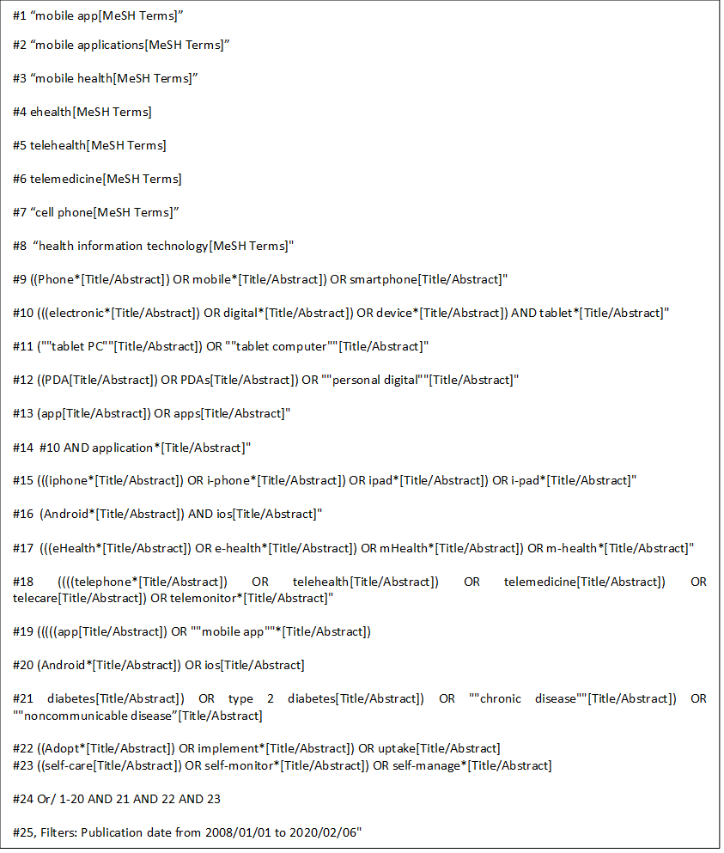

Quality assessment of the included studies

Online supplementary table 1: Quality assessment of cross-sectional studies
Criteria / Author (year) | [40] | [47] | [35] | [33] | [42] | [22] | [23] | [36] | [41] | [27] | [29] | [39] | [49]
- Were the criteria for inclusion in the sample clearly defined? | Yes | Yes | Yes | Yes | Yes | Yes | Yes | Yes | No | Yes | Yes | Yes | Yes
- Were the study subjects and the setting described in detail? | Yes | Yes | Yes | Yes | Yes | Yes | Yes | Yes | Yes | Yes | Yes | Yes | Yes
- Was the exposure measured in a valid and reliable way? | Unclear | Yes | Yes | Yes | Yes | Yes | Yes | Unclear | Unclear | Yes | Yes | Yes | Yes
- Were objective, standard criteria used for measurement of the condition? | Yes | Yes | Yes | Yes | Yes | Yes | Yes | Unclear | Yes | Yes | Yes | Yes | Yes
- Were confounding factors identified? | No | Yes | No | Yes | Yes | Yes | Yes | Unclear | No | Yes | Unclear | Yes | No
- Were strategies to deal with confounding factors stated? | No | Yes | No | Yes | Yes | Yes | Yes | Unclear | No | Yes | Unclear | Yes | No
- Were the outcomes measured in a valid and reliable way? | Yes | Yes | Yes | Yes | Yes | Yes | Yes | Unclear | Yes | Yes | Yes | Yes | Yes
- Was appropriate statistical analysis used? | Unclear | Yes | Yes | Yes | Yes | Yes | Yes | No | Yes | Yes | Yes | Yes | Yes
Total | 4/8 | 8/8 | 6/8 | 8/8 | 8/8 | 8/8 | 8/8 | 2/8 | 4/8 | 8/8 | 6/8 | 8/8 | 6/8

Online supplementary table 2: Quality assessment of the cohort study
Criteria/ Author (year) | [24]
- Were the two groups similar and recruited from the same population? | Yes
- Were the exposures measured similarly to assign people to both exposed and unexposed groups? | Yes
- Was the exposure measured in a valid and reliable way? | Unclear
- Were confounding factors identified? | Unclear
- Were strategies to deal with confounding factors stated? | Unclear
- Were the groups/participants free of the outcome at the start of the study (or at the moment of exposure)? | Unclear
- Were the outcomes measured in a valid and reliable way? | Yes
- Was the follow up time reported and sufficient to be long enough for outcomes to occur? | Not applicable
- Was follow up complete, and if not, were the reasons to loss to follow up described and explored? | Not applicable
- Were strategies to address incomplete follow up utilized? | Not applicable
- Was appropriate statistical analysis used? | Yes
Total | 4/11

Online supplementary table 3: Quality assessment of qualitative studies
Criteria/ Author (year) | [44] | [32] | [46] | [36] | [37] | [38] | [45] | [25]
- Is there congruity between the stated philosophical perspective and the research methodology? | Yes | Unclear | Yes | Unclear | No | Yes | Unclear | Yes
- Is there congruity between the research methodology and the research question or objectives? | Yes | Yes | Yes | Yes | Yes | Yes | Yes | Yes
- Is there congruity between the research methodology and the methods used to collect data? | Yes | Yes | Yes | Yes | Yes | Yes | Yes | Yes
- Is there congruity between the research methodology and the representation and analysis of data? | Yes | Yes | Yes | Unclear | Yes | Yes | Yes | Yes
- Is there congruity between the research methodology and the interpretation of results? | Yes | Yes | Yes | Yes | Yes | Yes | Yes | Yes
- Is there a statement locating the researcher culturally or theoretically? | Yes | Yes | Yes | No | No | Yes | Unclear | Yes
- Is the influence of the researcher on the research, and vice- versa, addressed? | No | Yes | No | No | No | No | Yes | No
- Are participants, and their voices, adequately represented? | Yes | Yes | Yes | Yes | Yes | Yes | Yes | Unclear
- Is the research ethical according to current criteria or, for recent studies, and is there evidence of ethical approval by an appropriate body? | Yes | Yes | Yes | Yes | Yes | Yes | Yes | Yes
- Do the conclusions drawn in the research report flow from the analysis, or interpretation, of the data? | Yes | Yes | Yes | Yes | Yes | Yes | Yes | Yes
Total | 9/10 | 9/10 | 9/10 | 6/10 | 7/10 | 9/10 | 8/10 | 8/10

Criteria/ Author (year) | [26] | [34] | [43] | [28] | [48] | [30] | [31]
- Is there congruity between the stated philosophical perspective and the research methodology? | Unclear | Unclear | Yes | No | Yes | Yes | Yes
- Is there congruity between the research methodology and the research question or objectives? | Yes | Yes | Yes | Yes | Yes | Yes | Yes
- Is there congruity between the research methodology and the methods used to collect data? | Yes | Yes | Yes | Yes | Yes | Yes | Yes
- Is there congruity between the research methodology and the representation and analysis of data? | Yes | Yes | Yes | Yes | Yes | Yes | Yes
- Is there congruity between the research methodology and the interpretation of results? | Yes | Yes | Yes | Yes | Yes | Yes | Yes
- Is there a statement locating the researcher culturally or theoretically? | Unclear | Unclear | Unclear | No | Yes | Unclear | Unclear
- Is the influence of the researcher on the research, and vice- versa, addressed? | No | No | Unclear | No | Yes | Unclear | Unclear
- Are participants, and their voices, adequately represented? | Yes | Yes | Yes | Yes | Yes | Yes | Yes
- Is the research ethical according to current criteria or, for recent studies, and is there evidence of ethical approval by an appropriate body? | Yes | Yes | Yes | Yes | Yes | Yes | Yes
- Do the conclusions drawn in the research report flow from the analysis, or interpretation, of the data? | Yes | Yes | Yes | Yes | Yes | Yes | Yes
Total | 7/10 | 7/10 | 8/10 | 7/10 | 10/10 | 8/10 | 8/10

