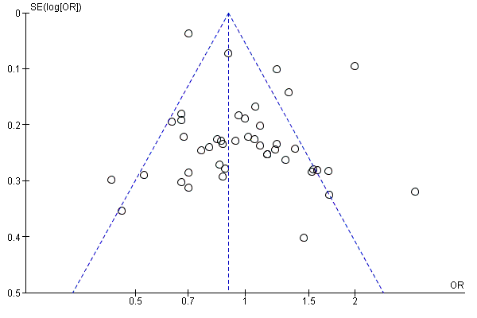
Supplementary Figure 1: Funnel plot of all the studies included in the meta-analysis

