Supplementary files

Appendix 1. List of full text articles and abstracts retrieved to assess eligibility for review.

1. Mohamed MS, Mufti GR. The surgical assessment unit—Effective strategy for improvement of the emergency surgical pathway? J R Soc Med 2005;98:14–7.
2. Narahari RK, Patel A, Abroaf A, Shaw MBKS, Dorkin TJ, Hasan ST, et al. "Endo-hour"—Our solution to emergency stone surgery. Br J Med Surg Urol 2012;5:141. Doi: 10.1016/j.bjmsu.2012.02.003
3. Russell A, Webster J, Izegbu V, Hellawell G. Consultant-delivered care—Is it worth it? BJU International 2012;Supp 7:41. Doi: 10.1111/j.1464-410X.2012.11177.x.
4. Martin L, Pillot P, Bardonnaud N, Lillaz J, Chabannes E, Bernardini S, et al. Evaluation of the activity of a urological emergency unit in university hospital. Prog Urol 2014;24:62–6. [Article in French].
5. Bass E, Patel S. Improving the handover and care of acute urological admissions. BMJ Qual Improv Rep 2015;4:u204762. Doi: 10.1136/bmjquality.u204762.w3422.
6. Ford KE, Cooper LLR, Thenabadu S. Acute testicular pain in children: Collaboration in timely management. Eur J Emerg Med 2015;22:55–7.
7. Lee T, Jain A. Audit of the implementation of a renal colic pathway in the accident and emergency department of a district general hospital. Int J Surg 2015;23(Supp 1):S123. Doi: 10.1016/j.ijsu.2015.10.028.
8. Nic An Riogh A, Fearon N, Cronin C, Sehgal R, Awan F, El-Faedy O, et al. The impact of the acute surgical assessment unit on emergency urological presentations. Ir J Med Sci 2015;184:S385. Doi: 10.1007/s11845-015-1334-1.
9. Tharakan T, Wou C, Phaily A, Dunsmuir W. A service improvement project for emergency urological admissions. Int J Surg. 2015;23:S125. Doi: 10.1016/j.ijsu.2015.10.028.
10. Raza MMA, Erete L, Tadtayev S, Bycroft J, Lane T, Hanbury D. Urology registrar of the week: How does it improve patient care? Int J Surg 2016;36:S125. Doi: 10.1016/j.ijsu.2016.08.239.
11. Golda N, Buckley RJ, Stefanova V. Implementing an acute care urology model of care at a large community teaching hospital in Ontario. Can Urol Assoc J 2017;11:S273. Doi: 10.5489/cuaj-6-s173.pdf.
12. Narra M, Evans G, Smith P, Antoniou S, Pridgeon S. An audit of a designated acute urological theatre list in Cairns Hospital: Benefits for patients, trainees and trainers. BJU Int 2017;119:S14. Doi: 10.1111/bju.13750.
13. Rapp DE, Wood NL, Wright JA, Booth BA, Colhoun A, Kramolowsky EV. Providing access to care through a 24-Hour dedicated stone line. Urol Prac 2017;4:43–7.
14. Hegazy M, Anderson S, Nusrat N, Jaffry S, Rogers E, Durkan G et al. The implementation of a protected emergency theatre pathway for acute urological admissions. Ir J Med Sci 2018;187:S141–S2. Doi: 10.1007/s11845-018-1861-7.
15. Jewitt K, Domes T. Utilization and impact of an ambulatory urology care centre in Saskatchewan. Can Urol Assoc J 2018;12:S74. Doi: 10.5489/cuaj-6-s51.pdf.
16. Trigylidas TE, Michael J, Schroeder L, Gatti J, Wickham A, Jain S. Timely management of testicular torsion: A collaborative quality improvement approach. Acad Emerg Med 2018;25 (Supp 1):S240–S1. Doi: 10.1111/acem.13424.
Appendix 2. Data extraction pro-forma.

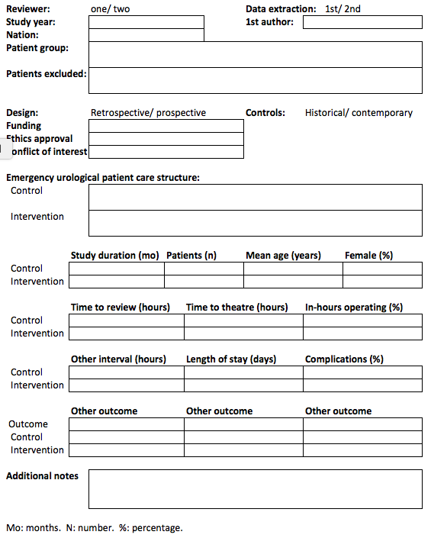
Appendix 3. Reviewer guidelines for assessing risk of bias.

Cohort studies; Guide for completing the Newcastle-Ottawa Quality Assessment Scale.

1. Selection
Representativeness of exposed cohort ★
Scoring studies will define and enrol adult emergency urological patients without further restriction by age, gender, time of day, disease severity or other limitation. Studies will be permitted to assess sub-groups, such as those presenting with testicular torsion or renal colic.

Selection of non-exposed cohort ★
To score, these must meet the requirements for the Exposed Cohort, be from the same centre(s), and either have an enrolment period of the same duration or be approximately matched in sample size.

Ascertainment of exposure ★
Scoring studies will reference hospital records.

Demonstration outcome of interest not present at start of study ★
Not applicable regarding this systematic review’s primary outcomes of time to theatre, length of stay, cost.

2. Comparability
Comparability of cohorts on the basis of the design or analysis ★★
One star will be given if the mean or median age of each group is given, and there is no significant difference. A second star will be given if data for any other ‘Representativeness’ criteria are given (such as gender, American Society of Anesthesiologists physical status score or Charlson Comorbidity Index), with no significant difference between groups. Statements of no differences between groups, unsupported either by data or statistical comparison, are not sufficient.

3. Outcome
Assessment of outcome ★
Scoring studies will reference hospital records.

Was follow-up long enough for outcomes to occur? ★
Not applicable, as all outcomes occurred during the index admission, without a follow-up period.

Adequacy of follow up of cohorts ★
Not applicable, as all outcomes occurred during the index admission, without a follow-up period.
Case series; Guide for completing the modified Delphi quality appraisal tool.

Assign one point for each of the following eighteen questions which can be answered in the affirmative.

Study objective
- Is the hypothesis/aim/objective of the study clearly stated?

Study population
- Are the characteristics of the participants included in the study described?
- Were the cases collected in more than one centre?
- Are the eligibility criteria (i.e. inclusion and exclusion criteria) for entry into the study explicit and appropriate?
- Were participants recruited consecutively?
- Did participants enter the study at a similar point in the disease?

Intervention(s)
- Was the intervention of interest clearly described?
- Were additional interventions (co-interventions) clearly reported in the study?

Outcome measure
- Are the outcome measures clearly defined in the introduction or methods section?
- Were the relevant outcomes measured with appropriate objective and/or subjective methods?
- Were the relevant outcomes measured before and after the intervention?

Statistical analysis
- Were the statistical tests used to assess the relevant outcomes appropriate?

Results and conclusions
- Was the length of follow-up reported?
- Was the loss to follow-up reported?
- Does the study provide estimates of the random variability in the data analysis of relevant outcomes?
- Are adverse events reported?
- Are the conclusions of the study supported by results?

Competing interests
- Are both competing interests and sources of support for the study reported?

