Supplemental Materials

eTable 1 PRISMA NMA Checklist

eTable 2 Characteristics of included studies

eTable 3 Risk of bias of included studies

eFigure 1A-F Pairwise comparisons for non-pharmacological Interventions

eTable 4 Model fit statistics and assessment of heterogeneity

eFigure 2 Checking for the consistency assumption (posterior mean deviance contribution plots)
eFigure 3 Comparison-adjusted funnel plots

eTable 5 References for each comparison with direct evidence, by outcome

eTable 6 Mean SUCRA vales for delirium occurrence

eTable 7 League table for the duration of mechanical ventilation

eTable 8 Mean SUCRA vales for duration of mechanical ventilation

eTable 9 Bayesian NMA summary of findings for the duration of mechanical ventilation

eTable 10 League table for the length of ICU stay

eTable 11 Mean SUCRA vales for length of ICU stay

eTable 12 Bayesian NMA summary of findings for the length of ICU stay

eTable 13 League table for the length of hospital stay

eTable 14 Mean SUCRA vales for length of hospital stay

eTable 15 Bayesian NMA summary of findings for the length of hospital stay

eTable 16 League table for mortality

eTable 17 Mean SUCRA vales for mortality

eTable 18 Bayesian NMA summary of findings for mortality

eFigure 4 Pairwise comparisons for pharmacological interventions for delirium duration

eTable 19 League table for arrhythmia

eTable 20 Mean SUCRA values for arrhythmia

eTable 21 Bayesian NMA summary of findings for arrhythmia

eTable 1: PRISMA NMA Checklist of Items to Include When Reporting a Systematic Review Involving a Network Meta-analysis

Section/Topic | Item # | Checklist Item | Reported on Page #
TITLE
Title | 1 | Identify the report as a systematic review incorporating a network meta-analysis (or related form of meta-analysis). | 1
ABSTRACT
Structured summary | 2 | Provide a structured summary including, as applicable:  Background: main objectives  Methods: data sources; study eligibility criteria, participants, and interventions; study appraisal; and synthesis methods, such as network meta-analysis.  Results: number of studies and participants identified; summary estimates with corresponding confidence/credible intervals; treatment rankings may also be discussed. Authors may choose to summarize pairwise comparisons against a chosen treatment included in their analyses for brevity.  Discussion/Conclusions: limitations; conclusions and implications of findings.  Other: primary source of funding; systematic review registration number with registry name. | 3-4
INTRODUCTION
Rationale | 3 | Describe the rationale for the review in the context of what is already known, including mention of why a network meta-analysis has been conducted. | 5
Objectives | 4 | Provide an explicit statement of questions being addressed, with reference to participants, interventions, comparisons, outcomes, and study design (PICOS). | 6
METHODS
Protocol and registration | 5 | Indicate whether a review protocol exists and if and where it can be accessed (e.g., Web address); and, if available, provide registration information, including registration number. | 6
Eligibility criteria | 6 | Specify study characteristics (e.g., PICOS, length of follow-up) and report characteristics (e.g., years considered, language, publication status) used as criteria for eligibility, giving rationale. Clearly describe eligible treatments included in the treatment network, and note whether any have been clustered or merged into the same node (with justification). | 7
Information sources | 7 | Describe all information sources (e.g., databases with dates of coverage, contact with study authors to identify additional studies) in the search and date last searched. | 7
Search | 8 | Present full electronic search strategy for at least one database, including any limits used, such that it could be repeated. | previously published in Cochrane treatment NMA & referenced as such
Study selection | 9 | State the process for selecting studies (i.e., screening, eligibility, included in systematic review, and, if applicable, included in the meta-analysis). | 7
Data collection process | 10 | Describe method of data extraction from reports (e.g., piloted forms, independently, in duplicate) and any processes for obtaining and confirming data from investigators. | 8
Data items | 11 | List and define all variables for which data were sought (e.g., PICOS, funding sources) and any assumptions and simplifications made. | 8
Geometry of the network | S1 | Describe methods used to explore the geometry of the treatment network under study and potential biases related to it. This should include how the evidence base has been graphically summarized for presentation, and what characteristics were compiled and used to describe the evidence base to readers. | 8-9, etables
Risk of bias within individual studies | 12 | Describe methods used for assessing risk of bias of individual studies (including specification of whether this was done at the study or outcome level), and how this information is to be used in any data synthesis. | 8
Summary measures | 13 | State the principal summary measures (e.g., risk ratio, difference in means). Also describe the use of additional summary measures assessed, such as treatment rankings and surface under the cumulative ranking curve (SUCRA) values, as well as modified approaches used to present summary findings from meta-analyses. | 8-9
Planned methods of analysis | 14 | Describe the methods of handling data and combining results of studies for each network meta-analysis. This should include, but not be limited to:  - Handling of multi-arm trials;  - Selection of variance structure;  - Selection of prior distributions in Bayesian analyses; and  - Assessment of model fit. | 8-9
Assessment of Inconsistency | S2 | Describe the statistical methods used to evaluate the agreement of direct and indirect evidence in the treatment network(s) studied. Describe efforts taken to address its presence when found. | 8-9
Risk of bias across studies | 15 | Specify any assessment of risk of bias that may affect the cumulative evidence (e.g., publication bias, selective reporting within studies). | 8-9
Additional analyses | 16 | Describe methods of additional analyses if done, indicating which were pre-specified. This may include, but not be limited to, the following:  - Sensitivity or subgroup analyses;  - Meta-regression analyses;  - Alternative formulations of the treatment network; and  - Use of alternative prior distributions for Bayesian analyses (if applicable).
RESULTS†
Study selection | 17 | Give numbers of studies screened, assessed for eligibility, and included in the review, with reasons for exclusions at each stage, ideally with a flow diagram. | 10, figure
Presentation of network structure | S3 | Provide a network graph of the included studies to enable visualization of the geometry of the treatment network. | 10, figure
Summary of network geometry | S4 | Provide a brief overview of characteristics of the treatment network. This may include commentary on the abundance of trials and randomized patients for the different interventions and pairwise comparisons in the network, gaps of evidence in the treatment network, and potential biases reflected by the network structure. | 10, figure
Study characteristics | 18 | For each study, present characteristics for which data were extracted (e.g., study size, PICOS, follow-up period) and provide the citations. | 10, table 1 and etable 2
Risk of bias within studies | 19 | Present data on risk of bias of each study and, if available, any outcome level assessment. | 10,  Table 1 and etable 3
Results of individual studies | 20 | For all outcomes considered (benefits or harms), present, for each study: 1) simple summary data for each intervention group, and 2) effect estimates and confidence intervals. Modified approaches may be needed to deal with information from larger networks. | 10
Synthesis of results | 21 | Present results of each meta-analysis done, including confidence/credible intervals. In larger networks, authors may focus on comparisons versus a particular comparator (e.g. placebo or standard care), with full findings presented in an appendix. League tables and forest plots may be considered to summarize pairwise comparisons. If additional summary measures were explored (such as treatment rankings), these should also be presented. | 10-14, figures table 2 and 3 + etables
Exploration for inconsistency | S5 | Describe results from investigations of inconsistency. This may include such information as measures of model fit to compare consistency and inconsistency models, P values from statistical tests, or summary of inconsistency estimates from different parts of the treatment network. | supplement
Risk of bias across studies | 22 | Present results of any assessment of risk of bias across studies for the evidence base being studied. | etable3
Results of additional analyses | 23 | Give results of additional analyses, if done (e.g., sensitivity or subgroup analyses, meta-regression analyses, alternative network geometries studied, alternative choice of prior distributions for Bayesian analyses, and so forth).
DISCUSSION
Summary of evidence | 24 | Summarize the main findings, including the strength of evidence for each main outcome; consider their relevance to key groups (e.g., healthcare providers, users, and policy-makers). | 14-17, table 3 and etables
Limitations | 25 | Discuss limitations at study and outcome level (e.g., risk of bias), and at review level (e.g., incomplete retrieval of identified research, reporting bias). Comment on the validity of the assumptions, such as transitivity and consistency. Comment on any concerns regarding network geometry (e.g., avoidance of certain comparisons). | 16-17
Conclusions | 26 | Provide a general interpretation of the results in the context of other evidence, and implications for future research. | 17
FUNDING
Funding | 27 | Describe sources of funding for the systematic review and other support (e.g., supply of data); role of funders for the systematic review. This should also include information regarding whether funding has been received from manufacturers of treatments in the network and/or whether some of the authors are content experts with professional conflicts of interest that could affect use of treatments in the network. | 18
ABBREVIATIONS: PICOS = population, intervention, comparators, outcomes, study design.
* Text in italics indicate wording specific to reporting of network meta-analyses that has been added to guidance from the PRISMA statement.

eTable 2. Characteristics of Included Studies
Study, Year [reference]  Country,  No. of centres, Registration No. | Intervention Type | N | Population | Age, Years  [mean ± SD or median (IQR)] | Severity of Illness Score  [mean ± SD or median (IQR)] | Intervention | Control | Additional Treatments  for  Pain, Sedation,  or Delirium | Delirium Assessment Tool  Occurrence of Delirium
Abbasi 2018 [34]  Iran  Single centre  IRCT2015022421159N1 | P | 137 | Mixed ICU | Intervention: 52 ± 18.4  Control: 49.9 ± 19.0 | APACHE II  Intervention: 8.1 ± 4.3  Control: 7.3 ± 4.6 | Melatonin PO 3mg qHS x 5d | Placebo PO 3mg qHS x 5d | Haloperidol permitted (no difference between groups, total low < 5 mg) | CAM-ICU daily  Intervention: 4%  Control: 1%
Abdelgalel 2016 [35]  Egypt  Single centre  No registration reported | P | 90 | ICU (type unspecified)  100% Non-invasive ventilation | Intervention 1: 51.1 ± 8.4  Intervention 2: 51.0 ± 8.8  Control: 49.1 ± 8.0 | APACHE II  Intervention 1: 17.0 ± 2.0  Intervention 2: 16.7 ± 1.9  Control: 16.8 ± 1.9 | Intervention 1: dexmedetomidine IV 0.2-0.7 mcg/kg/h preceded if needed by loading dose 1.0 mcg/kg  Intervention 2: haloperidol IV 0.5-2 mg/h preceded if needed by loading dose 2.5mg  Titrated to clinical status | Placebo  Saline IV infusion 2-8 mL/h preceded if needed by loading dose 10 mL | Fentanyl administered based on pain scores  Supplementary midazolam or propofol based on agitated sedation scores | CAM-ICU q4h  Intervention 1: 10%  Intervention 2: 33%  Control: 43%
Al-Qadheeb 2016 [36]  United States  Single centre  NCT01174290 | P | 68 | Mixed ICU  100% mechanical ventilation | Intervention: 61.7 ± 16.9  Control: 59.3 ± 14.9 | APACHE II  Intervention: 19 (17-23)  Control: 20 (17-24) | Haloperidol IV 1mg IV q6h  Until delirium, 10 days of treatment or ICU discharge | Placebo IV D5W q6h  Until delirium, 10 days of treatment, or ICU discharge | Aim for targeted light sedation. Choice of analgesic and sedative left to treating team. Non-study antipsychotic use discouraged | ICDSC twice daily  Intervention: 35%  Control: 23%
Alvarez 2017 [37]  Chile  Single centre  NCT01555996 | NP | 140 | Mixed ICU | Intervention: 71 (63-78.5)  Control:  68 (63-75.5) | APACHE II  Intervention: 10 (9-12)  Control: 11 (8-12) | Occupational therapy twice daily up to 5d  (polysensory stimulation, positioning, cognitive stimulation, basic activities of daily living, stimulation of upper extremity motor function, and family participation) plus standard prevention strategies | Standard prevention strategies up to 5d  (re-orientation, mobilization, correction of sensory deficits, management of environment, sleep protocol) | Avoidance of deliriogenic medications | CAM, DRS twice daily  Intervention: 3%  Control: 20%
Azeem 2018  [38]  Egypt  Single centre  NCT03078946 | P | 60 | Cardiac ICU  100% mechanical ventilation | Intervention: 65.3 (60-68)  Control: 66.7 (60-71) | NR | Dexmedetomidine IV loading dose 1 mcg/kg and continuous infusion 0.2-0.7 mcg/kg/h  Titration included interruption (q4h) and reduction aimed at light sedation before (RASS -2 to +1) and after extubation (RASS 0) | Morphine IV 10-50 mcg/kg/h as an analgesic and midazolam 0.05 mg/kg up to 0.2 mg/kg, as needed  Titration included interruption (q4h) and reduction aimed at light sedation before (RASS -2 to +1) and after extubation (RASS 0) | Fentanyl and midazolam permitted. No differences between groups | CAM-ICU daily  Intervention: 3%  Control: 6%
Azuma 2018 [39]  Japan  Single centre  UMIN000016471 | P | 70 | Mixed ICU  ~50% mechanical ventilation | Intervention: 61.9 ± 19.6  Control: 61.6 ± 21.7 | APACHE II  Intervention: 10.6 ± 7.8  Control: 11.5 ± 7.2 | Suvorexant PO 20 mg (age <65 years) or 15 mg (age ≥65 years) daily  Up to 7d or until developed delirium | Trazadone PO 25 mg daily for insomnia  Up to 7d or until developed delirium | All patients permitted trazodone for insomnia  Benzodiazepines not permitted. Fentanyl for analgesia if intubated.  All patients received ABCDE bundle | ICDSC daily  Intervention: 14%  Control: 33%
van den Boogaard 2018 [40]  Netherlands  Multi-centre  NCT01785290 | P | 1789 | Mixed ICU  ~70% mechanical ventilation | Intervention 1: 66.1 ± 12.6  Intervention 2: 66.7 ± 12.7  Intervention 3: 67.0 ± 12.6 | APACHE II  Intervention 1: 20.1 ± 7.1  Intervention 2: 19.2 ± 6.9  Placebo 19.0 ± 6.8 | Intervention 1: Haloperidol IV 1 mg q8h  Intervention 2: Haloperidol IV 2 mg q8h  Dose reductions for special populations | Placebo IV saline q8h  Until day 28 or ICU discharge  Dose reductions for special populations | >90% of all sites routinely used non-pharmacological delirium prevention strategies | CAM-ICU or ICDSC twice daily  Intervention 1: 39%  Intervention 2: 33%  Control: 33%
Brummel 2014 [41]  United States  Single centre  NCT01270269 | NP | 87 | Mixed ICU  ~80% mechanical ventilation | Intervention 1: 60 (51-69)  Intervention 2: 62 (48-67)  Control: 62 (54-69) | Intervention 1: 21.4 (20.0-28.8)  Intervention 2: 25.0 (19.5-29.5)  Control: 27 (17.5-31.0) | Intervention 1: Early physical therapy daily  Intervention 2: Early physical (daily) + cognitive (orientation, memory, attention, problem-solving exercises, other activities) (twice daily) | Usual care (i.e., physical therapy once ordered by physician), 1-2 sessions per week | Sedation and weaning practices were standardized | CAM-ICU twice daily  Not reported
Burkhart 2014 [42]  Switzerland  Single centre  NCT00772096 | P | 50 | Mixed ICU  Sepsis or shock | Intervention:  66 ± 13  Control: 72 ± 9 | APACHE II  Intervention: 26 ± 9  Control:  26 ± 11 | Lipid emulsion (2 mL/kg/d) containing highly refined fish oil (equivalent to n-3 fatty acids 0.12 mg/kg/d) plus standard sepsis treatment | Standard sepsis treatment  Administered for 7d | Not reported | ICDSC daily  Intervention: 75%  Control: 71%
Chang 2018 [43]  Taiwan  Single centre  NCT02393066 | P | 60 | Surgical ICU | Intervention: 71 ± 12  Control: 70 ± 10 | APACHE II  Intervention: 13 ± 4  Control: 13 ± 3 | Dexmedetomidine IV 0.1-0.7 mcg/kg/h no loading dose  Administered for 24h, as required, to RASS -2 to 0 | Propofol IV 0.3-1.6 mg/kg/h  Administered for 24h, as required, to RASS -2 to 0 | All patients received post-operative pain management titrated to pain scale | CAM-ICU daily  Intervention: 0%  Control: 0%
Chanques 2017 [44]  France  Multi-centre  NCT01486121 | P | 137 | Surgical ICU  100% mechanical ventilation | Intervention: 70 (59-76)  Control: 67 (57-78) | SOFA  Intervention: 8 (6-9)  Control: 8 (6-10) | IV sedation interruption  Until successful extubation | Usual (continuous IV) sedation  Until successful extubation | Multimodal analgesia and sedation were similarly assessed in both groups | CAM-ICU daily  Intervention: 43%  Control: 72%
Chlan 2017 [45]  United States  Multi-centre  NCT01606852 | P | 37 | Mixed ICU  100% mechanical ventilation | Intervention: 53.4 ± 15.3  Control: 48.3 ± 14.9 | APACHE III  Intervention:  65.6 3 ± 32.0  Control:  55.2 ± 33.3 | Dexmedetomidine IV by patient-controlled with a loading dose 0.5 mcg/kg then 0.2 - 0.7 mcg/kg/hour | Usual care decided by clinical team | Ventilation, weaning, and sedation standard order sets used in both groups | CAM-ICU daily  Intervention: 0%  Control: 5%
Damshens 2018 [46]  Iran  Single-center  No registration reported | NP | 80 | Trauma ICU  100% mechanical ventilation | Intervention: 34.6 ± 17.67  Control: 33.95 ± 15.06 | APACHE IV  Intervention:  30.1 ± 14.1  Control:  35.7 ± 16.1 | Music for 45 min twice daily | Usual care without music | Not standardized; could use haloperidol, midazolam, opioids and NSAIDs  No differences between groups | CAM-ICU twice daily  Intervention: 37%  Control: 40%
De Jong 2018 [47]  Netherlands  Multi-centre  NCT01362959 | P | 47 | Mixed ICU  100% mechanical ventilation | Intervention:  60.1 ± 10.55  Control: 65. 2 ± 9.13 | Intervention:  19.0 ± 5.0  Control:  21.1 ± 8.6 | Nicotine replacement therapy (transdermal patch)  Until ICU discharge or a maximum of 30 days | Placebo (similar non-transparent plaster)  Until ICU discharge or a maximum of 30 days | Not reported | CAM-ICU three times daily  Not reported
Demoule 2017 [48]  France  Single-centre  NCT02292134 | NP | 61 | Mixed ICU  ~20% mechanical ventilation | Intervention:  65 (58-74)  Control: 64 (54-74) | SAPS II  Intervention:  42 (26-60)  Control:  45 (27-65) | Eye mask + ear plugs from 22:00-08:00 + routine night care until ICU discharge | Routine night care until ICU discharge not involving eye mask or ear plugs | Analgesia permitted and used by <50%. Patients had to be off sedation 24 h to enroll | CAM-ICU daily  Intervention: 7%  Control: 6%
De Jonghe ST Group 2018 [49]  France  Multi-centre  NCT01617265 | P | 1174 | Mixed ICU  100% mechanical ventilation | Intervention:  66 ± 13  Control:  67 ± 14 | SOFA  Intervention:  9 (7-12)  Control:  9 (7-12) | Oversedation prevention protocol, identification of agitation, ventilator asynchrony, and pain, gradual on-demand responses, frequent reassessments, and promotion of alternatives to continuous hypnotics infusion | Sedation practice as per bedside practice | Dexmedetomidine not permitted in any group | CAM-ICU daily  Intervention: 39%  Control: 39%
Devlin 2014 [50]  United States  Single-centre  NCAT00871624 | P | 33 | Mixed ICU  100% non-invasive ventilation | Intervention: 68 ± 6  Control: 62 ± 17 | APACHE II  Intervention:  16 (9-22)  Control:  15 (12-22) | Dexmedetomidine IV 0.2 mcg/kg/h titrated every 30 min to 0.7 mcg/kg/h to SAS 3 to 4 up to 72h  Until non-invasive ventilation was stopped for >2h, or until intubation | Placebo IV  Until non-invasive ventilation was stopped for >2h, or until intubation | As needed IV midazolam,  fentanyl, and haloperidol was similar between  the two groups | ICDSC twice daily  Intervention: 37%  Control: 76%
Djaiani 2016 [51]  Canada  Single-centre  NCT01378741 | P | 183 | Cardiac ICU  100% mechanical ventilation | Intervention:  72.7 ± 6.4  Control: 72.4 ± 6.2 | NR | Dexmedetomidine IV 0.4 mcg/kg bolus followed by 0.2-0.7 mcg/kg/h, maximum of 24h | Propofol IV 25-50 mcg/kg/min | Patients requiring more than 24 hr of ventilation were switched to propofol.  As needed haloperidol permitted (~25% all patients, 2x higher in the propofol group) | CAM-ICU twice daily  Intervention: 17%  Control: 31%
Eghbali-Babadi 2017 [52]  Iran  Single-centre  IRCT201604107391N3 | NP | 68 | Cardiac ICU | Intervention:  54.12 ± 13.11  Control: 55.11 ± 12.11 | Not reported | Family intervention (family member educated on signs of, and prevention methods for delirium, 30-40 min visits with patient)  Until ICU discharge | Usual care (no structure for family visits)  until ICU discharge | Not reported | CAM-ICU twice daily  Intervention: 11%  Control: 23%
Finotto 2006 [53]  Italy  Single-centre | NP | 48 | Cardiac ICU | Not reported but all patients > 65 years to enroll | Not reported | Multicomponent delirium prevention strategies (re-orientation, correction of sensory deficits, management of environment, sleep protocol) | Standard of care  Limited detail of the comparator arm | Used as needed | CAM-ICU three times daily  Intervention: 17%  Control: 19%
Foreman 2015 [54]  United States  Single-centre | M | 12 | Neuro ICU  60% mechanical ventilation | Intervention: 59 ± 15  Control:  56 ± 18 | APACHE II  Intervention: 13 ± 7  Control: 10 ± 6 | Multicomponent sleep promotion (eye covers, noise cancelling headphones or ear plugs 22:00 to 06:00 plus melatonin PO 3 mg | Standard of care | Not reported | Not specified  Intervention: 16%  Control: 16%
Gandolfi 2020 [55]  Brazil  Multi-centre  RBR-4d9cv7 | P | 203 | Mixed ICU | Intervention: 60 ± 15  Control:  57 ± 15 | APACHE III  Intervention: 43 ± 13.4  Control: 41 ± 11.7 | Melatonin 10 mg PO qHS up to 7d | Placebo PO qHS up to 7d | Use at discretion of clinical team. Details not reported | ICDSC daily  Intervention: 2.3%  Control: 1.7%
Girard 2008 [56]  United States  Multi-centre  NCT00097630 | P | 336 | Mixed ICU  100% mechanical ventilation | Intervention:  60 (48-71)  Control:  64 (51-75) | APACHE II  Intervention:  26 (21-33)  Control:  26.5 (21-31) | Paired awakening and breathing trial - spontaneous awakening trial followed by spontaneous breathing trial daily | Usual care sedation and spontaneous breathing trials lead by bedside care providers | Not standardized. Used a mix of opioids, benzodiazepines, and propofol. Other treatments not described | CAM-ICU daily  Intervention: 74%  Control: 71%
Giraud 2016 [57]  United Kingdom  Single-centre  NCT01599689 | NP | 223 | Cardiac surgery ICU | Intervention:  77.4 ± 4.8  Control: 77.0 ± 4.9 | EuroSCORE  Intervention:7 (3–16)  Control: 7 (3–18) | Mirrors (use of mirrors to support mental status and attention, physical mobilization, and multisensory feedback and integration) | Usual post-operative care. If a patient brought a mirror it was permitted but not in the structured manor of the intervention (traditional use) | Not reported | CAM-ICU twice daily  Intervention: 17%  Control: 16%
Guo 2016 [58]  China  Single-centre | NP | 160 | Surgical ICU | Intervention:  73.3 ± 6.1  Control: 73.7 ± 5.2 | Not reported | Multicomponent, non-pharmacologic interventions (pre-surgical education, re-orientation, music, correction of sensory deficits, management of environment, and sleep protocol) | Usual post-operative ICU care. Team providing care to intervention group did not provide care to the usual care group | Not reported | CAM-ICU twice daily  Intervention: 15%  Control: 31%
Hakim 2012 [59]  Egypt  Single-centre | P | 101 | Cardiac surgery ICU  100% mechanical ventilation | Not specified  All patients over 65 for inclusion | Not reported | Risperidone PO 0.5 mg q12h  Continued for 24 h after subsidence of the sub-syndromal delirium or development of delirium | Placebo PO q12h  Continued for 24 h after subsidence of the sub-syndromal delirium or development of delirium | Initially received propofol, morphine and NSAIDs | ICDSC three times a day  Intervention: 13%  Control: 34%
Hu 2015 [60]  China  Single-centre | P | 76 | Mixed ICU  100% mechanical ventilation | Intervention 1: 62.9 ± 20.5  Intervention 2:  57.7 ± 18.5  Control:  63.8 ± 16.4 | APACHE II  Intervention 1: 23.2 ± 3.9  Intervention 2: 21.6 ± 4.5  Control: 21.4 ± 5.4 | Intervention 1: Dexmedetomidine IV plus propofol IV 5 mcg/kg/min  Intervention 2: Propofol IV 5.0 mcg/kg/min, titration 2.5-10.0 mcg/kg/min | Midazolam IV 0.06 mg/kg/h, titration 0.01-0.05 mg/kg/h | NR | CAM-ICU q4h  Reported no difference
Huang 2014 [61]  China  Single-centre | P | 108 | Surgical ICU  100% mechanical ventilation | Intervention: 73.7 ± 3.1  Control: 74.2 ± 4.2 | APACHE II  Intervention:  12.5 ± 2.3  Control:  12.7 ± 2.1 | Dexmedetomidine IV 0.2-0.7 mcg/kg/h | Propofol IV 0.3-4.0 mg/kg/h | NR | CAM-ICU daily  Reported no difference
Hughes 2021 [62]  USA  Multi-centre  NCT01739933 | P | 432 | Mixed ICU  100% sepsis with mechanical ventilation | Intervention:  59 (48-68)  Control: 60 (50-68) | APACHE II  Intervention: 27 (21-32)  Control: 27 (22-32) | Dexmedetomidine IV weight-based titration 0.15-1.5 mcg/kg/h to RASS target | Propofol 5-50 mcg/kg/min titration to RASS target | All sites enforced the ABCDEF delirium bundle | CAM-ICU twice daily
Javaherforooh 2021 [63]  Iran  Single-centre  IRCT20180909040979N3 | P | 60 | Cardiac ICU | Intervention: 60.2 ± 9.5  Control: 62.9 ± 8.1 | EuroSCORE  Intervention: 2.6 ± 2.65  Control: 2.86 ± 2.8 | Melatonin PO 3mg qHS | Placebo PO qHS | Anaethesia with midazolam, sufentanil, ketamine and cisatracurium and isoflurane  Once in ICU standard protocol for sedation, analgesia and mechanical ventilation for all patients | CAM-ICU daily  Intervention: 10.0%  Control: 46.6%
Johansson 2017 [64]  Sweden  Single-centre | NP | 31 | Mixed ICU  ~50% mechanical ventilation | Intervention:  56.8 ± NR  Control:  57.9 ± NR | SAPS III  Intervention:  49.8 9 ± NR  Control: 54.1 ± NR | Noise reduction, refurbished rooms with suspended wall-to-wall ceiling and low frequency sound absorber | Unaltered or standard rooms | Not standardized. No differences between groups for sedatives or opioids | CAM-ICU daily  Intervention: 33%  Control: 20%
Johnson 2018 [65]  United States  Single-centre | NP | 40 | Trauma ICU | Intervention:  70.20 ± 8.93  Control: 73.50 ± 9.45 | NR | Music 60 min twice daily x 3 days | Usual care x 3 days | NR | CAM-ICU twice daily  Intervention: 0%  Control: 0%
Karadas 2016 [66]  Turkey  Single-centre | NP | 94 | Medical ICU  Non-invasive ventilation | Intervention: 75 ± 7.5  Control: 72.6 ± 6.8 | NR | Range of motion exercises (passive, assisted active, or active) 30 min/d until ICU discharge | Usual care until ICU discharge | Not reported  No difference in antipsychotic use | CAM-ICU daily  Intervention: 8%  Control:21%
Kawazoe 2017 [67]  Japan  Multi-centre  NCT01760967 | P | 201 | Mixed ICU  100% mechanical ventilation | Intervention: 68 ± 14.9  Control: 69 ± 13.6 | APACHE II  Intervention:  23 (18-29)  Control:  22 (16-29.5) | Sedation with dexmedetomidine IV (dexmedetomidine and analgesia continuously, and other sedatives added as needed) | Sedation without dexmedetomidine (propofol, midazolam, and analgesia) | Sedation with fentanyl, propofol and midazolam permitted in either group. Frequency and dose of propofol and midazolam lower in dexmedetomidine group | CAM-ICU daily  Not reported
Keh 2016 [68]  Germany  Multi-centre  NCT00670254 | P | 380 | Mixed ICU  ~60% mechanical ventilation | Intervention:  65.5 ± 14.2  Control: 64.6 ± 14.6 | APACHE II  Intervention:  18.5 ± 6  Control:  19.5 ± 7 | Hydrocortisone IV 50 mg, followed 200 mg infusion daily over x 5d, and 24h IV infusions 100 mg x 2d, 50 mg x 2d, and 25 mg | Placebo IV on same protocol as intervention group | Not reported | CAM-ICU daily  Intervention: 11%  Control: 28%
Khan 2018 [69]  United States  Single-centre  NCT02213900 | P | 135 | Surgical ICU  100% mechanical ventilation | Intervention:  60 (51.8 - 68)  Control:  62.3 (52.6 - 69.2) | APACHE II  Intervention:  16 (13-24)  Control: 17 (11-24) | Haloperidol IV 0.5 mg three times daily x 11 doses | Placebo IV saline x 11 doses | Permitted use of opioids and propofol in mechanically ventilated participants and dexmedetomidine  for non-mechanically ventilated participants.  Open label antipsychotics discouraged | CAM-ICU twice daily  Intervention: 22%  Control: 28%
Khan 2020 [70]  United States  Single-centre | NP | 52 | Mixed ICU  100% mechanical ventilation | Not reported | Intervention 1:  20 (17-32)  Intervention 2: 19.5 (14.0-24.5)  Control: 19.5 (16-28) | Intervention 1: Personalized music 1h twice daily  Intervention 2: Relaxing slow-tempo music not personalized 1 h twice daily  Up to 7d | Audiobook 1h twice daily  Up to 7d | Drug exposures not standardized. No differences between groups | CAM-ICU twice daily  Not reported
Li 2016 [71]  China  Single-centre  ChiCTR-IPR-15006644 | P | 70 | Mixed ICU  100% mechanical ventilation | 43.25 ± 12.51  49.93 ± 13.46  39.38 ± 15.94  45.13 ± 11.36  50.00 ± 13.99  Control:  47.69 ± 10.25 | Intervention 1: 12.1 ± 3.3  Intervention 2: 17.5 ± 5.6  Intervention 3: 16.0 ± 5.3  Control: 14.8 ± 3.6 | Patients in each group sub-divided into dexmedetomidine (n=8), propofol (n=14), and dexmedetomidine with propofol (n=13)  Simulated circadian clock with targeted to RASS 0 to 1 during the day, and -1 to -2 at night | Sedation targeted to RASS -1 to -2 during both day and night | NR | CAM-ICU daily  Intervention: 37%  Control: 14%
Litton 2017 [72]  Australia  Single-centre  ACTRN12615001125516 | NP | 40 | Mixed ICU  100% mechanical ventilation | Intervention: 70 (63-74)  Control:  66 (57-74) | APACHE II  Intervention: 16 (12-19)  Control: 14 (11-16) | Ear plugs at time of ICU admission, once extubated, ear plugs between 22:00 and 06:00 | Usual care | Not standardized  No differences in fentanyl or propofol use  No patients received antipsychotics | Not specified  Not reported
Liu 2017 [73]  China  Single-centre  NCT02078583 | P | 105 | Surgical ICU  100% mechanical ventilation | Intervention 1:  66.11 ± 11.94  Intervention 2: 62.00 ± 9.96  64.49 ± 10.01 | NR | Intervention 1: Remifentanil IV 1 mcg/kg/h and midazolam IV 0.05 mg/kg followed by 0.02 ± 0.1 mg/kg/h  Intervention 2: Fentanyl IV 1 mcg/kg/h and midazolam IV 0.05 mg/kg followed by 0.02 ± 0.1 mg/kg/h | Placebo IV 1 mcg/kg/h and midazolam IV 0.05 mg/kg followed by 0.02 ± 0.1 mg/kg/h | Pain assessed with CPOT or BPS  Once delirium detected dexmedetomidine was used | CAM-ICU daily  Intervention: 35%  Control: 46%
Lyu 2015 [74]  China  Single-centre  No registration | P | 140 | Surgical ICU  100% mechanical ventilation | Intervention: 64.5 ± 10.9  Control: 66.1 ± 11.9 | NR | Midazolam (same as above) with remifentanyl at 1 mcg/kg/min | Midazolam loading dose 0.05 mg/kg and 0.02-0.10 mg/kg/h | NR | CAM-ICU daily  Intervention: 22%  Control: 57%
Mahrose 2021 [75]  Egypt  Single-centre  No registration | P | 110 | Cardiac ICU  100% mechanical ventilation | Intervention: 67 ± 6.7  Control: 66.1 ± 6.3 | NR | Dexmedetomidine IV loading dose then 0.2-0.7 mcg/kg/h infusion + Melatonin PO 5 mg qHS | Dexmedetomidine IV loading dose then 0.2-0.7 mcg/kg/h infusion + Placebo PO qHS | NR | CAM-ICU and CAM
Mehta 2012 [76]  Canada  Multi-centre  NCT00675363 | P | 423 | Mixed ICU  100% Mechanical ventilation | Intervention: 57 (46-70)  Control: 60 (49-70) | APACHE II  Intervention: 24 (23-34)  Control: 23 (19-29) | Protocolized sedation opioids and benzodiazepines plus daily interruption | Protocolized sedation with opioids and benzodiazepines | Propofol and dexmedetomidine not permitted. Antipsychotics were permitted and balanced between groups | ICDSC daily  Intervention: 53%  Control: 54%
Mitchell 2017 [77]  Australia  Single-centre | NP | 61 | Mixed ICU | Intervention: 51.0 ± 22  Control: 54.5 ± 22 | APACHE II  Intervention: 21 ± 8  Control: 18 ± 13 | Family intervention, training/supervision in the provision of orientation (memory clues), therapeutic engagement (cognitive stimulation) and sensory checks (i.e. glasses and hearing aids) daily | No directed family engagement | NR | CAM-ICU daily  Intervention: 50%  Control: 56%
Mohammadi 2016 [78]  Iran  Single-centre  IRCT201312203449N13 | P | 40 | Mixed ICU | Intervention: 59.5 ± 17.9  Control: 59.9 ± 12.9 | APACHE II  Intervention: 14 ± 6.2  Control: 16 ± 6.1 | Cyproheptadine PO 4 mg three times daily  Up to 7d | Placebo PO up to 7d | Sedation protocol for all as analgosedation. Haloperidol was considered for patients who experienced delirium | CAM-ICU daily  Intervention: 15 %  Control: 35%
Mokhtari 2020 [79]  Iran  Single-centre  IRCT2017011810178N12 | P | 40 | Neurosurgical ICU | Intervention: 44. 5± 16.5  Control: 49.3 ± 14.5 | APACHE II  Intervention: 8.9 ± 2.3  Control:8.2 ± 2.7 | Aripiprazole 15 mg PO daily up to 7d | Placebo daily up to 7d | NR | CAM-ICU daily  Intervention: 20%  Control: 55%
Moon 2015 [80]  Korea  Single-centre | NP | 123 | Mixed ICU  < 20% mechanical ventilation | Intervention: 70.4 ± 13.8  Control: 69.0 ± 12.4 | APACHE II  Intervention: 13.0 ± 5.8  Control: 14.9 ± 6.2 | Delirium prevention protocol consisting screening for delirium risk factors, subsequent cognitive assessment and orientation, management of the environment, and therapeutic intervention x 7d | Standard care | Stated control pain, carefully use sleeping pills, anticholinergic and opiates | CAM-ICU daily  Intervention: 20%  Control: 33%
Nassar 2014 [81]  Brazil  Single-centre  NCT00824239 | P | 60 | Mixed ICU mechanical ventilation | Intervention: 47 ± 33.58  Control: 51 ± 46.59 | APACHE II  Intervention: 22 (18,28)  Control: 18 (15.5,25) | Daily sedation interruption | Intermittent sedation | Fentanyl plus midazolam or propofol at choice of bedside team. Haloperidol was permitted | CAM-ICU twice daily  Intervention: 30%  Control: 40%
Nishikimi 2018 [82]  Japan  Single-centre  UMIN000016541 | P | 88 | Mixed ICU | Intervention: 68 (57-75)  Control: 68 (52-78) | APACHE II  Intervention: 23.9 ± 7.3  Control: 23.9 ± 8.6 | Ramelteon PO 8 mg daily  Until ICU discharge | Placebo PO daily  Until ICU discharge | NR | CAM-ICU q4h  Intervention: 24%  Control: 46%
Nydahl 2019 [83]  Germany  Multi-centre | NP | 172 | Mixed ICU | Intervention: 70 (58-79.7)  Control: 74 (61-81) | SOFA  Intervention: 7.5 (7-10)  Control: 7 (8-9) | Interprofessional protocol for early mobilization | Standard care | NR | CAM-ICU or ICDSC daily  Intervention: 14.2%  Control: 20.2%
Ono 2011 [84]  Japan  Single-centre | NP | 22 | Surgical ICU  100% mechanical ventilation | Intervention:  63.4 ± 9.7  Control: 63.8 ± 7.8 | APACHE II  Intervention: 7.6 ± 2.5  Control: 8.8 ± 2.2 | Bright light therapy for 2 hours (07:30 to 09:30) on post-operative day 2-5 | Normal lighting | NR | NEECHAM twice daily  Intervention: 10%  Control: 41%
Pandharipande 2007 [85]  United States  Multi-centre  NCT00095251 | P | 103 | Mixed ICU  100% mechanical ventilation | Intervention: 60 (49-65)  Control: 59 (45-67) | APACHE II  Intervention: 29 (24-32)  Control: 27 (24-32) | Dexmedetomidine IV 0.15 mcg/kg/h, titrated to maximum 1.5 mcg/kg/h | Lorazepam IV 1 mg/h, titrated to maximum 10 mg/h | Antipsychotics permitted and balanced between groups. Fentanyl permitted in both groups with 3 times higher dose exposure in dexmedetomidine group | CAM-ICU twice daily  Intervention: 79%  Control: 82%
Park 2014 [86]  Korea  Single-centre | P | 142 | Cardiac ICU  100% mechanical ventilation | Intervention: 51.09 ± 16.10  Control: 54.35 ± 13.97 | NR | Dexmedetomidine IV 0.5 mcg/kg then 0.2-0.8 mcg/kg/h | Remifentanil IV 1,000-2,500 mcg/hr infusion rate of drugs was maintained by titration as per the specified protocol to maintain target sedation and adequate analgesia | If patient developed delirium haloperidol 5 mg q6h was used as needed. | CAM-ICU daily  Intervention: 9%  Control: 22%
Perbet 2018 [87]  France  Multi-centre  NCT01560390 | P | 162 | Mixed ICU  100% mechanical ventilation | Intervention: 63 ± 15  Control: 61 ± 14 | SOFA  Intervention: 9 ± 4  Control: 9 ± 4 | Ketamine IV 3.3 mcg/kg/min infusion | Placebo IV 0.4 ml/kg/h NaCL infusion | Remifentanil and midazolam or propofol titrated based on RASS needs. | CAM-ICU daily  Intervention: 21%  Control: 37%
Potharajaroen 2018 [88]  Thailand  Single-centre  TCTR20170330001 | NP | 62 | Surgical ICU  100% mechanical ventilation | Intervention: 68.1 ± 9.5  Control: 68.3 ± 13.1 | APACHE II  Intervention: 9.3 ± 3.7  Control: 11.5 ± 6.6 | Bright light therapy for 2 hours (09:00 to 11:00) started within 24h of ICU admission and for 3 days | Normal lighting | Haloperidol permitted | CAM-ICU twice daily  Intervention: 6%  Control: 33%
Prakanrattana 2007 [89]  Thailand  Single-centre | P | 126 | Cardio-surgical ICU | Intervention: 61.3 ± 9.7  Control: 60.7 ± 9.8 | NR | Risperidone 1 mg SL | Listerine strip | Fentanyl and midazolam given during the surgery.  Intermittent morphine in the ICU. Sedatives nor antipsychotics permitted | CAM-ICU twice daily  Intervention: 11%  Control: 31%
Priye 2015 [90]  India  Single-centre | P | 64 | Cardiac ICU | Intervention: 45.1 ± 14.7  Control: 41.4 ± 11.9 | NR | Dexmedetomidine IV 0.4 mcg/kg/h | Placebo IV NaCL infusion | During surgery all received midazolam, fentanyl, propofol and vecuronium. Fentanyl used for pain; approximately 2x dose total exposure in the intervention group | CAM-ICU daily  Intervention: 3%  Control: 15%
Rice 2017 [91]  United States  Single-centre | NP | 125 | Neuro ICU | Intervention: 66.53 ± 9.41  Control: 65.59 ± 10.59 | NR | Delirium care, standardized stroke care, therapeutic activities twice daily based on the Hospital Elder Life Program, and assessment of anticholinergic burden and drug risk | Standardized stroke care to optimize physiological parameters, physical function, and geriatric outcomes | Pharmacists calculated anticholinergic drug burden and guided team adjustments | CAM twice daily  Intervention: 5%  Control: 10%
Robinson 2014 [92]  United States  Single-centre  NCT00865202 | P | 301 | Surgical ICU  ~10% mechanical ventilation | Intervention: 69 ± 8  Control: 69 ± 7 | NR | L-tryptophan PO 1 g TID  Until ICU discharge or total of 9 doses | Placebo PO  Until ICU discharge or total of 9 doses | Opioids, benzodiazepines and haloperidol permitted. Balanced between groups | CAM-ICU daily  Intervention: 40%  Control: 37%
Rubino 2010 [93]  Italy  Single-centre | P | 30 | Surgical ICU  100% mechanical ventilation for surgery | Intervention: 63.9 ± 8.9  Control: 61.3 ± 6.3 | NR | Clonidine IV, bolus 0.5 mcg/kg at start of, and 1-2 mcg/kg/h throughout weaning | Placebo IV NaCl infusion | Fentanyl, propofol, cisatracurium for surgery | DSM Delirium Detection Score  Intervention: 40%  Control: 33%
Ruokonen 2009 [94]  Finland  Multi-centre  NCT00226785 | P | 85 | Mixed ICU  100% mechanical ventilation | Intervention: 64 (18-83)  Control: 68 (18-83) | NR | Dexmedetomidine IV infusion without loading dose titrated to RASS | Standard IV sedation with propofol or midazolam titrated to RASS | Fentanyl boluses as needed. Rescue medication (first-line rescue propofol for patients receiving midazolam, midazolam for those receiving propofol before randomization). Antipsychotics not reported | CAM-ICU daily  Intervention: 43%  Control: 25%
Schaller 2016 [95]  Austria, Germany, United States  Multi-centre  NCT01363102 | NP | 200 | Surgical ICU  100% Mechanical ventilation | Intervention: 66 (48-73)  Control: 64 (45-76) | APACHE II  Intervention: 16 (12-22)  Control: 17 (11-22) | Early goal-directed mobilization until ICU discharge | Standard care until ICU discharge | Sedation, analgesia, and paralysis permitted.  No difference in mean opioid dose between groups | CAM-ICU twice daily  Not reported
Schweikert 2009 [96]  United States  Multi-centre  NCT00322010 | NP | 104 | Medical ICU  100% mechanical ventilation | Intervention: 57.7 (36.3-69.1)  Control: 54.4 (46.5-66.4) | APACHE II  Intervention: 20.0 (15.8-32.4)  Control: 19.0 (13.3-23.0) | Early exercise and mobilisation with physical and occupational therapy during daily sedation interruption | Daily interruption with mobilisation as ordered for duration of hospital stay | No difference in use of propofol, opioids, benzodiazepines, or haloperidol | CAM-ICU daily  Not reported
Shehabi 2009 [97]  Australia  Multi-centre  ACTRN12606000084583 | P | 299 | Cardiothoracic ICU  100% mechanical ventilation | Intervention: 71.5 (66-76)  Control: 71.0 (65-75) | NR | Dexmedetomidine IV 0.1-0.7 mcg/kg/h  Until discharge from ICU or for up to 48h of mechanical ventilation | Morphine IV 10-70 mcg/kg/h titrate to sedation target  Until discharge from ICU or for up to 48 h of mechanical ventilation | Open label morphine and propofol permitted | CAM-ICU daily  Intervention: 8%  Control: 15%
Shehabi 2013 [98]  Australia, New Zealand  Multi-centre  ACTRN12311000166976 | P | 37 | Mixed ICU  100% mechanical ventilation | Intervention: 65 ± 15  Control: 61.6 ± 17 | APACHE II  Intervention: 18.6 ± 8.8  Control: 20.2 ± 6.2 | Early goal-directed IV sedation, IV dexmedetomidine-based sedation titrated to RASS target.  Until sedation no longer required or up to 28 days | Standard IV sedation with propofol and/or midazolam as clinically appropriate  Until sedation no longer required or up to 28 days | Haloperidol use permitted (< 10%) and no difference between groups | CAM-ICU daily  Intervention: 38%  Control: 38%
Shehabi 2019 [99]  Australia, Ireland, Italy, Malaysia, New Zealand, Saudi Arabia, Switzerland, United Kingdom  Multi-centre  NCT01728558 | P | 4000 | Mixed ICU  100% mechanical ventilation | Intervention: 61.2 ± 15.5  Control: 61.4 ± 15.3 | APAHCE II  Intervention: 22.1± 7.7  Control: 21.9 ± 7.7 | Dexmedetomidine IV as primary (or, once adequate sedation achieved, the sole) sedating agent starting at 1 mcg/kg/h (no loading dose) to maximum 1.5 mcg/kg/h until target RASS until ICU discharge or up to 28 d post randomization | Standard care with IV sedation either propofol, midazolam or other sedatives. Rescue dexmedetomidine permitted for uncontrolled agitation until ICU discharge or up to 28 d post randomization | Antipsychotics permitted (use not reported) | CAM-ICU daily  Not reported
Shu 2019 [100]  China  Single-centre | P | 80 | Mixed ICU  100% Mechanical ventilation | Intervention: 73.38 ± 8.59  Control: 73.83 ± 7.96 | NR | Dexmedetomidine IV 1 mcg/kg then 0.2-0.7 mcg/kg/h | Midazolam IV 0.05 mg/kg then 0.05-0.1 mg/kg/h | NR | Not reported  Intervention: 0%  Control: 10%
Simons 2016 [101]  Netherlands  Single-centre  NCT01274819 | NP | 734 | Mixed ICU  65% mechanical ventilation | Intervention: 66.3 ± 12.8  Control: 64.4 ± 13.7 |  | Dynamic light application therapy 09:00 to 16:00 except 11:30-13:30 | Normal lighting | Haloperidol permitted. Balanced between groups (~ 30%). | CAM-ICU three times daily  Intervention: 38%  Control: 33%
Skrobik 2018 [102]  Canada, United States  Multi-centre  NCT01791296 | P | 100 | Mixed ICU  90% mechanical ventilation | Intervention: 62.16 ± 13.2  Control: 62.4 ± 14.1 | APAHCE II  Intervention: 23.6 ± 7.8  Control: 21.9 ± 7.9 | Dexmedetomine IV 0.2 mcg/kg/h, titrated by 0.1 mcg/kg/h q15min to RASS -1 or maximum 0.7 mcg/kg/h between 21:30 to 06:15  until ICU discharge | Placebo IV NaCl infusion  Until ICU discharge | Antipsychotic use was permitted but discouraged | ICDSC twice daily  Intervention: 20%  Control: 46%
Song 2015 [103]  China  Single-centre | P | 90 | Mixed ICU 100% mechanical ventilation | Intervention: 46.33 ± 12.89  Control: 45.42 ± 10.06 | NR | Dexmedetomidine IV 0.2-0.7 mcg/kg/h titrated to RASS target | Midazolam IV 2-3 mg then 0.5 mcg/kg/h titrated to RASS target | NR | CAM-ICU daily  Intervention: 9%  Control: 31%
Sosnowski 2018 [104]  Australia  Single-centre  ACTRN12614000763640 | NP | 30 | Mixed ICU  100% mechanical ventilation | Intervention: 54.9 ± 15.9  Control: 60.6 ± 11.0 | APACHE II  Intervention: 14.9 ± 5.9  Control: 13.7 ± 5.0 | ABCDE bundle daily (awakening and breathing trials, delirium monitoring, exercise, mobility regimens | Standard care | NR | CAM-ICU twice daily  Not reported
Spies 2011 [105]  Germany  Multi-centre  EudraCT200500190721 | P | 60 | Mixed ICU  100% mechanical ventilation | Intervention: 64 ± 15  Control: 63 ± 12 | APACHE II  Intervention: 24 ± 8  Control: 26 ± 9 | Remifentanyl IV 0.1-0.4 mcg/kg ideal body weight/min titrated to analgesia target  up to a maximum of 30 days | Fentanyl IV 0.02-0.08 mcg/kg ideal body weight/min titrated to analgesia target  up to a maximum of 30 days | Propofol, midazolam, morphine, haloperidol permitted. No difference between groups | CAM-ICU daily  Intervention: 29%  Control: 22%
Strom 2010 [106]  Denmark  Single-centre  NCT00466492 | P | 113 | Mixed ICU  100% mechanical ventilation | Intervention: 67 (54-74)  Control: 65 (54-74) | APACHE II  Intervention: 26 (19-30)  Control: 26 (22-31) | Analgesia with opioid, no sedation | Analgesia with opioid, sedation with propofol titrated to RASS | Morphine, propofol, benzodiazepines, and haloperidol permitted. No difference in haloperidol or morphine between groups. | DSM daily  Intervention: 11%  Control: 7%
Su 2016 [105]  China  Multi-centre  ChiCTR-TRC-10000802 | P | 700 | Surgical ICU  100% mechanical ventilation | Intervention: 74.3 ± 6.7  Control: 74.4 ± 7.0 | APACHE II  Intervention: 10.6 ± 3.9  Control: 10.2 ± 3.3 | Dexmedetomidine IV for non-intubated, 0.1 mcg/kg/h within 1 hour of ICU admission to 08:00 day after surgery; for intubated, infusion started after sedatives titrated to RASS target | Placebo IV NaCl infusion | Non-pharmacological methods for those who developed delirium. Haloperidol permitted. | CAM-ICU twice daily  Intervention: 9%  Control: 23%
Susheela 2017 [108]  United States  Single-centre  NCT02546765 | P | 12 | Cardiac ICU  100% mechanical ventilation | NR | NR | Intervention 1: Propofol IV (as above) with acetaminophen 1 g IV q6h for 48 post-operative hours (n=3)  Intervention 2: Dexmedetomidine IV per doctor discretion during surgery, 0.1-1.0 mcg/kg/h post-operatively (n=3)  Intervention 3: Dexmedetomidine IV (as above) with acetaminophen 1 g IV q6h for 48 post-operative hours (n=3) | Propofol IV per doctor discretion during surgery, 25-100 mcg/kg/min post-operatively (n=3)  Infusions administered until extubation or a minimum of 6 hours | NR | CAM-ICU daily  Intervention 1: 0%  Intervention 2: 67%  Intervention 3: 33%  Control: 67%
Taguchi 2007 [109]  Japan  Single-centre | NP | 11 | Surgical ICU | NR | NR | Bright light therapy 07:30 to 09:30 pm x 4d | Normal lighting x 4d | NR | NEECHAM twice daily  Intervention: 16%  Control: 40%
Takieddine 2018 [110]  United Stated  Single-centre  NCT022062879 | P | 20 | Surgical ICU  100% non-intubated | Intervention: 39 (28-47)  Control: 26 (22-30) | NR | Ketamine IV 1.5-6 mg bolus (6 min lockout)  until transfer out of ICU | Hydromorphone IV 0.1-0.4 mg bolus (6 min lockout)  until transfer out of ICU | Lorazepam permitted | CAM-ICU  Intervention: 10%  Control: 0%
Van Rompaey 2012 [111]  Belgium  Single-centre  ISRCTN36198138 | NP | 136 | Mixed ICU | Intervention: 57 (19-81)  Control: 62 (18-84) | SOFA  Intervention: 7.2 (1-14)  Control: 7.0 (2-15) | Ear plugs from 22:00 to 06:00 up to 5d | No intervention up to 5d | NR | NEECHAM three times daily  Intervention: 19%  Control: 20%
Wan 2011 [112]  China  Single-centre | P | 200 | Surgical ICU mechanical ventilation | NR | NR | Dexmedetomidine IV titration details not provided | Midazolam IV titration details not provided | NR | Not specified  Intervention: 4%  Control: 31%
Wang 2012 [113]  China  Multi-centre | P | 457 | Surgical ICU | Intervention: 74.0 ± 5.8  Control: 74.4 ± 7.0 | NR | Haloperidol IV 0.5 mg then 0.1 mg/h | Placebo IV NaCl infusion | Post-op analgesia with morphine or fentanyl. Propofol or midazolam permitted if mechanically ventilated.  Open label haloperidol was permitted | CAM-ICU daily  Intervention: 15%  Control: 23%
Abbreviations: ABCDE bundle = “A” for Assessment, Prevention, and Manage pain; “B” for Both Spontaneous Awakening Trials and Spontaneous Breathing Trials; “C” for Choice of Analgesia and Sedation; “D” for Delirium Assess, Prevent, and Manage; “E” for Early Mobility and Exercise; APACHE = Acute Physiology And Chronic Health Evaluation; BPS = Behavioral Pain Scale; CAM = Confusion Assessment Method for the ICU; CPOT = Critical Care Pain Observation Tool; d = day; D5W = 5% Dextrose in Water; DRS = Delirium Rating Scale; DSM = Diagnostic and Statistical Manual of Mental Disorders; h = hour; ICDSC =Intensive Care Delirium Screening Checklist; ICU = intensive care unit; IQR = interquartile range; IV = intravenous; kg = kilogram; M = mixed pharmacological and non-pharmacological intervention; mcg = microgram; mg = milligram; min = minute; mL = millilitre; NaCl = sodium chloride; NEECHAM = NEECHAM Confusion Scale; No. = number; NP = Non-pharmacological intervention; NR = not reported; P = Pharmacological intervention; PO = per os; q4h = every 4 hours; q6h = every 6 hours; qHS = every night; RASS = Richmond Agitation Sedation Scale; SAPS = Simplified Acute Physiology Score 3; SAS = Sedation Agitation Scale; SD = standard deviation; SOFA = Sequential Organ Failure Assessment score

eTable 3. Risk of Bias of Included Studies

Study | Selection bias  Random sequence generation | Selection bias  Allocation concealment | Performance Bias  Blinding of participants | Detection bias  Blinding of primary outcome assessors | Attrition bias  Incomplete primary outcome data | Reporting bias  Selective reporting | Other sources of bias  Funding, baseline characteristics | Overall
Abbasi 2018 | Low | Low | Low | Low | Low | Low | Low | Low
Abdelgalel 2016 | Low | Low | Low | Low | Low | Low | Low | Low  No trial registry but results reported match methods so likely low risk of bias.
Al-Qadheeb 2016 | Low | Low | Low | Low | Low | Low | Low | Low
Alvarez 2017 | Low | Low | Low | Low | Low | Low | Low | Low  Difficult to blind intervention. Although participants were not blinded the lack of blinding likely low risk of influencing outcome.  Blinded outcome assessment and statistical analysis.
Azeem 2018 | Low | Low | Low | Low | Low | Low | Low | Low
Azuma 2018 | Low | Low | Low | Low | Low | Low | Low | Low
vanden Boogaard 2018 | Low | Low | Low | Low | Low | Low | Low | Low
Brummel 2014 | Low | Low | Low | Low | Low | Low | Low | Low  Difficult to blind intervention. Although participants were not blinded the lack of blinding likely low risk of influencing outcome.  Blinded outcome assessment.
Burkhart 2014 | Low | Low | Low | Low | Low | Low | Low | Low  Participants were not blind but unlikely to lead to bias due to mode of administration. Blinded outcome assessment.
Chang 2018 | Low | Unclear | Low | High | Low | Low | Low | High  Reported computer generated randomization codes in sealed envelopes however the principal investigator or research assistant assigned the sedatives to patients. Unclear risk.
Chanques 2017 | Low | Low | Low | High | Low | Low | Low | High  Difficult to blind intervention. Although participants were not blinded the lack of blinding likely low risk of influencing outcome.
Chlan 2017 | Low | Low | Low | High | Low | Low | Low | High  Although participants were not blinded the lack of blinding likely low risk of influencing outcome.
Damshens 2018 | Unclear | High | Low | High | Low | Unclear | Low | High  Stated patients were randomly assigned to two groups. No information on randomization, allocation, no blinding or participants or assessors, no trial registry. Although participants were not blinded the lack of blinding likely low risk of influencing outcome. Outcomes reported in methods also reported in results.
De Jong 2018 | Low | Low | Low | Low | Low | Low | Low | Low
De Jonghe 2018 | Low | Low | Low | High | Low | Low | Low | High  Although participants were not blinded the lack of blinding likely low risk of influencing outcome.
Demoule 2017 | Low | Low | Low | High | Low | Low | Low | High  Although participants were not blinded the lack of blinding likely low risk of influencing outcome.
Devlin 2014 | Low | Low | Low | Low | Low | Low | Low | Low
Djaiani 2016 | Low | Low | Low | Low | Low | Low | Low | Low  Stated as single blind but assessors not aware of assignment.
Eghbali-Babadi 2017 | Unclear | High | Low | Low | Low | Low | Low | High  Stated as randomized trial. However, also stated those who met criteria were selected through convenient sampling and assigned to groups.
Finotto 2006 | Low | High | Low | High | High | Low | Unclear | High  No trial registry but results reported match methods. Likely low risk.  Process of allocation concealment not reported.  Stated prepared 100 randomization envelops but stopped at 48. No demographic data reported. Only outcome mentioned and reported is delirium.
Foreman 2015 | Low | High | Low | High | Low | Low | Low | High  Process of allocation concealment not reported.  No trial registry but results reported match methods. Likely low risk.  Although participants not blinded the lack of blinding likely low risk of influencing outcome.
Gandolfi 2020 | Low | Low | Low | Low | Low | Low | Low | Low  Patients were randomly assigned  by pharmacy, using random assignment as only detail provided. Described as double-blind but no further details but study drug appear to be matched.
Girard 2008 | Low | Low | Low | High | Low | Low | Low | High  Difficult to blind intervention.  Although participants were not blinded the lack of blinding likely low risk of influencing outcome.
Giraud 2016 | Low | Low | Low | High | Low | Low | Low | High  Difficult to blind intervention. Although participants not blinded the  lack of blinding for participants likely low risk of influencing outcome.
Guo 2016 | Low | Low | Low | Low | Low | Unclear | Low | Low  No trial registry but results reported match methods. Likely low risk.
Hakim 2012 | Low | Low | Low | Low | Low | Low | Low | Low
Hu 2015 | Unclear | High | Low | High | High | Unclear | Low | High  Stated as randomized without further detail. Not blinded. No trial registry. Insufficient details to determine bias risk.
Huang 2014 | Low | High | Low | High | High | Unclear | Low | High  No details regarding allocation concealment. No blinded assessment of outcome. No trial registry to confirm.
Hughes 2021 | Low | Low | Low | Low | Low | Low | Low | Low  Drug company supplied drug but no role in the design, conduct, analysis, or writing of the manuscript.
Javaherforoosh Zadeh 2021 | Low | High | Low | Low | Low | Low | Low | High  No details on allocation concealment. Described as double-blinded but no details provided. Study drug appears similar.
Johansson 2017 | High | High | Low | High | Low | Unclear | Low | High  Quasi-randomization based on room availability and charge nurse. Although participants not blinded the  lack of blinding for participants likely low risk of influencing outcome. Outcome assessment not blinded. No trial registry to confirm.
Johnson 2018 | Unclear | Unclear | Low | High | Low | Unclear | Low | High  Stated as randomized without further detail. Although participants not blinded the lack of blinding for participants likely low risk of influencing outcome. Outcome assessment not blinded. No trial registry.
Karadas 2016 | Unclear | High | Low | High | Unclear | Low | Low | High  Stated as randomized without further detail. No information on blinding of outcome assessment or clinical team. Small attrition.
Kawazoe 2017 | Low | Low | Low | High | Low | Low | Low | High  Open label design. Although participants were not blinded the lack of blinding for participants likely low risk of influencing outcome. Not blinded assessment.
Keh 2016 | Low | Low | Low | Low | Low | Low | Low | Low
Khan 2018 | Low | Low | Low | Low | Low | Low | Low | Low
Khan 2020 | Low | Low | Low | Low | Low | Low | Low | Low  Stated as single blind. Lack of blinding for participants likely low risk of influencing outcome.
Li 2016 | Low | Low | Low | Low | High | Low | Low | High  Blinded outcome assessment. Attrition of patients based on inadequate target score or serious adverse events.
Litton 2017 | Low | Low | Low | High | Low | Low | Low | High  Difficult to blind the intervention. Lack of blinding for participants likely low risk of influencing outcome.
Liu 2017 | Low | Low | Low | Low | Low | Low | Low | Low
Lyu 2015 | Low | High | Low | High | High | Low | Low | High  Method of allocation not reported.  Stated single blind. Lack of blinding for participants likely low risk. Approximately 10% attrition.
Mahrose 2021 | Unclear | High | Low | High | Low | Low | Low | High  Stated as randomized but no details provided. No mention of allocation or blinding. Lack of blinding for participants likely low risk of influencing outcome.
Mehta 2012 | Low | Low | Low | High | Low | Low | Low | High  Intervention difficult to blind. Outcome assessment not blinded.
Mitchell 2017 | Low | Low | Low | High | Low | Low | Low | High  No information on blinding. Likely difficult to blind. Lack of blinding for participants likely low risk of influencing outcome.
Mohammadi 2016 | Unclear | High | Low | Low | Unclear | Low | Low | High  States simple randomization but no details provided. Attrition <5% per group and equal.
Mokhtari 2020 | Low | High | Low | Low | High | Low | Low | High  No description of the allocation concealment process. ~20% attrition.
Moon 2015 | Low | Low | Low | High | Unclear | Low | Low | High  Not blinded outcome assessment. Attrition of 5% equal between groups.
Nassar 2014 | Low | Low | Low | High | Low | Low | Low | High  Intervention difficult to blind. Outcome assessment not blinded.
Nishikimi 2018 | Low | Low | Low | Low | Low | Low | Low | Low
Nydhal 2019 | Low | Low | Low | High | Low | Low | Low | High  Difficult to blind the intervention.  Lack of blinding for participants likely low risk of influencing outcome. Not blinded outcome assessment.
Ono 2011 | Low | Low | Low | High | Unclear | Unclear | Low | High  Not blinded outcome assessment. No trial registry to check. No information to confirm attrition.
Pandharipande 2007 | Low | Low | Low | Low | Low | Low | Low | Low
Park 2014 | Unclear | High | Low | High | Low | Low | Low | High  Stated as randomized but no details provided. No mention of allocation or blinding. Lack of blinding for participants likely low risk of influencing outcome.
Perbet 2018 | Low | Low | Low | Low | Low | Low | Low | Low
Potharajaroen 2018 | High | High | Low | Low | Low | Low | Low | High  Stated as systematically allocated to groups but not details. Difficult to blind the intervention. Lack of blinding for participants likely low risk of influencing outcome. Outcome assessor blinding.
Prakanrattana 2007 | Low | Low | Low | Low | Low | Low | Low | Low
Priye 2015 | Low | Low | Low | Low | Low | Low | Low | Low
Rice 2017 | Low | Low | Low | High | Low | Low | Low | High  Blinding of intervention difficult.  Blinding not reported. However, lack of blinding for participants likely low risk of influencing outcome.
Robinson 2014 | Low | Low | Low | Low | Low | Low | Low | Low
Rubino 2010 | Unclear | Unclear | Low | Low | Low | Unclear | Low | Moderate  Stated as randomized but method of randomization and allocation not reported. States envelop opened on admission to ICU. No trial registry to confirm.
Ruokonen 2009 | Low | Low | Low | Low | Low | Low | Low | Low
Schaller 2016 | Low | Low | Low | Low | Low | Low | Low | Low  lack of blinding for participants likely low risk of influencing outcome. Therapists who did outcome assessment were blinded.
Schweikert 2009 | Low | Low | Low | Low | Low | Low | Low | Low  Therapists who did outcome assessment were blinded.
Shehabi 2009 | Low | Low | Low | Low | Low | Low | Low | Low
Shehabi 2013 | Low | Low | Low | High | Low | Low | Low | High  Lack of blinding for participants likely low risk. Outcome assessment not blinded.
Shehabi 2019 | Low | Low | Low | High | Low | Low | Low | High  Lack of blinding for participants likely low risk. Outcome assessment not blinded.
Shu 2019 | Unclear | High | Low | High | High | Unclear | Unclear | High  Stated randomized trial but no information on randomization, allocation concealment, blinding, attrition. Lack of blinding for participants likely low risk. Outcome assessment not blinded. No trial registry to check.
Simons 2016 | Low | Low | Low | High | Low | Low | Low | High  Lack of blinding for participants likely low risk. Outcome assessment not blinded.
Skrobik 2018 | Low | Low | Low | Low | Low | Low | Low | Low
Song 2015 | Low | High | Low | High | Low | Unclear | Low | High  No information on allocation concealment or blinding of assessment. No trial registry to confirm.
Sosnowski 2018 | Low | Low | Low | Low | Low | Low | Low | Low  Lack of blinding for participants likely low risk. Blinded assessment.
Spies 2011 | Low | Low | Low | Low | Low | Low | Low | Low
Strom 2010 | Low | Low | Low | High | Low | Low | Low | High  Blinding was not possible for research staff or clinical staff. Lack of blinding for participants likely low risk.
Su 2016 | Low | Low | Low | Low | Low | Low | Low | Low
Susheela 2017 | Low | Low | Low | Low | Unclear | Low | Low | Moderate  Attrition ~15% enrolled but not randomized in a small sample size.
Taguchi 2007 | Unclear | High | Low | High | High | Unclear | Low | High  Stated as randomized but no details provided. ~30% attrition. No mention of outcome assessment. No trial registry to confirm.
Takieddine 2018 | Low | Low | Low | Low | Low | Low | Low | Low
Van Rompaey 2012 | Low | Low | Low | Low | Low | Low | Low | Low  Lack of blinding for participants likely low risk of influencing outcome. Researchers and assessors blinded.
Wan 2011 | Low | High | Low | High | High | Unclear | Low | High  Lack of blinding for participants likely low risk of influencing outcome. No information on assessment and attrition.
Wang 2012 | Low | Low | Low | Low | Low | Low | Low | Low

eFigure 1 Pairwise Comparisons for Non-Pharmacological Interventions

1A: Delirium Occurrence

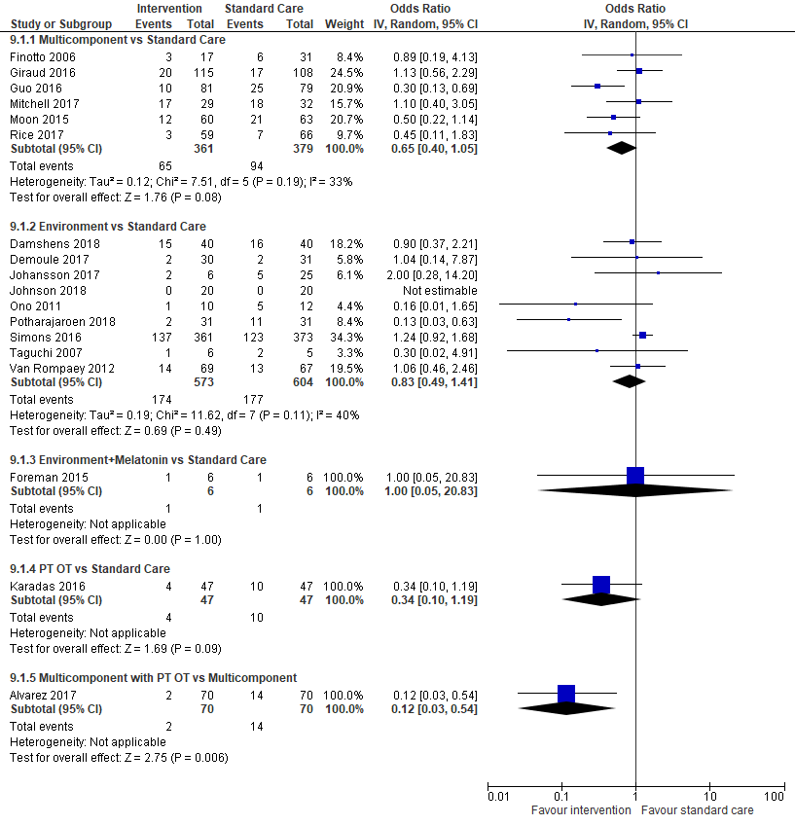

1B: Duration of Delirium
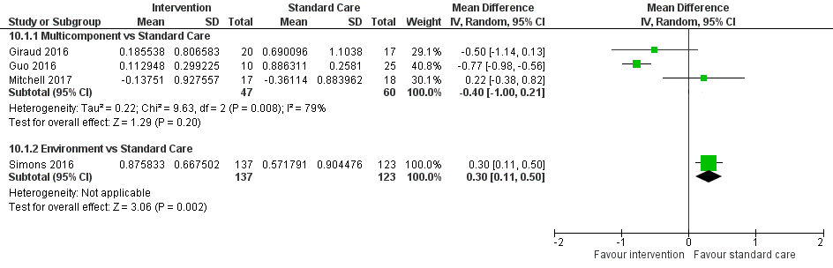

1C: Duration of Mechanical Ventilation
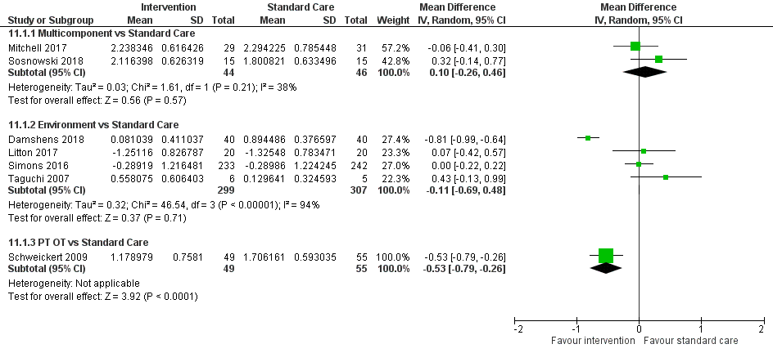

1D: Length of ICU Stay

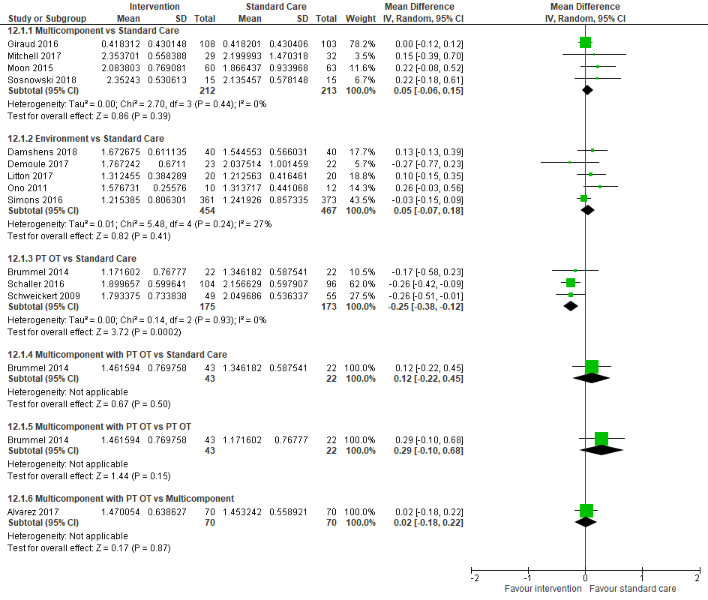

1E: Length of Hospital Stay
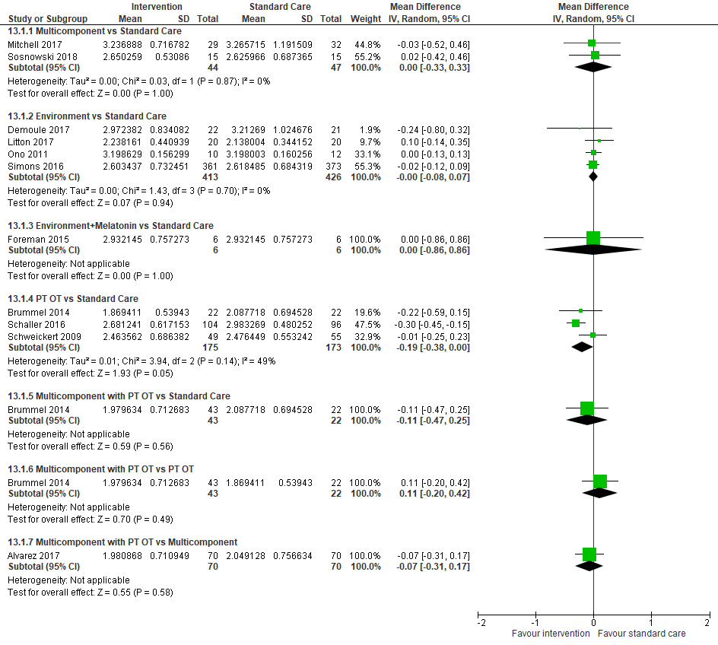

1F: Mortality
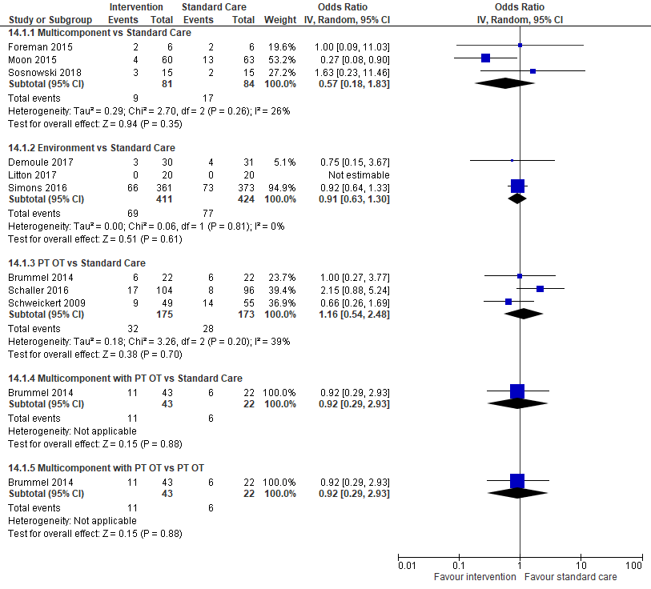

eTable 4: Model fit statistics and assessment of heterogeneity
Delirium occurrence | The random-effects consistency model for delirium occurrence was an adequate fit, with a posterior total residual deviance of 77.61 (compared to 77 unconstrained data points). The between-study SD, as a measure of heterogeneity, was estimated as 0.60 (95% CrI 0.34 to 0.95).  Comparison of Deviance Information Criterion (DIC) values between the random-effects consistency model (451.8) and the corresponding random-effects unrelated means model (454.0) as well as inspection of a scatterplot of posterior mean deviance contributions from both models (eFigure 2, Panel A) suggested a slight violation to the consistency assumption, possibly attributed to a cardiac surgery study that had very short duration of mechanical ventilation. The comparison-adjusted funnel plot to assess for small-study effects provided evidence of minimal asymmetry (eFigure 3, Panel A).
Duration of mechanical ventilation | The random-effects consistency model for duration of mechanical ventilation was an adequate fit, with posterior total residual deviance of 53.03 (compared to 50 unconstrained data points). The between-study SD, as a measure of heterogeneity, was estimated as 0.33 (95% CrI 0.20 to 0.51).  Comparison of DIC values between the random-effects consistency model (-61.91) and the corresponding random-effects unrelated means model (-66.03, but the DIC difference was < 5) as well as inspection of a scatterplot of posterior mean deviance contributions from both models (eFigure 2, Panel B) suggested a slight violation to the consistency assumption, possibly attributed to a cardiac surgery study that had very short duration of mechanical ventilation. The comparison-adjusted funnel plot to assess for small-study effects provided minimal evidence of asymmetry (eFigure 3, Panel B).
Length of ICU stay | The random-effects consistency model for length of ICU stay was an adequate fit, with a posterior total residual deviance of 62.40 (compared to 65 unconstrained data points). The between-study SD, as a measure of heterogeneity, was estimated as 0.20 (95% CrI 0.14 to 0.28).  Comparison of DIC values between the random-effects consistency model (-104.90) and the corresponding random-effects unrelated means model (-105.30) as well as inspection of a scatterplot of posterior mean deviance contributions from both models (eFigure 2, Panel C) suggested no evidence of violation to the consistency assumption. The comparison-adjusted funnel plot to assess for small-study effects provided minimal evidence of asymmetry (eFigure 3, Panel C).
Length of hospital stay | The random-effects consistency model for length of hospital stay was an adequate fit, with posterior total residual deviance of 46.03 (compared to 46 unconstrained data points). The between-study SD, as a measure of heterogeneity, was estimated as 0.22 (95% CrI 0.14 to 0.34).  Comparison of DIC values between the random-effects consistency model (-90.11) and the corresponding random-effects unrelated means model (-90.99) as well as inspection of a scatterplot of posterior mean deviance contributions from both models (eFigure 2, Panel D) suggested no evidence of violation to the consistency assumption. The comparison-adjusted funnel plot to assess for small-study effects provided minimal evidence of asymmetry (eFigure 3, Panel D).
Mortality | The random-effects consistency model for mortality had a posterior total residual deviance of 43.65 (smaller than 53 unconstrained data points, due to 0 mortality in both study arms in two studies). The between-study SD, as a measure of heterogeneity, was estimated as 0.13 (95% CrI 0.01 to 0.42).  Comparison of DIC values between the random-effects consistency model (280.40) and the corresponding random-effects unrelated means model (280.10) as well as inspection of a scatterplot of posterior mean deviance contributions from both models (eFigure 2, Panel E) suggested no evidence of violation to the consistency assumption. The comparison-adjusted funnel plot to assess for small-study effects provided minimal evidence of asymmetry (eFigure 3, Panel E).
Adverse events - Arrhythmias | The random-effects consistency model was an adequate fit, with posterior total residual deviance of 14.63 (compared to 15 unconstrained data points). The between-study SD, as a measure of heterogeneity, was estimated as 1.39 (95% CrI 0.64 to 2.67), suggests high heterogeneity.  Comparison of DIC values between the random-effects consistency model (90.51) and the corresponding random-effects unrelated means model (DIC 90.44) as well as inspection of a scatterplot of posterior mean deviance contributions from both models (eFigure 2, Panel F) suggested no evidence of violation to the consistency assumption. The comparison-adjusted funnel plot to assess for small-study effects provided minimal evidence of asymmetry (eFigure 3, Panel F).

eFigure 2: Checking for the consistency assumption (posterior mean deviance contribution plots)
eFigure 3: Comparison-adjusted funnel plots

Panel A: Delirium Occurrence | Panel B: Duration of Mechanical Ventilation
Panel C: ICU Length of Stay | Panel D: Hospital Length of Stay
Panel E: Mortality | 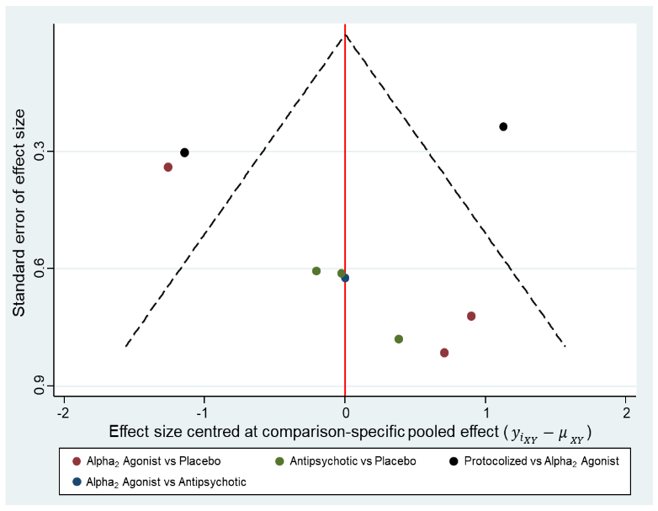  Panel F: Arrhythmia
eTable 5: References used for each comparison with direct evidence, by outcome
Comparisons with Direct Evidence | N of trials  (participants) | References
Delirium Occurrence | 38 trials  (11993)
Alpha₂ Agonist vs Placebo | 5  (1055) | 35 Abdelgalel et al (2016); 67 Kawazoe et al (2017); 90 Priye et al (2015); 93 Rubino et al (2010); 107 Su et al (2016)
Antipsychotic vs Placebo | 8  (2776) | 35 Abdelgalel et al (2016); 36 Al-Qadheeb et al (2016); 40 van den Boogaard et al (2018); 59 Hakim et al 2012); 69 Khan et al (2018); 79 Mokhtari et al (2020); 89 Prakanrattana et al (2007); 113 Wang et al (2012)
Melatonin / MRA vs Placebo | 2  (225) | 34 Abbasi et al (2018); 82 Nishikimi et al (2018)
Sedation Interruption vs Protocolized Sedation | 5  (2129) | 44 Chanques et al (2017); 49 de Jonghe et al / SRLF Trial Group (2018); 56 Girard et al (2008); 76 Mehta et al (2012); 81 Nassar et al (2014)
Alpha₂ Agonist vs Protocolized Sedation | 5  (4372) | 50 Devlin et al (2014); 94 Ruokonen et al (2009); 97 Shehabi et al (2009); 98 Shehabi et al (2013); 99 Shehabi et al (2019)
Alpha₂ Agonist vs Sedation Interruption | 1  (60) | 38 Azeem et al (2018)
Alpha₂ Agonist vs Propofol | 4  (373) | 43 Chang et al (2018); 51 Djaiani et al (2015); 61 Huang et al (2014); 71 Li et al (2016)
Alpha₂ Agonist vs Benzodiazepine | 4  (473) | 85 Pandharipande et al (2007); 100 Shu et al (2019); 103 Song et al (2015); 112 Wan et al (2011)
Alpha₂ Agonist vs Opioid (short acting) | 1  (142) | 86 Park et al (2014)
Alpha₂ Agonist vs Antipsychotic | 1  (60) | 35 Abdelgalel et al (2016)
Opioid vs Sedation Interruption | 1  (113) | 106 Strom et al (2010)
Opioid vs Opioid (short acting) | 1  (60) | 105 Spies et al (2011)
Opioid + Benzodiazepine vs Benzodiazepine | 2  (245) | 73 Liu et al (2017); 74 Lyu et al (2015)
Duration of Mechanical Ventilation | 23 trials  (5203)
Alpha₂ Agonist vs Placebo | 4  (702) | 67 Kawazoe et al (2017); 93 Rubino et al (2010); 102 Skrobik et al (2018); 107 Su et al (2016)
Antipsychotic vs Placebo | 4  (2349) | 35 Abdelgalel et al (2016); 40 van den Boogaard et al (2018); 69 Khan et al (2018); 113 Wang et al (2012)
Melatonin / MRA vs Placebo | 2  (263) | 55 Gandolfi et al (2020); 63 Zadeh et al (2021)
Sedation Interruption vs Protocolized Sedation | 2  (560) | 44 Chanques et al (2017); 76 Mehta et al (2012)
Alpha₂ Agonist vs Protocolized Sedation | 2  (332) | 50 Devlin et al (2014); 97 Shehabi et al (2009)
Alpha₂ Agonist vs Sedation Interruption | 1  (60) | 38 Azeem et al (2018)
Alpha₂ Agonist vs Propofol | 3  (313) | 51 Djaiani et al (2015); 61 Huang et al (2014); 71 Li et al (2016)
Alpha₂ Agonist vs Benzodiazepine | 2  (290) | 103 Song et al (2015); 112 Wan et al (2011)
Alpha₂ Agonist + Propofol vs Propofol | 2  (80) | 60 Hu et al (2015); 71 Li et al (2016)
Alpha₂ Agonist + Propofol vs Benzodiazepine | 1  (49) | 60 Hu et al (2015)
Alpha₂ Agonist + Propofol vs Alpha₂ Agonist | 1  (21) | 71 Li et al (2016)
Propofol vs Benzodiazepine | 1  (50) | 60 Hu et al (2015)
Opioid + Benzodiazepine vs Benzodiazepine | 2  (245) | 73 Liu et al (2017); 74 Lyu et al (2015)
Length of ICU Stay | 31 trials  (10270)
Alpha₂ Agonist vs Placebo | 5  (1091) | 35 Abdelgalel et al (2016); 67 Kawazoe et al (2017); 93 Rubino et al (2010); 102 Skrobik et al (2018); 107 Su et al (2016)
Antipsychotic vs Placebo | 8  (2776) | 35 Abdelgalel et al (2016); 36 Al-Qadheeb et al (2016); 40 van den Boogaard et al (2018); 59 Hakim et al 2012); 69 Khan et al (2018); 79 Mokhtari et al (2020); 89 Prakanrattana et al (2007); 113 Wang et al (2012)
Melatonin / MRA vs Placebo | 4  (488) | 34 Abbasi et al (2018); 55 Gandolfi et al (2020); 63 Zadeh et al (2021); 82 Nishikimi et al (2018)
Sedation Interruption vs Protocolized Sedation | 4  (955) | 44 Chanques et al (2017); 56 Girard et al (2008); 76 Mehta et al (2012); 81 Nassar et al (2014)
Alpha₂ Agonist vs Protocolized Sedation | 4  (4287) | 50 Devlin et al (2014); 97 Shehabi et al (2009); 98 Shehabi et al (2013); 99 Shehabi et al (2019)
Alpha₂ Agonist vs Sedation Interruption | 1  (60) | 38 Azeem et al (2018)
Alpha₂ Agonist vs Propofol | 2  (205) | 51 Djaiani et al (2015); 71 Li et al (2016)
Alpha₂ Agonist vs Benzodiazepine | 2  (193) | 85 Pandharipande et al (2007); 103 Song et al (2015)
Alpha₂ Agonist vs Antipsychotic | 1  (60) | 35 Abdelgalel et al (2016)
Opioid + Benzodiazepine vs Benzodiazepine | 2  (245) | 73 Liu et al (2017); 74 Lyu et al (2015)
Length of Hospital Stay | 22 trials  (9471)
Alpha₂ Agonist vs Placebo | 4  (1061) | 35 Abdelgalel et al (2016); 67 Kawazoe et al (2017); 102 Skrobik et al (2018); 107 Su et al (2016)
Antipsychotic vs Placebo | 6  (2668) | 35 Abdelgalel et al (2016); 40 van den Boogaard et al (2018); 59 Hakim et al 2012); 69 Khan et al (2018);  89 Prakanrattana et al (2007); 113 Wang et al (2012)
Melatonin / MRA vs Placebo | 2  (340) | 34 Abbasi et al (2018); 55 Gandolfi et al (2020)
Sedation Interruption vs Protocolized Sedation | 3  (620) | 44 Chanques et al (2017); 76 Mehta et al (2012); 81 Nassar et al (2014)
Alpha₂ Agonist vs Protocolized Sedation | 3  (4254) | 97 Shehabi et al (2009); 98 Shehabi et al (2013); 99 Shehabi et al (2019)
Alpha₂ Agonist vs Propofol | 2  (243) | 43 Chang et al (2018); 51 Djaiani et al (2015)
Alpha₂ Agonist vs Opioid (short acting) | 1  (142) | 86 Park et al (2014)
Alpha₂ Agonist vs Antipsychotic | 1  (60) | 35 Abdelgalel et al (2016)
Opioid vs Sedation Interruption | 1  (113) | 106 Strom et al (2010)
Opioid vs Opioid (short acting) | 1  (60) | 105 Spies et al (2011)
Mortality * | 26  (11385) | * Note: we prioritized selection of mortality data as follows: 90-day, hospital, 28/30-day, and ICU mortality, if a trial reported multiple mortality outcomes.
Alpha₂ Agonist vs Placebo | 4  (1061) | 35 Abdelgalel et al (2016); 67 Kawazoe et al (2017); 102 Skrobik et al (2018); 107 Su et al (2016)
Antipsychotic vs Placebo | 6  (2572) | 35 Abdelgalel et al (2016); 36 Al-Qadheeb et al (2016); 40 van den Boogaard et al (2018); 59 Hakim et al 2012); 69 Khan et al (2018); 113 Wang et al (2012)
Melatonin / MRA vs Placebo | 3  (428) | 34 Abbasi et al (2018); 55 Gandolfi et al (2020); 82 Nishikimi et al (2018)
Sedation Interruption vs Protocolized Sedation | 5  (2129) | 44 Chanques et al (2017); 49 de Jonghe et al / SRLF Trial Group (2018); 56 Girard et al (2008); 76 Mehta et al (2012); 81 Nassar et al (2014)
Alpha₂ Agonist vs Protocolized Sedation | 4  (4273) | 50 Devlin et al (2014); 97 Shehabi et al (2009); 98 Shehabi et al (2013); 99 Shehabi et al (2019)
Alpha₂ Agonist vs Propofol | 2  (604) | 51 Djaiani et al (2015); 62 Hughes et al (2021)
Alpha₂ Agonist vs Benzodiazepine | 1  (103) | 85 Pandharipande et al (2007)
Alpha₂ Agonist vs Antipsychotic | 1  (60) | 35 Abdelgalel et al (2016)
Opioid + Benzodiazepine vs Benzodiazepine | 2  (245) | 73 Liu et al (2017); 74 Lyu et al (2015)
Arrhythmia | 7  (5791)
Alpha₂ Agonist vs Placebo | 3  (961) | 35 Abdelgalel et al (2016); 67 Kawazoe et al (2017); 107 Su et al (2016)
Antipsychotic vs Placebo | 3  (643) | 35 Abdelgalel et al (2016); 89 Prakanrattana et al (2007); 113 Wang et al (2012)
Alpha₂ Agonist vs Protocolized Sedation | 2  (4217) | 97 Shehabi et al (2009); 99 Shehabi et al (2019)
Alpha₂ Agonist vs Antipsychotic | 1  (60) | 35 Abdelgalel et al (2016)

eTable 6: Mean SUCRA value and mean rank for each treatment based on delirium occurrence
Interventions | Mean SUCRA | Mean Rank (95% CrI*)
Alpha₂ Agonist | 0.827 | 2.73 (1 to 5)
Sedation interruption | 0.819 | 2.81 (1 to 7)
Protocolized sedation | 0.673 | 4.27 (1 to 8)
Opioid + Benzodiazepine | 0.664 | 4.36 (1 to 10)
Antipsychotic | 0.620 | 4.80 (1 to 9)
Melatonin/MRA | 0.578 | 5.22 (1 to 11)
Placebo | 0.347 | 7.53 (4 to 10)
Propofol | 0.323 | 7.77 (2 to 11)
Opioid | 0.309 | 7.91 (2 to 11)
Opioid (short acting) | 0.227 | 8.73 (3 to 11)
Benzodiazepine | 0.113 | 9.87 (6 to 11)
Abbreviations: CrI = 95% credible interval; MRA = melatonin receptor agonist
* Mean rank with 2.5% and 97.5% quantiles in the parentheses.

eTable 7 Duration of mechanical ventilation - league table of pairwise ORs with 95% CrI (lower triangle) and pairwise probabilities of superiority (upper triangle)

Alpha₂ Agonist + Propofol | 0.668 | 0.632 | 0.922 | 0.887 | 0.913 | 0.931 | 0.931 | 0.974 | 0.892
0.90  (0.55-1.48) | Alpha₂ Agonist | 0.533 | 0.890 | 0.898 | 0.890 | 0.958 | 0.944 | 0.978 | 0.933
0.88  (0.40-1.95) | 0.98  (0.53-1.81) | Melatonin / MRA | 0.720 | 0.839 | 0.800 | 0.836 | 0.849 | 0.870 | 0.847
0.72  (0.45-1.15) | 0.80  (0.55-1.16) | 0.82  (0.40-1.67) | Propofol | 0.620 | 0.687 | 0.712 | 0.743 | 0.816 | 0.573
0.66  (0.33-1.34) | 0.73  (0.44-1.21) | 0.75  (0.41-1.37) | 0.91  (0.49-1.71) | Antipsychotic | 0.568 | 0.583 | 0.632 | 0.640 | 0.391
0.62  (0.30-1.26) | 0.69  (0.36-1.28) | 0.70  (0.29-1.68) | 0.86  (0.44-1.67) | 0.94  (0.41-2.09) | Opioid + Benzodiazepine | 0.504 | 0.556 | 0.576 | 0.374
0.62  (0.30-1.18) | 0.68  (0.42-1.06) | 0.70  (0.32-1.47) | 0.85  (0.46-1.51) | 0.93  (0.46-1.79) | 1.00  (0.44-2.14) | Protocolized | 0.596 | 0.556 | 0.342
0.59  (0.26-1.21) | 0.65  (0.35-1.11) | 0.66  (0.28-1.47) | 0.81  (0.40-1.55) | 0.89  (0.40-1.82) | 0.94  (0.39-2.15) | 0.95  (0.59-1.49) | Interruption | 0.485 | 0.301
0.59  (0.35-1.00) | 0.66  (0.44-0.98) | 0.67  (0.32-1.40) | 0.82  (0.51-1.30) | 0.90  (0.47-1.70) | 0.96  (0.59-1.55) | 0.96  (0.53-1.82) | 1.01  (0.52-2.11) | Benzodiazepine | 0.273
0.69  (0.37-1.28) | 0.77  (0.53-1.10) | 0.78  (0.48-1.29) | 0.96  (0.57-1.60) | 1.05  (0.74-1.48) | 1.12  (0.54-2.31) | 1.12  (0.64-2.07) | 1.18  (0.62-2.40) | 1.17  (0.68-2.02) | Placebo
Abbreviations: CrI = credible intervals; OR = odds ratio; RoM = ratio of means; SUCRA = Surface Under the Cumulative Ranking

NOTE: For pairwise probabilities of each comparison (i.e., a treatment is better than another), the lower/right-most treatment is the reference treatment, and thus values <1 favor the upper/left-most intervention. Differences where the 95% CrI excludes the null value of 1 are shown in bold font.

eTable 8: Mean SUCRA value and mean rank for each treatment based on duration of mechanical ventilation
Interventions | Mean SUCRA | Mean Rank (95% CrI*)
Alpha₂ Agonist + Propofol | 0.861 | 2.25 (1 to 7)
Alpha₂ Agonist | 0.818 | 2.64 (1 to 5)
Melatonin / MRA | 0.733 | 3.40 (1 to 9)
Propofol | 0.513 | 5.38 (2 to 10)
Placebo | 0.453 | 5.93 (2 to 9)
Antipsychotic | 0.397 | 6.43 (2 to 10)
Opioid + Benzodiazepine | 0.350 | 6.85 (1 to 10)
Protocolized sedation | 0.330 | 7.03 (2 to 10)
Sedation interruption | 0.282 | 7.46 (2 to 10)
Benzodiazepine | 0.264 | 7.62 (3 to 10)
Abbreviations: CrI = 95% credible intervals; MRA = melatonin receptor agonist
* Mean rank with 2.5% and 97.5% quantiles in the parenthese
 | eTable9 Bayesian NMA-Summary of Findings – Duration of Mechanical Ventilation
Patient or population: critically ill adults
Interventions: any interventions and strategies for sedation titration (e.g., protocolized, interruption)
Comparator (reference): placebo
Outcome: duration of mechanical ventilation (MV)
Setting(s): mixed intensive care unit setting
Total studies: 23  Total Participants: 5203 |  | Relative effect *  (95% CrI) | Assumed risk (duration of mechanical ventilation) for placebo | Corresponding risk (duration of MV) for intervention based on ratio of means (RoM) estimates | Certainty of the evidence | Number of participants  (trials) | Ranking **  (95% CrI)
Alpha₂ Agonist vs Placebo |  | RoM 0.77  (0.53 to 1.10)  NMA estimate | Mean duration of MV  ranged 0.29 to 6.67 days  (based on 4 trials) | 2.30 days of mechanical ventilation (95% CrI 1.60 to 3.30) corresponding to 3 days in the placebo group | ⊕⊕◯◯  Low  Due to Inconsistency² and Imprecision³ | Direct evidence:  702 (4 trials) | 2.64  (1 to 5)
Antipsychotic vs Placebo |  | RoM 1.05  (0.74 to 1.48)  NMA estimate | Mean duration of MV  ranged 0.31 to 5.33 days  (based on 4 trials) | 3.14 days of mechanical ventilation (95% CrI 2.22 to 4.43) corresponding to 3 days in the placebo group | ⊕⊕⊕◯  Moderate  Due to Imprecision³ | Direct evidence:  2349 (4 trials) | 6.43  (2 to 10)
Melatonin / MRA vs Placebo |  | RoM 0.78  (0.48 to 1.29)  NMA estimate | Mean duration of MV  ranged 0.27 to 4.17 days  (based on 2 trials) | 2.35 days of mechanical ventilation (95% CrI 1.43 to 3.86) corresponding to 3 days in the placebo group | ⊕⊕◯◯  Low  Due to Inconsistency² and Imprecision³ | Direct evidence:  263 (2 trials) | 3.40  (1 to 9)
Alpha2 Agonist + Propofol vs Placebo |  | RoM 0.69  (0.37 to 1.28)  NMA estimate | Mean duration of MV  ranged 0.27 to 6.67 days ¹ | 2.08 days of mechanical ventilation (95% CrI 1.12 to 3.83) corresponding to 3 days in the placebo group | ⊕◯◯◯  Very Low  Due to Imprecision³, Indirectness⁴, and Inconsistency⁵ | No direct evidence. Indirect evidence only. | 2.25  (1 to 7)
Sedation interruption vs Placebo |  | RoM 1.18  (0.62 to 2.40)  NMA estimate | Mean duration of MV  ranged 0.27 to 6.67 days ¹ | 3.55 days of mechanical ventilation (95% CrI 1.87 to 7.21) corresponding to 3 days in the placebo group | ⊕◯◯◯  Very Low  Due to Imprecision³, Indirectness⁴, Inconsistency⁵ | No direct evidence. Indirect evidence only. | 7.46  (2 to 10)
Protocolized sedation vs Placebo |  | RoM 1.12  (0.64 to 2.07)  NMA estimate | Mean duration of MV  ranged 0.27 to 6.67 days ¹ | 3.36 days of mechanical ventilation (95% CrI 1.92 to 6.22) corresponding to 3 days in the placebo group | ⊕◯◯◯  Very Low  Due to Imprecision³, Indirectness⁴, Inconsistency⁶ | No direct evidence. Indirect evidence only. | 7.03  (2 to 10)
Opioid+Benzodiazepine vs Placebo |  | RoM 1.12  (0.54 to 2.31)  NMA estimate | Mean duration of MV  ranged 0.27 to 6.67 days ¹ | 3.35 days of mechanical ventilation (95% CrI 1.63 to 6.94) corresponding to 3 days in the placebo group | ⊕◯◯◯  Very Low  Due to Imprecision³,  Serious Indirectness⁷, Inconsistency⁸ | No direct evidence. Indirect evidence only. | 6.85  (1 to 10)
Propofol vs Placebo |  | RoM 0.96  (0.57 to 1.60)  NMA estimate | Mean duration of MV  ranged 0.27 to 6.67 days ¹ | 2.87 days of mechanical ventilation (95% CrI 1.71 to 4.82) corresponding to 3 days in the placebo group | ⊕◯◯◯  Very Low  Due to Imprecision³, Indirectness⁴, and Inconsistency⁵ | No direct evidence. Indirect evidence only. | 5.38  (2 to 10)
Benzodiazepine vs Placebo |  | RoM 1.17  (0.68 to 2.02)  NMA estimate | Mean duration of MV  ranged 0.27 to 6.67 days ¹ | 3.50 days of mechanical ventilation (95% CrI 2.04 to 6.05) corresponding to 3 days in the placebo group | ⊕◯◯◯  Very Low  Due to Imprecision³, Indirectness⁴, Inconsistency⁵ | No direct evidence. Indirect evidence only. | 7.62  (3 to 10)
Placebo |  | Reference Comparator | - | - |  | - | 5.93  (2 to 9)
NMA-SoF table definitions
* Network meta-analysis estimates are reported as ratio of means (RoM). CrI: credible interval (rather than confidence interval), since a Bayesian network meta-analysis has been conducted.
** Median and credible intervals are presented. Rank statistics is defined as the probabilities that a treatment out of n treatments in a network meta-analysis is the best, the second, the third and so on until the least effective treatment.
GRADE Working Group grades of evidence (or certainty in the evidence)
High quality: We are very confident that the true effect lies close to that of the estimate of the effect
Moderate quality: We are moderately confident in the effect estimate: The true effect is likely to be close to the estimate of the effect, but there is a possibility that it is substantially different
Low quality: Our confidence in the effect estimate is limited: The true effect may be substantially different from the estimate of the effect
Very low quality: We have very little confidence in the effect estimate: The true effect is likely to be substantially different from the estimate of effect
Explanatory Footnotes
¹ Given that there were no head-to-head trials for these comparisons, we took the range for mean duration of mechanical ventilation in the placebo group among 10 randomized control trials. For example, Skrobik (2018) reported the median of 4 days (IQR 2 to 10) in the placebo group and the approximated mean was 5.33. The median of the reported or calculated mean length of ICU stay in the placebo group was 3.183 (rounded to 3).
² Inconsistency: due to heterogeneity in the direct comparison.
³ Imprecision: due to wide credible intervals in the OR estimate.
⁴ Indirectness: only indirect evidence available (through one degree of intermediary, alpha₂ agonist).
⁵ Inconsistency: due to heterogeneity in the direct comparison of alpha₂ agonist vs. placebo.
⁶ Inconsistency: due to heterogeneity in the direct comparison of alpha₂ agonist vs. placebo and the direct comparison of protocolized vs. alpha₂ agonist.
⁷ Serious indirectness: only indirect evidence available (through two degrees of intermediaries, alpha₂ agonist and benzodiazepine).
⁸ Inconsistency: due to heterogeneity in the direct comparison of alpha₂ agonist vs. placebo and the direct comparison of benzodiazepine vs. alpha₂ agonist.
eTable 10: Length of ICU stay - league table of pairwise OR with 95% CrI (lower triangle) and pairwise probabilities of superiority (upper triangle)
Opioid + Benzodiazepine | 0.586 | 0.559 | 0.626 | 0.709 | 0.826 | 0.830 | 0.898 | 0.895
0.95  (0.62-1.47) | Alpha₂ Agonist | 0.474 | 0.596 | 0.782 | 0.735 | 0.907 | 0.983 | 0.991
0.96  (0.58-1.61) | 1.01  (0.76-1.33) | Sedation  interruption | 0.591 | 0.814 | 0.695 | 0.850 | 0.932 | 0.934
0.92  (0.53-1.58) | 0.96  (0.69-1.34) | 0.95  (0.62-1.47) | Propofol | 0.589 | 0.596 | 0.770 | 0.866 | 0.863
0.88  (0.54-1.42) | 0.92  (0.74-1.15) | 0.91  (0.74-1.12) | 0.96  (0.64-1.43) | Protocolized sedation | 0.521 | 0.742 | 0.871 | 0.872
0.87  (0.64-1.18) | 0.91  (0.67-1.24) | 0.90  (0.60-1.36) | 0.95  (0.60-1.49) | 0.99  (0.68-1.45) | Benzodiazepine | 0.698 | 0.817 | 0.810
0.78  (0.46-1.33) | 0.81  (0.60-1.11) | 0.81  (0.54-1.23) | 0.85  (0.54-1.34) | 0.89  (0.61-1.30) | 0.89  (0.58-1.39) | Melatonin /  MRA | 0.673 | 0.660
0.73  (0.45-1.20) | 0.76  (0.61-0.98) | 0.76  (0.53-1.10) | 0.80  (0.53-1.21) | 0.83  (0.61-1.16) | 0.84  (0.58-1.25) | 0.94  (0.71-1.24) | Antipsychotic | 0.426
0.74  (0.46-1.19) | 0.78  (0.64-0.95) | 0.77  (0.55-1.09) | 0.81  (0.55-1.20) | 0.84  (0.63-1.14) | 0.85  (0.59-1.24) | 0.95  (0.75-1.20) | 1.01  (0.87-1.18) | Placebo
Abbreviations: CrI = credible intervals; OR = odds ratio; RoM = ratio of means; SUCRA = Surface Under the Cumulative Ranking
NOTE: A complete summary of estimates for efficacy from the random effects consistency model assuming vague priors is displayed. Treatments other than placebo are in the order of decreasing SUCRA value from upper left to lower right. For pairwise probabilities of superiority for each comparison (i.e., a treatment is better than another), the lower/right-most treatment is the reference treatment, and thus values <1 favor the upper/left-most intervention. Differences where the 95% CrI excludes the null value of 1 are shown in bold font.
eTable 10: Mean SUCRA value and mean rank for each treatment based on length of ICU stay
Interventions | Mean SUCRA | Mean Rank (95% CrI*)
Opioid + Benzodiazepine | 0.741 | 3.07 (1 to 9)
Alpha₂ Agonist | 0.735 | 3.12 (1 to 6)
Sedation interruption | 0.723 | 3.22 (1 to 8)
Propofol | 0.609 | 4.13 (1 to 9)
Protocolized sedation | 0.514 | 4.89 (2 to 9)
Benzodiazepine | 0.494 | 5.05 (2 to 9)
Melatonin / MRA | 0.317 | 6.46 (1 to 9)
Placebo | 0.194 | 7.45 (4 to 9)
Antipsychotic | 0.173 | 7.61 (4 to 9)
Abbreviations: CrI = 95% credible intervals; MRA = melatonin receptor agonist
* Mean rank with 2.5% and 97.5% quantiles in the parentheses
 | eTable 12: Bayesian NMA-Summary of Findings – Length of ICU Stay
Patient or population: critically ill adults
Interventions: any interventions and strategies for sedation titration (e.g., protocolized, interruption)
Comparator (reference): placebo
Outcome: length of ICU stay
Setting(s): mixed intensive care unit setting
Total studies: 31  Total Participants: 10270 |  | Relative effect *  (95% CrI) | Assumed risk (length of ICU stay) for placebo | Corresponding risk (length of ICU stay) for intervention based on ratio of means (RoM) estimates | Certainty of the evidence | Number of participants  (trials) | Ranking **  (95% CrI)
Alpha₂ Agonist vs Placebo |  | RoM 0.78  (0.64 to 0.95)  NMA estimate | Mean length of ICU stay ranged 0.90 to 10.33 days  (based on 5 trials) | 3.88 days of ICU stay (95% CrI 3.20 to 4.76) corresponding to 5 days in the placebo group | ⊕⊕⊕◯  Moderate  Due to nconsistency² | Direct evidence:  1091 (5 trials) | 3.12  (1 to 6)
Antipsychotic vs Placebo |  | RoM 1.01  (0.87 to 1.18)  NMA estimate | Mean length of ICU stay ranged 0.96 to 11.55 days  (based on 8 trials) | 5.07 days of ICU stay (95% CrI 4.36 to 5.88) corresponding to 5 days in the placebo group | ⊕⊕◯◯  Low  Due to Imprecision³ and Inconsistency² | Direct evidence:  2776 (8 trials) | 7.61  (4 to 9)
Melatonin / MRA vs Placebo |  | RoM 0.95  (0.75 to 1.20)  NMA estimate | Mean length of ICU stay ranged 3.83 to 9.80 days  (based on 4 trials) | 4.77 days of ICU stay (95% CrI 3.77 to 6.00) corresponding to 5 days in the placebo group | ⊕⊕◯◯  Low  Due to Imprecision³ and Inconsistency² | Direct evidence:  488 (4 trials) | 6.46  (1 to 9)
Sedation interruption vs Placebo |  | RoM 0.77  (0.55 to 1.09)  NMA estimate | Mean length of ICU stay ranged 0.90 to 10.33 days ¹ | 3.84 days of ICU stay (95% CrI 2.75 to 5.44) corresponding to 5 days in the placebo group | ⊕◯◯◯  Very Low  Due to Imprecision³, Indirectness⁴, Inconsistency⁵ | No direct evidence. Indirect evidence only. | 3.22  (1 to 8)
Protocolized sedation vs Placebo |  | RoM 0.84  (0.63 to 1.14)  NMA estimate | Mean length of ICU stay ranged 0.90 to 10.33 days ¹ | 4.22 days of ICU stay (95% CrI 3.15 to 5.72) corresponding to 5 days in the placebo group | ⊕◯◯◯  Very Low  Due to Imprecision³, Indirectness⁴, Inconsistency⁶ | No direct evidence. Indirect evidence only. | 4.89  (2 to 9)
Opioid+Benzodiazepine vs Placebo |  | RoM 0.74  (0.46 to 1.19)  NMA estimate | Mean length of ICU stay ranged 0.90 to 10.33 days ¹ | 3.70 days of ICU stay (95% CrI 2.32 to 5.97) corresponding to 5 days in the placebo group | ⊕◯◯◯  Very Low  Due to Imprecision³,  Serious Indirectness⁷, Inconsistency⁸ | No direct evidence. Indirect evidence only. | 3.07  (1 to 9)
Propofol vs Placebo |  | RoM 0.81  (0.55 to 1.20)  NMA estimate | Mean length of ICU stay ranged 0.90 to 10.33 days ¹ | 4.04 days of ICU stay (95% CrI 2.76 to 5.98) corresponding to 5 days in the placebo group | ⊕◯◯◯  Very Low  Due to Imprecision³, Indirectness⁴, Inconsistency⁵ | No direct evidence. Indirect evidence only. | 4.13  (1 to 9)
Benzodiazepine vs Placebo |  | RoM 0.85  (0.59 to 1.24)  NMA estimate | Mean length of ICU stay ranged 0.90 to 10.33 days ¹ | 4.26 days of ICU stay (95% CrI 2.97 to 6.18) corresponding to 5 days in the placebo group | ⊕◯◯◯  Very Low  Due to Imprecision³, Indirectness⁴, Inconsistency⁵ | No direct evidence. Indirect evidence only. | 5.05  (2 to 9)
Placebo |  | Reference Comparator | - | - | - | - | 7.45  (4 to 9)
NMA-SoF table definitions
* Network meta-analysis estimates are reported as ratio of means (RoM). CrI: credible interval (rather than confidence interval), since a Bayesian network meta-analysis has been conducted.
** Median and credible intervals are presented. Rank statistics is defined as the probabilities that a treatment out of n treatments in a network meta-analysis is the best, the second, the third and so on until the least effective treatment.
GRADE Working Group grades of evidence (or certainty in the evidence)
High quality: We are very confident that the true effect lies close to that of the estimate of the effect
Moderate quality: We are moderately confident in the effect estimate: The true effect is likely to be close to the estimate of the effect, but there is a possibility that it is substantially different
Low quality: Our confidence in the effect estimate is limited: The true effect may be substantially different from the estimate of the effect
Very low quality: We have very little confidence in the effect estimate: The true effect is likely to be substantially different from the estimate of effect
Explanatory Footnotes
¹ Given that there were no head-to-head trials for these comparisons, we took the range for mean length of ICU stay in the placebo group among 16 randomized control trials. For example, Skrobik (2018) reported the median of 9 days (IQR 3 to 19) in the placebo group and the approximated mean was 10.33. The median of the reported or calculated mean length of ICU stay in the placebo group was 5.167 (rounded to 5).
² Inconsistency: due to heterogeneity in the direct comparison.
³ Imprecision: due to wide credible intervals in the RoM estimate.
⁴ Indirectness: only indirect evidence available (through one degree of intermediary, alpha₂ agonist).
⁵ Inconsistency: due to heterogeneity in the direct comparison of alpha₂ agonist vs. placebo.
⁶ Inconsistency: due to heterogeneity in the direct comparison of alpha₂ agonist vs. placebo and the direct comparison of protocolized vs. alpha₂ agonist.
⁷ Serious indirectness: only indirect evidence available (through two degrees of intermediaries, alpha₂ agonist and benzodiazepine).
⁸ Inconsistency: due to heterogeneity in the direct comparison of alpha₂ agonist vs. placebo and the direct comparison of benzodiazepine vs. alpha₂ agonist.

eTable 13: Length of hospital stay - league table of pairwise OR with 95% CrI (lower triangle) and pairwise probabilities of superiority (upper triangle)

Opioid | 0.689 | 0.922 | 0.916 | 0.893 | 0.941 | 0.979 | 0.995 | 0.995
0.89  (0.57-1.43) | Opioid  (short acting) | 0.803 | 0.866 | 0.836 | 0.877 | 0.971 | 0.994 | 0.995
0.73  (0.47-1.14) | 0.82  (0.50-1.32) | Sedation interruption | 0.553 | 0.596 | 0.674 | 0.907 | 0.975 | 0.978
0.71  (0.44-1.17) | 0.80  (0.52-1.20) | 0.98  (0.67-1.41) | Alpha₂ Agonist | 0.586 | 0.607 | 0.946 | 0.998 | 0.999
0.69  (0.37-1.26) | 0.77  (0.44-1.32) | 0.94  (0.56-1.57) | 0.96  (0.67-1.37) | Propofol | 0.498 | 0.869 | 0.961 | 0.963
0.69  (0.43-1.11) | 0.77  (0.48-1.22) | 0.94  (0.72-1.24) | 0.96  (0.73-1.28) | 1.00  (0.64-1.59) | Protocolized sedation | 0.893 | 0.978 | 0.982
0.50  (0.26-0.97) | 0.56  (0.31-1.02) | 0.69  (0.39-1.22) | 0.71  (0.46-1.09) | 0.73  (0.42-1.29) | 0.73  (0.44-1.22) | Melatonin / MRA | 0.688 | 0.680
0.46  (0.26-0.81) | 0.51  (0.31-0.84) | 0.63  (0.39-1.00) | 0.64  (0.49-0.85) | 0.67  (0.43-1.05) | 0.67  (0.45-0.99) | 0.91  (0.61-1.36) | Antipsychotic | 0.437
0.47  (0.27-0.80) | 0.52  (0.32-0.83) | 0.64  (0.41-0.99) | 0.65  (0.52-0.83) | 0.68  (0.44-1.04) | 0.68  (0.47-0.97) | 0.92  (0.64-1.32) | 1.01  (0.85-1.21) | Placebo
Abbreviations: CrI = credible intervals; OR = odds ratio; RoM = ratio of means; SUCRA = Surface Under the Cumulative Ranking
NOTE: A complete summary of estimates for efficacy from the random effects consistency model assuming vague priors is displayed. Treatments other than placebo are in the order of decreasing SUCRA value from upper left to lower right. For pairwise probabilities of each comparison (i.e., a treatment is better than another), the lower/right-most treatment is the reference treatment, and thus values <1 favor the upper/left-most intervention. Statistically significant differences based on pairwise RoM estimates are shown in bold font.
eTable 14: Mean SUCRA value and mean rank for each treatment based on length of hospital stay
Interventions | Mean SUCRA | Mean Rank (95% CrI*)
Opioid | 0.916 | 1.67 (1 to 5)
Opioid (short acting) | 0.832 | 2.35 (1 to 6)
Sedation interruption | 0.620 | 4.04 (1 to 7)
Alpha₂ Agonist | 0.600 | 4.20 (2 to 6)
Propofol | 0.547 | 4.62 (1 to 8)
Protocolized sedation | 0.532 | 4.74 (2 to 7)
Melatonin / MRA | 0.225 | 7.20 (3 to 9)
Placebo | 0.121 | 8.03 (7 to 9)
Antipsychotic | 0.106 | 8.15 (6 to 9)
Abbreviations: CrI = 95% credible intervals; MRA = melatonin receptor agonists
* Mean rank with 2.5% and 97.5% quantiles in the parentheses
 | eTable 15: Bayesian NMA-Summary of Findings – Length of Hospital Stay
Patient or population: critically ill adults
Interventions: any interventions and strategies for sedation titration (e.g., protocolized, interruption)
Comparator (reference): placebo
Outcome: length of hospital stay
Setting(s): mixed intensive care unit setting
Total studies: 22  Total Participants: 9471 |  | Relative effect *  (95% CrI) | Assumed risk (length of hospital stay) for placebo | Corresponding risk (length of hospital stay) for intervention based on ratio of means (RoM) estimates | Certainty of the evidence | Number of participants  (trials) | Ranking **  (95% CrI)
Alpha₂ Agonist vs Placebo |  | RoM 0.65  (0.52 to 0.83)  NMA estimate | Mean length of hospital stay ranged 11 to 35.33 days  (based on 4 trials) | 7.81 days of hospital stay (95% CrI 6.21 to 9.91) corresponding to 12 days in the placebo group | ⊕⊕⊕◯  Moderate  Due to nconsistency² | Direct evidence:  1061 (4 trials) | 4.20  (2 to 6)
Antipsychotic vs Placebo |  | RoM 1.01  (0.85 to 1.21)  NMA estimate | Mean length of hospital stay ranged 6.33 to 16.67 days  (based on 6 trials) | 12.17 days of hospital stay (95% CrI 10.15 to 14.57) corresponding to 12 days in the placebo group | ⊕⊕◯◯  Low  Due to Imprecision³ and Inconsistency² | Direct evidence:  2668 (6 trials) | 8.15  (6 to 9)
Melatonin / MRA vs Placebo |  | RoM 0.92  (0.64 to 1.32)  NMA estimate | Mean length of hospital stay ranged 12.33 to 18.6 days  (based on 2 trials) | 11.06 days of hospital stay (95% CrI 7.73 to 15.82) corresponding to 12 days in the placebo group | ⊕⊕⊕◯  Moderate  Due to Imprecision³ | Direct evidence:  340 (2 trials) | 7.20  (3 to 9)
Sedation interruption vs Placebo |  | RoM 0.64  (0.41 to 0.99)  NMA estimate | Mean length of hospital stay ranged 6.33 to 35.33 days ¹ | 7.63 days of hospital stay (95% CrI 4.91 to 11.85) corresponding to 12 days in the placebo group | ⊕◯◯◯  Very Low  Due to Serious Indirectness⁴, and Inconsistency⁵ | No direct evidence. Indirect evidence only. | 4.04  (1 to 7)
Protocolized sedation vs Placebo |  | RoM 0.68  (0.47 to 0.97)  NMA estimate | Mean length of hospital stay ranged 6.33 to 35.33 days ¹ | 8.10 days of hospital stay (95% CrI 5.63 to 11.67) corresponding to 12 days in the placebo group | ⊕⊕◯◯  Low  Due to Indirectness⁶, and Inconsistency⁵ | No direct evidence. Indirect evidence only. | 4.74  (2 to 7)
Propofol vs Placebo |  | RoM 0.68  (0.44 to 1.04)  NMA estimate | Mean length of hospital stay ranged 6.33 to 35.33 days ¹ | 8.11 days of hospital stay (95% CrI 5.32 to 12.52) corresponding to 12 days in the placebo group | ⊕◯◯◯  Very Low  Due to Imprecision³, Indirectness⁶, and Inconsistency⁵ | No direct evidence. Indirect evidence only. | 4.62  (1 to 8)
Opioid vs Placebo |  | RoM 0.47  (0.27 to 0.80)  NMA estimate | Mean length of hospital stay ranged 6.33 to 35.33 days ¹ | 5.59 days of hospital stay (95% CrI 3.24 to 9.63) corresponding to 12 days in the placebo group | ⊕◯◯◯  Very Low  Due to Serious Indirectness⁴ and Inconsistency⁵ | No direct evidence. Indirect evidence only. | 1.67  (1 to 5)
Opioid (short acting) vs Placebo |  | RoM 0.52  (0.32 to 0.83)  NMA estimate | Mean length of hospital stay ranged 6.33 to 35.33 days ¹ | 6.25 days of hospital stay (95% CrI 3.84 to 10.02) corresponding to 12 days in the placebo group | ⊕⊕◯◯  Low  Due to Indirectness⁶, and Inconsistency⁵ | No direct evidence. Indirect evidence only. | 2.35  (1 to 6)
Placebo |  | Reference Comparator | - | - | - | - | 8.03  (7 to 9)
NMA-SoF table definitions
* Network meta-analysis estimates are reported as ratio of means (RoM). CrI: credible interval (rather than confidence interval), since a Bayesian network meta-analysis has been conducted.
** Median and credible intervals are presented. Rank statistics is defined as the probabilities that a treatment out of n treatments in a network meta-analysis is the best, the second, the third and so on until the least effective treatment.
GRADE Working Group grades of evidence (or certainty in the evidence)
High quality: We are very confident that the true effect lies close to that of the estimate of the effect
Moderate quality: We are moderately confident in the effect estimate: The true effect is likely to be close to the estimate of the effect, but there is a possibility that it is substantially different
Low quality: Our confidence in the effect estimate is limited: The true effect may be substantially different from the estimate of the effect
Very low quality: We have very little confidence in the effect estimate: The true effect is likely to be substantially different from the estimate of effect
Explanatory Footnotes
¹ Given that there were no head-to-head trials for these comparisons, we took the range for mean length of hospital stay in the placebo group among 12 randomized control trials. For example, Skrobik (2018) reported the median of 29 days (IQR 17 to 41) in the placebo group and the approximated mean was 29. The median of the reported or calculated mean length of hospital stay in the placebo group was 12.333 (rounded to 12).
² Inconsistency: due to heterogeneity in the direct comparison.
³ Imprecision: due to wide credible intervals in the RoM estimate.
⁴ Serious indirectness: only indirect evidence available (through two degrees of intermediary nodes).
⁵ Inconsistency: due to heterogeneity in the direct comparison of alpha₂ agonist vs. placebo.
⁶ indirectness: only indirect evidence available (through one degree of intermediary, alpha₂ agonist).

eTable 16: Mortality - league table of pairwise OR with 95% CrI (lower triangle) and pairwise probabilities of superiority (upper triangle)
Sedation interruption | 0.734 | 0.542 | 0.832 | 0.685 | 0.848 | 0.827 | 0.901 | 0.899
0.89  (0.60-1.45) | Alpha₂ Agonist | 0.489 | 0.534 | 0.592 | 0.810 | 0.792 | 0.891 | 0.887
0.92  (0.24-3.73) | 1.02  (0.30-3.80) | Opioid + Benzodiazepine | 0.517 | 0.537 | 0.654 | 0.677 | 0.946 | 0.683
0.88  (0.70-1.19) | 0.99  (0.69-1.40) | 0.97  (0.25-3.54) | Protocolized sedation | 0.553 | 0.776 | 0.764 | 0.867 | 0.836
0.85  (0.44-1.74) | 0.95  (0.56-1.60) | 0.93  (0.22-3.44) | 0.96  (0.51-1.80) | Propofol | 0.726 | 0.731 | 0.839 | 0.780
0.68  (0.34-1.53) | 0.77  (0.41-1.45) | 0.75  (0.19-3.06) | 0.78  (0.39-1.61) | 0.80  (0.37-1.83) | Antipsychotic | 0.595 | 0.719 | 0.639
0.63  (0.24-1.64) | 0.70  (0.28-1.67) | 0.69  (0.15-3.00) | 0.71  (0.28-1.77) | 0.73  (0.27-1.97) | 0.92  (0.41-1.94) | Melatonin /  MRA | 0.667 | 0.466
0.49  (0.16-1.40) | 0.55  (0.19-1.41) | 0.52  (0.23-1.19) | 0.56  (0.19-1.52) | 0.56  (0.18-1.73) | 0.71  (0.20-2.20) | 0.78  (0.20-2.66) | Benzodiazepine | 0.305
0.65  (0.34-1.30) | 0.72  (0.42-1.24) | 0.70  (0.18-2.68) | 0.73  (0.39-1.38) | 0.76  (0.37-1.61) | 0.95  (0.65-1.32) | 1.03  (0.52-2.11) | 1.33  (0.44-4.47) | Placebo
Abbreviations: CrI = credible intervals; OR = odds ratio; RoM = ratio of means; SUCRA = Surface Under the Cumulative Ranking
NOTE: Treatments other than placebo are in order (upper left to lower right) of decreasing SUCRA value. For pairwise probabilities of each comparison (i.e., a treatment is better than another), the lower/right-most treatment is the reference treatment. Thus values <1 favor the upper/left-most intervention. We prioritized selection of mortality data as follows: 90-day, hospital, 28/30-day, and ICU mortality, if a trial reported multiple mortality outcomes. In this NMA, 95% CrI are wide and no significant differences between regimens are identified.
eTable 17: Mean SUCRA value and mean rank for each treatment based on mortality
Interventions | Mean SUCRA | Mean Rank (95% CrI*)
Sedation interruption | 0.783 | 2.73 (1 to 7)
Alpha₂ Agonist | 0.658 | 3.74 (1 to 7)
Opioid + Benzodiazepine | 0.623 | 4.02 (1 to 9)
Protocolized sedation | 0.614 | 4.09 (2 to 8)
Propofol | 0.589 | 4.29 (1 to 9)
Antipsychotic | 0.392 | 5.86 (1 to 9)
Melatonin / MRA | 0.343 | 6.25 (1 to 9)
Placebo | 0.313 | 6.49 (2 to 9)
Benzodiazepine | 0.184 | 7.52 (2 to 9)
NOTE: Order of mortality outcomes to use in priority: 90-day, hospital, 28/30-day, and ICU mortality, if multiple were reported.
Abbreviations: CrI = credible interval; MRA = melatonin receptor agonist
* Mean rank with 2.5% and 97.5% quantiles in the parentheses
 | eTable 18: Bayesian NMA-Summary of Findings – Mortality
Patient or population: critically ill adults
Interventions: any interventions and strategies for sedation titration (e.g., protocolized, interruption)
Comparator (reference): placebo
Outcome: Mortality; we prioritized selection of mortality data as follows: 90-day, hospital, 28/30-day, and ICU mortality, if a trial reported multiple mortality outcomes.
Setting(s): mixed intensive care unit setting
Total studies: 26  Total Participants: 11385 |  | Relative effect *  (95% CrI) | Anticipated absolute effect (95% CrI) |  |  | Certainty of the evidence | Number of participants  (trials) | Ranking ***  (95% CrI)
 |  | Relative effect *  (95% CrI) | Placebo | Intervention | Risk Difference ** | Certainty of the evidence | Number of participants  (trials) | Ranking ***  (95% CrI)
Alpha₂ Agonist vs Placebo |  | OR 0.72  (0.42 to 1.24)  NMA estimate | 87 per 1000  (46 / 531 based on 4 trials) | 66 per 1000  (35 / 530 based on 4 trials) | 22 fewer per 1000  (from 48 fewer to 19 more) | ⊕⊕⊕◯  Moderate  Due to Imprecision² | Direct evidence:  1061 (4 trials) | 3.74  (1 to 7)
Antipsychotics vs Placebo |  | OR 0.95  (0.65 to 1.32)  NMA estimate | 133 per 1000  (147 / 1103 based on 6 trials) | 142 per 1000  (208 / 1469 based on 6 trials) | 6 fewer per 1000  (from 42 fewer to 36 more) | ⊕⊕⊕◯  Moderate  Due to Imprecision² | Direct evidence:  2572 (6 trials) | 5.86  (1 to 9)
Melatonin / MRA vs Placebo |  | OR 1.03  (0.52 to 2.11)  NMA estimate | 98 per 1000  (21 / 214 based  on 3 trials) | 98 per 1000  (21 / 214 based on 3 trials) | 2 more per 1000  (from 44 fewer to 89 more) | ⊕⊕⊕◯  Moderate  Due to Imprecision² | Direct evidence:  428 (3 trials) | 6.25  (1 to 9)
Sedation interruption vs Placebo |  | OR 0.65  (0.34 to 1.30)  NMA estimate | 187 per 1000 ¹ | No head-to-head comparison with placebo | 58 fewer per 1000  (from 115 fewer to 44 more) | ⊕◯◯◯  Very Low  Due to Imprecision², and Serious Indirectness³ | No direct evidence. Indirect evidence only. | 2.73  (1 to 7)
Protocolized sedation vs Placebo |  | OR 0.73  (0.39 to 1.38)  NMA estimate | 187 per 1000 ¹ | No head-to-head comparison with placebo | 43 fewer per 1000  (from 105 fewer to 54 more) | ⊕⊕◯◯  Low  Due to Imprecision²,  and Indirectness⁴ | No direct evidence. Indirect evidence only. | 4.09  (2 to 8)
Opioid+Benzodiazepine vs Placebo |  | OR 0.70  (0.18 to 2.68)  NMA estimate | 187 per 1000 ¹ | No head-to-head comparison with placebo | 49 fewer per 1000  (from 147 fewer to 195 more) | ⊕◯◯◯  Very Low  Due to Imprecision², Serious Indirectness⁵ | No direct evidence. Indirect evidence only. | 4.02  (1 to 9)
Propofol vs Placebo |  | OR 0.76  (0.37 to 1.61)  NMA estimate | 187 per 1000 ¹ | No head-to-head comparison with placebo | 39 fewer per 1000  (from 109 fewer to 83 more) | ⊕⊕◯◯  Low  Due to Imprecision²,  and Indirectness⁴ | No direct evidence. Indirect evidence only. | 4.29  (1 to 9)
Benzodiazepine vs Placebo |  | OR 1.33  (0.44 to 4.47)  NMA estimate | 187 per 1000 ¹ | No head-to-head comparison with placebo | 48 more per 1000  (from 95 fewer to 320 more) | ⊕⊕◯◯  Low  Due to Imprecision²,  and Indirectness⁴ | No direct evidence. Indirect evidence only. | 7.52  (2 to 9)
Placebo |  | Reference Comparator | - | - | - | - | - | 6.49  (2 to 9)
Abbreviations: CrI = credible interval; OR = odds ratio
NMA-SoF table definitions
* Network meta-analysis estimates are reported as odds ratio. CrI: credible interval (rather than confidence interval), since a Bayesian network meta-analysis has been conducted.
** Anticipated absolute effect: risk difference is calculated based on the control group risk and the estimated odds ratio.
*** Median and credible intervals are presented. Rank statistics is defined as the probabilities that a treatment out of n treatments in a network meta-analysis is the best, the second, the third and so on until the least effective treatment.
GRADE Working Group grades of evidence (or certainty in the evidence)
High quality: We are very confident that the true effect lies close to that of the estimate of the effect
Moderate quality: We are moderately confident in the effect estimate: The true effect is likely to be close to the estimate of the effect, but there is a possibility that it is substantially different
Low quality: Our confidence in the effect estimate is limited: The true effect may be substantially different from the estimate of the effect
Very low quality: We have very little confidence in the effect estimate: The true effect is likely to be substantially different from the estimate of effect
Explanatory Footnotes
¹ Given that there were no head-to-head trials for these comparisons, the control group rate is based on the placebo arm of a large, randomized control trial (Boogaard et al 2018, antipsychotic vs placebo).
² Imprecision: due to wide credible intervals in the OR estimate.
³ Serious indirectness: only indirect evidence available (through two degrees of intermediaries, alpha₂ agonist and protocolized).
⁴ Indirectness: only indirect evidence available (through one degree of intermediary, alpha₂ agonist).
⁵ Serious indirectness: only indirect evidence available (through two degrees of intermediaries, alpha₂ agonist and benzodiazepine).

eTable 19: Side Effect-Arrhythmia - league table of pairwise OR with 95% CrI (lower triangle) and pairwise probabilities of superiority (upper triangle)
Protocolized | 0.709 | 0.903 | 0.707
0.48  (0.02-11.59) | Antipsychotic | 0.705 | 0.456
0.28  (0.03-2.41) | 0.59  (0.06-5.45) | Alpha₂ Agonist | 0.213
0.52  (0.03-9.35) | 1.09  (0.18-6.93) | 1.86  (0.33-12.29) | Placebo
Abbreviations: CrI = credible intervals; OR = odds ratio; RoM = ratio of means; SUCRA = Surface Under the Cumulative Ranking
NOTE: Treatments other than placebo are in order (upper left to lower right) of decreasing SUCRA value. For pairwise probabilities of each comparison (i.e., a treatment is better than another), the lower/right-most treatment is the reference treatment. Thus values <1 favor the upper/left-most intervention. In this NMA, 95% CrI are wide and no significant differences between regimens are identified.
Table 20: Mean SUCRA value and mean rank for each treatment based on arrhythmia
Interventions | Mean SUCRA | Mean Rank (95% CrI*)
Protocolized sedation | 0.773 | 1.68 (1 to 4)
Placebo | 0.541 | 2.38 (1 to 4)
Antipsychotic | 0.484 | 2.55 (1 to 4)
Alpha₂ Agonist | 0.202 | 3.39 (2 to 4)
Abbreviations: CrI = credible intervals
* Mean rank with 2.5% and 97.5% quantiles in the parentheses

eFigure 4: Pairwise comparison pharmacological interventions for delirium duration
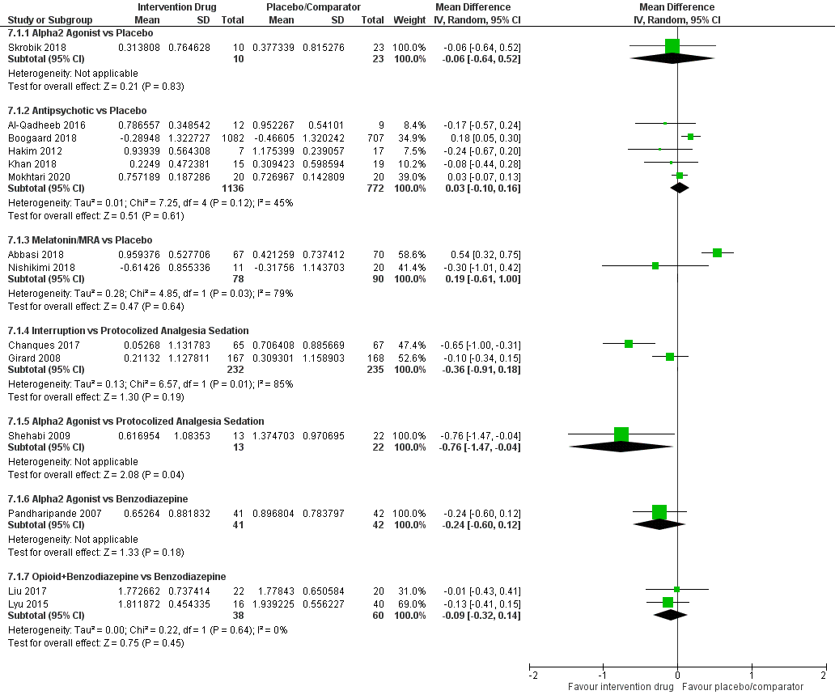

 | eTable 21: Bayesian NMA-Summary of Findings – Arrhythmia
Patient or population: critically ill adults
Interventions: any interventions and strategies for sedation titration (e.g., protocolized, interruption)
Comparator (reference): placebo
Outcome: Arrhythmia
Setting(s): mixed intensive care unit setting
Total studies: 7  Total Participants: 5791 |  | Relative effect *  (95% CrI) | Anticipated absolute effect (95% CrI) |  |  | Certainty of the evidence | Number of participants  (trials) | Ranking ***  (95% CrI)
 |  | Relative effect *  (95% CrI) | Placebo | Intervention | Risk Difference ** | Certainty of the evidence | Number of participants  (trials) | Ranking ***  (95% CrI)
Alpha₂ Agonist vs Placebo |  | OR 1.86  (0.33 to 12.29)  NMA estimate | 64 per 1000  (31 / 481 based on 3 trials) | 65 per 1000  (31 / 480 based on 4 trials) | 49 more per 1000  (from 42 fewer to 394 more) | ⊕⊕⊕◯  Moderate  Due to Imprecision² | Direct evidence:  961 (3 trials) | 3.39  (2 to 4)
Antipsychotics vs Placebo |  | OR 1.09  (0.18 to 6.93)  NMA estimate | 44 per 1000  (14 / 321 based on 3 trials) | 53 per 1000  (17 / 322 based on 3 trials) | 4 more per 1000  (from 35 fewer to 197 more) | ⊕⊕⊕◯  Moderate  Due to Imprecision² | Direct evidence:  643 (3 trials) | 2.55  (1 to 4)
Protocolized sedation vs Placebo |  | OR 0.52  (0.03 to 9.35)  NMA estimate | 74 per 1000 ¹ | No head-to-head comparison with placebo | 34 fewer per 1000  (from 72 fewer to 354 more) | ⊕⊕◯◯  Low  Due to Imprecision²,  and Indirectness³ | No direct evidence. Indirect evidence only. | 1.68  (1 to 4)
Placebo |  | Reference Comparator | - | - | - | - | - | 2.38  (1 to 4)
Abbreviations: CrI = credible interval; OR = odds ratio
NMA-SoF table definitions
* Network meta-analysis estimates are reported as odds ratio. CrI: credible interval (rather than confidence interval), since a Bayesian network meta-analysis has been conducted.
** Anticipated absolute effect: risk difference is calculated based on the control group risk and the estimated odds ratio.
*** Median and credible intervals are presented. Rank statistics is defined as the probabilities that a treatment out of n treatments in a network meta-analysis is the best, the second, the third and so on until the least effective treatment.
GRADE Working Group grades of evidence (or certainty in the evidence)
High quality: We are very confident that the true effect lies close to that of the estimate of the effect
Moderate quality: We are moderately confident in the effect estimate: The true effect is likely to be close to the estimate of the effect, but there is a possibility that it is substantially different
Low quality: Our confidence in the effect estimate is limited: The true effect may be substantially different from the estimate of the effect
Very low quality: We have very little confidence in the effect estimate: The true effect is likely to be substantially different from the estimate of effect
Explanatory Footnotes
¹ Given that there were no head-to-head trials for this comparison, the control group rate is based on the placebo arm of a large, randomized control trial (Su et al 2016, alpha2 agonist vs placebo).
² Imprecision: due to wide credible intervals in the OR estimate.
³ Indirectness: only indirect evidence available (through one degree of intermediary, alpha₂ agonist).

