Additional File 4: Subgroup analysis
4A1: Subgroup analysis according to axSpA phenotype (AS only) – Anti-TNF mAb
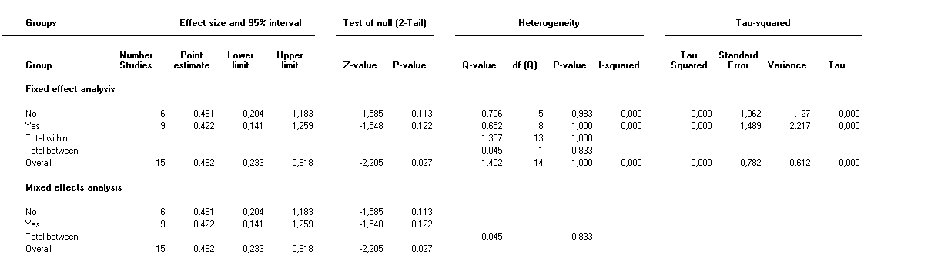
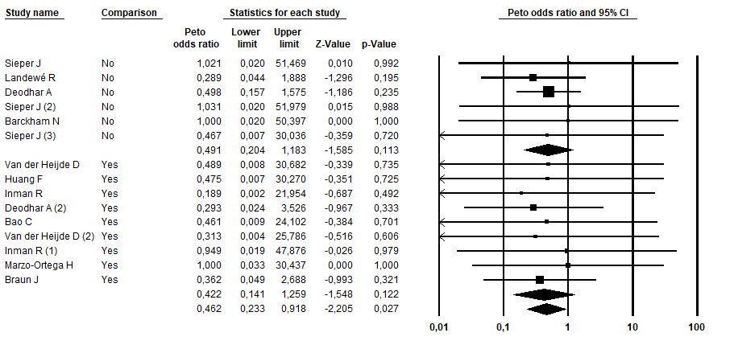
4A2: Subgroup analysis according to axSpA phenotype (AS only) – ETN

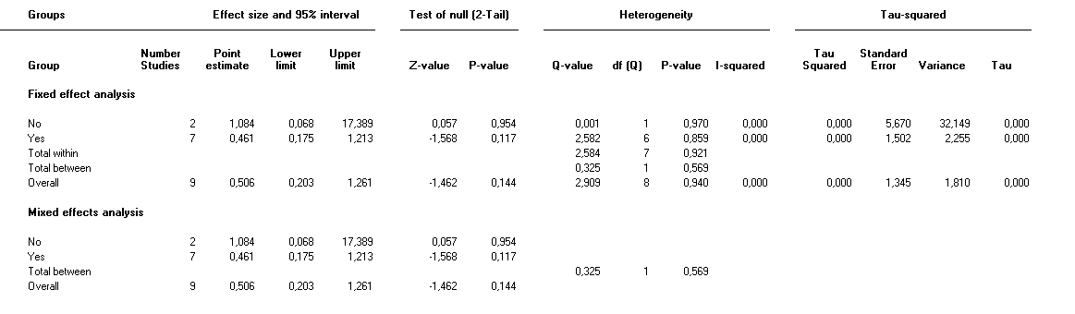

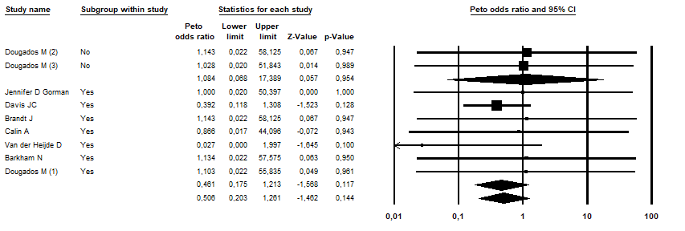

4A3: Subgroup analysis according to axSpA phenotype (AS only) – Anti-IL17A
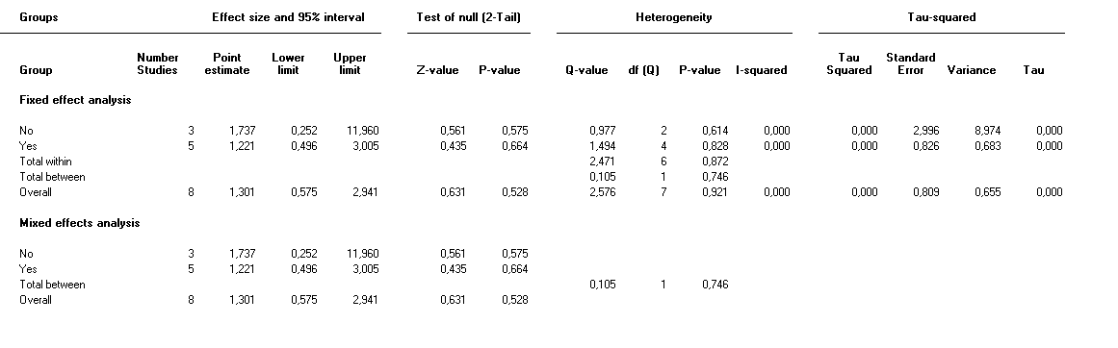
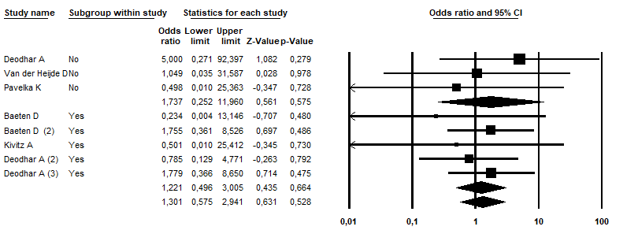

4B1: Subgroup analysis according to disease duration (<5 years) – Anti-TNF mAb
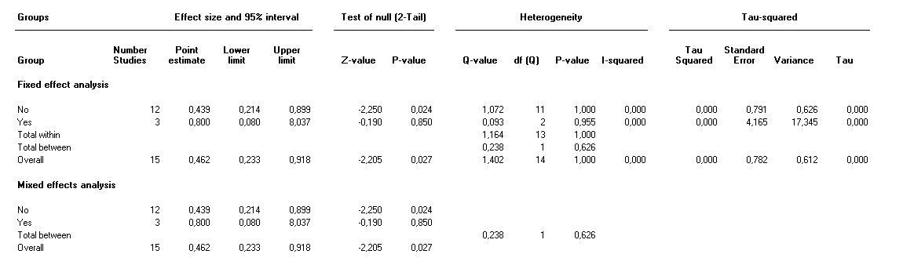
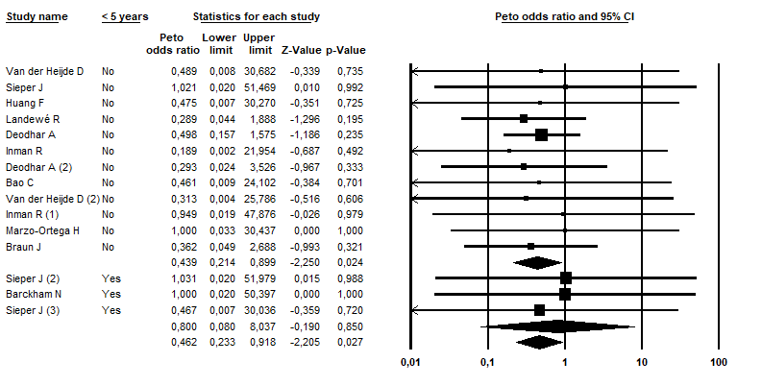

4B2: Subgroup analysis according to disease duration (<5 years) – ETN
Analysis not carried out as only one study was concerned

4B3: Subgroup analysis according to disease duration (<5 years) – Anti-IL17A
Analysis not carried out as no study was concerned

4C1: Subgroup analysis according to risk of biais (Cochrane RiOB) – Anti-TNF mAb

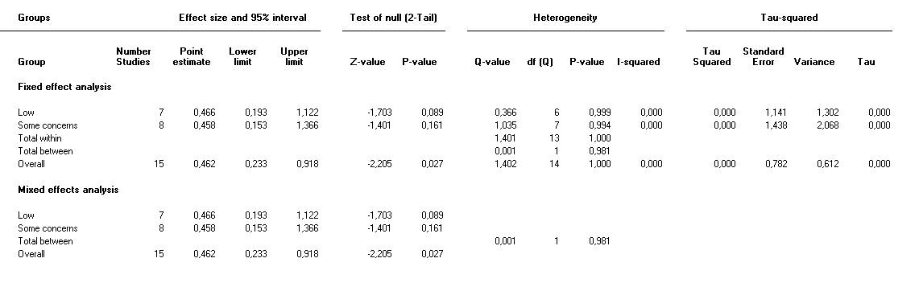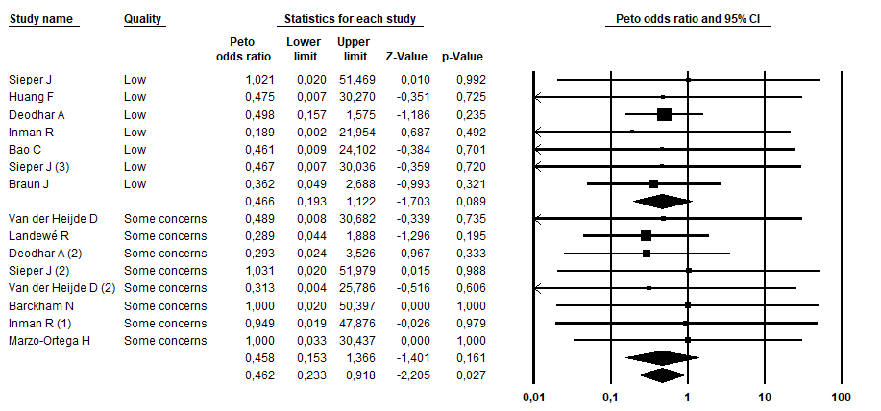
4C2: Subgroup analysis according to risk of biais (Cochrane RiOB) – ETN
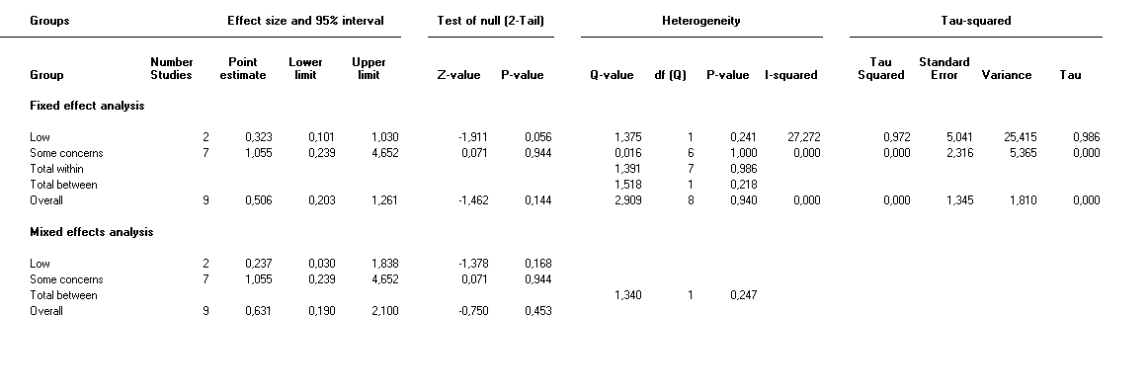
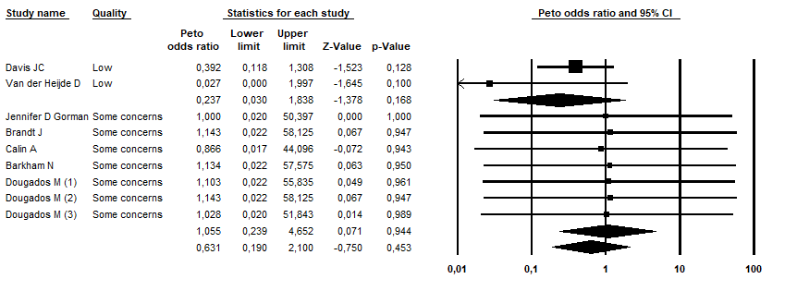
4C3: Subgroup analysis according to risk of biais (Cochrane RiOB) – Anti-IL17A
Analysis not carried out as only one study was classified as “some concerns”

4D1: Subgroup analysis according to history of AAU collected – Anti-TNF mAb

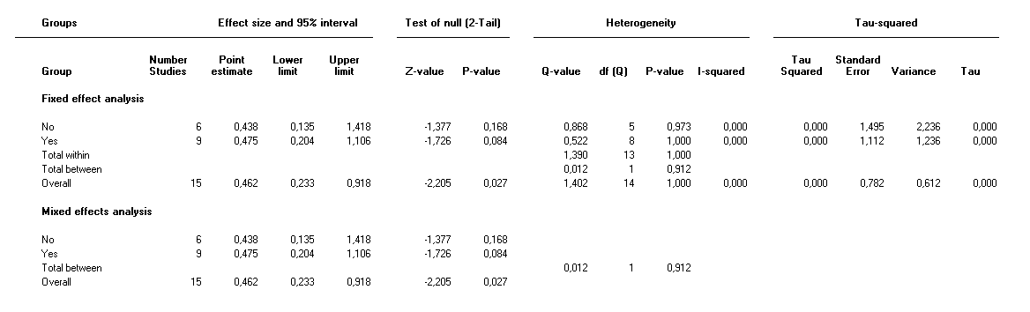
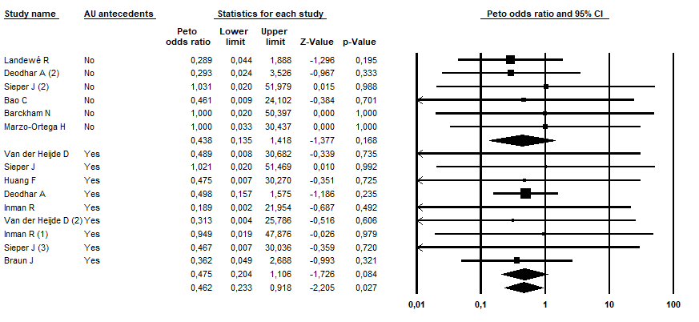

4D2: Subgroup analysis according to history of AAU collected – ETN
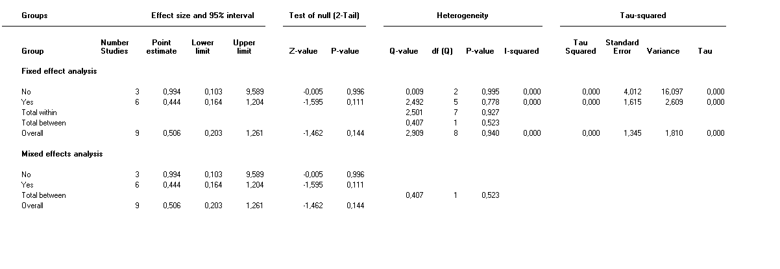
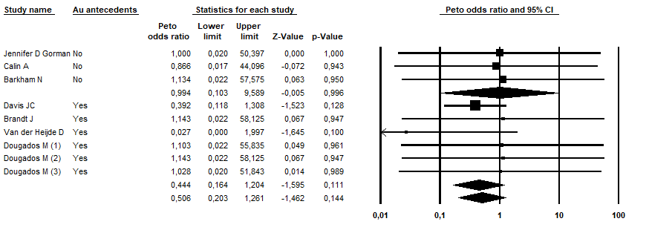
4D3: Subgroup analysis according to history of AAU collected – Anti-IL17A



