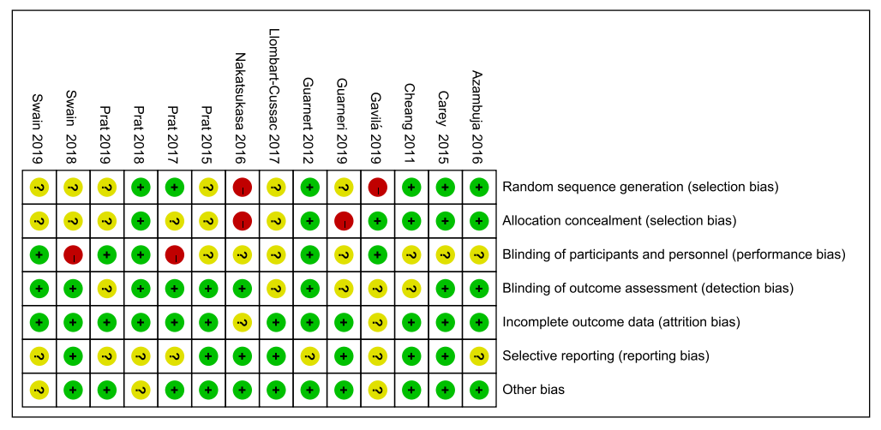
A
B
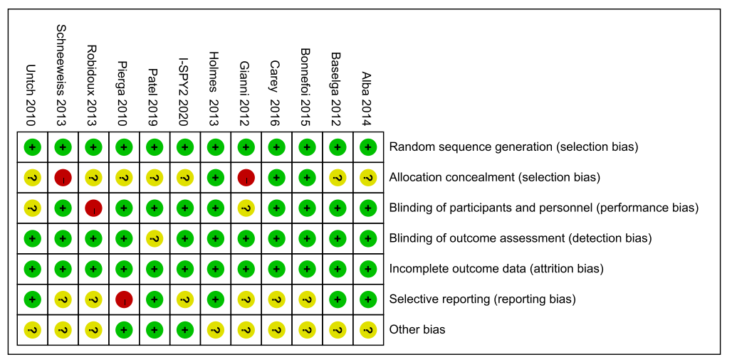
C
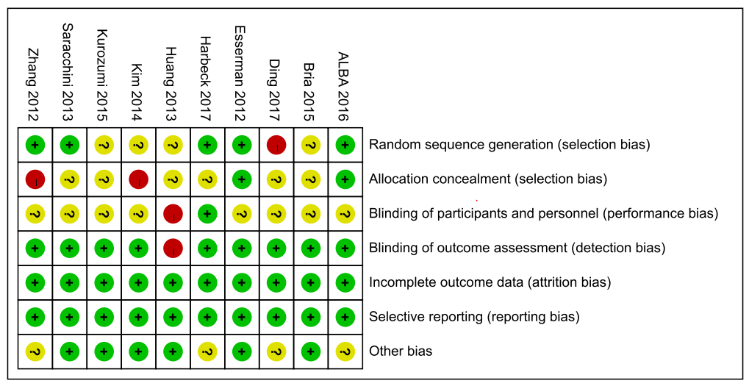

Figure S1

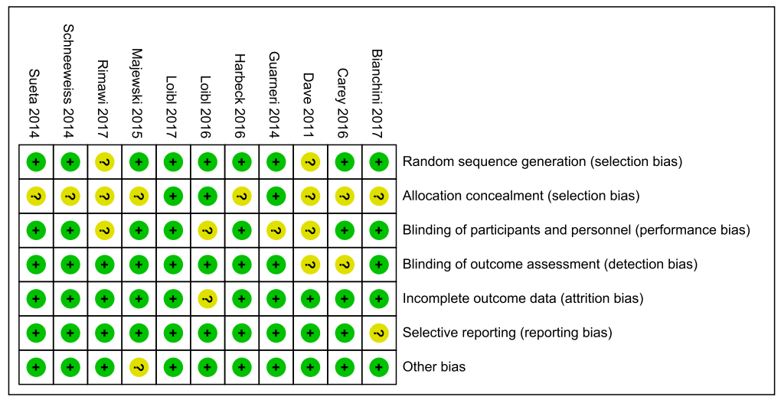
D
E
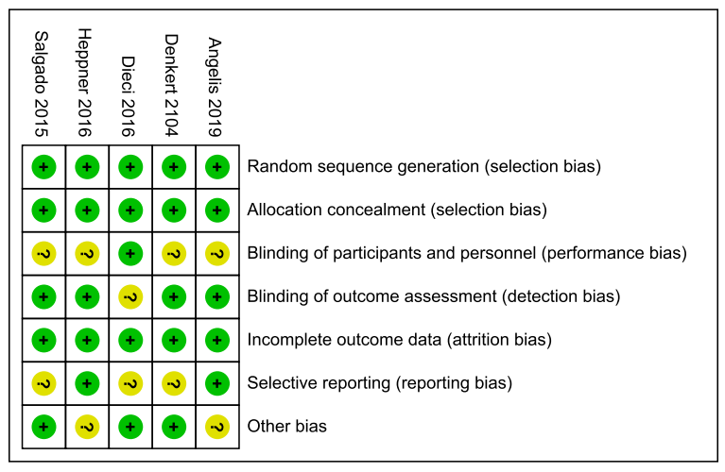

A：Her-2 enriched B：Hormone receptor C：Ki-67 D：phosphatase phosphoinositol-3 (PI3) kinase E：Tumor-infiltrating lymphocytes

Supplementary Figure 1

Figure S1

