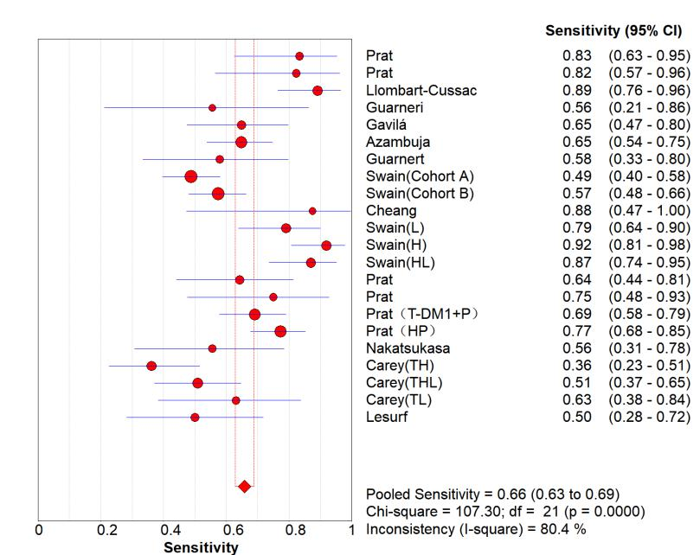
A
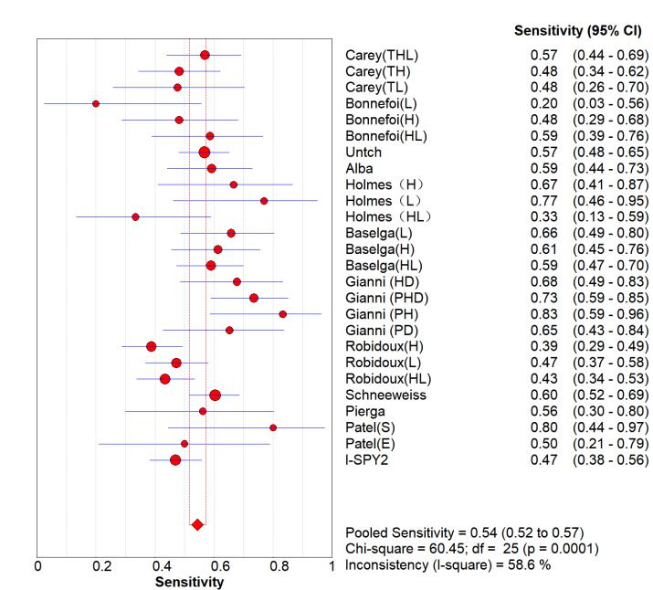
B
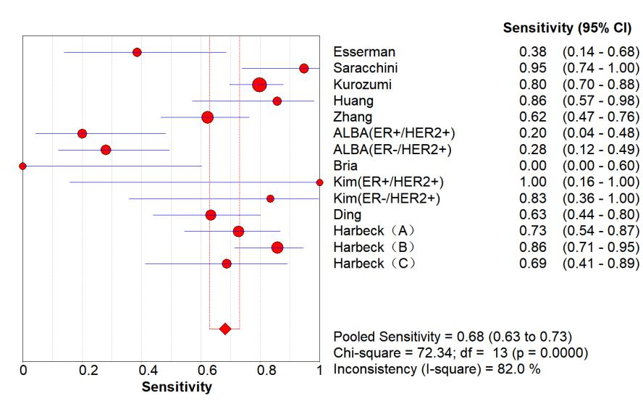
C

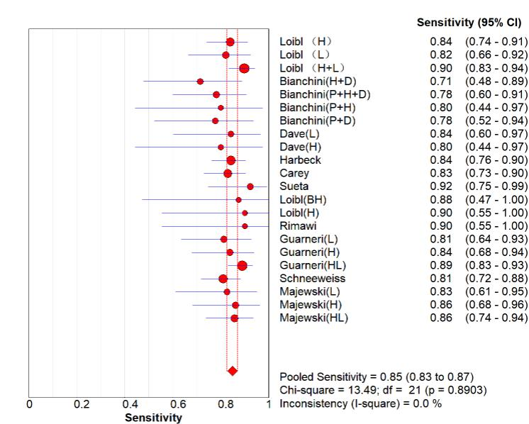
D

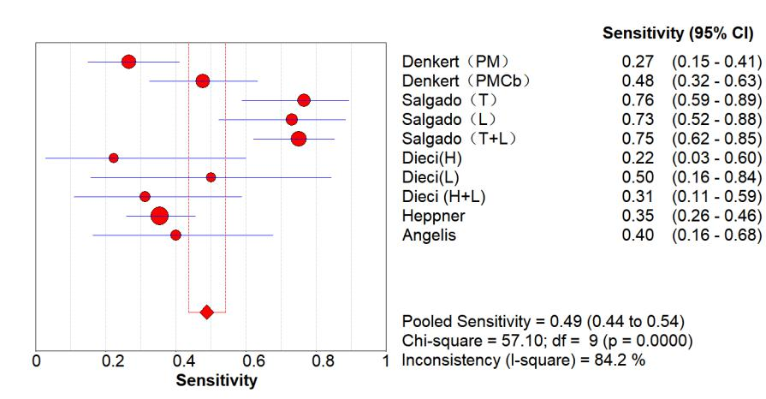
E

A：Her-2 enriched B：Hormone receptor C：Ki-67 D：phosphatase phosphoinositol-3 (PI3) kinase E：Tumor-infiltrating lymphocytes

Figure S2A

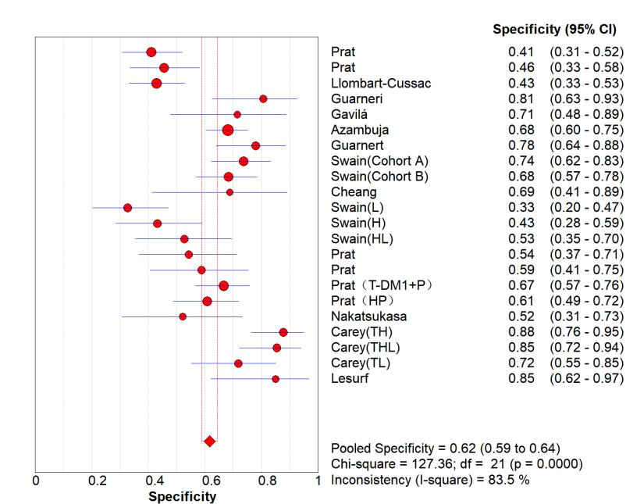
A
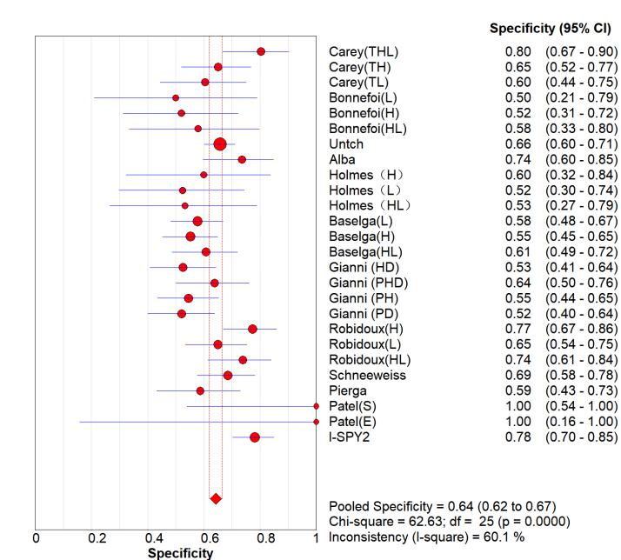
B
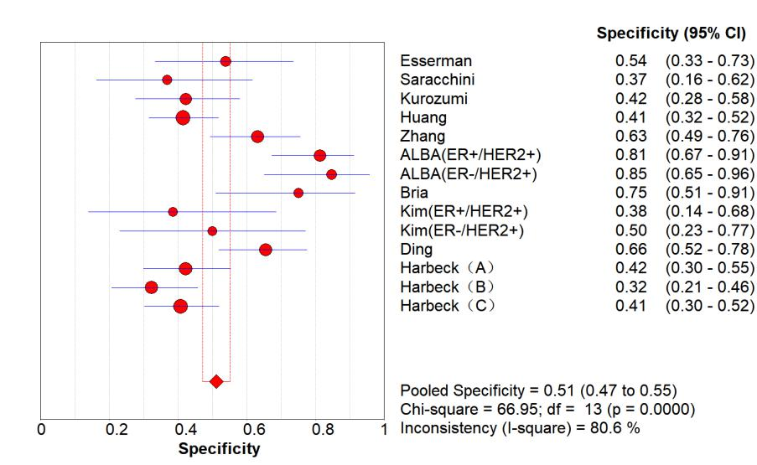
C
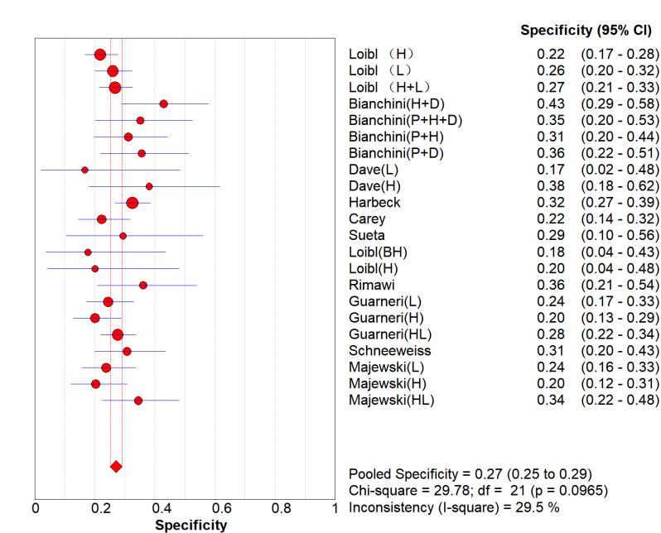
D
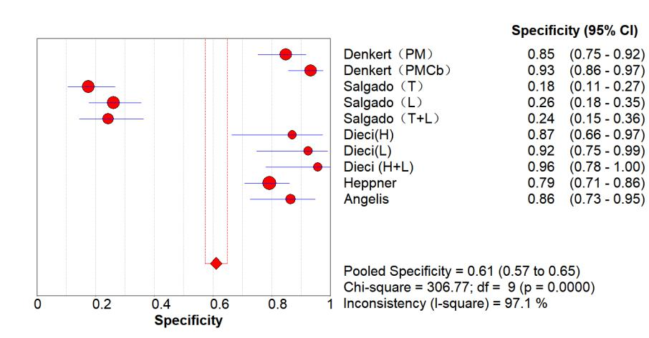
E

A：Her-2 enriched B：Hormone receptor C：Ki-67 D：phosphatase phosphoinositol-3 (PI3) kinase E：Tumor-infiltrating lymphocytes

Figure S2B

