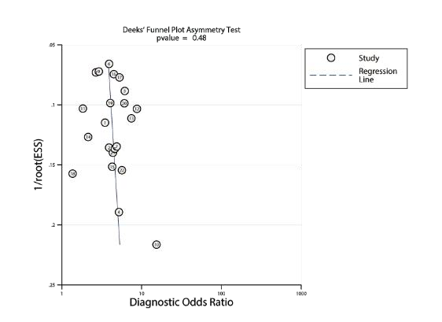
A
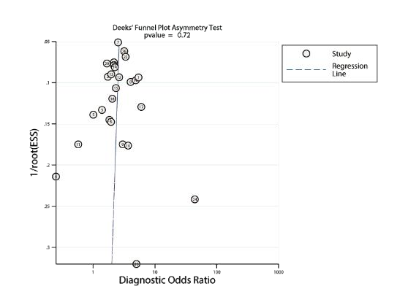
B
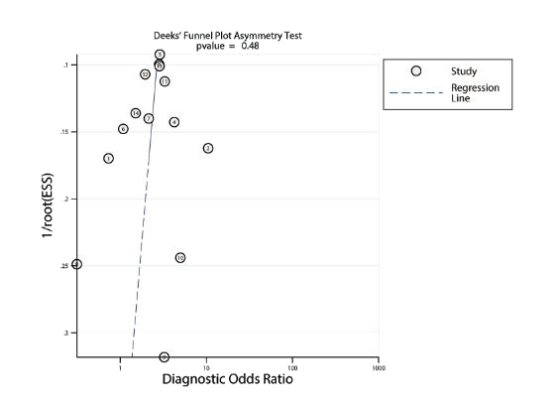
C

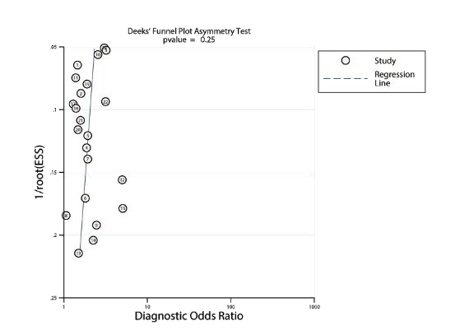
D
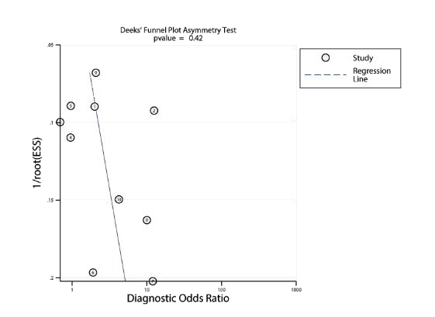
E
A：Her-2 enriched B：Hormone receptor C：Ki-67 D：phosphatase phosphoinositol-3 (PI3) kinase E：Tumor-infiltrating lymphocytes

Supplementary Figure 1

Figure S3

