Supplemental file
Effect of renal function on the risk of thrombocytopenia in patients receiving linezolid therapy: a systematic review and meta-analysis

CONTENTS
 | Abbreviations …………………………………………………………………………………………………… | 1
Table S1. | Search strategy used and studies identified in PubMed, EMBASE and the Cochrane Library databases……… | 2
Table S2. | Quality assessment of the included studies……………………………………………………………………… | 3
Table S3. | Unadjusted data of the association between renal impairment and thrombocytopenia ………………………… | 4
Table S4. | Adjusted data of the association between renal impairment and thrombocytopenia …………………………… | 4
Table S5. | Unadjusted data of the association between severe renal impairment and thrombocytopenia…………………… | 4
Table S6. | Adjusted data of the association between severe renal impairment and thrombocytopenia……………………… | 5
Table S7. | Unadjusted data of the association between hemodialysis status and thrombocytopenia ……………………… | 5
Table S8. | Adjusted data of the association between hemodialysis status and thrombocytopenia ………………………… | 5
Table S9. | Baseline indicators of renal function between thrombocytopenia and non-thrombocytopenia patients………… | 6
Table S10. | Leave-one-out sensitivity analyses of the association between renal impairment and thrombocytopenia……… | 7
Table S11. | Leave-one-out sensitivity analyses of the association between severe renal impairment and thrombocytopenia | 8
Table S12. | Leave-one-out sensitivity analyses of the association between hemodialysis status and thrombocytopenia…… | 8
Table S13. | Leave-one-out sensitivity analyses of the association between renal function indicators and thrombocytopenia | 9
Table S14. | Publication bias analyses for each outcome … ………………………………………………………………… | 9
Figure S1. | Funnel plot of the association between renal impairment and thrombocytopenia……………………………… | 10
Figure S2. | Funnel plot of the association between severe renal impairment and thrombocytopenia……………………… | 10
Figure S3. | Funnel plot of the association between hemodialysis status and thrombocytopenia…………………………… | 11
Figure S4. | Funnel plot of the association between renal function indicators and thrombocytopenia……………………… | 11

Abbreviations
Ccr, creatinine clearance rate; eGFR, estimated glomerular filtration rate; LCI, lower confidence interval; NA, not available; OR, odds ratio; SCr, serum creatinine; SD, standard deviation; UCI, upper confidence interval; WMD, weighted mean difference.
a: The number of patients with thrombocytopenia in exposed group.
b: The number of patients in exposed group.
c: The number of patients with thrombocytopenia in non-exposed group.
d: The number of patients in non-exposed group.

Table S1. Search strategy used and studies identified in PubMed, EMBASE and the Cochrane Library databases
No. | PubMed |  | EMBASE |  | The Cochrane Library database
No. | Search query | Results | Search query | Results | Search query | Results
#1 | linezolid [mh] | 6550 | linezolid [exp] | 22622 | linezolid | 517
#2 | thrombocytopenia [mh] | 77376 | thrombocytopenia [exp] | 197932 | thrombocytopenia | 9661
#3 | thrombopenia | 77454 | thrombopenia [exp] | 186308 | thrombopenia | 152
#4 | platelet | 286502 | platelet [exp] | 408646 | platelet | 25163
#5 | thrombocytopenic | 22287 | thrombocytopenic | 44804 | thrombocytopenic | 1324
#6 | renal | 720994 | renal [exp] | 975890 | renal | 67965
#7 | kidney [mh] | 921881 | kidney [exp] | 1458382 | kidney | 53735
#8 | creatinine clearance | 24711 | creatinine clearance [exp] | 40407 | creatinine clearance | 6161
#9 | glomerular filtration rate [mh] | 67321 | glomerular filtration rate [exp] | 123964 | glomerular filtration rate | 9621
#10 | serum creatinine | 66002 | serum creatinine [exp] | 135496 | serum creatinine | 13495
#11 | hemodialysis | 159192 | hemodialysis [exp] | 160914 | hemodialysis | 12181
#12 | risk factor | 1533356 | risk factor [exp] | 1225523 | risk factor | 41289
#13 | predictor | 404911 | predictor | 326312 | predictor | 15120
#14 | #2 OR #3 OR #4 OR #5 | 338942 | #2 OR #3 OR #4 OR #5 | 555913 | #2 OR #3 OR #4 OR #5 | 33237
#15 | #6 OR #7 OR #8 OR #9 OR #10 OR #11 OR #12 OR #13 | 2886885 | #6 OR #7 OR #8 OR #9 OR #10 OR #11 OR #12 OR #13 | 1766281 | #6 OR #7 OR #8 OR #9 OR #10 OR #11 OR #12 OR #13 | 146039
#16 | #1 AND #14 AND #15 | 112 | #1 AND #14 AND #15 | 570 | #1 AND #14 AND #15 | 14

Table S2. Quality assessment of the included studies
Study | Total (0-9) | Selection (0-4) | Comparability (0-2) | Exposure/ Outcome (0-3)
Bi 2013 | 6 | 2 | 2 | 2
Cazavet 2020 | 5 | 3 | 0 | 2
Chen 2012 | 5 | 3 | 0 | 2
Choi 2019 | 8 | 3 | 2 | 3
Crass 2019 | 6 | 3 | 1 | 2
Dai 2021 | 4 | 2 | 0 | 2
Dong 2014 | 4 | 2 | 0 | 2
Fujii 2013 | 4 | 2 | 0 | 2
González-Del 2017 | 6 | 2 | 1 | 3
Hanai 2016 | 7 | 2 | 2 | 3
Hirano 2014 | 7 | 3 | 2 | 2
Ichie 2015 | 6 | 3 | 0 | 3
Ishida 2013 | 6 | 3 | 1 | 2
Kaya 2019 | 4 | 2 | 0 | 2
Kim 2019 | 7 | 3 | 1 | 3
Lima 2020 | 6 | 3 | 1 | 2
Lin 2006 | 6 | 3 | 0 | 3
Niwa 2014 | 7 | 2 | 2 | 3
Nukui 2013 | 4 | 2 | 0 | 2
Rabon 2018 | 6 | 2 | 2 | 2
Sato 2020 | 5 | 2 | 0 | 3
Takahashi 2011 | 6 | 2 | 2 | 2
Tanaka 2020 | 5 | 3 | 0 | 2
Wu 2006 | 6 | 2 | 1 | 3

Table S3. Unadjusted data of the association between renal impairment and thrombocytopenia
Study | OR | LCI | UCI | a | b | c | d | Ethnicity | Definition
Choi 2019 | 4.01 | 2.07 | 7.79 | 64 | 167 | 13 | 97 | Asian patients | Ccr < 60 ml/min
Crass 2019 | 3.71 | 2.25 | 6.11 | 57 | 133 | 35 | 208 | Western patients | eGFR < 60 ml/min/1.73 m²
Fujii 2013 | 1.79 | 0.77 | 4.19 | 19 | 39 | 18 | 52 | Asian patients | eGFR < 60 ml/min/1.73 m²
González-Del 2017 | 2.44 | 1.67 | 3.57 | 79 | 184 | 86 | 365 | Western patients | Ccr < 50 ml/min
Hanai 2016 | 18.75 | 9.05 | 38.87 | 75 | 99 | 14 | 98 | Asian patients | Ccr < 60 ml/min
Hirano 2014 | 2.65 | 1.00 | 7.03 | 20 | 41 | 9 | 34 | Asian patients | Ccr < 60 ml/min
Kaya 2019 | 1.18 | 0.71 | 1.96 | 30 | 92 | 81 | 279 | Western patients | eGFR <50 ml/min/1.73 m²
Kim 2019 | 5.61 | 1.82 | 17.33 | 18 | 25 | 11 | 35 | Asian patients | Scr ≥1.5 mg/dL
Lima 2020 | 7.67 | 0.90 | 65.13 | 9 | 36 | 1 | 24 | Western patients | Ccr < 60 ml/min
Lin 2006 | 3.32 | 1.03 | 10.67 | 11 | 17 | 16 | 45 | Asian patients | Scr ≥ 1.5 mg/dL
Nukui 2013 | 39.0 | 3.80 | 399.8 | NA | NA | NA | NA | Asian patients | Ccr < 60 ml/min
Takahashi 2011 | 2.24 | 1.43 | 3.52 | 74 | 151 | 54 | 180 | Western patients | Ccr < 50 ml/min

Table S4. Adjusted data of the association between renal impairment and thrombocytopenia
Study | OR | LCI | UCI | Ethnicity | Definition
Choi 2019 | 1.40 | 0.50 | 3.88 | Asian patients | Ccr 30-60 ml/min
Crass 2019 | 3.28 | 1.70 | 8.02 | Western patients | eGFR < 60 ml/min/1.73 m²
González-Del 2017 | 2.132 | 1.401 | 3.243 | Western patients | Ccr < 50 ml/min
Kim 2019 | 8.728 | 2.087 | 36.507 | Asian patients | SCr ≥ 1.5 mg/dL
Lima 2020 | 4.57 | 1.26 | 16.5 | Western patients | SCr > 1.5 mg/dL
Takahashi 2011 | 2.32 | 1.45 | 3.74 | Asian patients | Ccr < 50 ml/min

Table S5. Unadjusted data of the association between severe renal impairment and thrombocytopenia
Study | OR | LCI | UCI | a | b | c | d | Definition
Choi 2019 | 3.85 | 2.21 | 6.73 | 45 | 95 | 32 | 169 | Ccr < 30 ml/min
Dong 2014 | 2.37 | 0.69 | 8.14 | 8 | 13 | 23 | 57 | Ccr < 30 ml/min
Fujii 2013 | 0.85 | 0.28 | 2.59 | 6 | 16 | 31 | 75 | eGFR < 30 ml/min/1.73 m²
Hanai 2016 | 8.10 | 3.51 | 18.70 | 35 | 43 | 54 | 154 | Ccr < 30 ml/min
Hirano 2014 | 3.35 | 1.16 | 9.70 | 12 | 20 | 17 | 55 | Ccr < 30 ml/min
Lima 2020 | 3.19 | 0.79 | 12.90 | 6 | 22 | 4 | 38 | Ccr < 30 ml/min
Niwa 2014 | 3.89 | 0.83 | 18.20 | NA | NA | NA | NA | Ccr < 30 ml/min
Rabon 2018 | 2.12 | 1.04 | 4.34 | 21 | 43 | 36 | 116 | eGFR < 30 ml/min/1.73 m²

Table S6. Adjusted data of the association between severe renal impairment and thrombocytopenia
Study | OR | LCI | UCI | Definition
Bi 2013 | 1.064 | 0.22 | 5.148 | Ccr < 30 ml/min
Choi 2019 | 4.19 | 1.59 | 11.06 | Ccr < 30 ml/min
Ishida 2013 | 2.13 | 0.501 | 9.07 | eGFR < 30 ml/min/1.73 m²
Niwa 2014 | 0.64 | 0.05 | 7.57 | Ccr < 30 ml/min
Rabon 2018 | 2.342 | 1.01 | 5.43 | eGFR < 30 ml/min/1.73 m²

Table S7. Unadjusted data of the association between hemodialysis status and thrombocytopenia
Study | OR | LCI | UCI | a | b | c | d
Hanai 2016 | 3.64 | 1.39 | 9.56 | 18 | 24 | 89 | 197
Kim 2019 | 1.36 | 0.37 | 5.04 | 6 | 11 | 23 | 49
Niwa 2014 | 1.18 | 0.20 | 6.79 | 2 | 10 | 7 | 40
Rabon 2018 | 3.00 | 1.01 | 8.92 | 9 | 15 | 48 | 144
Takahashi 2011 | 2.18 | 1.22 | 3.87 | 31 | 57 | 97 | 274
Wu 2006 | 4.89 | 1.74 | 13.71 | 22 | 28 | 27 | 63

Table S8. Adjusted data of the association between hemodialysis status and thrombocytopenia
Study | OR | LCI | UCI
Hanai 2016 | 3.32 | 1.14 | 9.67
Hirano 2014 | 0.90 | 0.10 | 6.20
Wu 2006 | 6.14 | 1.63 | 23.26

Table S9. Baseline indicators of renal function between thrombocytopenia and non-thrombocytopenia patients
Indicators of renal function /study | Thrombocytopenia |  |  | Non-thrombocytopenia |  |  | Note
Indicators of renal function /study | Mean | SD | N | Mean | SD | N | Note
Ccr, ml/min
Bi 2013 | 46 | 36 | 24 | 60 | 43 | 26
Cazavet 2020 | 89.24 | 52.51 | 10 | 104.2 | 51.07 | 62 | *
Chen 2012 | 84.37 | 63.12 | 69 | 102.07 | 57.26 | 184
Hanai 2016 | 35 | 24.3 | 107 | 78.4 | 36.4 | 114
Hirano 2014 | 47.4 | 34.1 | 29 | 84 | 68.7 | 46
Ichie 2015 | 82.58 | 46.10 | 25 | 80.58 | 35.90 | 22 | *
Lima 2020 | 31.20 | 15.50 | 12 | 90.63 | 54.01 | 54 | *
Niwa 2014 | 64.5 | 60.4 | 9 | 103.6 | 89.0 | 41
Sato 2020 | 86.3 | 38.6 | 17 | 92.5 | 56.7 | 20
Tanaka 2020 | 50.47 | 32.86 | 25 | 90.63 | 59.55 | 38 | *
eGFR, ml/min/1.73 m²
Cazavet 2020 | 66.08 | 33.88 | 10 | 80.55 | 33.32 | 62 | *
Dai 2021 | 66.02 | 48.11 | 52 | 94.32 | 58.29 | 93 | *
Ishida 2013 | 59.9 | 37 | 49 | 70.6 | 42.1 | 32
Kaya 2019 | 60.57 | 48.4 | 111 | 66.05 | 45.11 | 260
Kim 2019 | 60.1 | 57.1 | 29 | 81.1 | 52.3 | 31
* The mean and standard deviation were calculated based on the formulas by Wan et al. (BMC Med Res Methodol. 2014; 14:135).

Table S10. Leave-one-out sensitivity analyses of the association between renal impairment and thrombocytopenia
Adjustment | Study omitted | OR (95% CI)
Unadjusted | Choi 2019 | 3.53 (2.16, 5.75)
 | Crass 2019 | 3.58 (2.16, 5.93)
 | Fujii 2013 | 3.80 (2.36, 6.13)
 | González-Del 2017 | 3.80 (2.24, 6.44)
 | Hanai 2016 | 2.76 (1.98, 3.84)
 | Hirano 2014 | 3.66 (2.26, 5.90)
 | Kaya 2019 | 3.99 (2.58, 6.18)
 | Kim 2019 | 3.43 (2.15, 5.48)
 | Lima 2020 | 3.46 (2.19, 5.46)
 | Lin 2006 | 3.58 (2.23, 5.74)
 | Nukui 2013 | 3.29 (2.12, 5.10)
 | Takahashi 2011 | 3.81 (2.29, 6.36)
 | Combined | 3.54 (2.27, 5.54)
Adjusted | Choi 2019 | 2.64 (1.90, 3.69)
 | Crass 2019 | 2.43 (1.66, 3.54)
 | González-Del 2017 | 2.81 (1.79, 4.43)
 | Kim 2019 | 2.32 (1.77, 3.06)
 | Lima 2020 | 2.42 (1.73, 3.39)
 | Takahashi 2011 | 2.73 (1.70, 4.38)
 | Combined | 2.51 (1.82, 3.45)

Table S11. Leave-one-out sensitivity analyses of the association between severe renal impairment and thrombocytopenia
Adjustment | Study omitted | OR (95% CI)
Unadjusted | Choi 2019 | 2.86 (1.63, 5.01)
 | Dong 2014 | 3.12 (1.89, 5.16)
 | Fujii 2013 | 3.59 (2.54, 5.06)
 | Hanai 2016 | 2.68 (1.84, 3.88)
 | Hirano 2014 | 3.00 (1.79, 5.02)
 | Lima 2020 | 3.03 (1.84, 4.99)
 | Niwa 2014 | 2.99 (1.82, 4.89)
 | Rabon 2018 | 3.29 (1.96, 5.50)
 | Combined | 3.06 (1.95, 4.80)
Adjusted | Bi 2013 | 2.64 (1.50, 4.65)
 | Choi 2019 | 1.86 (0.98, 3.52)
 | Ishida 2013 | 2.36 (1.26, 4.42)
 | Niwa 2014 | 2.53 (1.46, 4.36)
 | Rabon 2018 | 2.28 (1.07, 4.85)
 | Combined | 2.38 (1.39, 4.05)

Table S12. Leave-one-out sensitivity analyses of the association between hemodialysis status and thrombocytopenia
Adjustment | Study omitted | OR (95% CI)
Unadjusted | Hanai 2016 | 2.40 (1.58, 3.65)
 | Kim 2019 | 2.73 (1.82, 4.08)
 | Niwa 2014 | 2.67 (1.80, 3.96)
 | Rabon 2018 | 2.51 (1.66, 3.79)
 | Takahashi 2011 | 2.92 (1.75, 4.89)
 | Wu 2006 | 2.31 (1.53, 3.50)
 | Combined | 2.57 (1.75, 3.77)

Table S13. Leave-one-out sensitivity analyses of the association between renal function indicators and thrombocytopenia
Indicators of renal function | Study omitted | WMD (95% CI)
Ccr, ml/min | Bi 2013 | -29.95 (-43.41, -16.48)
Ccr, ml/min | Cazavet 2020 | -29.24 (-42.64, -15.84)
Ccr, ml/min | Chen 2012 | -29.65 (-43.42, -15.88)
Ccr, ml/min | Hanai 2016 | -25.56 (-40.36, -10.76)
Ccr, ml/min | Hirano 2014 | -27.13 (-41.28, -12.98)
Ccr, ml/min | Ichie 2015 | -32.11 (-44.04, -20.19)
Ccr, ml/min | Lima 2020 | -24.12 (-36.94, -11.28)
Ccr, ml/min | Niwa 2014 | -27.61 (-40.99, -14.21)
Ccr, ml/min | Sato 2020 | -30.24 (-43.33, -17.15)
Ccr, ml/min | Tanaka 2020 | -26.71 (-40.86, -12.56)
Ccr, ml/min | Combined | -28.25 (-41.02, -15.47)
eGFR, ml/min/1.73 m² | Cazavet 2020 | -14.22 (-25.41, -3.02)
eGFR, ml/min/1.73 m² | Dai 2021 | -9.00 (-17.06, -0.93)
eGFR, ml/min/1.73 m² | Ishida 2013 | -15.30 (-27.21, -3.39)
eGFR, ml/min/1.73 m² | Kaya 2019 | -18.76 (-28.96, -8.55)
eGFR, ml/min/1.73 m² | Kim 2019 | -13.23 (-23.57, -2.90)
eGFR, ml/min/1.73 m² | Combined | -13.57 (-22.50, -4.65)

Table S14. Publication bias analyses for each outcome
Indicators of renal function | Adjustment | Egger
Renal impairment | Unadjusted | 0.141
 | Adjusted | 0.199
Severe renal impairment | Unadjusted | 0.588
 | Adjusted | 0.139
Hemodialysis status | Unadjusted | 0.861
 | Adjusted | 0.536
Ccr | Unadjusted | 0.118
eGFR | Unadjusted | 0.223

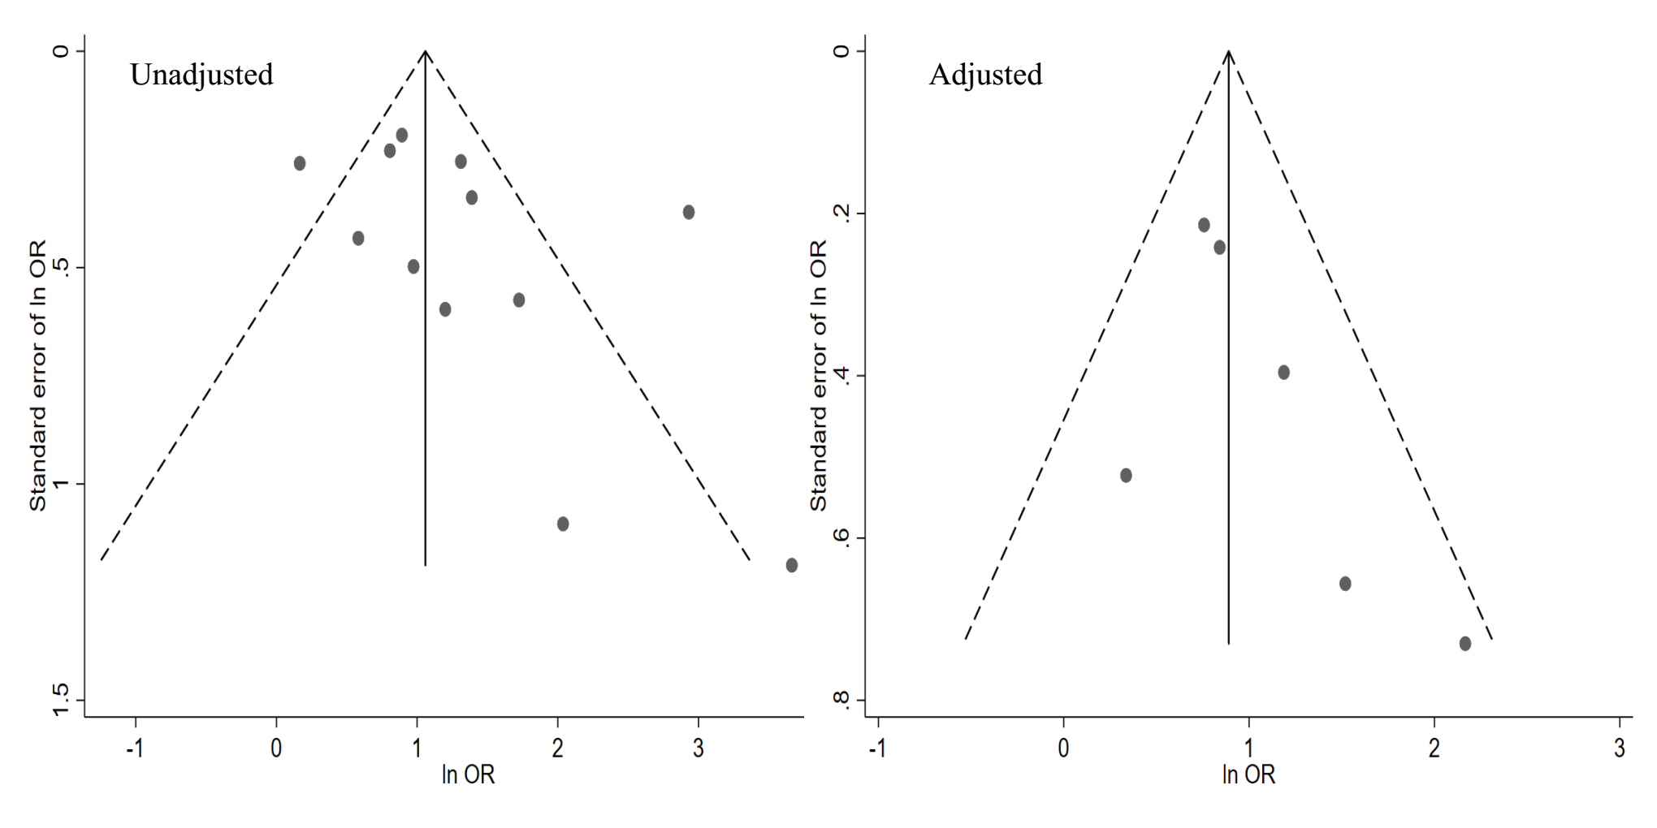
Figure S1. Funnel plot of the association between renal impairment and thrombocytopenia

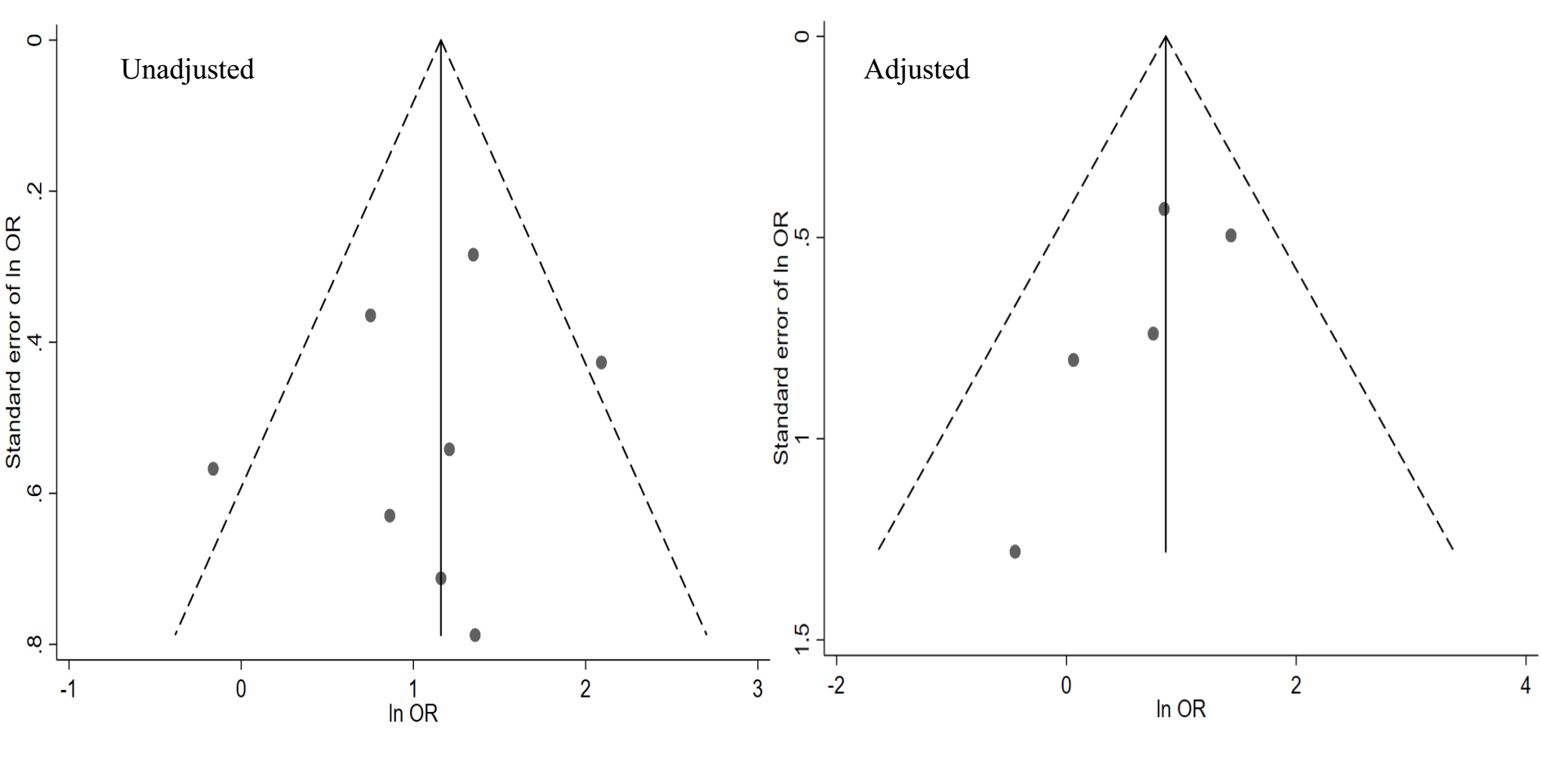
Figure S2. Funnel plot of the association between severe renal impairment and thrombocytopenia 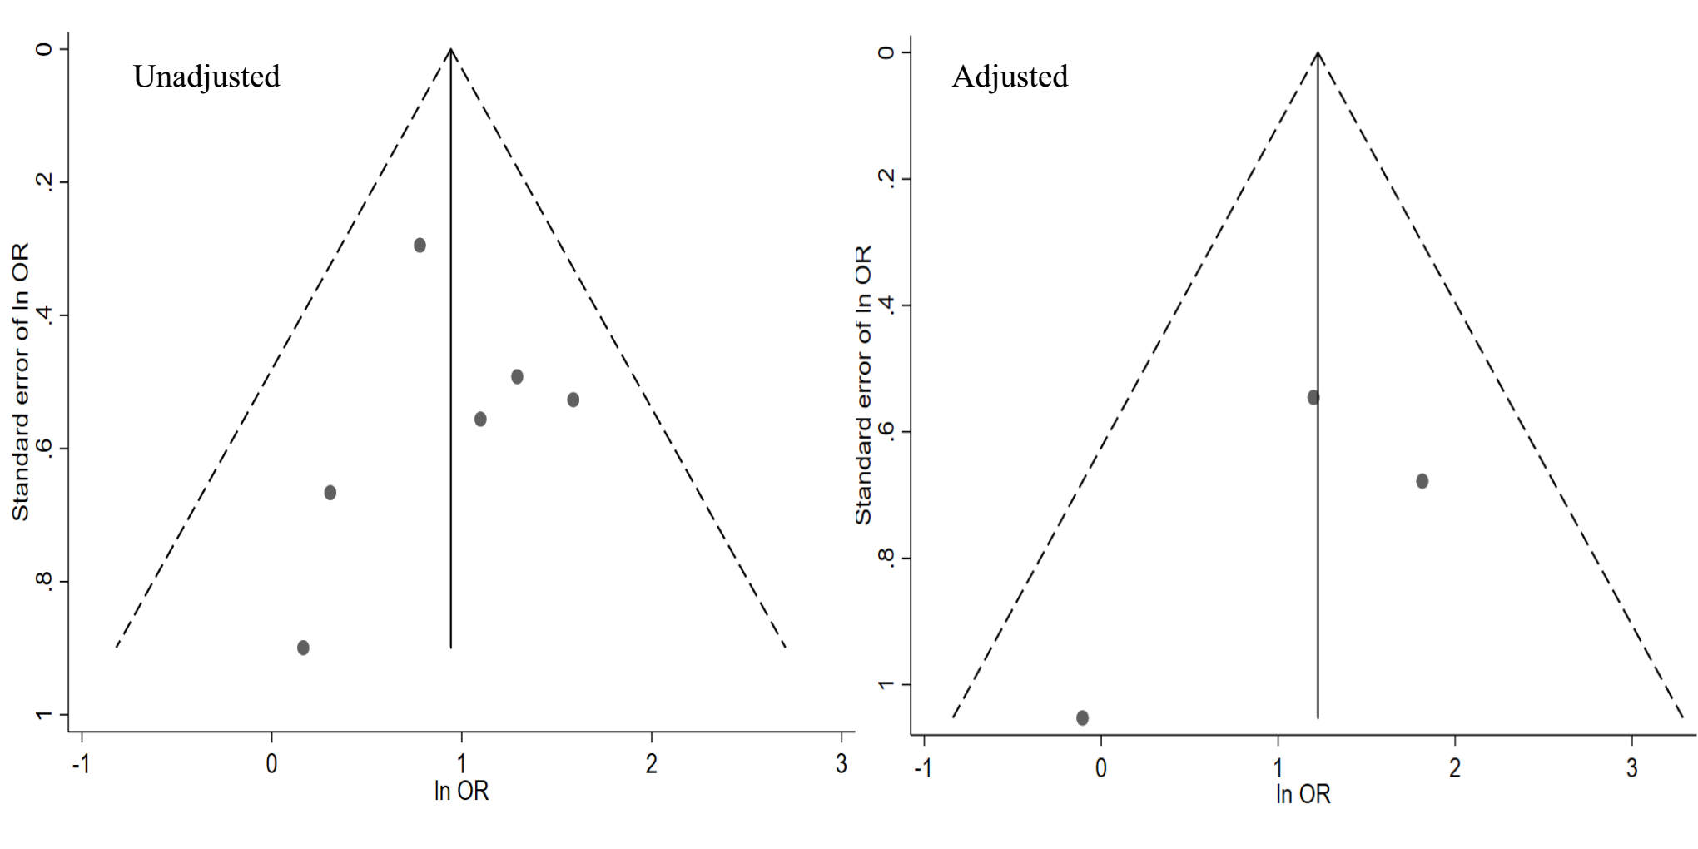
Figure S3. Funnel plot of the association between hemodialysis status and thrombocytopenia

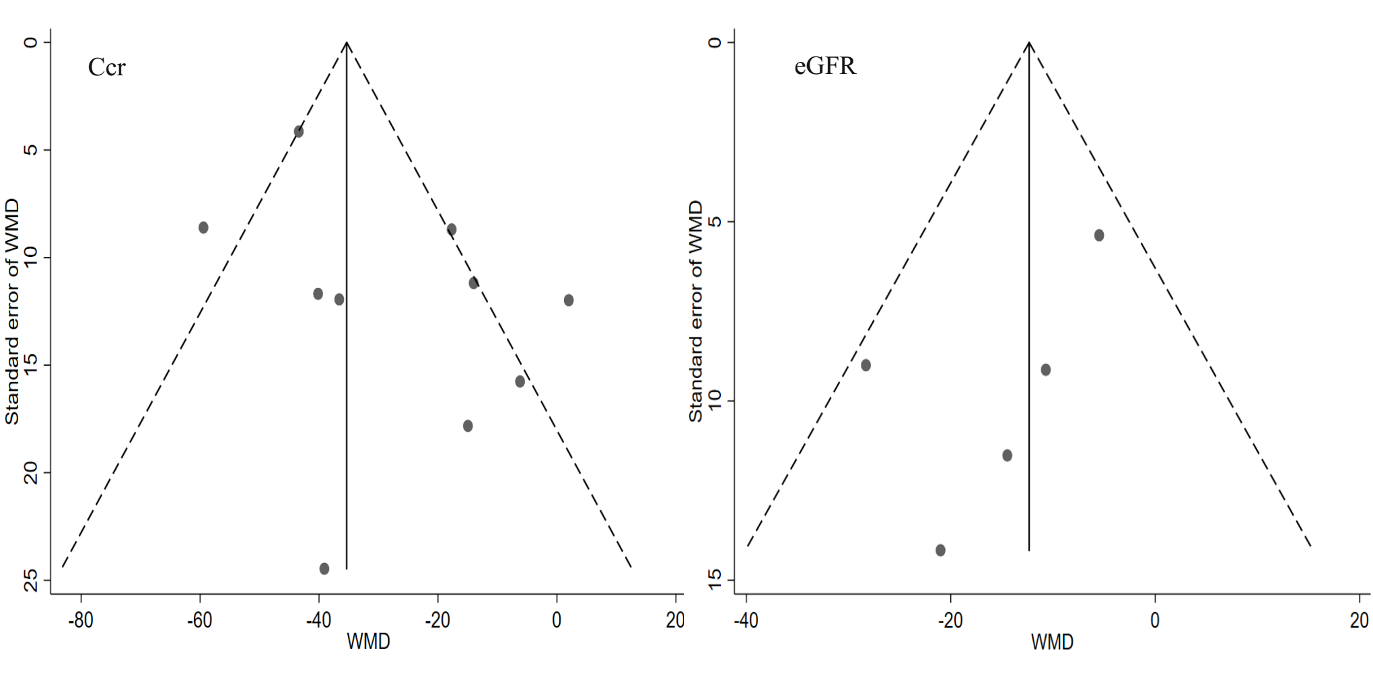
Figure S4. Funnel plot of the association between renal function indicators and thrombocytopenia

