Additional file 2:
Search terms used in PICOS search
PICOS | Definition | Search keywords
Population | Pregnant women | pregnan* OR gestat* OR “expectant mother*” OR “pregnant woman” OR “pregnant women” OR prenatal OR antenatal OR pre-natal OR ante-natal OR “first time mother*” OR “first-time mother*” OR “first-time mum*” OR post-natal OR postnatal OR postpartum OR post-partum
Intervention | Yoga for pregnancy | yoga*
Comparator | Treatment as usual or any active treatment other than yoga | Not set
Outcomes | Stress, anxiety, depression, quality of life, labour duration, pain management in labour, mode of birth | Not set
Study design | RCTs or quasi-experimental studies | Not set

Search strategy for EMBASE 29 July 2019
Concept 1: Pregnancy
EMBASE: 'pregnancy'/exp OR 'expectant mother'/exp

Keywords (title & abstract): pregnan* OR gestat* OR “expectant mother*” OR “pregnant woman” OR “pregnant women” OR prenatal OR antenatal OR pre-natal OR ante-natal OR “first time mother*” OR “first-time mother*” OR “first-time mum*” OR post-natal OR postnatal OR postpartum OR post-partum
Concept 2: Yoga
EMBASE: 'yoga'/exp

Keywords (title & abstract): yoga*
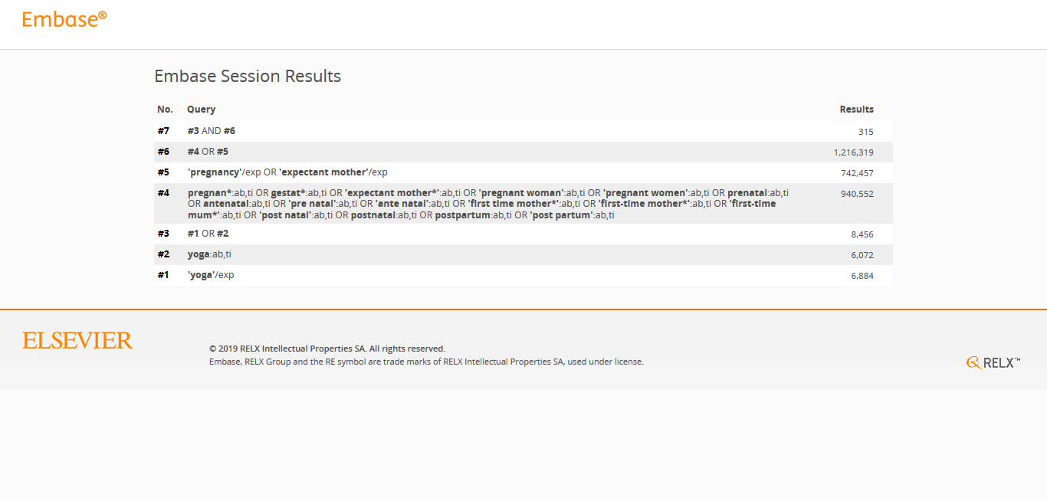

Search Queries
No. | Query | Results | Date
#7 | ('yoga'/exp OR yoga:ab,ti) AND ((pregnan*:ab,ti OR gestat*:ab,ti OR 'expectant mother*':ab,ti OR 'pregnant woman':ab,ti OR 'pregnant women':ab,ti OR prenatal:ab,ti OR antenatal:ab,ti OR 'pre natal':ab,ti OR 'ante natal':ab,ti OR 'first time mother*':ab,ti OR 'first-time mother*':ab,ti OR 'first-time mum*':ab,ti OR 'post natal':ab,ti OR postnatal:ab,ti OR postpartum:ab,ti OR 'post partum':ab,ti) OR ('pregnancy'/exp OR 'expectant mother'/exp)) | 315 | 29 Jul 2019
#6 | (pregnan*:ab,ti OR gestat*:ab,ti OR 'expectant mother*':ab,ti OR 'pregnant woman':ab,ti OR 'pregnant women':ab,ti OR prenatal:ab,ti OR antenatal:ab,ti OR 'pre natal':ab,ti OR 'ante natal':ab,ti OR 'first time mother*':ab,ti OR 'first-time mother*':ab,ti OR 'first-time mum*':ab,ti OR 'post natal':ab,ti OR postnatal:ab,ti OR postpartum:ab,ti OR 'post partum':ab,ti) OR ('pregnancy'/exp OR 'expectant mother'/exp) | 1216319 | 29 Jul 2019
#5 | 'pregnancy'/exp OR 'expectant mother'/exp | 742457 | 29 Jul 2019
#4 | pregnan*:ab,ti OR gestat*:ab,ti OR 'expectant mother*':ab,ti OR 'pregnant woman':ab,ti OR 'pregnant women':ab,ti OR prenatal:ab,ti OR antenatal:ab,ti OR 'pre natal':ab,ti OR 'ante natal':ab,ti OR 'first time mother*':ab,ti OR 'first-time mother*':ab,ti OR 'first-time mum*':ab,ti OR 'post natal':ab,ti OR postnatal:ab,ti OR postpartum:ab,ti OR 'post partum':ab,ti | 940552 | 29 Jul 2019
#3 | 'yoga'/exp OR yoga:ab,ti | 8456 | 29 Jul 2019
#2 | yoga:ab,ti | 6072 | 29 Jul 2019
#1 | 'yoga'/exp | 6884 | 29 Jul 2019

