SUPPLEMENTARY MATERIAL
Supplemental Table 1. Search strategy used in each database searched
Database (Articles Retrieved) | Search Strategy
 | ((("direct"[All Fields] OR "directed"[All Fields] OR "directing"[All Fields] OR "direction"[All Fields] OR "directional"[All Fields] OR "directions"[All Fields] OR "directivities"[All Fields] OR "directivity"[All Fields] OR "directs"[All Fields]) AND ("mouth"[MeSH Terms] OR "mouth"[All Fields] OR "oral"[All Fields]) AND ("anticoagulants"[Pharmacological Action] OR "anticoagulants"[MeSH Terms] OR "anticoagulants"[All Fields] OR "anticoagulant"[All Fields] OR "anticoagulate"[All Fields] OR "anticoagulated"[All Fields] OR "anticoagulating"[All Fields] OR "anticoagulation"[All Fields] OR "anticoagulations"[All Fields] OR "anticoagulative"[All Fields])) OR "DOACs"[All Fields] OR (("novel"[All Fields] OR "novel s"[All Fields] OR "novels"[All Fields]) AND ("mouth"[MeSH Terms] OR "mouth"[All Fields] OR "oral"[All Fields]) AND ("anticoagulants"[Pharmacological Action] OR "anticoagulants"[MeSH Terms] OR "anticoagulants"[All Fields] OR "anticoagulant"[All Fields] OR "anticoagulate"[All Fields] OR "anticoagulated"[All Fields] OR "anticoagulating"[All Fields] OR "anticoagulation"[All Fields] OR "anticoagulations"[All Fields] OR "anticoagulative"[All Fields])) OR ("New"[All Fields] AND ("mouth"[MeSH Terms] OR "mouth"[All Fields] OR "oral"[All Fields]) AND ("anticoagulants"[Pharmacological Action] OR "anticoagulants"[MeSH Terms] OR "anticoagulants"[All Fields] OR "anticoagulant"[All Fields] OR "anticoagulate"[All Fields] OR "anticoagulated"[All Fields] OR "anticoagulating"[All Fields] OR "anticoagulation"[All Fields] OR "anticoagulations"[All Fields] OR "anticoagulative"[All Fields])) OR ("Non"[All Fields] AND ("vitamin k"[MeSH Terms] OR "vitamin k"[All Fields]) AND ("antagonist"[All Fields] OR "antagonists and inhibitors"[MeSH Subheading] OR ("antagonists"[All Fields] AND "inhibitors"[All Fields]) OR "antagonists and inhibitors"[All Fields] OR "antagonists"[All Fields]) AND ("mouth"[MeSH Terms] OR "mouth"[All Fields] OR "oral"[All Fields]) AND ("anticoagulants"[Pharmacological Action] OR "anticoagulants"[MeSH Terms] OR "anticoagulants"[All Fields] OR "anticoagulant"[All Fields] OR "anticoagulate"[All Fields] OR "anticoagulated"[All Fields] OR "anticoagulating"[All Fields] OR "anticoagulation"[All Fields] OR "anticoagulations"[All Fields] OR "anticoagulative"[All Fields])) OR ("n 4 oleylcytosine arabinoside"[Supplementary Concept] OR "n 4 oleylcytosine arabinoside"[All Fields] OR "noac"[All Fields]) OR ("Target-specific"[All Fields] AND ("mouth"[MeSH Terms] OR "mouth"[All Fields] OR "oral"[All Fields]) AND ("anticoagulants"[Pharmacological Action] OR "anticoagulants"[MeSH Terms] OR "anticoagulants"[All Fields] OR "anticoagulant"[All Fields] OR "anticoagulate"[All Fields] OR "anticoagulated"[All Fields] OR "anticoagulating"[All Fields] OR "anticoagulation"[All Fields] OR "anticoagulations"[All Fields] OR "anticoagulative"[All Fields])) OR ("tsoac"[All Fields] OR "tsoacs"[All Fields]) OR ("factor xa inhibitors"[Pharmacological Action] OR "factor xa inhibitors"[MeSH Terms] OR ("factor"[All Fields] AND "xa"[All Fields] AND "inhibitors"[All Fields]) OR "factor xa inhibitors"[All Fields]) OR ("rivaroxaban"[MeSH Terms] OR "rivaroxaban"[All Fields]) OR ("apixaban"[Supplementary Concept] OR "apixaban"[All Fields] OR "apixaban s"[All Fields]) OR ("edoxaban"[Supplementary Concept] OR "edoxaban"[All Fields]) OR ("dabigatran"[MeSH Terms] OR "dabigatran"[All Fields] OR "dabigatran s"[All Fields]) OR ("betrixaban"[Supplementary Concept] OR "betrixaban"[All Fields])) AND ("aspirin"[MeSH Terms] OR "aspirin"[All Fields] OR "aspirins"[All Fields] OR "aspirin s"[All Fields] OR "aspirine"[All Fields] OR (("acetyl"[All Fields] OR "acetylate"[All Fields] OR "acetylated"[All Fields] OR "acetylates"[All Fields] OR "acetylating"[All Fields] OR "acetylation"[MeSH Terms] OR "acetylation"[All Fields] OR "acetylations"[All Fields] OR "acetyls"[All Fields]) AND ("salicylic acid"[MeSH Terms] OR ("salicylic"[All Fields] AND "acid"[All Fields]) OR "salicylic acid"[All Fields])) OR ("o-acetyl"[All Fields] AND ("salicylic acid"[MeSH Terms] OR ("salicylic"[All Fields] AND "acid"[All Fields]) OR "salicylic acid"[All Fields])) OR ("aspirin"[MeSH Terms] OR "aspirin"[All Fields] OR "2 acetoxybenzoic acid"[All Fields]) OR "ASA"[All Fields])
Cochrane Library  (776 results) | (Direct oral anticoagulants OR DOACs OR Novel oral anticoagulants OR New oral anticoagulants OR Non vitamin K antagonist oral anticoagulants OR noac OR Target-specific oral anticoagulants OR TSOACs OR Factor Xa inhibitors OR rivaroxaban OR apixaban OR edoxaban OR dabigatran OR betrixaban) AND (Aspirin OR acetyl salicylic acid OR o-acetyl salicylic acid OR 2-acetoxybenzoic acid OR ASA)

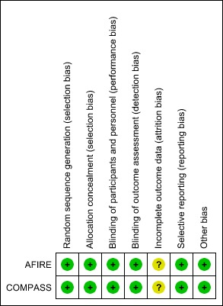
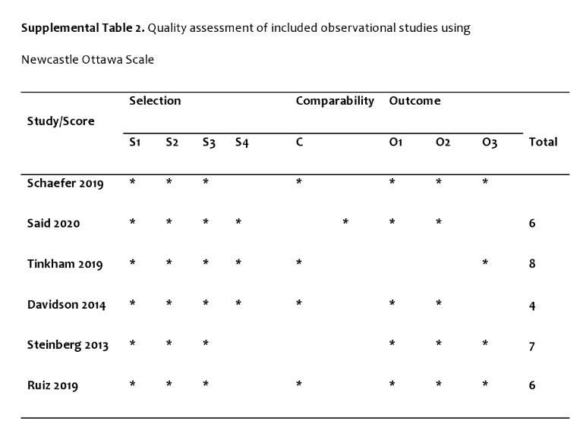

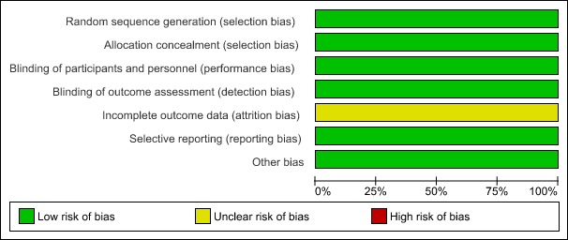
Supplemental Figure 1a. Quality Assessment of included Randomized Controlled Trials using Cochrane Risk of Bias Tool

Supplemental Figure 1b. Quality Assessment of included Randomized Controlled Trials using Cochrane Risk of Bias Tool

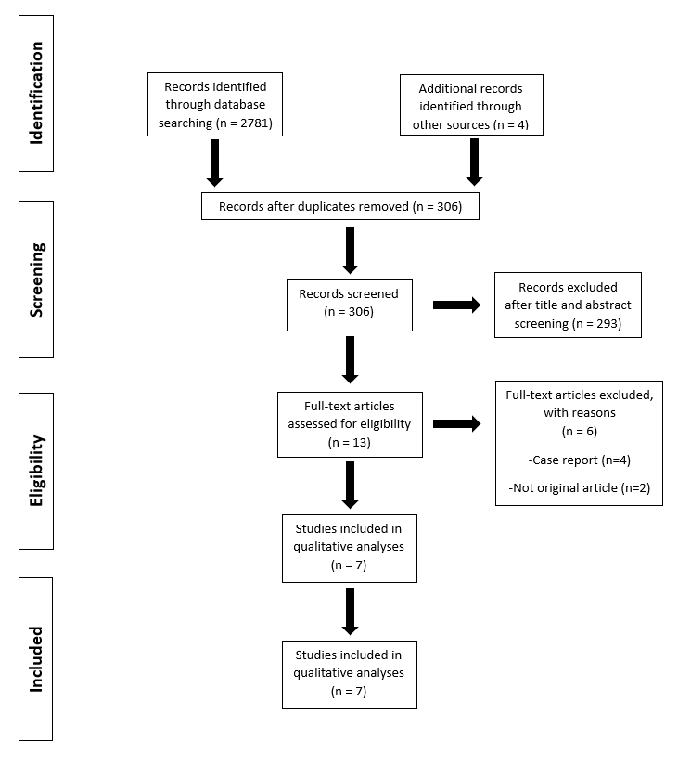
Supplemental Figure 2. Prisma Flow Diagram

Supplemental Table 3. Baseline Characteristics of Patients
RCTs | COMPASS |  |  | AFIRE
Characteristic | Rivaroxaban plus Aspirin  (N=9152) | Rivaroxaban Alone  (N=9117) | Aspirin Alone (N=9126) | Rivaroxaban Monotherapy  (N=1107) | Combination Therapy  (N=1108)
Age — yr | 68.3±7.9 | 68.2±7.9 | 68.2±8.0 | 74.3±8.3 | 74.4±8.2
Female sex — no. (%) | 2059 (22.5) | 1972 (21.6) | 1989 (21.8) | N/A | N/A
Male sex — no. (%) | N/A | N/A | N/A | 875 (79.0) | 876 (79.1)
Body-mass index† | 28.3±4.8 | 28.3±4.6 | 28.4±4.7 | 24.5±3.7 | 24.5±3.7
Race or ethnic group — no. (%)†
White | 5673 (62.0) | 5672 (62.2) | 5682 (62.3) | N/A | N/A
Black | 76 (0.8) | 94 (1.0) | 92 (1.0) | N/A | N/A
Asian | 1451 (15.9) | 1421 (15.6) | 1397 (15.3) | N/A | N/A
American Indian or Alaska Native | N/A | N/A | N/A | N/A | N/A
Other or unknown | 1952 (21.3) | 1930 (21.2) | 1955 (21.4) | N/A | N/A
Previous stroke — no. (%) | 351 (3.8) | 346 (3.8) | 335 (3.7) | 148 (13.4) | 175 (15.8)
Previous myocardial infarction — no. (%) | 5654 (61.8) | 5653 (62.0) | 5721 (62.7) | 384 (34.7) | 393 (35.5)
Diabetes — no. (%) | 3448 (37.7) | 3419 (37.5) | 3474 (38.1) | 461 (41.6) | 466 (42.1)
Type of atrial fibrillation — no. (%)
Paroxysmal | N/A | N/A | N/A | 596 (53.8) | 580 (52.3)
Persistent | N/A | N/A | N/A | 164 (14.8) | 175 (15.8)
Permanent | N/A | N/A | N/A | 347 (31.3) | 353 (31.9)
Current smoker — no. (%) | N/A | N/A | N/A | 146 (13.2) | 146 (13.2)
AF: Atrial fibrillation, PCI: Percutaneous Coronary Intervention, CABG: Coronary artery bypass graft, CAD: Coronary artery disease, PAD: Peripheral artery disease, GFR: Glomerular filtration rate, DAPT: Dual antiplatelet therapy, MI: Myocardial infarction, ISTH: International Society on Thrombosis and Haemostasis (ISTH), DOAC: Direct oral anticoagulant, VTE: Venous thromboembolic disease, DVT: Deep vein thrombosis, PE: Pulmonary embolism, AFL: Atrial flutter, MACE: Major adverse cardiac events, ACS: Acute coronary syndromes, CRNMB: Clinically relevant non-major bleeding

Supplemental Table 3. Baseline Characteristics of Patients (continued)
Observational  Studies | Schaefer, 2019 |  | Tinkham, 2019 |  |  | Davidson, 2014 |  |  |  | Steinberg, 2013 |  |  | Ruiz, 2019
Characteristic | DOAC  (N=639) | DOAC+ASA  (N=639) | Overall  (N=407) | DOAC+APT  (N=78) | DOAC monotherapy (N=329) | No NSAID Use  (N=6362) | Any NSAID Use  (N= 1884) | No Aspirin Use  (N = 7044) | Any Aspirin Use  (N=1202) | Overall (N=7347) | OAC Alone (N=4804) | OAC+ASA (N=2543) | Whole Population (N=2361) | Without ATP therapy (N=2216) | With  ATP  (N=145)
Age,  mean (SD),y | 71.6 | 71.8 | 63.7  (16.0) | 63.4  (16.2) | 63.2  (16.0) | 58  (17) | 55  (17) | 56  (17) | 64  (15) | 75  (68–82) | 76  (68–82) | 75  (67–81) | 76 ± 9 | 76 ± 10 | 77 ± 7
Female sex  no. (%) |  |  |  |  |  |  |  |  |  | 43% | 47% | 34% | 1260  (53) | 1201  (54) | 59  (41)
Male sex  no. (%) | 357  (55.9) | 357  (55.9) | 228  (56.0) | 43  (55.1) | 185  (56.2) | 3558  (55.9) | 942  (50.0) | 3811  (54.1) | 689  (57.3)
BMI, mean (SD),  kg/m2 | N/A | N/A | 29.1  (5.3) | 30.7  (5.3) | 28.4  (5.2) | N/A | N/A | N/A | N/A | N/A | N/A | N/A | N/A | N/A | N/A
Hypertension  no.(%) | N/A | N/A | 297  (73) | 59  (75.6) | 238  (72.3) | N/A | N/A | N/A | N/A | 85 | 83 | 87 | 2057  (87) | 1922  (87) | 135  (93)
Atrial fibrillation  no.(% | 475  (74.3) | 476  (74.5) | 190  (46.7) | 38  (48.7) | 152  (46.2) | N/A | N/A | N/A | N/A | N/A | N/A | N/A | 1208  (52) | 1134  (52) | 74  (54)
Heart Failure  no.(%) | N/A | N/A | N/A | N/A | N/A | N/A | N/A | N/A | N/A | 34 | 31 | 39 | 436  (19) | 404  (18) | 32  (22)
Diabetes  no. (%) | N/A | N/A | 78  (19.2) | 21  (26.9) | 57  (17.3) | N/A | N/A | N/A | N/A | 30 | 28 | 35 | 735  (31) | 659  (30) | 76  (52)
Current smoker  no. (%) | N/A | N/A | N/A | N/A | N/A | N/A | N/A | N/A | N/A | 48 | 45 | 54 | 140  (5.9) | 131  (5.9) | 9  (6.2)
AF: Atrial fibrillation, PCI: Percutaneous Coronary Intervention, CABG: Coronary artery bypass graft, CAD: Coronary artery disease, PAD: Peripheral artery disease, GFR: Glomerular filtration rate, DAPT: Dual antiplatelet therapy, MI: Myocardial infarction, ISTH: International Society on Thrombosis and Haemostasis (ISTH), DOAC: Direct oral anticoagulant, VTE: Venous thromboembolic disease, DVT: Deep vein thrombosis, PE: Pulmonary embolism, AFL: Atrial flutter, MACE: Major adverse cardiac events, ACS: Acute coronary syndromes, CRNMB: Clinically relevant non-major bleeding

