Additional file 5. Supplementary tables and figures.

Supplementary table S1. Supplementary summary of included RCTs in this review
Characteristics | PEXIVAS 2020 | Szpirt 2011 | Zäuner 2002 | Pusey 1991 | MEPEX 2007, 2013
Observational period | Max 7 years (median 2.9 years) | Max 5 years  (median 4.6 years) | Max 10 years (weighted average 2.0 years) | Max 11 years (median 4 years) | Max 10 years (median 3.95 years)
ANCA status
PR3-ANCA(C-ANCA) | 41% | 100% | 69% | N/D | 43%
MPO-ANCA(P-ANCA) | 59% | N/D | 18% | N/D | 52%
Organ involvement†
Kidney | 98% | 69%* | 100% | 100% | 100%
Lung | 42% | 66% | N/D | N/D | N/D
Nervous | 9% | 9% | N/D | N/D | N/D
Skin | 11% | 22% | N/D | N/D | N/D
Ear, nose, and throat | 28% | 81% | N/D | N/D | N/D
Combined treatments‡
GC | i.v. and p.o. | p.o. | i.v. and p.o. | p.o. | p.o.
CYC | i.v. or p.o. (if physician selected) | p.o. | p.o. | p.o. | p.o.
Rituximab | i.v. (if physician selected) | N/D | N/D | N/D | N/D
AZA | p.o. (after CYC treatment) | p.o. (if disease is clinically active after 12 months) | N/D | p.o. | p.o.
CyA | N/D | p.o. (if allocated to CyA group) | N/D | N/D | N/D
Chlorambuchil | N/D | p.o. (if AZA intolerability) | N/D | N/D | N/D
†, partially omitted; * percentage of patients with elevated serum creatinine level, ‡other than intervention and control. Abbreviation; GC, glucocorticoid; CYC, cyclophosphamide; AZA, azathioprine; CyA, cyclosporine A; i.v., intravenous injection; p.o., per os (oral administration), N/D, not described

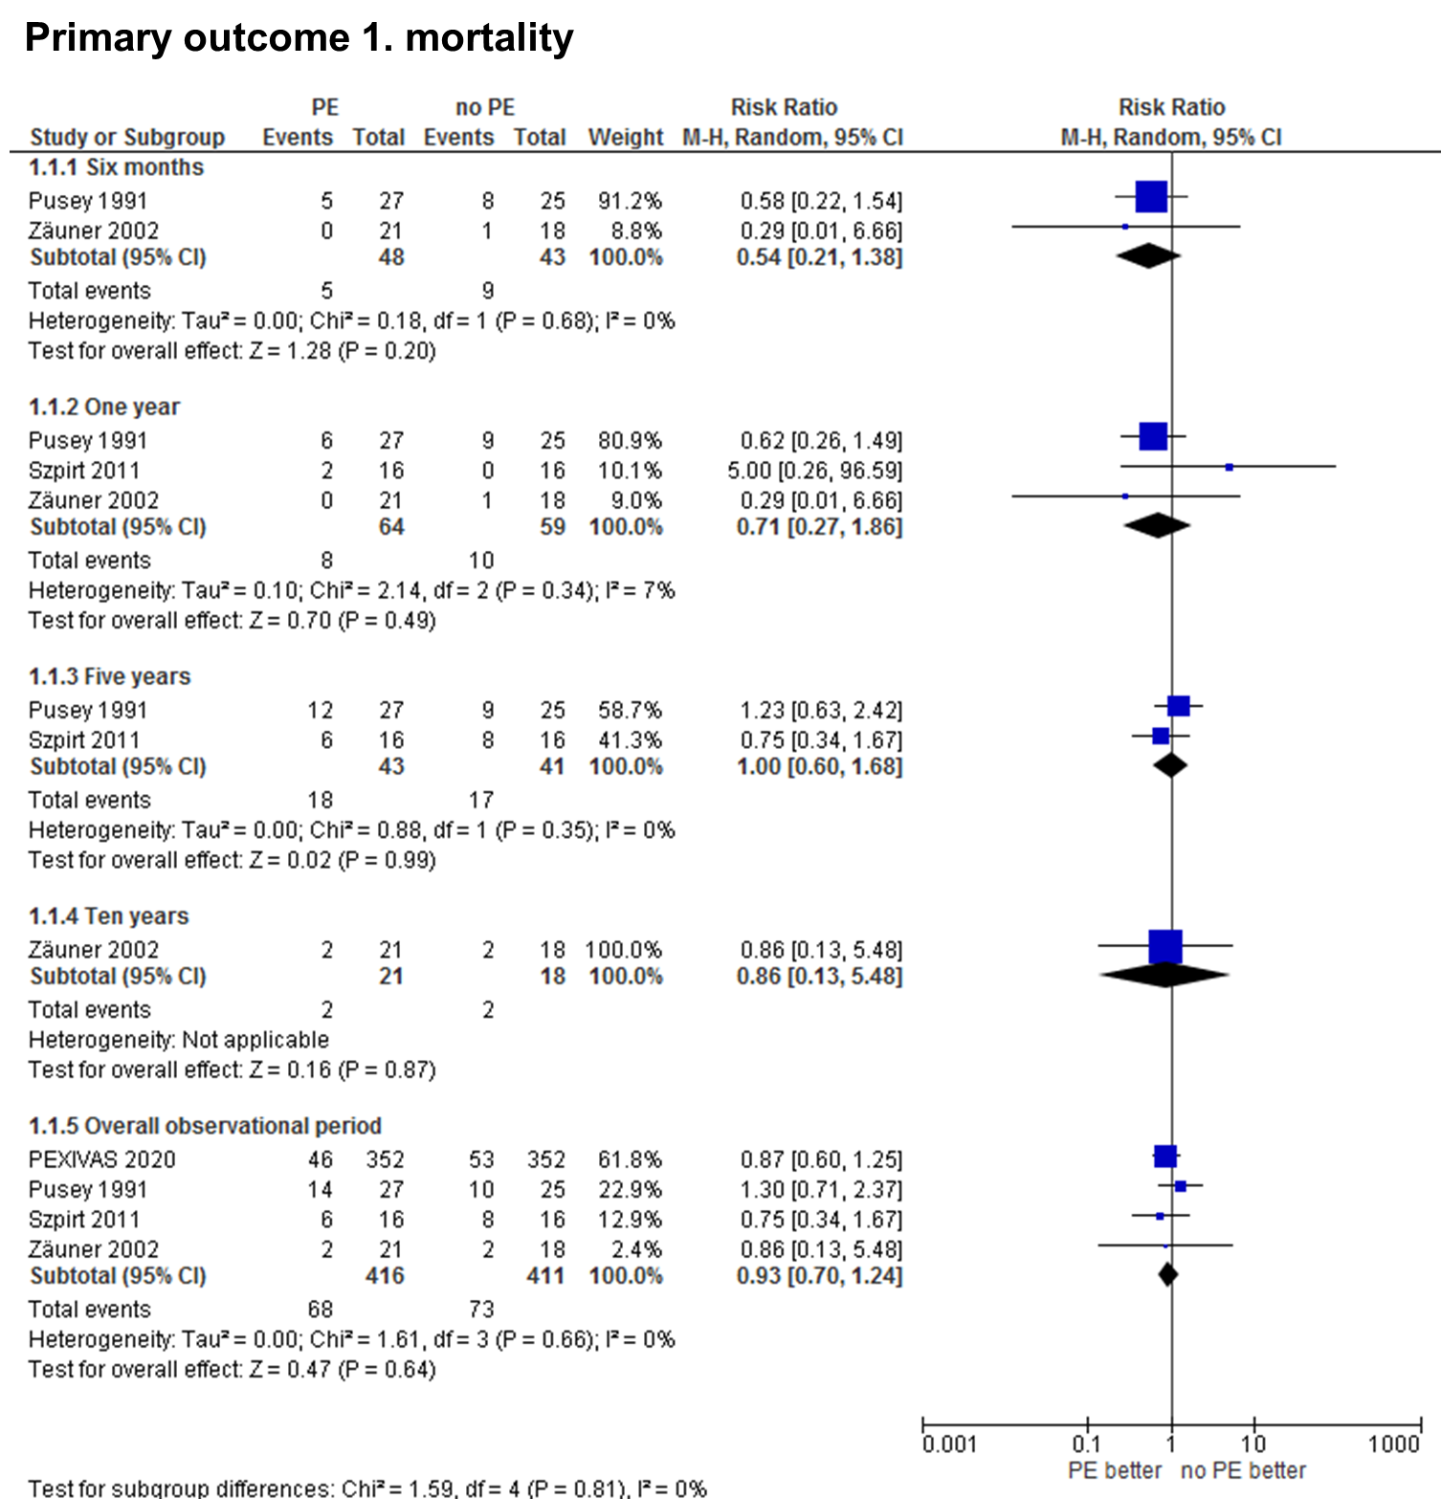
Supplementary figure S1. Forest plot of mortality in patients with plasma exchange (PE) or no plasma exchange.

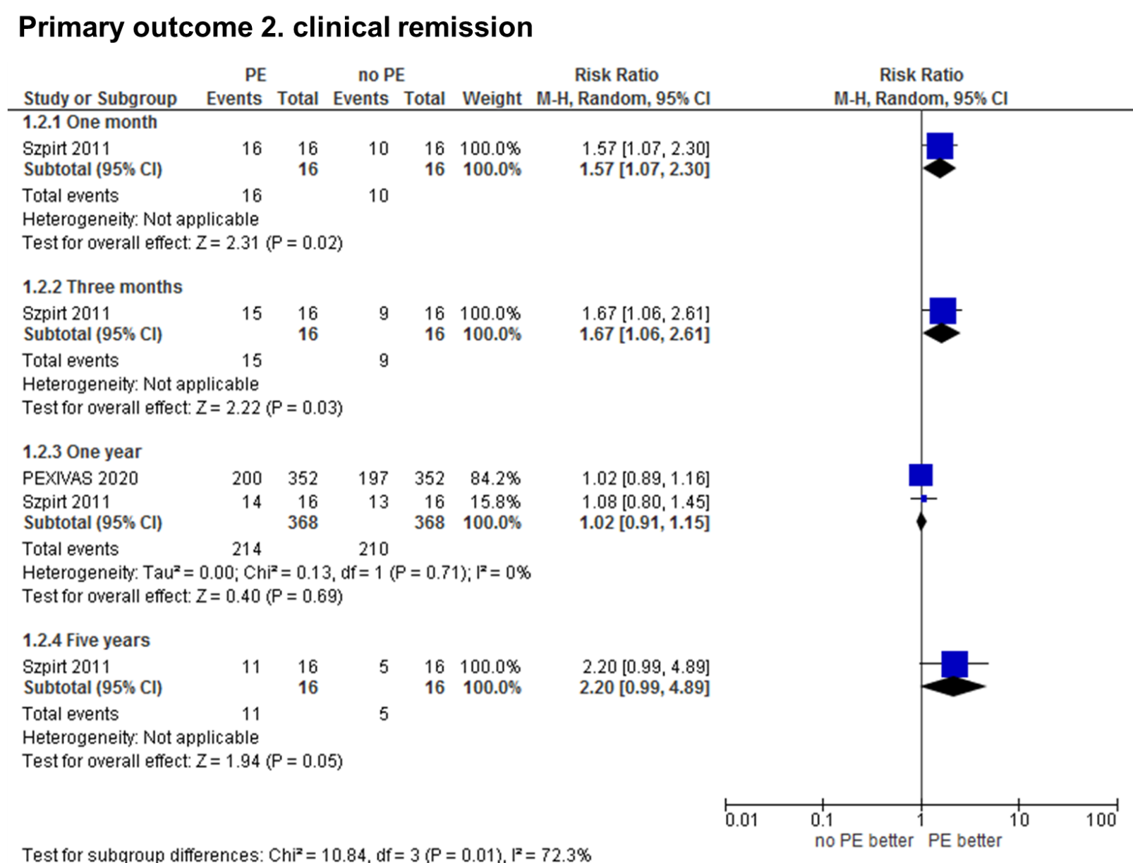
Supplementary figure S2. Forest plot of clinical remission in patients with plasma exchange (PE) or no plasma exchange.

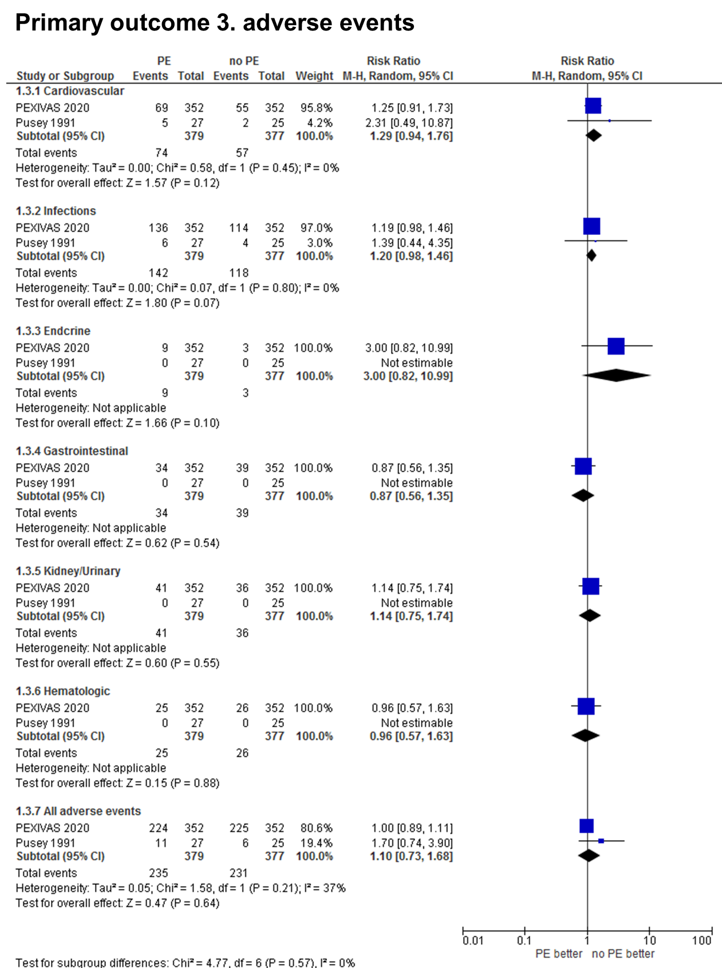
Supplementary figure S3. Forest plot of adverse events in patients with plasma exchange (PE) or no plasma exchange.

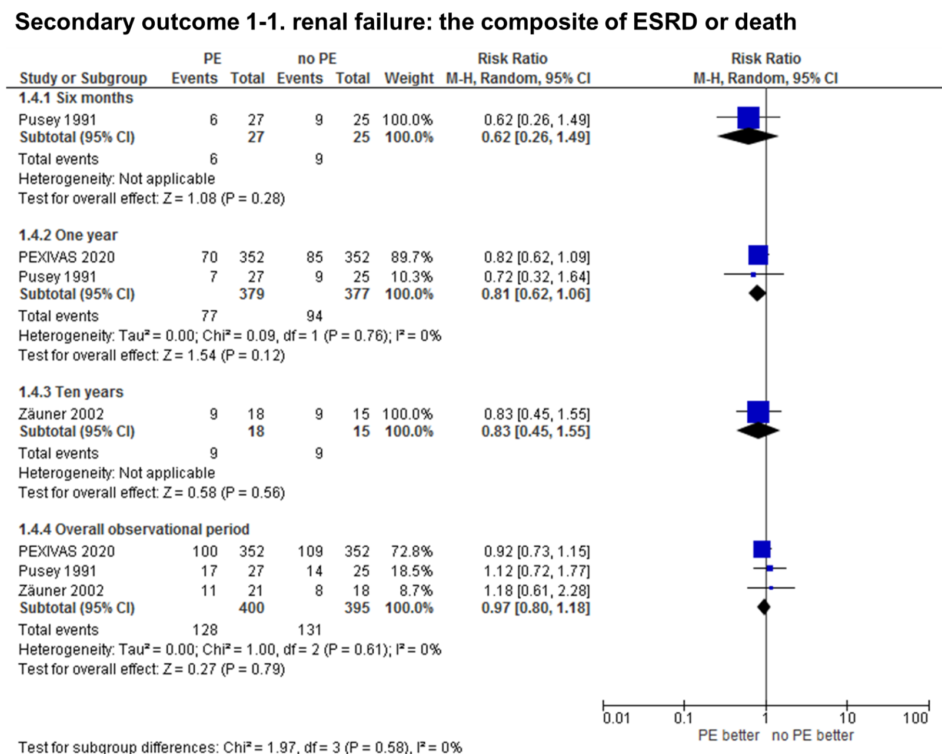
Supplementary figure S4. Forest plot of the composite of end-stage renal disease (ESRD) in patients with plasma exchange (PE) or no plasma exchange.

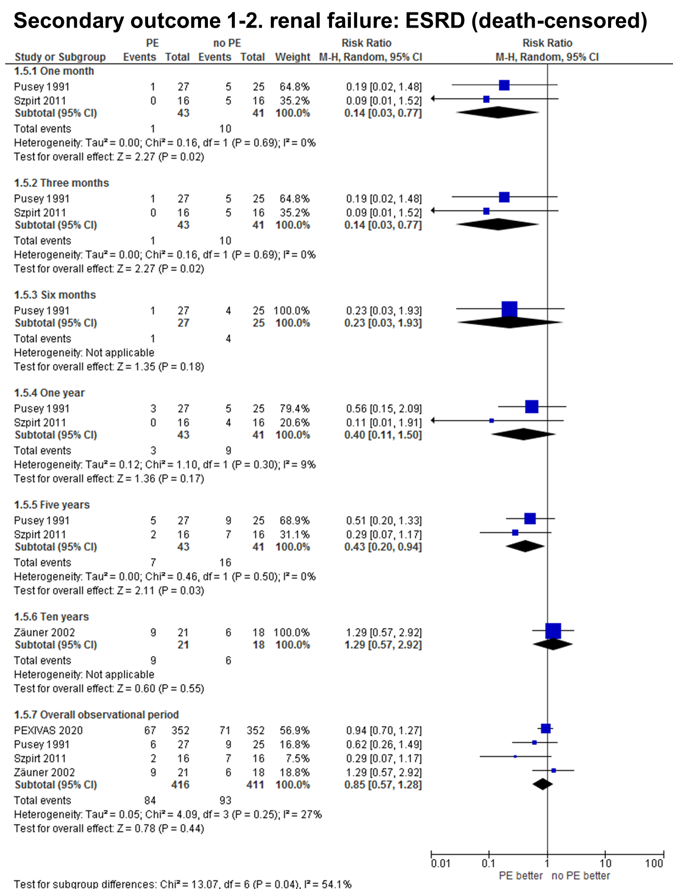
Supplementary figure S5. Forest plot of end-stage renal disease (ESRD) (death-censored) in patients with plasma exchange (PE) or no plasma exchange.

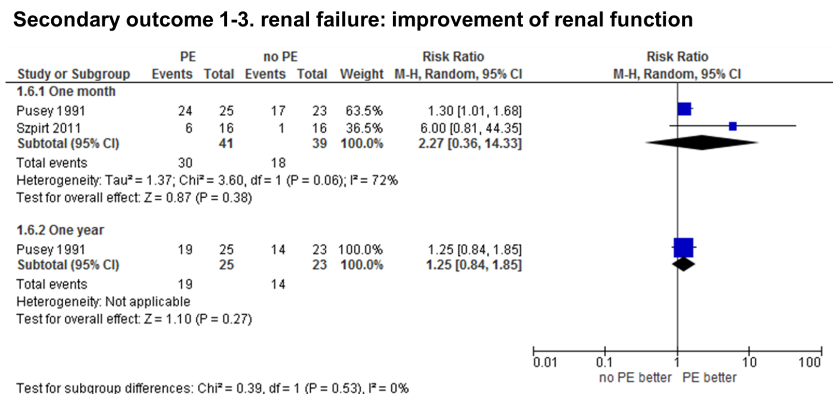
Supplementary figure S6. Forest plot of improvement of renal function in patients with plasma exchange (PE) or no plasma exchange.

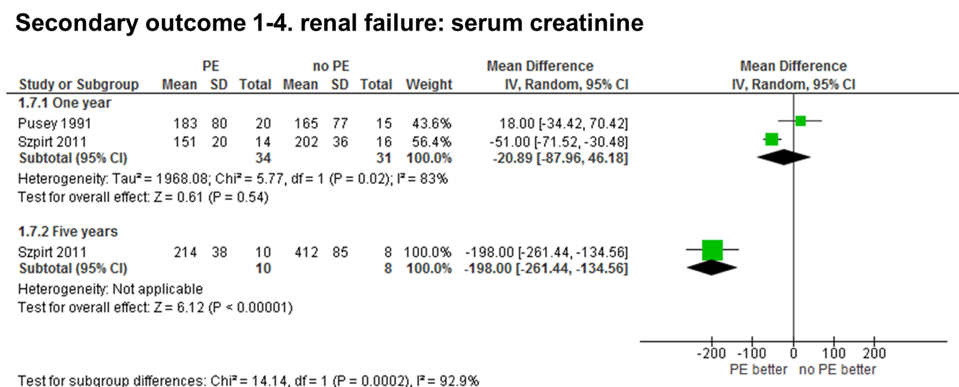
Supplementary figure S7. Forest plot of serum creatinine in patients with plasma exchange (PE) or no plasma exchange. Unit, µmol/L

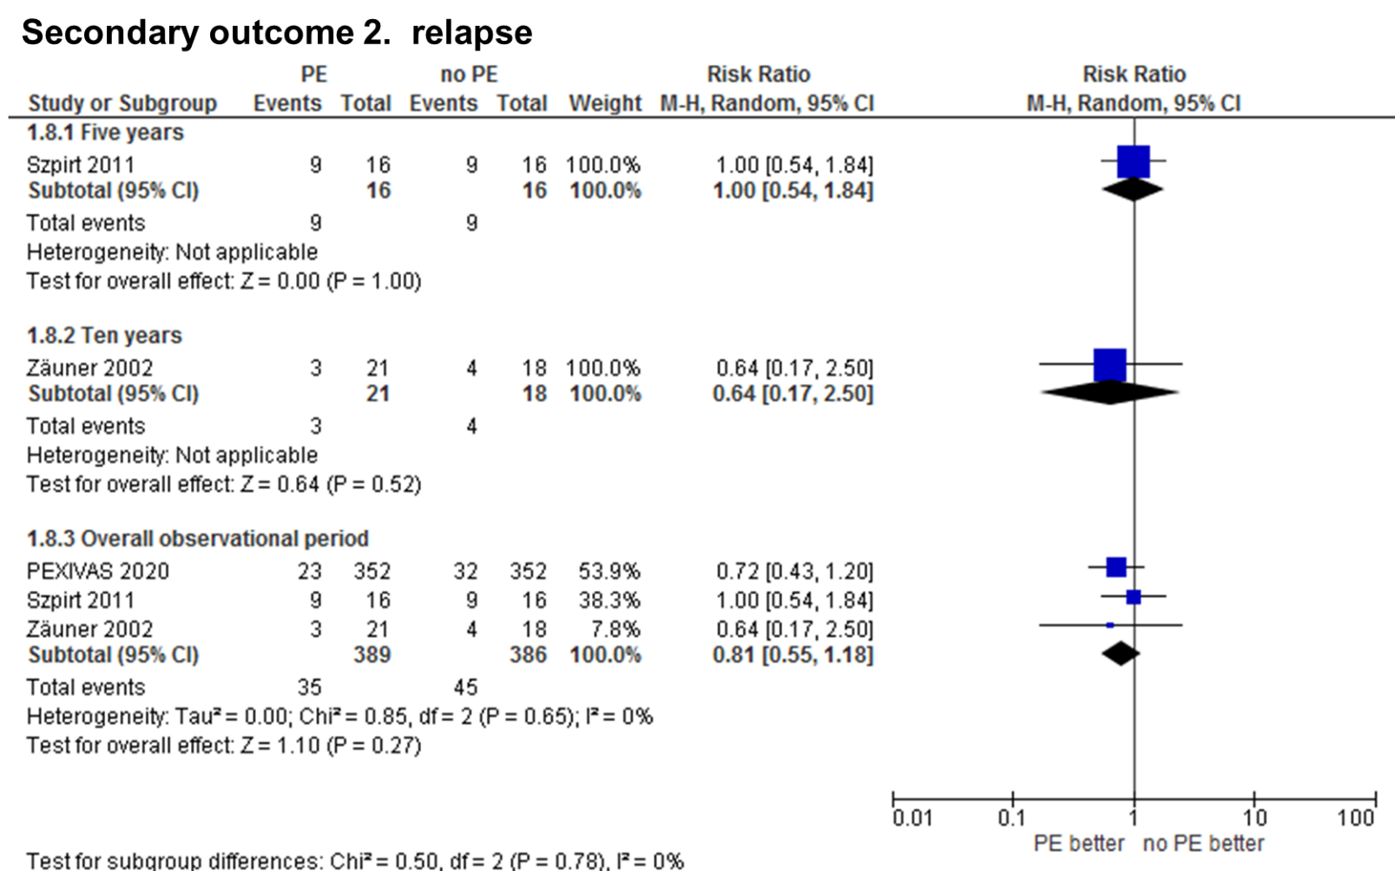
Supplementary figure S8. Forest plot of relapse in patients with plasma exchange (PE) or no plasma exchange.

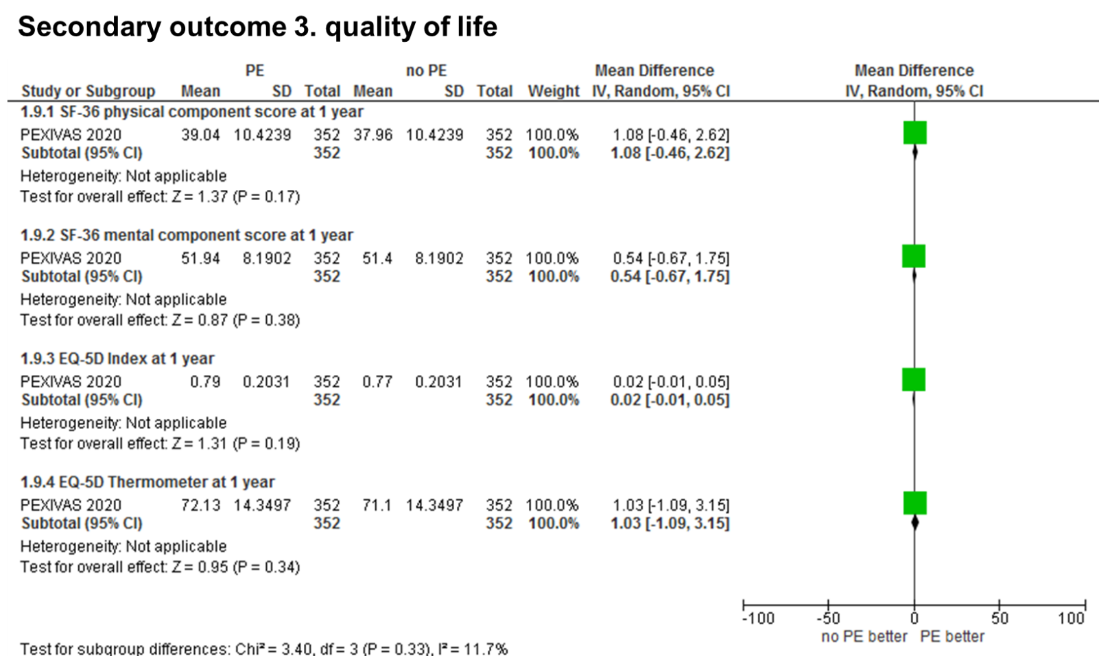
Supplementary figure S9. Forest plot of quality of life in patients with plasma exchange (PE) or no plasma exchange.

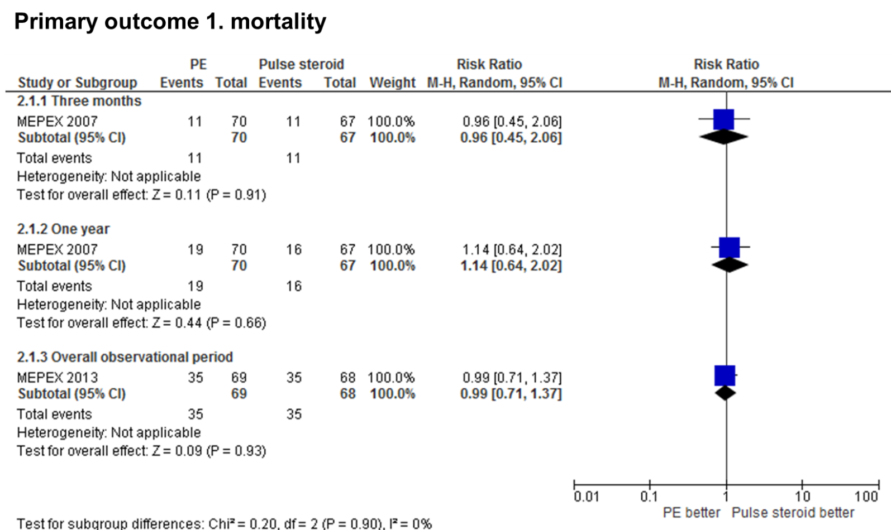
Supplementary figure S10. Forest plot of mortality in patients with plasma exchange (PE) or pulse steroid treatment.

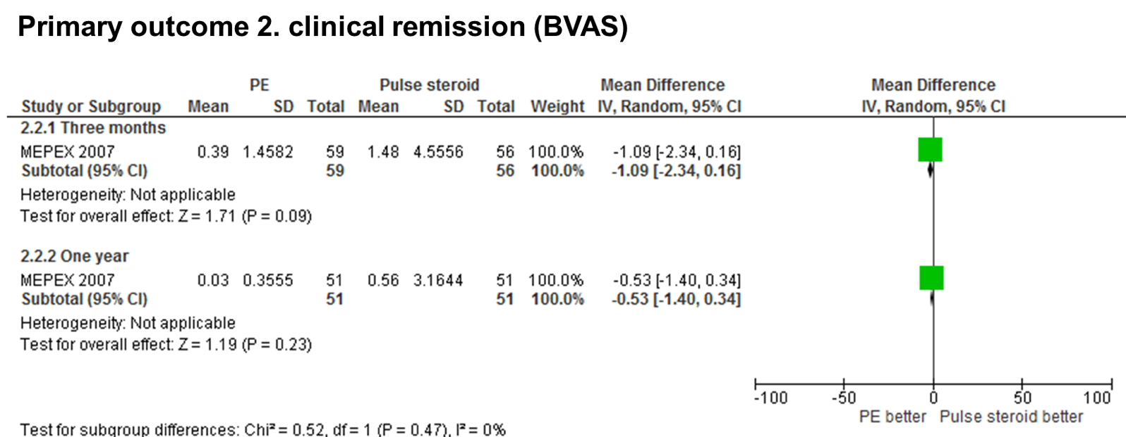
Supplementary figure S11. Forest plot of Birmingham Vasculitis Activity Score (BVAS) in patients with plasma exchange (PE) or pulse steroid treatment. BVAS was compared as continuous value.

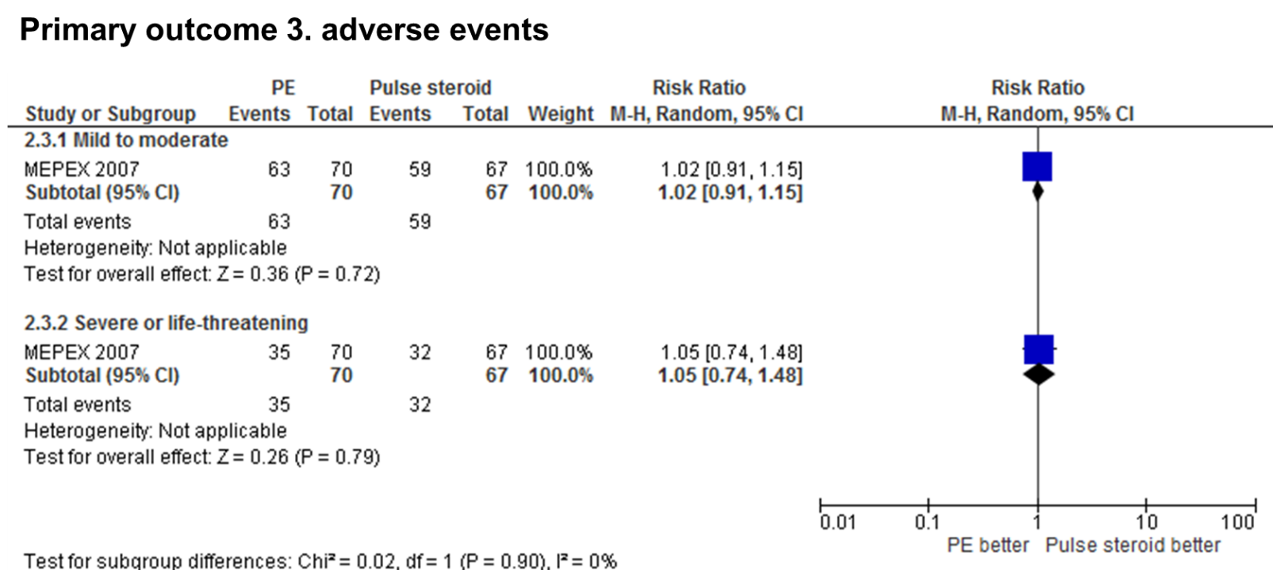
Supplementary figure S12. Forest plot of adverse events in patients with plasma exchange (PE) or pulse steroid treatment.

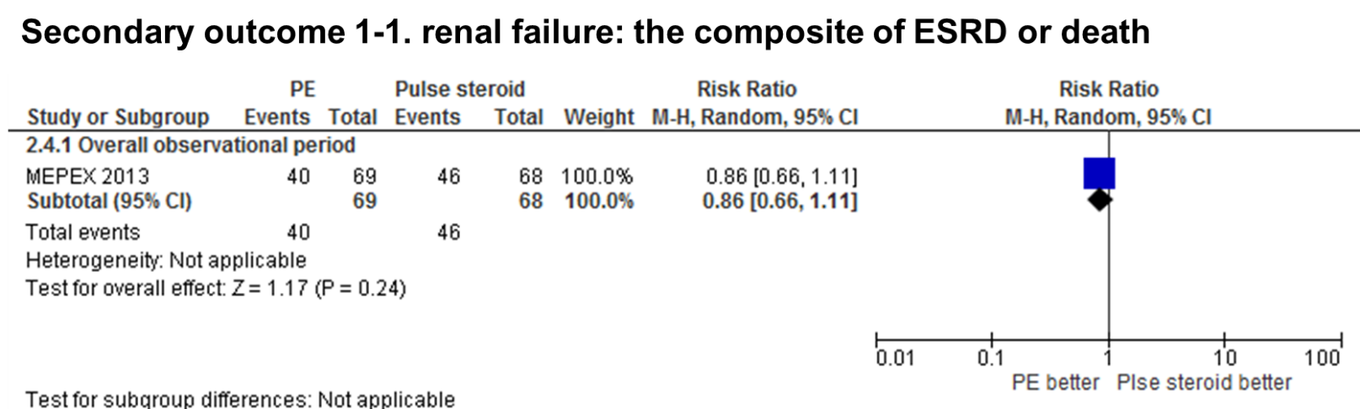
Supplementary figure S13. Forest plot of the composite of end-stage renal disease (ESRD) or death in patients with plasma exchange (PE) or pulse steroid treatment.

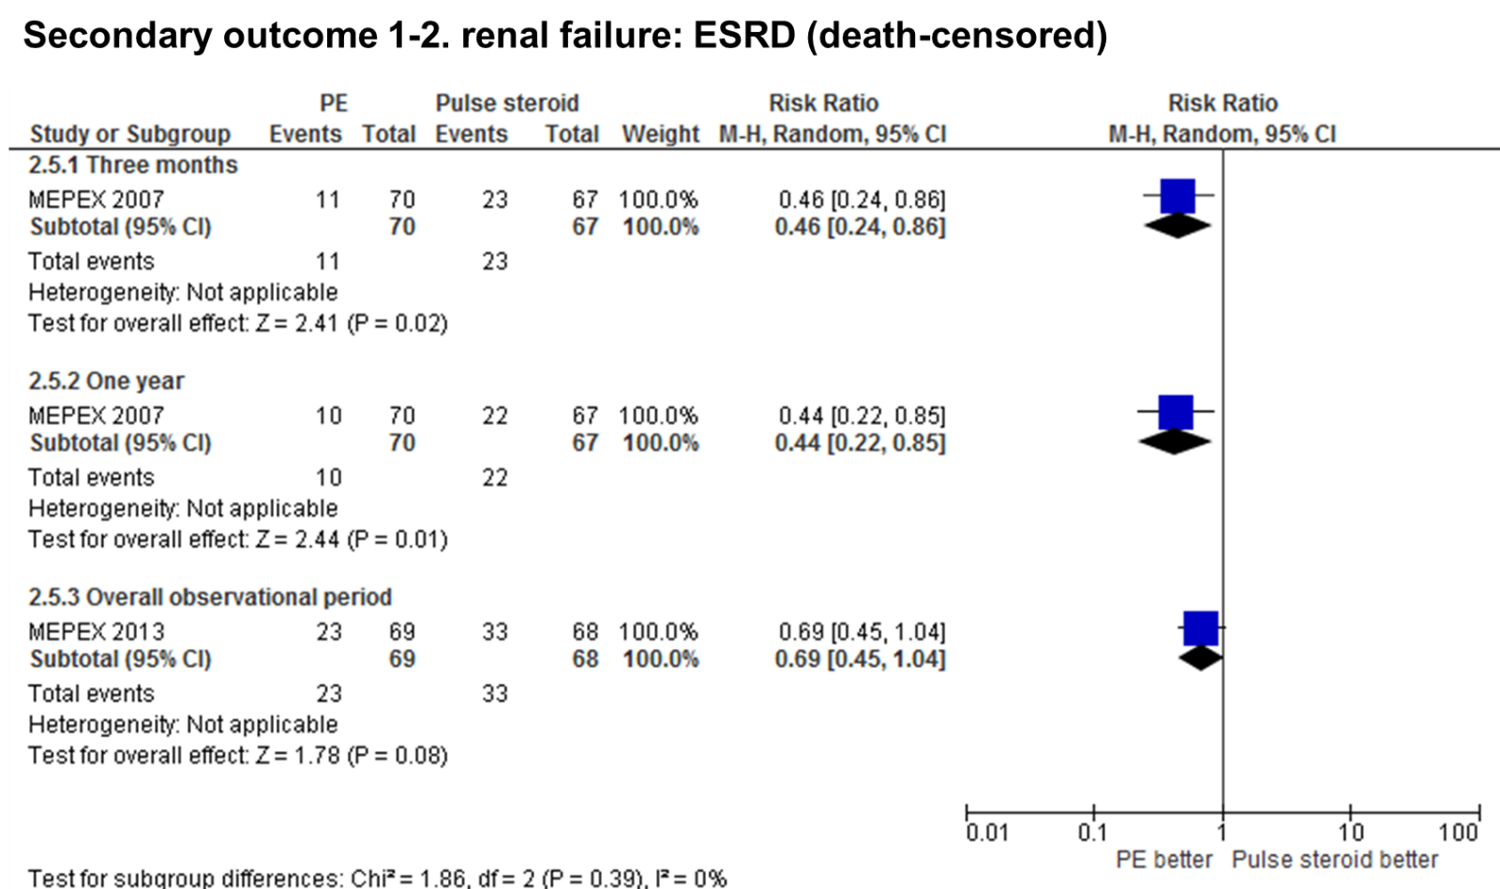
Supplementary figure S14. Forest plot of end-stage renal disease (ESRD) (death-censored) in patients with plasma exchange (PE) or pulse steroid treatment.

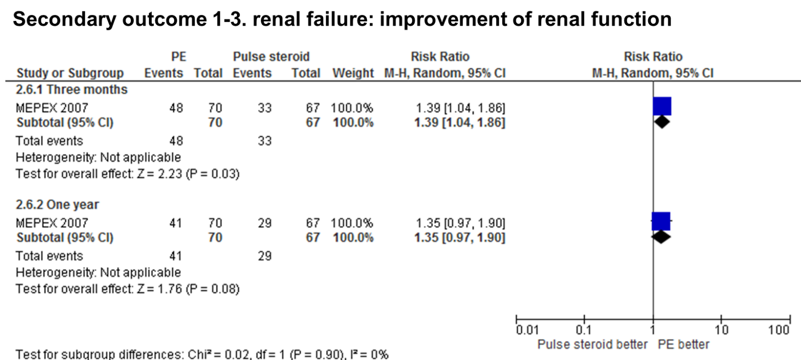
Supplementary figure S15. Forest plot of improvement of renal function in patients with plasma exchange (PE) or pulse steroid treatment.

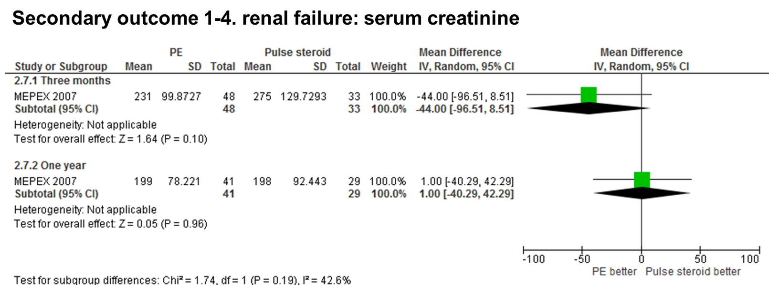
Supplementary figure S16. Forest plot of serum creatinine in patients with plasma exchange (PE) or pulse steroid treatment. Unit, µmol/L

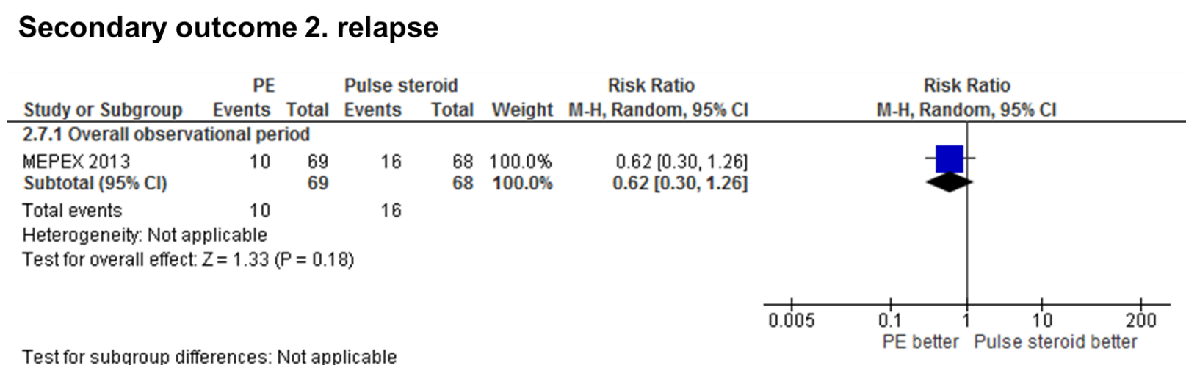
Supplementary figure S17. Forest plot of relapse in patients with plasma exchange (PE) or pulse steroid treatment.

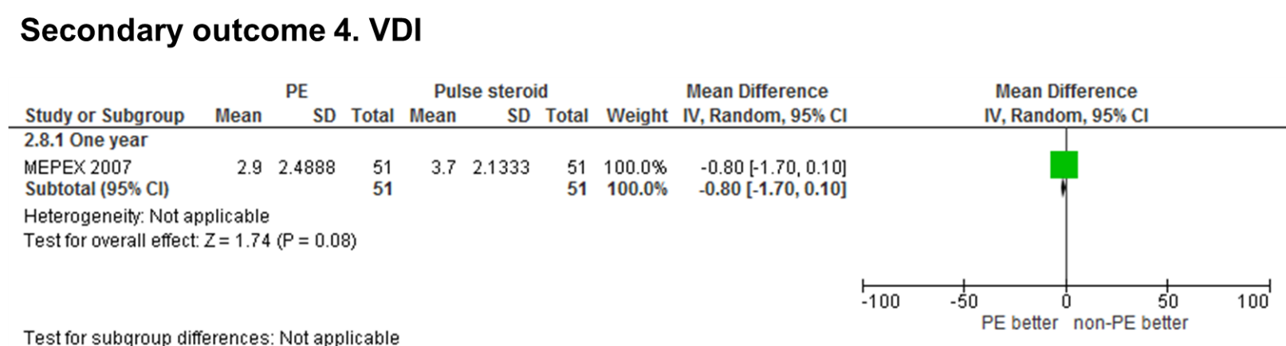
Supplementary figure S18. Forest plot of vasculitis damage index (VDI) in patients with plasma exchange (PE) or pulse steroid treatment.

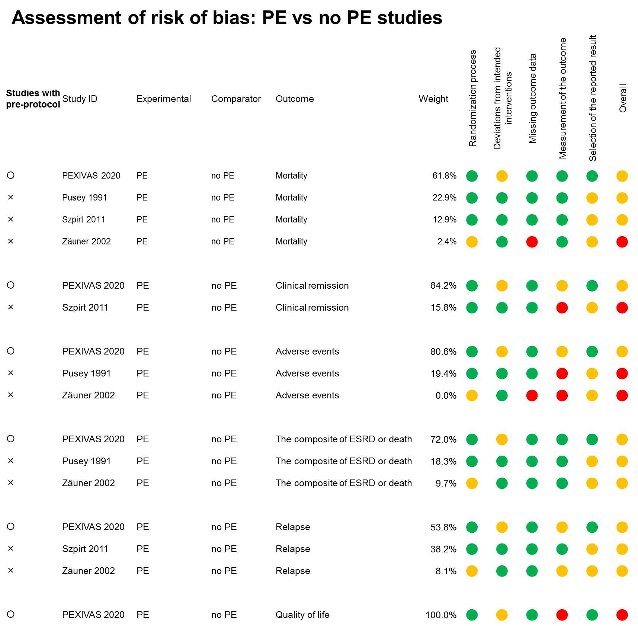

Supplementary figure S19. Assessment of risk of bias of plasma exchange (PE) vs no PE studies, using the Cochrane 'Risk of bias' tool 2. Green circle, low risk of bias; Yellow circle, some concerns; Red circle, high risk of bias

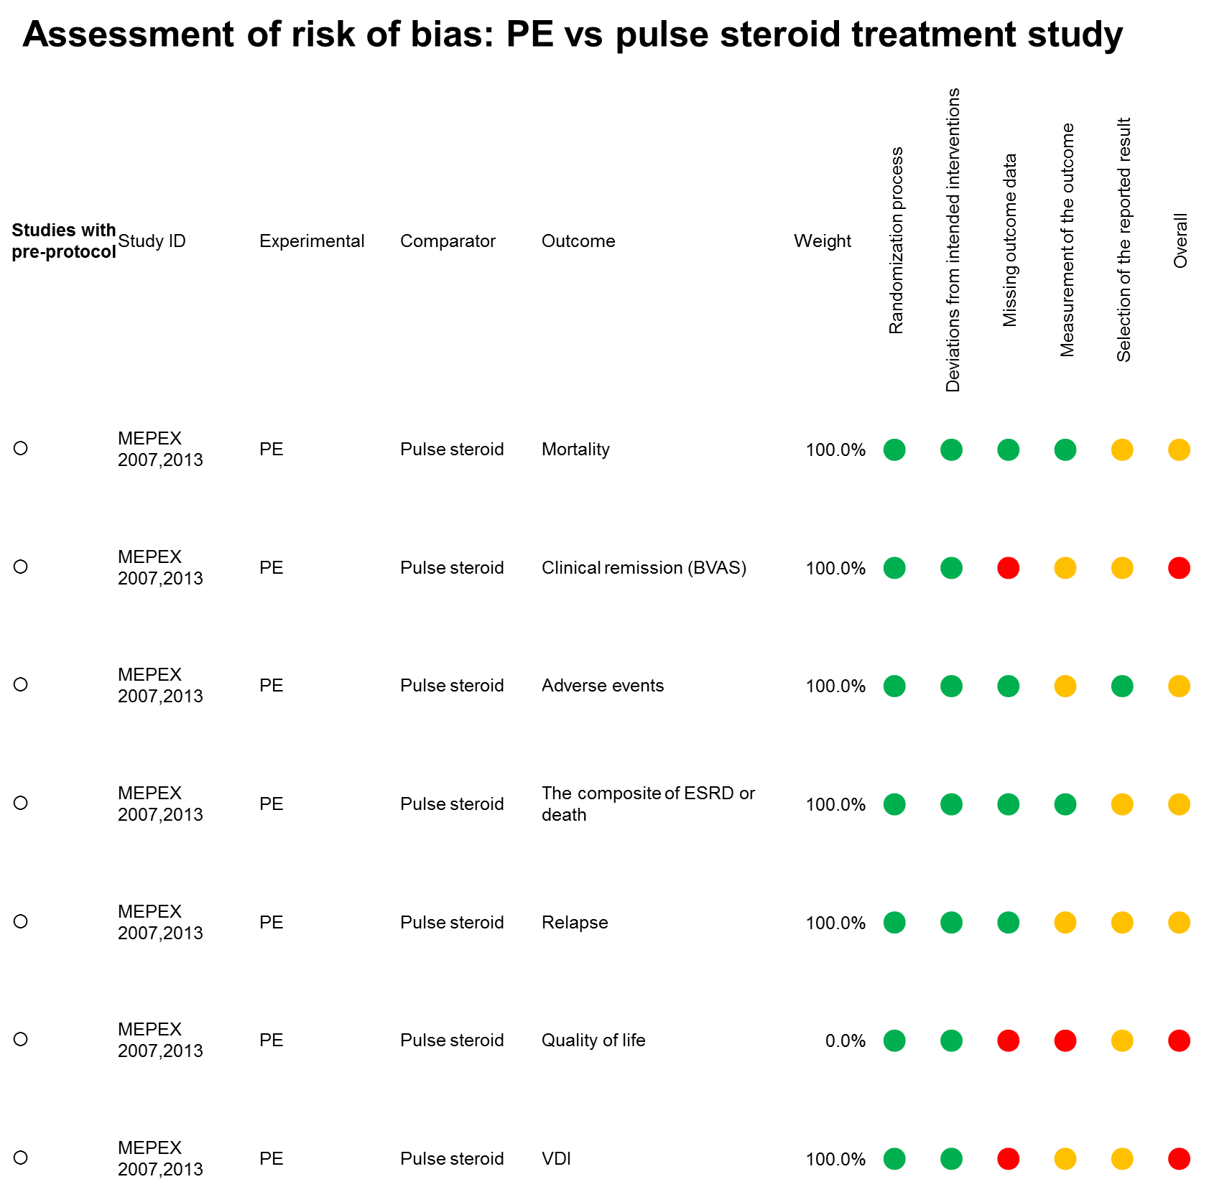

Supplementary figure S20. Assessment of risk of bias of plasma exchange (PE) vs pulse steroid treatment study, using the Cochrane 'Risk of bias' tool 2. Green circle, low risk of bias; Yellow circle, some concerns; Red circle, high risk of bias

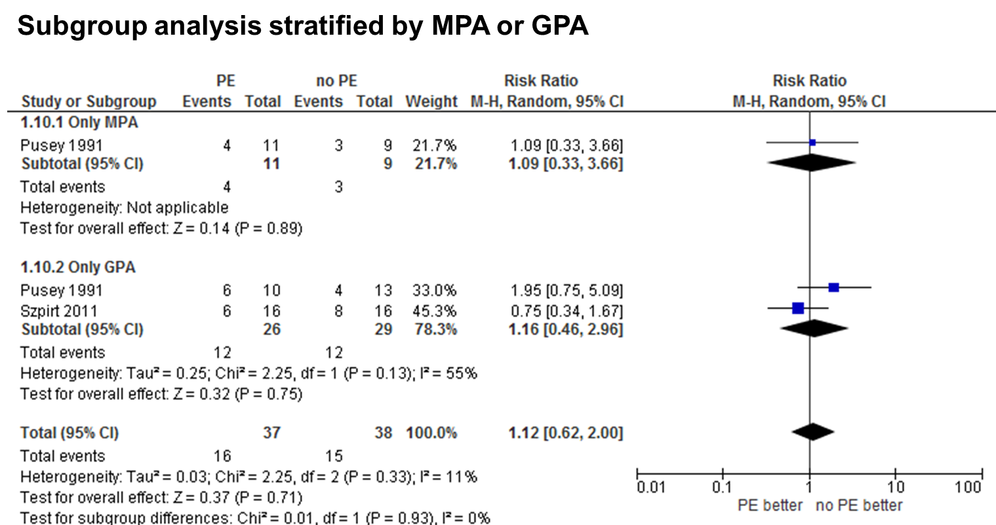
Supplementary figure S21. Subgroup analysis considering mortality in patients with plasma exchange (PE) or no PE, stratified by only patients suffered from microscopic polyangiitis (MPA) or granulomatosis with polyangiitis (GPA).

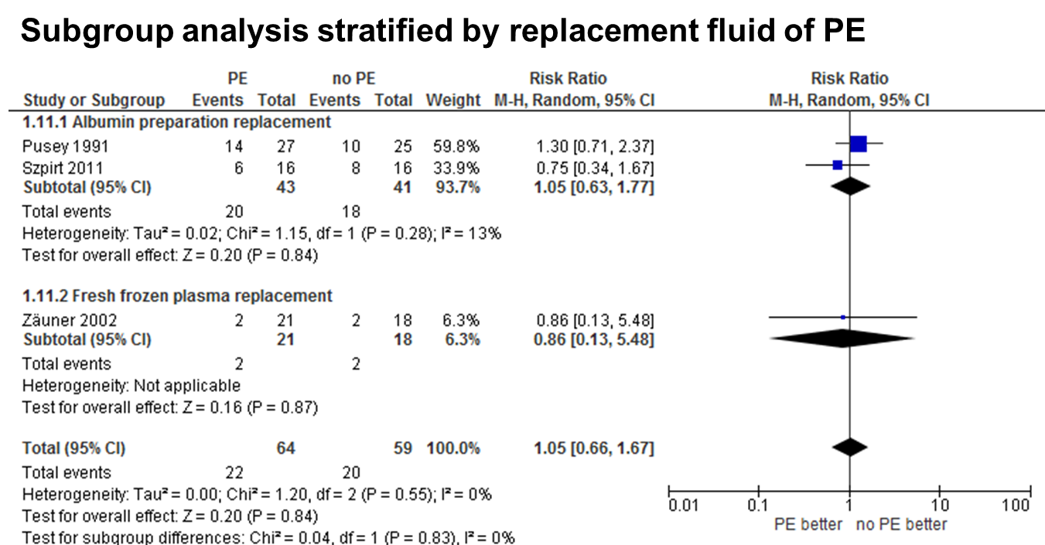

Supplementary figure S22. Subgroup analysis considering mortality in patients with plasma exchange (PE) or no PE, stratified by PE replacement fluid, albumin preparation or fresh frozen plasma.

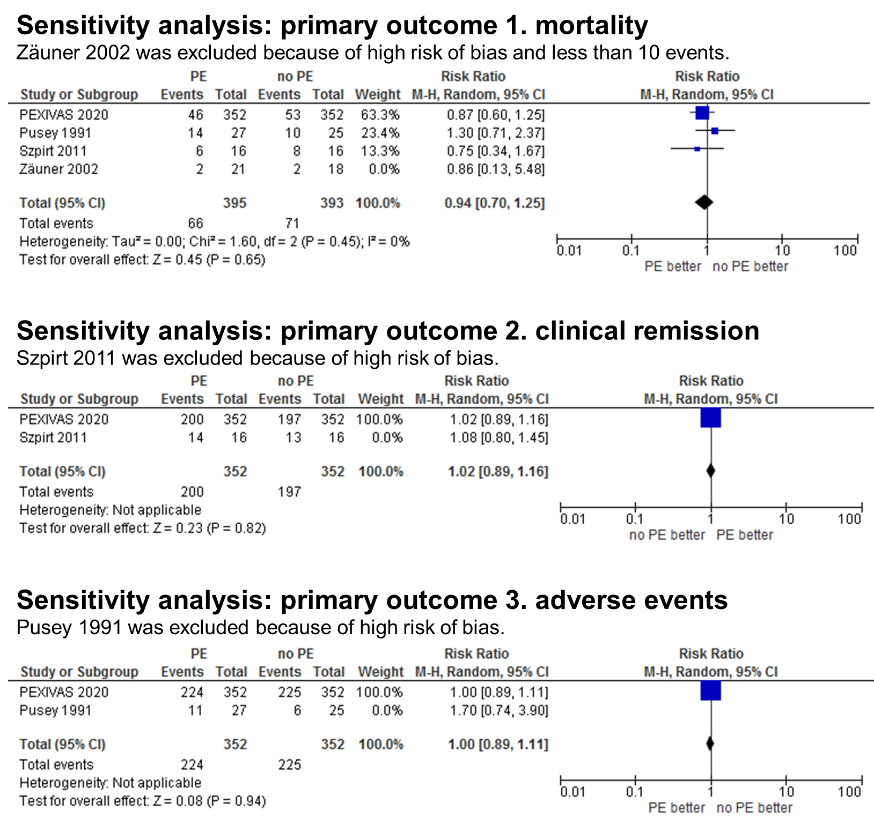
Supplementary figure S23. Results of sensitivity analysis in PE vs no PE studies: exclusion of studies at high risk of bias or trials with ≤10 events. Similar results were observed between the primary analysis and sensitivity analysis.

Supplementary table S2. Sensitivity analysis comparing fixed-effect pooled estimates or 95% CIs versus random-effect pooled estimates or 95% CIs in PE vs no PE studies
Mortality
Random-effect model | RR 0.93 (95% CI, 0.70–1.24)
Fixed-effect model | RR 0.92 (95% CI, 0.68–1.23)
Clinical remission
Random-effect model | RR 1.02 (95% CI, 0.91–1.15)
Fixed-effect model | RR 1.02 (95% CI, 0.90–1.15)
Adverse events
Random-effect model | RR 1.10 (95% CI, 0.73–1.68)
Fixed-effect model | RR 1.01 (95% CI, 0.91–1.13)
Similar results were observed between fixed-effect and random-effect models.

