Additional file 4. MMAT Version 2018
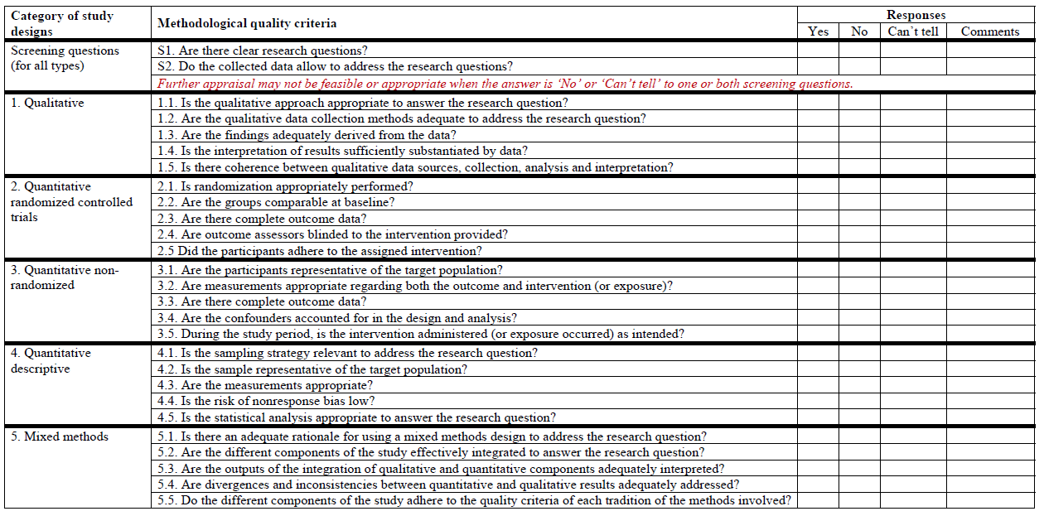
(Quality assessment found below)

 | Qualitative studies |  |  |  |  | Randomised controlled trials |  |  |  |  | Non-randomised studies |  |  |  |  | Quantitative descriptive studies |  |  |  |  | Mixed methods studies
First Author (Year) | 1.1 | 1.2 | 1.3 | 1.4 | 1.5 | 2.1 | 2.2 | 2.3 | 2.4 | 2.5 | 3.1 | 3.2 | 3.3 | 3.4 | 3.5 | 4.1 | 4.2 | 4.3 | 4.4 | 4.5 | 5.1 | 5.2 | 5.3 | 5.4 | 5.5 | Score  (%)
Al-Azzam (2012)  [36] |  |  |  |  |  |  |  |  |  |  |  |  |  |  |  | Yes | Yes | Yes | Yes | Yes |  |  |  |  |  | 100
Bonfait (2010)  [37] |  |  |  |  |  |  |  |  |  |  |  |  |  |  |  | Can’t tell | Yes | Yes | Can't tell | Yes |  |  |  |  |  | 60
Brink (2017)  [45] |  |  |  |  |  |  |  |  |  |  | Yes | Yes | Yes | No | Yes |  |  |  |  |  |  |  |  |  |  | 80
Broom  (2018)  [38] | Yes | Yes | Yes | Yes | Yes |  |  |  |  |  |  |  |  |  |  |  |  |  |  |  |  |  |  |  |  | 100
Broom  (2018)  [39] | Yes | Yes | Yes | Yes | Yes |  |  |  |  |  |  |  |  |  |  |  |  |  |  |  |  |  |  |  |  | 100
Bryson (2015)  [46] |  |  |  |  |  |  |  |  |  |  | Yes | Yes | Yes | Can't tell | Yes |  |  |  |  |  |  |  |  |  |  | 80
Cameron  (2015)  [47] |  |  |  |  |  |  |  |  |  |  | Yes | Yes | Yes | Can't tell | Yes | Yes | Yes | Yes | Can't tell | Yes |  |  |  |  |  | 80
Carles  (2006)  [48] |  |  |  |  |  |  |  |  |  |  | Yes | Yes | Yes | Yes | Yes |  |  |  |  |  |  |  |  |  |  | 100
Caruso  (2017)  [49] |  |  |  |  |  |  |  |  |  |  | Yes | Yes | Can't tell | Yes | Yes |  |  |  |  |  |  |  |  |  |  | 80
Chen (2018)  [40] |  |  |  |  |  |  |  |  |  |  |  |  |  |  |  | Yes | Can't tell | Yes | No | Yes |  |  |  |  |  | 60
Collier (1998)  [50] |  |  |  |  |  |  |  |  |  |  | Yes | Yes | Yes | Can't  tell | Yes |  |  |  |  |  |  |  |  |  |  | 80
Conaty (2018)  [51] |  |  |  |  |  |  |  |  |  |  | Yes | Yes | Yes | Can't tell | Yes |  |  |  |  |  |  |  |  |  |  | 80
De Almeida  (2012)  [52] |  |  |  |  |  |  |  |  |  |  | Yes | Yes | Yes | Can't tell | Yes |  |  |  |  |  |  |  |  |  |  | 80
Dimopo-ulou  (2016)  [53] |  |  |  |  |  |  |  |  |  |  | Yes | Yes | Yes | Yes | Yes |  |  |  |  |  |  |  |  |  |  | 100
Garcell  (2017)  [54] |  |  |  |  |  |  |  |  |  |  | Yes | Yes | Yes | Can't tell | Yes |  |  |  |  |  |  |  |  |  |  | 80
Giusti  (2016)  [41] | Yes | Yes | Yes | Yes | Yes |  |  |  |  |  |  |  |  |  |  | Yes | Yes | Yes | Yes | Yes | Yes | Yes | Yes | Yes | Yes | 100
Haynes  (2011)  [55] |  |  |  |  |  |  |  |  |  |  | Yes | Yes | Yes | Can't tell | Yes |  |  |  |  |  |  |  |  |  |  | 80
Hermsen  2008  [56] |  |  |  |  |  |  |  |  |  |  | Yes | Yes | No | No | Yes |  |  |  |  |  |  |  |  |  |  | 60
Hincker  (2008)  [57] |  |  |  |  |  |  |  |  |  |  | Yes | Yes | Yes | Yes | Yes |  |  |  |  |  |  |  |  |  |  | 100
Kao  (2010)  [58] |  |  |  |  |  |  |  |  |  |  | Yes | Yes | Yes | Yes | Yes |  |  |  |  |  |  |  |  |  |  | 100
Kim  (2012)  [59] |  |  |  |  |  |  |  |  |  |  | Yes | Yes | Yes | No | Yes |  |  |  |  |  |  |  |  |  |  | 80
Knox  (2016)  [81] |  |  |  |  |  |  |  |  |  |  | Can't tell | Yes | Yes | Can't tell | Yes |  |  |  |  |  |  |  |  |  |  | 60
Kritchev  -sky  (2008)  [60] |  |  |  |  |  | Yes | Yes | Yes | Can't tell | Yes |  |  |  |  |  |  |  |  |  |  |  |  |  |  |  | 80
Lingard (2011)  [61] |  |  |  |  |  |  |  |  |  |  | Yes | Yes | No | Can't tell | Yes |  |  |  |  |  |  |  |  |  |  | 60
Madubu  -eze  (2015)  [42] |  |  |  |  |  |  |  |  |  |  |  |  |  |  |  | Yes | Yes | Yes | Can't tell | Yes |  |  |  |  |  | 80
Nair  (2010)  [63] |  |  |  |  |  |  |  |  |  |  | Yes | Yes | Yes | Yes | Yes |  |  |  |  |  |  |  |  |  |  | 100
Nair  (2011)  [62] |  |  |  |  |  |  |  |  |  |  | Yes | Yes | Yes | Can't tell | Yes |  |  |  |  |  |  |  |  |  |  | 80
Nemeth  (2010)  [82] |  |  |  |  |  |  |  |  |  |  | Yes | Yes | Yes | Can't tell | Yes |  |  |  |  |  |  |  |  |  |  | 80
Nobile  (2014)  [43] |  |  |  |  |  |  |  |  |  |  | Yes | Yes | Yes | Can't tell | Yes | Yes | Can't tell | Can't tell | Yes | Yes |  |  |  |  |  | 70
O’Reilly  (2006)  [64] |  |  |  |  |  |  |  |  |  |  | Yes | Yes | Yes | No | Yes |  |  |  |  |  |  |  |  |  |  | 80
Ozgun  (2010)  [65] |  |  |  |  |  |  |  |  |  |  | Yes | Yes | Yes | Can't tell | Yes |  |  |  |  |  |  |  |  |  |  | 80
Parker  (2007)  [66] |  |  |  |  |  |  |  |  |  |  | Yes | Yes | Yes | Can't tell | Yes |  |  |  |  |  |  |  |  |  |  | 80
Putnam  (2015)  [83] |  |  |  |  |  |  |  |  |  |  | Yes | Yes | Yes | Can't tell | Yes |  |  |  |  |  |  |  |  |  |  | 80
Ribed  (2018)  [67] |  |  |  |  |  |  |  |  |  |  | Yes | Yes | No | Yes | Yes |  |  |  |  |  |  |  |  |  |  | 80
Riggi  (2014)  [68] |  |  |  |  |  |  |  |  |  |  | Yes | Yes | Yes | Yes | Yes |  |  |  |  |  |  |  |  |  |  | 100
Ritchie  (2004)  [69] |  |  |  |  |  |  |  |  |  |  | Yes | Yes | No | Yes | Yes |  |  |  |  |  |  |  |  |  |  | 80
Rosenb  -erg  (2008)  [70] |  |  |  |  |  |  |  |  |  |  | Yes | Yes | No | Can't tell | No |  |  |  |  |  |  |  |  |  |  | 40
Schwann  (2011)  [71] |  |  |  |  |  |  |  |  |  |  | Yes | Yes | Yes | No | Yes |  |  |  |  |  |  |  |  |  |  | 80
Shapiro  (2018)  [72] |  |  |  |  |  |  |  |  |  |  | Yes | Yes | Can't tell | Can't tell | Yes |  |  |  |  |  |  |  |  |  |  | 60
Suther  -land  (2014)  [73] |  |  |  |  |  |  |  |  |  |  | Yes | Yes | Yes | Can't tell | Yes |  |  |  |  |  |  |  |  |  |  | 80
Tan  (2006)  [44] | Yes | Yes | Yes | Yes | Yes |  |  |  |  |  |  |  |  |  |  |  |  |  |  |  |  |  |  |  |  | 100
Telfah  (2015)  [74] |  |  |  |  |  |  |  |  |  |  | Yes | Yes | Yes | Can't tell | Yes |  |  |  |  |  |  |  |  |  |  | 80
Wax  (2007)  [75] |  |  |  |  |  |  |  |  |  |  | Yes | Yes | Yes | No | Yes |  |  |  |  |  |  |  |  |  |  | 80
Whitman  (2008)  [76] |  |  |  |  |  |  |  |  |  |  | Yes | Yes | Yes | Yes | Yes |  |  |  |  |  |  |  |  |  |  | 100
Willems  (2005)  [77] |  |  |  |  |  |  |  |  |  |  | Yes | Yes | Yes | Yes | Yes |  |  |  |  |  |  |  |  |  |  | 100
Zanetti  (2003)  [78] |  |  |  |  |  | Yes | Can't tell | Yes | Yes | Yes |  |  |  |  |  |  |  |  |  |  |  |  |  |  |  | 80
Zanotto  (2006)  [79] |  |  |  |  |  |  |  |  |  |  | Yes | Yes | Yes | Can't tell | Can't tell |  |  |  |  |  |  |  |  |  |  | 60
Zhou  (2016)  [80] |  |  |  |  |  |  |  |  |  |  | Yes | Yes | Yes | Yes | Yes |  |  |  |  |  |  |  |  |  |  | 100

