Supplementary file 1.
Electronic search details
PubMed
(“emphysema” OR “barotrauma” OR “pneumothorax” OR “pneumomediastinum”) AND (“COVID-19” OR “SARS-CoV-2”)
Hits: 322
https://pubmed.ncbi.nlm.nih.gov/?term=%28%22emphysema%22+OR+%22barotrauma%22+OR+%22pneumothorax%22+OR+%22pneumomediastinum%22%29+AND+%28%22COVID-19%22+OR+%22SARS-CoV-2%22%29
PubMed Central
(“emphysema” OR “barotrauma” OR “pneumothorax” OR “pneumomediastinum”) AND (“COVID-19” OR “SARS-CoV-2”)
Hits: 2884
https://www.ncbi.nlm.nih.gov/pmc/?term=(%E2%80%9Cemphysema%E2%80%9D+OR+%E2%80%9Cbarotrauma%E2%80%9D+OR+%E2%80%9Cpneumothorax%E2%80%9D+OR+%E2%80%9Cpneumomediastinum%E2%80%9D)+AND+(%E2%80%9CCOVID-19%E2%80%9D+OR+%E2%80%9CSARS-CoV-2%E2%80%9D)

Embase
('emphysema'/exp OR 'emphysema' OR 'barotrauma'/exp OR 'barotrauma' OR 'pneumothorax'/exp OR 'pneumothorax' OR 'pneumomediastinum'/exp OR 'pneumomediastinum') AND ('covid-19'/exp OR 'covid-19' OR 'sars-cov-2'/exp OR 'sars-cov-2')
Hits: 740
https://www.embase.com/#advancedSearch/resultspage/history.1/page.1/25.items/orderby.date/source

Scopus
(“emphysema” OR “barotrauma” OR “pneumothorax” OR “pneumomediastinum”) AND (“COVID-19” OR “SARS-CoV-2”)
Hits: 542
https://www.scopus.com/results/results.uri?src=s&sot=b&sdt=b&origin=searchbasic&rr=&sl=118&s=TITLE-ABS-KEY((%E2%80%9Cemphysema%E2%80%9D%20OR%20%E2%80%9Cbarotrauma%E2%80%9D%20OR%20%E2%80%9Cpneumothorax%E2%80%9D%20OR%20%E2%80%9Cpneumomediastinum%E2%80%9D)%20AND%20(%E2%80%9CCOVID-19%E2%80%9D%20OR%20%E2%80%9CSARS-CoV-2%E2%80%9D))&searchterm1=(%E2%80%9Cemphysema%E2%80%9D%20OR%20%E2%80%9Cbarotrauma%E2%80%9D%20OR%20%E2%80%9Cpneumothorax%E2%80%9D%20OR%20%E2%80%9Cpneumomediastinum%E2%80%9D)%20AND%20(%E2%80%9CCOVID-19%E2%80%9D%20OR%20%E2%80%9CSARS-CoV-2%E2%80%9D)&searchTerms=&connectors=&field1=TITLE_ABS_KEY&fields=

Table 1. JBI critical appraisal of case-control studies
Questions | Miro O[2] et al | Rodriguez-Arciniega TG[8] et al | Udi J[9] et al
Were the groups comparable other than the presence of disease in cases of the absence of disease in controls? | Unclear | No | Unclear
Were cases and controls matched appropriately? | Unclear | No | Unclear
Were the same criteria used for the identification of cases and controls? | Yes | Yes | Yes
Was exposure measured in a standard, valid and reliable way? | Yes | Yes | Yes
Was exposure measured in the same way for cases and controls? | Yes | Yes | Yes
Were confounding factors identified? | Unclear | Unclear | Unclear
Were strategies to deal with confounding factors stated? | Unclear | Unclear | Unclear
Were outcomes assessed in a standard, valid and reliable way for cases and controls? | Yes | Yes | Yes
Was the exposure period of interest long enough to be meaningful? | Yes | Yes | Yes
Was appropriate statistical analysis used? | Yes | Yes | Yes

Table 2. JBI critical appraisal of cohort studies
Questions | Belletti A[10] et al | Elsaaran H[11] et al | Jones E[12] et al | Kahn MR[13] et al | Lemmers DHL[14] et al | Loffi M[15] et al | McGuiness G[1] et al | Ozdemir S[16] et al | Ozsoy IE[17] et al | Swain SK[18] et al
Were the two groups similar and recruited from the same population? | Yes | Yes | Yes | Yes | Yes | Yes | Yes | Yes | Yes | Yes
Were the exposures measured similarly to assign people to both exposed and unexposed groups? | Yes | Yes | Yes | Yes | Yes | Yes | Yes | Yes | Yes | Yes
Was the exposure measured in a valid and reliable way? | Yes | Yes | Yes | Yes | Yes | Yes | Yes | Yes | Yes | Yes
Were confounding factors identified? | No | No | No | No | No | No | No | No | No | No
Were strategies to deal with confounding factors stated? | N/A | N/A | N/A | N/A | N/A | N/A | N/A | N/A | N/A | N/A
Were the groups/participants free of the outcome at the start of the study (or at the moment of exposure)? | Yes | Yes | Yes | Yes | Yes | Yes | Yes | Yes | Yes | Yes
Were the outcomes measured in a valid and reliable way? | Yes | Yes | Yes | Yes | Yes | Yes | Yes | Yes | Yes | Yes
Was the follow up time reported and sufficient to be long enough for outcomes to occur? | Yes | Yes | Yes | Yes | Yes | Yes | Yes | Yes | Yes | Yes
Was follow-up complete, and if not, were the reasons for loss to follow-up described and explored? | Yes | Yes | Yes | Yes | Yes | Yes | Yes | Yes | Yes | Yes
Were strategies to address incomplete follow-up utilized? | N/A | N/A | N/A | N/A | N/A | N/A | N/A | N/A | N/A | N/A
Was appropriate statistical analysis used? | Yes | Yes | Yes | Yes | Yes | Yes | Yes | Yes | Yes | Yes

Table 3. JBI critical appraisal of case series
QUESTION | Tofigh[19] et al. | Wong[20] et al.
1) Were there clear criteria for inclusion in the case series? | No | Yes
2) Was the condition measured in a standard, reliable way for all participants included in the case series? | Yes | Yes
3) Were valid methods used for identification of the condition for all participants included in the case series? | Yes | Yes
4) Did the case series have consecutive inclusion of participants? | No | Yes
5) Did the case series have complete inclusion of participants? | Unclear | Yes
6) Was there clear reporting of the demographics of the participants in the study? | No | No
7) Was there clear reporting of clinical information of the participants? | Yes | Yes
8) Were the outcomes or follow up results of cases clearly reported? | Yes | Yes
9) Was there clear reporting of the presenting site(s)/clinic(s) demographic information? | Yes | Yes
10) Was statistical analysis appropriate? | Yes | Unclear

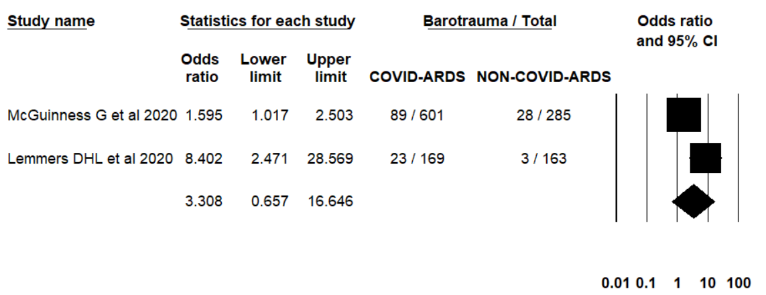
Figure 1. Barotrauma in COVID-19 ARDS vs. Non-COVID ARDS

Figure 2. The proportion of barotrauma in case studies

