SUPPLEMENTARY FILE 3 – Risk of Bias

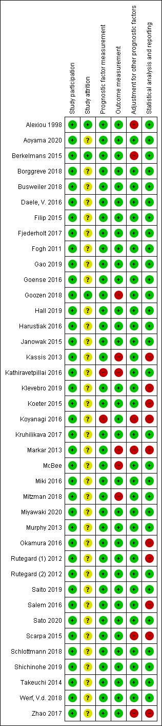
Table S1 - Table showing the classification of study quality of all included studies using the Quality In Prognosis Studies (QUIPS) tool ¹. On the horizontal axis show the different assed domains per study. The vertical axis shows all included studies. The green bullet = low risk of bias, yellow = unclear risk of bias, red = high risk of bias.

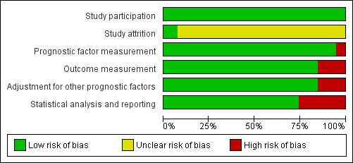
Table S2 – Summary table showing an overview of classification of study quality of all included studies using the QUIPS tool as shown in table S1.
REFERENCES
1. Hayden, J.A., et al., Assessing bias in studies of prognostic factors. Ann Intern Med, 2013. 158(4): p. 280-6.

