SUPPLEMENTARY FILE 4 – Minimally Invasive Esophagectomy

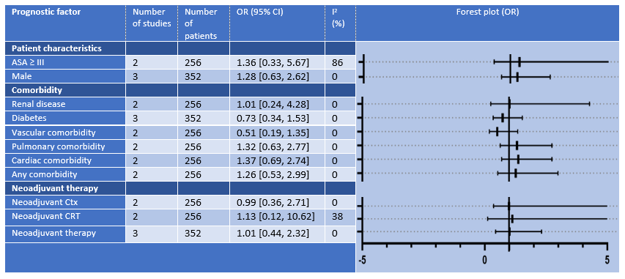
Table S3 - Results of meta-analyses identifying patient-related prognostic factors for anastomotic leakage after minimally invasive esophagectomy. ASA-score; American Society of Anesthesiologists score, CRT; Chemoradiotherapy, Ctx; Chemotherapy, OR; Odds Ratio.

