Supplement material
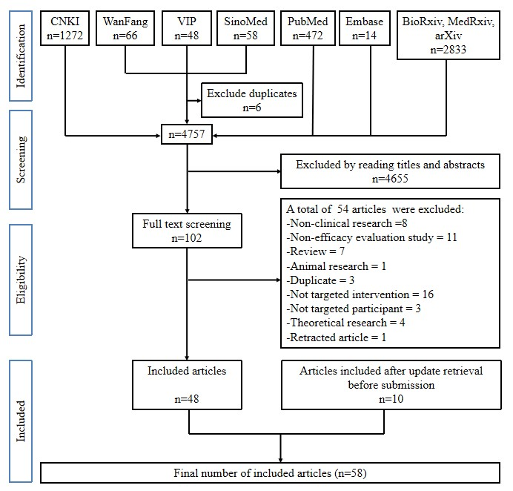
Supplement-Figure 1 Flow diagram of published studies selection for the previous review regarding Chinese herbal medicine on COVID-19
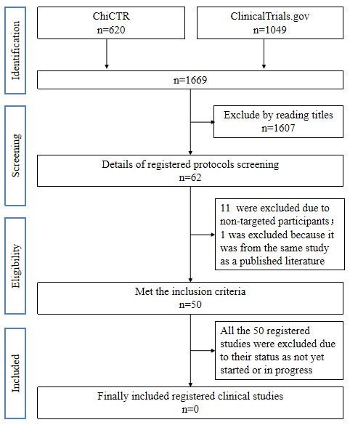
Supplement-Figure 2 Flow diagram of registered clinical studies selection for the previous review regarding Chinese herbal medicine on COVID-19

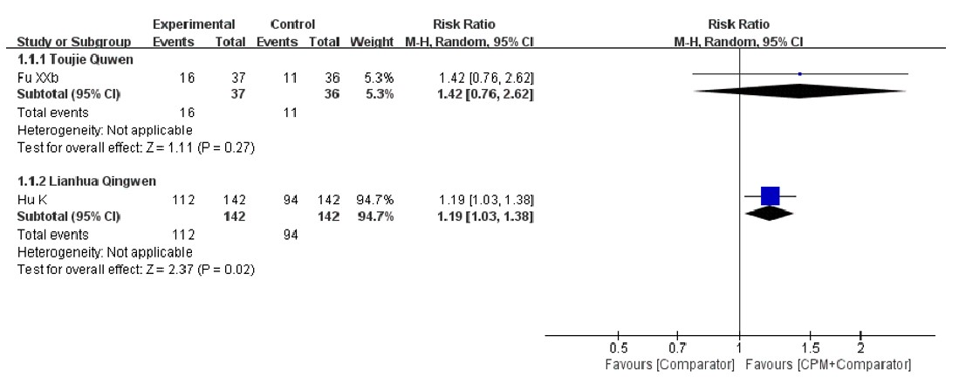

Supplement-Figure 3 Forest plot: subgroup analysis of cure rate based on different CPMs.

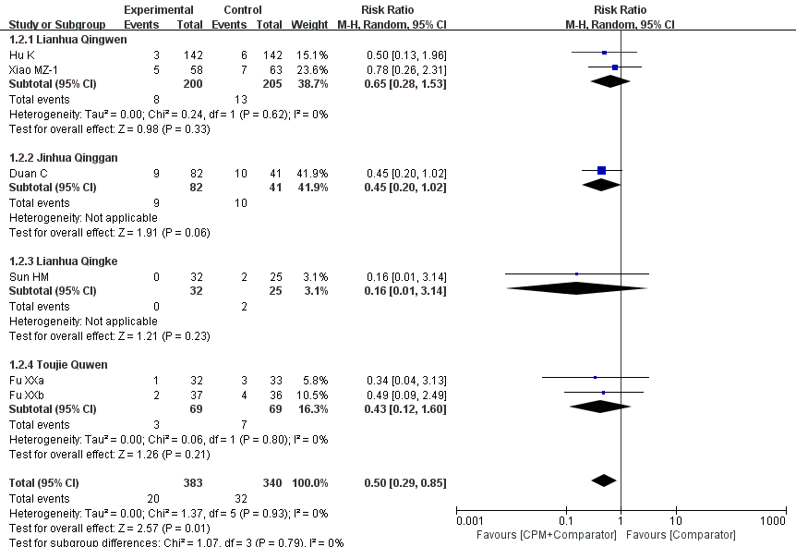
Supplement-Figure 4 Forest plot: subgroup analysis of aggravation rate based on different CPMs

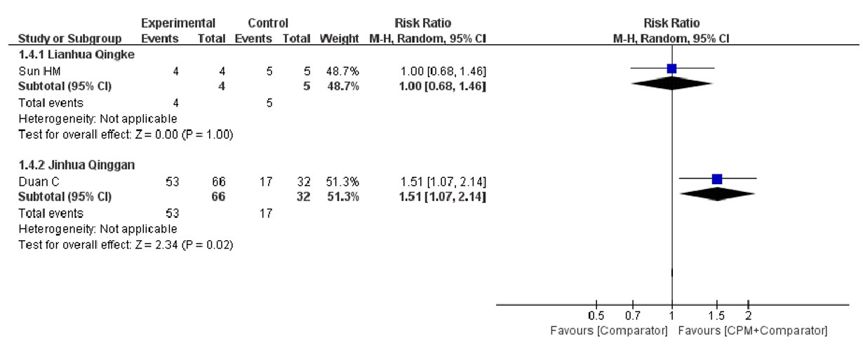
Supplement-Figure 5 Forest plot: subgroup analysis of the recovery rate of fever based on different CPMs

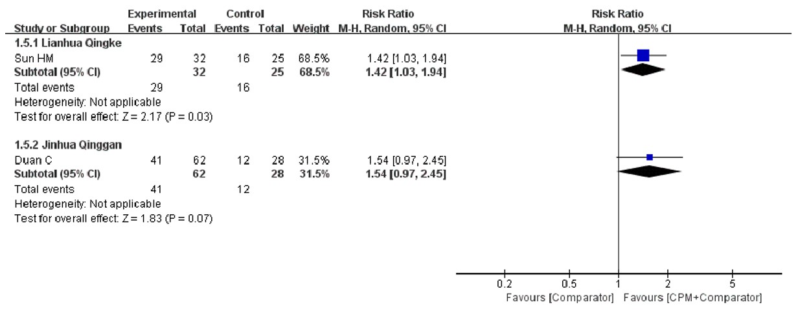
Supplement-Figure 6 Forest plot: subgroup analysis of the recovery rate of cough based on different CPMs

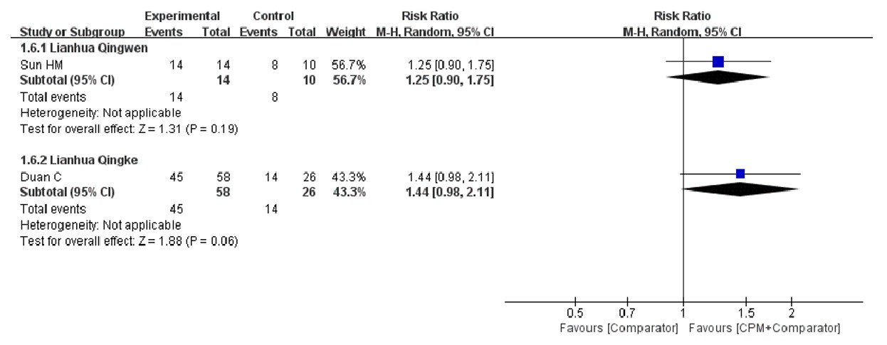
Supplement-Figure 7 Forest plot: subgroup analysis of the recovery rate of fatigue based on different CPMs

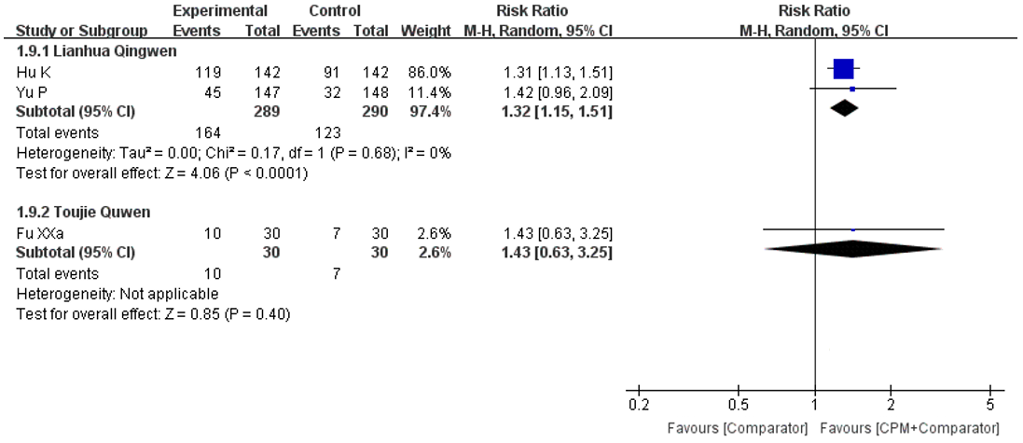
Supplement-Figure 8 Forest plot: subgroup analysis of the recovery rate of chest CT manifestations based on different CPMs

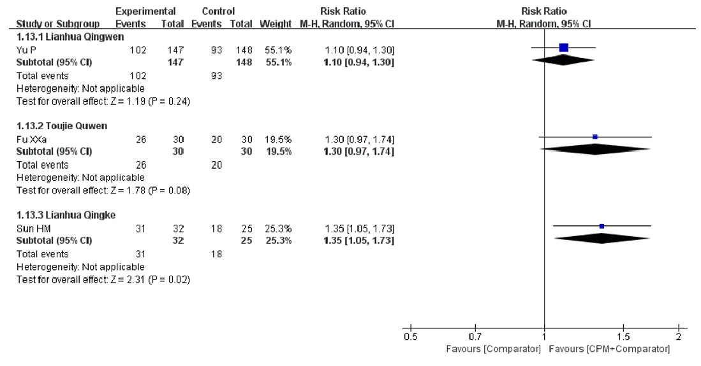
Supplement-Figure 9 Forest plot: subgroup analysis of the improvement rate of chest CT manifestations based on different CPMs

