Supplementary Fig. 1. Forest plot showing the pooled proportion of changes in stage in the subgroup of patients with initial stage I breast cancer

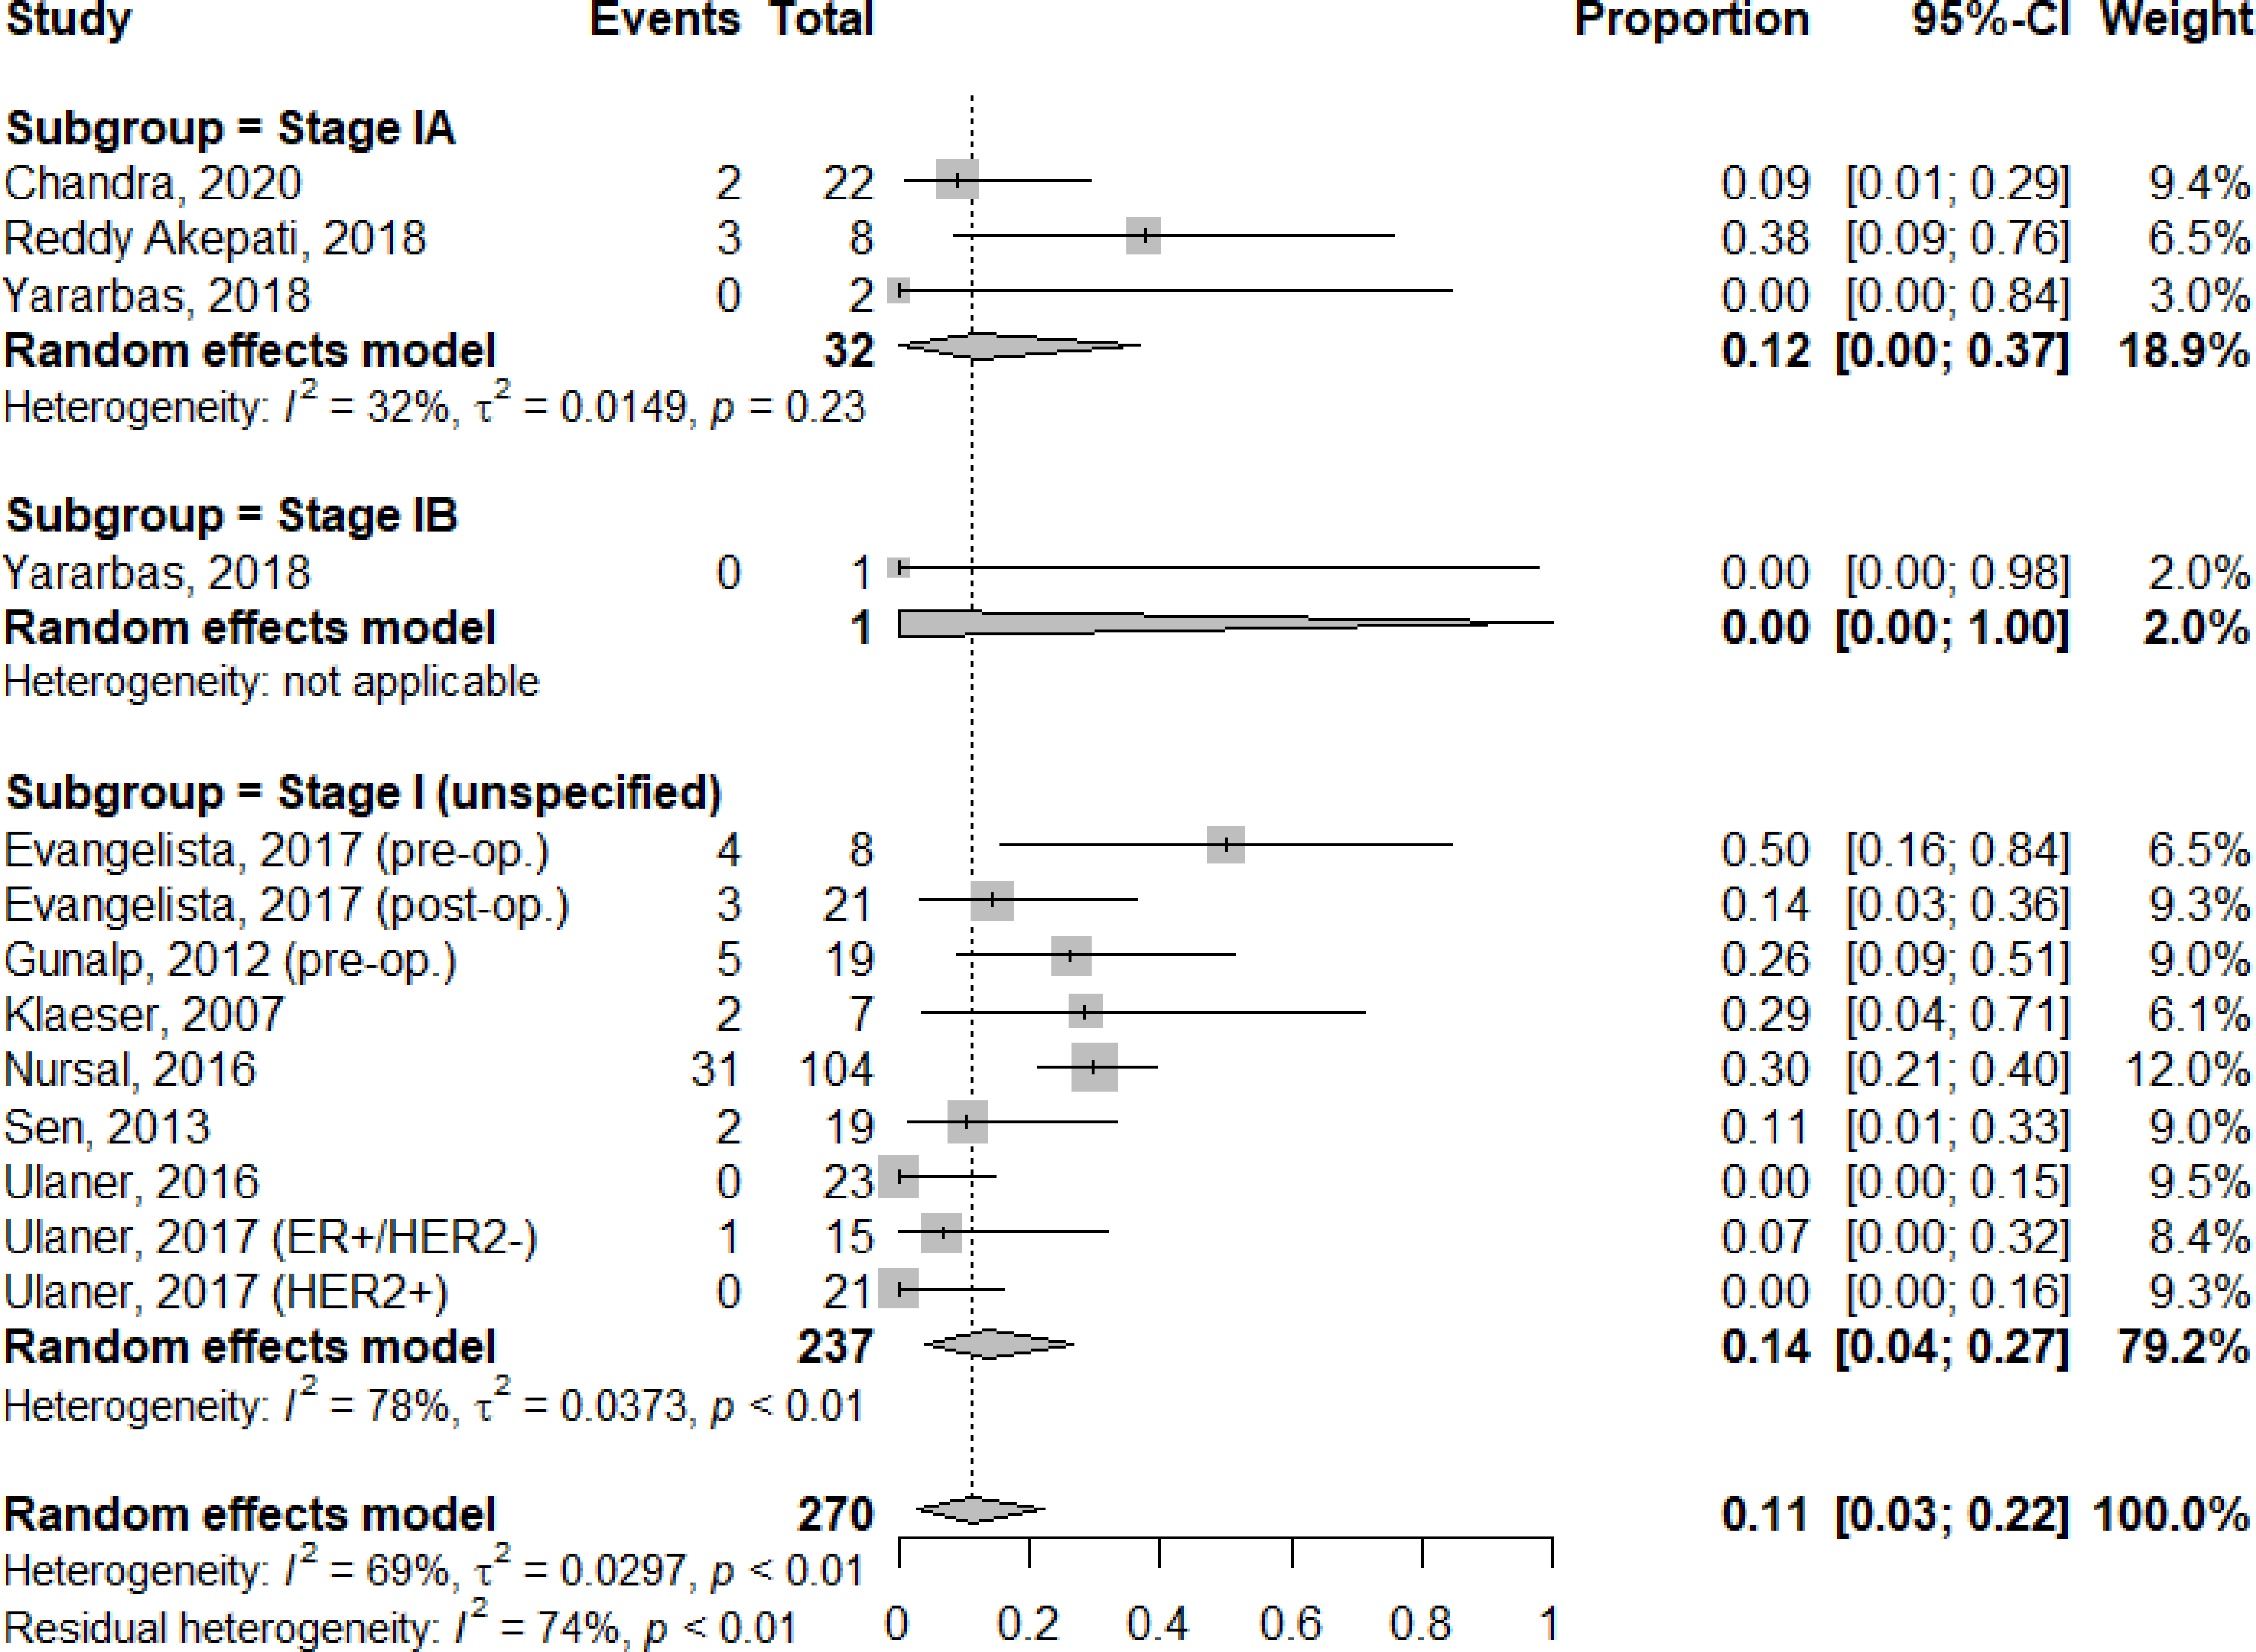
Supplementary Fig. 2. Forest plot showing the pooled proportion of changes in stage in the subgroup of patients with initial stage II breast cancer

Supplementary Fig. 3. Forest plot showing the pooled proportion of changes in stage in the subgroup of patients with initial stage III breast cancer

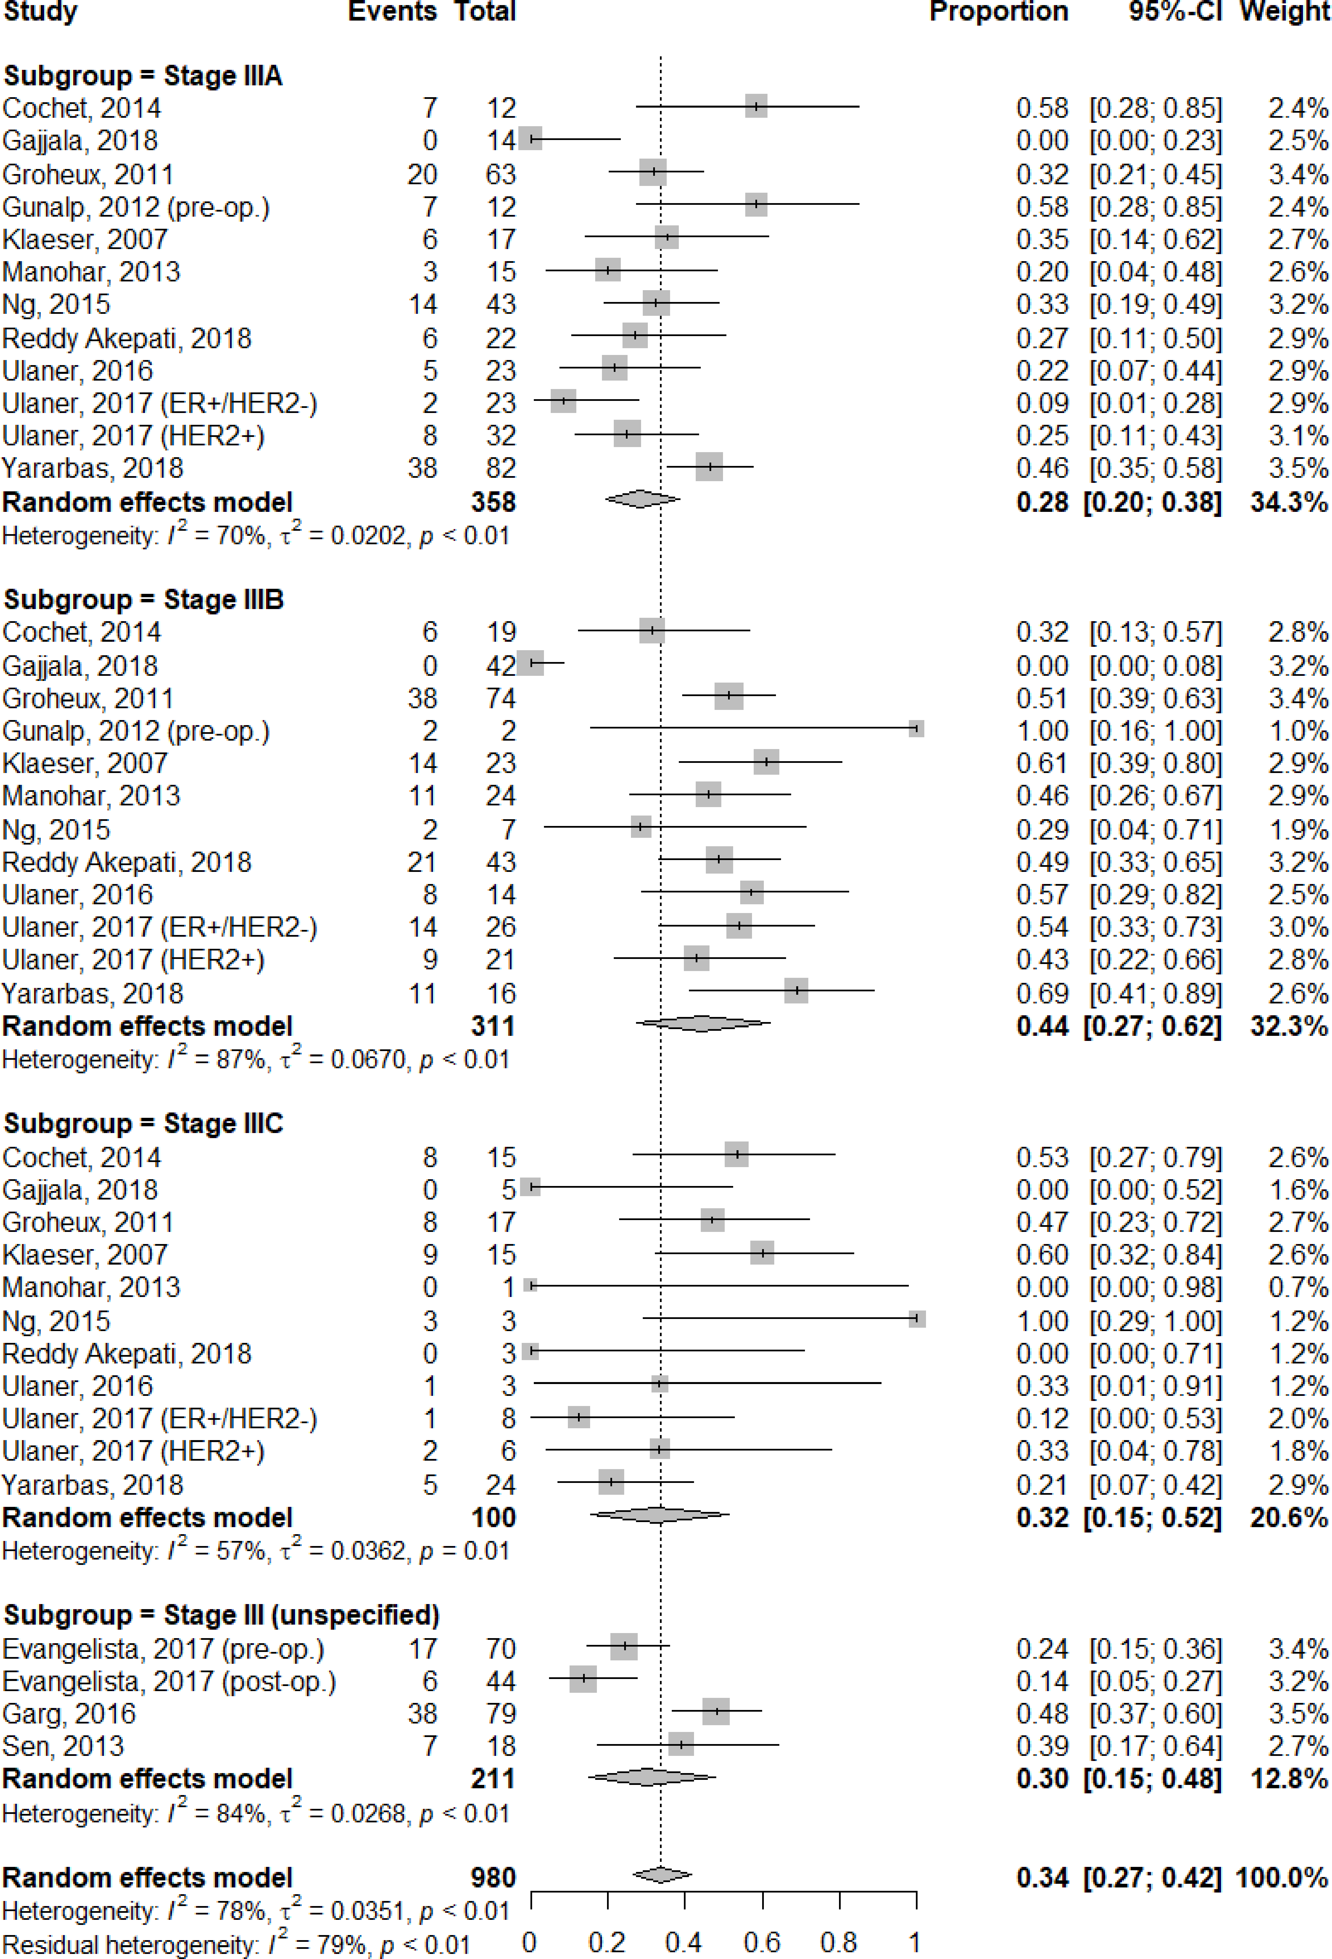
Supplementary Fig. 4. Bubble plots of meta-regression analyses showing the relationship between the proportion of changes in stage and mean age (A), the proportions of initial stage ≥III (B) and histologic grade II–III (C), the proportion of changes in management and mean age (D), and the proportions of initial stage III–IV (E) and histologic grade II–III (F).



