Figure. S1: Funnel plot of effectiveness of clinical treatment

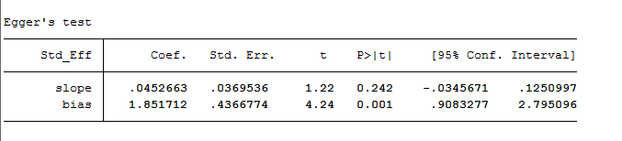
Figure. S2: Egger’s test

