Supplementary materials
Table 2: categorization of studies according to risk factors (PPE= Personal Protective Equipment)
N | Reference | RT-PCR:  positive samples/tested samples | Positivity rate | Cell culture:  positive samples/tested samples | Sampled area - Descriptive | Virus source | Location of surface | Duration of exposure | Cumulative score | Contamination risk
1 | Ahn et al 2020 | 12/73 | 0,16 | 6/12 | Isolation rooms | 4 | 3 | 3 | 10 | High
2 | Aytogan et al 2020 | 2/7 | 0,29 | - | Opthalmological examination room | 3 | 3 | 2 | 8 | Medium
3 | Bloise et al. 2020 | 4/22 | 0,18 | - | HCW areas | 2 | 4 | 4 | 10 | High
4 | Cheng et al. 2020 | 19/377 | 0,05 | 19/19 | Isolation rooms | 4 | 4 | 3 | 11 | High
5 | Chia et al. 2020 | 56/245 | 0,23 | - | Room surfaces and fomites - risk area | 4 | 4 | 3 | 11 | High
6 | Colaneri et al. 2020a | 0/12 | 0,00 | 0/12 | Subintensive care ward | 3 | 3 | 2 | 8 | Medium
7 | Colaneri et al. 2020a | 0/4 |  | 0/4 | Subintensive care ward-PPE | 4 | 3 | 2 | 9 | Medium
8 | Colaneri et al. 2020a | 0/8 | 0,00 | 0/8 | Infectious disease emergency unit | 2 | 3 | 2 | 7 | Medium
9 | Colaneri et al. 2020a | 0/4 | 0,00 | 0/4 | Infectious disease emergency unit - PPE | 4 | 3 | 2 | 9 | Medium
10 | Colaneri et al. 2020b | 0/16 | 0,00 | - | Wards | 2 | 2 | 2 | 6 | Low
11 | Guo et al 2020 | 0/36 | 0,00 | - | Room surfaces and fomites-clean area-general ward | 2 | 2 | 1 | 5 | Low
12 | Guo et al 2020 | 0/16 | 0,00 | - | Room surfaces and fomites-semicontaminated area-general ward | 2 | 3 | 2 | 7 | Medium
13 | Guo et al 2020 | 0/12 | 0,00 | - | PPE-general ward | 4 | 3 | 2 | 9 | Medium
14 | Guo et al 2020 | 6/59 | 0,10 | - | Room surfaces and fomites-contaminated area-isolation ward-general ward | 4 | 4 | 3 | 11 | High
15 | Guo et al 2020 | 1/23 | 0,04 | - | Room surfaces and fomites-contaminated area-corridor-general ward | 4 | 3 | 2 | 9 | Medium
16 | Guo et al 2020 | 0/56 | 0,00 | - | Room surfaces and fomites-clean area-ICU | 2 | 2 | 2 | 6 | Low
17 | Guo et al 2020 | 3/26 | 0,12 | - | Room surfaces and fomites-semicontaminated area-ICU | 2 | 2 | 2 | 6 | Low
18 | Guo et al 2020 | 5/22 | 0,23 | - | PPE-ICU | 4 | 3 | 2 | 9 | Medium
19 | Guo et al 2020 | 35/57 | 0,61 | - | Room surfaces and fomites-contaminated area-isolation ward-ICU | 4 | 3 | 3 | 10 | High
20 | Guo et al 2020 | 3/3 | 1,00 | - | Room surfaces and fomites-contaminated area-pharmacy-ICU | 2 | 2 | 3 | 7 | Medium
21 | Jerry et al 2020a | 1/30 | 0,03 | - | Room surfaces - Nurses ward | 2 | 2 | 3 | 7 | Medium
22 | Jerry et al 2020a | 11/26 | 0,42 | - | Room surfaces - patients room | 4 | 3 | 4 | 11 | High
23 | Jiang et al 2020a | 3/12 | 0,25 | - | Room surfaces and fomites (Door handle, light switch, faucet, bathroom door handle, toilet seat, flush handle, tv remote) | 4 | 3 | 2 | 9 | Medium
24 | Jiang et al 2020a | ¼ | 0,25 | - | Room surfaces and fomites (Thermometer, towel) | 4 | 4 | 2 | 10 | High
25 | Jiang et al 2020a | 4/6 | 0,67 | - | Room surfaces and fomites (Pillow cover, duvet cover, sheet) | 4 | 4 | 3 | 11 | High
26 | Jiang et al 2020b | 0/5 | 0,00 | - | Nurse station tables | 2 | 2 | 2 | 6 | Low
27 | Jiang et al 2020b | 0/15 | 0,00 | - | Nurse rolling carts | 3 | 3 | 2 | 8 | Medium
28 | Jiang et al 2020b | 0/60 | 0,00 | - | Face shields, protective goggles (PPE) | 4 | 3 | 2 | 9 | Medium
29 | Jiang et al 2020b | 0/10 | 0,00 | - | Patients' water cups | 4 | 4 | 2 | 10 | High
30 | Jiang et al 2020b | 1/20 | 0,05 | - | Patients' mobile phone | 4 | 4 | 3 | 11 | High
31 | Lee et al 2020 | 2/12 | 0,17 | - | Room surfaces and fomites (door handle) | 4 | 3 | 3 | 10 | High
32 | Lei et al 2020 | 0/160 | 0,00 | - | Room surfaces and fomites ICU, daily disinfection | 2 | 3 | 1 | 6 | Low
33 | Lei et al 2020 | 6/318 | 0,02 | - | Room surfaces and fomites (Ward) | 4 | 4 | 3 | 11 | High
34 | Lv et al 2020 | 0/41 | 0,00 | - | Lab surfaces | 2 | 1 | 3 | 6 | Low
35 | Lv et al 2020 | 0/6 | 0,00 | - | Other facilities - low risk | 2 | 1 | 3 | 6 | Low
36 | Lv et al 2020 | 0/14 | 0,00 | - | PPE | 4 | 3 | 2 | 9 | Medium
37 | Mouchtouri et al 2020 | 5/9 | 0,56 | - | Ferry boat surfaces | 2 | 3 | 3 | 8 | Medium
38 | Mouchtouri et al 2020 | 0/10 | 0,00 | - | Room surfaces from isolation facilities for asymptomatic people | 4 | 2 | 3 | 9 | Medium
39 | Mouchtouri et al 2020 | 4/20 | 0,20 | - | Room surfaces Nursing home | 4 | 3 | 3 | 10 | High
40 | Mouchtouri et al 2020 | 3/25 | 0,12 | - | Room surfaces from hospital negative pressure Isolation room | 4 | 3 | 3 | 10 | High
41 | Nelson et al 2020 | 0/2 | 0,00 | - | Main area | 1 | 2 | 3 | 6 | Low
42 | Nelson et al 2020 | 0/7 | 0,00 | - | Kitchen area | 1 | 2 | 3 | 6 | Low
43 | Nelson et al 2020 | 0/20 | 0,00 | - | Staff area | 2 | 2 | 3 | 7 | Medium
44 | Nelson et al 2020 | 6/60 | 0,10 | - | Care provision area | 4 | 2 | 2 | 8 | Medium
45 | Ong et al 2020 | 0/1 | 0,00 | - | corridor outside room - floor | 2 | 2 | 2 | 6 | Low
46 | Ong et al 2020 | 0/5 | 0,00 | - | anteroom | 2 | 2 | 3 | 7 | Medium
47 | Ong et al 2020 | 1/10 | 0,10 | - | PPE | 4 | 3 | 2 | 9 | Medium
48 | Ong et al 2020 | 14/17 | 0,82 | - | patient's room | 4 | 3 | 3 | 10 | High
49 | Ong et al 2020 | 3/5 | 0,60 | - | toilet area | 4 | 3 | 3 | 10 | High
50 | Pasquarella et al 2020 | 5/16 | 0,31 | - | Room surfaces + patient surgical mask | 4 | 4 | 3 | 11 | High
51 | Peyrony et al 2020 | 0/74 | 0,00 | - | Room surfaces and fomites, ED non patient care area | 2 | 2 | 1 | 5 | Low
52 | Peyrony et al 2020 | 2/20 | 0,10 | - | Room surfaces and fomites BEFORE DECONTAMINATION, non direct contact, ED patient care area | 2 | 2 | 3 | 7 | Medium
53 | Peyrony et al 2020 | 1/16 | 0,06 | - | PPE | 4 | 3 | 2 | 9 | Medium
54 | Peyrony et al 2020 | 3/5 | 0,60 | - | Room surfaces and fomites BEFORE DECONTAMINATION, direct contact, ED patient care area | 4 | 3 | 3 | 10 | High
55 | Razzini et al 2020 | 0/13 | 0,00 | - | Room surfaces and fomites-clean area | 1 | 2 | 1 | 4 | Low
56 | Razzini et al 2020 | 2/4 | 0,50 | - | Room surfaces and fomites-semicontaminated area | 2 | 3 | 3 | 8 | Medium
57 | Razzini et al 2020 | 7/20 | 0,35 | - | Room surfaces and fomites-contaminated area | 4 | 4 | 3 | 11 | High
58 | Ryu et al. 2020 | 0/14 | 0,00 | - | Environmental surfaces in hospital A - outside room samples | 4 | 2 | 2 | 8 | Medium
59 | Ryu et al. 2020 | 0/12 | 0,00 | - | Environmental surfaces in hospital B- outside room samples | 4 | 2 | 2 | 8 | Medium
60 | Ryu et al. 2020 | 3/22 | 0,14 | - | Environmental surfaces in hospital B - inside room samples | 4 | 3 | 3 | 10 | High
61 | Ryu et al. 2020 | 10/57 | 0,18 | - | Environmental surfaces in hospital A - inside room samples | 4 | 3 | 3 | 10 | High
62 | Santarpia et al. 2020 | 99/128 | 0,77 | NR | Room surfaces and fomites (hospital) | 4 | 3 | 3 | 10 | High
63 | Shin et al 2020 | 0/12 | 0,00 | - | Room surfaces and patients objects | 4 | 3 | 3 | 10 | Medium
64 | Tan et al 2020 | 1/39 | 0,03 | - | Room surfaces and fomites/low contact surfaces | 4 | 3 | 2 | 9 | Medium
65 | Tan et al 2020 | 0/54 | 0,00 | - | PPE of nurses | 4 | 3 | 2 | 9 | Medium
66 | Tan et al 2020 | 0/36 | 0,00 | - | Patients mask | 4 | 4 | 3 | 11 | High
67 | Tan et al 2020 | 10/205 | 0,05 | - | Room surfaces and fomites/ high contact surfaces | 4 | 4 | 3 | 11 | High
68 | Wang et al 2020a | 0/34 | 0,00 | - | General ward | 4 | 2 | 2 | 8 | Low
69 | Wang et al 2020a | 2/27 | 0,07 | - | ICU | 4 | 3 | 2 | 9 | Medium
70 | Wang et al 2020a | 0/1 | 0,00 |  | ICU-PPE | 4 | 3 | 2 | 9 | Medium
71 | Wang et al. 2020b | 0/4 | 0,00 | - | Clean area (ICU ward-isolation ward) | 1 | 2 | 2 | 5 | Low
72 | Wang et al. 2020b | 0/20 | 0,00 | - | Contaminated area (ICU and isolation ward) | 4 | 3 | 2 | 9 | Low
73 | Wang et al. 2020b | 0/12 | 0,00 | - | Semicontaminated area (ICU and isolation ward) | 2 | 2 | 2 | 6 | Medium
74 | Wang et al. 2020b | 0/9 | 0,00 | - | PPE staff | 4 | 3 | 2 | 9 | Medium
75 | Wei et al 2020 | 34/77 | 0,44 |  | Patients room | 4 | 4 | 3 | 11 | High
76 | Wei et al 2020 | 10/35 | 0,29 | - | Toilet area | 4 | 3 | 3 | 10 | High
77 | Wu et al. 2020 | 2/55 | 0,04 | - | Living quarter | 4 | 2 | 2 | 8 | Medium
78 | Wu et al. 2020 | 36/145 | 0,25 | - | Medical area | 4 | 3 | 3 | 10 | High
79 | Yamagishi et al 2020 | 0/160 | 0,00 | - | Cabin surfaces without positive subjects | 2 | 2 | 2 | 6 | Low
80 | Yamagishi et al 2020 | 1/53 | 0,02 | 0/1 | non specified Shared cruise areas | 3 | 1 | 2 | 6 | Low
81 | Yamagishi et al 2020 | 57/330 | 0,17 | 0/57 | Cabin surfaces with positive subjects | 4 | 4 | 3 | 11 | Medium
82 | Ye et al. 2020 | 0/52 | 0,00 | - | Administration, parking lot | 1 | 1 | 1 | 3 | Low
83 | Ye et al. 2020 | 8/137 | 0,06 | - | Fever clinic, ct examination room, general ward | 3 | 2 | 2 | 7 | Medium
84 | Ye et al. 2020 | 77/437 | 0,18 | - | ICU, Isolation ward, NCP ward, obstetric ward | 3 | 3 | 3 | 9 | High
85 | Yung et al. 2020 | 0/3 | 0,00 | - | PPE | 4 | 3 | 2 | 9 | Medium
86 | Yung et al. 2020 | 3/3 | 1,00 | - | Environmental surfaces | 4 | 4 | 4 | 12 | High
87 | Zhou et al 2020 | 2/24 | 0,08 | 0/24 | Public areas | 2 | 2 | 2 | 6 | Low
88 | Zhou et al 2020 | 21/194 | 0,11 | 0/194 | Clinical areas | 4 | 3 | 3 | 10 | High

Sensitivity analysis
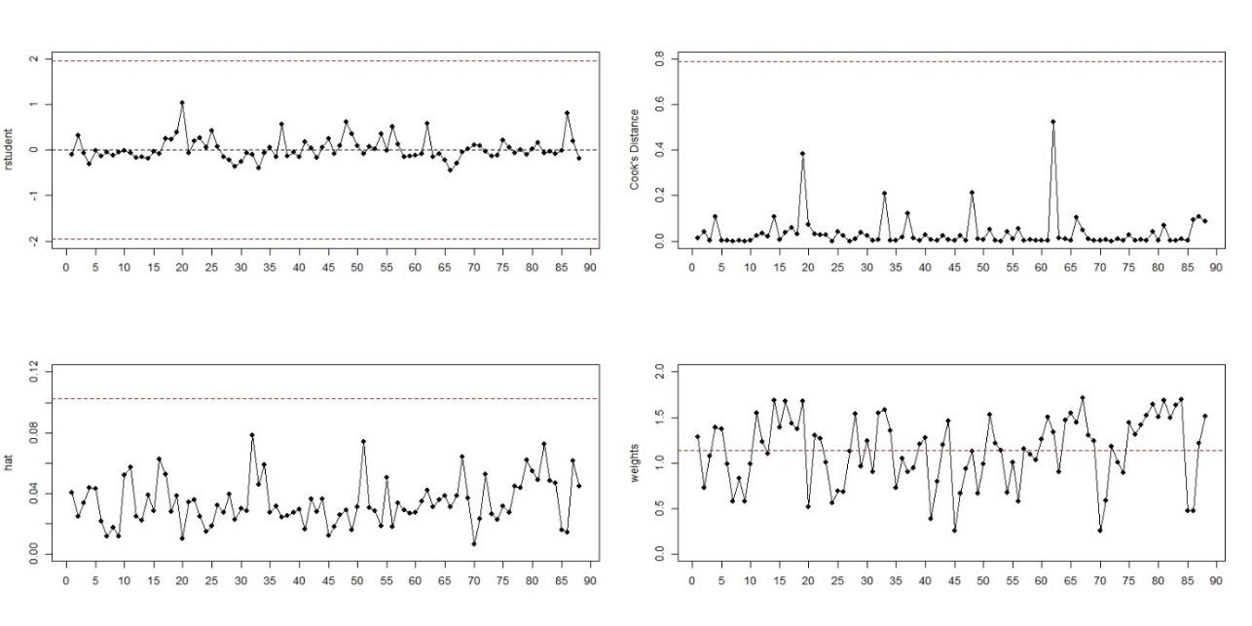
Figure 1: influence plots resulting from the sensitivity analysis of the univariate metaregression model with “contamination risk” as moderator.
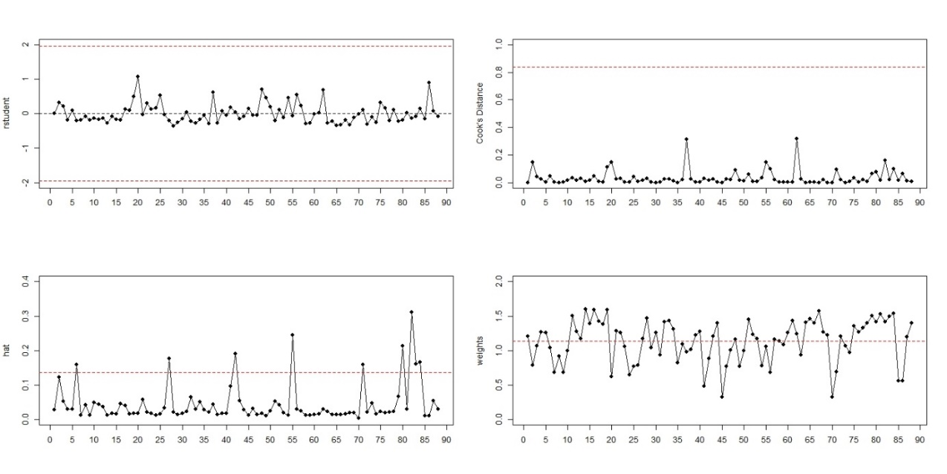
Figure 2: influence plots resulting from the sensitivity analysis of the univariate metaregression model with “virus source” as moderator.
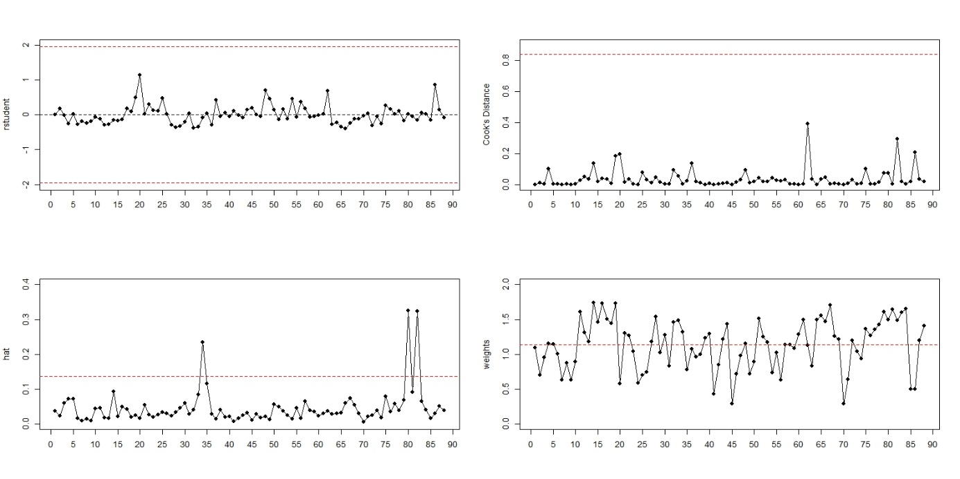
Figure 3: influence plots resulting from the sensitivity analysis of the univariate metaregression model with “location of surface” as moderator.
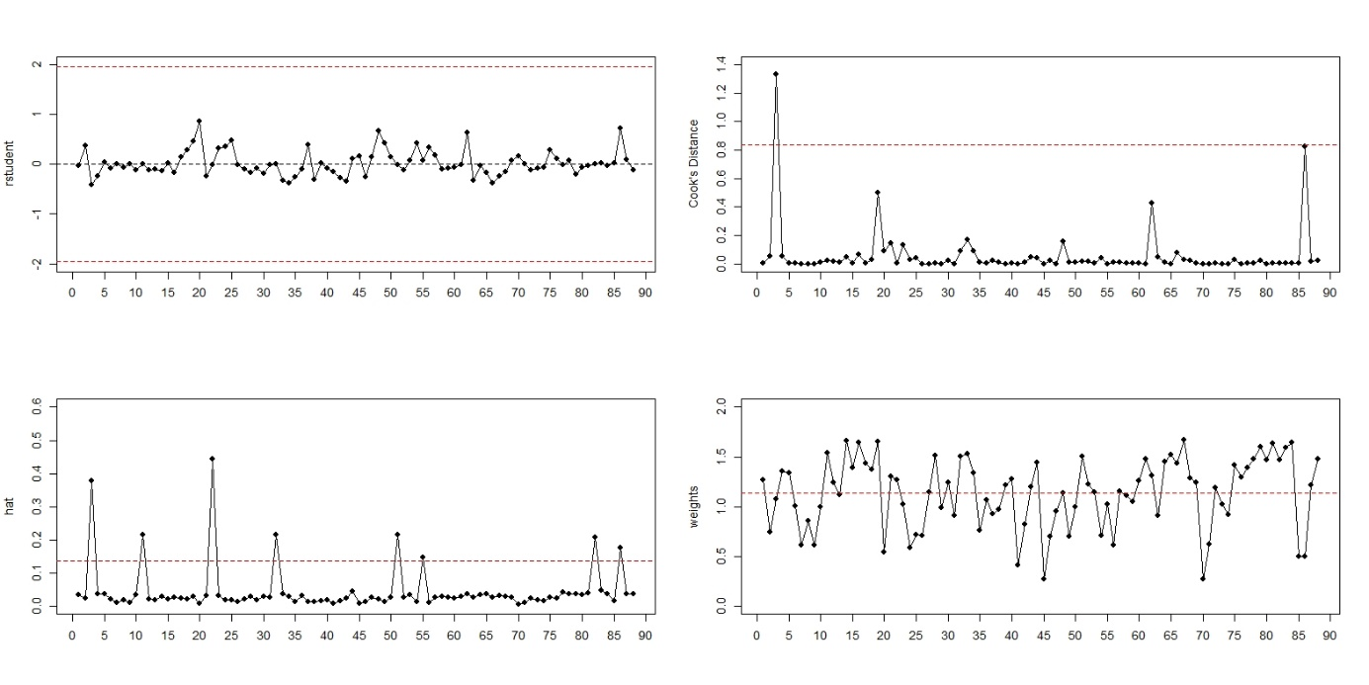
Figure 4: influence plots resulting from the sensitivity analysis of the univariate metaregression model with “duration of exposure” as moderator
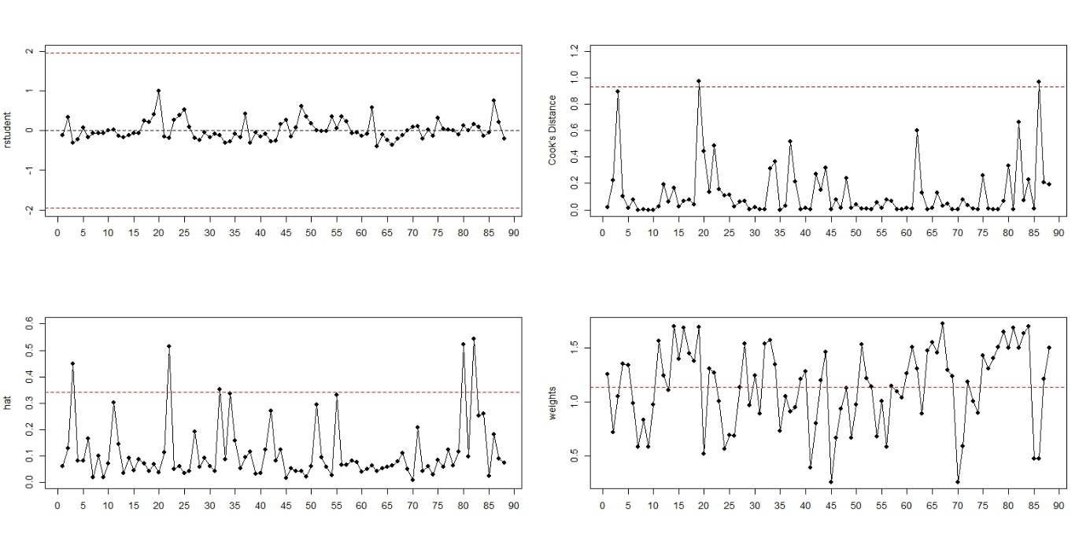
Figure 5: influence plots resulting from the sensitivity analysis of the multivariate metaregression model.

Funnel plot
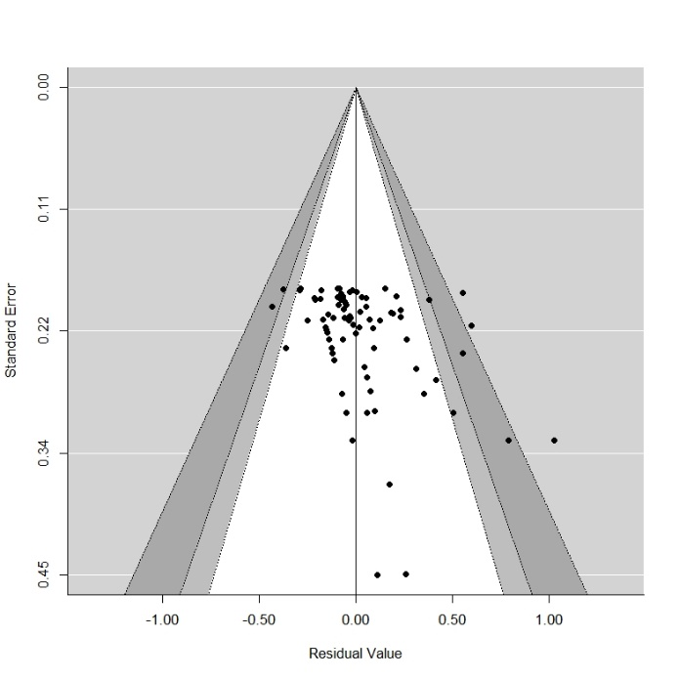 | 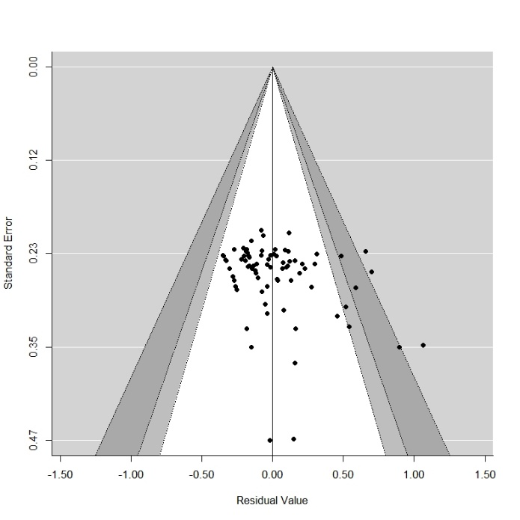
Figure 6: influence plots resulting from the sensitivity analysis of the univariate metaregression model with “contamination risk” as moderator. | Figure 7: influence plots resulting from the sensitivity analysis of the univariate metaregression model with “virus source” as moderator.
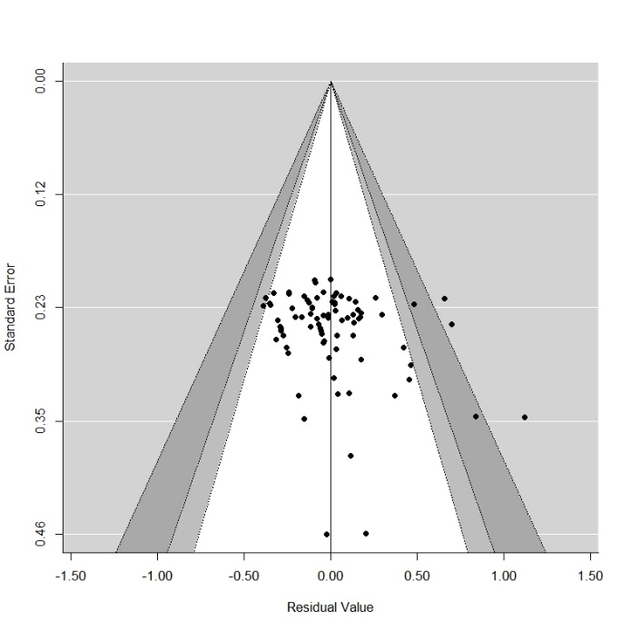 | 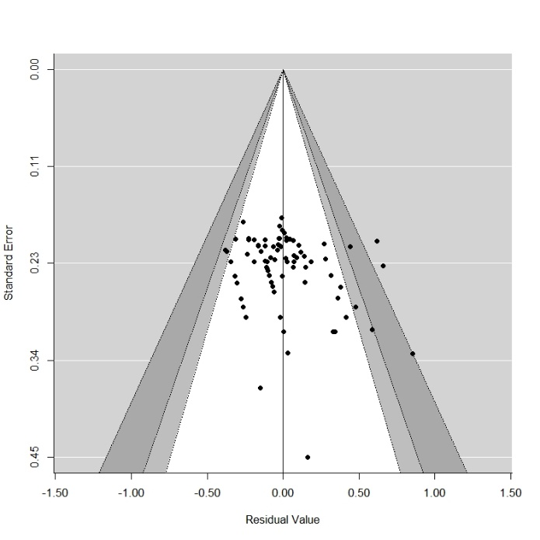
Figure 8: influence plots resulting from the sensitivity analysis of the univariate metaregression model with “location of surface” as moderator. | Figure 9: influence plots resulting from the sensitivity analysis of the univariate metaregression model with “duration of exposure” as moderator

