Supplementary Figure 1. A forest plot illustrating results of the pooled prevalence values for abnormal CXR in COVID-19 patients
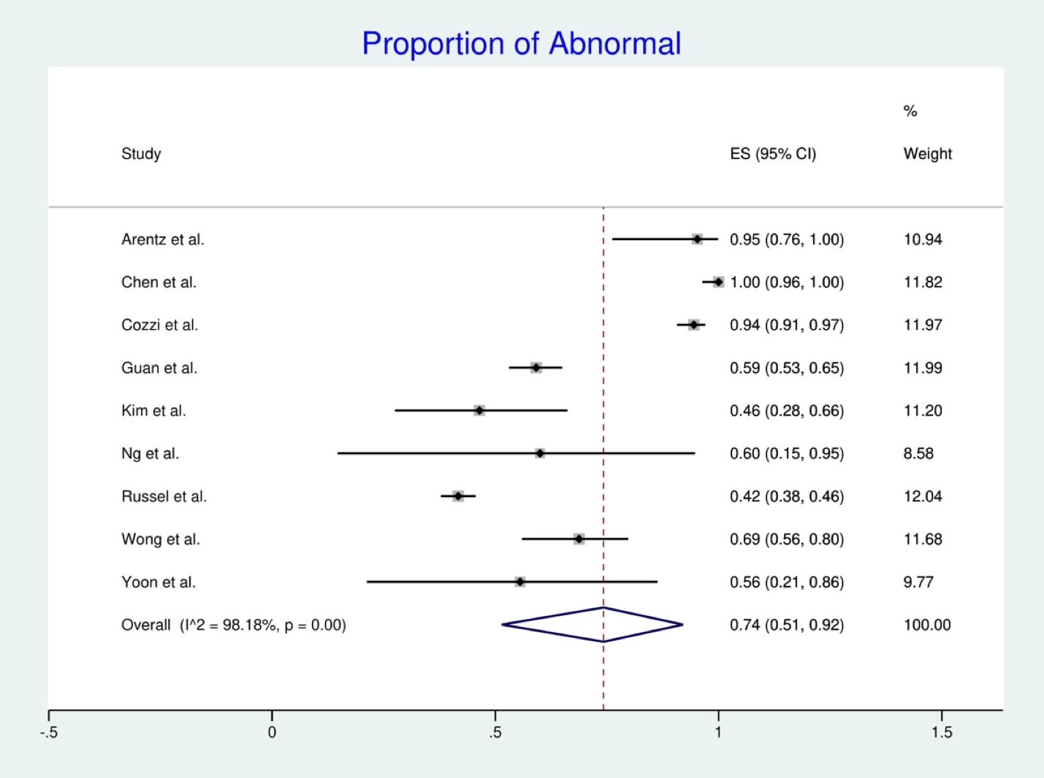

Supplementary Figure 2. A forest plot illustrating results of the pooled prevalence values for initial normal CXR to later abnormal CXR presentation in COVID-19 patients

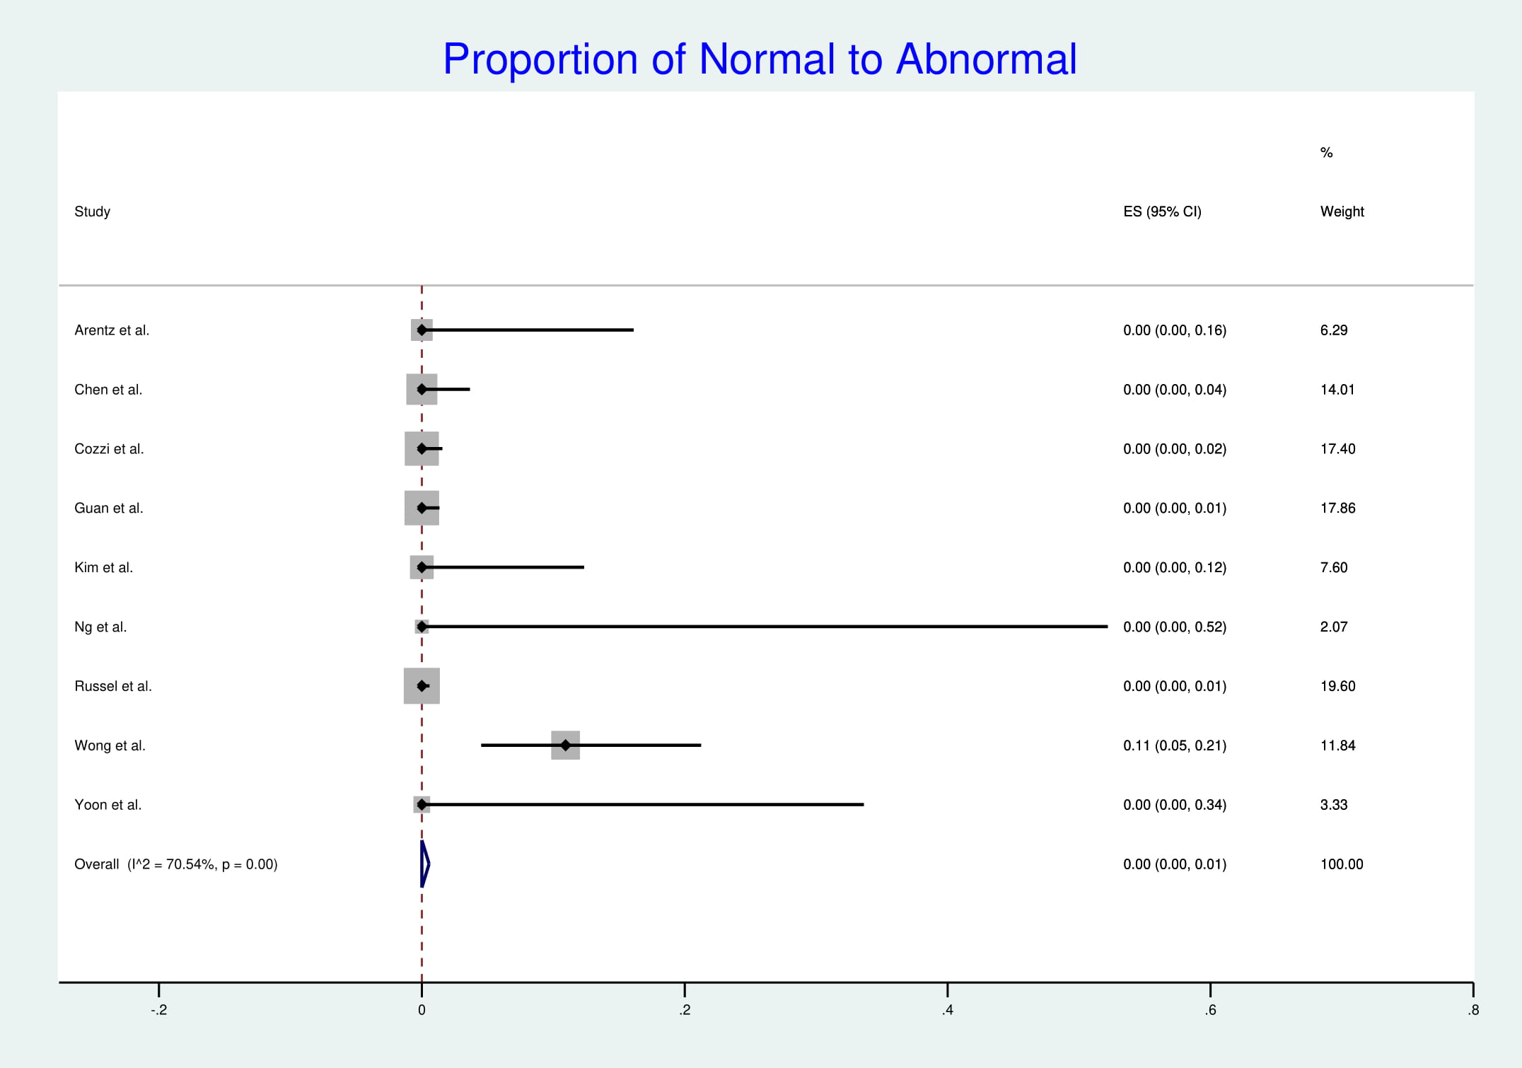

Supplementary Figure 3. A forest plot illustrating results of the pooled prevalence values for bilateral lung involvement in COVID-19 patients

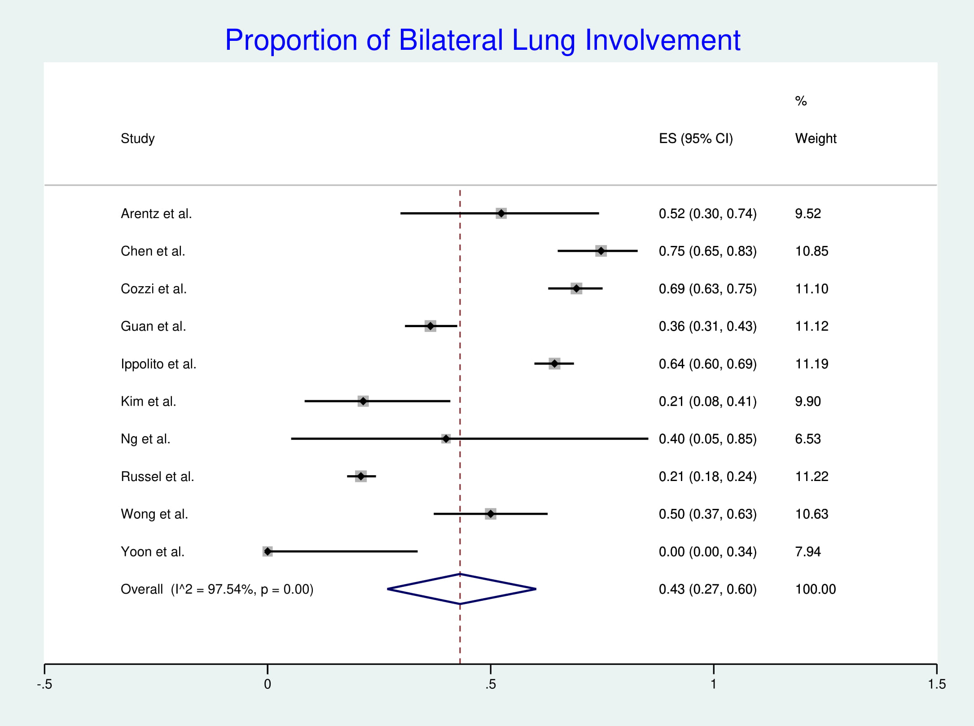

Supplementary Figure 4. A forest plot illustrating results of the pooled prevalence values for left lung involvement in COVID-19 patients

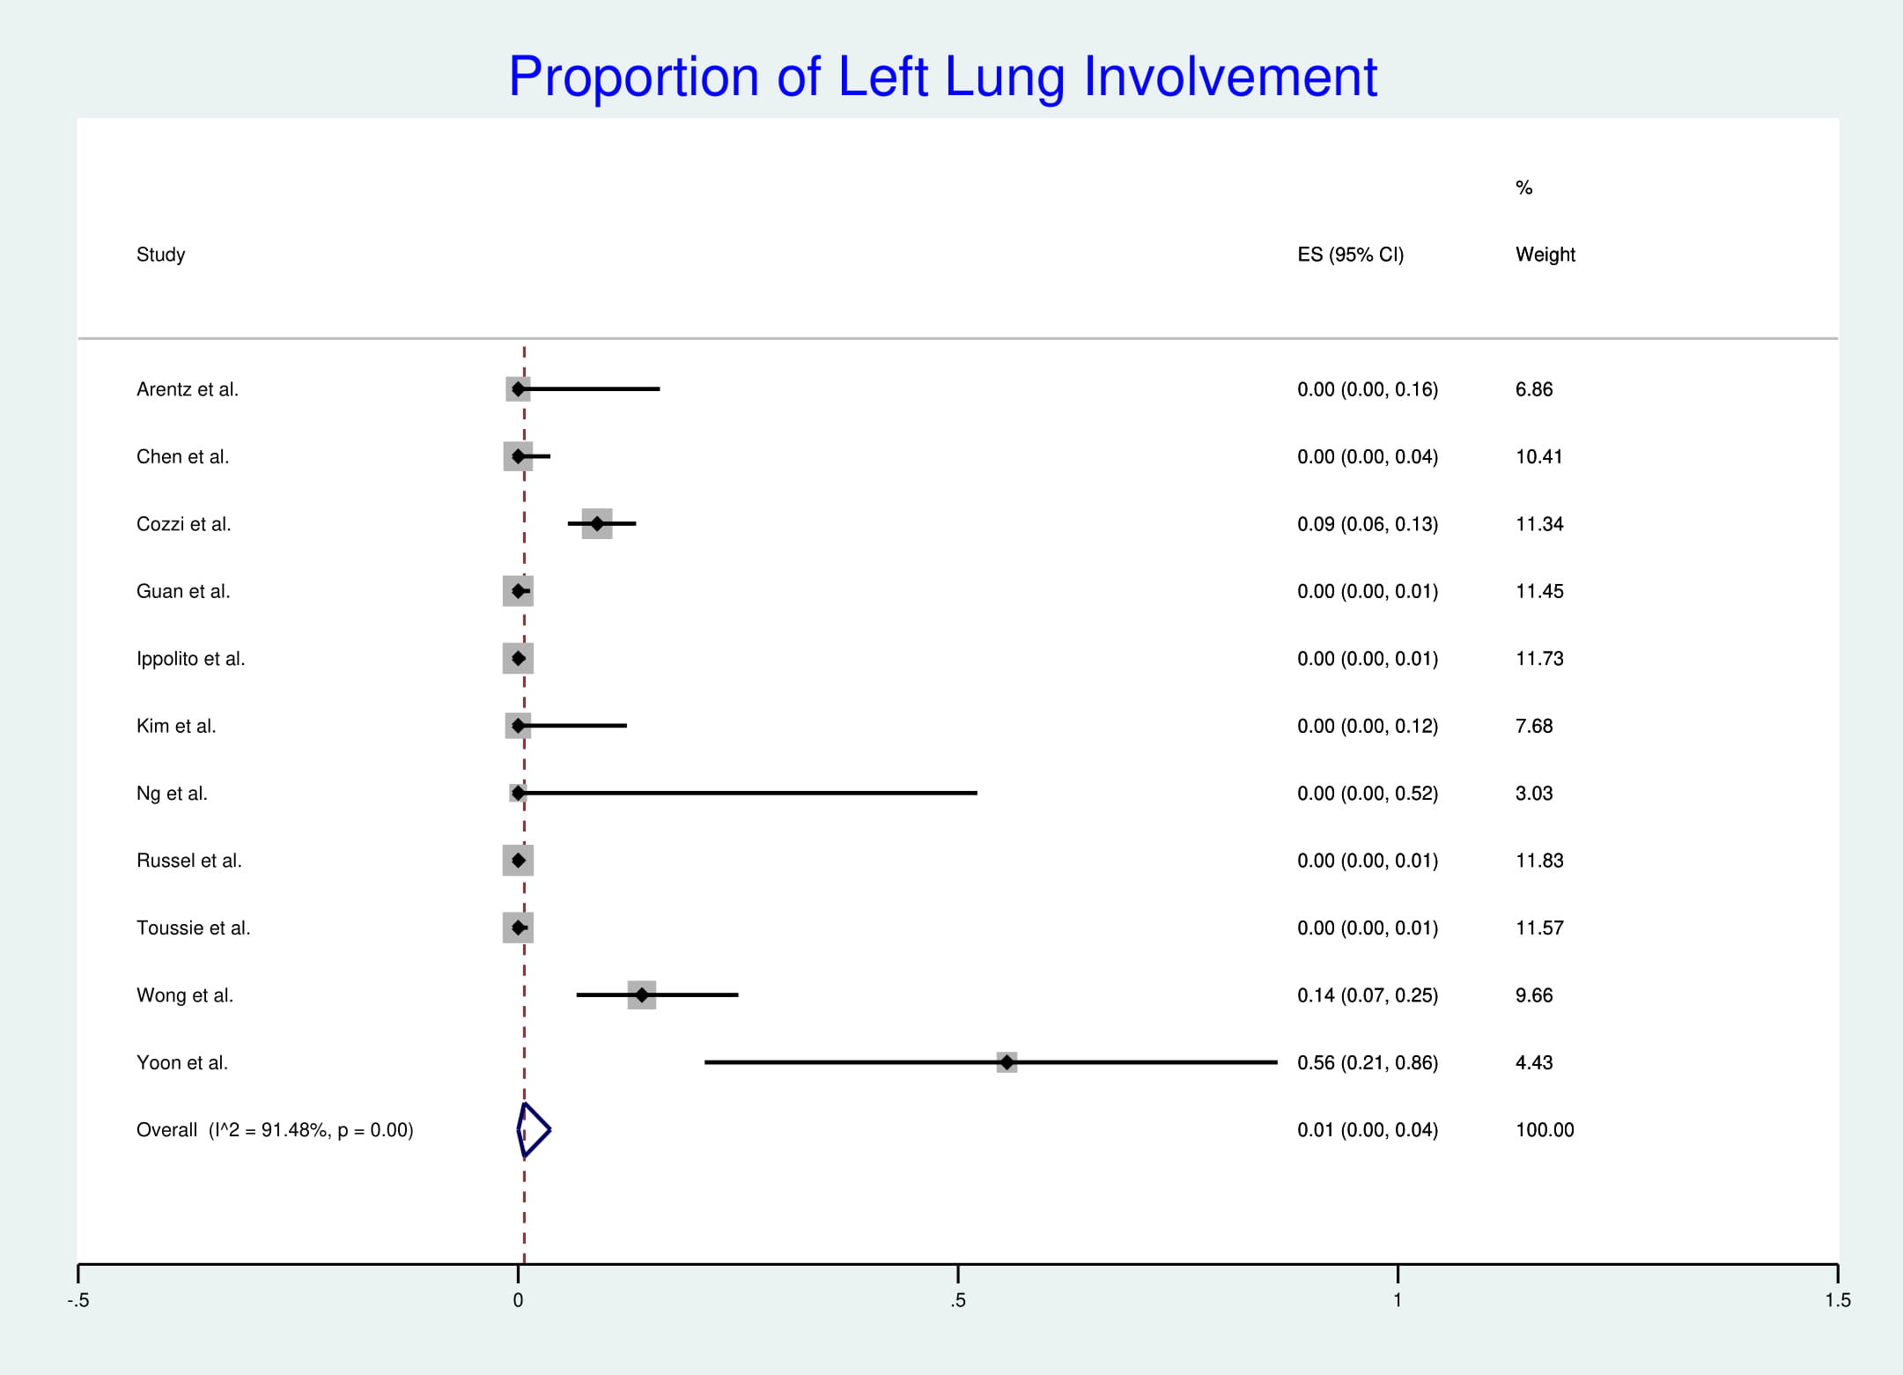

Supplementary Figure 5. A forest plot illustrating results of the pooled prevalence values for right lung involvement in COVID-19 patients

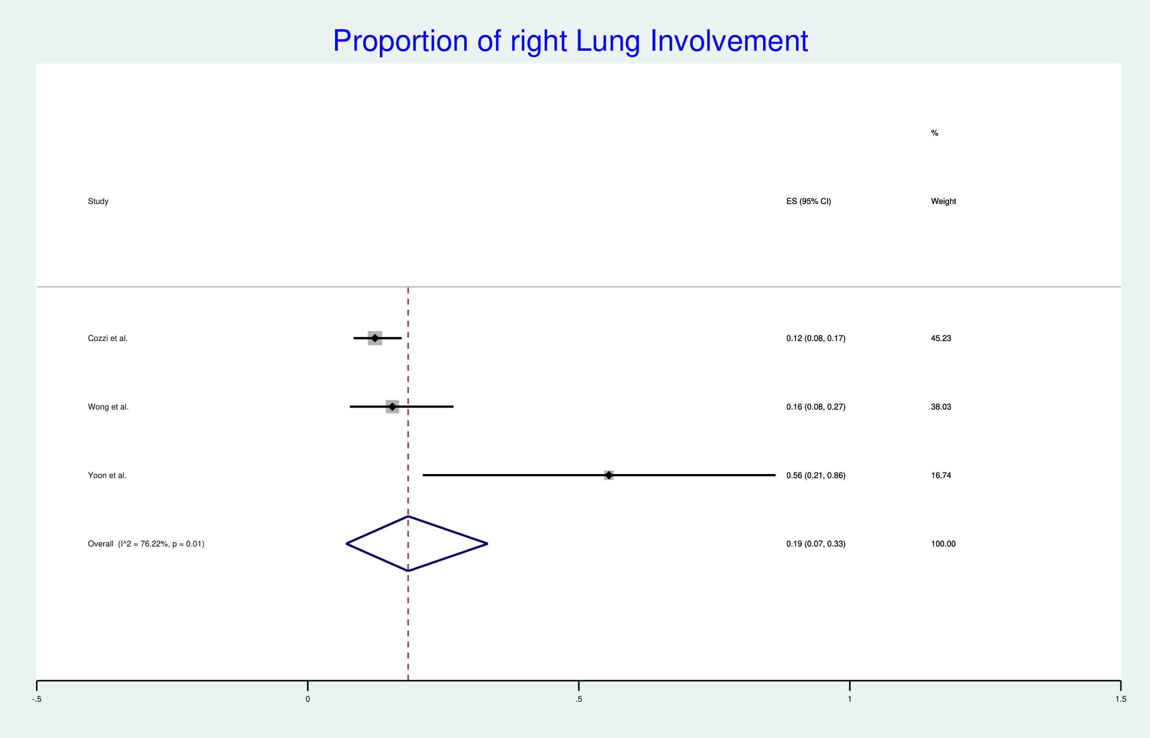

Supplementary Figure 6. A forest plot illustrating results of the pooled prevalence values for peripheral lung involvement in COVID-19 patients

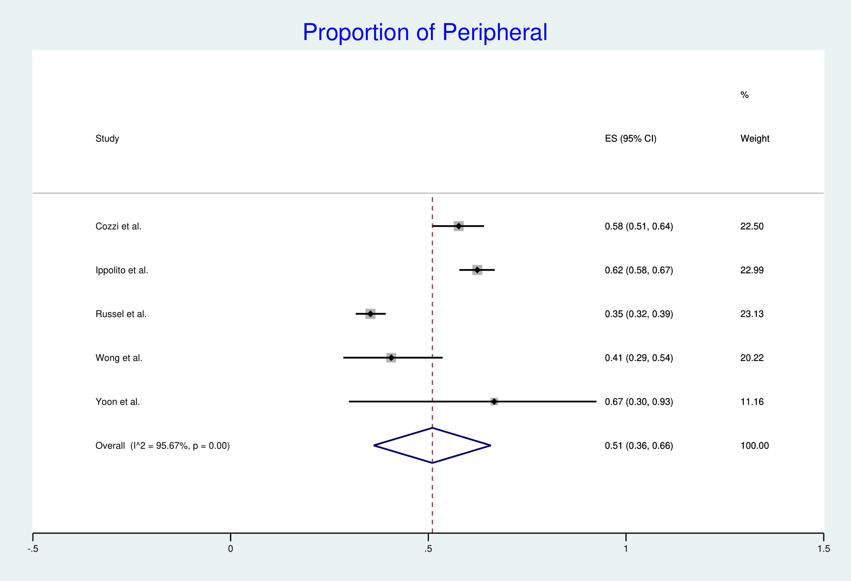

Supplementary Figure 7. A forest plot illustrating results of the pooled prevalence values for perihilar lung involvement in COVID-19 patients

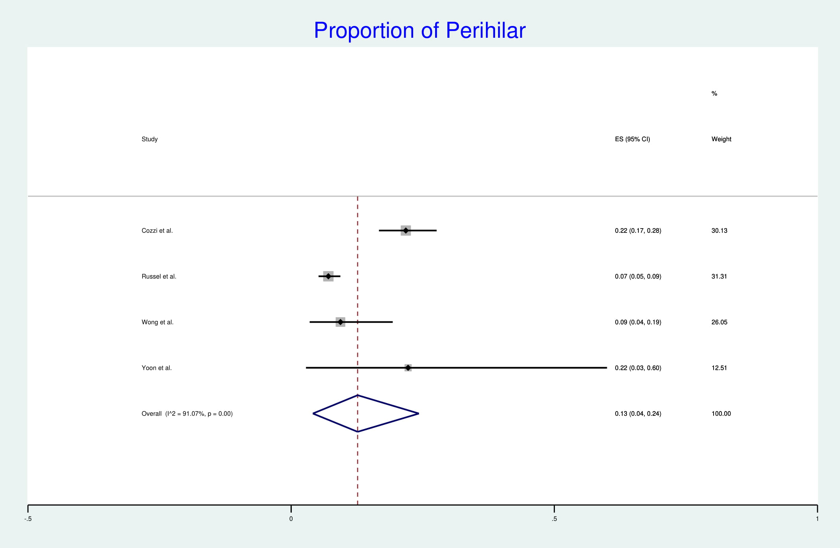

Supplementary Figure 8. A forest plot illustrating results of the pooled prevalence values for consolidation in COVID-19 patients

Supplementary Figure 9. A forest plot illustrating results of the pooled prevalence values for GGOs in COVID-19 patients

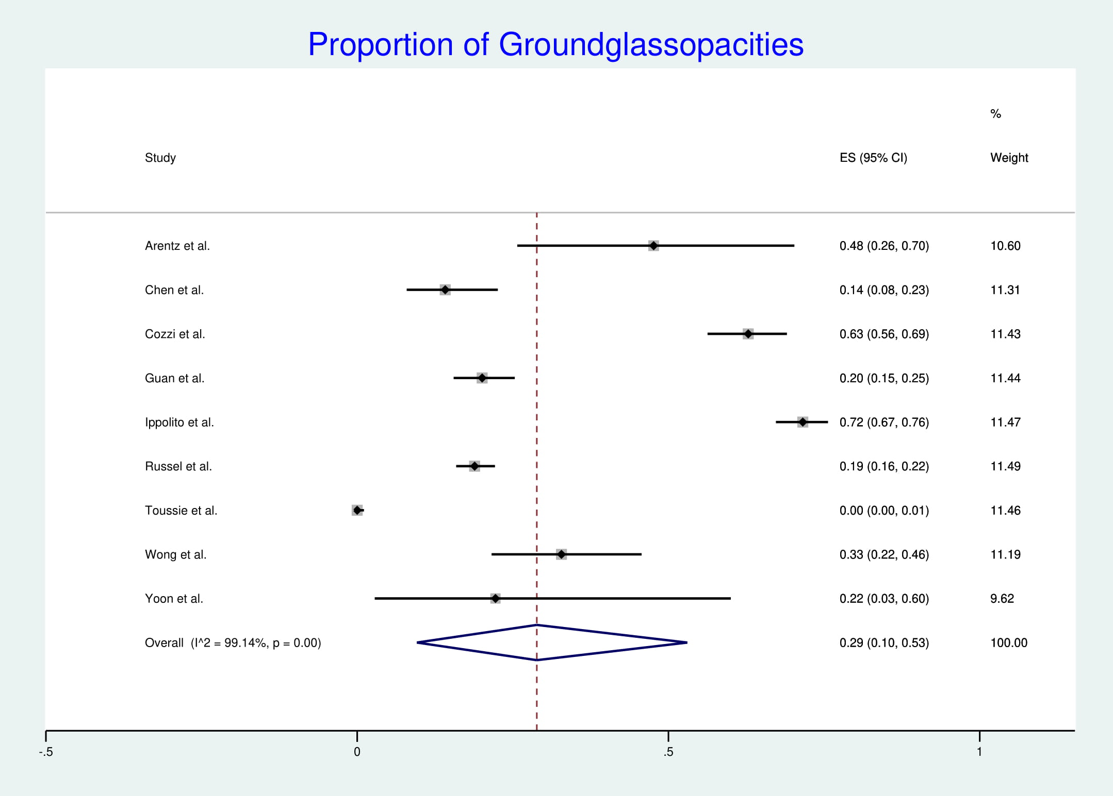

Supplementary Figure 10. A forest plot illustrating results of the pooled prevalence values for basal zone lung predominance in COVID-19 patients

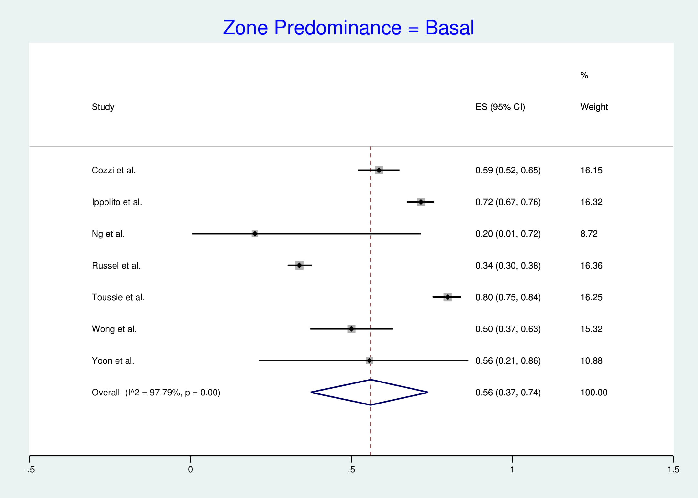

Supplementary Figure 11. A forest plot illustrating results of the pooled prevalence values for superior zone lung predominance in COVID-19 patients

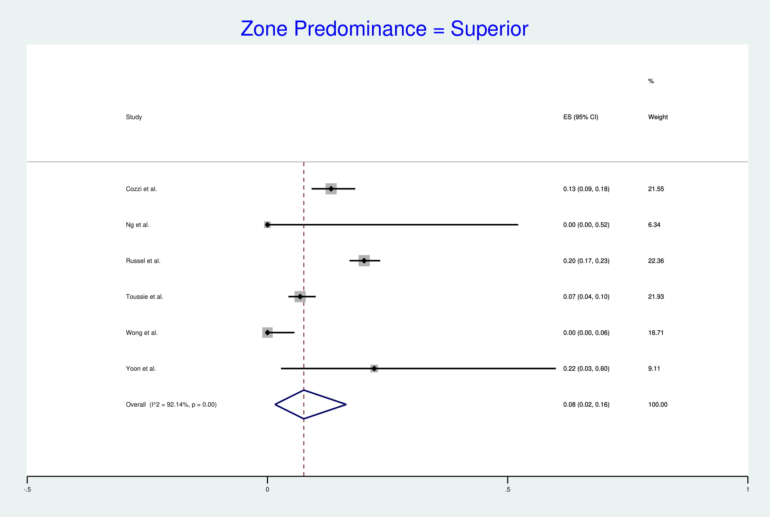

Supplementary Figure 12. A forest plot illustrating results of the pooled prevalence values for no zone lung predominance in COVID-19 patients

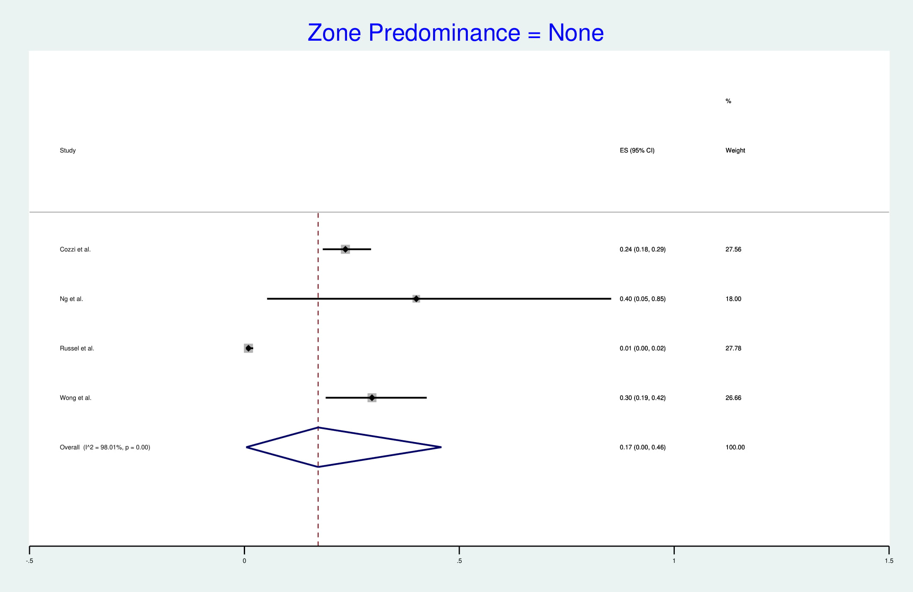

Supplementary Figure 13. A forest plot illustrating results of the pooled prevalence values for pleural effusion in COVID-19 patients



