Quality assessment
Table 1. Quality assessment of NOS.
Study | Selection | Comparability | Outcome | Quality Score
Vijay Gayam (2019) | ★★★★ | ★★ | ★★★ | 9
A. ALIMOHAMMADI (2019) | ★★★ | ★ | ★★ | 6
Angelika Schütz (2018) | ★★ | - | ★★★ | 5
Jean-Baptiste Trabut (2018) | ★★★ | ★★ | ★★★ | 8
Leith Morris (2017) | ★★★ | ★ | ★★★ | 7
Phillip Read (2017) | ★★★ | ★ | ★★★ | 7
NOS, Newcastle-Ottawa quality assessment scale.

Fig. 1. Assessment of the quality of the studies included in the comprehensive analysis.
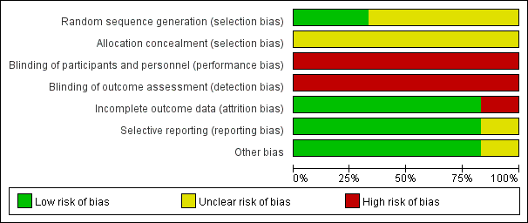

Fig. 2. Assessment of the quality of the studies included in the comprehensive analysis.


