Funnel plot, Egger’s test results and Sensitivity assessment

Fig. 1. Funnel plot for the evaluation of publication bias of the whole study.
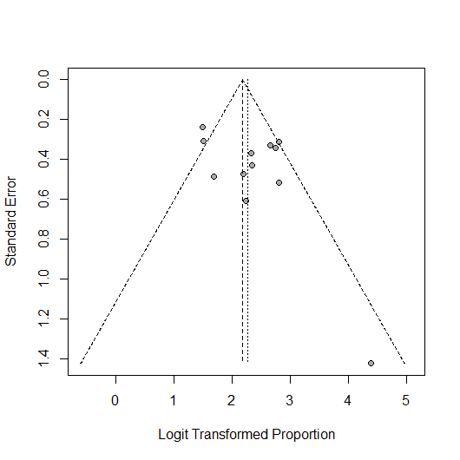

Fig. 2. Egger’s funnel plot for the evaluation of publication bias of the whole study.
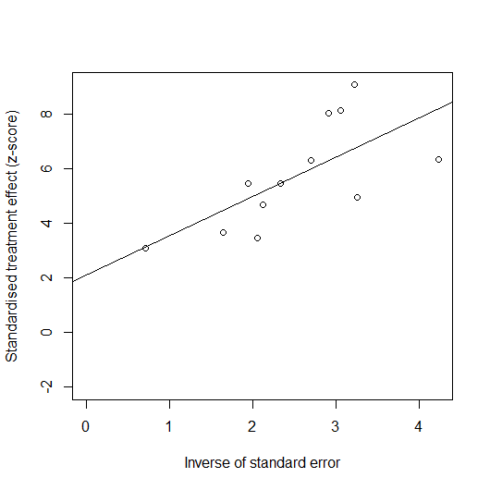

Fig. 3. Funnel plot for the evaluation of publication bias of the LDV/SOF.
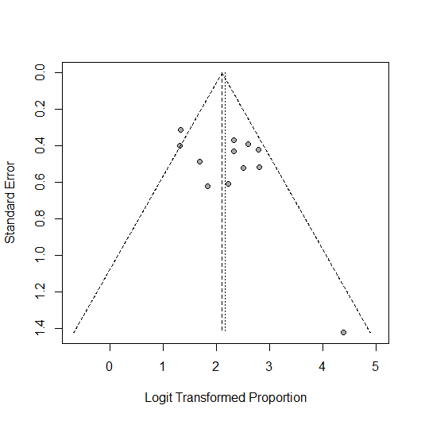

Fig. 4. Egger’s funnel plot for the evaluation of publication bias of the LDV/SOF.
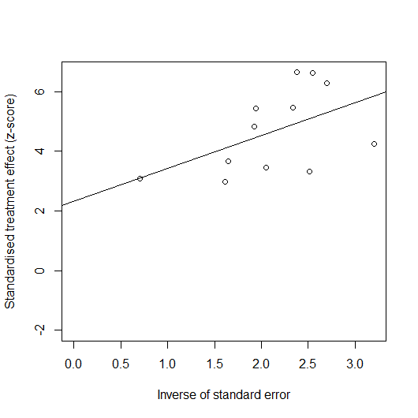

Fig. 5. The sensitivity analysis of SVR12 rate.


