Weight reduction added to CPAP decreases blood pressure and triglyceride level in OSA: systematic review and meta-analysis

Authors: Dóra K Kovács¹, Noémi Gede¹, László Szabó¹, Péter Hegyi^{2,3,4}, Zsolt Szakács¹, Béla Faludi⁵, Ágnes Sebők⁵, András Garami¹, Margit Solymár¹, Dániel Kósa¹, Lilla Hanák¹, Zoltán Rumbus¹, Márta Balaskó¹

¹Institute for Translational Medicine, Medical School, University of Pécs, Pécs Hungary
²Institute for Translational Medicine, Medical School, Szentágothai Research Centre, University of Pécs, Pécs, Hungary
³Centre for Translational Medicine, Semmelweis University, Budapest, Hungary
⁴Division for Pancreatic Disorders, Heart and Vascular Center, Semmelweis University, Budapest, Hungary
⁵Department of Neurology, Medical School, University of Pécs, Pécs, Hungary

Corresponding author:
Márta Balaskó, M.D., Ph.D.
E-mail: marta.balasko@aok.pte.hu

Figure S1 Forest plot representing reduction of blood low-density lipoprotein level after CPAP+WL versus CPAP therapies.
Squares show the weighted mean difference (WMD) of blood low-density lipoprotein level after continuous positive pressure ventilation (CPAP) + weight reduction (WL) versus CPAP therapies. The grey area reflects the weight assigned to the study. Horizontal bars indicate 95% confidence intervals (95% CI). The diamond shows the overall WMD with its corresponding 95% CI. N – number of participants.

Figure S2 Forest plot representing changes in blood high-density lipoprotein level after CPAP+WL versus CPAP therapies.
Squares show the weighted mean difference (WMD) of blood high-density lipoprotein level after continuous positive pressure ventilation (CPAP) + weight reduction (WL) versus CPAP therapies. The grey area reflects the weight assigned to the study. Horizontal bars indicate 95% confidence intervals (95% CI). The diamond shows the overall WMD with its corresponding 95% CI. N – number of participants.
Figure S3 Sensitivity analysis of intention-to-treat (ITT) data on changes in systolic blood pressure (WL+CPAP vs. CPAP)
Sensitivity analysis by omitting each study sequentially. Authors of the only study, in which only per-protocol (PP) data were published (López-Padrós et al. 2020), emphasized that there was no difference between their ITT and PP results.

Figure S4 Sensitivity analysis of intention-to-treat (ITT) data on changes in diastolic blood pressure (WL+CPAP vs. CPAP)
Sensitivity analysis by omitting each study sequentially. Authors of the only study, in which only per-protocol (PP) data were published (López-Padrós et al. 2020), emphasized that there was no difference between their ITT and PP results.

Figure S5 Sensitivity analysis of intention-to-treat (ITT) data on changes in systolic blood pressure (WL+CPAP vs. WL)
Sensitivity analysis by omitting each study sequentially.

Figure S6 Sensitivity analysis of intention-to-treat (ITT) data on changes in diastolic blood pressure (WL+CPAP vs. WL)
Sensitivity analysis by omitting each study sequentially.

Figure S7 Sensitivity analysis of intention-to-treat (ITT) data on changes in triglyceride level (WL+CPAP vs. CPAP)
Sensitivity analysis by omitting each study sequentially. Authors of the only study, in which only per-protocol (PP) data were published (López-Padrós et al. 2020), emphasized that there was no difference between their ITT and PP results.

Figure S8 Sensitivity analysis of intention-to-treat (ITT) data on changes in low-density lipoprotein (LDL) (WL+CPAP vs. CPAP)
Sensitivity analysis by omitting each study sequentially. Authors of the only study, in which only per-protocol (PP) data were published (López-Padrós et al. 2020), emphasized that there was no difference between their ITT and PP results.

Figure S9 Sensitivity analysis of intention-to-treat (ITT) data on changes in high-density lipoprotein (HDL) (WL+CPAP vs. CPAP) Sensitivity analysis by omitting each study sequentially. Authors of the only study, in which only per-protocol (PP) data were published (López-Padrós et al. 2020), emphasized that there was no difference between their ITT and PP results.

Table S1: Risk of bias assessment by the revised Cochrane risk of bias tool 2 for randomized trials (RoB2 tool)
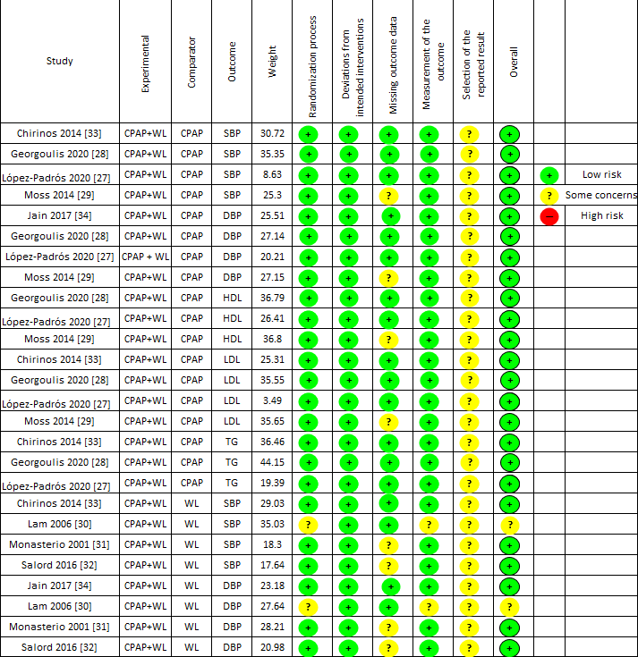
CPAP – continuous positive airway pressure; DBP – diastolic blood pressure; SBP – systolic blood pressure; WL – weight loss

Table S2: GRADE evidence profile table
Certainty assessment |  |  |  |  |  |  | № of patients |  | Effect | Certainty | Importance
№ of studies | Study design | Risk of bias | Inconsistency | Indirectness | Imprecision | Other considerations | CPAP | CPAP + Weight loss | WMD  (95% CI) | Certainty | Importance
Systolic blood pressure (assessed with: mmHg)
4 | randomised trials | not serious | serious | not serious | not serious | none | 147 | 131 | -8.89  ([-13.67; -4.10) | ⨁⨁⨁◯  MODERATE | IMPORTANT
Dyastolic blood pressure (assessed with: mmHg)
4 | randomised trials | not serious | very serious | not serious | serious | none | 137 | 127 | -5.82  (-14.26; 2.63) | ⨁◯◯◯  VERY LOW | IMPORTANT
High-density lipoprotein (assessed with: mmol/L)
3 | randomised trials | not serious | serious | not serious | serious | none | 99 | 99 | 0.04  (-0.11, 0.19) | ⨁⨁◯◯  LOW | IMPORTANT
Low-density lipoprotein (assessed with: mmol/L)
4 | randomised trials | not serious | very serious | not serious | not serious | none | 138 | 123 | -0.12  (-0.27; 0.03) | ⨁⨁◯◯  LOW | IMPORTANT
Triglyceride (assessed with: mmol/L)
3 | randomised trials | not serious | serious | not serious | not serious | none | 117 | 101 | -0.31  (-0.58; -0.04) | ⨁⨁⨁◯  MODERATE | IMPORTANT

Certainty assessment |  |  |  |  |  |  | № of patients |  | Effect | Certainty | Importance
№ of studies | Study design | Risk of bias | Inconsistency | Indirectness | Imprecision | Other considerations | Weight loss | CPAP + Weight loss | WMD  (95% CI) | Certainty | Importance
Systolic blood pressure (assessed with: mmHg)
4 | randomised trials | not serious | serious | serious | serious | none | 157 | 166 | -3.88  (-7.78; 0.02) | ⨁◯◯◯  VERY LOW | IMPORTANT
Dyastolic blood pressure (assessed with: mmHg)
4 | randomised trials | not serious | very serious | serious | serious | none | 152 | 162 | -3.47  (-8.57; 1.63) | ⨁◯◯◯  VERY LOW | IMPORTANT

GRADE Working Group grades of evidence
High certainty: We are very confident that the true effect lies close to that of the estimate of the effect.
Moderate certainty: We are moderately confident in the effect estimate: The true effect is likely to be close to the estimate of the effect, but there is a possibility that it is substantially different.
Low certainty: Our confidence in the effect estimate is limited: The true effect may be substantially different from the estimate of the effect.
Very low certainty: We have very little confidence in the effect estimate: The true effect is likely to be substantially different from the estimate of effect.
CI – confidence interval; WMD – weighted mean difference

