Supplementary materials
Incidence, risk factors and mortality of invasive pulmonary aspergillosis in patients with influenza: A systematic review and meta-analysis

CONTENTS
Abbreviations and notes………………………………………………………………………………………3
Table S1. Search strategy used in PubMed, EMBASE and the Cochrane Library databases…………………4
Table S2. Diagnostic criteria for invasive pulmonary aspergillosis……………………………………………5
Table S3. Characteristics of influenza patients with invasive pulmonary aspergillosis…………………………7
Table S4. Quality assessment of the included studies…………………………………………………………8
Table S5. Data on the association between smoking history and the risk of IPA………………………………9
Table S6. Data on the association between male sex and the risk of IPA………………………………………9
Table S7. Data on the association between advanced age and the risk of IPA…………………………………9
Table S8. Data on the association between obesity and the risk of IPA…………………………………………9
Table S9. Data on the association between chronic lung disease and the risk of IPA…………………………10
Table S10. Data on the association between COPD and the risk of IPA………………………………………10
Table S11. Data on the association between chronic kidney disease and the risk of IPA………………………10
Table S12. Data on the association between liver cirrhosis and the risk of IPA………………………………10
Table S13. Data on the association between diabetes mellitus and the risk of IPA……………………………11
Table S14. Data on the association between solid organ malignancy and the risk of IPA……………………11
Table S15. Data on the association between influenza A and the risk of IPA…………………………………11
Table S16. Data on the association between influenza A (H1N1) and the risk of IPA…………………………12
Table S17. Data on the association between influenza A (H3N2) and the risk of IPA…………………………12
Table S18. Data on the association between influenza B and the risk of IPA…………………………………12
Table S19. Data on the association between neuraminidase inhibitor and the risk of IPA……………………12
Table S20. Data on the association between vasopressor use and the risk of IPA……………………………13
Table S21. Data on the association between renal replacement therapy and the risk of IPA…………………13
Table S22. Data on the association between ECMO and the risk of IPA………………………………………13
Table S23. Data on the association between invasive mechanical ventilation and the risk of IPA……………13
Table S24. Data on the association between EORTC/MSG host factor and the risk of IPA……………………14
Table S25. Data on the association between solid organ transplant and the risk of IPA………………………14
Table S26. Data on the association between hematological malignancy and the risk of IPA…………………14
Table S27. Data on the association between corticosteroid use before admission and the risk of IPA…………14
Table S28. Sensitivity analyses of risk factors for IPA………………………………………………………15
Table S29. Data on the association between IPA and mortality………………………………………………16
Figure S1. Flow diagram of the literature search and selection process………………………………………17
Figure S2. Forest plot of the association between smoking history and the risk of IPA………………………18
Figure S3. Forest plot of the association between male sex and the risk of IPA………………………………18
Figure S4. Forest plot of the association between advanced age and the risk of IPA…………………………18
Figure S5. Forest plot of the association between obesity and the risk of IPA…………………………………18
Figure S6. Forest plot of the association between chronic lung disease and the risk of IPA…………………18
Figure S7. Forest plot of the association between COPD and the risk of IPA…………………………………19
Figure S8. Forest plot of the association between chronic kidney disease and the risk of IPA………………19
Figure S9. Forest plot of the association between liver cirrhosis and the risk of IPA…………………………19
Figure S10. Forest plot of the association between diabetes mellitus and the risk of IPA………………………19
Figure S11. Forest plot of the association between solid organ malignancy and the risk of IPA………………20
Figure S12. Forest plot of the association between influenza A and the risk of IPA…………………………20
Figure S13. Forest plot of the association between influenza A (H1N1) and the risk of IPA…………………20
Figure S14. Forest plot of the association between influenza A (H3N2) and the risk of IPA…………………20
Figure S15. Forest plot of the association between influenza B and the risk of IPA…………………………21
Figure S16. Forest plot of the association between neuraminidase inhibitor and risk of IPA…………………21
Figure S17. Forest plot of the association between vasopressor use and the risk of IPA………………………21
Figure S18. Forest plot of the association between renal replacement therapy and the risk of IPA……………21
Figure S19. Forest plot of the association between ECMO and the risk of IPA………………………………22
Figure S20. Forest plot of the association between invasive mechanical ventilation and the risk of IPA……22
Figure S21. Forest plot of the association between EORTC/MSG host factor and risk of IPA………………22
Figure S22. Forest plot of the association between solid organ transplant and the risk of IPA………………22
Figure S23. Forest plot of the association between hematological malignancy and the risk of IPA…………23
Figure S24. Forest plot of the association between corticosteroid use before admission and the risk of IPA…23
Figure S25. Forest plot of the association between IPA and mortality………………………………………23
Figure S26. Forest plot of the association between IPA and mortality (ICU patients) ………………………23

Abbreviations and notes
Abbreviations:
COPD, chronic obstructive pulmonary disease; ECMO, extracorporeal membrane oxygenation; EORTC/MSG, European Organization for Research and Treatment of Cancer/Invasive Fungal Infections Cooperative Group and the National Institute of Allergy and Infectious Diseases Mycoses Study Group; IPA, invasive pulmonary aspergillosis.
Notes:
a: The number of persons exposed to risk factors in the IPA group.
b: The number of persons unexposed to risk factors in the IPA group.
c: The number of persons exposed to risk factors in the non-IPA group.
d: The number of persons unexposed to risk factors in the non-IPA group.

Table S1. Search strategy used in PubMed, EMBASE and the Cochrane Library databases
Database | PubMed |  | EMBASE |  | The Cochrane Library database
No. | Search query | Results | Search query | Results | Search query | Results
#1 | aspergillus [mh] | 53982 | aspergillus [exp] | 80868 | aspergillus | 502
#2 | aspergillosis [mh] | 21470 | aspergillosis | 31958 | aspergillosis | 522
#3 | invasive pulmonary aspergillosis [mh] | 3505 | invasive pulmonary aspergillosis [exp] | 6748 | invasive pulmonary aspergillosis | 74
#4 | #1 OR #2 OR #3 | 63163 | #1 OR #2 OR #3 | 96390 | #1 OR #2 OR #3 | 848
#5 | influenza | 142931 | influenza | 172902 | influenza | 7857
#6 | #4 AND #5 | 399 | #4 AND #5 | 1113 | #4 AND #5 | 11
#7 | influenza-associated pulmonary aspergillosis | 26 | influenza-associated pulmonary aspergillosis | 14 | influenza-associated pulmonary aspergillosis | 2
#8 | influenza associated pulmonary aspergillosis | 84 | influenza associated pulmonary aspergillosis | 14 | influenza associated pulmonary aspergillosis | 2
#9 | IAPA | 52 | IAPA | 68 | IAPA | 6
#10 | #7 OR #8 OR #9 | 128 | #7 OR #8 OR #9 | 75 | #7 OR #8 OR #9 | 6
#11 | #6 OR #10 | 442 | #6 OR #10 | 1166 | #6 OR #10 | 15

Table S2. Diagnostic criteria for invasive pulmonary aspergillosis
Name | Diagnostic criteria
EORTC/MSG criteria 2008 | Proven: histopathological/microscopic evidence of hyphae, with evidence of tissue damage or positive culture on sterile material.  Probable: the presence of at least one host factor, a clinical feature and mycologic evidence.  1. Host factors: (1) a recent history of neutropenia temporally related to the onset of invasive fungal disease, (2) a history of allogeneic stem cell transplantation, (3) prolonged use of corticosteroids at a mean minimum dose of 0.3 mg/kg/day of prednisone equivalent for >3 weeks, (4) treatment with other recognized T cell immunosuppressants during the past 90 days, and (5) inherited severe immunodeficiency.  2. Clinical features: (1) dense, well-circumscribed lesions(s) with or without a halo sign, (2) an air-crescent sign, or (3) a cavity.  3. Mycological evidence: (1) fungus in sputum, BAL fluid, bronchial brush, or a sinus aspirate sample, as indicated by one of the following: the presence of fungal elements indicating mold and proliferation of Aspergillus on culture, and (2) GM antigen detection in plasma, serum, BAL fluid, or CSF.
EORTC/MSG criteria 2020 | Proven: histopathological/microscopic evidence of hyphae, with evidence of tissue damage or positive culture on sterile material.  Probable: the presence of at least one host factor, a clinical feature and mycologic evidence.  Host factors: (1) a recent history of neutropenia temporally related to the onset of invasive fungal disease, (2) hematologic malignancy, (3) a history of allogeneic stem cell transplantation, (4) a history of solid organ transplantation, (5) prolonged use of corticosteroids at a therapeutic dose of ≥0.3 mg/kg corticosteroids for ≥3 weeks in the past 60 days, (6) treatment with other recognized T cell immunosuppressants during the past 90 days, (7) treatment with recognized B cell immunosuppressants, (8) inherited severe immunodeficiency, and (9) acute graft-versus-host disease grade III or IV involving the gut, lungs, or liver that is refractory to first-line treatment with steroids.  Clinical features: (1) dense, well-circumscribed lesions(s) with or without a halo sign, (2) an air crescent sign, (3) a cavity, or (4) wedge-shaped and segmental or lobar consolidation.  Mycological evidence: (1) Aspergillus positivity on culture of sputum, BAL, bronchial brush, or aspirate samples, (2) microscopical detection of fungal elements in sputum, BAL, bronchial brush, or aspirate samples indicating a mold, (3) GM antigen detection in plasma, serum, BAL, or CSF (one of the following: single serum or plasma ≥1.0, BAL fluid ≥1.0, single serum or plasma ≥0.7 and BAL fluid ≥0.8, CSF ≥1.0), or Aspergillus detection by PCR (one of the following: plasma, serum, or whole blood two or more consecutive positive PCR tests; BAL fluid two or more duplicate positive PCR tests; at least one PCR test positive in plasma, serum, or whole blood and one PCR test positive in BAL fluid).

Table S2. Continued
Name | Diagnostic criteria
AspICU criteria | Proven: idem EORTC/MSG criteria.  Putative: all four criteria must be met.  1. Aspergillus-positive lower respiratory tract specimen culture (entry criterion)  2. Compatible signs and symptoms (one of the following): (1) fever refractory to at least 3 d of appropriate antibiotic therapy, (2) recrudescent fever after a period of defervescence of at least 48 h while still on antibiotics and without another apparent cause, (3) pleuritic chest pain, (4) pleuritic rub, (5) dyspnea, (6) hemoptysis, and (7) worsening respiratory insufficiency despite appropriate antibiotic therapy and ventilatory support.  3. Abnormal medical imaging by portable chest X-ray or CT scan of the lungs.  4. Either 4a or 4b.  4a Host risk factors (one of the following): (1) neutropenia (absolute neutrophil count, 500/mm³) preceding or at the time of ICU admission, (2) underlying hematological or oncological malignancy treated with cytotoxic agents, (3) glucocorticoid treatment (prednisone equivalent, >20 mg/d), and (4) congenital or acquired immunodeficiency.  4b Semiquantitative Aspergillus-positive culture of BAL fluid (+ or ++) without bacterial growth and a positive cytological smear showing branching hyphae.
Modified AspICU criteria | The definition of invasive pulmonary aspergillosis was modified from the AspICU criteria and was based on the presence of clinical, radiological, and mycological criteria.  1. Clinical criteria (one of the following): (1) fever refractory to at least 3 days of appropriate antibiotic therapy, (2) recrudescent fever after a period of defervescence of at least 48 h while still on antibiotics and without another apparent cause, (3) dyspnea, (4) hemoptysis, (5) pleural friction rub or chest pain, and (6) worsening respiratory insufficiency despite appropriate antibiotic therapy and ventilatory support.  2. Radiological criteria: any infiltrate on pulmonary imaging, including portable X-ray or lung CT scan.  3. Mycological criteria (at least one of the following): (1) histopathological or direct microscopic evidence of dichotomous septate hyphae and positive culture of Aspergillus from tissue, (2) positive Aspergillus culture from BAL fluid, (3) a BAL fluid GM optical index of ≥1, and (4) a serum GM optical index of ≥0.5.
Criteria developed by Verweij et al. | Entry criterion: influenza-like illness, a positive influenza PCR or antigen test, and a temporal relationship.  Proven: lung biopsy showing invasive fungal elements and Aspergillus growth on culture or PCR positivity for Aspergillus in tissue.  Probable: (1) pulmonary infiltrate and at least one of the following: a serum GM index >0.5, a BAL fluid GM index ≥1.0, and positive BAL fluid culture, or (2) cavitating infiltrate (not attributed to another cause) and at least one of the following: positive sputum culture or positive tracheal aspirate culture.
Abbreviations: BAL, bronchoalveolar lavage; CSF, cerebrospinal fluid, CT, computed tomography, GM galactomannan; ICU, intensive care unit.

Table S3. Characteristics of influenza patients with invasive pulmonary aspergillosis
Study | N | Smoking history | Obesity | Underlying disease (n) | LOS in hospital, daysª | LOS in ICU, daysª
Bellelli 2020 | 5 | 5 | NA | COPD (4), CHF (2), CKD (1), ND (1), PD (1) and AD (1) | 37 (33-49) | NA
Chen 2020 | 21 | 7 | NA | DM (15), COPD (6), cerebrovascular disease (4), asthma (3), CHF (3) and CKD (2) | 24 (11-42) | 9 (7-11)
Coste 2021 | 10 | NA | NA | NA | NA | NA
Duan 2021 | 72 | NA | NA | NA | NA | NA
Huang 2020 | 41 | 24 | 3 | DM (14), CLD (14), CHD (6), CKD (3), malignancy (3) and moderate to severe LD (1) | NA | NA
Ku 2017 | 21 | NA | NA | DM (7), malignancy (5), COPD (2), LC (2) and SOT (1) | NA | NA
Lin 2021 | 18 | NA | NA | HP (7), CLD (7), COPD (6), DM (6), CKD (4), SOM (3) and LD (1) | 14 (11-25) | 9 (6-21)
Martin-Loeches 2017 | 35 | NA | NA | NA | NA | NA
Nyga 2020 | 35 | 9 | NA | COPD (13), dyslipidemia (9), HM (7), CHF (7), DM (6), AD (5), CKD (4), neutropenia (4), CLF (2), LC (2), SOT (2) and SOM (2) | NA | 24 (10-30)
Schauwvlieghe 2018 | 83 | 26 | 17 | HM (22), CKD (16), COPD (13), SOT (11), neutropenia (11), DM (10), LC (5) and SOM (4) | NA | 19 (12-38)
Schwartz 2020 | 8 | 1 | 3 | CLD (4), COPD (2), DM (1), LC (1) and SOM (1) | NA | NA
Vanderbeke 2021 | 21 | 10 | 6 | DM (7), COPD (7), HM (1) and SOT (1) | 52 (17-187) | 23 (9-49)
Waldeck 2020 | 9 | NA | NA | DM (3), CKD (3), cardiovascular disease (3), COPD (2), asthma (2) and SOM (1) | 40^{b} | 17^{b}
Zou 2020 | 18 | 9 | NA | HP (7), DM (2), COPD (2) and CHD (2) | 23.5 (16.3-45.3) | 22 (16.3-57.5)
Abbreviations: AD, autoimmune disease; CHD, chronic heart disease; CHF, chronic heart failure; CKD, chronic kidney disease; CLF, chronic liver failure; COPD, chronic obstructive pulmonary disease; CLD, chronic lung disease; DM, diabetes mellitus; HM, hematologic malignancy; HP, hypertension; ICU, intensive care unit; IPA, invasive pulmonary aspergillosis; LC, liver cirrhosis; LD, liver disease; LOS, length of stay; NA, not available; ND, neurologic diseases; PD, psychiatric disease; SOM, solid organ malignancy; SOT, solid organ transplant.
ªValues are expressed as medians (interquartile ranges).
^{b}Value are expressed as medians.

Table S4. Quality assessment of the included studies
Risk of Bias Assessment-Randomized Controlled Trials
Study | Randomization process |  | Deviations from intended interventions |  |  | Missing outcome data |  | Measurement of the outcome |  |  | Selection of the reported result |  | Overall bias
Vanderbeke 2021 | High risk |  | Low risk |  |  | Low risk |  | Some concerns |  |  | Low risk |  | High risk
Newcastle-Ottawa Scale-Observational Studies
Study | Selection |  |  |  |  |  | Comparability |  | Outcomes |  |  |  | Total  scores
Study | S1 | S2 |  | S3 | S4 |  | C1 |  | O1 | O2 |  | O3 | Total  scores
Bellelli 2020 | ★ | ★ |  | ★ |  |  |  |  | ★ | ★ |  | ★ | 6
Chen 2020 | ★ | ★ |  |  |  |  | ★★ |  | ★ | ★ |  | ★ | 7
Coste 2021 | ★ | ★ |  |  |  |  | ★★ |  | ★ | ★ |  | ★ | 7
Duan 2021 | ★ | ★ |  | ★ |  |  | ★ |  | ★ |  |  |  | 5
Huang 2020 | ★ | ★ |  | ★ |  |  |  |  | ★ | ★ |  | ★ | 6
Ku 2017 | ★ | ★ |  |  |  |  | ★★ |  | ★ | ★ |  | ★ | 7
Lin 2021 | ★ | ★ |  | ★ |  |  |  |  | ★ |  |  | ★ | 5
Martin-Loeches 2017 | ★ | ★ |  | ★ | ★ |  |  |  |  |  |  |  | 4
Nyga 2020 | ★ | ★ |  | ★ |  |  |  |  | ★ | ★ |  | ★ | 6
Schauwvlieghe 2018 | ★ | ★ |  | ★ |  |  | ★★ |  | ★ | ★ |  | ★ | 8
Schwartz 2020 | ★ | ★ |  | ★ |  |  |  |  | ★ | ★ |  | ★ | 6
Waldeck 2020 | ★ | ★ |  | ★ |  |  |  |  | ★ | ★ |  | ★ | 6
Zou 2020 | ★ | ★ |  | ★ |  |  |  |  | ★ | ★ |  | ★ | 6
S1 Representativeness of the exposed cohort, S2 Selection of the non-exposed cohort, S3 Ascertainment of exposure, S4 Demonstration that outcome of interest was not present at the start of the study, C1 Comparability of cohorts on the basis of the design or analysis, O1 Assessment of outcome, O2 Adequate follow-up for the outcome, O3 Adequacy of follow up of cohorts

Table S5. Data on the association between smoking history and the risk of IPA
Study | a | b | c | d | Definition
Bellelli 2020 | 5 | 0 | 30 | 42 | Smoker
Chen 2020 | 7 | 14 | 236 | 436 | Smoking history
Huang 2020 | 24 | 17 | 31 | 60 | Smoking in the past half year
Schauwvlieghe 2018 | 26 | 35 | 88 | 183 | Smoking in the past half year
Vanderbeke 2021 | 10 | 9 | 24 | 29 | Smoking in the past half year
Zou 2020 | 9 | 9 | 67 | 250 | Smoking in the past 1 year

Table S6. Data on the association between male sex and the risk of IPA
Study | a | b | c | d
Bellelli 2020 | 3 | 2 | 36 | 36
Chen 2020 | 18 | 3 | 443 | 229
Duan 2021 | 50 | 22 | 57 | 27
Huang 2020 | 33 | 8 | 51 | 40
Ku 2017 | 11 | 10 | 66 | 37
Lin 2021 | 11 | 7 | 82 | 57
Schauwvlieghe 2018 | 56 | 27 | 184 | 165
Schwartz 2020 | 5 | 3 | 55 | 48
Vanderbeke 2021 | 13 | 8 | 37 | 30
Waldeck 2020 | 6 | 3 | 37 | 35
Zou 2020 | 12 | 6 | 220 | 97

Table S7. Data on the association between advanced age and the risk of IPA
Study | a | b | c | d | Definition
Duan 2021 | 24 | 48 | 35 | 49 | Age ≥ 65 years
Huang 2020 | 22 | 19 | 42 | 49 | Age > 60 years
Lin 2021 | 10 | 8 | 55 | 84 | Age ≥ 65 years

Table S8. Data on the association between obesity and the risk of IPA
Study | a | b | c | d | Definition
Huang 2020 | 3 | 38 | 8 | 83 | Body-mass index > 30 kg/m²
Schauwvlieghe 2018 | 17 | 66 | 76 | 251 | Body-mass index > 30 kg/m²
Vanderbeke 2021 | 6 | 15 | 21 | 45 | Body-mass index > 30 kg/m²

Table S9. Data on the association between chronic lung disease and the risk of IPA
Study | a | b | c | d
Huang 2020 | 14 | 27 | 16 | 75
Lin 2021 | 7 | 11 | 30 | 109
Schwartz 2020 | 4 | 4 | 39 | 64

Table S10. Data on the association between COPD and the risk of IPA
Study | a | b | c | d
Bellelli 2020 | 4 | 1 | 10 | 62
Chen 2020 | 6 | 15 | 34 | 638
Ku 2017 | 2 | 19 | 20 | 83
Lin 2021 | 6 | 12 | 23 | 116
Schauwvlieghe 2018 | 13 | 70 | 66 | 283
Vanderbeke 2021 | 7 | 14 | 12 | 55
Waldeck 2020 | 2 | 7 | 25 | 47
Zou 2020 | 2 | 16 | 14 | 303

Table S11. Data on the association between chronic kidney disease and the risk of IPA
Study | a | b | c | d
Bellelli 2020 | 1 | 4 | 5 | 67
Chen 2020 | 2 | 19 | 14 | 658
Huang 2020 | 3 | 38 | 7 | 84
Ku 2017 | 2 | 19 | 12 | 91
Lin 2021 | 4 | 14 | 5 | 134
Schauwvlieghe 2018 | 16 | 67 | 55 | 294
Waldeck 2020 | 3 | 6 | 16 | 56
Zou 2020 | 0 | 18 | 12 | 305

Table S12. Data on the association between liver cirrhosis and the risk of IPA
Study | a | b | c | d
Bellelli 2020 | 0 | 5 | 2 | 70
Ku 2017 | 2 | 19 | 2 | 101
Schauwvlieghe 2018 | 5 | 78 | 20 | 329
Vanderbeke 2021 | 0 | 21 | 1 | 66

Table S13. Data on the association between diabetes mellitus and the risk of IPA
Study | a | b | c | d
Bellelli 2020 | 0 | 5 | 15 | 57
Chen 2020 | 15 | 6 | 77 | 595
Huang 2020 | 14 | 27 | 30 | 61
Ku 2017 | 7 | 14 | 44 | 59
Lin 2021 | 6 | 12 | 26 | 113
Schauwvlieghe 2018 | 10 | 73 | 78 | 271
Vanderbeke 2021 | 7 | 14 | 8 | 59
Waldeck 2020 | 3 | 6 | 18 | 54
Zou 2020 | 4 | 14 | 53 | 264

Table S14. Data on the association between solid organ malignancy and the risk of IPA
Study | a | b | c | d
Bellelli 2020 | 0 | 5 | 6 | 66
Chen 2020 | 0 | 21 | 16 | 656
Huang 2020 | 2 | 39 | 10 | 81
Ku 2017 | 5 | 16 | 8 | 95
Lin 2021 | 3 | 15 | 14 | 125
Schauwvlieghe 2018 | 4 | 79 | 17 | 332
Vanderbeke 2021 | 0 | 21 | 5 | 62
Waldeck 2020 | 1 | 8 | 4 | 68

Table S15. Data on the association between influenza A and the risk of IPA
Study | a | b | c | d
Bellelli 2020 | 2 | 3 | 46 | 26
Duan 2021 | 69 | 3 | 83 | 1
Huang 2020 | 33 | 8 | 79 | 12
Lin 2021 | 12 | 6 | 119 | 20
Nyga 2020 | 28 | 7 | 144 | 24
Schauwvlieghe 2018 | 71 | 12 | 284 | 65
Schwartz 2020 | 7 | 1 | 80 | 18
Vanderbeke 2021 | 19 | 2 | 54 | 13
Waldeck 2020 | 5 | 4 | 32 | 40

Table S16. Data on the association between influenza A (H1N1) and the risk of IPA
Study | a | b | c | d
Bellelli 2020 | 3 | 2 | 26 | 46
Duan 2021 | 66 | 6 | 67 | 17
Ku 2017 | 8 | 13 | 33 | 70
Nyga 2020 | 23 | 12 | 67 | 101
Schwartz 2020 | 7 | 1 | 47 | 51

Table S17. Data on the association between influenza A (H3N2) and the risk of IPA
Study | a | b | c | d
Duan 2021 | 1 | 71 | 2 | 82
Nyga 2020 | 4 | 31 | 16 | 152
Schwartz 2020 | 0 | 8 | 33 | 65

Table S18. Data on the association between influenza B and the risk of IPA
Study | a | b | c | d
Bellelli 2020 | 3 | 2 | 26 | 46
Duan 2021 | 3 | 69 | 1 | 83
Huang 2020 | 8 | 33 | 12 | 79
Lin 2021 | 6 | 12 | 20 | 119
Nyga 2020 | 7 | 28 | 24 | 144
Schauwvlieghe 2018 | 12 | 71 | 65 | 284
Schwartz 2020 | 1 | 7 | 18 | 85
Vanderbeke 2021 | 2 | 19 | 14 | 53
Waldeck 2020 | 4 | 5 | 46 | 26

Table S19. Data on the association between neuraminidase inhibitor and the risk of IPA
Study | a | b | c | d
Chen 2020 | 10 | 11 | 222 | 450
Nyga 2020 | 29 | 2 | 127 | 27
Schauwvlieghe 2018 | 70 | 13 | 268 | 77
Schwartz 2020 | 8 | 0 | 94 | 4
Vanderbeke 2021 | 20 | 1 | 64 | 3

Table S20. Data on the association between vasopressor use and the risk of IPA
Study | a | b | c | d
Chen 2020 | 11 | 10 | 16 | 656
Schauwvlieghe 2018 | 67 | 15 | 220 | 121
Vanderbeke 2021 | 19 | 2 | 41 | 26
Waldeck 2020 | 8 | 1 | 32 | 40

Table S21. Data on the association between renal replacement therapy and the risk of IPA
Study | a | b | c | d
Bellelli 2020 | 2 | 3 | 2 | 70
Huang 2020 | 12 | 29 | 10 | 81
Schauwvlieghe 2018 | 35 | 48 | 65 | 275
Vanderbeke 2021 | 9 | 12 | 10 | 57
Waldeck 2020 | 4 | 5 | 9 | 63

Table S22. Data on the association between ECMO and the risk of IPA
Study | a | b | c | d
Bellelli 2020 | 1 | 4 | 1 | 71
Huang 2020 | 8 | 33 | 16 | 75
Schauwvlieghe 2018 | 16 | 67 | 36 | 313
Schwartz 2020 | 5 | 3 | 8 | 95
Vanderbeke 2021 | 5 | 16 | 10 | 57
Waldeck 2020 | 2 | 7 | 10 | 62
Zou 2020 | 4 | 14 | 36 | 281

Table S23. Data on the association between invasive mechanical ventilation and the risk of IPA
Study | a | b | c | d
Bellelli 2020 | 5 | 0 | 8 | 64
Chen 2020 | 18 | 3 | 140 | 532
Huang 2020 | 29 | 12 | 43 | 48
Lin 2021 | 12 | 6 | 34 | 105
Schauwvlieghe 2018 | 75 | 8 | 251 | 98
Schwartz 2020 | 8 | 0 | 84 | 18
Vanderbeke 2021 | 19 | 2 | 35 | 32
Waldeck 2020 | 9 | 0 | 30 | 42

Table S24. Data on the association between EORTC/MSG host factor and the risk of IPA
Study | a | b | c | d
Nyga 2020 | 16 | 19 | 34 | 134
Schauwvlieghe 2018 | 38 | 45 | 79 | 270
Schwartz 2020 | 1 | 7 | 18 | 85
Vanderbeke 2021 | 3 | 18 | 9 | 58
Waldeck 2020 | 1 | 8 | 15 | 57

Table S25. Data on the association between solid organ transplant and the risk of IPA
Study | a | b | c | d
Ku 2017 | 1 | 20 | 1 | 102
Schauwvlieghe 2018 | 11 | 72 | 21 | 328
Vanderbeke 2021 | 1 | 20 | 0 | 67

Table S26. Data on the association between hematological malignancy and the risk of IPA
Study | a | b | c | d
Huang 2020 | 1 | 40 | 0 | 91
Schauwvlieghe 2018 | 22 | 61 | 44 | 305
Vanderbeke 2021 | 1 | 20 | 3 | 64
Waldeck 2020 | 0 | 9 | 8 | 64

Table S27. Data on the association between corticosteroid use before admission and the risk of IPA
Study | a | b | c | d | Definition
Chen 2020 | 18 | 3 | 114 | 558 | Systemic corticosteroid use before IPA diagnosis
Duan 2021 | 10 | 62 | 6 | 78 | Steroid use before admission
Huang 2020 | 15 | 26 | 14 | 77 | Accumulated dosage of systemic steroid 28 days before ICU > 200 mg
Lin 2021 | 8 | 10 | 43 | 96 | Methylprednisolone use 90 days before admission
Nyga 2020 | 16 | 17 | 49 | 54 | Corticosteroid use 28 days before ICU admission
Schauwvlieghe 2018 | 46 | 36 | 99 | 245 | Corticosteroid use 28 days before ICU admission
Vanderbeke 2021 | 7 | 14 | 19 | 47 | Systemic corticosteroid use 30 days before ICU admission

Table S28. Sensitivity analyses of risk factors for IPA
Risk factors | Pre-sensitivity analyses  (All hospitalized patients)  RR (95% Cl) | Post-sensitivity analyses  (All ICU patients)  RR (95% Cl)
Demographic factors
Smoking history | 1.57 [1.19, 2.08] | 1.41 [1.12, 1.77]
Male sex | 1.18 [1.07, 1.30] | 1.23 [1.08, 1.39]
Advanced age | 1.09 [0.79, 1.49] | 1.25 [0.94, 1.66]
Obesity | 0.88 [0.60, 1.29] | 0.88 [0.60, 1.29]
Comorbid conditions
Chronic lung disease | 1.70 [1.16, 2.50] | 1.70 [1.16, 2.50]
Chronic obstructive pulmonary disease | 1.83 [0.90, 3.72] | 1.12 [0.66, 1.90]
Chronic kidney disease | 1.71 [1.02, 2.87] | 1.51 [0.83, 2.75]
Liver cirrhosis | 1.46 [0.66, 3.21] | 1.42 [0.60, 3.36]
Diabetes mellitus | 1.39 [0.62, 3.14] | 1.12 [0.71, 1.77]
Solid organ malignancy | 1.34 [0.79, 2.25] | 1.30 [0.67, 2.53]
Influenza type
Influenza A | 0.99 [0.94, 1.03] | 1.01 [0.93, 1.09]
Influenza A (H1N1) | 1.44 [1.12, 1.85] | 1.65 [1.34, 2.04]
Influenza A (H3N2) | 0.80 [0.28, 2.29] | 0.62 [0.08, 4.74]
Influenza B | 1.17 [0.82, 1.67] | 1.07 [0.72, 1.60]
Medication use
Neuraminidase inhibitor | 1.06 [0.98, 1.15] | 1.06 [0.99, 1.13]
Supportive therapy
Vasopressor use | 2.77 [1.40, 5.48] | 1.49 [1.18, 1.88]
Renal replacement therapy | 2.73 [1.91, 3.89] | 2.43 [1.85, 3.19]
Extracorporeal membrane oxygenation | 2.27 [1.28, 4.03] | 2.13 [1.07, 4.24]
Invasive mechanical ventilation | 2.17 [1.51, 3.13] | 1.62 [1.28, 2.04]
Classic risk factors
EORTC/MSG host factor | 1.90 [1.41, 2.56] | 1.90 [1.41, 2.56]
Solid organ transplant | 2.45 [1.28, 4.71] | 2.45 [1.28, 4.71]
Hematological malignancy | 2.01 [1.30, 3.10] | 2.01 [1.30, 3.10]
Corticosteroid use before admission | 1.89 [1.06, 3.38] | 1.53 [1.10, 2.12]

Table S29. Data on the association between IPA and mortality
Study | a | b | c | d
Bellelli 2020 | 5 | 0 | 6 | 66
Chen 2020 | 9 | 12 | 127 | 545
Duan 2021 | 38 | 34 | 19 | 65
Lin 2021 | 10 | 8 | 18 | 121
Nyga 2020 | 20 | 15 | 44 | 121
Schauwvlieghe 2018 | 42 | 41 | 99 | 250
Schwartz 2020 | 4 | 4 | 28 | 75
Vanderbeke 2021 | 13 | 8 | 16 | 51
Waldeck 2020 | 3 | 6 | 13 | 59
Zou 2020 | 4 | 14 | 92 | 225

Figure S1. Flow diagram of the literature search and selection process

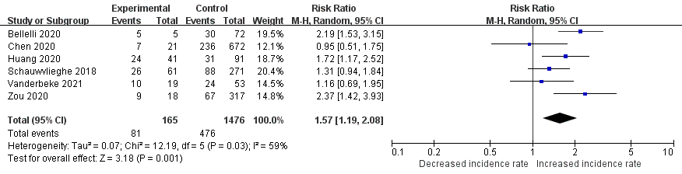
Figure S2. Forest plot of the association between smoking history and the risk of IPA

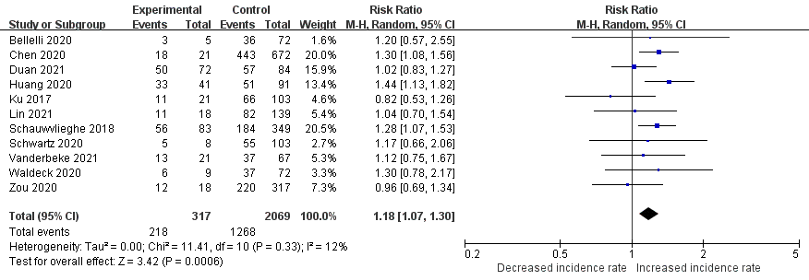
Figure S3. Forest plot of the association between male sex and the risk of IPA

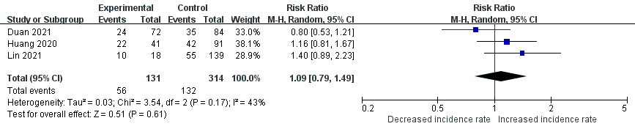
Figure S4. Forest plot of the association between advanced age and the risk of IPA

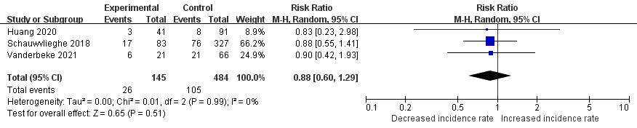
Figure S5. Forest plot of the association between obesity and the risk of IPA

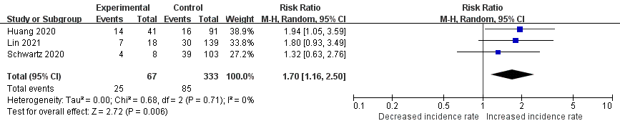
Figure S6. Forest plot of the association between chronic lung disease and the risk of IPA
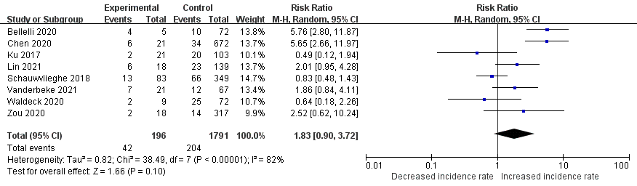
Figure S7. Forest plot of the association between COPD and the risk of IPA

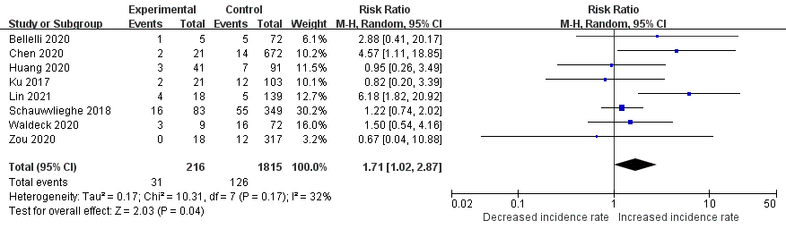
Figure S8. Forest plot of the association between chronic kidney disease and the risk of IPA
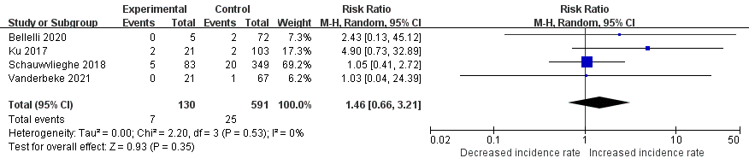
Figure S9. Forest plot of the association between liver cirrhosis and the risk of IPA

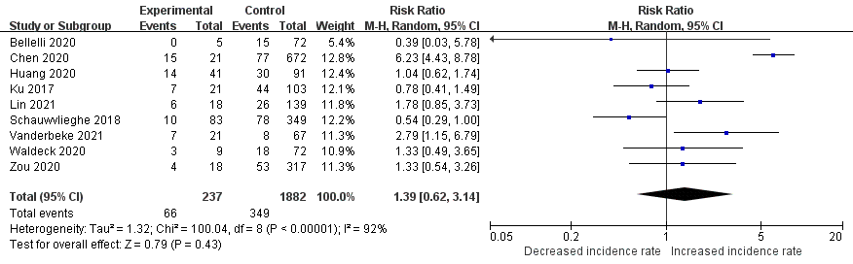
Figure S10. Forest plot of the association between diabetes mellitus and the risk of IPA

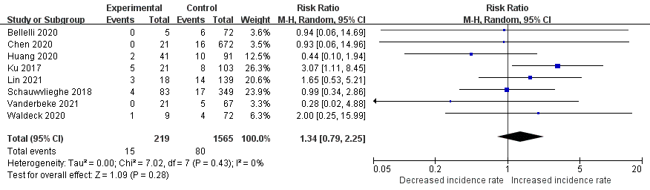
Figure S11. Forest plot of the association between solid organ malignancy and the risk of IPA

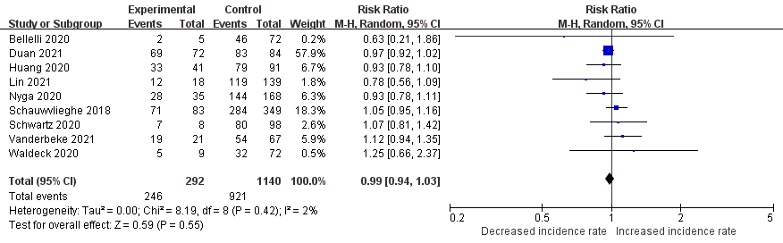
Figure S12. Forest plot of the association between influenza A and the risk of IPA

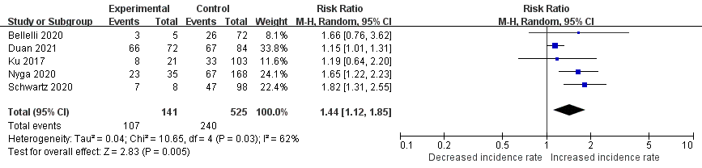
Figure S13. Forest plot of the association between influenza A (H1N1) and the risk of IPA

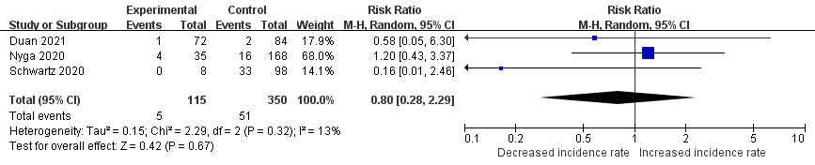
Figure S14. Forest plot of the association between influenza A (H3N2) and the risk of IPA

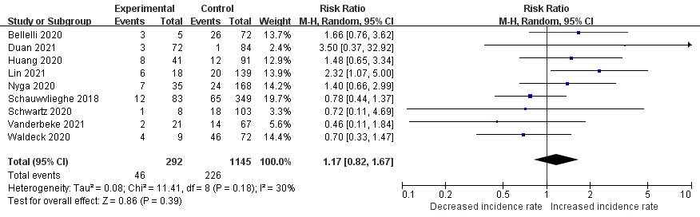
Figure S15. Forest plot of the association between influenza B and the risk of IPA

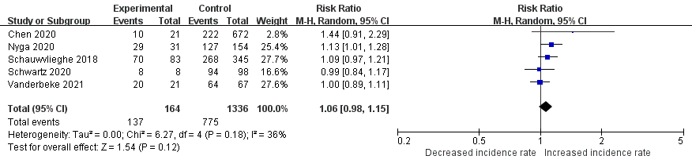
Figure S16. Forest plot of the association between neuraminidase inhibitor and the risk of IPA

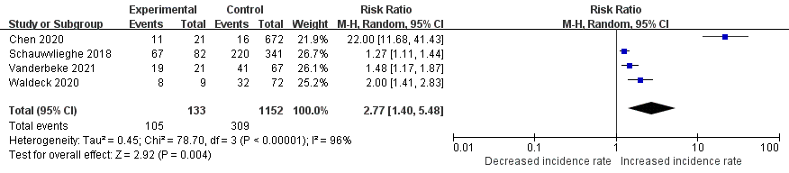
Figure S17. Forest plot of the association between vasopressor use and the risk of IPA

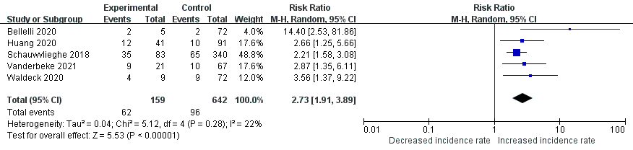
Figure S18. Forest plot of the association between renal replacement therapy and the risk of IPA

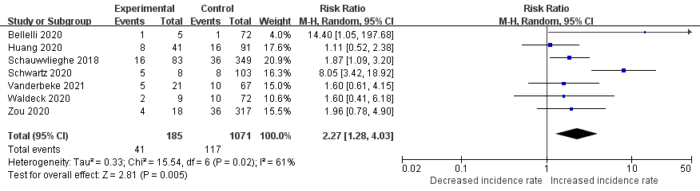
Figure S19. Forest plot of the association between ECMO and the risk of IPA

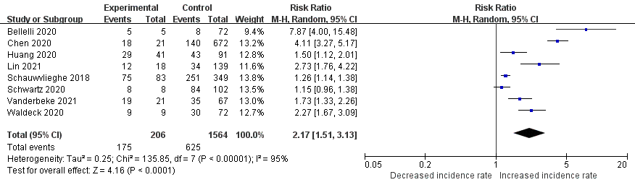
Figure S20. Forest plot of the association between invasive mechanical ventilation and the risk of IPA

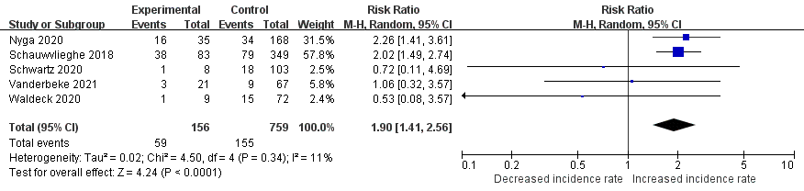
Figure S21. Forest plot of the association between EORTC/MSG host factor and the risk of IPA

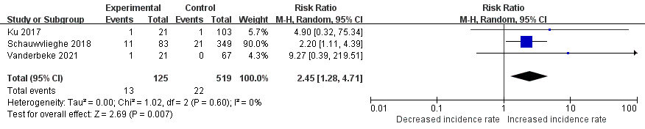
Figure S22. Forest plot of the association between solid organ transplant and the risk of IPA

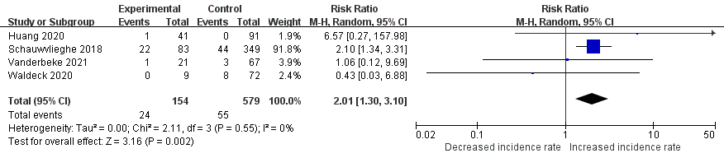
Figure S23. Forest plot of the association between hematological malignancy and the risk of IPA

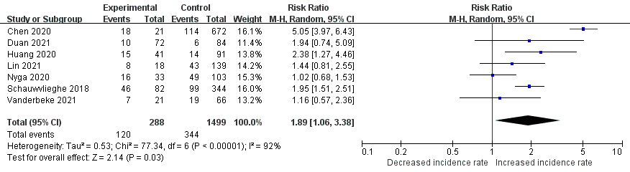
Figure S24. Forest plot of the association between corticosteroid use before admission and the risk of IPA
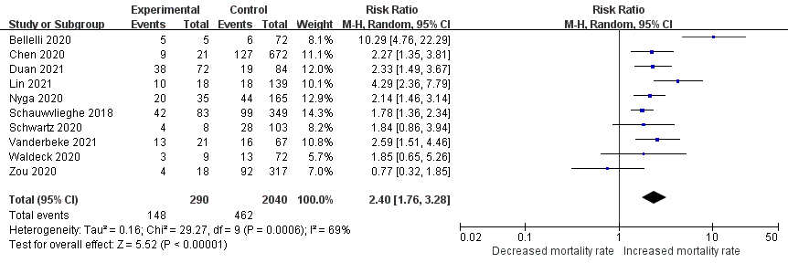
Figure S25. Forest plot of the association between IPA and mortality

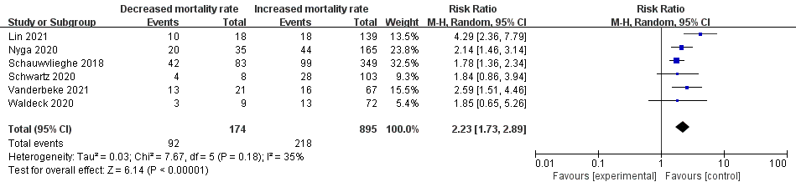
Figure S26. Forest plot of the association between IPA and mortality (ICU patients)

