SUPPLEMENTARY
The following material accompanies the article “Comparative Risks of Fracture among Direct Oral Anticoagulants and warfarin: A Systematic Review and Network Meta-analysis”

Table of Content
Supplementary Figure 1 Risk of bias assessment of the included studies | P3
Supplementary Figure 2 Rank plot | P5
Supplementary Figure 3 Forest plot of network meta-analysis results | P7
Supplementary Figure 4: Publication bias | P10
Supplementary Table 1 Electronic database search strategy | P12
Supplementary Table 2 Excluded studies with reasons | P15
Supplementary Table 3 Descriptions of the included studies | P16
Supplementary Table 4 Patient characteristics included in the studies | P21
Supplementary Table 5 Risk of bias assessment according to Newcastle-Ottawa Quality Assessment Scale for cohort studies | P23
Supplementary Table 6 Pairwise meta-analysis of risk ratio (95% CI) for fractures | P24
Supplementary Table 7 Mean rank and SUCRA (surface under the cumulative ranking curve) of five anticoagulants for risk of fractures | P25
Supplementary Table 8 Studies involved in sensitivity analysis | P26
Supplementary Table 9 Subgroup Pairwise meta-analysis of risk ratio (95% CI) for any fracture | P27
Supplementary Table 10 Subgroup Network meta-analysis of risk ratio (95% CI) for any fracture | P28
Supplementary Table 11 Assessment of inconsistency | P29
Supplementary Table 12 Assessment of the quality of included studies by GRADE | P31
Supplementary Table 13 GRADE approach for rating the quality of treatment effect estimate | P32

Supplementary Figure 1 Risk of bias assessment of the included studies
Supplementary Figure 1A Summary of the risk of bias items of RCTs
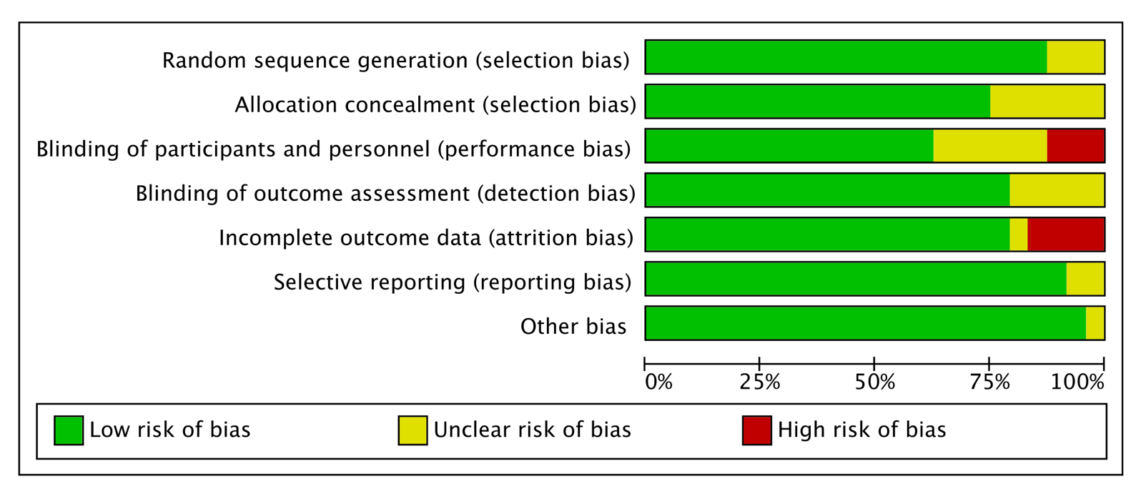

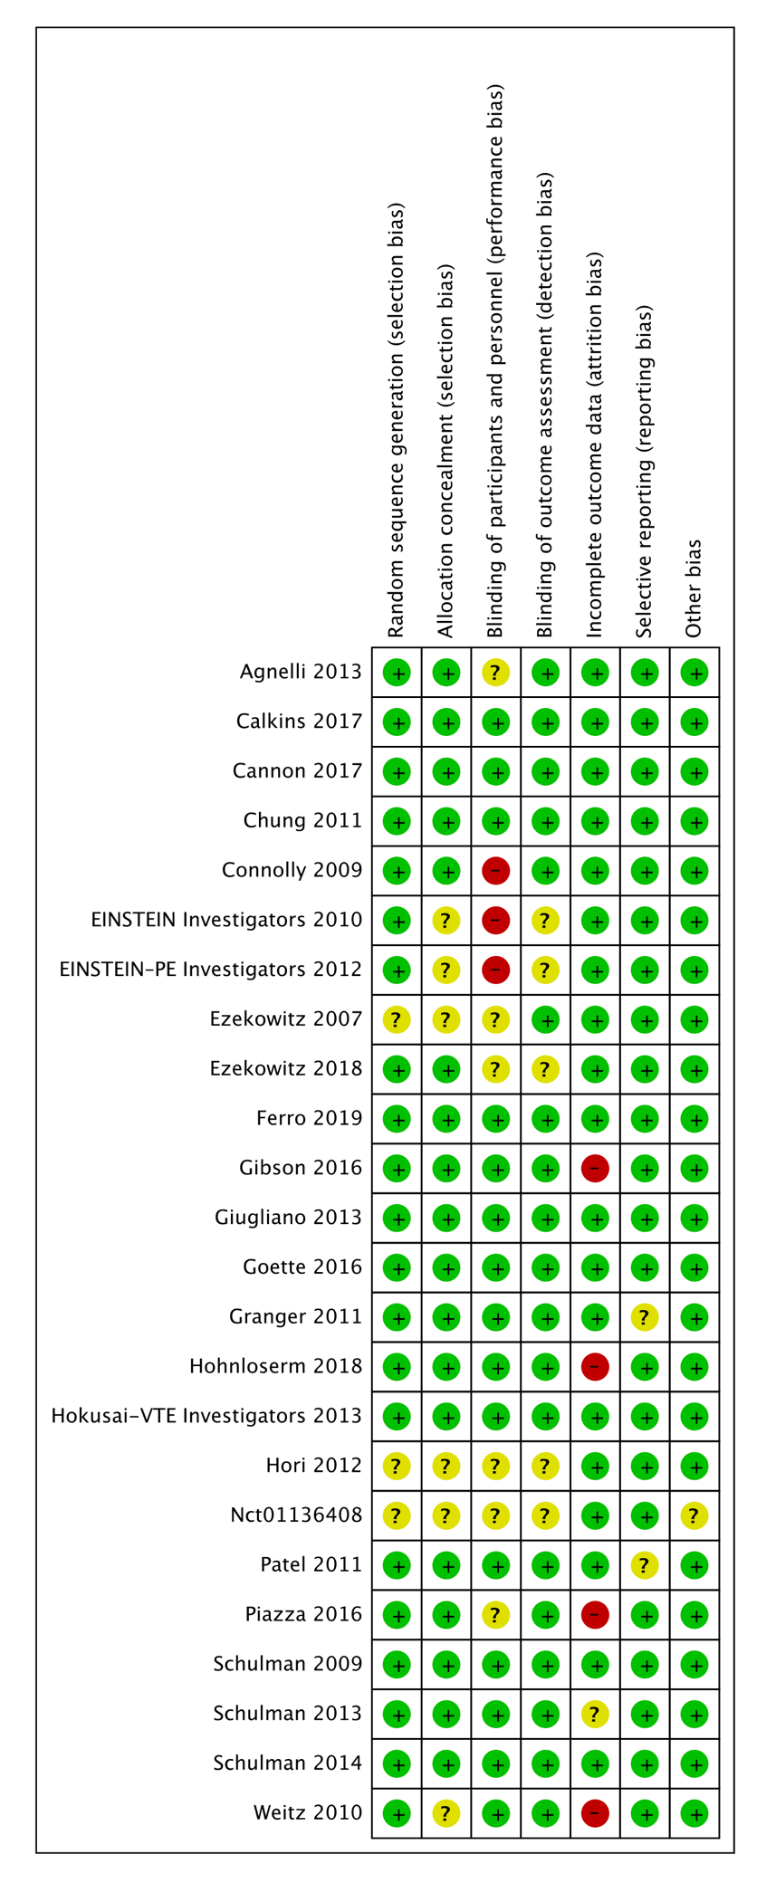
Supplementary Figure 1B Detailed risk of bias assessment of the individual RCTs

Supplementary Figure 2 Rank plot
Supplementary Figure 2A Rank plot of five anticoagulants for risk of fractures
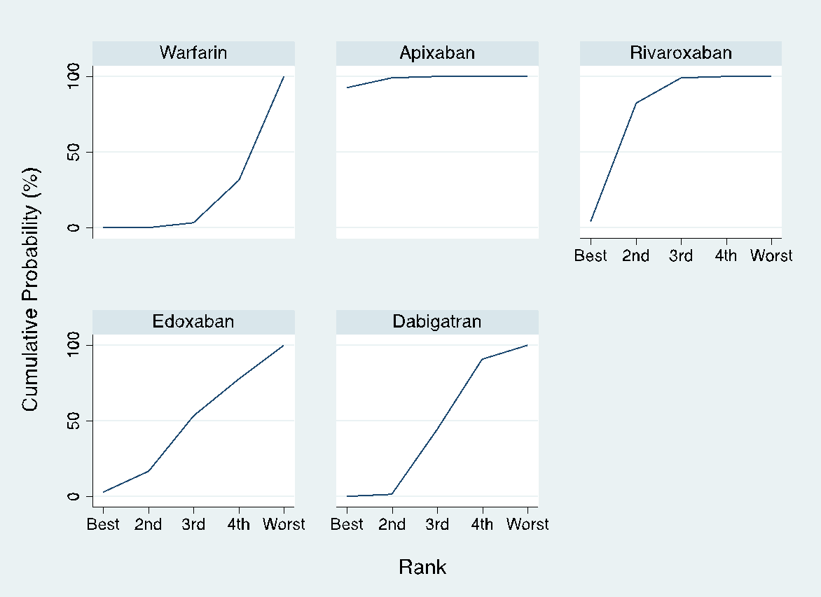 | 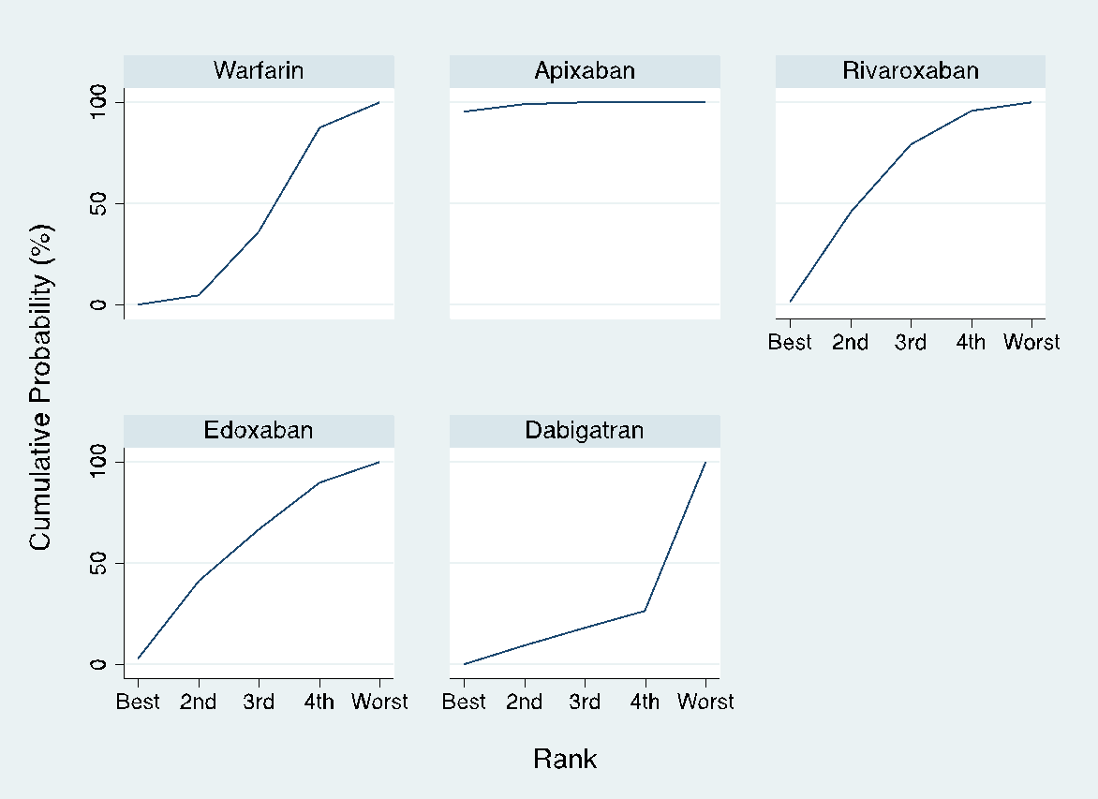 | 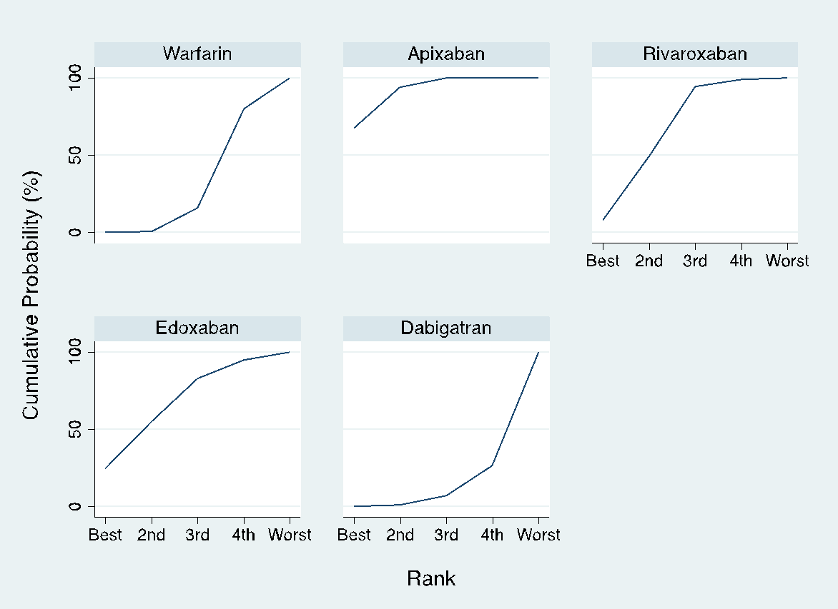
All Fracture | Spinal Fracture | Hip fracture

Supplementary Figure 2B Cumulative rank of five anticoagulants for risk of fracture
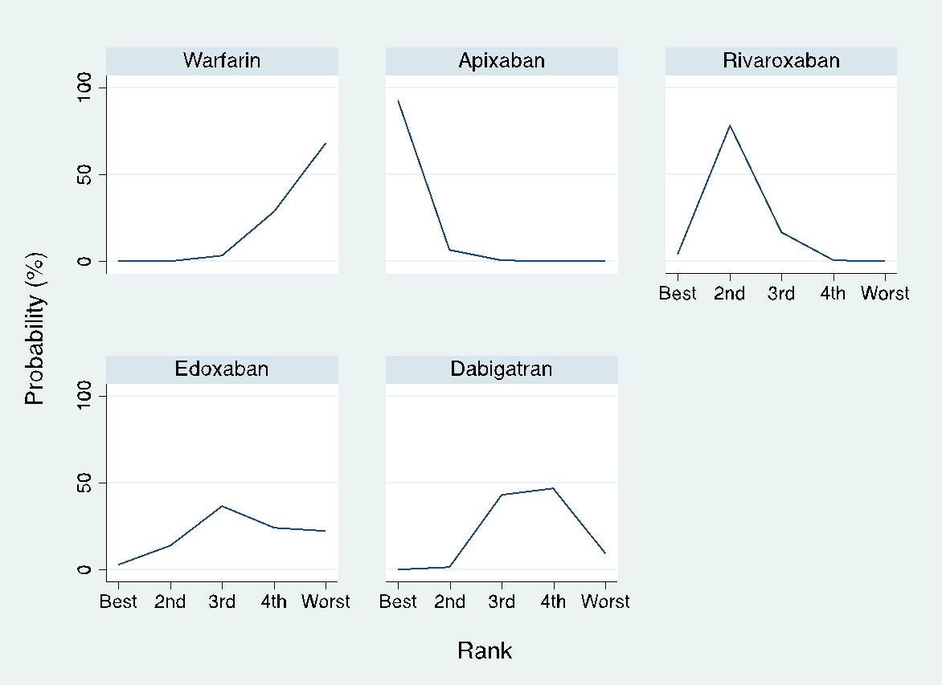 | 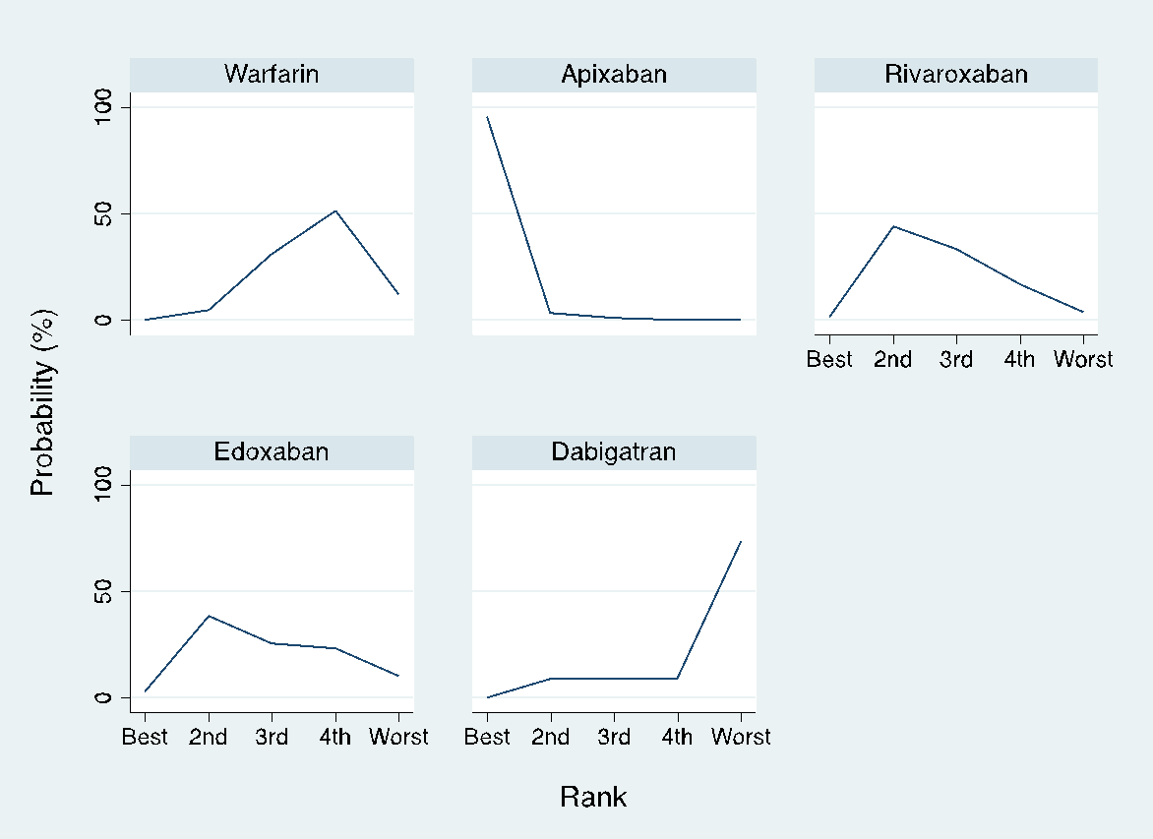 | 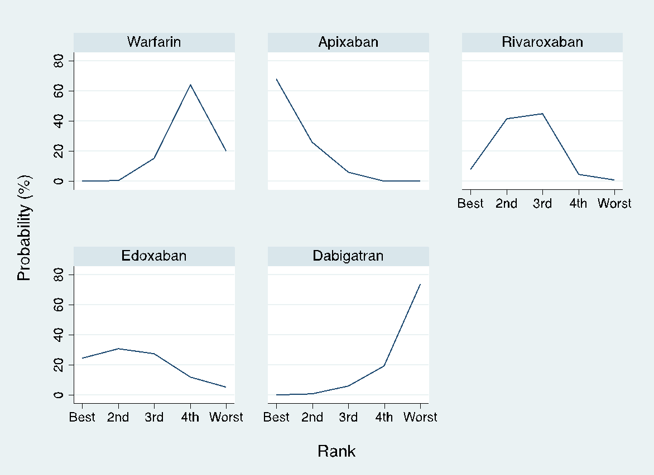
All Fracture | Spinal Fracture | Hip fracture

Supplementary Figure 3 Forest plot of network meta-analysis results
Supplementary Figure 3A Forest plot of network meta-analysis results for all fracture risk. ES, effect size; CI, confidence interval; Prl, prediction interval
Supplementary Figure 3B Forest plot of network meta-analysis results for spine fracture risk. ES, effect size; CI, confidence interval; Prl, prediction interval
Supplementary Figure 3C Forest plot of network meta-analysis results for hip fracture risk. ES, effect size; CI, confidence interval; Prl, prediction interval

Supplementary Figure 4: Publication bias
Supplementary Figure 4A Comparison-adjusted funnel plot for the network
A: Apixaban, B: Dabigatran, C: Edoxaban, D: Rivaroxaban, E: Warfarin
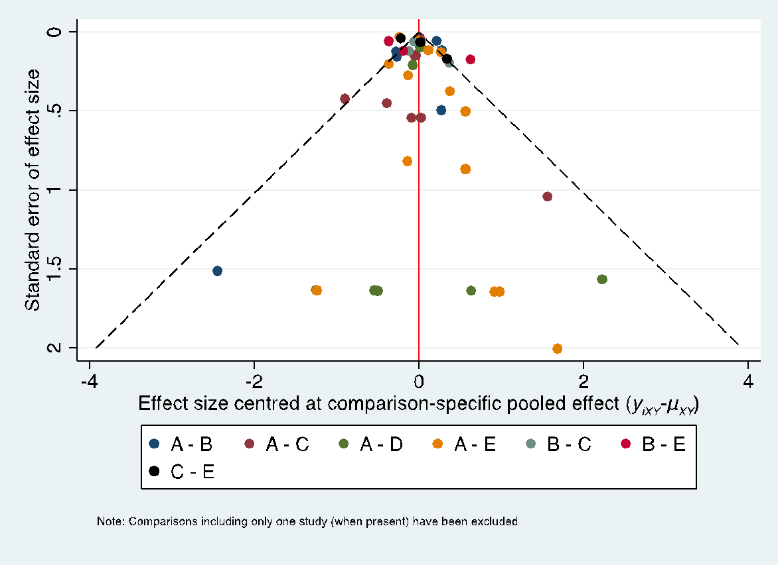 | 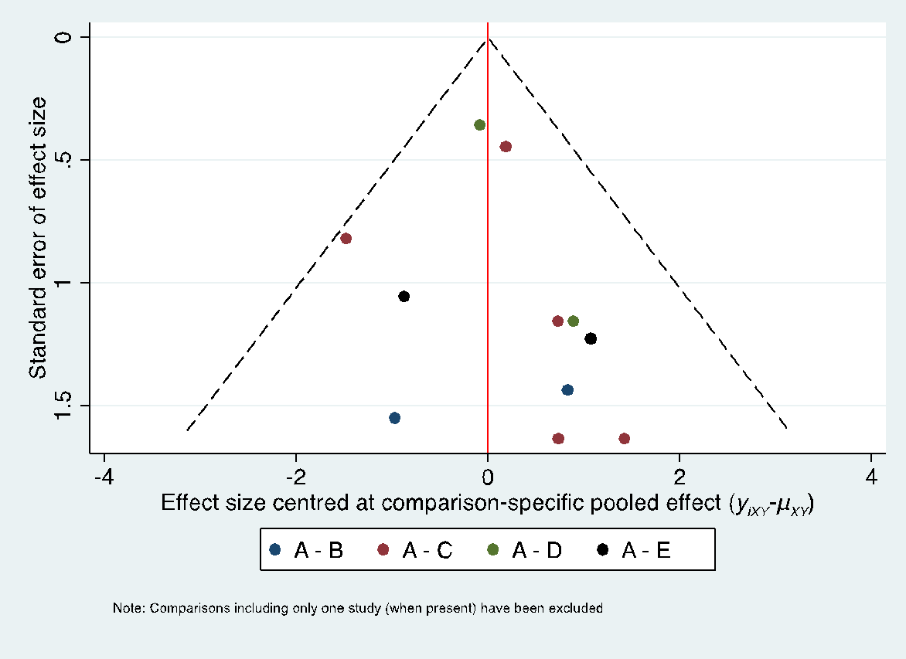 | 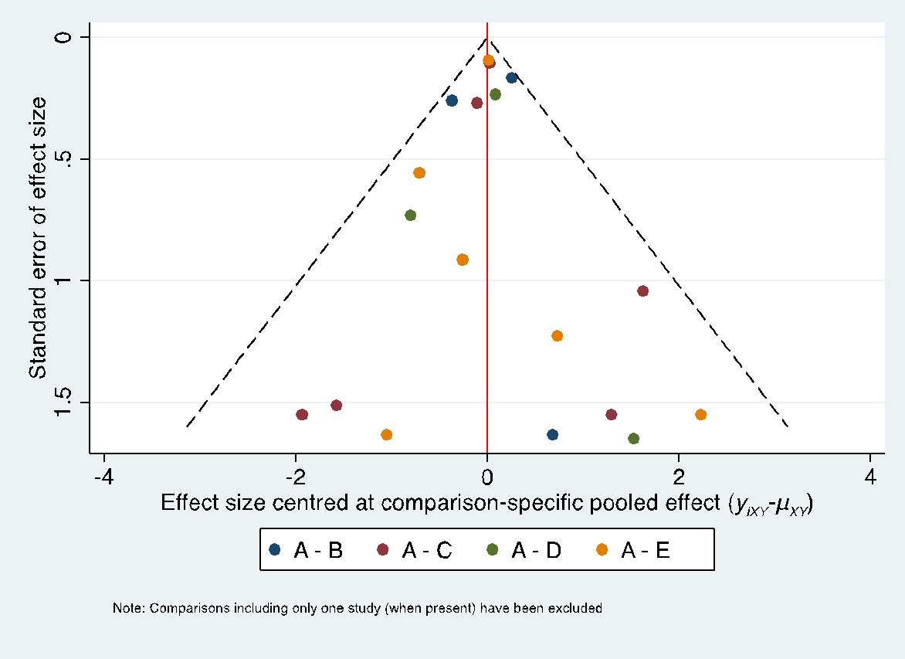
All Fracture | Spinal Fracture | Hip fracture

Supplementary Figure 4B Egger’s test for the network
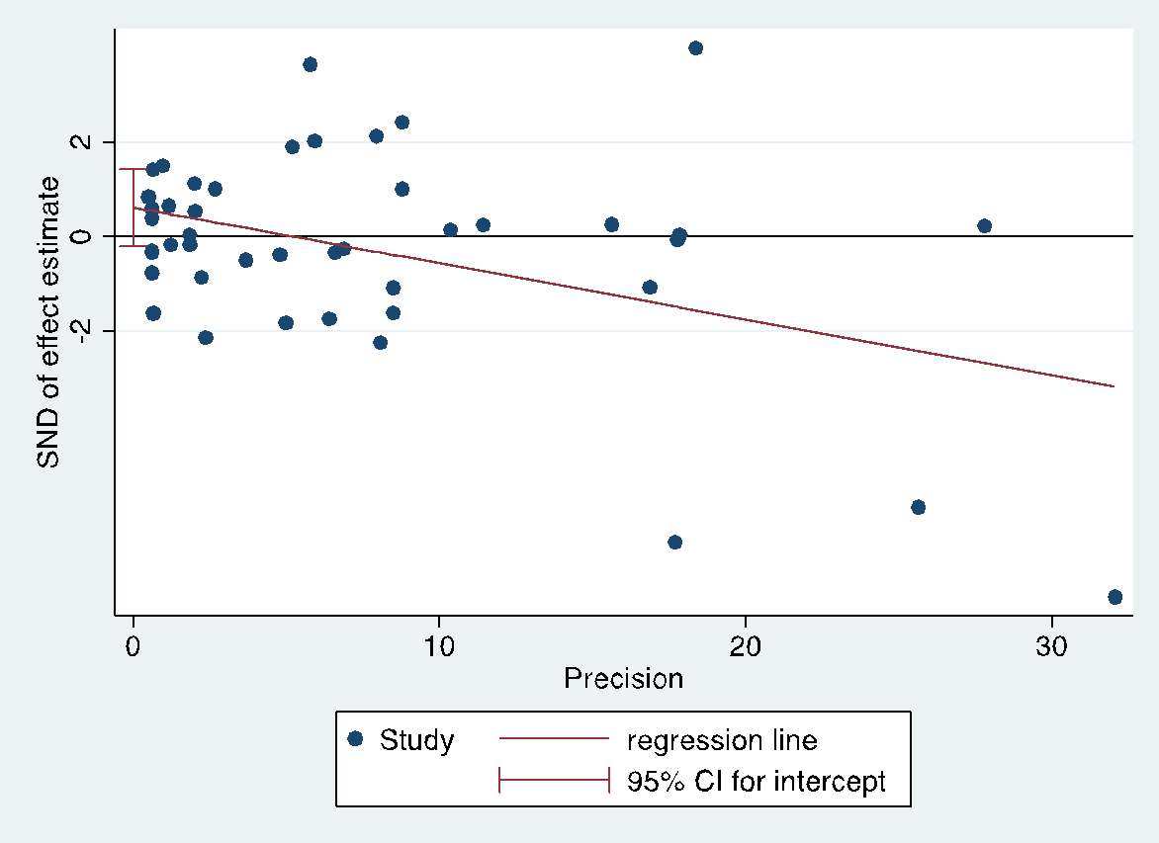 | 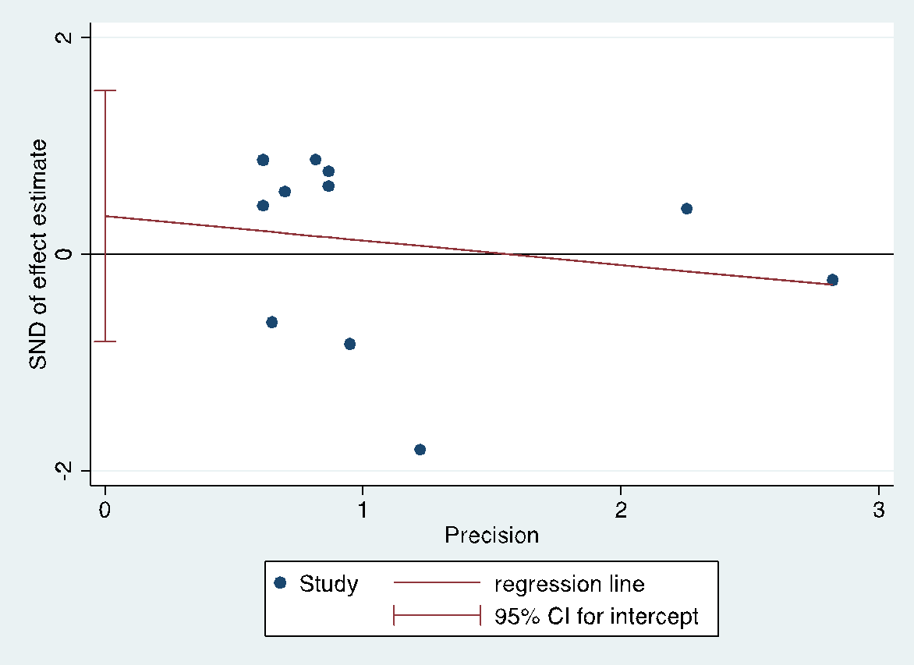 | 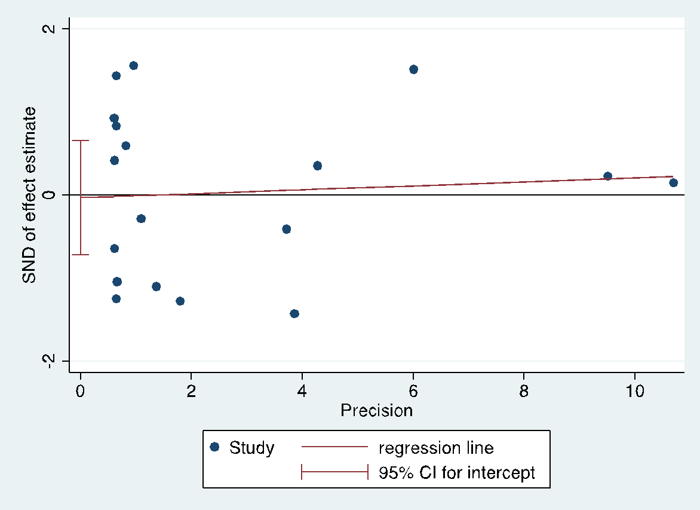
All Fracture (P=0.131) | Spinal Fracture (P=0.507) | Hip fracture (P=0.923)

Supplementary Table 1 Electronic database search strategy
MEDLINE
- direct oral anticoagulant. AF
- non-vitamin K antagonist oral anticoagulants. AF
- novel oral anticoagulants. AF
- new oral anticoagulants. AF
- factor Xa inhibitors. AF
- factor IIa inhibitors. AF
- Savaysa. AF
- dabigatran. AF
- Pradaxa. AF
- rivaroxaban. AF
- Xarelto. AF
- apixaban. AF
- Eliquis. AF
- Edoxaban. AF
- 1 or 2 or 3 or 4 or 5 or 6 or 7 or 8 or 9 or 10 or 11 or 12 or 13 or 14
- vitamin K antagonist oral anticoagulants. AF
- warfarin. AF
- placebo. AF
- 16 or 17 or 18
- 15 or 19
- fracture. AF
- osteoporosis. AF
- osteoporotic fractures. AF
- 21 or 22 or 23
- Observational Study
- Randomized Controlled Trial
- 25 or 26
- 20 and 24 and 27
EMBASE
- direct oral anticoagulant/exp
- non vitamin K antagonist oral anticoagulants/exp
- novel oral anticoagulants/exp
- new oral anticoagulants/exp
- factor 10a inhibitor/exp
- factor 2a inhibitors
- Savaysa
- dabigatran/exp
- Pradaxa
- rivaroxaban/exp
- Xarelto
- apixaban/exp
- Eliquis
- Edoxaban /exp
- 1 or 2 or 3 or 4 or 5 or 6 or 7 or 8 or 9 or 10 or 11 or 12 or 13 or 14
- vitamin K antagonist oral anticoagulants
- warfarin/exp
- placebo/exp
- 16 or 17 or 18
- 15 or 19
- Fracture/exp
- osteoporosis/exp
- osteoporotic fractures
- 21 or 22 or 23
- controlled clinical trial/lim
- randomized controlled trial/lim
- 25 or 26
- 20 and 24 and 27
Cochrane CENTRAL
- direct oral anticoagulant. AF
- non-vitamin K antagonist oral anticoagulants. AF
- novel oral anticoagulants. AF
- new oral anticoagulants. AF
- factor Xa inhibitors. AF
- factor IIa inhibitors. AF
- Savaysa. AF
- dabigatran. AF
- Pradaxa. AF
- rivaroxaban. AF
- Xarelto. AF
- apixaban. AF
- Eliquis. AF
- Edoxaban. AF
- 1 or 2 or 3 or 4 or 5 or 6 or 7 or 8 or 9 or 10 or 11 or 12 or 13 or 14
- vitamin K antagonist oral anticoagulants. AF
- warfarin. AF
- placebo. AF
- 16 or 17 or 18
- 15 or 19
- fracture. AF
- osteoporosis. AF
- osteoporotic fractures. AF
- 21 or 22 or 23
- Observational Study
- Randomized Controlled Trial
- 25 or 26
- 20 and 24 and 27
Web of Science
(TS= (Savaysa OR Edoxaban OR Eliquis OR Apixaban OR Xarelto OR Rivaroxaban OR Pradaxa OR Dabigatran) OR TS=(factor IIa inhibitors OR novel oral anticoagulants OR new oral anticoagulants OR Non-vitamin K Antagonist) OR TS=(factor Xa inhibitors) ) AND TS=(fracture)
Scopus
(dabigatran OR pradaxa OR rivaroxaban OR xarelto OR apixaban OR eliquis OR edoxaban OR savaysa OR non-vitamin AND k AND antagonist OR novel AND oral AND anticoagulants OR new AND oral AND anticoagulants OR factor AND xa AND inhibitors OR factor AND iia AND inhibitors ) AND (fracture)

Supplementary Table 2 Excluded studies with reasons
Author | Study Name | Reasons for exclusion
Monaco 2017 | Safety profile of the direct oral anticoagulants: an analysis of the WHO database of adverse drug reactions.  British Journal of Clinical Pharmacology 2017 | Wrong study design
Rao 2018 | Clinical Outcomes and History of Fall in Patients with Atrial Fibrillation Treated with Oral Anticoagulation: Insights From the ARISTOTLE Trial. American Journal of Medicine 2018 | Wrong outcome
Gosch 2020 | Outcome of older hip fracture patients on anticoagulation: a comparison of vitamin K-antagonists and Factor Xa inhibitors. Archives of Orthopaedic and Trauma Surgery 2020 | Wrong patient population
Coleman 2018 | Effectiveness and safety of rivaroxaban versus warfarin in patients with provoked venous thromboembolism. Journal of Thrombosis and Thrombolysis 2018 | Wrong patient population
DeCaterina 2020 | Vitamin K antagonists and osteoporotic fractures: Insights from comparisons with the NOACs, European Heart Journal 2020 | Wrong study design
Sugiyama 2017 | Osteoporotic fractures associated with dabigatran vs warfarin. JAMA - Journal of the American Medical Association 2017 | Wrong study design
Rodríguez-OllerosRodríguez 2019 | Vitamin K and Bone Health: A Review on the Effects of Vitamin K Deficiency and Supplementation and the Effect of Non-Vitamin K Antagonist Oral Anticoagulants on Different Bone Parameters. Journal of Osteoporosis 2019 | Wrong study design
Sugiyama 2017 | Edoxaban Versus Warfarin: Bone Fractures Due to Falling. Journal of the American College of Cardiology 2017 | Wrong study design
Lau 2017 | Osteoporotic Fractures Associated With Dabigatran vs Warfarin Reply. JAMA - Journal of the American Medical Association 2017 | Wrong study design
Uzoigwe 2020 | Oral Anticoagulants, Proton Pump Inhibitors, and Fracture. Jama Internal Medicine 2020 | Wrong study design
Dadwal 2020 | Effect of antithrombotic drugs on bone health. Zeitschrift Fur Gerontologie Und Geriatrie 2020 | Wrong study design

Supplementary Table 3 Descriptions of the included studies
Study  (Author, year) | Types of fractures | Other comorbidities | Other Co-medications | Other outcomes
Ezekowitz, 2007 | Radius fracture | NA | AAM, HTN medications, CAD medications | Bleeding events, systemic embolic event, abnormal liver function test
Connolly, 2009 | Ankle fracture, cervical vertebral fracture, clavicle fracture, compression fracture, facial bones fracture, femoral neck fracture, facture, femur fracture, fibula fracture, foot fracture, forearm fracture, hand fracture; hip fracture; humerus fracture, lower limb fracture, lumbar vertebral fracture, multiple fractures, pathological fracture, patella fracture, pelvic fracture, radius fracture, rib fracture, scapula fracture, skull fracture, spinal compression fracture, spinal fracture, sternal fracture, thoracic vertebral fracture, tibia fracture, upper limb fracture, wrist fracture | NA | AAM, Antiplatelet therapy, HTN medications, CAD medications, PPI | Bleeding events, death, ICH, stroke, VTE, abnormal liver function test
Schulman, 2009 | Femur fracture, hip fracture, lower limb fracture, radius fracture, rib fracture, tibia fracture | NA | LMWH | Bleeding events, CAD events, VTE, death, DVT, PE
NCT01136408, 2010 | Femur fracture | NA | NA | abnormal liver function test, alkaline phosphatase, bleeding events, adverse events
Weitz, 2010 | Clavicle fracture, upper limb fracture | Hypertension | Antiplatelet therapy | Adverse cardiac events, bleeding events, CAD events, death, VTE, stroke
EINSTEIN Investigators,2010 | Ankle fracture, clavicle fracture, femoral neck fracture, femur fracture, humerus fracture, radius fracture, rib fracture, spinal compression fracture, thoracic vertebral fracture, ulna fracture, pathological fracture | NA | NA | Bleeding events, death, VTE
Chung, 2011 | NA | NA, liver function | Antiplatelet therapy | Bleeding events
Granger, 2011 | Acetabulum fracture, ankle fracture, cervical vertebral fracture, clavicle fracture, facial bones fracture, femoral neck fracture, fracture, femur fracture, fibula fracture, foot fracture, forearm fracture, fracture, hand fracture, hip fracture, lower limb fracture, lumbar vertebral fracture, open fracture, patella fracture, pelvic fracture, pubis Fracture, radius fracture, rib fracture, scapula fracture, skull fracture, spinal compression, spinal fracture, sternal fracture, thoracic vertebral fracture, tibia fracture; Ulna fracture, upper limb fracture, wrist fracture, pathological fracture | NA | AAM, HTN medications, CAD medications, NSAIDs. PPI, statin | Death, bleeding events, stroke
Patel, 2011 | Ankle fracture, avulsion fracture, cervical vertebral fracture, clavicle fracture, compression fracture, facial bones fracture, femoral neck fracture, femur fracture, fibula fracture, foot fracture, fracture, hand fracture, hip fracture, humerus fracture, lower limb fracture, lumbar vertebral fracture, multiple fractures, pathological fracture, patella fracture, pelvic fracture, pubis fracture, radius fracture, rib fracture, spinal compression fracture, spinal fracture, thoracic vertebral fracture, tibia fracture, upper limb fracture, wrist fracture | PAD, CPD | Antiplatelet therapy | Bleeding events, ICH
EINSTEIN-PE  Investigators, 2012 | Ankle fracture, cervical vertebral fracture, facial bones fracture, femoral neck fracture, femur fracture, fibula fracture, foot fracture, hip fracture, humerus fracture, lumbar vertebral fracture, rib fracture, spinal compression fracture, sternal fracture, thoracic vertebral fracture, tibia fracture, upper limb fracture | DVT | NA | Bleeding events, death, malignancy, MI, PE, VTE
Hori, 2012 | Femur fracture, fibula fracture, patella fracture, radius fracture, rib fracture, skull fracture, spinal compression fracture, tibia fracture, ulna fracture | NA | NA | Back pain, bleeding events, CHF, diarrhea, death, nasopharyngitis, upper respiratory tract inflammation
Hokusai-VTE Investigators, 2013 | Acetabulum fracture, ankle fracture, clavicle fracture, compression fracture, facial bones fracture, femoral neck fracture, femur fracture, fibula fracture, foot fracture, forearm fracture, fractured sacrum, hand fracture, hip fracture, humerus fracture, jaw fracture, lower limb fracture, lumbar vertebral fracture, multiple fractures, pelvic fracture, pubis fracture, radius fracture, rib fracture, spinal compression fracture, spinal fracture, thoracic vertebral fracture, tibia fracture, upper limb fracture, wrist fracture | NA | Heparin | VTE, PE, bleeding events
Agnelli, 2013 | Ankle fracture, cervical vertebral fracture, facial bones fracture, femur fracture, hip fracture, humerus fracture, lower limb fracture, lumbar vertebral fracture, pelvic fracture, radius fracture, spinal compression fracture, upper limb fracture, wrist fracture | NA | LMWH, heparin | Death, VTE, bleeding events
Giugliano, 2013 | Acetabulum fracture, ankle fracture, cervical vertebral fracture, clavicle fracture, compression fracture, facial bones fracture, femoral neck fracture, femur fracture, fibula fracture, foot fracture, forearm fracture, fracture, fractured coccyx, hand fracture, hip fracture, humerus fracture, jaw fracture, lower limb fracture, lumbar vertebral fracture, multiple fracture, pathological fracture, patella fracture, pelvic fracture, pubis fracture, radius fracture, rib fracture, scapula fracture, skull fracture, spinal compression fracture, spinal fracture, sternal fracture, thoracic vertebral fracture, tibia fracture, ulna fracture, upper limb fracture, wrist fracture | NA | AAM, Antiplatelet therapy, CAD medications | Death, bleeding events, MI, stroke
Schulman, 2013 | Acetabulum fracture, ankle fracture, femoral neck fracture, femur fracture, fibula fracture, foot fracture, hand fracture, hip fracture, humerus fracture, lower limb fracture, radius fracture, tibia fracture, upper limb fracture | NA | NA | Bleeding event, CAD, abnormal liver function test, VTE
Schulman, 2014 | Femoral neck fracture, hip fracture, humerus fracture, multiple fractures, upper limb fracture | NA | NA | Bleeding event, CAD, abnormal liver function test, MI, PE, VTE or VTE-related death
Gibson, 2016 | Compression fracture, femoral neck fracture, hip fracture, humerus fracture, lower limb fracture, pubis fracture, radius fracture, rib fracture, traumatic fracture, upper limb fracture | NA | Antiplatelet therapy | Bleeding event, death, MI, stroke
Goette, 2016 | Ankle fracture | Life-threatening bleeding event | NA | Bleeding events, renal function, CAD-related death, ICH, MI, stroke, VTE
Piazza, 2016 | Femoral neck fracture, rib fracture | Pulmonary disease, recent bone fracture, renal disease liver disease, | Antiplatelet therapy | Adverse events, bleeding events, ICH
Bengtson, 2017 | Hip fracture, pelvic fracture | PAD, CPD, renal/liver disease,  GI bleeding | AAM, Antiplatelet therapy, CAD medications, DM medications, statin | Bleeding events, ICH, MI, stroke
Calkins, 2017 | Acetabulum fracture | Left ventricular dysfunction, previous major bleeding, previous GI bleeding or gastritis, renal disease | AAM, NSAIDs, PPI, statins | Bleeding events, VTE, stroke, adverse events
Cannon, 2017 | Ankle fracture, clavicle fracture, femoral neck fracture, femur fracture, hand fracture, hip fracture, lumbar vertebral fracture, multiple fracture, pelvic fracture, periprosthetic fracture, pubis fracture, rib fracture, skull fracture, skull fractured base, sternal fracture, upper limb fracture, wrist fracture | NA | NA | Bleeding events, death, ICH, VTE, stroke
Lucenteforte, 2017 | Hip fracture, vertebral fracture | NA | NA | NA
Norby, 2017 | Hip fracture, pelvic fracture | CPD, dementia, renal/liver, disease,  GI bleeding, PAD | AAM, Antiplatelet therapy, CAD medications, DM medications, statin | Asthma, malignancy, bleeding events, MI, ICH, Stroke
Ezekowitz, 2018 | Femur fracture, radius fracture | NA | NA | Bleeding events, stroke, VTE, death
Hohnloserm, 2018 | Foot fracture | PAD, valvular heart disease | AAM, Antiplatelet therapy, CAD medications, NSAIDs, PPI, Osteoporosis medications | Death, bleeding events, stroke, VTE
Ferro, 2019 | Upper limb fracture | Genetic thrombophilia inflammatory bowel disease, Infection (ear, nose, throat), parenchymal lesion, puerperium, previous VTE, other inflammatory systemic disorder, severe dehydration, surgery | NA | Bleeding event, ICH, VTE
Huang, 2020 | Hip fracture, vertebral fracture, humerus/forearm/wrist fracture | Cataract, CKD, CPD, DVT, dementia, depression, epilepsy, hyperthyroidism, hypothyroidism, liver cirrhosis, PAD, RA, Parkinsonism, osteoporosis | Antiepileptics, antiparkinsonian, antipsychotics, antidepressants, antithyroid drugs, anxiolytics, CAD medications, NSAIDs, PPI, statin, thyroxine, Osteoporosis medications | NA
Lutsey, 2020 | All fracture, inpatient fracture, hip fracture | Alcohol abuse, CPD, dementia, depression, DVT, GI bleeding, hematological disorder, epilepsy, osteoporosis, PAD, Parkinsonism, renal/liver disease, prior fracture | AAM, Antiplatelet therapy, CAD medications, Osteoporosis medications, DM medications, statin | NA
Wang, 2020 | Hip fracture, pelvic fracture | Asthma, dementia, depression, liver disease, alcohol abuse | DM medications | Asthma, malignancy, bleeding events, ICH, MI, stroke
Lau, 2020 | Hip fracture, vertebral fracture | CKD, CPD, history of falls,  prior fracture, osteoporosis, liver/renal disease, RA | AAM, HTN medications, antidepressants, Osteoporosis medications | NA
Abbreviations:
CAD: Cardiovascular disease; CHF: Congestive heart failure; CKD: Chronic kidney disease; CPD: Chronic pulmonary disease; DM: Diabetes mellitus; DVT: Deep vein thrombosis; GI: gastrointestinal; HTN: Hypertension; MI: Myocardial infarction; PAD: Peripheral arterial disease; PE: Pulmonary embolism; RA: Rheumatoid arthritis; VTE: Venous Thromboembolism; AAM: Anti-arrhythmic medications; LMWH: Low molecular weight heparin; PPI: Proton pump inhibitor; DVT: Deep vein thrombosis; ICH: Intracranial hemorrhage; PE: Pulmonary embolism; VTE: Venous Thromboembolism

Supplementary Table 4 Patient characteristics included in the studies
Study | Treatment | CAD  (%) | Cancer  (%) | CHF  (%) | DM  (%) | HTN  (%) | Stroke  (%) | Steroid  (%) | Smoking  (%)
Ezekowitz, 2007 | Warfarin | 60 | NA | 34.3 | 21.4 | 70 | 18.6 | NA | 75.7
Ezekowitz, 2007 | Dabigatran 50 mg | 61 | NA | 33.3 | 25.7 | 66.7 | 18 | NA | 72.4
Ezekowitz, 2007 | Dabigatran 150 mg | 63 | NA | 31.3 | 27 | 71 | 17.5 | NA | 72.3
Ezekowitz, 2007 | Dabigatran 300 mg | 59.6 | NA | 22.4 | 24 | 74 | 16 | NA | 72
Connolly, 2009 | Warfarin | 16.1 | NA | 31.9 | 23.4 | 78.9 | 19.8 | NA | NA
Connolly, 2009 | Dabigatran 100 mg | 16.8 | NA | 32.2 | 23.4 | 78.8 | 19.9 | NA | NA
Connolly, 2009 | Dabigatran 150 mg | 16.9 | NA | 31.8 | 23.1 | 78.9 | 20.3 | NA | NA
Schulman, 2009 | Warfarin | NA | 4.5 | NA | NA | NA | NA | NA | NA
Schulman, 2009 | Dabigatran 150 mg | NA | 5.0
NCT01136408, 2010 | Warfarin | NA | NA | NA | NA | NA | NA | NA | NA
NCT01136408, 2010 | Dabigatran 110 mg
NCT01136408, 2010 | Dabigatran 150 mg
Weitz, 2010 | Warfarin | NA | NA | NA | NA | NA | NA | NA | NA
Weitz, 2010 | Edoxaban 30 mg QD
Weitz, 2010 | Edoxaban 30 mg BID
Weitz, 2010 | Edoxaban 60 mg QD
Weitz, 2010 | Edoxaban 60 mg BID
EINSTEIN Investigators, 2010 | Warfarin + enoxaparin | NA | NA | NA | NA | NA | NA | NA | NA
EINSTEIN Investigators, 2010 | Rivaroxaban
Chung, 2011 | Warfarin | NA | NA | 32 | 22.7 | 69.3 | 22.7 | NA | NA
Chung, 2011 | Edoxaban 30 mg | NA | NA | 22.8 | 38 | 70.9 | 26.6 | NA | NA
Chung, 2011 | Edoxaban 60 mg | NA | NA | 31.3 | 27.5 | 73.8 | 23.8 | NA | NA
Granger, 2011 | Warfarin | 13.9 | NA | 35.4 | 24.9 | 87.6 | 19.7 | NA | NA
Granger, 2011 | Apixaban | 14.5 | NA | 35.5 | 25.0 | 87.3 | 19.8 | NA | NA
Patel, 2011 | Warfarin  Apixaban | 18.0  16.6 | NA | 62.3  62.6 | 39.5  40.4 | 90.8  90.3 | 54.6  54.9 | NA | NA
EINSTEIN-PE Investigators, 2012 | Warfarin | NA | NA | NA | NA | NA | NA | NA | NA
EINSTEIN-PE Investigators, 2012 | Rivaroxaban
Hori, 2012 | Warfarin | 8.3 | NA | 40.2 | 37.1 | 79.5 | 63.4 | NA | NA
Hori, 2012 | Rivaroxaban | 7.0 | NA | 41.3 | 39.0 | 79.5 | 63.8 | NA | NA
Hokusai-VTE Investigators, 2013 | Warfarin | NA | NA | NA | NA | NA | NA | NA | NA
Hokusai-VTE Investigators, 2013 | Edoxaban
Agnelli, 2013 | Warfarin+ enoxaparin | NA | 2.8 | NA | NA | NA | NA | NA | NA
Agnelli, 2013 | Apixaban | NA | 2.5
Giugliano, 2013 | Warfarin | NA | NA | 57.5 | 35.8 | 93.6 | 28.3 | NA | NA
Giugliano, 2013 | Edoxaban 30mg | NA | NA | 56.6 | 36.2 | 93.5 | 28.5 | NA | NA
Giugliano, 2013 | Edoxaban 60mg | NA | NA | 58.2 | 36.4 | 93.7 | 28.1 | NA | NA
Schulman, 2013 | Warfarin | 6.1 | 4.1 | NA | *7.6 | 36.5 | NA | NA | NA
Schulman, 2013 | Dabigatran | 8.4 | 4.2 |  | *10.5 | 40.7
Schulman, 2014 | Warfarin | NA | 3.9 | NA | NA | NA | NA | NA | NA
Schulman, 2014 | Dabigatran | NA | 3.9
Gibson, 2016 | Warfarin | 52.2 | NA | NA | NA | NA | NA | NA | 6.8
Gibson, 2016 | Rivaroxaban 2.5 mg | 53.2 |  |  |  |  |  |  | 7.9
Gibson, 2016 | Rivaroxaban 15 mg | 51.5 |  |  |  |  |  |  | 5.2
Goette, 2016 | Warfarin | 18 | NA | 44 | 18 | 78 | 6 | NA | NA
Goette, 2016 | Edoxaban | 17 | NA | 43 | 20 | 78 | 6 | NA | NA
Piazza, 2016 | Warfarin | 14.3 | 10.7 | NA | NA | NA | NA | NA | 17.9
Piazza, 2016 | Edoxaban | 16.1 | 17.9 |  |  |  |  |  | 21.4
Bengtson, 2017 | Warfarin | 14.7 | 2.3 | 30.4 | 32.1 | 72.9 | 22.3 | NA | NA
Bengtson, 2017 | Dabigatran | 13.4 | 1.6 | 24.3 | 28.6 | 75.2 | 20.6 | NA | NA
Calkins, 2017 | Warfarin | 15.1 | NA | 10.7 | 10.7 | 55. | 2.8 | NA | NA
Calkins, 2017 | Dabigatran | 10.1 | NA | 9.8 | 9.5 | 52.4 | 3.2 | NA | NA
Cannon, 2017 | Warfarin | 27.3 | NA | NA | 39.9 | NA | 10.2 | NA | NA
Cannon, 2017 | Dabigatran 110 mg | 24.2 | NA | NA | 36.9 | NA | 7.5 | NA | NA
Cannon, 2017 | Dabigatran 150 mg | 25.4 | NA | NA | 34.1 | NA | 6.8 | NA | NA
Lucenteforte, 2017 | Warfarin | NA | NA | NA | NA | NA | NA | NA | NA
Lucenteforte, 2017 | Direct Xa inhibitor (R,A)
Lucenteforte, 2017 | Dabigatran
Norby, 2017 | Warfarin | 8.1 | 11.3 | 26.0 | 26.7 | 62.8 | 17.2 | NA | NA
Norby, 2017 | Rivaroxaban | 7.1 | 10.9 | 23.1 | 25.7 | 66.0 | 15.5 | NA | NA
Ezekowitz, 2018 | Warfarin | NA | NA | NA | 18.7 | 64.4 | NA | NA | NA
Ezekowitz, 2018 | Apixaban | NA | NA | NA | 20.5 | 65.9 | NA | NA | NA
Hohnloserm, 2018 | Warfarin | 20.3 | NA | 19.2 | 15.8 | 59.6 | 3.9 | NA | NA
Hohnloserm, 2018 | Edoxaban | 18.6 | NA | 17.3 | 13.4 | 60.8 | 5.4 | NA | NA
Ferro, 2019 | Warfarin | NA | 1.7 | NA | NA | NA | NA | NA | NA
Ferro, 2019 | Dabigatran | NA | 0
Huang, 2020 | Warfarin  DOAC (D, R, A) | NA | 5.5  5.8 | 28.4  26.3 | 25.9  25.6 | 55.5  56.1 | 25.9  27.4 | 6.0  5.9 | NA
Huang, 2020 | Warfarin  Dabigatran | 24.2  23.4 | 5.4  5.5 | 21.6  20.2 | 26.5  26.5 | 58.6  58.5 | 31.1  32.7 | 5.4  5.6 | NA
Huang, 2020 | Warfarin  Rivaroxaban | 26.1  25.4 | 6.1  6.0 | 26.8  25.1 | 25.8  24.6 | 57.3  57.8 | 27.2  27.0 | 6.5  6.1 | NA
Huang, 2020 | Warfarin  Apixaban | 27.0  26.2 | 6.8  6.5 | 23.5  22.4 | 27.0  27.0 | 59.3  58.8 | 28.9  27.9 | 5.6  5.6 | NA
#Lutsey,2020 | Warfarin | 11.2 | 14.0 | 33.0 | 33.2 | 75.5 | 24 | NA | NA
#Lutsey,2020 | Dabigatran | 7.2 | 11.1 | 23.8 | 27.7 | 72.5 | 17.7 | NA | NA
#Lutsey,2020 | Rivaroxaban | 8.2 | 12.4 | 24.6 | 28.2 | 75.7 | 17.9 | NA | NA
#Lutsey,2020 | Apixaban | 9.2 | 13.0 | 27.9 | 30.3 | 79.6 | 20.8 | NA | NA
Wang, 2020 | Warfarin | NA | NA | NA | 100 | 36 | NA | NA | 44
Wang, 2020 | Rivaroxaban | NA | NA | NA | 100 | 29 | NA | NA | 43
Lau, 2020 | Warfarin | NA | NA | 30.6 | 30.7 | NA | 27.9 | 9.5 | NA
Lau, 2020 | Dabigatran | NA | NA | 19.8 | 29.3 | NA | 29.2 | 7.3 | NA
Lau, 2020 | Rivaroxaban | NA | NA | 19.9 | 27.4 | NA | 24.7 | 8.2 | NA
Lau, 2020 | Apixaban | NA | NA | 23.8 | 28.3 | NA | 29.9 | 8.9 | NA
*Significantly different; #Treatment group before characteristic match
Abbreviations: A, apixaban; D, dabigatran; DOAC, direct oral anticoagulants, E, edoxaban; R, rivaroxaban

Supplementary Table 5 Risk of bias assessment according to Newcastle-Ottawa Quality Assessment Scale for cohort studies
Study | Quality Assessment Criteria
Study | Selection |  |  |  | Comparability | Outcome |  |  | Total Score
Study | Representativeness of Exposed Cohort | Selection of non Exposed Cohort | Ascertainment of Exposure | Outcome of Interest | Based on Analysis | Assessment of Outcome | Follow up length | Adequacy of follow up of cohorts | Total Score
Lucenteforte 2017 | * | * |  | * | * | * |  |  | 5
Bengtson 2017 | * | * | * | * | * | * | * | * | 8
Norby 2017 | * | * | * | * | * | * | * | * | 8
Huang 2020 | * | * | * | * | * | * | * | * | 8
Lutsey 2020 | * | * | * | * | * | * | * | * | 8
Wang 2020 | * | * | * | * | * | * | * | * | 8
Lau 2020 | * | * | * | * | * | * | * | * | 8

      - Selection:
        - Representativeness of Exposed Cohort: Score given if truly representative of the community
        - Selection of non Exposed Cohort: Score given if drawn from the same community
        - Ascertainment of Exposure: Score given if secure record
        - Outcome of Interest: Score given if outcome of interest was not present at start of study
      - Comparability: Score given if study controls for important confounding factors including age and sex
      - Outcome:
        - Assessment of Outcome: Score given if record linkage is correct
        - Follow up length: Score given if follow-up long enough for outcomes to occur
        - Adequacy of follow up of cohort: Score given if complete follow up described in the study

Supplementary Table 6 Pairwise meta-analysis of risk ratio (95% CI) for fractures
Comparison |  | Pairwise meta-analysis | No of participants | No. of studies | Heterogeneity I²
All fractures
Apixaban | Warfarin | 0.60 (0.46 to 0.79)* | 120817 | 6 | 79.6%
Dabigatran | Warfarin | 0.87 (0.74 to 1.03) | 223007 | 14 | 66.6%
Edoxaban | Warfarin | 0.87 (0.73 to 1.03) | 26585 | 7 | 0%
Rivaroxaban | Warfarin | 0.68 (0.64 to 0.72)* | 220559 | 10 | 0%
Rivaroxaban | Apixaban | 1.30 (1.06 to 1.60)* | 64240 | 3 | 61.1%
Dabigatran | Apixaban | 1.58 (0.98 to 2.56) | 64922 | 3 | 93.4%
Dabigatran | Rivaroxaban | 1.32 (1.03 to 1.69)* | 87868 | 3 | 89.2%
Spinal fracture
Apixaban | Warfarin | 0.07 (0.01 to 0.55)* | 23866 | 2 | 0%
Dabigatran | Warfarin | 1.88 (0.28 to 12.51) | 20806 | 2 | 30.9%
Edoxaban | Warfarin | 0.81 (0.42 to 1.58) | 22311 | 2 | 0%
Rivaroxaban | Warfarin | 0.69 (0.29 to 1.63) | 25947 | 5 | 16.6%
Hip fracture
Apixaban | Warfarin | 0.60 (0.36 to 1.02) | 95337 | 3 | 52.6%
Dabigatran | Warfarin | 1.04 (0.87 to 1.25) | 116069 | 6 | 0%
Edoxaban | Warfarin | 0.74 (0.43 to 1.28) | 22395 | 3 | 8.1%
Rivaroxaban | Warfarin | 0.71 (0.59 to 1.02) | 113519 | 6 | 16.3%
Rivaroxaban | Apixaban | 1.51 (1.06 to 2.14)* | 48085 | 1 | NA
Dabigatran | Apixaban | 2.20 (1.57 to 3.09)* | 47257 | 1 | NA
Dabigatran | Rivaroxaban | 1.46 (1.17 to 1.83)* | 64052 | 1 | NA
* Statistical significance
Supplementary Table 7 Mean rank and SUCRA (surface under the cumulative ranking curve) of five anticoagulants for risk of fractures
 | All fractures |  |  | Spine fracture |  |  | Hip fracture
Treatment | SUCRA | PrBest | MeanRank | SUCRA | PrBest | MeanRank | SUCRA | PrBest | MeanRank
Apixaban | 98.0 | 92.6 | 1.1 | 98.5 | 95.4 | 1.1 | 90.4 | 67.8 | 1.4
Rivaroxaban | 71.6 | 4.5 | 2.1 | 55.6 | 1.4 | 2.8 | 62.7 | 7.8 | 2.5
Edoxaban | 37.6 | 2.9 | 3.5 | 50.3 | 2.9 | 3.0 | 64.2 | 24.4 | 2.4
Dabigatran | 34.1 | 0 | 3.6 | 13.5 | 0.3 | 4.5 | 8.5 | 0 | 4.7
Warfarin | 8.8 | 0 | 4.6 | 32.1 | 0 | 3.7 | 24.1 | 0 | 4.0
PrBest, Probability of best; SUCRA, surface under the cumulative ranking curve.
Supplementary Table 8 Studies involved in sensitivity analysis
Study  (Author, year) | RCT | Given drug dose | Af | VTE | Age> 65 | Male> 50% | Pt No.>5000
Ezekowitz, 2007 | * | * | * |  | * | *
Connolly, 2009 | * | * | * |  | * | * | *
Schulman, 2009 | * | * |  | * |  | *
NCT01136408, 2010 | * | * | * |  | * | *
Weitz, 2010 | * | * | * |  | * | *
EINSTEIN Investigators,2010 | * | * |  | * |  | *
Chung, 2011 | * | * | * |  |  | *
Granger, 2011 | * | * | * |  | * | * | *
Patel, 2011 | * | * | * |  | * | * | *
EINSTEIN-PE  Investigators, 2012 | * | * |  | * |  | *
Hori, 2012 | * | * | * |  | * | *
Hokusai-VTE Investigators, 2013 | * | * |  | * |  | * | *
Agnelli, 2013 | * | * |  | * |  | * | *
Giugliano, 2013 | * | * | * |  | * | * | *
Schulman, 2013 | * | * |  | * |  | *
Schulman, 2014 | * | * |  | * |  | *
Gibson, 2016 | * | * | * |  | * | *
Goette, 2016 | * | * | * |  |  | *
Piazza, 2016 | * | * |  | * |  | *
Bengtson, 2017 |  |  | * |  | * | * | *
Calkins, 2017 | * | * | * |  |  | *
Cannon, 2017 | * | * | * |  | * | *
Lucenteforte, 2017 |  |  |  |  |  |  | *
Norby, 2017 |  |  | * |  | * | * | *
Ezekowitz, 2018 | * | * | * |  |  | *
Hohnloserm, 2018 | * | * | * |  |  | *
Ferro, 2019 | * | * | *
Huang, 2020 |  |  | * |  | * | * | *
Lutsey, 2020 |  |  | * |  | * | * | *
Wang, 2020 |  |  | * |  | * | *
Lau, 2020 |  |  | * |  | * |  | *
Abbreviations: Af, atrial fibrillation; RCT, randomized controlled trial; VTE, venous thromboembolism.

Supplementary Table 9 Subgroup Pairwise meta-analysis of risk ratio (95% CI) for any fracture
Comparison | Subgroup | Pairwise meta-analysis | No. of studies | Heterogeneity I²
Apixaban vs. Warfarin | All | 0.62 (0.48 to 0.79)* | 6 | 78%
Apixaban vs. Warfarin | NVAF | 0.63 (0.48 to 0.82)* | 5 | 82%
Apixaban vs. Warfarin | VTE | 0.46 (0.18 to 1.22) | 1 | NA
Apixaban vs. Warfarin | Age< 65 | 1.23 (0.10 to 15.72) | 2 | 66%
Apixaban vs. Warfarin | Age>65 | 0.62 (0.48 to 0.80)* | 4 | 85%
Apixaban vs. Warfarin | RCT | 0.76 (0.40 to 1.44) | 3 | 38%
Apixaban vs. Warfarin | Cohort | 0.56 (0.44 to 0.71)* | 3 | 77%
Apixaban vs. Warfarin | N <5000 | 6.94 (0.36 to 134.21)* | 1 | NA
Apixaban vs. Warfarin | N >5000 | 0.61 (0.47 to 0.77)* | 5 | 80%
Dabigatran vs. Warfarin | All | 0.88 (0.75 to 1.03)* | 14 | 66.5%
Dabigatran vs. Warfarin | NVAF | 0.89 (0.74 to 1.06) | 10 | 75%
Dabigatran vs. Warfarin | VTE | 0.83 (0.54 to 1.28) | 4 | 0%
Dabigatran vs. Warfarin | Age< 65 | 0.61 (0.30 to 1.25) | 5 | 0%
Dabigatran vs. Warfarin | Age>65 | 0.88 (0.74 to 1.06) | 9 | 80%
Dabigatran vs. Warfarin | RCT | 0.94 (0.69 to 1.28) | 9 | 0%
Dabigatran vs. Warfarin | Cohort | 0.73 (0.67 to 0.93)* | 5 | 87%
Dabigatran vs. Warfarin | N <5000 | 0.59 (0.36 to 0.97)* | 8 | 0%
Dabigatran vs. Warfarin | N >5000 | 0.92 (0.75 to 1.03) | 6 | 84%
Edoxaban vs. Warfarin | - | 0.87 (0.73 to 1.03) | 7 | 0%
Rivaroxaban vs. Warfarin | - | 0.68 (0.64 to 0.72)* | 10 | 0%
Rivaroxaban vs. Apixaban | - | 1.30 (1.06 to 1.60)* | 3 | 61.1%
Dabigatran vs. Apixaban | - | 1.58 (0.98 to 2.56) | 3 | 93.4%
Dabigatran vs. Rivaroxaban | - | 1.32 (1.03 to 1.69)* | 3 | 89.2%
* Statistical significance
Abbreviations: NVAF, non-vulvular atrial fibrillation; NA, not available; RCT, randomized controlled trial; VTE, venous thromboembolism.

Supplementary Table 10 Subgroup Network meta-analysis of risk ratio (95% CI) for any fracture
Comparison | Subgroup | No. of studies | Network meta-analysis (RR, 95% CI)
Apixaban vs. warfarin | All | 31 | 0.59 (0.48 to 0.73)*
Apixaban vs. warfarin | RCT only | 24 | 0.77 (0.52 to 1.13)
Apixaban vs. warfarin | Cohort | 7 | 0.53 (0.41 to 0.68)*
Apixaban vs. warfarin | NVAF | 22 | 0.59 (0.58 to 0.75)*
Apixaban vs. warfarin | VTE | 8 | 0.46 (0.18 to 1.22)
Apixaban vs. warfarin | Age < 65 | 14 | 0.60 (0.24 to 1.51)
Apixaban vs. warfarin | Age ≥ 65 | 16 | 0.59 (0.47 to 0.73)*
Apixaban vs. warfarin | Male predominant | 28 | 0.54 (0.44 to 0.65)*
Apixaban vs. warfarin | N <5000 | 19 | 6.97 (0.36 to 135.21)
Apixaban vs. warfarin | N ≥ 5000 | 12 | 0.58 (0.47 to 0.72)*
Rivaroxaban vs. warfarin | All | 31 | 0.72 (0.60 to 0.86)*
Rivaroxaban vs. warfarin | RCT | 24 | 0.83 (0.57 to 1.19)
Rivaroxaban vs. warfarin | Cohort | 7 | 0.54 (0.54 to 0.82)*
Rivaroxaban vs. warfarin | NVAF | 22 | 0.70 (0.58 to 0.85)*
Rivaroxaban vs. warfarin | VTE | 8 | 1.23 (0.64 to 2.36)
Rivaroxaban vs. warfarin | Age < 65 | 14 | 1.22 (0.62 to 2.40)
Rivaroxaban vs. warfarin | Age ≥ 65 | 16 | 0.69 (0.57 to 0.84)*
Rivaroxaban vs. warfarin | Male predominant | 28 | 0.71 (0.60 to 0.83)*
Rivaroxaban vs. warfarin | N < 5000 | 19 | 0.93 (0.59 to 1.47)
Rivaroxaban vs. warfarin | N ≥ 5000 | 12 | 0.70 (0.58 to 0.85)*
Edoxaban vs. warfarin | All | 31 | 0.88 (0.62 to 1.23)
Edoxaban vs. warfarin | RCT | 24 | 0.88 (0.65 to 1.19)
Edoxaban vs. warfarin | Cohort | NA | NA
Edoxaban vs. warfarin | NVAF | 22 | 0.88 (0.56 to 1.38)
Edoxaban vs. warfarin | VTE | 8 | 0.90 (0.60 to 1.35)
Edoxaban vs. warfarin | Age < 65 | 14 | 0.93 (0.63 to 1.38)
Edoxaban vs. warfarin | Age ≥ 65 | 16 | 0.84 (0.53 to 1.34)
Edoxaban vs. warfarin | Male predominant | 28 | 0.88 (0.65 to 1.17)
Edoxaban vs. warfarin | N < 5000 | 19 | 0.75 (0.18 to 3.09)
Edoxaban vs. warfarin | N ≥ 5000 | 12 | 0.88 (0.63 to 1.25)
Dabigatran vs. warfarin | All | 31 | 0.90 (0.75 to 1.07)
Dabigatran vs. warfarin | RCT | 24 | 0.87 (0.56 to 1.35)
Dabigatran vs. warfarin | Cohort | 7 | 0.87 (0.71 to 1.07)
Dabigatran vs. warfarin | NVAF | 22 | 0.90 (0.74 to 1.10)
Dabigatran vs. warfarin | VTE | 8 | 0.58 (0.27 to 1.23)
Dabigatran vs. warfarin | Age < 65 | 14 | 0.61 (0.30 to 1.25)
Dabigatran vs. warfarin | Age ≥ 65 | 16 | 0.90 (0.74 to 1.10)
Dabigatran vs. warfarin | Male predominant | 28 | 0.97 (0.82 to 1.14)
Dabigatran vs. warfarin | N < 5000 | 19 | 0.59 (0.35 to 0.97)*
Dabigatran vs. warfarin | N ≥ 5000 | 12 | 0.93 (0.78 to 1.12)
* Statistical significance
Abbreviations: NVAF, non-valvular atrial fibrillation; NA, not available; RCT, randomized controlled trial; VTE, venous thromboembolism.
Supplementary Table 11 Assessment of inconsistency
Supplemetary Table 11A Design inconsistency
 | Chi-Square | P value for test of global inconsistency
All fracture | 2.15 | 0.5412
Hip fracture | 4.25 | 0.2361

Supplementary Table 11B side-splitting methods
Side splitting method separated evidence on a particular comparison into direct and indirect evidence and then assessed their differences. Throughout this study, the statistical significance level was set at 5%.
Comparison A B means A vs.B; A: Warfarin, B: Apixaban, C: Rivaroxaban, D: Edoxaban, E: Dabigatran
All fracture |  | Spinal fracture |  | Hip fracture
Comparison | P-value | Comparison | P-value | Comparison | P-value
AB | 0.853 | NA | NA | AB | 0.920
AC | 0.726 | NA | NA | AC | 0.052
AD | NA | NA | NA | AD | NA
AE | 0.248 | NA | NA | AE | 0.257
BC | 0.616 | NA | NA | BC | 0.372
BE | 0.215 | NA | NA | BE | 0.423
CE | 0.566 | NA | NA | CE | 0.781

Supplementary Table 12 Assessment of the quality of included studies by GRADE

Outcome | Quality Assessment Criteria
Outcome | No. of Studies | No. of Patients | Inconsistency | Indirectness | Imprecision | Other consideration  (Biases) | Relative Effect (95% CI) | Confidence to Effect Estimates  (GRADE)
Overall fracture risk | 31 | 455,343 | Serious | Not serious | Not serious | Not serious | - | High
Apixaban versus warfarin in fracture risks | 6 | 35,359 | Serious | Not serious | Not serious | Not serious | 0.59 (0.48, 0.73) | Moderate
Rivaroxaban versus warfarin in fracture risks | 10 | 106,996 | Serious | Not serious | Not serious | Not serious | 0.72 (0.60, 0.86) | Moderate
Edoxaban versus warfarin in fracture risks | - | 12,975 | Serious | Not serious | Not serious | Not serious | 0.88 (0.62, 1.23) | Moderate
Dabigatran versus warfarin in fracture risks | 14 | 78,810 | Serious | Not serious | Not serious | Not serious | 0.90 (0.75, 1.07) | Moderate

Supplementary Table 13. GRADE approach for rating the quality of treatment effect estimate
Supplementary Table 13A All fracture
Comparison |  | Direct evidence |  | Indirect evidence |  | Network meta-analysis
 |  | MD (95% CI) | Quality of evidence | MD (95% CI) | Quality of evidence | MD (95% CI) | Quality of evidence
Apixaban | Warfarin | 0.60 (0.46 to 0.79) | B† | 0.56 (0.32 to 0.98) | B** | 0.59 (0.48 to 0.73) | B
Rivaroxaban | Warfarin | 0.68 (0.64 to 0.72) | B* | 0.79 (0.43 to 1.45) | C†† | 0.72 (0.60 to 0.86) | B
Edoxaban | Warfarin | 0.87 (0.73 to 1.03) | B* | - | - | 0.88 (0.62 to 1.23) | B
Dabigatran | Warfarin | 0.87 (0.74 to 1.03) | C†* | 1.25 (0.69 to 2.27) | B** | 0.90 (0.75 to 1.07) | B
Rivaroxaban | Apixaban | 1.30 (1.06 to 1.60) | B‡ | 1.09 (0.67 to 1.79) | B** | 1.22 (0.96 to 1.54) | B
Edoxaban | Apixaban | - | - | 1.49 (1.00 to 2.22) | C†† | 1.49 (1.00 to 2.22) | C
Dabigatran | Apixaban | 1.58 (0.98 to 2.56) | B† | 1.19 (0.75 to 1.89) | C†† | 1.53 (1.20 to 1.94) | B
Edoxaban | Rivaroxaban | - | - | 1.22 (0.83 to 1.80) | C†† | 1.22 (0.83 to 1.80) | C
Dabigatran | Rivaroxaban | 1.32 (1.03 to 1.69) | B† | 1.14 (0.76 to 1.69) | B** | 1.25 (1.01 to 1.56) | B
Dabigatran | Edoxaban | - | - | 1.03 (0.70 to 1.51) | C†† | 1.03 (0.70 to 1.51) | C
* Limitation (risk of bias), † heterogeneity ‡imprecision, ¶ inconsistency in side-splitting and down grading, p<0.05, ** contributing direct evidence of
moderate quality, †† contributing evidence of low or very low quality, ‡‡ no first order indirect loop
Quality of evidence: A: high, B: moderate, C: low, D: very low

Supplementary Table 13B Spinal fracture
Comparison |  | Direct evidence |  | Indirect evidence |  | Network meta-analysis
 |  | MD (95% CI) | Quality of evidence | MD (95% CI) | Quality of evidence | MD (95% CI) | Quality of evidence
Apixaban | Warfarin | 0.07 (0.01 to 0.59) | B‡ | - | - | 0.07 (0.01 to 0.59) | B
Rivaroxaban | Warfarin | 0.69 (0.30 to 1.51) | B* | - | - | 0.69 (0.30 to 1.51) | B
Edoxaban | Warfarin | 0.75 (0.26 to 2.15) | B* | - | - | 0.75 (0.26 to 2.15) | B
Dabigatran | Warfarin | 1.93 (0.36 to 10.25) | B* | - | - | 1.93 (0.36 to 10.25) | B
Rivaroxaban | Apixaban | - | - | 9.91 (0.99 to 98.93) | C†† | 9.91 (0.99 to 98.93) | C
Edoxaban | Apixaban | - | - | 10.84 (1.00 to 118.05) | C†† | 10.84 (1.00 to 118.05) | C
Dabigatran | Apixaban | - | - | 27.80 (1.84 to 419.35) | C†† | 27.80 (1.84 to 419.35) | C
Edoxaban | Rivaroxaban | - | - | 1.09 (0.29 to 4.19) | C†† | 1.09 (0.29 to 4.19) | C
Dabigatran | Rivaroxaban | - | - | 2.80 (0.43 to 18.20) | C†† | 2.80 (0.43 to 18.20) | C
Dabigatran | Edoxaban | - | - | 2.56 (0.36 to 18.03) | C†† | 2.56 (0.36 to 18.03) | C
* Limitation (risk of bias), † heterogeneity ‡imprecision, ¶ inconsistency in side-splitting and down grading, p<0.05, ** contributing direct evidence of
moderate quality, †† contributing evidence of low or very low quality, ‡‡ no first order indirect loop
Quality of evidence: A: high, B: moderate, C: low, D: very low

Supplementary Table 13C Hip fracture
Comparison |  | Direct evidence |  | Indirect evidence |  | Network meta-analysis
 |  | MD (95% CI) | Quality of evidence | MD (95% CI) | Quality of evidence | MD (95% CI) | Quality of evidence
Apixaban | Warfarin | 0.60 (0.36 to 1.02) | A | 0.94 (0.02 to 50.00) | C†† | 0.59 (0.40 to 0.87) | B
Rivaroxaban | Warfarin | 0.71 (0.59 to 1.02) | B* | 3.43 (0.64 to 18.50) | C†† | 0.77 (0.55 to 1.07) | B
Edoxaban | Warfarin | 0.74 (0.43 to 1.28) | B* | - | - | 0.74 (0.43 to 1.28) | B
Dabigatran | Warfarin | 1.04 (0.87 to 1.25) | C* | 1.89 (0.75 to 4.76) | B** | 1.15 (0.70 to 1.67) | B
Rivaroxaban | Apixaban | 1.51 (1.06 to 2.14) | B‡ | 0.92 (0.38 to 2.22) | B** | 1.29 (0.84 to 2.00) | B
Edoxaban | Apixaban | - | - | 1.26 (0.84 to 2.00) | C†† | 1.26 (0.65 to 2.43) | C
Dabigatran | Apixaban | 2.20 (1.57 to 3.09) | A | 1.30 (0.43 to 4.00) | C†† | 1.94 (1.24 to 3.02) | B
Edoxaban | Rivaroxaban | - | - | 0.97 (0.51 to 1.83) | C†† | 0.97 (0.51 to 1.83) | C
Dabigatran | Rivaroxaban | 1.46 (1.17 to 1.83) | A | 1.72 (0.61 to 4.76) | B** | 1.50 (1.00 to 2.24) | A
Dabigatran | Edoxaban | - | - | 1.54 (0.81 to 2.94) | C†† | 1.54 (0.81 to 2.94) | C
* Limitation (risk of bias), † heterogeneity ‡imprecision, ¶ inconsistency in side-splitting and down grading, p<0.05, ** contributing direct evidence of
moderate quality, †† contributing evidence of low or very low quality, ‡‡ no first order indirect loop
Quality of evidence: A: high, B: moderate, C: low, D: very low

